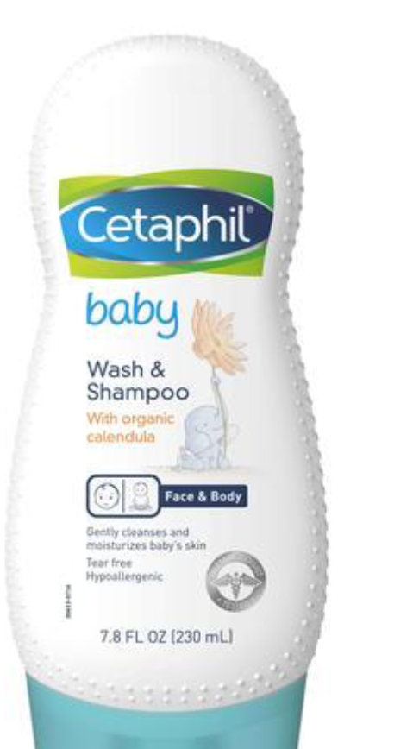

### 

## INTRODUCE PRODUCT

This gentle, tear free moisturizing wash blends into a rich lather and rinses clean, leaving your baby’s skin and hair with a soft, fresh fragrance. It is specially formulated with soothing organic calendula extract, derived from the marigold flower and used for centuries to soothe dry, sensitive skin.

## BENEFITS

* Tear free
* Contains soothing organic calendula extract
* Paraben free
* Colorant free
* Mineral Oil free
* Hypoallergenic
* Dermatologist tested

## INGREDIENTS

Sodium Laureth Sulfate, Disodium Laureth Sulfosuccinate, Cocamidopropyl Betaine, Glycerin, Panthenol (Vitamin B5), PEG-120 Methyl Glucose Dioleate, Glycol Distearate, Hydrolyzed Wheat Protein, Calendula Officinalis Flower Extract, Aloe Barbadensis Leaf Juice Powder, Fragrance, Citric Acid, Sodium Benzoate, Phenoxyethanol, Sodium Citrate, Laureth-4, Heliotropine, Polyquaternium-10, Sodium Chloride, Sodium Hydroxide, Tocopherol (Vitamin E)

## HOW TO USE

Pour into hand or washcloth and apply to hair and body. Lather, rinse and towel-dry.

## ORIGIN

Germany