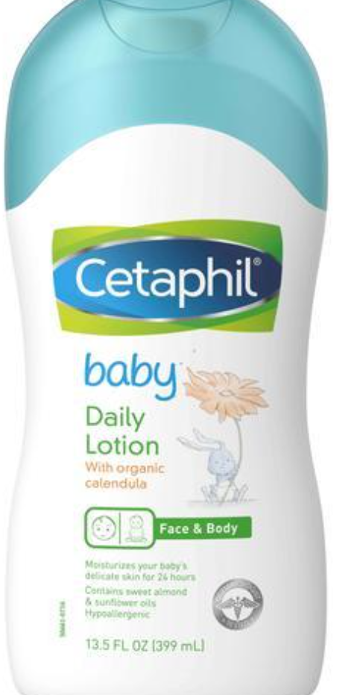

### 



## INTRODUCE PRODUCT

This gentle baby lotion is designed to soothe and nourish, while moisturizing and protecting your baby’s skin from dryness. It is specially formulated with soothing organic calendula extract, derived from the marigold flower and used for centuries to soothe dry, sensitive skin.

## BENEFITS

* With sweet almond oil and sunflower oil to soften and smooth
* Contains soothing organic calendula extract
* Paraben free
* Colorant free
* Mineral Oil free
* Hypoallergenic
* Dermatologist tested

## INGREDIENTS

Water, Sorbitol, Helianthus Annuus (Sunflower) Seed Oil, Isopropyl Palmitate, Octyldodecanol, Polyglyceryl-3 Diisostearate, Glycerin, Panthenol (Vitamin B5), Hexyldecanol, Hexyldecyl Laurate, Prunus Amygdalus Dulcis (Sweet Almond) Oil, Caprylyl Glycol, Carbomer, Fragrance, Disodium Cocoyl Glutamate, Sodium Hydroxide, Dipropylene Glycol, Calendula Officinalis Flower Extract, Squalane, Propylene Glycol, Glyceryl Caprylate, Heliotropine, Tocopherol (Vitamin E), Glycine Soja (Soybean) Oil

## HOW TO USE

Apply liberally where needed.

## ORIGIN

Germany