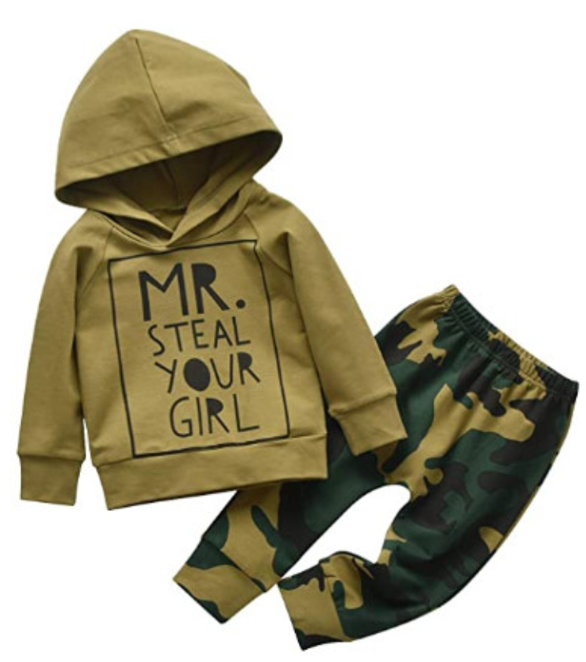

### 

### Toddler Infant Baby Boy Clothes Long Sleeve Pocket Hoodie Tops Sweatsuit Pants Outfit Set

**Color:** Green

* Material:cotton blend,soft,comfortable and high quality.
* Best gift for your baby.
* Comfortable and breathable for your baby to wear.
* Package:1* Hoodie Tops + 1*Pants
* Please read the size information carefully before purchasing.

### Product details

**Package Dimensions :** 10.3 x 10.2 x 1.2 inches; 8.78 Ounces

**Department :** Baby-boys

**Date First Available :** September 25, 2020

**ASIN :** B08K3MPY88

**Amazon Best Sellers Rank:**#29,860 in Clothing, Shoes & Jewelry