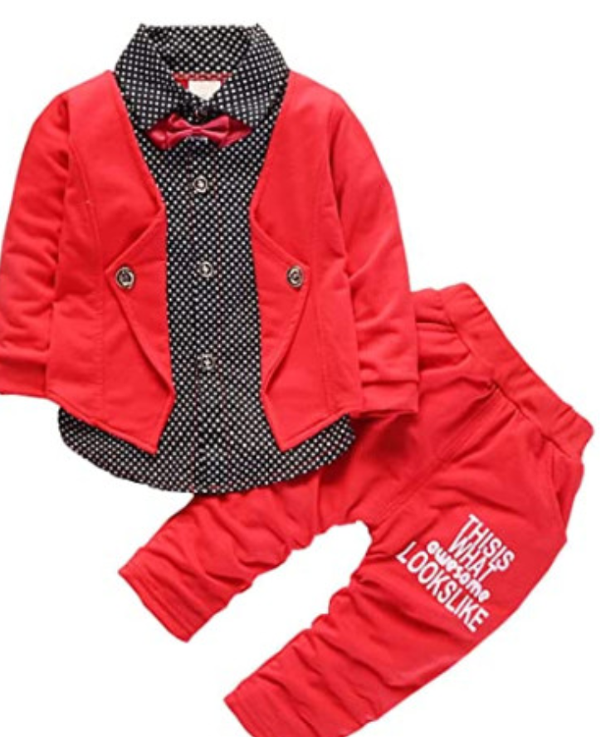

### 

**Color:** Red

* Cotton Blend.
* Our tag S for 0-6 Months, tag M for 6-12 Months, tag L for 12-24 Months, tag XL for 2T-3T.
* Good quality cotton to protect baby soft skin.
* New and Fashion design.

### Product description

S, Age about 0-6 Months: T-shirt Length 13.3", Bust 20.5 ", Pants Length 18.5" M, Age about 6-12 Months: T-shirt Length 14.2 ", Bust 21.3", Pants Length 19.3 " L, Age about 12-24 Months: T-shirt Length 15", Bust 22.1 ", Pants Length 20.1" XL, Age about 2-3 Years: T-shirt Length 15.8 ", Bust 22.8", Pants Length 20.8 "

### Product details

**Department :** Baby-boys

**Date First Available :** December 26, 2019

**ASIN :** B0834L37JL

**Amazon Best Sellers Rank:**#22,147 in Clothing, Shoes & Jewelry