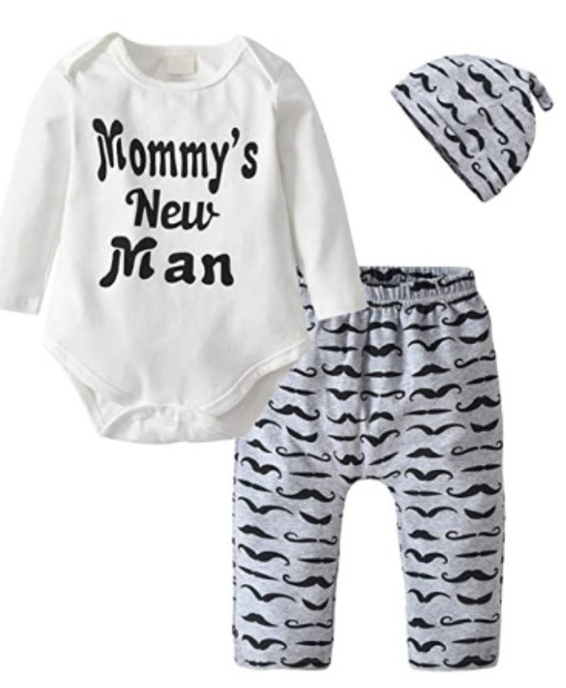

### 

### 3Pcs Baby Boys Clothes Mommy's New Man Romper Moustache Pants Hat Outfits Set

**Color:** White-long Sleeve

* Cotton
* High Quality.
* Best gift for your baby boy.
* Package:1*tops + 1*pants + 1*hat
* Please read the size information carefully before purchasing.

### Product details

**Department :** Baby-boys

**Date First Available :** May 3, 2018

**ASIN :** B07CV8R1NY

**Amazon Best Sellers Rank:**#87,067 in Clothing, Shoes & Jewelry