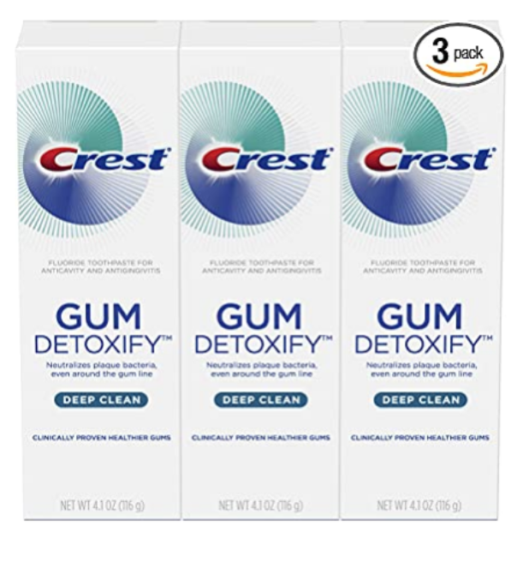

### 

### Crest Toothpaste Gum Detoxify Deep Clean, 4.1oz (Pack of 3)

**Brand:** Crest

* Item Form: Paste
* Design: Crest. ntroducing new Crest Gum Detoxify Deep Clean toothpaste. Created after years of research by Crest scientists, it’s been specially formulated to target the millions of plaque bacteria around the gum line. Crest Gum Detoxify Deep Clean uses a cooling activated foam to help penetrate hard to reach areas, finding and neutralizing harmful plaque bacteria around the gum line for clinically proven healthier gums.
* Use Crest Gum Detoxify Deep Clean Toothpaste for clinically proven healthier gums
* Neutralizes plaque bacteria, even around the gum line to fight gingivitis
* Activated foam seeks out plaque bacteria in hard to reach places

### Product information

**Product Dimensions :**1.5 x 5.95 x 5.79 inches

**Department :**Crest

**Date First Available :** December 21, 2020

**ASIN :** B0791V11PS

**Amazon Best Sellers Rank:**#374 in Health & Household (See Top 100 in Health & Household) #9 in Toothpaste