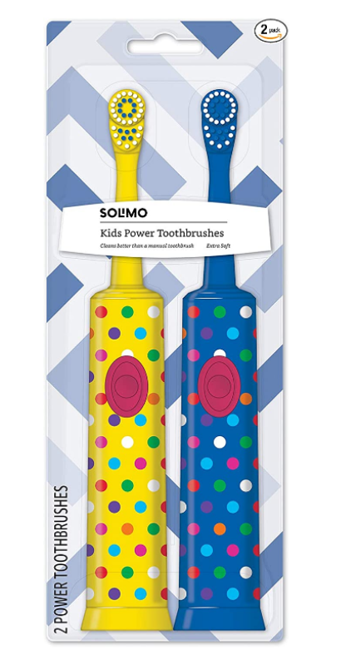

### 



### Solimo Kids Battery Powered Toothbrush, 2 Count

**Color:** Yellow,Blue

* Safe Material: Toothbrush is BPA free.
* Design: Solimo. Superior Plaque Removal Oscillating brush head removes up to 70% more plaque than a manual toothbrush
* Oscillating brush head
* Soft bristles provide a gentle, thorough cleaning
* Battery powered (two AAA batteries included) For children age 4+

### Product description

Product description

The Solimo Kids Battery Powered Toothbrush cleans better than a manual toothbrush by removing up to 70% more plaque. Featuring an oscillating brush head, this toothbrush provides a gentle, thorough cleaning.

### Product information

**Product Dimensions :**1.38 x 3.51 x 9 inches; 6.38 Ounces

**Department :**Solimo

**Date First Available :** December 21, 2020

**ASIN :** B07QF798HC

**Best Sellers Rank:**#2,929 in Health & Household (See Top 100 in Health & Household) #4 in Children's Electric Toothbrushes