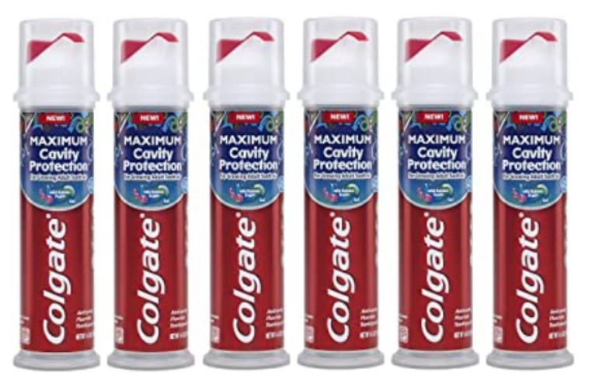

### 



### Colgate Kids Toothpaste Pump with Fluoride for Maximum Cavity Protection, Mild Bubble Fruit Gel - 4.4 ounces (6 Pack)

**Brand:** Colgate

* Item Form: Paste
* Design: Colgate. Kids toothpaste with fluoride provides clinically proven cavity protection for kids 6 years and up
* Gentle formula for children that fortifies weak spots on enamel Helps reduce plaque buildup with regular brushing
* American Dental Association (ADA) accepted toothpaste for kids Toothpaste pump dispenser allows kids to apply gel toothpaste to a brush with ease
* Mild bubble fruit flavor to help encourage brushing and freshen breath Pack of 6 toothpaste pumps with 4.4 ounces in each; a total of 26.4 ounces

### Product information

**Product Dimensions :**1.8 x 1.8 x 7.1 inches; 6.66 Ounces

**Department :**Colgate

**Date First Available :** December 21, 2020

**ASIN :** B07DT7M9BS

**Amazon Best Sellers Rank:**#10,778 in Health & Household (See Top 100 in Health & Household) #30 in Kid's Oral Hygiene Products #54 in Children's Dental Care Products