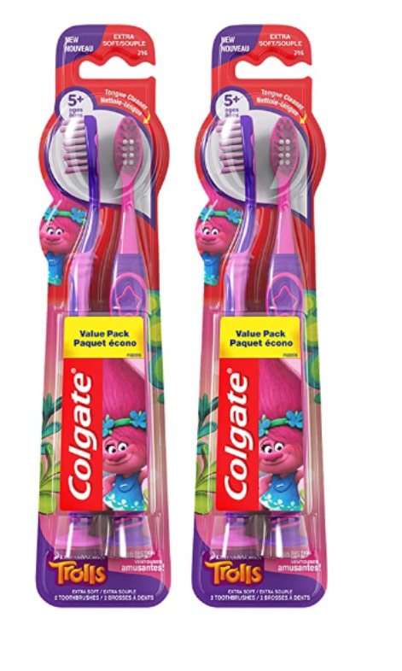

### 

### Colgate Kids Toothbrush with Extra Soft Bristles and Suction Cup Holder, Trolls - 4 Count

**Color:** Purple-Pink

* Safe Material: Toothbrush is BPA free.
* Design: Colgate. Trolls kids toothbrush provides a fun way to encourage good oral care habits early on
* Kids soft toothbrush features a unique tongue cleaner to clean beyond teeth
* Thumb grip and rounded handle offer a comfortable grip
* Built in suction cup for easy and fun upright storage

### Product information

**Product Dimensions :**9.25 x 1.25 x 11.25 inches; 4.61 Ounces

**Department :**Colgate

**Date First Available :** December 20, 2020

**ASIN :** B0795VHRY1

**Amazon Best Sellers Rank:**#596 in Health & Household (See Top 100 in Health & Household) #1 in Children's Electric Toothbrushes