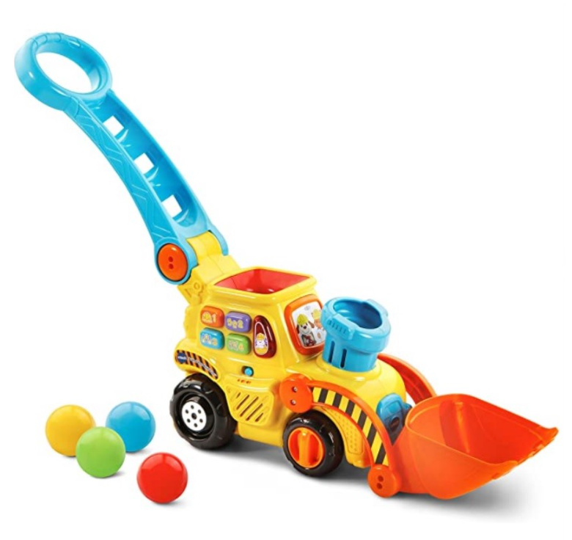

### 

### VTech Pop-a-Balls Push & Pop Bulldozer,Yellow

**Color:** Yellow

* Material: Natural Plastic, it is made of good quality material
* Design: VTech Store. Push the handle to roll the bulldozer across the floor and watch it pop balls out of the chimney into the bucket
* -Press the buttons to learn colors, numbers, phrases and music
* Roll the bulldozer and trigger motion sensors to listen to fun tunes and songs on the move stimulating attention and coordination
* Grab the chunky handle to encourage motor skill development

### Product description

Product description Age: 2-3 Years Encourage imaginative play and motor skills with this ball pit filled with fun activities! Age: 3-4 Years Have a ball with this interactive toy! Play with six colorful balls, dropping them down the slides or pressing the yellow button to pop them out of three holes. Age: 4-5 Years Toss the basketball into the hoop to score points, or kick the soccer ball into the net to hear fun sounds Age: 5-6 Years Play ten activities while learning letters, numbers, colors and more.

**Product Dimensions :**6.18 x 6.18 x 6.3 inches; 3.51 pounds

**Department :**V-Tech

**Date First Available :** December 21, 2020

**ASIN :** B06WV7VBY5

**Amazon Best Sellers Rank:**#382 in Toys & Games (See Top 100 in Toys & Games) #4 in Toddler Push & Pull Toys #5 in Push & Pull Baby Toys #151 in Pre-Kindergarten Toys