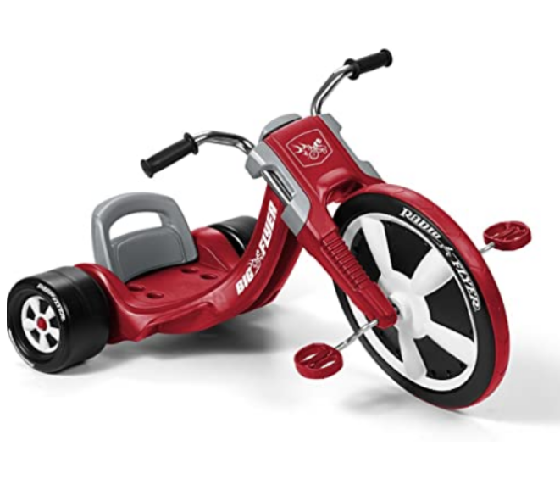

### 

### Radio Flyer Deluxe Big Flyer, Outdoor Toy for Kids Ages 3-7

Price: $79.99

**Color:** Red

* Material: Stanless steel,Chrome,Plastic.
* Design: Deluxe Big Flyer. Take a ride on the Deluxe Big Flyer, the performance trike. This award-winning trike is designed to be your child's favorite new ride! The Deluxe Big Flyer is a chopper-style tricycle with sleek racing design. It features a large 16” front wheel with performance grip tread to hug the road and allow your child to take off without slipping or spinning out. The seat is adjustable to grow with your child, and it comes complete with chrome handlebars.
* LARGE 16” WHEEL: This chopper-style tricycle has a large 16” front tire. The performance grip tread prevents spinning out
* ADJUSTABLE SEAT: The adjustable seat grows with your toddler to ensure years of fun. This outdoor toy is recommended for kids 3 – 7 years
* CHROME DETAILS: The chrome handlebars add to the sleek design while the hand grips add comfort SPECIFICATIONS: Assembled

### Product information

**Product Dimensions :**35.43 x 24.41 x 20.67 inchess; 12.2 pounds

**Department :**Deluxe Big Flyer

**Date First Available :** December 21, 2020

**ASIN :** B00P4CF10S

**Amazon Best Sellers Rank:**#7,229 in Sports & Outdoors (See Top 100 in Sports & Outdoors)#6 in Kids' Tricycles