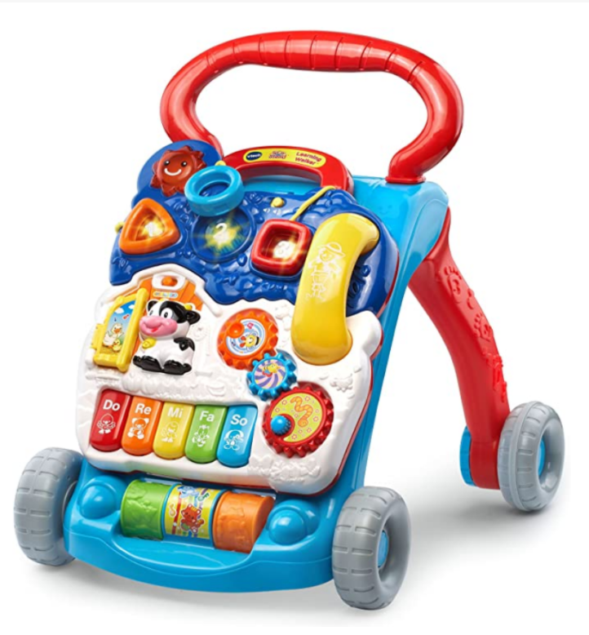

### 

### VTech Sit-To-Stand Learning Walker (Frustration Free Packaging), Blue

**Color:** Blue

* Material: Natural Plastic, it is made of good quality material
* Design: VTech Store. Get ready to walk. Little ones can play with the detachable activity panel on the floor while discovering animals, colors, music, shapes and numbers. Attach the panel to the walker as babies grow and they’ll continue to learn as they move along.
* -Interactive learning baby walker has a removable play panel; Frustration Free Packaging means it comes in a plain brown box
* Early learning center has 5 piano keys that play music and encourage creativity; wheels work on carpeted and hard floors
* Features 2 colorful spinning rollers, 3 shape sorters, and 3 light-up buttons that develop motor skills

### Product information

**Product Dimensions :**16.5 x 14.2 x 18.1 inches; 2.2 pounds

**Department :**V-Tech

**Date First Available :** December 21, 2020

**ASIN :** B07CRSXMW8

**Amazon Best Sellers Rank:**#36 in Toys & Games (See Top 100 in Toys & Games) #1 in Toddler Push & Pull Toys #1 in Push & Pull Baby Toys #11 in Pre-Kindergarten Toys