Solution for data migration

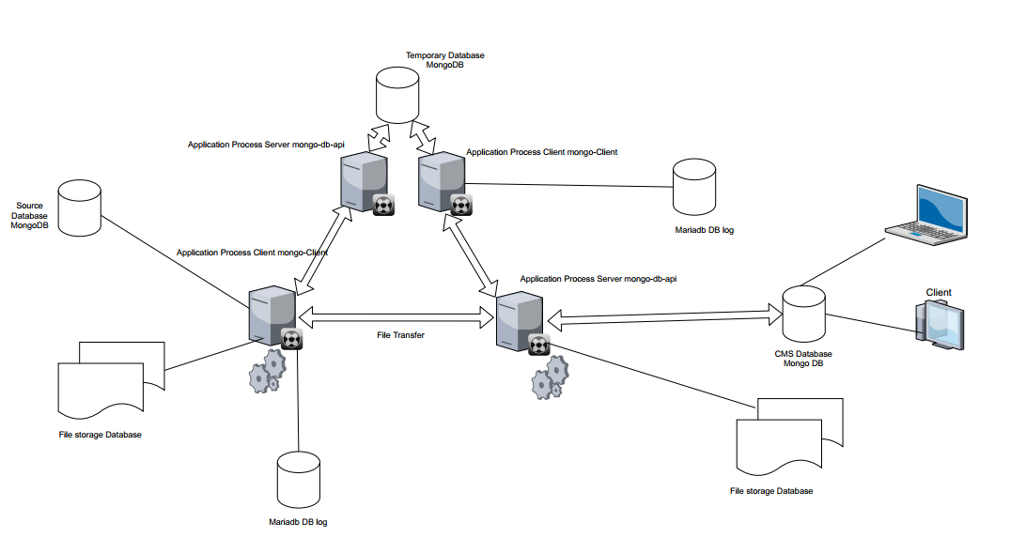

* Source database is mongo database source
* Application Process is Java or Python process using for copy database from Source database and push data to CMS Database .When copy data process will write log to data log to trace database if have error. In this process we define batch process to run multilthread for boot high speed copy
* CMS database is destination database get data from application process

**Server Service mongo-db-api**

* Application using Spring boot get data from client by Resfull Api check data duplicate and insert document to mongo database

**Server Service mongo-db-api-temp**

* Application using Spring boot get data from client by Resfull Api check data duplicate and insert document to mongo database template
* **mongo-Client**
* is java application client get data from source database check duplicate and save id of document to MariaDB after that send object to server using httpClient. Mongo-client copy data from db template to destination db (cms database)
* **mongo-Client-Temp**
* is java application client get data from source database check duplicate and save id of document to MariaDB after that send object to server using httpClient. Mongo-client-temp copy data from db source to template db

**pre conditional**

install Docker for windows

and run file build_container.cmd to create container in docker

after run process java by checkout this link

Link GitHub <https://github.com/khoahung/JavaMongoDB.git>

create database name logdb in mariadb

create table in logdb mariadb by this format

CREATE TABLE LogData (id int(11) NOT NULL AUTO_INCREMENT,recordid varchar(100) NOT NULL,updateTime date DEFAULT CURRENT_TIMESTAMP NOT NULL, PRIMARY KEY (id) );

CREATE TABLE LogFile (id int(11) NOT NULL AUTO_INCREMENT,FileName varchar(100) NOT NULL,updateTime date DEFAULT CURRENT_TIMESTAMP NOT NULL, PRIMARY KEY (id) );