**The Catholic University of America**

**CSC 527 Fundamentals of Neural Networks**

**Project 2: Least Mean Square Algorithm**

Student: Lan Nguyen

Instructor: Dr. Hieu Bui

Date: 11/12/2020

Contents

I. Introduction: 3

II. Working environment: 3

III. Task1: 3

IV. Task2: 4

A. LMS algorithm: 4

B. LMS implementation: 5

V. Task3: 6

VI. Task 4: 8

VII. Conclusion: 8

VIII. References 8

# I. Introduction:

The least-mean-square (LMS) algorithm, developed by Widrow and Hoff (1960), was the first linear adaptive-filtering algorithm for solving problems such as prediction and communication-channel equalization. The objective of this project is to understand the theory behind the LMS algorithm and compare its performance with the Least square method and the Perceptron method.

# II. Working environment:

* Google colab: Using python notebook for result organization
* Python 3.7
* Matplotlib, numpy: plot figure and processing data.

# III. Task1:

 Step1: Generate data using generative model from textbook (formula 3.64):

 5000 data points is selected from 10000 random points

Step2: Train the linear prediction by iterating 100 epochs:

 Each error is calculated based on the formula

Where : - d(n) is desired output

- x(n)w(n) is dot product to get predict output

 Weights update based on the formula

Step3: Calculate the LMS learning curve in theory using formular 3.63

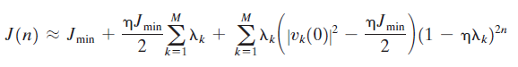

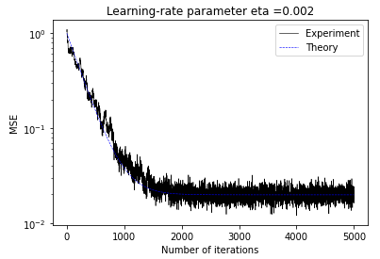Results:

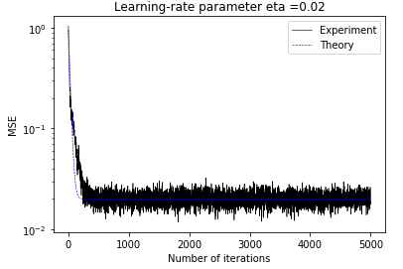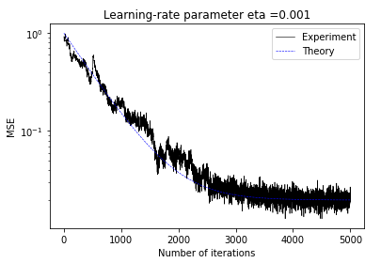

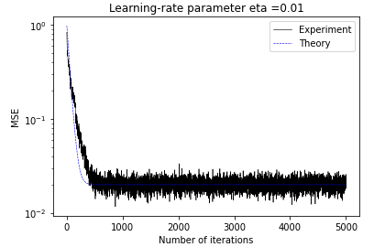

# IV. Task2:

## A. LMS algorithm:

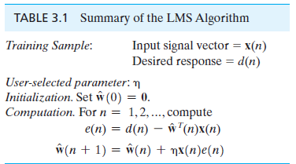

* Input vector at time n, denoted by x(n)
* Desired value at time n, denoted by d(n)
* Initial the filter coefficients w(0) =0
* The model is linear in parameters, producing output y(n) = w(n).x(n)
* For each iteration the error is computed as e(n) = d(n) – w(n).x(n)
* Update rule is: w(n+1) = w(n) + learningRate*x(n)*e(n)

## B. LMS implementation:

Step 1: Processing the data using getDataSet() function. The function will return XX which is a 2d array with n rows and 2 columns where n is the total number of data points. The other variable is YY which is the label of dataset.

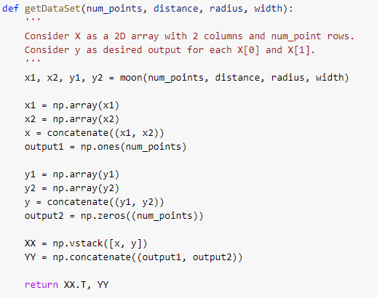

Step 2: Normalize the data by subtract each data point by the mean and divided by standard deviation.

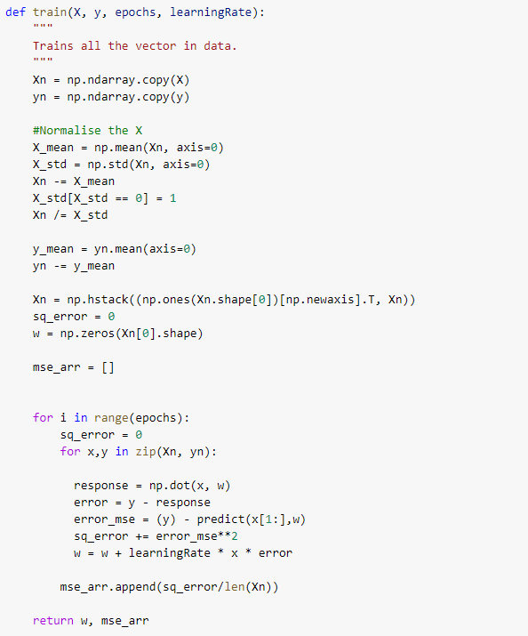

Step 3: Train the dataset using LMS algorithm.



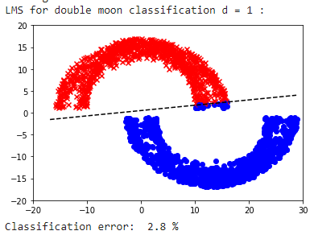Results:

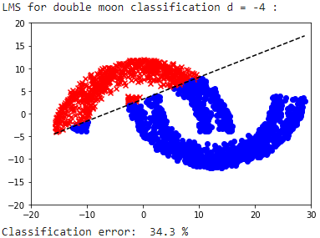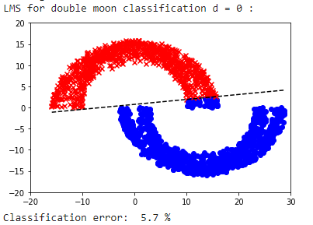

# V. Task3:

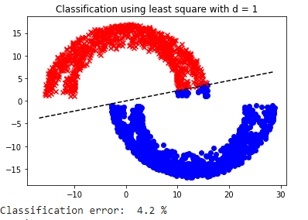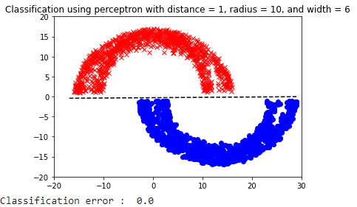Results from the experiments on the perceptron and on the method of least squares:

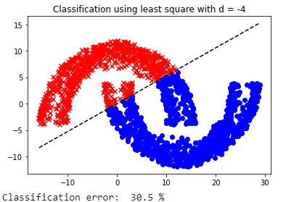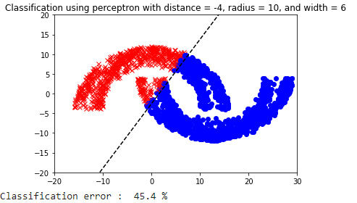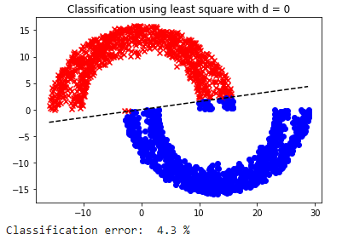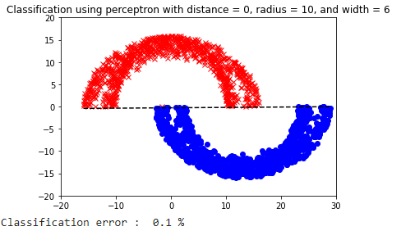

|  |  |  |  |
| --- | --- | --- | --- |
|  | LMS | Least squares | Perceptron |
| Classification error (d=0) | 5.7% | 4.3% | **0.1%** |
| Classification error (d=1) | 2.8% | 4.7% | **0.0%** |
| Classification error (d=-4) | 34.4% | **30.5%** | 45.4% |

Overall, these three algorithms works for linear classification. However, according to the classification error, the perceptron perform very good at distance = 0 and 1. On the other hand when the dataset become more complex compare with a linear problem the least square method and the LMS algorithm prove its stability and more accuracy than the perceptron.

# VI. Task 4:

The range of MSE using LMS algorithm varies between [0.25, 0.35] meanwhile the range of Perceptron varies from 0.0 to 0.6. This indicate that the LMS algorithm have less difference between the estimated values and the actual value when the distance of the two moon increase. In other words, LMS is more robust with respect to external disturbances.

# VII. Conclusions and Github:

1. The LMS algorithm perform the most robust when the learning rate parameter is small enough.
2. The LMS algorithm is effective and simple to implement.
3. The complexity of LMS algorithm follows a linear law with regard to the number of adjustable parameter hence it is efficient.

My github link: <https://github.com/khoalan/CSC527>

# VIII. References

1. Simon, H. (2009). *Neural Networks and Learning Machines*. Pearson
2. Jessica, Y. (09/2018). Generating Autoregressive data for experiments. *Jessica Yung*. Retrieve from: https://www.jessicayung.com/generating-autoregressive-data-for-experiments/
3. Least mean squares filter. (n. d.). In *Wikipeadia*. Retrieved November, 12, 2020, from <https://en.wikipedia.org/wiki/Least_mean_squares_filter>