Project Data Wrangling Report
Anh Khoa Mai

MovieLens Analysis

Table of Contents
Part 1: Data Wrangling 2
Import and initial exploration 2
Merge and integrate tables 3
Clean and transform 4
Load and validate 6
Part 2: Exploration and Insight 7
Q1. Rating patterns by genre 7
Q2. Tags, relevance, and movie engagement 8
Q3. Release year and audience response 9
Q4. Genre combinations and engagement patterns 10
Q5. Relationship between genre and audience rating shifted over time 12

Part 1: Data Wrangling

Import and initial exploration
ratings.csv is the core behavioural data: who rated what, how highly, and when. This is the dependent variable for almost any analysis. On its own it’s just numbers tied to opaque IDs.
movies.csv gives every movieId a human-readable identity: title and genre. Without it, ratings is unanalyzable.
links.csv bridges movieId to imdbId / tmdbId. On its own its’s just a lookup table. Without movies / ratings it’s meaningless in isolation.
tags.csv is free-text, user-generated descriptors. This adds a qualitative layer that genres can’t capture, while tags reveal finer-grained themes, tone, and audience reaction. Alone it’s just scattered text with no rating or movie context attached.
genome_score.csv + genome_tags.csv, together, give a quantified relevance score between every movie and a fixed 1,128-term vocabulary. This is the difference between "a user happened to write 'sci-fi'" and "this movie is 0.87 relevant to the concept of sci-fi." genome_tags alone is just a list of terms with no meaning; genome_score alone is just numbers next to opaque tagIds. They only become useful together, and only mean anything once tied to specific movies via movieId.
- Merging gives clearer context to answer real analysis questions.
Dataset overview
Source: MovieLens dataset (Multiple CSV files)
Total records: 761,780
Representative Dataset – ratings:
- Rows: 192,820
- Columns: 4
Incorrect type findings
ratings[‘timestamp’]: object => datetime64
tags[‘timestamp’]: object => datetime64
links[‘tmdbId’]: float64 => int64
Quality findings
- Overall missingness rate: 0.2% across all datasets
- Duplicate: No exact duplicate rows found across any datasets and no duplicate composite key for ratings, tags, and genome_score
- Categorical consistency:
Whitespace contamination: 81 values with leading/trailing whitespace detected in tags[‘tag’]. Encoded missing values were also detected in tags[‘tag’] (a non-breaking space, ‘missing’ and ‘na’).
- Numeric Distribution and Outliers:
Impossible/Unusual values: 541 rows in genome_score[‘relevance’] and 7,712 rows in ratings[‘rating’] contain negative values
IQR-Based Outlier Detection: 7,655 outliers in genome_score[‘relevance’] and 18,705 outliers in ratings[‘rating’] are detected

Merge and integrate tables
Step1: movies + links
Key: movieId. Relationship: one-to-one
Both are movie-level tables with 8,305 rows each and 100% overlapping movieId
Step 2: tags (aggregated)
Key: movieId (grouped-by key). Relationship: many-to-one after aggregation
Tags are grouped by movieId into one row per movie: tag_count (every tag record), unique_tag_count (distinct tags) and top_tags (the five most-used tags). The roughly 470,000 cleaned tag rows become 7,938 movie-level rows.
Step 3: genome_score + genome_tags
Key: tagId. Relationship: many-to-one
Each genome_score row has exactly one tagId; joining brings in the human-readable tag name for that ID.
Step 4: genome result (aggregated)
Key: movieId (group-by key). Relationship: many-to-one after aggregation
Same fix as step 2: collapses ~11 rows/movie down to one row per movie (top 5 tags by relevance, and mean relevance as an overall "how genome-tagged is this movie" signal).
Step 5: movie_dim + tag_summary + genome_summary
Key: movieId. Relationship: one-to-one (left join)
All three are now at one-row-per-movie grain. Left join is used because not every movie has tags (7,938/8,305) or genome data (7,200/8,305); those movies get nulls in the relevant columns rather than being dropped.
Step 6: ratings (cleaned) + full movie dimension
Key: movieId. Relationship: many-to-one
The key join of the whole pipeline: many ratings can reference the same movie, but the movie dimension has exactly one row per movieId, so each rating gets exactly one set of movie attributes attached. Row count is verified to stay at 185,107 (the cleaned ratings count) after this join.
Why each table was included (or how it was included)
movies / links are included in full: these are the core movie identity/metadata and cost nothing (1:1, no row inflation).
ratings is the analysis fact table; everything else exists to describe what was rated.
tags is included only as movie-level summary features (tag volume, vocabulary breadth, top tags), not as raw rows, because raw inclusion is what causes a row explosion (merging tag rows onto ratings by movieId would repeat each rating once for every tag row of that movie, giving tens of millions of rows) and doesn't fit the ratings grain anyway (a tag is a property of the movie/user pair, not of a specific rating event).
genome_score + genome_tags has same treatment: included as movie-level summary features (top 5 relevant tags with scores, mean relevance), for the same row-explosion reason.

Clean and transform
Removing duplicate records
Don't have to remove any duplicate records on genome_score, tags, and ratings because they contain composite key. In addition to that, later checks on duplicate records on composite key show no duplicate records.
Handle missing value and impossible value
Case | Count | Treatment | Why
Rating is null | 5,141 | Drop the row | Rating is the target of the analysis, so a row without it has no use. Imputing would invent the outcome.
Blank, whitespace-only and null tags | 16 | Strip whitespace, lower-case, drop empty tags | They carry no tag content: 11 null and 5 whitespace-only tags (a non-breaking space is removed by .str.strip()). The strings ‘na’, ‘missing’ and ‘?’ were flagged as encoded missing values but are left in; they are 3 of 470,006 rows.
Movie has no tag rows | 358 | Left as NaN in the dataset; counted as 0 in the analysis | 358 movies (455 rating rows). NaN marks a movie as untagged: Q2 flags these movies with has_tags = False, and Q3 and Q4 fill tag_count with 0 at the movie level.
Movie has no genome data | 1,066 | Left as NaN | 1,066 movies (1,090 rating rows). A relevance score that was never measured is unknown, so a zero would be false.
tmdbId null | 26 rows | Left as NaN | It isn’t used in any analysis and can’t be derived.
Rating is negative | 7,712 | Repair with absolute value | Sign-flip corruption: after taking the absolute value, all 7,712 values fall inside the valid 0.5–5.0 scale, so the rows are kept.
 | 2,572 | Drop the row | Values such as 9.9966 are outside the valid 0.5–5.0 scale and cannot be recovered, so the rows are dropped.
  Rating is above 5
Genome relevance: negative, above 1 or null | 1,624 | Flip negatives; drop the rest | 541 negative scores are flipped to positive and kept (same sign-flip logic as ratings). 271 scores above 1 and 812 nulls (1,083 rows) cannot be recovered and are dropped from genome_score before aggregation, leaving 80,133 rows. No movie is removed from the dataset.

Fix categorical inconsistent
Timestamps are converted to datetime64 so they can be used for time-series analysis, and tmdbId is converted to an integer type where possible (it remains a float in the final dataset because 26 values are missing). In the tags table, whitespace is removed with ‘.str.strip()’, tags are lower-cased and empty tags are dropped, which reduces the distinct tags from 37,360 to about 34,000. Impossible values in ratings and relevance are handled as set out in the table above: negative values are treated as sign errors and flipped back to positive, and values that are still outside the valid range (ratings above 5, relevance above 1) are dropped. Finally, the IQR check flagged 18,705 rating and 7,655 relevance outliers, but after these fixes every remaining value lies inside the valid range (0.5–5.0 for ratings, 0–1 for relevance), so no further outlier removal was applied.
Before and after cleaning
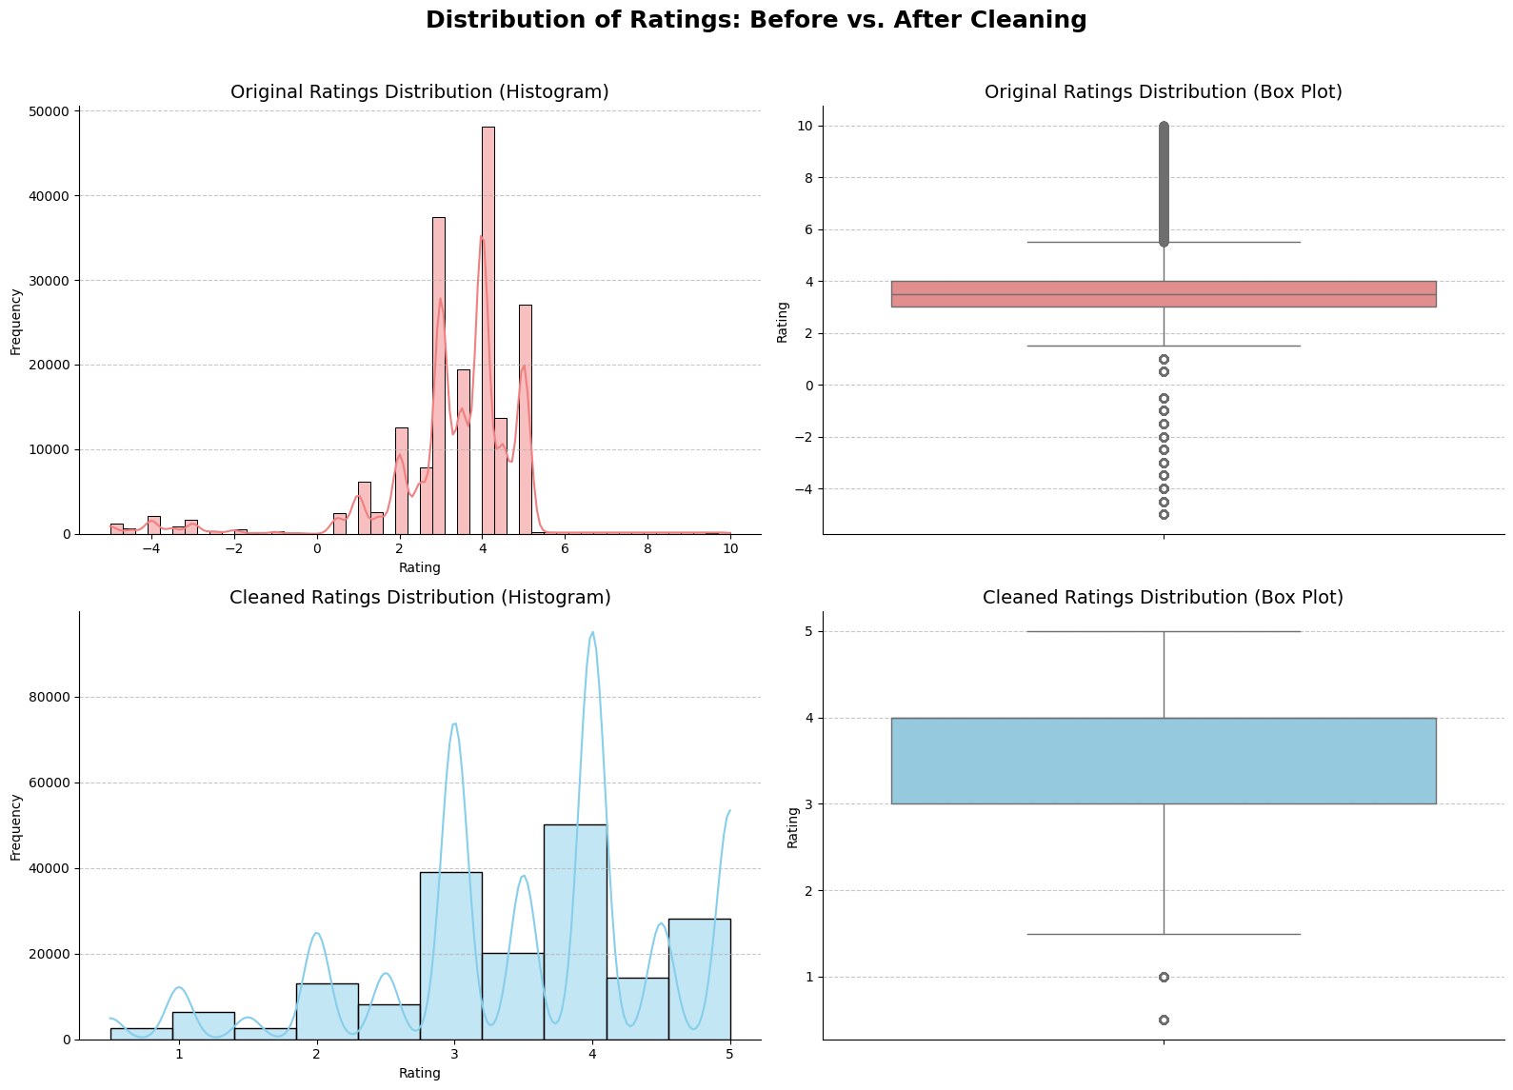
Figure 1: Before and after cleaning comparison

Load and validate
The final dataset has 185,107 rows and 17 columns: the 13 merged columns plus four derived features (release_year, release_decade, genre_count and genre_diversity). It has one row per rating event, with movie identity, genre, and pre-aggregated tag/genome summary features attached. All rating values fall inside the valid 0.5-5.0 scale, there are no nulls in any core column (userId, movieId, rating, timestamp, title, genres), and no duplicate (userId, movieId) rating pairs - so the fact-table grain is intact and safe to group/aggregate on.
The only nulls remaining are in the enrichment columns: tag_count, unique_tag_count and top_tags are missing for 455 rows (358 movies with no tags), genome_top_tags and genome_avg_relevance for 1,090 rows (1,066 movies with no usable genome scores), and tmdbId for 26 rows. These are legitimate “not available” values, not merge errors, and dropping them would remove otherwise-valid ratings, so they are kept and handled per analysis (for example, untagged movies are given a tag count of 0 in Q3 and Q4). For orientation, ratings average 3.53 (median 4.0), genome_avg_relevance averages 0.14 (range 0.01–0.46), release years run from 1914 to 2004, and movies carry between 1 and 7 genres (mean 2.6 per rating row).
- The dataset is ready for exploratory analysis (e.g. rating distributions, genre trends, tag/genome-based content analysis) with the one caveat that enrichment-column nulls need to be handled per-analysis rather than blanket-dropped.

Part 2: Exploration and Insight

Q1. Rating patterns by genre
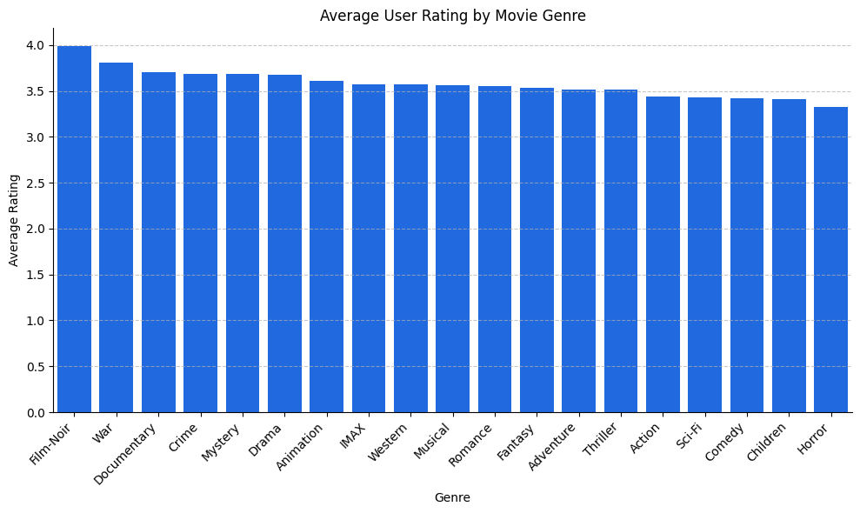
Figure 2: Average User Rating by Movie Genre
The analysis of the average user ratings by genre clearly shows preferences:
The top genres are Film-Noir with the highest average rating (3.98), followed by War (3.81) and Documentary (3.70). In sum, users of these genres are more likely to give a favourable rating to a movie, although Film-Noir and Documentary have only 2,004 and 1,647 ratings.
Lowest Rated Genres: The genres with the lowest ratings were Horror (3.33), Children (3.41) and Comedy (3.42). This does not mean they are unpopular (Comedy has 69,495 ratings and Horror 14,305), but their ratings are more spread out: Horror has the highest standard deviation of any genre (1.14).
Implications: The results can help to develop content acquisition strategies and indicate genres that are positively received by the audience. But it's also important to think about how many ratings each genre has. If a genre has fewer ratings, the average score may be less reliable (Film-Noir has 2,004 ratings and Documentary 1,647, against 80,361 for Drama).

Q2. Tags, relevance, and movie engagement
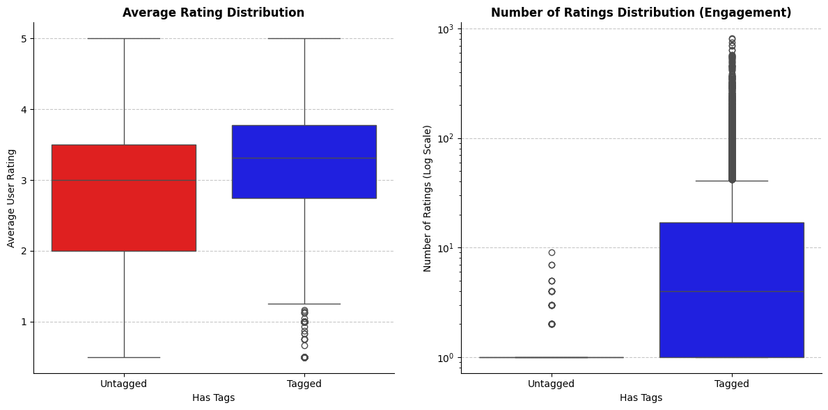
Figure 3: Rating Distribution Charts
The comparison between tagged and untagged movies gives important insights into audience engagement and perception:
More Engagement with Tagged Movies: Tagged Movies (7,836 movies that have been tagged by users) have a higher number of ratings (mean of 23.56) compared to Untagged Movies (358 movies, mean of 1.27). This means that movies with tags generated by users tend to be significantly more popular and have a larger audience.
Tagged Movies Have Higher Average Ratings: Tagged movies also have a higher average rating of 3.19 compared to Untagged Movies which have an average rating of 2.78. Untagged movies are also more variable (standard deviation 1.16 against 0.85).
Implications: Tagging activity is clearly associated with popularity: tagged movies receive more than 18 times as many ratings on average (23.56 vs 1.27). The link with quality is weaker than it looks. Untagged movies have on average only 1.27 ratings, so their average rating (2.78) usually reflects a single viewer, and this analysis compares group means only, without a correlation or significance test. The relationship could run in either direction: popular movies attract more tags, or tags make movies easier to discover and so bring more ratings. For recommendation and content discovery, tag data is therefore most useful as an exposure and metadata signal, and untagged, rarely rated movies are likely to be under-recommended even when they are good. The genome relevance score was not used in this comparison.

Q3. Release year and audience response
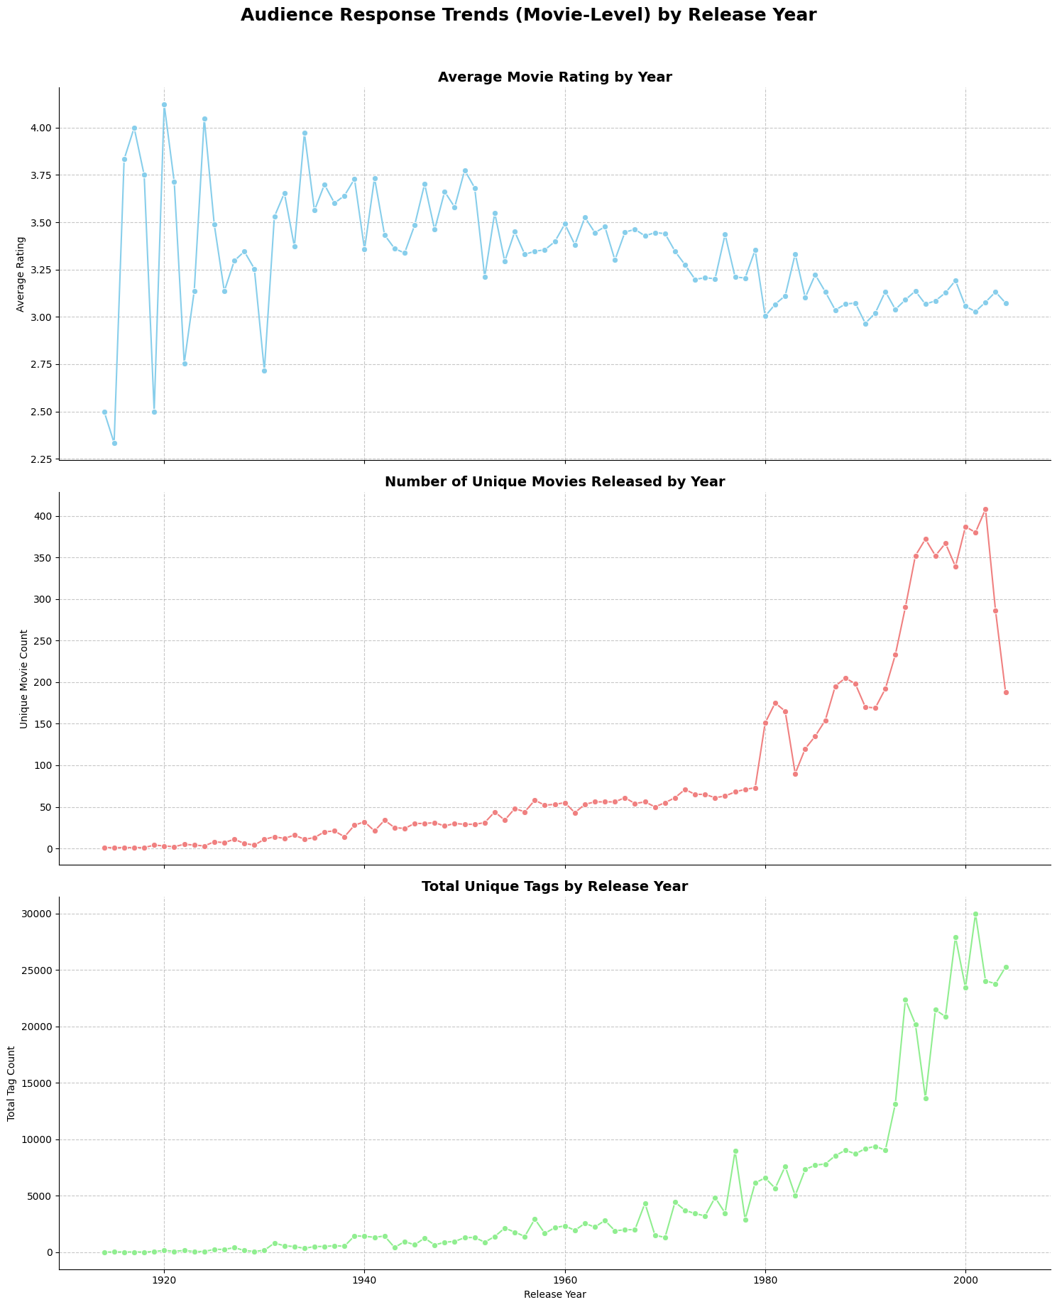
Figure 4: Audience Response Trends by Release Year
Examining the release year and decade of movies reveals several trends in audience response, popularity and tagging activity. All figures are movie-level (one value per movie), and release years run from 1914 to 2004, so there are no 2010s or 2020s titles in the data:
Audience Response (Average Rating): The top panel of Figure 4 and the decade table show that the average movie rating falls over time. Decade averages are highest for the 1930s (3.58) and 1940s (3.51), then fall to 3.42–3.44 in the 1950s–1960s, 3.28 in the 1970s and about 3.10 in the 1980s, 1990s (3.10) and 2000s (3.07). The earliest years (1914–1919) rest on only one to four movies a year and swing between 2.3 and 4.0, so they should not be over-interpreted. The higher scores for older films could be a survivorship effect, where mainly highly regarded older films are still being rated.
Popularity (Unique movie count): The middle panel counts how many distinct movies were released each year, so it shows how much of the catalogue comes from each year rather than how many ratings it received. Releases stay below about 75 movies a year until 1980, rise to 90–205 a year in the 1980s and to roughly 340–410 a year between 1996 and 2002 (the peak is 408 in 2002), then fall to 286 in 2003 and 188 in 2004 because the data end in 2004. By decade, the 1990s contribute the most movies (2,836), followed by the 2000s (1,649 in only five years) and the 1980s (1,588).
Tagging Activity (Total tag count): The bottom panel sums tag_count over the movies released each year (the chart title says “unique tags”, but tag_count counts every tag record, not distinct tags). Tagging is low for early decades (under 25,000 tag records per decade up to the 1960s) and rises sharply from the 1970s (42,485) and 1980s (74,097) to the 1990s (167,312), with yearly totals peaking at about 30,000 for 2001 releases. These totals reflect both the larger number of recent movies and more tags per movie.
- The Difference Between Older and Newer Titles and How Audiences React:
Older Titles (pre-1980s): Fewer movies per year (at most 73) and far fewer tag records, but higher average ratings (about 3.3–3.6 by decade). This could be a classic effect, where mainly well-regarded old films are remembered and rated, or a smaller, more dedicated audience; the notebook does not test either explanation.
- Newer Titles (1990s onwards): Many more movies (2,836 in the 1990s) and tag records (167,312), but lower average ratings (3.10 in the 1990s and 3.07 in the 2000s). More movies are being released, rated and tagged, yet the average movie is rated lower than the average older film. This may reflect a larger, more varied audience and a catalogue that includes many lesser-known titles, but that is not tested here.
To summarise, average movie ratings decline from the 1930s to the 1980s and then level off at about 3.1, while the number of movies and the amount of tagging are concentrated in releases from the 1980s onward, especially the 1990s and early 2000s. Engagement and perceived quality therefore move in opposite directions across release years: the periods with the most movies and tags have the lowest average ratings.

Q4. Genre combinations and engagement patterns
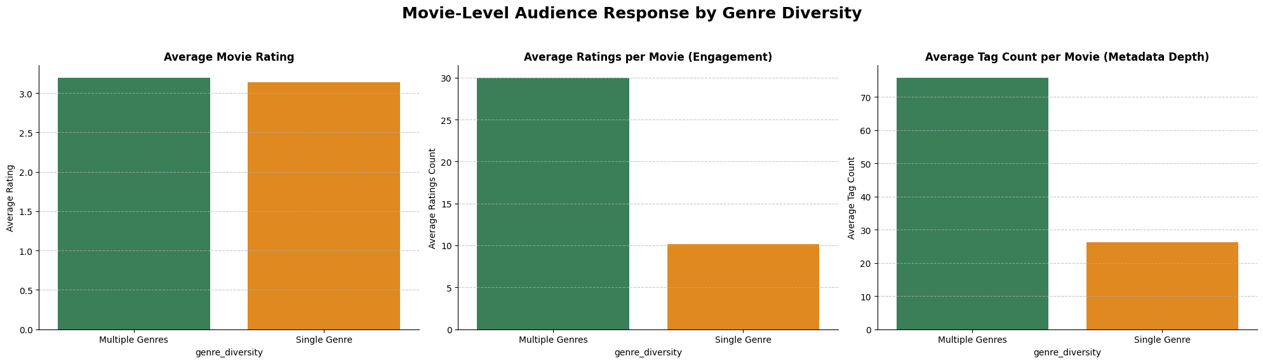
Figure 5: Audience Response by Genre Diversity
The analysis investigates whether multi-genre movies differ from single-genre movies regarding audience response, measured by average movie rating, average number of ratings per movie (popularity) and average tag count per movie. All figures are movie-level averages, and untagged movies count as 0 tags:
- Summary Table and Visualisations - Highlights:
Average Rating: The average movie rating is 3.14 for single-genre movies (3,051 movies) and 3.19 for multi-genre movies (5,143 movies). The difference is only about 0.05 stars and may not be substantial without further statistical testing; the two bars in Figure 5 are almost the same height.
- Popularity (Average ratings per movie): Multi-genre movies receive about 30 ratings each on average, against about 10 for single-genre movies, almost three times as many. Thus, genre diversity is linked to higher audience engagement, both in terms of the number of viewers and the level of rating activity.
- Tagging Activity (Average tag count per movie): Likewise, multi-genre movies have 75.7 tags on average against 26.1 for single-genre movies, again almost three times as many. This mirrors the pattern in ratings, which suggests that movies with diverse genres attract more user-generated material and discussion. Because tagged movies are also the most-rated movies (Q2), the two gaps are related and should not be read as independent evidence.
Conclusion: Genre Diversity and Engagement
We find that genre diversity is strongly related to higher levels of audience engagement, especially ratings per movie (about 30 vs 10) and tags per movie (75.7 vs 26.1). The average rating difference is small (3.19 vs 3.14), so multi-genre films draw a much larger audience without being rated noticeably higher or lower. There are a few possible factors, none of which is tested here, which could explain this pattern:
- Broader Appeal: Films that blend various genres can attract a broader audience of viewers, because they might appeal to tastes for more than one genre.
- Complexity and Richness: Multi-genre movies might offer more complex stories, themes, or experiences, leading to more discussion and a higher chance of users tagging them with varied descriptive terms.
- Marketing and Discoverability: Being a multi-genre movie, it may appear in more genre-specific searches or recommendations, thus increasing its visibility and chances of engagement.

Q5. Relationship between genre and audience rating shifted over time
Has the relationship between genre and audience rating shifted over time (by the year ratings were submitted), and if so, which genres are "rising" vs. "declining" in audience favour, with implications for content acquisition strategy?
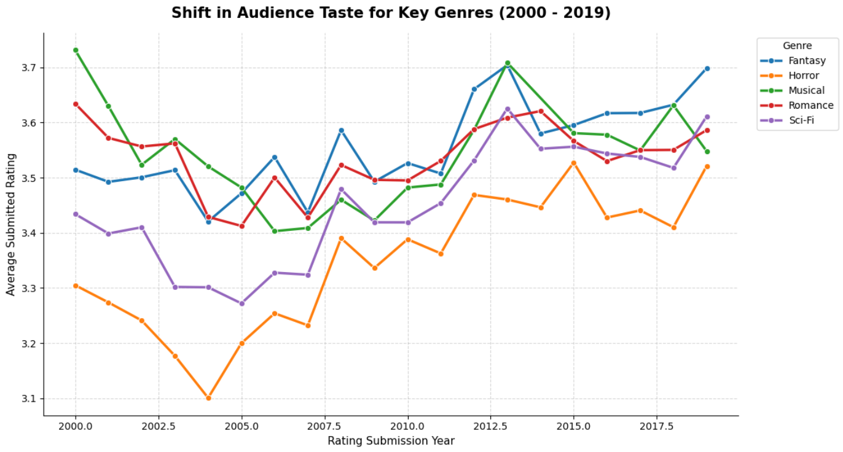
Figure 6: Shift in Audience Taste for Key Genres (2000 – 2019)
Yes, to some extent. Because release years in this dataset stop at 2004, recent shifts in taste cannot be seen by release decade, so this analysis follows the average rating given in each rating year (1996–2019, ignoring genre-year combinations with fewer than 100 ratings) and compares 2000 with 2019. A handful of genres changed by 0.14–0.22 stars, in both directions, while the remaining genres changed by less than that. This implies that audience tastes are not fixed, although the year-to-year movement is noisy.
1. Rising Genres (Growing Appreciation)
These five genres had the largest increases in average rating between 2000 and 2019:
- Horror (+0.22)
  - Baseline (2000): 3.31 (1,390 ratings)
  - Recent (2019): 3.52 (449 ratings)
  - Insight: Horror’s yearly average dipped to about 3.1 in 2004 and has stayed around 3.4–3.5 since 2012, so most of the gain is a recovery rather than a steady climb. Why it changed is not tested here.
- Fantasy (+0.18) & Sci-Fi (+0.18)
  - Baseline (2000): 3.51 (Fantasy) / 3.43 (Sci-Fi)
  - Recent (2019): 3.70 (Fantasy) / 3.61 (Sci-Fi)
  - Insight: Both genres rate higher in 2019 than in 2000 and have reasonably large samples in both years (630 and 918 ratings in 2019); the reason is not tested here.
- Thriller (+0.15) & Action (+0.14)
  - Insight: Both rise modestly (Thriller from 3.49 to 3.64, Action from 3.46 to 3.60).
2. Declining Genres (Waning Interest)
These genres had the largest declines between 2000 and 2019 (the five largest were Musical −0.18, Romance −0.05, Mystery −0.03, Children −0.02 and Animation −0.02), so only Musical shows a clear fall:
- Musical (-0.18)
  - Baseline (2000): 3.73 (763 ratings)
  - Recent (2019): 3.55 (198 ratings)
  - Insight: The fall was not steady: Musical’s yearly average dropped to about 3.4 in 2006–2007, recovered to 3.71 in 2013 and was 3.55 in 2019. The 2019 value rests on only 198 ratings, so the decline should be treated with caution.
- Romance (-0.05)
  - Insight: Romance moved only from 3.63 to 3.59, which is small relative to its year-to-year variation, so it is better described as roughly stable.
Strategic Content Acquisition Implications
- Prioritise Sci-Fi, Fantasy and Horror: These genres combine higher ratings in 2019 than in 2000 (+0.18 to +0.22) with substantial volumes (Sci-Fi 29,296, Fantasy 19,679 and Horror 14,305 ratings in total), so they are reasonable acquisition candidates. Because Horror’s gain is mostly a recovery since the mid-2000s, the evidence points to positive momentum rather than a guaranteed trend.
- Treat Musicals and Romance as targeted acquisitions: Musical ratings are lower in 2019 than in 2000 but fluctuate and rest on few ratings, and Romance is essentially flat, so they are better treated as targeted rather than broad-appeal plays and reviewed again with more recent data.
Analysis of Shifting Audience Tastes (2000 vs. 2019)
The line plot above shows the yearly average rating for Horror, Sci-Fi, Fantasy, Musical and Romance from 2000 to 2019:
- Rising Stars (Horror, Sci-Fi, Fantasy): Horror (orange line) and Sci-Fi (purple line) have the lowest averages of the five genres in the mid-2000s and end higher in 2019, but both move up and down from year to year rather than climbing steadily.
- Declining / Stagnant Genres (Musical, Romance): Musical (green line) falls from about 3.7 in 2000 to about 3.4 in the mid-2000s, recovers in the early 2010s and ends at 3.55; Romance (red line) stays between about 3.4 and 3.7 throughout. These comparisons use two end years and some genre-year points rest on only a few hundred ratings, so they describe movement in the ratings submitted rather than its causes.

