**Configuration for SynchroPopulationBatch**

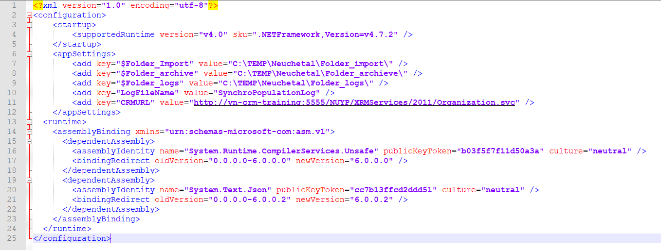

* Config path for folder_import, folder_archive and folder_logs at line 7, 8, 9, remember to add character ‘\’ at the end of each path.
* Config log file name at line 10, enter just the name of file, file will be created with text type (<file name>.txt)
* Config CRMURL at line 11: enter CRM service link.