Title Page

An Evaluation of Algorithmic Bias and Fragility in Rate My Professor Sentiment Analysis Model:
Audit Report
Danny D. Munoz and Daniel Nguyen
Texas A&M University - Central Texas
MATH-5389: AI Mathematics
Dr. Mienie Roberts
July 23, 2026

Table of Contents
Title Page 1
Table of Contents 2
List of Tables and Figures 3
List of Abbreviations 3
Introduction 4
Methodology 5
1. Data Pre-processing 5
2. TFIDF 6
3. LRC 7
Result and Analysis 8
1. Statistical analysis 8
2. Overfitting Demonstration 9
3. Adversarial & Edge-Case Failures 10
4. Bias Analysis 11
Recommendations 12
Conclusion 13
References 14

List of Tables and Figures
Figure 1: Data format after being processed 5
Figure 2: TF-IDF equation (Hashim et al., 2023) 6
Figure 3: Functional Cost equation 7
Figure 4: Overfitting rate of all unigrams 10
Table 2: Evaluation metrics of each unigram 10
Table 3: Sentiment analysis of the overfitting model vs the baseline model 11
Figure 5: Bias analysis result 11

List of Abbreviations
Abbreviation | Full Term
AI | Artificial Intelligence
LR | Logistic Regression
RMP | Rate My Professor
TF-IDF | Term Frequency-Inverse Document Frequency

An Evaluation of Algorithmic Bias and Fragility in Rate My Professor Sentiment Analysis Model: Audit Report

Introduction
Rate-my-professor is a well-known website among university students used to read reviews of both schools and professors. It could be a deciding factor when it comes to course selection, as students might want to avoid classes with unpopular professors or heavy workloads. Because these are subjective opinions, we can use sentiment analysis as a neutral tool to classify them into positive or negative categories (Gong et al., 2022). However, the model can become fragile under small wording changes, overfit to surface-level patterns, and reproduce harmful social biases present in the training data (Diaz et al., 2018; Liu et al., 2023). Because RMP’s reviews usually contain informal language, slang, sarcasm, emotion, and comments about identity, they provide an excellent setting to study how classical machine learning models perform with high levels of noise and emotionally heavy text (Sarlis & Maglogiannis, 2020). Therefore, the research aims to evaluate a TF-IDF and Logistic Regression sentiment classifier trained to sort through 10,000 RMP reviews into three categories: Awful, Neutral, and Great. Beyond reporting standard accuracy, the purpose of this project is to deliberately stress-test the model by pushing it to overfit, attacking it with five adversarial inputs, and auditing its predictions for systematic bias.

Methodology

Data Pre-processing
The dataset consists of real RMP reviews, sourced from a public GitHub collection of reviews. The 10,000 most recent reviews were selected and cleaned before use. Rows with missing comments, placeholder text (e.g., “n/a,” “none,” “no comment,” blank space), and comments shorter than 20 characters were removed, because they did not carry a useful sentiment signal. Each review’s raw sentiment label was mapped into one of three categories, “Awful,” “Neutral,” or “Great”, replacing inconsistent raw label strings like “terrible” or “bad.”
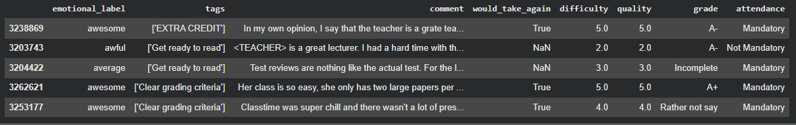

Figure 1: Data format after being processed
The cleaned dataset was split into training and test sets using an 80/20 stratified split, ensuring all three categories were represented in both sets. This stratification was important because the classes are unbalanced: Great and Awful reviews were more common than Neutral ones. Without this step, the split risks producing a test set that either over- or under-represents the minority class, which would not leave a good evaluation. The training set was used only to fit the model, and the test set was reserved for evaluation, to make sure performance reflects the model’s behavior on data it had not seen. The review text was converted to numerical features using TF-IDF vectorization with it assigning each word a weight based on how often it appears in a review. Unique and sentiment-heavy words are weighted more heavily than frequently occurring ones, and the vectorizer was configured with sublinear term-frequency scaling to lower the effect of very high word counts

TFIDF
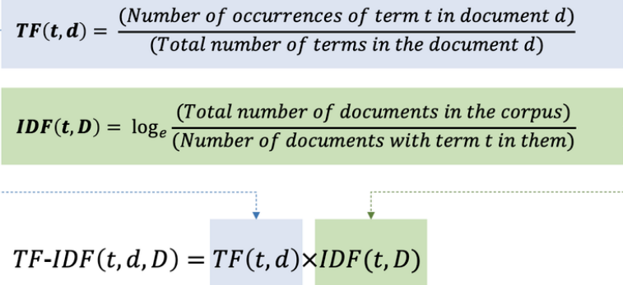
Prior to feeding text into a classifier the words must be converted to numbers. TF-IDF measures how important a word is to a specific review within the entire dataset (Lu, 2025).

Figure 2: TF-IDF equation (Hashim et al., 2023)
For the sublinear term frequency, when sublinear_tf=True is used, the importance of a word is based on a logarithmic scale instead of its raw count, which means that even if the words are repeated many times, it does not increase its importance by very much. 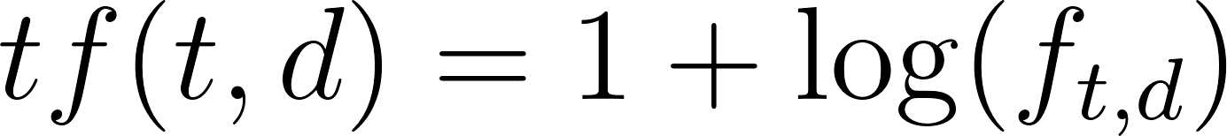 where 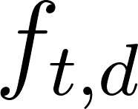 is the raw count of term t in document d, and 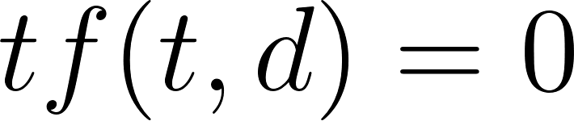 if 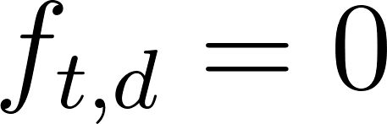 . For the inverse document frequency part, it measures how unique or informative a word is across all documents with words that appear in many documents receiving a lower score, while words that appear in only a few documents receive a higher score. Scikit-learn is used to prevent the zero division errors 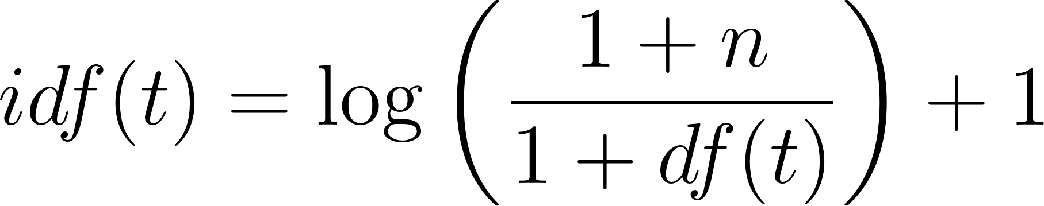, where n is the total number of documents and 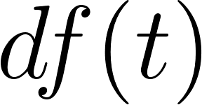 is the number of documents containing term t. The formula is derived from the standard formula for idf: 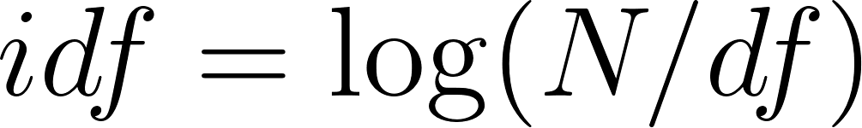, but adding 1 will prevent the division-by-zero errors when the model see new vocabularies. There is also a use of norm="l2", which makes sure that each document vector is scaled so that its total length is 1. It has to be standardized because longer documents do not automatically receive larger values.

LRC
The classifier calculates the probability that a review belongs to each of the following classes: "Awful", "Neutral", "Great", and then assigns the review to the class that has the highest possibility. The probability is calculated through this equation, where  represents the weight vector for class k.
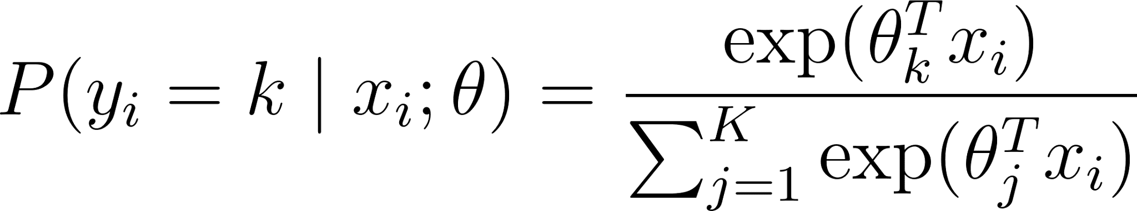
After that, the model learns by reducing prediction errors and preventing the weights from becoming too large, all by the help of the C parameter that controls to reduce overfitting. A smaller C gives stronger regularization, and vice versa. Different values of C from 0.1, 1.0, 100.0, and 1000.0 are tested to find the model with the best performance. Also, the algorithm minimises the loss function by penalizing the L2 norm of the weights.
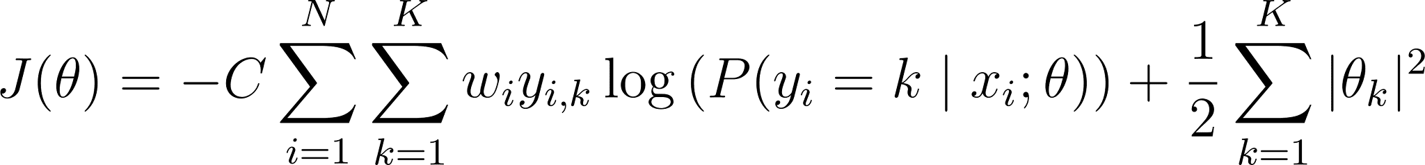

Figure 3: Functional Cost equation
With class_weight="balanced" , the model gives more importance to reviews from classes with fewer samples to allow it to learn fairly from imbalanced datasets instead of favoring the majority class. The sample weight  in the function is inversely proportional to class frequencies. Lastly, there is a solver called SAGA that is a variant of the stochastic average gradient descent. With the solver, we do not need to build a program to optimize or calculate the softmax probability. Scikit-learn will automatically calculate and optimize through the .fit(X_train, y_train) method that trains the Logistic Regression model and the .predict(X_test) method is used to assign each test sample to the class with the highest predicted probability.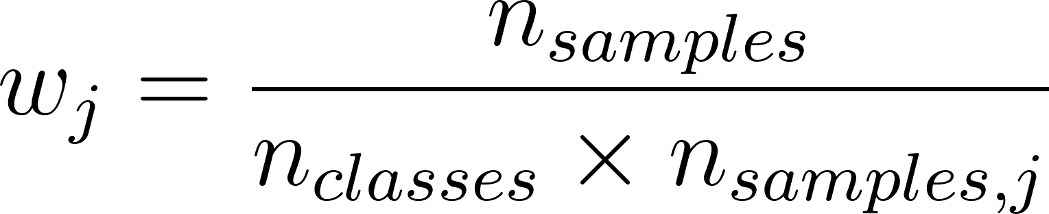

Result and Analysis

Statistical analysis
The baseline classifier is a LR model where class weights were balanced to account for the clear difference in frequency between the Great/Awful reviews and the Neutral ones. Regularization keeps the model from placing too much weight on certain words or phrases. C = 1.0 is the middle-ground setting, as it is not too strict or too loose, and is later pushed to C = 1000 to deliberately break the model. Using min_df = 2, a word or phrase is only kept as a feature if it shows up in at least two different reviews. If it appears in only one review, it is dropped, since there is no way to tell whether it is truly meaningful or not. The min_df value is later lowered to 1 when breaking the model. These choices on the baseline allowed the project to be balanced and gave it a reliable reference point before the model was pushed toward overfitting.
The baseline model reached a training accuracy of 79.94% and a test accuracy of 75.25%, a gap of 4.69%. Comparing the three categories, we can look at three metrics from the data: precision (how often it is actually right), recall (out of all the reviews that are truly the category, how many were caught), and F1 (a single score that blends precision and recall together). Awful: precision 83.75%, recall 78.82%, F1 81.21%. Neutral: precision 18.34%, recall 57.59%, F1 27.83%. Great: precision 94.95%, recall 74.84%, F1 83.70%. It appears that the model performs well identifying Awful and Great reviews; however, it struggles to identify Neutral reviews. The test accuracy of 75.25% sounds good on the surface, but when you look at the specific categories, it is clear there is horrible performance on Neutral reviews.
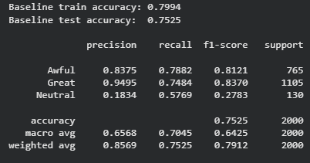
Table 1: Core evaluation metrics of the model

Overfitting Demonstration
To test how model complexity affects the gap between training and test performance, five versions of the Logistic Regression pipeline were trained, each with different constraints: varying n-gram ranges, lower minimum document frequency, and varying C values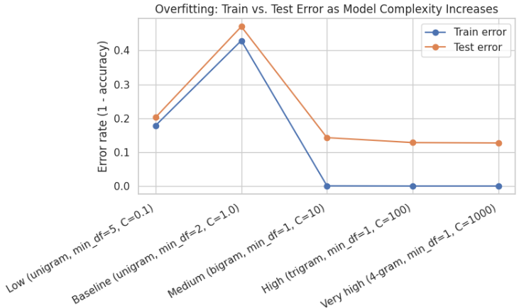

Figure 4: Overfitting rate of all unigrams
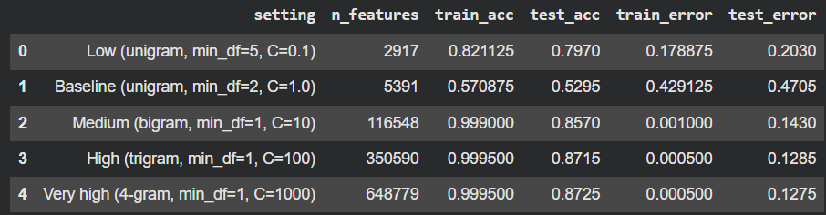

Table 2: Evaluation metrics of each unigram
The results show clear overfitting behavior, but the trend in the testing error is not a linear climb. The training and testing gap jumps between the Baseline and Medium settings, tripling from 4.14% to 14.20%. The feature count significantly increases from around 5,300 to over 116,000, and the training accuracy reaches a near-perfect 99.90%. Past the Medium setting, however, the gap does not keep growing, it actually decreases slightly at High and Very High (12.80%, then 12.70%). This suggests the model’s capacity is somewhere around the Medium setting, a bigram, min_df = 1, and C = 10, since the training accuracy is already close to its ceiling at that point and remains about the same beyond it. There is no need to continue changing the parameters further.

Adversarial & Edge-Case Failures
Five handwritten reviews were designed to exploit and push the pipeline. These reviews included sarcasm, keyword stuffing, negation, and backhanded compliments. The baseline model correctly classified only one of the five examples, and the overfit model classified none. What is a bit surprising is that the overfit model incorrectly classified the same review the baseline model had gotten correct. This shows that the overfitting model memorized 4-gram phrases from the training data rather than truly understanding what was written. Reviews labeled with a mixed sentiment were also predicted Awful by both models. Even looking at the prediction labels, there are zero Neutral predictions, showing that the baseline struggles to identify a Neutral review. The model has extreme difficulty identifying sarcasm or any mixed sentiments, and if it is unsure, the default label is Awful.
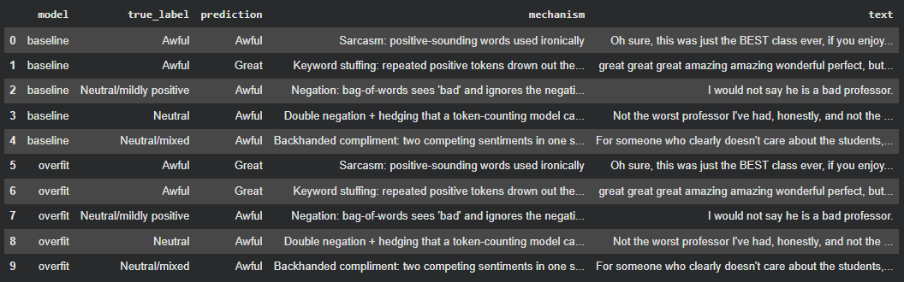

Table 3: Sentiment analysis of the overfitting model vs the baseline model

Bias Analysis
Reviews were tested for two categories of potential bias: accent/language and gendered language.
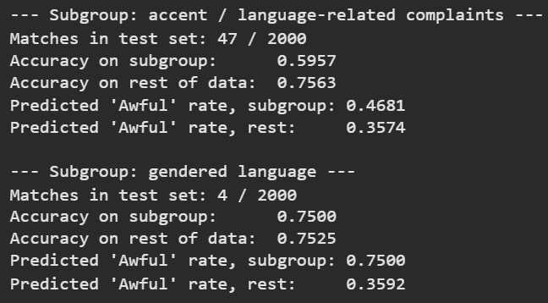

Figure 5: Bias analysis result
The accent/language category shows a noticeable difference: accuracy drops by at least 16%, and the model predicts the Awful label about 11% more often than for the rest of the data. Prior research (Zheng et al., 2023) has documented that online teaching evaluations often subject instructors to scrutiny over language and communication style, regardless of their actual teaching quality. The classifier’s behavior is consistent with this pattern, showing that reviews mentioning accent or language barriers are pushed toward the negative class. The gendered language subgroup shows an even more significant gap in the Awful rate; however, it should be noted that this is based on only 4 reviews. The sample is too small to support a reliable conclusion.

Recommendations
Based on the data collected, there are a few ideas that would meaningfully improve the model and increase its reliability. First, regularization and feature complexity should be constrained by default. During the overfitting process, no meaningful gains occurred past the Medium restrictions, anything beyond that point did not meaningfully improve generalization. Capping the n-gram range would help prevent the model from memorizing training-specific phrases. Second, expand and rebalance the training data, since the Neutral class was both underrepresented and the model’s weakest category. Collecting more Neutral-based examples, or applying targeted oversampling, could improve the model’s ability to distinguish moderate feedback from strongly positive or negative feedback. To make this project a bit more personal, we could also collect RMP reviews from professors at our own university. Doing so would let us compare data across various professors from different departments, not just by their Neutral, Awful, and Great ratings, but by which department essentially “performs better” according to the reviews. Third, the gendered-language sample should be increased, since there were only four matching reviews, far too few to determine a reliable conclusion. Alternatively, if the sample cannot be increased, the model could be trained on additional keywords or phrases related to gendered language that were not included in this analysis.

Conclusion
After reviewing and analyzing the data, these findings show that the sentiment model is not reliable. A controlled complexity sweep shows that the model’s training and testing gap nearly tripled with increased complexity, and a small set of adversarial examples showed the model failing on sarcasm, negation, mixed sentiment, with the overfit model performing worse than the baseline on an identical review that it had previously classified correctly. When we tested reviews that mentioned a professor’s accent or language barriers, the model performed noticeably worse and labeled them Awful more often, a pattern that lines up with known biases in how these kinds of reviews tend to get written and read. None of this suggests that the model is poorly built; rather, it reflects structural limitations common to word-based classifiers trained on this kind of data. A model can be built, achieve good accuracy, and even look acceptable at a glance, but still carry risks that only become visible during stress testing. Any future use of this model, or one similar, should be paired with ongoing evaluation rather than relying on the headline accuracy score alone.

References
Diaz, M., Johnson, I., Lazar, A., Piper, A. M., & Gergle, D. (2018, April 21). Addressing Age-Related Bias in Sentiment Analysis. Proceedings of the 2018 CHI Conference on Human Factors in Computing Systems, 1-14. 10.1145/3173574.3173986
Gong, X., Ying, W., Zhong, S., & Gong, S. (2022, May 13). Text Sentiment Analysis Based on Transformer and Augmentation. Frontiers in Psychology, 13, 906061. 10.3389/fpsyg.2022.906061
Liu, M., Zhang, Z., Zhang, Y., Zhang, C., Li, Z., Li, Q., Duan, H., & Sun, D. (2023, March 1). Automatic Generation of Adversarial Readable Chinese Texts. IEEE Transactions on Dependable and Secure Computing, 20(2), 1756-1770. 10.1109/TDSC.2022.3164289
Savini, E., & Caragea, C. (2020, April 3). A Multi-Task Learning Approach to Sarcasm Detection (Student Abstract). Proceedings of the AAAI Conference on Artificial Intelligence, 34(10), 13907-13908. 10.1609/aaai.v34i10.7226
Zheng, X., Vastrad, S., He, J., & Ni, C. (2023, March 16). Contextualizing gender disparities in online teaching evaluations for professors. PLOS One, 18(3), e0282704. 10.1371/journal.pone.0282704

