**PRO192- Practice Exam – SU24 13/07/2024**

Duration: 85 minutes

Develop an Electricity Bill Management OOP application with the following components and requirements

1. **Create MVC console application in NetBean:**
   1. Define class Bill with the following attributes and methods: **(1.5 marks)**  
      + Id (int), customerName (string), amount (double), dueDate (Date).   
      + Constructors, get/set(), toString() (in where display the Date attribute in the format “dd/MM/yyyy”).  
      ***Note****: No IO console is used in this model class*
   2. Define class ListBill to manage the list of electricity bills has the following methods: **(3.0 marks)**  
      + Read text file to load data for ListBill –Electricitybill.txt is provided (1.0 mark)   
      + Method that can add a new bill (check this bill id does not exist in the list is required) (0.5 mark)

+ Method that can delete a Bill by any criteria (0.5 mark)

+ Method that can get a list of unpaid bills (0.5 mark)  
+ Method that can get the largest amount of bill (0.5 mark)  
***Note****: No IO console is used in this model class*

* 1. Develop BillManagement class to run the application **(4.0 marks)**  
     + Main menu for application includes: Display all bills, Add a new bill, Delete a bill, Find largest amount bill, List of unpaid bills, Quit (0.5 mark)   
     Hint: An abstract Menu class is provided for use in the application.   
     + Display all electricity bills (0.5 mark)  
     + Method for adding new bill from console (0.5 mark)  
     + Method for deleting an existing bill by ID, Customer name, or Due date(1.5 mark)   
     + Method for finding the largest amount bill in the list (0.5 marks)

+ Method for listing all unpaid bills (0.5 marks)  
+ main() method to run the program   
**Note**: This class allows interaction with user IO from the console.

1. **Technical requirements (1.5 marks)**:  
   + Create a package **model** for Bill and ListBill class. (0.5 mark)  
   + Create package **view_controller** for Menu and BillManagement class. (0.5 mark)  
   + Please handle every exception for adding a new bill function, asking the user to re-enter for incorrect input data. (0.5 mark)  
   + User view should be as follows:  
   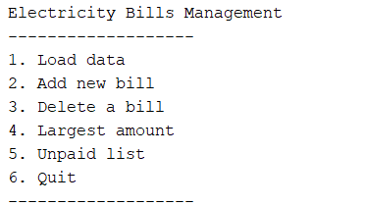

+ The list of bills may look like this:

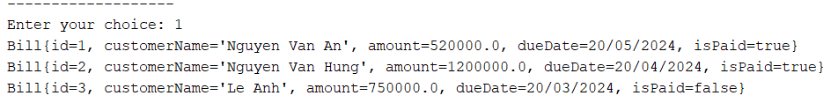

+ Delete menu should be as follows:

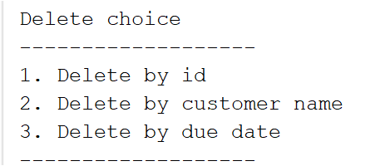  
**Notice: Student must strictly follow all requirements as described above for marking,   
Any modification of the requirement detail is not allowed and will get no mark!**

**Students can use offline material on individual computers and define additional classes/methods for code optimization.**