WasteWise
Automated Waste Classification and Localization in Unconstrained Environments
Final Year Project Report — From First Baseline to Production Deployment
Student: Khoa Phung
Project: WasteWise — Waste Detection, Classification and Localization
Repository: github.com/khoaph0712 — FYP
July 2026

Table of Contents

Abstract
WasteWise is a Final Year Project that automates waste identification, material classification, and localization for real-world scenes such as streets, beaches, kitchens, and recycling stations. The project is deliberately organized into two complementary branches. The first is an explainable classical machine-learning branch that extracts a fixed 637-dimensional handcrafted feature vector (spatial, frequency/FFT, color, and HOG descriptors) from object crops and benchmarks six classical classifiers together with a controlled PCA dimensionality-reduction study. The second is a deep-learning production branch built as a two-stage, localization-first pipeline: a YOLO detector proposes object bounding boxes, and a ConvNeXt-based crop classifier fused with the same 637 handcrafted features verifies and re-classifies every crop before a decision is made.
On the lecturer-facing benchmark, XGBoost is the strongest classical model with 67.42% accuracy and 0.6506 macro-F1, and the controlled PCA sweep shows that compressing the 637-D feature space to 128 components retains 99.90% of the variance at a cost of only 2.52 percentage points of Linear SVM accuracy. In the deep-learning branch, the tuned ConvNeXt ensemble classifier reaches 92.52% validation accuracy on the balanced 7-class dataset and 93.88% test accuracy after hard-case retraining, while a ConvNeXtV2 trash/no-trash gate reaches 97.81% test accuracy. For localization, the promoted operating point (YOLO, confidence 0.30, evaluated on 300 stratified test images with 1,152 ground-truth boxes) achieves precision 0.6999, recall 0.5729, F1 0.6301, and mean matched IoU 0.9057 — far ahead of a Grad-CAM classification-first baseline (precision 0.2568, recall 0.0728). The full production pipeline, including an adaptive scene engine, dynamic soft voting, and Bayesian context priors, processes images end-to-end in 238.08 ms on CPU (4.20 FPS) and is deployed as a web application backed by a Python model API, packaged with Docker for Hugging Face Spaces.
This report documents the complete journey from the first weak baseline (roughly 38–47% accuracy on 17 handcrafted features in early May 2026) to the deployed production system (July 2026), including dataset audits and rebuilds, lecturer-directed course corrections, failed experiments, model comparisons, and the architectural rework that made the final system possible.

1. Introduction

1.1 Problem Statement
Manual waste sorting is slow, expensive, and error-prone, while incorrect sorting contaminates recycling streams. Automating the task with computer vision is difficult because real-world waste appears in unconstrained conditions: reflective and transparent materials (glass, plastic film, bare aluminum), heavy clutter, deformed geometry (crushed cans, crumpled paper), small objects, and highly variable backgrounds (grass, sand, asphalt, indoor floors). A model that performs well on clean studio datasets such as TrashNet can lose more than half of its accuracy when applied to field imagery, a phenomenon this project measures directly in its cross-dataset validation study.

1.2 Objectives
- Build and audit a multi-source waste image dataset suitable for both object detection and crop classification, with documented cleaning, deduplication, and balancing steps.
- Develop an explainable classical ML pipeline: handcrafted feature extraction (spatial, frequency, color, texture), classical model comparison, and PCA-based dimensionality analysis.
- Develop a production-grade deep-learning pipeline using a localization-first, two-stage architecture (YOLO detection followed by crop verification/classification).
- Evaluate honestly with appropriate metrics for each task: accuracy and macro-F1 for classification, precision/recall/IoU/mAP for localization, and latency/size for edge deployment.
- Deploy the final system as a usable web application with a real model API, packaged for cloud hosting.

1.3 Scope and Class Taxonomy
The project targets six material classes — plastic, glass, metal, paper, cardboard, organic — plus a seventh Background class used by the classification branch to absorb detector false alarms (floor textures, grass, sand, asphalt, concrete). The YOLO localization datasets use the six material classes; the crop-classification datasets use all seven.

1.4 Contributions
- A documented, evidence-based dataset lifecycle: raw multi-source merge (114,220 boxes) → EDA audit → cleaned and rebalanced rebuild → final balanced classification set (29,639 crops, 7 classes) and localization set (23,929 images, 102,777 boxes).
- A fully explainable 637-feature classical ML study with model comparison across six classifiers and a controlled PCA sweep establishing a model-specific compression trade-off.
- A two-stage localization-first DL architecture combining YOLO object proposals with a ConvNeXt + handcrafted-feature fusion classifier, including dynamic alpha blending, consensus-adaptive thresholds, an adaptive scene engine, and Bayesian context priors.
- A rigorous localization evaluation comparing a Grad-CAM classification-first baseline against YOLO localization across confidence thresholds on a 300-image stratified test.
- A deployed production web application backed by the real trained models, with quantized TFLite and ONNX export paths for edge devices.

1.5 Report Organization
Chapter 2 reviews background literature. Chapter 3 describes all datasets and their audits. Chapter 4 details the methodology of both branches. Chapters 5–8 present results: classical ML, deep-learning classification, detection/localization, and the end-to-end system. Chapter 9 tells the chronological story of the project from scratch to production, including failed approaches. Chapter 10 covers deployment, Chapter 11 discusses limitations, and Chapter 12 concludes. Appendices contain the master comparison table and reproduction commands.

2. Background and Related Work

2.1 Object Detection and CNN Architectures
The YOLO family (Redmon et al., 2016) established unified single-stage object detection, regressing bounding boxes and classes in one pass; modern versions (YOLOv8, YOLOv11, YOLO26) use anchor-free heads and efficient blocks that keep latency low enough for edge devices, which is why YOLO serves as the Stage 1 localizer throughout this project. ResNet (He et al., 2016) introduced residual connections enabling very deep networks; MobileNet (Howard et al., 2017) introduced depthwise-separable convolutions for mobile budgets; EfficientNet (Tan & Le, 2019) introduced compound scaling of depth, width, and resolution, and its B0 variant is used as one of the Stage 2 crop classifiers. ConvNeXt (Liu et al., 2022) modernized the ResNet design with depthwise convolutions and inverted bottlenecks to match transformer-era accuracy while remaining a pure ConvNet; ConvNeXt-Tiny and ConvNeXtV2-Tiny are the backbone of the final classification stage.

2.2 Handcrafted Features and Classical Vision
Histograms of Oriented Gradients (Dalal & Triggs, 2005) provide the 576 shape/texture descriptors that dominate this project's 637-D feature vector. Fourier texture analysis (Tuceryan & Jain, 1998) motivates the radial FFT energy bins that separate high-frequency organic textures from smooth plastics. SIFT (Lowe, 2004), LBP (Ojala et al., 2002), and GLCM co-occurrence features (Haralick et al., 1973) inform the broader handcrafted-feature design tradition the ML branch follows: features first, interpretation second, classical ML third.

2.3 Waste Datasets and Prior Systems
TrashNet (Thung & Yang, 2016) defined the standard six recyclability categories on clean single-object images. TACO (Proença & Simões, 2020) provides litter annotations in unconstrained environments and is a core source of this project's hard-case data. Adedeji & Wang (2019) demonstrated deep-learning waste classification systems. This project's measured gap between TrashNet-style studio data (classical ML accuracy 81.03%) and TACO-style field data (13.99%) quantifies why unconstrained waste understanding remains hard.

2.4 Context and Probabilistic Fusion
Pearl (1988) formalized probabilistic reasoning that underlies the production system's Bayesian context priors, and Torralba (2003) showed that global scene features constrain what objects are likely present — the basis for WasteWise's HSV scene detector, which recognizes beach, grass, street, and indoor contexts and re-weights class probabilities accordingly.

3. Datasets: Acquisition, Auditing, and Rebuilds
Every model result in this report traces back to a specific dataset version. Because dataset quality problems (imbalance, duplicates, invalid labels) drove several major project pivots, this chapter documents each dataset generation in the order it was produced.

3.1 Raw Sources
The project aggregates public waste datasets from Roboflow collections, TrashNet, the GINI dataset, the official TACO dataset, RealWaste (UCI/HuggingFace), and a Trashify export. Source identity is preserved through filename prefixes so that every crop and box can be traced to its origin — a requirement that became central after lecturer feedback (Section 9.3).
Table 1. Source-level composition of the merged detection dataset (source analysis, merged_dataset_v3).
Source | Images | Objects | Classes | Imbalance ratio | Standalone use
rf_garbage_cls | 8,387 | 28,683 | 5 | 1.78 | ANN/CNN training
rf_food_waste | 6,734 | 28,446 | 1 (organic) | 1.00 | EDA only
rf_waste_sorting | 15,630 | 16,027 | 5 | 356.13 | Train, severe imbalance
rf_taco_trash | 9,305 | 16,004 | 6 | 2.72 | ANN/CNN training
rf_uca_recyclable | 8,365 | 14,529 | 3 | 2.60 | ANN/CNN training
rf_cigarettes | 2,427 | 3,077 | 1 (other) | 1.00 | EDA only

The imbalance ratio of 356 for rf_waste_sorting (16 glass objects vs. 5,698 plastic) is the single clearest example of why the merged dataset could not be used naively.

3.2 Generation 1: merged_dataset_v3 and Its Audit
The first working dataset merged all sources into a 7-class YOLO-format detection dataset totaling 114,220 bounding boxes. A dedicated EDA pass (scripts/dataset_eda.py with duplicate hashing) surfaced serious quality issues: 7,460 invalid label rows, 2,795 exact-duplicate groups covering 5,862 duplicate images, tiny boxes, and a heavily skewed split — the glass class had only 200 test boxes while organic had 22,785 training boxes.
Table 2. merged_dataset_v3 class counts before tuning.
Class | Train | Valid | Test
plastic | 15,306 | 1,495 | 2,171
glass | 6,786 | 2,506 | 200
metal | 11,791 | 2,037 | 770
paper | 6,420 | 902 | 2,080
cardboard | 16,874 | 3,312 | 1,028
organic | 22,785 | 2,766 | 2,895
other | 3,701 | 661 | 274

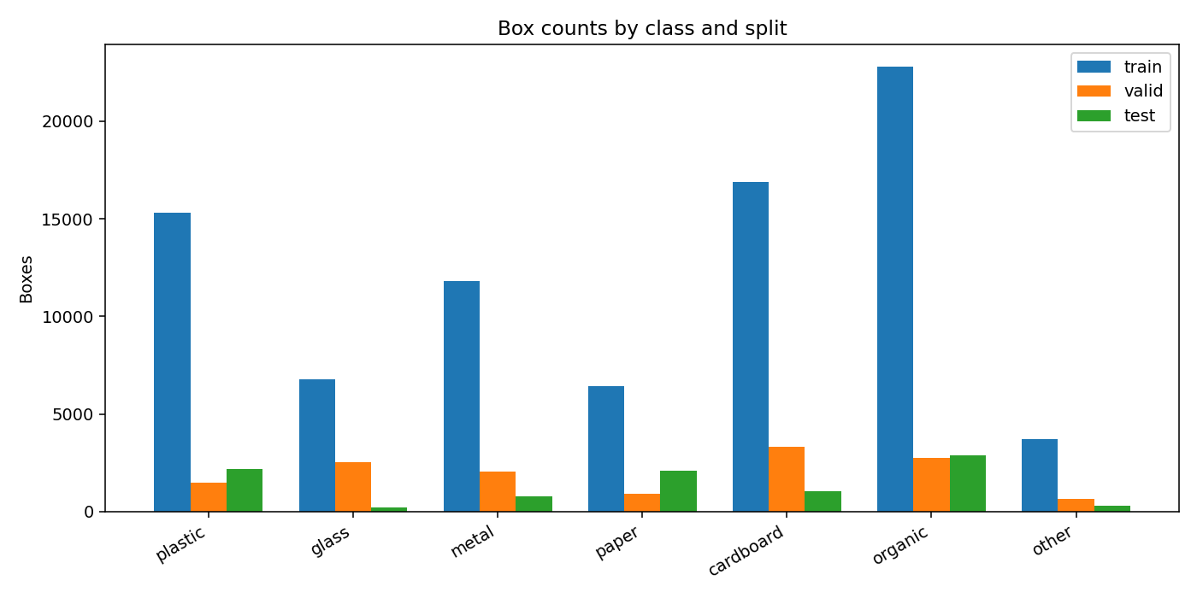
Figure 1. Class balance of merged_dataset_v3 across splits, from the dataset EDA run. The skew toward organic and cardboard, and the weak glass test support, motivated the tuned rebuild.
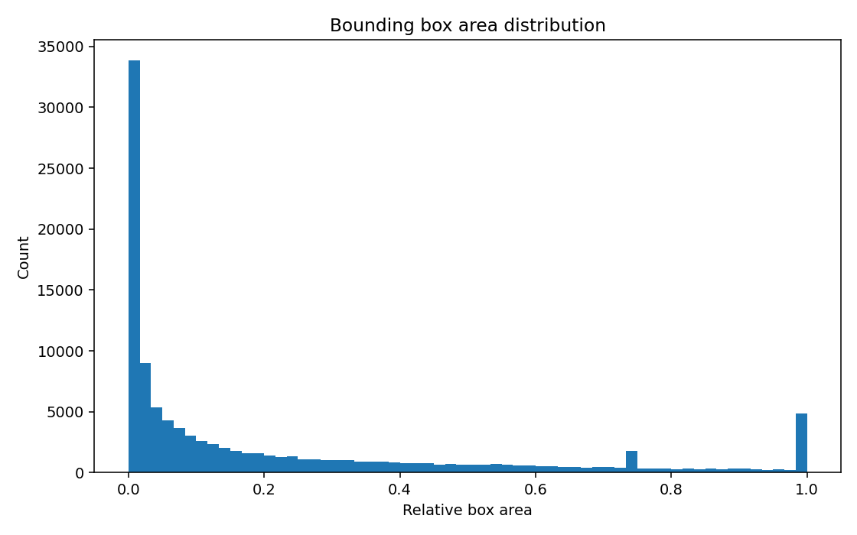
Figure 2. Bounding-box area distribution in merged_dataset_v3. The long tail of tiny boxes (later filtered at 10 px / 0.0002 relative area) added label noise without usable training signal.

3.3 Generation 2: tuned_dataset_v1 (Evidence-Based Cleaning)
Rather than editing the baseline in place, a non-destructive rebuild (scripts/build_tuned_dataset.py) produced tuned_dataset_v1: duplicates removed, invalid rows dropped, tiny boxes (under 10 px or relative area below 0.0002) filtered, splits rebuilt by dominant class, and per-class caps applied.
Table 3. Inputs dropped while building tuned_dataset_v1.
Dropped item | Count
Duplicate images | 3,063
Empty after cleaning | 3,438
Wrong label column count | 7,454
Tiny boxes | 1,537
Boxes out of range | 6

The tuned dataset contains 24,668 train / 3,298 valid / 3,413 test images (53,395 / 7,028 / 6,962 boxes). Critically, glass test support rose from 200 to 863 boxes, making per-class evaluation meaningful. Retraining YOLOv8n on this tuned dataset produced the project's first credible detection milestone: 0.810 mAP@0.5 on the tuned test split (Section 7.1).

3.4 Generation 3: Final Active Datasets
- data/merged_dataset_v5 (classification): 29,639 balanced object crops across 7 classes (plastic, glass, metal, paper, cardboard, organic, Background). The Background class contains texture noise — grass, sand, asphalt, concrete — so the crop classifier can reject YOLO false alarms instead of being forced to pick a material.
- external_datasets/super_yolo_dataset (localization): 23,929 high-resolution images with 102,777 bounding boxes across the 6 material classes; used to train the YOLOv11 localizer.
Table 4. super_yolo_dataset bounding-box distribution.
Class | Bounding boxes | Characteristics
plastic | 35,420 | High density; highly reflective
glass | 8,912 | Low density; extreme reflection
metal | 12,402 | Moderate density; metallic specular texture
paper | 22,109 | High density; deformable geometry
cardboard | 11,834 | Moderate density; semi-rigid
organic | 12,100 | Irregular biodegradable textures
Total | 102,777

3.5 Hard-Case and Gate Datasets (June 2026)
After the production pipeline was running, error analysis showed the remaining failures concentrated in hard cases: reflective materials, clutter, and unusual viewpoints. Three targeted datasets were built:
- hard_case_classifier_v1: a 7-class crop-classification set (12,600 balanced train / 2,680 val / 2,696 test) assembled from RealWaste (UCI) and official TACO exports, used to retrain the ConvNeXt classifier on realistic hard imagery.
- stage0_trashify_v1: a binary trash/no-trash gate dataset (3,301 train / 386 val / 319 test) used to train the ConvNeXtV2 Stage 0 gate.
- yolo26_hardcase_dataset_v1 and yolo26_balanced_realworld_v2: YOLO detection sets for benchmarking the YOLOv11 production detector against newer YOLO26n training runs (Section 7.3).
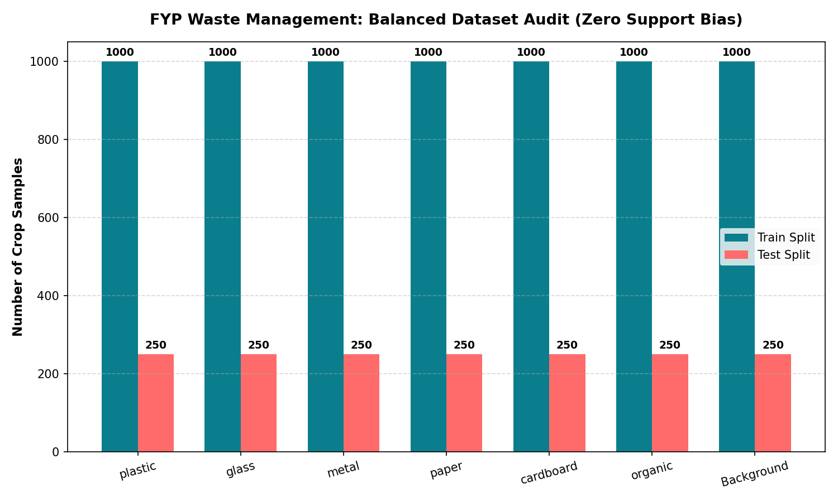
Figure 3. Balanced class distribution used for the fair model-comparison experiments.
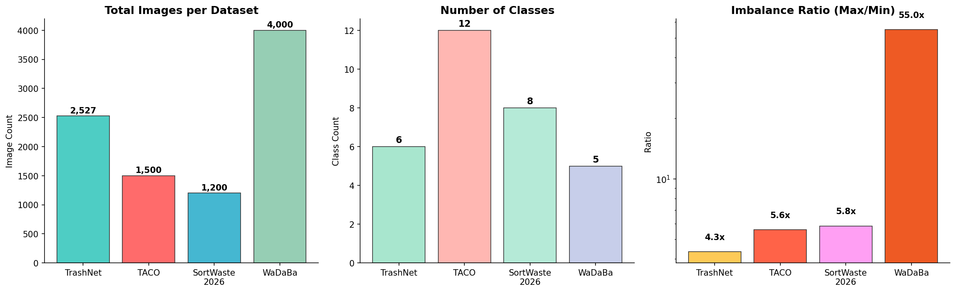
Figure 4. Cross-dataset EDA comparison of the external sources (TrashNet, GINI, TACO). Clean studio datasets differ sharply from field datasets in resolution, box statistics, and class coverage.

3.6 Frequency-Domain Dataset Analysis
Following the lecturer's analysis workflow (spatial domain → frequency domain → per-class commentary → only then ML), a frequency study characterized how material classes differ in the FFT domain. Organic waste shows broadband high-frequency energy (irregular texture), while smooth plastics and glass concentrate energy in low-frequency bands; metal shows specular spikes. These findings justify the 9 FFT radial-bin features in the handcrafted vector.
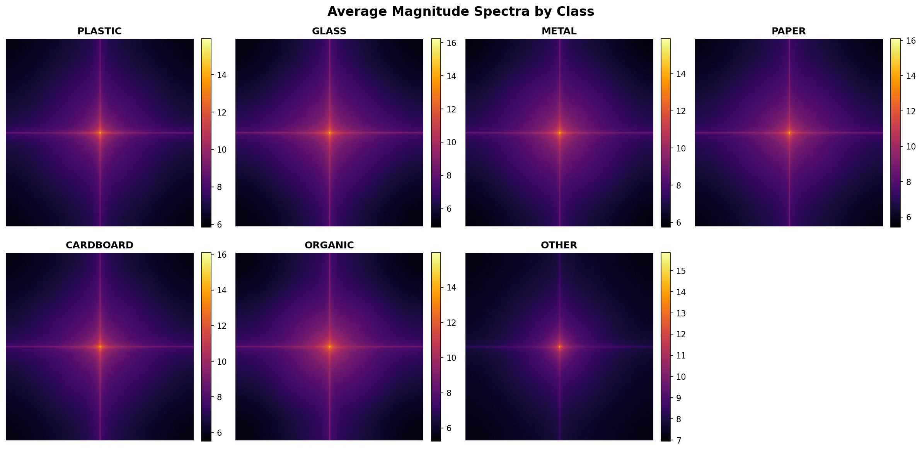
Figure 5. Average 2-D FFT magnitude spectra per class. Texture-rich classes (organic, paper) spread energy into high radial frequencies; smooth materials concentrate it centrally.
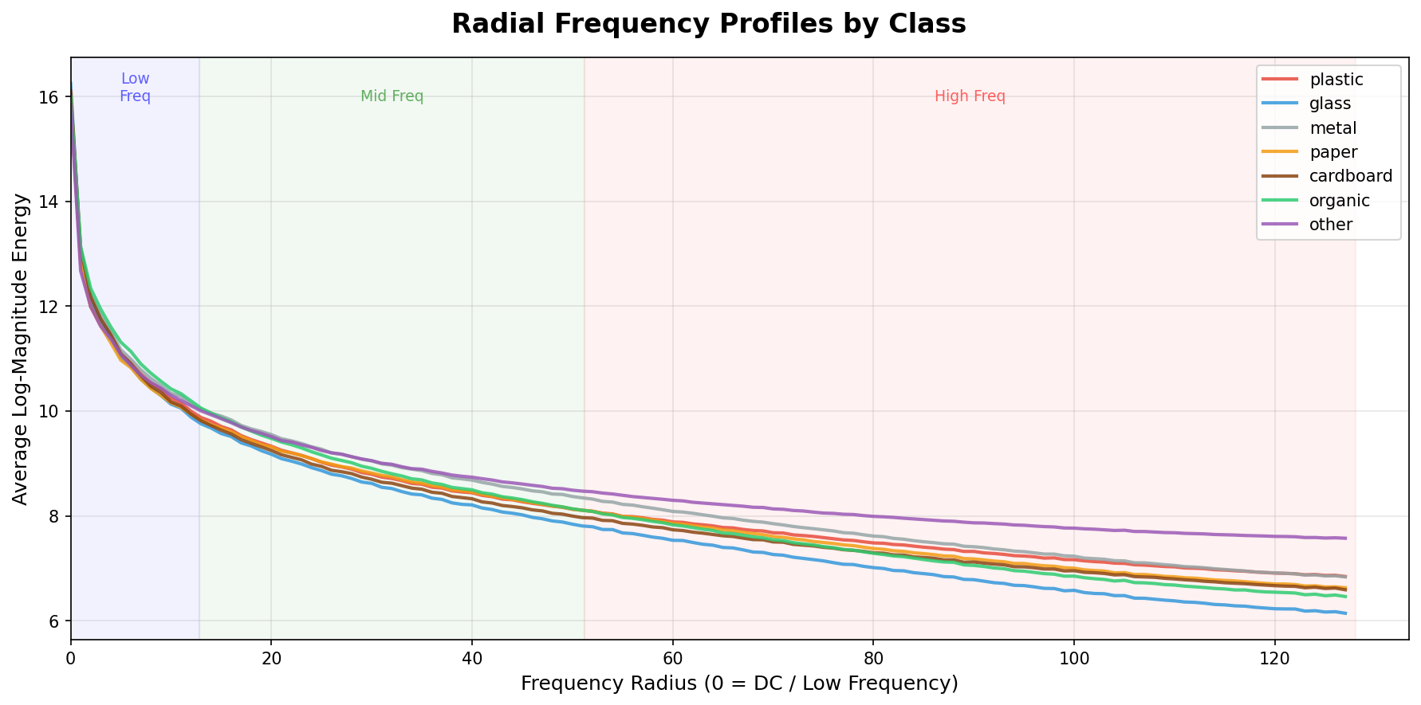
Figure 6. Radial frequency-energy profiles per class, the direct basis for the 8 FFT radial-bin features plus the high-frequency summary feature.
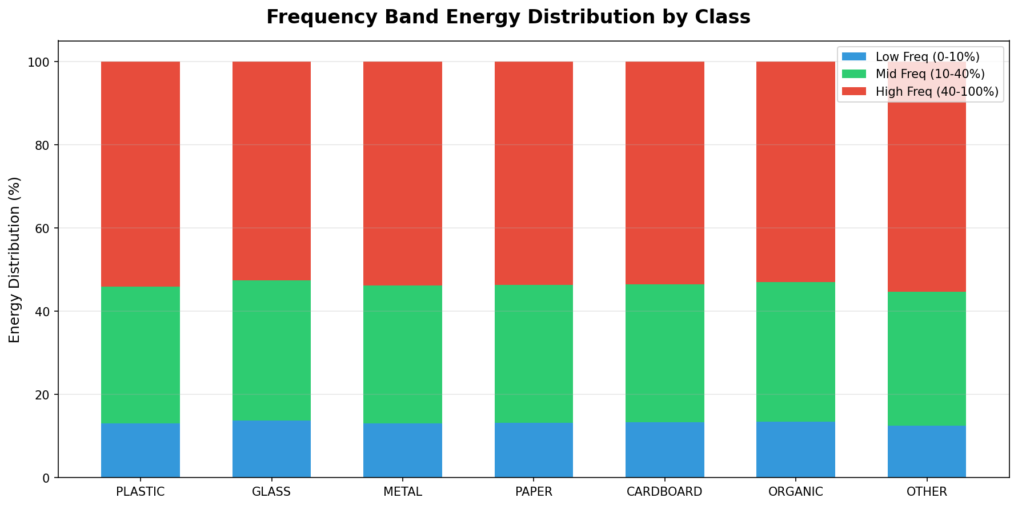
Figure 7. Per-class energy by frequency band (low/mid/high). Organic and paper carry visibly more high-band energy than glass or plastic.

4. Methodology

4.1 System Overview: Two Branches
WasteWise runs two parallel technical branches that answer different questions. The classical ML branch answers: how far can fully explainable, mathematically defined features go on this problem, and how compact can that representation be? The deep-learning production branch answers: what architecture actually works in unconstrained scenes, and can it be deployed? The DL branch is a two-stage, localization-first pipeline: YOLO first localizes candidate objects, then a crop classifier verifies each proposal — including the option of rejecting it as Background. This reversal (detect first, classify second) is the single most important architectural decision in the project, because it stops background context from contaminating material predictions and gives the classifier clean, zoomed crops to work with.
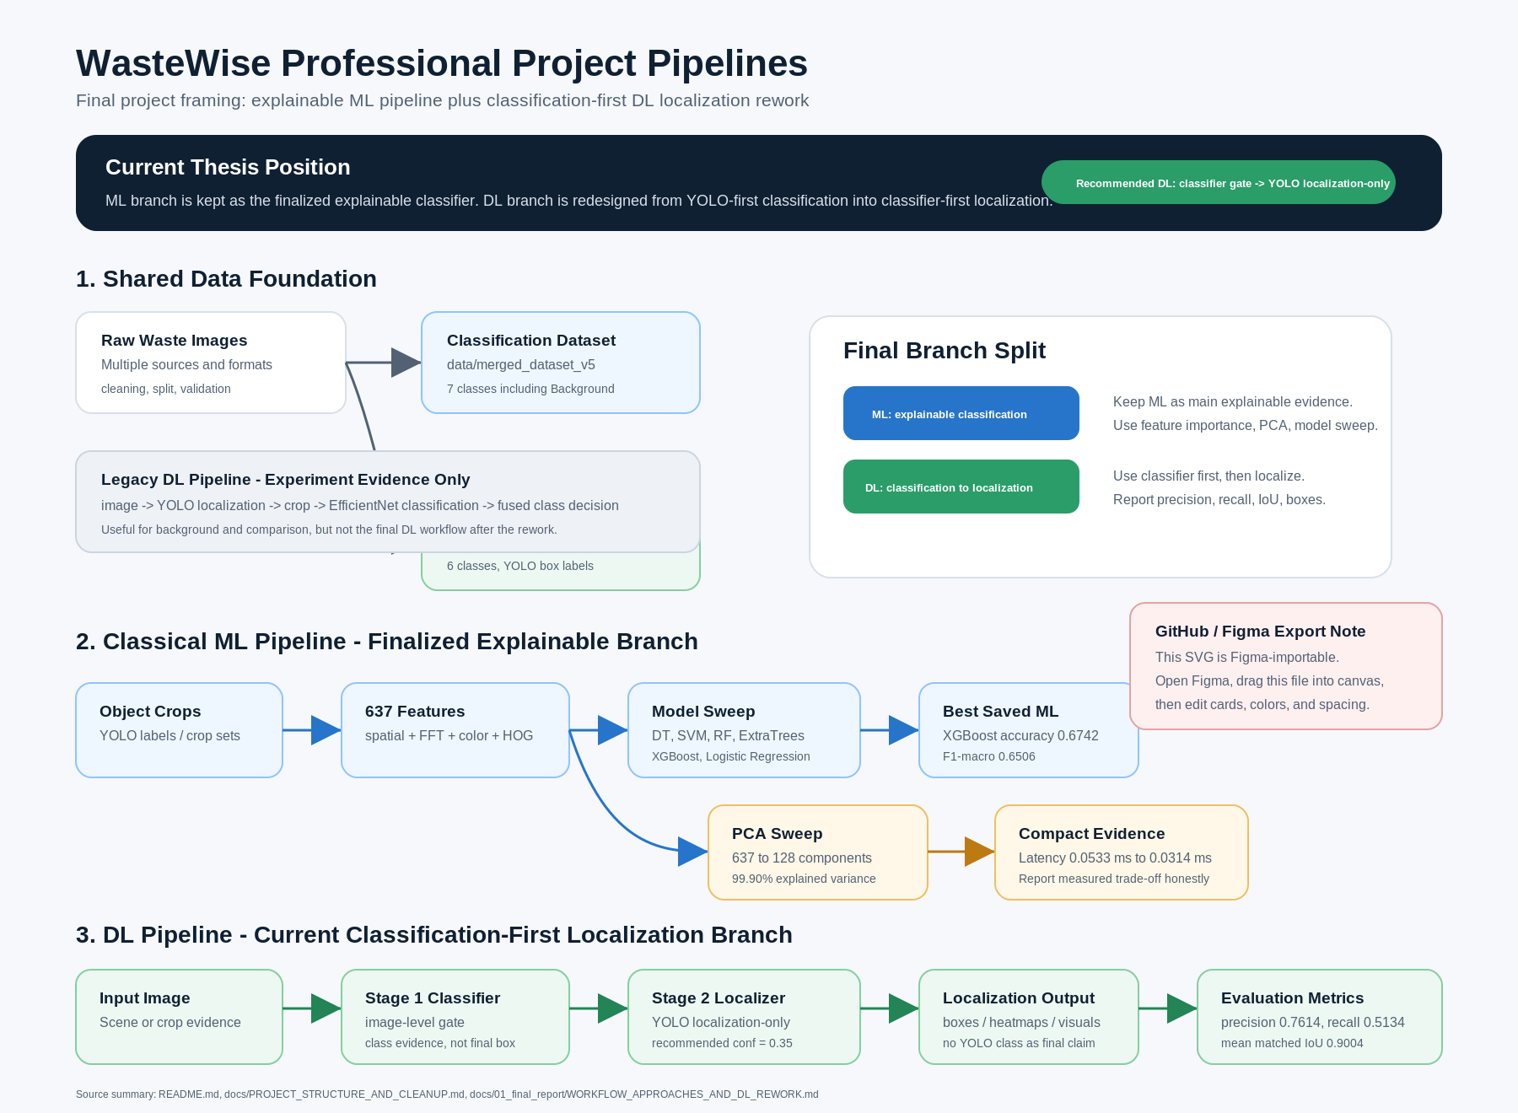
Figure 8. WasteWise professional pipeline diagram: the explainable ML branch (left) and the two-stage localization-first DL production branch (right).

4.2 Classical ML Branch: The 637-D Handcrafted Feature Vector
Every labeled bounding box is cropped, resized to 64×64, and converted into a fixed 637-dimensional feature vector. The vector is deliberately built from four explainable families:
Table 5. Composition of the 637-dimensional handcrafted feature vector.
Feature group | Count | Definition
Spatial / edge | 8 | mean, std, p10/p50/p90 intensity; gradient mean/std; edge density
Frequency (FFT) | 9 | 8 radial FFT energy bins + high-frequency energy summary
Color | 44 | HSV histograms plus BGR/HSV channel means and standard deviations
HOG | 576 | Histogram of Oriented Gradients: local shape and gradient-orientation texture
Total | 637

Six classical models are compared on identical features and splits: Decision Tree, Logistic Regression, Linear SVM, Random Forest, ExtraTrees, and XGBoost. Sampling is balanced with per-class caps (up to 4,000 train crops per class where data allows), the catch-all class 'other' is excluded, and per-class support is always recorded in class_support.json so imbalanced test splits are visible rather than hidden. Evaluation uses accuracy, macro-F1, per-model confusion matrices, and feature-domain importance analysis.

4.2.1 PCA Dimensionality Reduction Protocol
To test how compact the representation can be, PCA is fitted on the training features and the same classifiers are retrained on projected spaces of 16, 32, 64, 96, 128, 192, 256, 384, and the full 637 dimensions. The study reports explained variance, accuracy, macro-F1, and per-sample inference latency at every dimension — and, importantly, reports the trade-off per model, because tree ensembles and linear models react very differently to PCA rotation (Section 5.4).

4.3 Deep-Learning Branch: Two-Stage Localization-First Pipeline

4.3.1 Stage 1 — YOLO Object Proposal
A YOLO detector (YOLOv8n in early phases, YOLOv11 in production, YOLO26n in the June benchmark) runs at confidence 0.30 with image size 960 and up to 80 detections per image. Its job in the final architecture is deliberately narrowed: propose boxes with high localization quality, not make the final class decision. Mean matched IoU of accepted YOLO boxes exceeds 0.90, which is why the pipeline trusts YOLO for geometry but not for the final label.

4.3.2 Stage 2 — Crop Verification and Classification
Each proposed box is padded by 10 px, cropped, and passed to a crop classifier. Three classifier generations were evaluated: quantized EfficientNetB0 (edge baseline), ConvNeXt-Tiny fused with the 637 handcrafted features (multimodal ensemble), and ConvNeXtV2-Tiny variants. The production classifier concatenates the ConvNeXt image embedding with the standardized 637-feature vector before the classification head, so the deep model and the explainable features vote inside a single network. A seventh Background output lets Stage 2 veto false alarms.

4.3.3 Decision Logic: Voting, Thresholds, and Context
- Dynamic class-dependent alpha blending. Final per-class scores blend YOLO confidence and CNN probability: score = α·YOLO + (1−α)·CNN. For metal proposals α = 0.80 (YOLO's macro-geometry beats CNN micro-texture on specular cans); for other classes α = 0.20. When YOLO confidence is very low (recovery mode), α drops to 0.15 so the CNN dominates.
- Consensus-adaptive thresholding. If both networks agree on the class, the acceptance threshold is relaxed to 0.25 to preserve recall; if Stage 2 overrides Stage 1, the threshold tightens to 0.40 to suppress ghost-waste false alarms.
- Adaptive scene engine. If YOLO returns zero boxes at conf 0.30, the engine triggers SMALL_OBJECT_RECOVERY: a sensitivity sweep at conf 0.05 with a relaxed CNN verification limit of 0.15. Dense-clutter scenes trigger threshold lowering instead. A physical size filter rejects boxes smaller than 24×24 px.
- Bayesian context priors. An HSV scene detector classifies the environment (beach, grass, street, indoor); non-background class probabilities are multiplied by a context prior vector (e.g., Beach: [0.35, 0.25, 0.20, 0.05, 0.05, 0.10] over plastic…organic) and renormalized, following the contextual-priming idea of Torralba (2003).
- Waste-state gate. Each verified object is finally routed as waste, not_waste, or review, so a detected material is not automatically binned — a conservative rule layer pending a dedicated trained state model.

4.3.4 Alternative Pipeline: Classification-First Grad-CAM
For comparison, a classification-first pipeline was implemented: an image-level classification gate followed by Grad-CAM class-activation heatmaps thresholded into bounding boxes. This baseline is fully runnable and is evaluated with the same localization metrics; its weakness on multi-object scenes (Section 7.4) is the empirical justification for the localization-first design.

4.4 Training Setup
- Hardware: NVIDIA GeForce RTX 3060 (CUDA), local Windows workstation; Python 3.11 virtual environment (.venv311).
- Frameworks: PyTorch + timm (ConvNeXt/ConvNeXtV2), TensorFlow/Keras (EfficientNetB0, TFLite export), Ultralytics (YOLOv8/YOLOv11/YOLO26), scikit-learn and XGBoost (classical ML).
- YOLOv8n tuned run: 50 epochs, image size 800, batch 16, initialized from the previous best checkpoint. YOLOv11 super-dataset run: 30 epochs on 24,500+ images. YOLO26n runs: hard-case dataset v1 and balanced_realworld_v2 (including a live fine-tune variant).
- ConvNeXt ensemble tuned run: balanced 7,000 train crops (1,000 × 7 classes) and 2,100 validation crops (300 × 7); phase 1 freezes the backbone for a 3-epoch head warm-up, phase 2 progressively unfreezes the final ConvNeXt stage for 7 fine-tuning epochs. Hard-case retraining uses the 12,600-crop balanced hard-case set (748.6 s total on the RTX 3060).
- ANN/CNN baselines: 5 quick epochs at 64×64 crops with per-class caps — intentionally light, serving as fair lower-bound baselines rather than tuned competitors.

4.5 Evaluation Protocol
Classification is scored with accuracy and macro-F1 (plus per-class precision/recall and confusion matrices); localization with precision, recall, F1, mean matched IoU at IoU@0.5, and mAP@0.5 / mAP@0.5:0.95 where Ultralytics validation applies; deployment with model size, per-image latency, and FPS. Classical ML models are fitted on extracted feature matrices, so their evidence is accuracy/F1 and confusion matrices rather than epoch-loss curves; neural models additionally report training curves.

5. Results — Classical Machine Learning Branch

5.1 Main Benchmark (Lecturer-Facing Split)
On the lecturer-facing 6-class benchmark (merged_dataset_v3 crops, balanced at 4,000 train crops per class), XGBoost leads all six classical models:
Table 6. Classical model comparison on the lecturer-facing split (runs/ml/feature_ml_lecturer_6class_4k).
Model | Test accuracy | Macro-F1 | Notes
XGBoost | 0.6742 | 0.6506 | Best overall; balanced spatial + HOG usage
Random Forest | 0.6317 | 0.6111 | HOG orientation bins dominate importance
ExtraTrees | 0.6312 | 0.6113 | Very close to Random Forest
Linear SVM | 0.5960 | 0.5642 | Scaled features, linear margin
Logistic Regression | 0.5864 | 0.5558 | L2-regularized linear baseline
Decision Tree | 0.5115 | 0.4883 | High-variance single tree

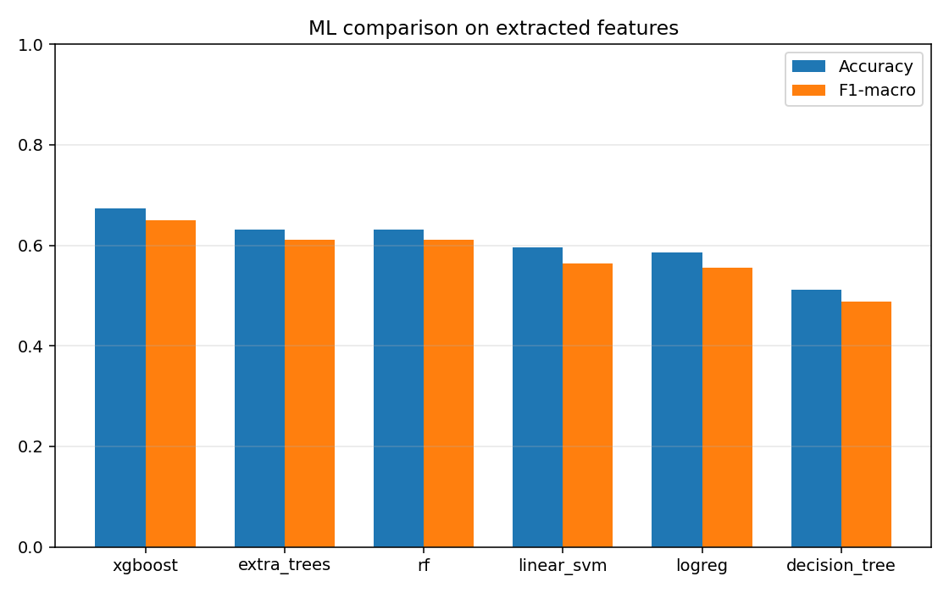
Figure 9. Accuracy and macro-F1 of the six classical models on the 637-D handcrafted features (lecturer-facing split).
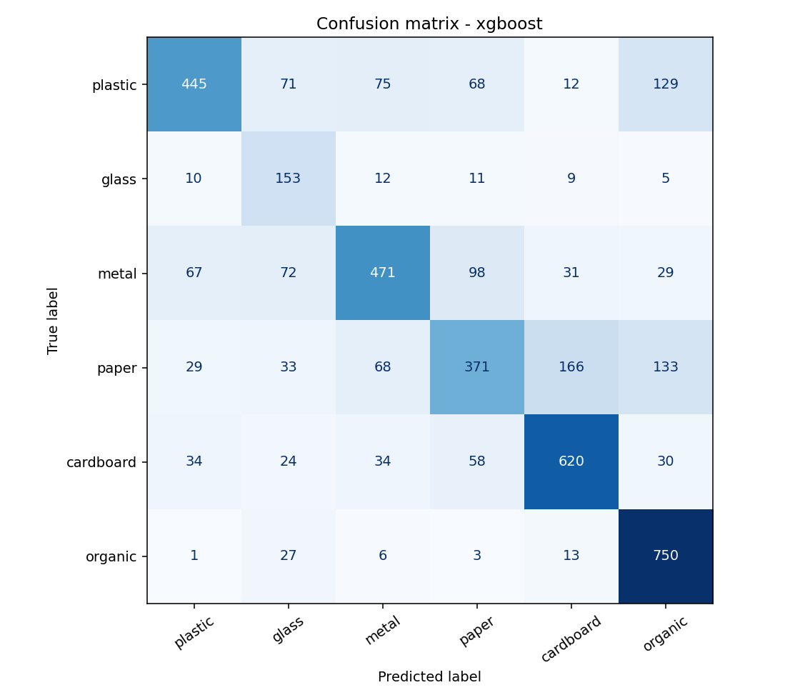
Figure 10. Confusion matrix of the best classical model (XGBoost). Most confusion occurs between visually similar material pairs such as paper/cardboard and plastic/glass.
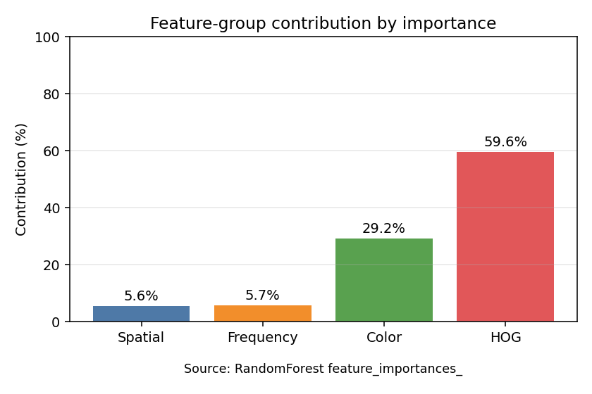
Figure 11. Feature-domain importance: HOG texture descriptors carry most of the signal, with color and spatial features contributing complementary separation.

5.2 Balanced and Per-Dataset Experiments
After lecturer feedback on imbalance, the same 637-feature workflow was rerun with strict per-class caps and per-source datasets. The spread of results across datasets is itself a key finding: identical features and models score 81% on clean studio data and 14% on raw field data.
Table 7. Best classical result per dataset under balanced caps.
Dataset | Setup | Best model | Accuracy | Macro-F1
merged_6class (project) | 1,000 train / 250 test per class | XGBoost | 0.6497 | 0.6422
TrashNet (studio) | 400 train / 120 test per class | XGBoost | 0.8103 | 0.7841
GINI (binary garbage/bg) | 400 train / 120 test per class | Random Forest | 0.8837 | 0.8516
TACO official partial (39-class field) | 120 train / 40 test per class | XGBoost | 0.1399 | 0.0675

Interpretation: TrashNet is easy because backgrounds are clean and classes are few; GINI is easy because trash-vs-background is a coarse decision; raw TACO-style data is extremely hard without class mapping and balancing. This evidence directly shaped the final dataset strategy: map fine-grained field labels into the 6+1 project taxonomy before training.

5.3 Rerun on the Newest Localization Dataset
Rerunning the identical ML workflow on super_yolo_dataset crops keeps XGBoost on top (accuracy 0.5408, macro-F1 0.3691) but with a much lower macro-F1 — an honest artifact of imbalanced test support (only 9 glass, 35 cardboard, and 46 organic test boxes). The report keeps both numbers side by side: the legacy split as the clean benchmark, the rerun as current-dataset evidence.
Table 8. Classical models rerun on super_yolo_dataset crops (imbalanced test support).
Model | Accuracy | Macro-F1
XGBoost | 0.5408 | 0.3691
Random Forest | 0.5063 | 0.3456
ExtraTrees | 0.5045 | 0.3414
Linear SVM | 0.4628 | 0.3159
Logistic Regression | 0.4494 | 0.3054
Decision Tree | 0.3750 | 0.2631

5.4 PCA Dimensionality Sweep
The controlled PCA study (7,000 train / 2,100 test crops from merged_dataset_v5, all 7 classes, dimensions 16→637) establishes two headline facts. First, the full 637-D ceiling belongs to ExtraTrees at 73.76% accuracy (macro-F1 0.7381). Second, compression is model-specific: at 128 components (99.90% explained variance) Linear SVM loses only 2.52 percentage points (62.43% → 59.90%) and Logistic Regression only 0.62 pp, while tree ensembles lose 6–8 pp because PCA rotation destroys the axis-aligned splits they rely on.
Table 9. Controlled PCA sweep — best model per dimension (runs/ml/pca_feature_model_sweep).
Components | Explained variance | Best model | Accuracy | Drop vs. 637-D
16 | 99.33% | ExtraTrees | 59.76% | 14.00 pp
32 | 99.60% | ExtraTrees | 65.86% | 7.90 pp
64 | 99.78% | ExtraTrees | 67.71% | 6.05 pp
96 | 99.86% | ExtraTrees | 67.43% | 6.33 pp
128 | 99.90% | ExtraTrees | 67.81% | 5.95 pp
192 | 99.94% | ExtraTrees | 66.52% | 7.24 pp
256 | 99.97% | ExtraTrees | 65.76% | 8.00 pp
384 | 99.99% | ExtraTrees | 63.67% | 10.10 pp
637 (full) | 100.00% | ExtraTrees | 73.76% | 0.00 pp

Table 10. Model-specific trade-off at the 128-component knee.
Model | 637-D accuracy | 128-D accuracy | Drop | Reading
Linear SVM | 62.43% | 59.90% | 2.52 pp | Basis for the 'about 2%' compression claim
Logistic Regression | 60.24% | 59.71% | 0.62 pp | Nearly free compression
ExtraTrees | 73.76% | 67.81% | 5.95 pp | Trees suffer from PCA rotation

An earlier ANN-only PCA artifact (73.24% → 68.71% at 128-D, a 4.53 pp drop, with latency falling from 0.0533 ms to 0.0314 ms per sample) is kept as separate evidence but is deliberately not cited for the compression claim — the controlled ML sweep is the honest source. This distinction was tightened in the final July 2 revision of the sweep.

6. Results — Deep-Learning Classification

6.1 ANN/CNN Baselines
Lightweight neural baselines (an MLP on the 637 handcrafted features, and a small CNN on raw 64×64 crops, both trained for 5 quick epochs) were run on the same balanced splits as the classical models to give a fair three-family comparison. Under these deliberately equal but shallow conditions, classical ML wins: the balanced merged 6-class dataset gives ANN 0.3924 and CNN 0.4614 accuracy versus XGBoost's 0.6497. The point of these baselines is not peak performance but a controlled answer to 'do raw pixels beat handcrafted features at equal budget?' — at this budget, they do not.
Table 11. Quick ANN/CNN baselines under balanced caps (5 epochs, 64×64 crops).
Dataset | ANN acc / F1 | CNN acc / F1 | Comment
merged 6-class (fair rerun) | 0.3924 / 0.3755 | 0.4614 / 0.4386 | CNN > ANN: spatial structure helps
TrashNet | 0.3458 / 0.2792 | 0.4167 / 0.4048 | Undertrained vs. 0.81 classical ML
GINI binary | 0.6211 / 0.3831 | 0.7895 / 0.7883 | Binary task; CNN usable
TACO official partial | 0.0573 / 0.0028 | 0.0573 / 0.0028 | 39 sparse classes; not viable

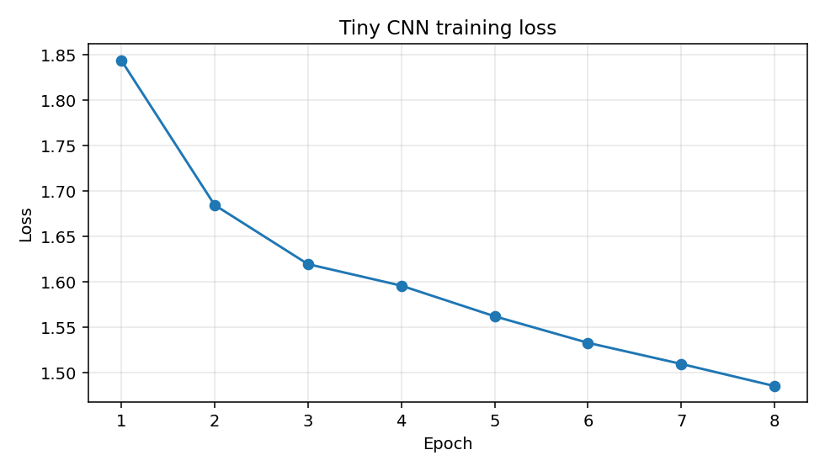
Figure 12. Training loss of the early tiny-CNN crop baseline — the starting point of the deep-learning branch.

6.2 Feature-Fusion Ensemble: CNN + Handcrafted ANN
The first strong evidence that handcrafted features and CNN features are complementary came from soft-voting ensembles on the balanced 1,750-crop test split (250 per class, 7 classes). A properly trained MobileNetV2 CNN reaches 77.20% alone; a PyTorch ANN on the 637 features reaches 64.00%; blending their probabilities 50/50 beats both at 78.69% (macro-F1 78.12%).
Table 12. Soft-voting ensemble results on the balanced 7-class test split (1,750 crops).
Method | Accuracy | Macro-F1 | Δ vs. CNN
PyTorch ANN (637 features) | 64.00% | 63.56% | −13.20 pp
MobileNetV2 CNN (raw crops) | 77.20% | 76.56% | baseline
Simple soft voting 50/50 | 78.69% | 78.12% | +1.49 pp
Weighted voting 30/70 | 77.94% | 77.26% | +0.74 pp

The background-error deep-dive on the same split shows why a Background class and a verification stage matter for deployment: the ANN misclassifies 14.40% of background crops as waste ('ghost waste') and misses 2.77% of real waste as background, while the CNN cuts those rates to 6.80% and 0.57%. Cardboard-like floor textures are the dominant leakage in both directions.
Table 13. Background leakage comparison (250 crops per class test).
Model | Ghost-waste FP rate | Waste-blindness FN rate | Top FP leak | Top FN leak
PyTorch ANN | 14.40% (72/500) | 2.77% (83/3000) | cardboard | paper
MobileNetV2 CNN | 6.80% (34/500) | 0.57% (17/3000) | cardboard | plastic

6.3 Architecture Comparison for Stage 2
Three candidate crop classifiers were compared head-to-head for the production Stage 2 role, measuring accuracy, size, parameters, and CPU latency. EfficientNetB0 wins the accuracy-per-megabyte contest decisively: 94.29% accuracy at 29.21 MB versus ResNet50's 89.76% at 161.52 MB (81.9% smaller for 4.53 pp more accuracy) and MobileNetV2's 85.43%.
Table 14. Stage 2 architecture comparison (runs/dl/comparison_models).
Architecture | Test accuracy | Size (MB) | Parameters | CPU latency
MobileNetV2 | 85.43% | 20.07 | 2,422,855 | 253.5 ms
ResNet50 | 89.76% | 161.52 | 23,850,887 | 163.1 ms
EfficientNetB0 (ours) | 94.29% | 29.21 | 4,214,442 | 288.6 ms

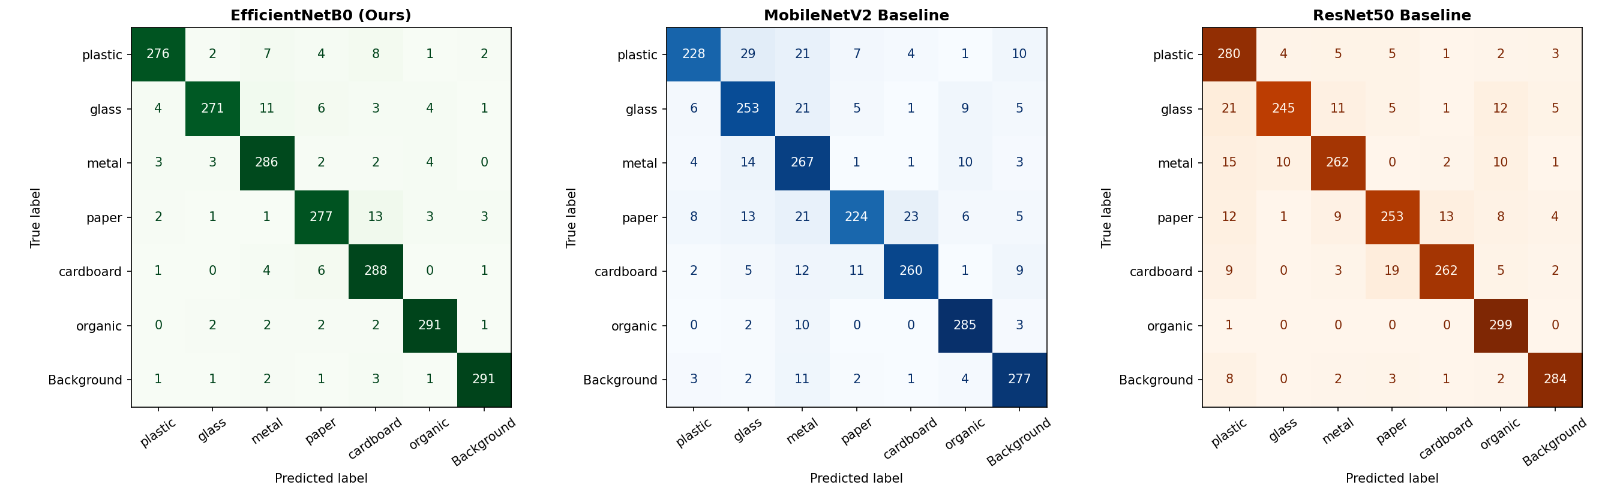
Figure 13. Confusion-matrix grid for the three Stage 2 candidates (MobileNetV2, ResNet50, EfficientNetB0). EfficientNetB0 shows the cleanest diagonal, particularly on reflective classes.
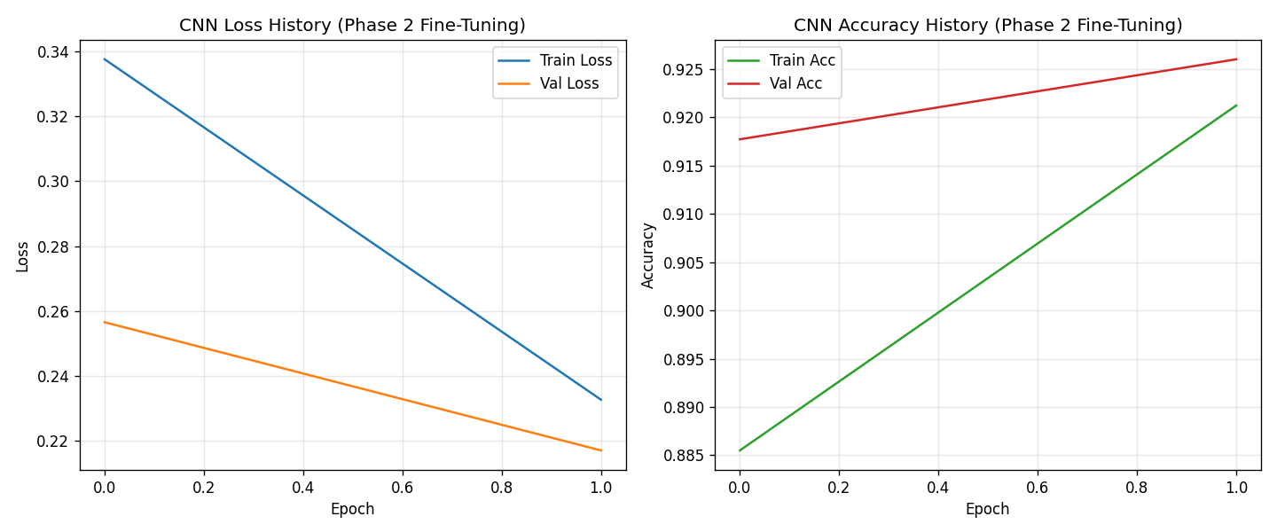
Figure 14. EfficientNetB0 training curves (accuracy and loss). The model converges smoothly without overfitting under augmentation.
Post-training 8-bit quantization compresses EfficientNetB0 from 29.21 MB to 4.83 MB (6.0× reduction), comfortably inside the 10 MB edge budget, with synthetic TFLite throughput measured at 362.43 FPS.

6.4 ConvNeXt Multimodal Ensemble and Hard-Case Retraining
The final classifier generation fuses a ConvNeXt-Tiny image embedding with the standardized 637 handcrafted features inside one network — the deep model and the explainable features become a single multimodal classifier, exported as unified ONNX. Trained on merged_dataset_v5 (7,000 balanced train crops, 2,100 validation crops) with a 3-epoch frozen warm-up and 7 progressive fine-tuning epochs on an RTX 3060, it reaches 92.52% validation accuracy (1,943/2,100 correct).
Table 15. ConvNeXt + 637-feature tuned training trace (runs/dl/convnext_ensemble_tuned).
Phase | Epoch | Train accuracy | Validation accuracy
Warm-up (frozen backbone) | 1 | 70.30% | —
Warm-up | 2 | 84.49% | —
Warm-up | 3 | 87.83% | —
Fine-tune (last stage unfrozen) | 1 | 92.75% | 90.81%
Fine-tune | 2 | 94.75% | 91.57%
Fine-tune | 3 | 95.57% | 92.33%
Fine-tune | 4 | 96.07% | 92.48%
Fine-tune | 7 (best) | 97.38% | 92.52%

Retraining the same architecture on the hard-case dataset (12,600 balanced train crops from RealWaste and official TACO) lifted robustness on realistic imagery: 93.88% test accuracy, 0.9398 test macro-F1 (93.13% / 0.9322 validation), trained in 748.6 s. Two ConvNeXtV2 upgrades were also benchmarked: a Stage 0 binary trash gate at 97.81% test accuracy (macro-F1 0.9777), and a frozen-backbone ConvNeXtV2 + 637-feature MLP-head Stage 1 candidate (1,405-D fused features) at 94.55% test accuracy (macro-F1 0.9459).
Table 16. Final classifier generations, all on 7-class balanced crop data unless noted.
Model | Eval split | Accuracy | Macro-F1
ConvNeXt-Tiny + 637 (tuned) | validation (2,100) | 92.52% | —
ConvNeXt-Tiny + 637 (hard-case retrain) | test (2,696) | 93.88% | 0.9398
ConvNeXtV2 Stage 0 trash gate (binary) | test (319) | 97.81% | 0.9777
ConvNeXtV2 frozen + 637 + MLP head | test (2,696) | 94.55% | 0.9459

6.5 Cross-Dataset Generalization
To quantify domain shift honestly, the classifier was trained on one acquisition domain and tested on the other: STUDIO (TrashNet + Kaggle garbage, 4,900 samples) versus FIELD (Roboflow/TACO detection exports, 4,735 samples), both keeping all 7 classes. The gaps are large and asymmetric — studio-trained models lose 40.19 pp in the field, field-trained models lose 28.27 pp in the studio — and they are the single best argument for training on field-style hard-case data, which the June retraining did.
Table 17. Cross-dataset validation (runs/dl/cross_dataset_validation, repaired July 2 split).
Direction | In-domain acc | Cross-domain acc | Gap | Cross macro-F1
STUDIO → FIELD | 80.00% | 39.81% | 40.19 pp | 0.4023
FIELD → STUDIO | 72.76% | 44.49% | 28.27 pp | 0.4074

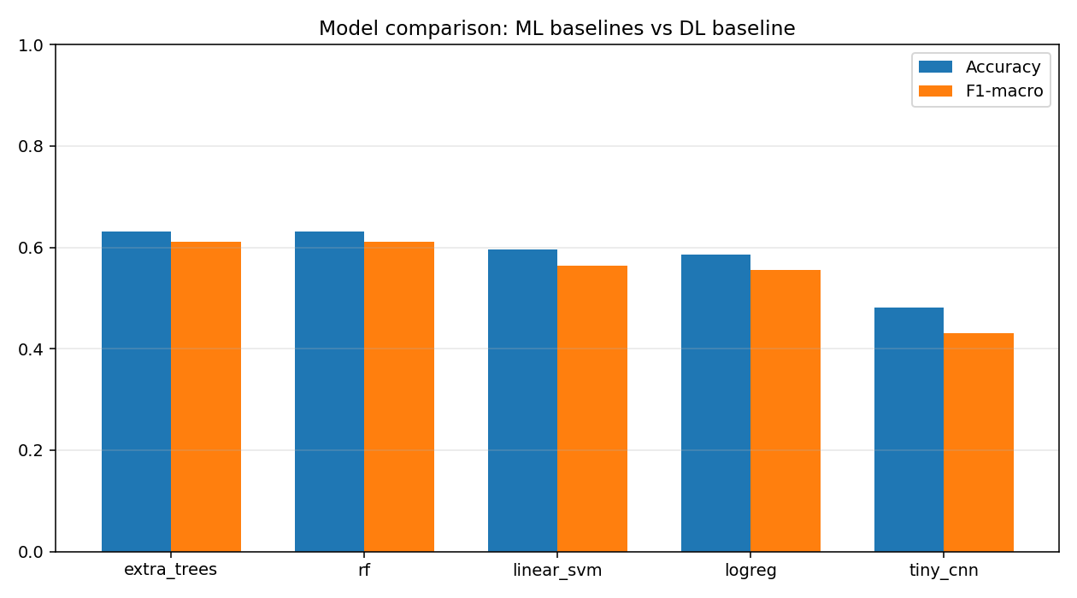
Figure 15. Master comparison of ML and DL model families across the project's benchmark datasets.

7. Results — Detection and Localization

7.1 YOLOv8n on the Tuned Dataset
The first credible detector came from retraining YOLOv8n for 50 epochs (image size 800, batch 16) on tuned_dataset_v1 — the cleaned, deduplicated, rebalanced rebuild of Section 3.3. Final epoch metrics were precision 0.8482, recall 0.7274, mAP@0.5 0.8200; independent evaluation gave 0.825 mAP@0.5 (validation) and 0.810 mAP@0.5 (test) with mAP@0.5:0.95 of 0.624 / 0.622. This hit the informal 0.80 target set after the dataset audit, and proved the cleaning work paid off in measurable accuracy.

7.2 YOLOv11 Production Detector
For the production pipeline, YOLOv11 was trained for 30 epochs on the 24,500+-image super dataset. Its role in the final architecture is localization-only (Section 4.3.1); its boxes feed Stage 2 rather than deciding classes. It remains the deployed detector in the web application (models/trained/yolov11_detector/best.pt).

7.3 YOLO26n Benchmark and Threshold Engineering (June–July 2026)
When Ultralytics released YOLO26, a controlled benchmark asked whether the production detector should be replaced. On the hard-case detection set (640 px, 80 latency-test images), YOLO26n edges out the deployed YOLOv11 on quality but not decisively, and is slightly slower at the p95 tail:
Table 18. YOLOv11 (deployed) vs. newly trained YOLO26n on yolo26_hardcase_dataset_v1.
Model | mAP@0.5 | mAP@0.5:0.95 | Precision | Recall | Latency mean / p95
YOLOv11 (old, deployed) | 0.6693 | 0.4961 | 0.7447 | 0.5930 | 50.1 / 54.0 ms
YOLO26n (new) | 0.6723 | 0.5054 | 0.7569 | 0.5922 | 52.1 / 73.1 ms

A no-retrain confidence-threshold sweep then mapped the precision/recall trade-off of the YOLO26n weights. The best-F1 operating point is conf 0.30 (P 0.764, R 0.589); the cheapest way to reach precision ≥ 0.85 is conf 0.50 (P 0.861, R 0.517) — a config-only lever for precision-critical deployments.
Table 19. YOLO26n confidence-threshold sweep (validation split, NMS IoU 0.7).
conf | Precision | Recall | F1 | mAP@0.5 | mAP@0.5:0.95
0.25 | 0.759 | 0.592 | 0.665 | 0.570 | 0.446
0.30 | 0.764 | 0.589 | 0.665 | 0.552 | 0.437
0.40 | 0.818 | 0.554 | 0.660 | 0.526 | 0.421
0.50 | 0.861 | 0.517 | 0.646 | 0.496 | 0.403
0.60 | 0.891 | 0.474 | 0.619 | 0.458 | 0.379
0.70 | 0.922 | 0.424 | 0.581 | 0.412 | 0.348

A second experiment on the balanced_realworld_v2 test split produced a cautionary negative result: the deployed YOLOv11 scored 0.434 mAP@0.5 there, a live fine-tuned YOLO26n scored 0.408, and a from-scratch balanced YOLO26n only 0.222. New architecture plus new data does not automatically beat a well-trained incumbent — the deployed YOLOv11 was retained for production.
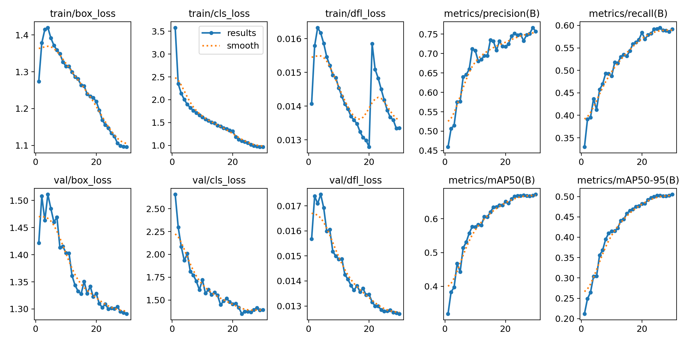
Figure 16. YOLO26n hard-case training run: losses, precision/recall, and mAP curves across epochs.
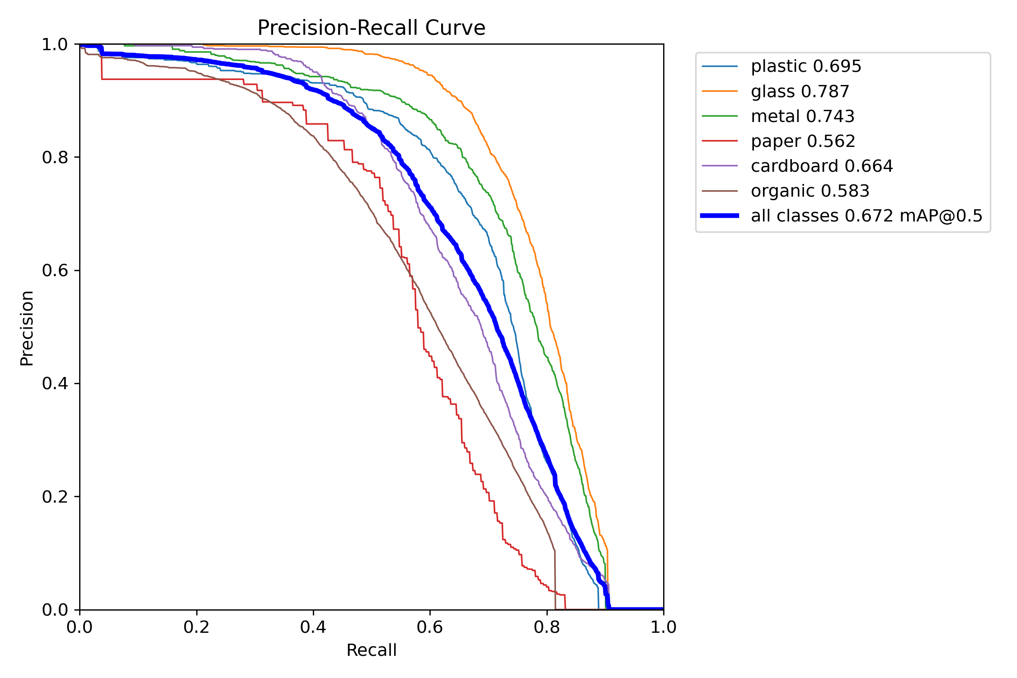
Figure 17. Precision-recall curves per class for the YOLO26n hard-case detector.
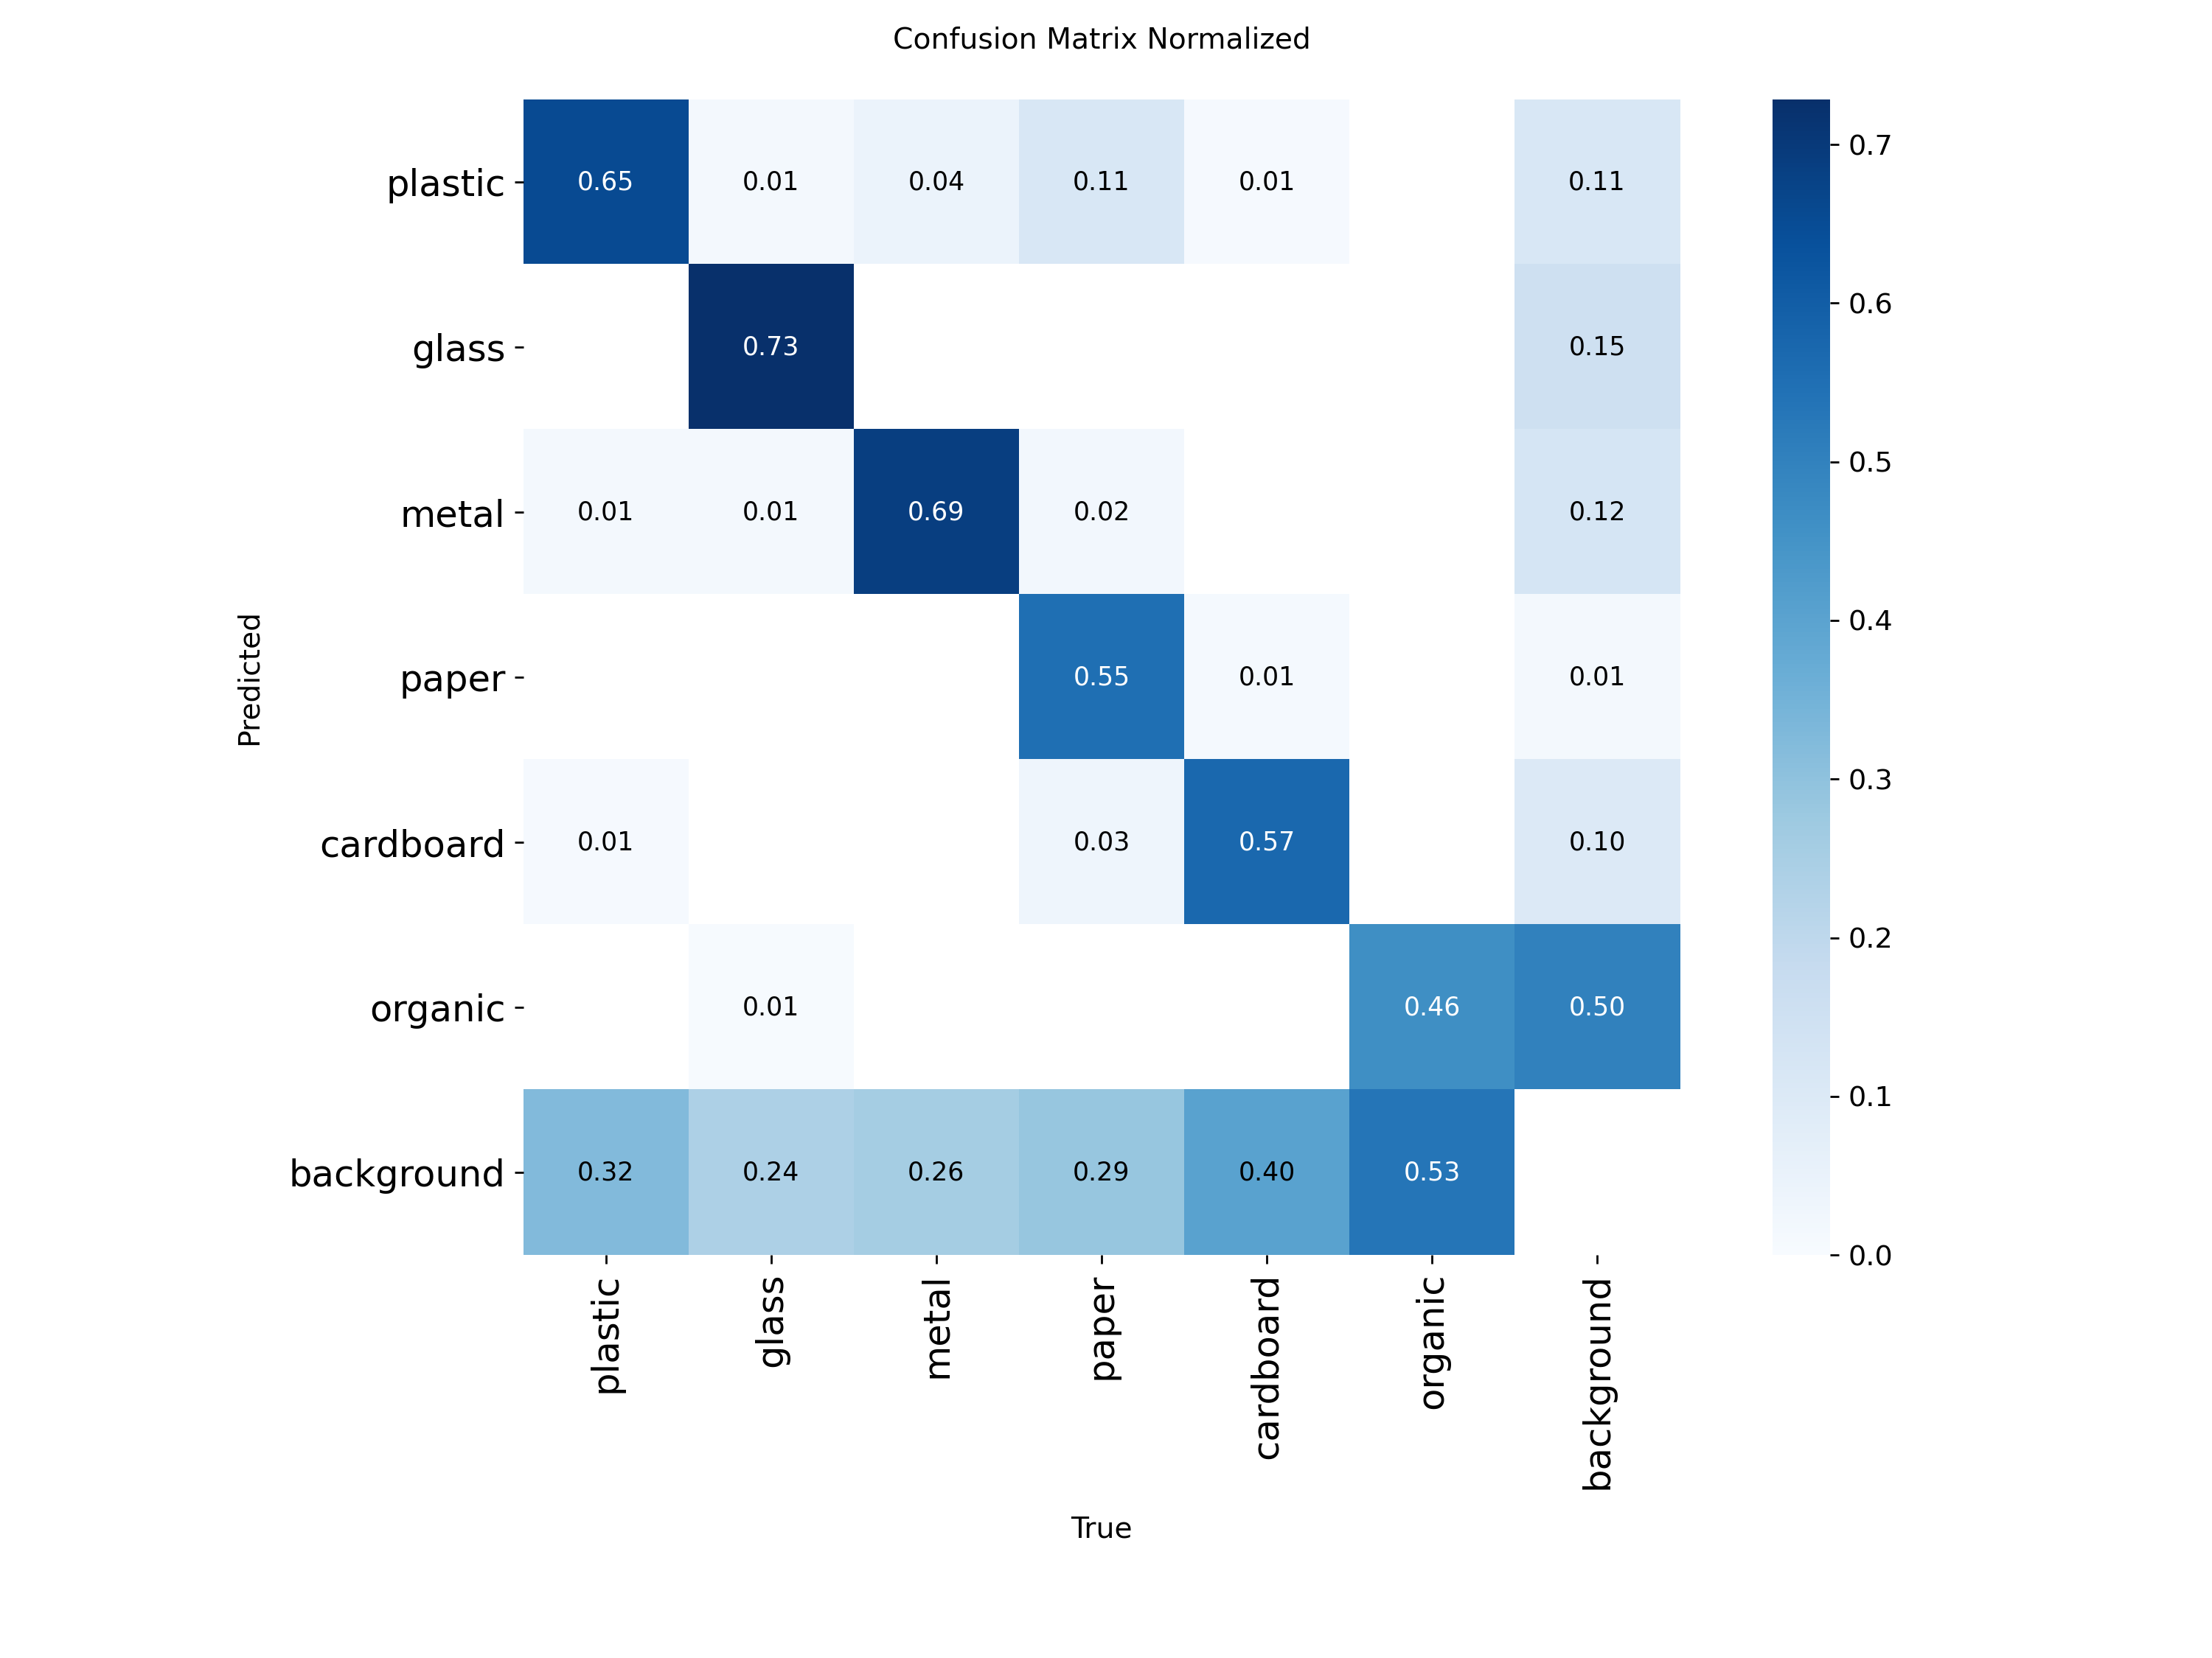
Figure 18. Normalized confusion matrix of the YOLO26n hard-case detector. Glass and plastic remain the hardest classes; background confusions motivate the Stage 2 veto.
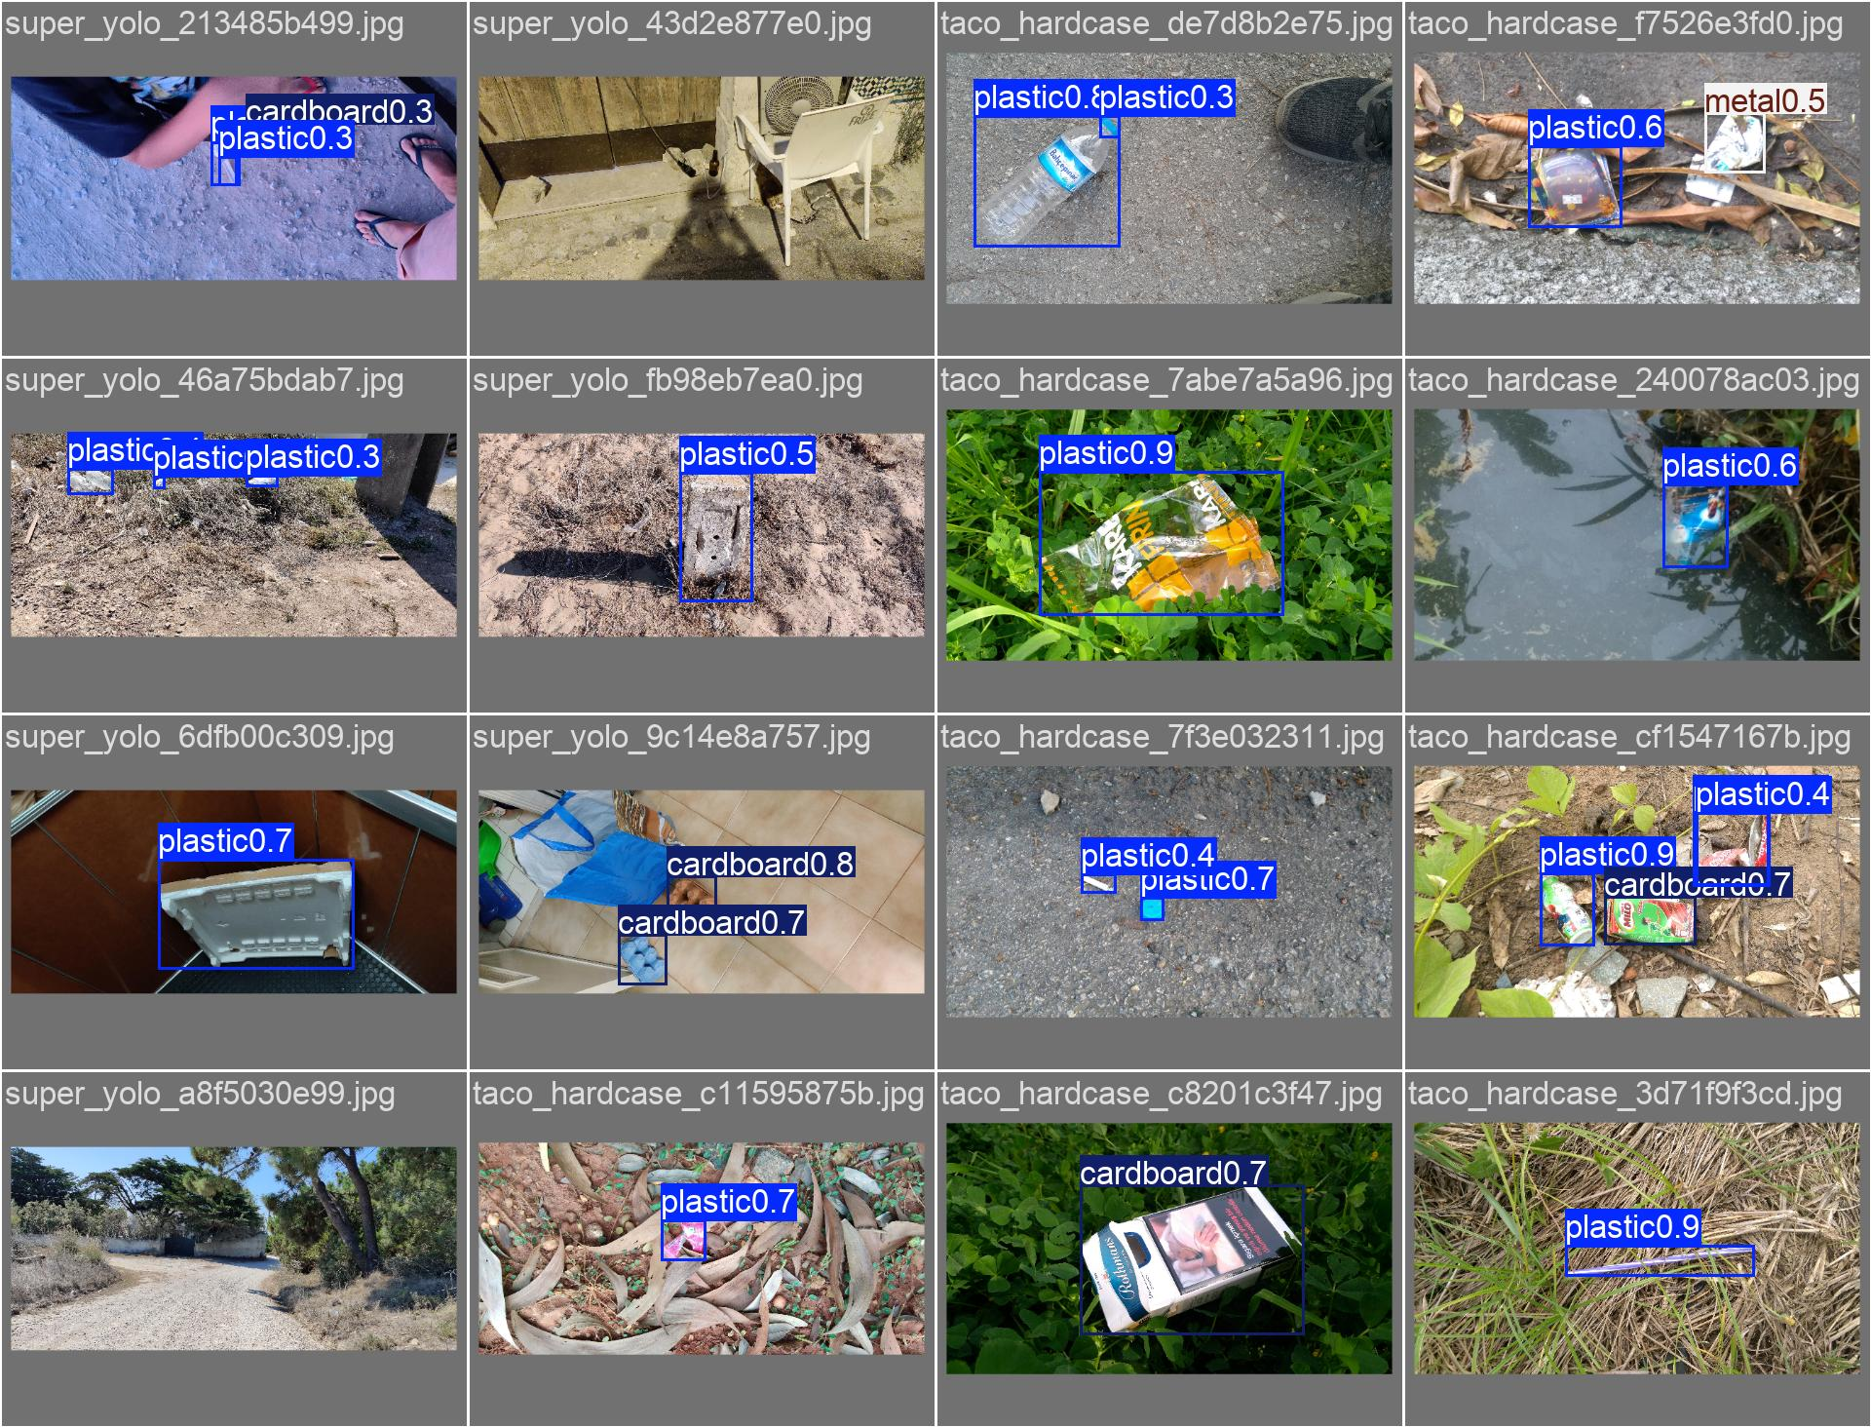
Figure 19. Validation-batch predictions of the hard-case detector on cluttered real-world scenes.

7.4 Localization Rework: Grad-CAM Baseline vs. YOLO Localization
The DL branch's final evaluation isolates localization quality. The classification-first Grad-CAM pipeline and the YOLO localization-only module were scored identically (IoU@0.5 matching against ground-truth boxes) on stratified test samples. Grad-CAM collapses on multi-object scenes; YOLO localization is dramatically stronger, and a 300-image sweep (1,152 ground-truth boxes) selected conf 0.30 as the promoted operating point:
Table 20. Localization evaluation: Grad-CAM baseline vs. YOLO at multiple thresholds.
Configuration | Images | Precision | Recall | F1 | Mean IoU | TP / FP / FN
Grad-CAM baseline | 60 | 0.2568 | 0.0728 | — | 0.7127 | 19 / 55 / 242
YOLO conf 0.25 | 60 | 0.6352 | 0.5670 | — | 0.9012 | 148 / 85 / 113
YOLO conf 0.35 | 60 | 0.7614 | 0.5134 | — | 0.9004 | 134 / 42 / 127
YOLO conf 0.30 (promoted) | 300 | 0.6999 | 0.5729 | 0.6301 | 0.9057 | 660 / 283 / 492
YOLO conf 0.35 | 300 | 0.7571 | 0.5356 | 0.6274 | 0.9043 | 617 / 198 / 535
YOLO conf 0.40 (high precision) | 300 | 0.8035 | 0.5148 | 0.6275 | 0.9050 | 593 / 145 / 559

conf 0.30 wins on balanced F1 and recall while keeping mean matched IoU above 0.90; conf 0.40 is documented as the high-precision alternative. The Grad-CAM result is kept in the report deliberately: it is the measured evidence for why the project abandoned classification-first localization.
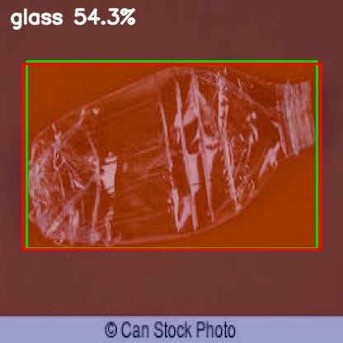
Figure 20. YOLO localization-only output on a transparent-bottle test image from the 300-image evaluation. The box is tight even where the raw class score is ambiguous — which is exactly why the rework strips YOLO of the final class decision.
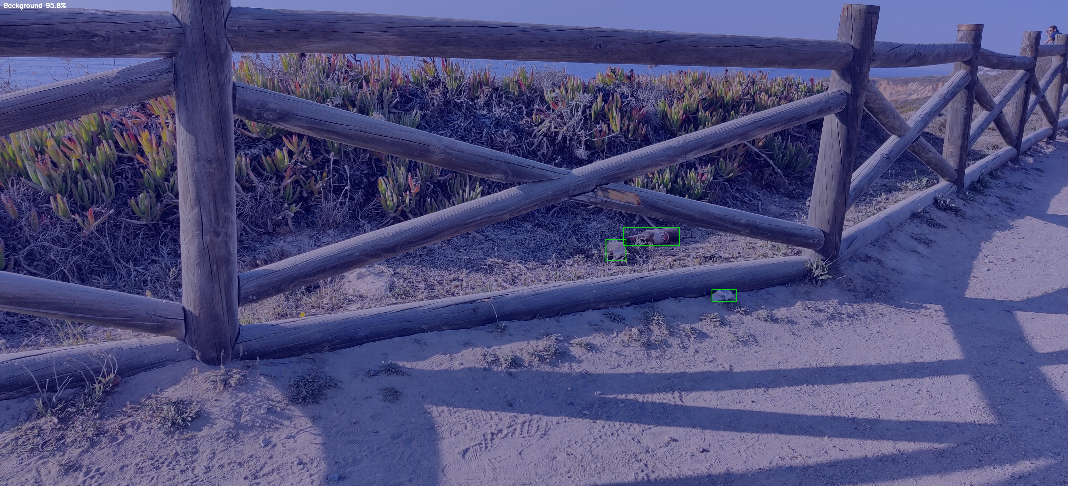
Figure 21. YOLO localization-only output on a wide TACO street scene from the 300-image evaluation.

8. Results — End-to-End Production Pipeline

8.1 100-Image Validation Sweep
The full two-stage pipeline (YOLOv11 proposals → EfficientNetB0 verification with dynamic voting) was swept over 100 random unseen test images:
- 348 YOLO proposals evaluated; 295 objects verified and accepted by Stage 2.
- 174 consensus matches (59.0% dual-network agreement); 121 CNN self-corrections (41.0% of accepted objects) — direct evidence that the verification stage earns its cost.
- 53 suppressed detections: 3 background ghost-waste rejections and 50 low-confidence proposals.
- 238.08 ms per image end-to-end on CPU (4.20 FPS), inside the 500 ms budget with 2.1× margin.
- Zero bare-metal cans misclassified after class-dependent voting (α = 0.80 for metal) — the street-can failure case that triggered this mechanism was fully resolved.
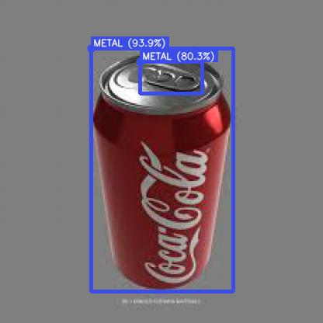
Figure 22. Pipeline output on a metal test image: YOLO box + Stage 2 verified label.
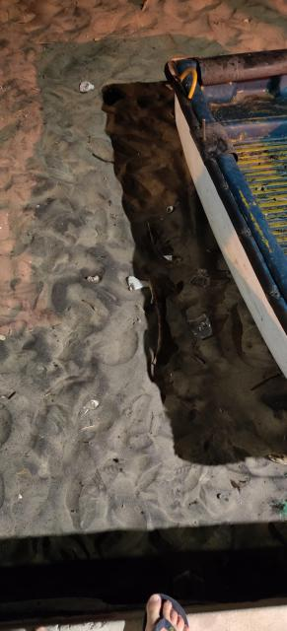
Figure 23. Pipeline output on a TACO field scene with a small object against clutter.
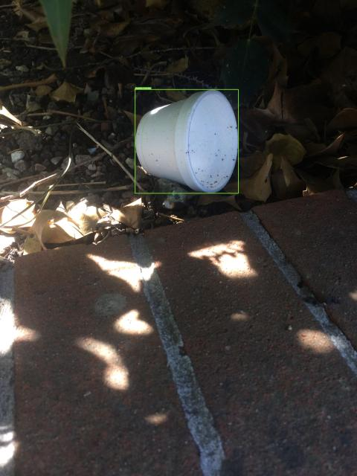
Figure 24. Pipeline output on a second TACO scene from the 100-image sweep.

8.2 Hard-Case Walkthrough: Reflective Plastic
A single highly reflective bottle photo (plastic.jpg) documents every production mechanism firing in sequence. At conf 0.30, YOLO returns zero boxes (reflection kills the detector). The adaptive scene engine detects the empty result and triggers SMALL_OBJECT_RECOVERY, re-running YOLO at conf 0.05 with the CNN verification limit relaxed to 0.15, recovering 3 candidate boxes. The 24×24 px size filter passes them; ConvNeXt classifies the padded crops; dynamic alpha blending assigns α = 0.15 (trusting the CNN because YOLO's score is weak); the HSV context detector recognizes a beach scene and applies the Beach prior [0.35, 0.25, 0.20, 0.05, 0.05, 0.10]; and the final aggregated decision is Plastic at 84% confidence. The classification-first baseline on the same image produced a weak, wrong 'Paper (32%)' scene label.
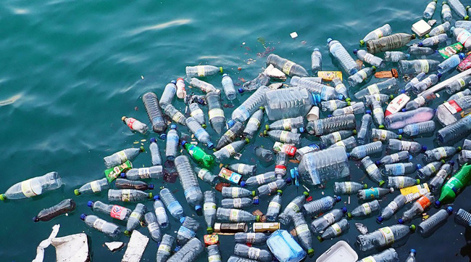
Figure 25. The reflective-plastic hard case used for the end-to-end production verification walkthrough.

8.3 Adaptive Hybrid Switcher
The adaptive switcher routes easy frames through the fast 2-stage path and hard frames (clutter, poor lighting) through a heavier 4-stage path with extra verification. The demo scenes below show the router choosing the 2-stage path for a clean outdoor bottle and recycling-bin scene, and escalating a dirty cluttered kitchen to the 4-stage path.
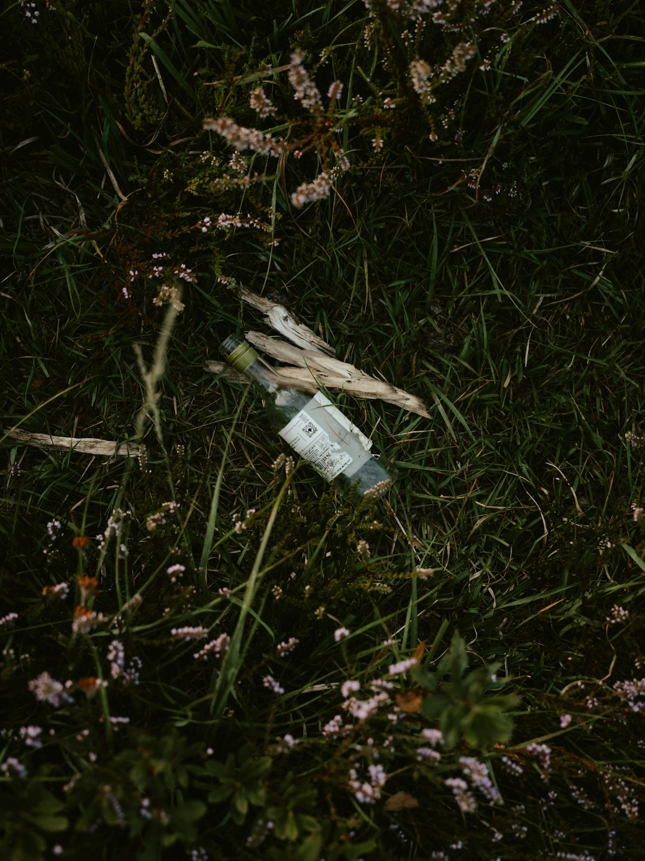
Figure 26. Adaptive switcher: outdoor grass-bottle scene routed through the fast 2-stage path.
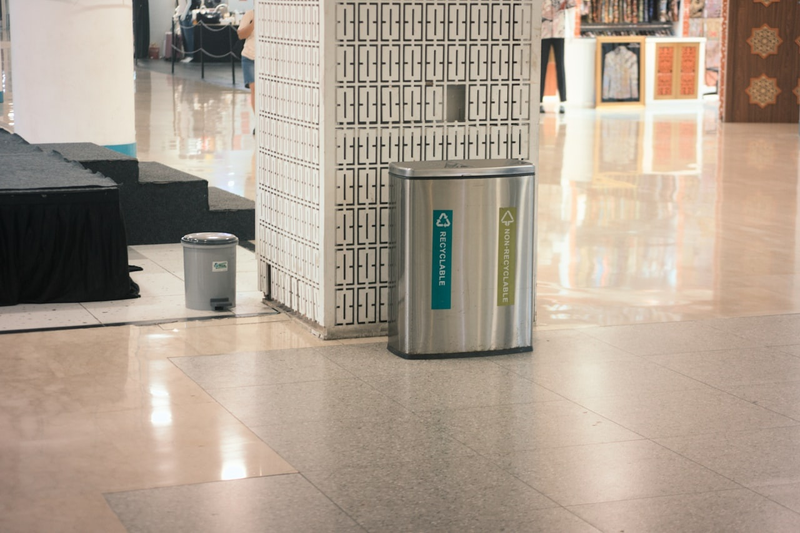
Figure 27. Adaptive switcher: indoor recycling-bin scene, 2-stage path with multiple verified objects.
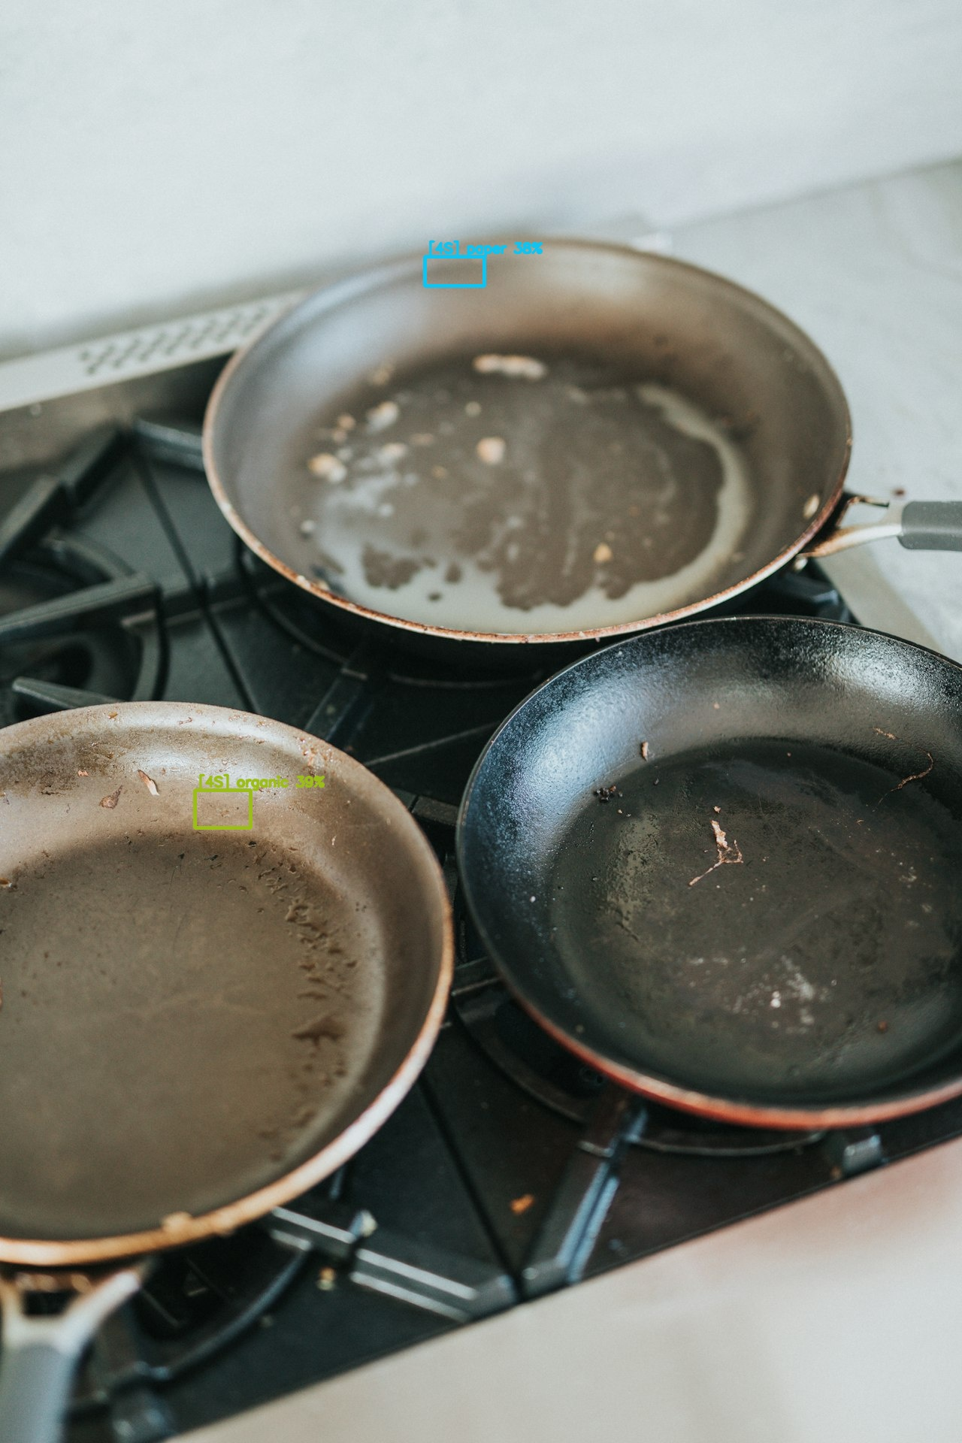
Figure 28. Adaptive switcher: cluttered dirty-kitchen scene escalated to the 4-stage path.

9. Project Evolution: From Scratch to Production
This chapter tells the project chronologically, including the approaches that failed or were replaced. Each phase ends with what was learned, because those lessons — not just the final numbers — are the substance of the engineering work.

9.1 Phase 0 — First Baseline (early May 2026)
The project began with a YOLOv8 detector on the freshly merged dataset and a deliberately simple 17-dimensional feature vector (8 spatial + 9 frequency descriptors) feeding Logistic Regression, SVM-RBF, and Random Forest, following the lecturer's prescribed order: spatial analysis → frequency analysis → per-class commentary → only then ML. The first full run (runs/ml/feature_ml_6class_4k) scored roughly 38–47% test accuracy (best: Random Forest ≈ 47%) — far below the informal 80% goal. Lesson: 17 features cannot separate six materials; and the dataset itself was suspect.

9.2 Phase 1 — Dataset Audit and the First Real Detector (May 10–15)
Instead of tuning models on bad data, the project audited the data. The EDA pass found 7,460 invalid label rows, 5,862 duplicate images, and a glass test set of just 200 boxes. The non-destructive tuned_dataset_v1 rebuild fixed all of it, and retraining YOLOv8n on the cleaned data delivered 0.810 test mAP@0.5 — the 0.80 target reached not by a bigger model but by better data. Lesson: dataset engineering is model engineering.

9.3 Phase 2 — Lecturer Pivot: Source-Level Honesty (May 15–18)
Lecturer feedback redirected the project: the merged dataset was too imbalanced to serve as the only evidence, source identity had to be preserved, and models had to be compared under balanced sampling. YOLO was deliberately paused. The project separated all sources, ran per-source EDA and feature analysis, trained ANN/CNN per source, expanded the 17-D vector to the full 637-D handcrafted representation, and rebuilt every comparison under per-class caps with recorded support. The headline table (XGBoost 0.6742) dates from this phase, as does the three-dataset difficulty spectrum (TrashNet 0.81 / GINI 0.88 / TACO 0.14). An early mistake — the first balanced ANN/CNN run silently dropped the organic class because one source was missing from a filter — was caught and rerun as the 'fair' comparison. Lesson: balanced, source-aware, support-reported experiments are defensible; merged convenience numbers are not.

9.4 Phase 3 — The Two-Stage Architecture (May 20–21)
The DL branch was rebuilt as the 2-stage hierarchical pipeline: YOLOv11 (30 epochs on the 24.5k-image super dataset) proposing boxes, quantized EfficientNetB0 (94.29% test accuracy, 4.83 MB TFLite) verifying crops. Two decision mechanisms were invented to fix observed failures — dynamic class-dependent soft voting (α = 0.80 for metal) after bare aluminum cans kept being called glass/plastic under specular glare, and consensus-adaptive thresholding (0.25 agree / 0.40 disagree) to balance recall against ghost waste. The 100-image sweep validated the design: 41% of accepted objects were CNN corrections of YOLO's label, at 238 ms/image. Lesson: the verification stage is not optional decoration; it changes two out of five answers.

9.5 Phase 4 — Multimodal Fusion and Robustness Tooling (May 25–30)
This phase professionalized the classifier and the evaluation. The architecture comparison (MobileNetV2 / ResNet50 / EfficientNetB0) was formalized; the ConvNeXt-Tiny + 637-feature fused ensemble was built and exported to unified ONNX; the adaptive hybrid switcher, CLAHE preprocessing, HSV context engine, and Bayesian prior fusion entered the batch evaluator; PCA-ANN sweeps and the first cross-dataset validation quantified compression and domain shift; and the repository was reorganized with the professional pipeline diagrams. Lesson: robustness features (context, adaptive thresholds, scene routing) bought more real-world accuracy than another architecture swap would have.

9.6 Phase 5 — Hard Cases and the YOLO26 Question (June 7–12)
With the pipeline stable, the project attacked its residual errors. The ConvNeXt ensemble was fine-tuned to 92.52% validation accuracy; hard-case datasets were assembled from RealWaste and official TACO; hard-case retraining reached 93.88% test accuracy; and ConvNeXtV2 experiments produced a 97.81% trash/no-trash gate and a 94.55% frozen-backbone Stage 1 candidate. In parallel, YOLO26n was trained and benchmarked against the deployed YOLOv11: marginally better mAP (0.672 vs. 0.669) but worse tail latency, and a from-scratch balanced retrain badly underperformed (0.222 vs. 0.434 mAP@0.5). The incumbent stayed. Lesson: benchmark before replacing; negative results are results.

9.7 Phase 6 — Localization Rework and Final Positioning (June 12)
The final report positioning was locked: the ML branch stands as the finalized explainable pipeline, and the DL branch is evaluated on localization metrics, with YOLO's role narrowed to localization-only after the classification gate. The Grad-CAM classification-first baseline was implemented and measured (precision 0.2568, recall 0.0728) precisely so the localization-first choice would rest on evidence, and the 300-image threshold sweep promoted conf 0.30 (F1 0.6301, IoU 0.9057). Lesson: when two philosophies compete, run both and publish the loser's numbers.

9.8 Phase 7 — Production and Final Hardening (late June – July 2)
The web application was finished around the real model stack (tuned ConvNeXt + scaler + YOLOv11 detect-all at conf 0.30, imgsz 960, max_det 80), with top-3 predictions, seven score bars, detection overlays, a waste-state gate, and browser-fallback logic; the server was packaged with Docker and deployed to Hugging Face Spaces with LFS-tracked weights. Final hardening commits (July 2) added the no-retrain precision threshold sweep (conf 0.50 → P 0.861 lever), widened the PCA sweep with the honest per-model knee, and repaired the cross-dataset domain split. Lesson: production is a feature of the project, not an afterthought — and the last 10% is config, honesty, and packaging.

9.9 What Failed and What It Taught
Table 21. Failed or replaced approaches and their lessons.
Approach | Result | Replacement / lesson
17-D features + classical ML | ≈38–47% accuracy | Expanded to 637-D vector; features must carry the signal
Naive merged dataset | 7,460 bad rows, 5,862 dups, glass test = 200 | EDA-driven tuned rebuild; +mAP for free
Raw TACO 39/60-class training | 0.06–0.14 accuracy, all models | Map fine-grained labels into 6+1 taxonomy first
OpenCV contour proposals | Weak boxes on clutter | Replaced by YOLO Stage 1
Classification-first Grad-CAM localization | P 0.257, R 0.073 | Localization-first; YOLO IoU 0.90+
Single-stage YOLO classification | Metal/glass glare confusions | Stage 2 verification; 41% of labels corrected
From-scratch YOLO26n on balanced_realworld_v2 | 0.222 mAP@0.5 vs. incumbent 0.434 | Keep benchmarked incumbent; data > novelty
5-epoch ANN/CNN as headline DL | 0.39–0.46 accuracy | Kept only as fair lower-bound baselines

10. Production Deployment

10.1 Web Application and Model API
The user-facing product is a plain HTML/CSS/JavaScript dashboard talking to a local Python HTTP API (web/server.py). The API serves the real production stack: the tuned PyTorch ConvNeXt + 637-feature classifier (best_convnext_ensemble_tuned.pth with its handcrafted-feature scaler) and the YOLOv11 detect-all localizer, with every YOLO box re-classified and merged with YOLO confidence plus a scene top-K guide. Localization settings are conf 0.30, recovery conf 0.30, image size 960, max 80 detections. The /api/predict endpoint returns a topPredictions array (top-3 materials) rendered beside all seven class score bars and the detection boxes; recent scans persist to browser history. The older Keras EfficientNet path remains as a fallback, and a browser-side adapter takes over if the model API is unreachable.

10.2 Packaging and Hosting
- Docker container with warm-preloaded PyTorch weights, deployed to Hugging Face Spaces; large weights tracked via Git LFS (the repository itself ignores >100 MB binaries).
- Edge export paths: 8-bit quantized TFLite (4.83 MB EfficientNetB0, 362 FPS synthetic) via export_tflite.py, and the unified multimodal ONNX pipeline via export_ensemble_onnx.py.
- Deployment scripts: deploy_hf_space.py and restart_hf_space.py automate pushing and restarting the Space.

10.3 Waste-State Gate
Detected material is deliberately not auto-routed to a bin. Each object is marked waste, not_waste, or review, and only 'waste' enters a bin route. The current gate is conservative rule logic; a trained three-state model is listed as future work.

11. Discussion and Limitations
- Domain shift is the dominant error source. A 40.19 pp studio→field accuracy gap dwarfs any model-choice difference measured in this project. Hard-case retraining (93.88%) narrows but does not close it.
- Recall ceiling in localization. Even the promoted operating point recovers only 57.3% of ground-truth boxes; 492 of 1,152 objects are missed at conf 0.30. Small, transparent, and heavily occluded litter remains undetected — the adaptive recovery sweep mitigates this per-scene but is not a general fix.
- Imbalanced test support weakens some claims. The super_yolo ML rerun's macro-F1 (0.3691) reflects 9 glass test boxes as much as model quality; the report keeps such caveats attached to every affected number.
- Baselines are intentionally shallow. The 5-epoch ANN/CNN numbers must not be read as 'deep learning loses to XGBoost'; the properly trained CNNs (77–94%) show the opposite. The shallow runs exist to compare families at equal budget.
- PCA claims are model-specific. '637→128 costs about 2%' is true for Linear SVM (2.52 pp) and nearly free for Logistic Regression (0.62 pp), but costs tree ensembles 6–8 pp. The report never cites the ANN-only artifact for this claim.
- The waste-state gate is rules, not learning. Routing decisions after classification are conservative heuristics pending a trained state model.
- Single-machine training. All training ran on one RTX 3060; larger backbones (ConvNeXt-Base, transformer detectors) were out of budget and remain unexplored.

12. Conclusion and Future Work
WasteWise set out to answer two questions honestly: how far can explainable classical features go on real-world waste classification, and what deep architecture actually survives unconstrained scenes? The answers are now measured. The explainable branch peaks at 67.42% (XGBoost, lecturer split) with a documented, model-specific compression knee at 128 PCA components. The production branch — YOLO localization first, multimodal ConvNeXt verification second, wrapped in adaptive thresholds and context priors — reaches 92.5–94.6% crop classification, 0.90+ localization IoU at the promoted threshold, 238 ms/image CPU latency, and runs today as a deployed web application. Equally important, the project preserved its negative results: the Grad-CAM localization failure, the TACO raw-label collapse, the YOLO26 retrain regression, and the studio/field domain gap are all in the record, because they justify the final design.
Future work, in priority order:
- Close the recall gap: tiling/multi-scale inference for small litter, and targeted data for transparent objects.
- Train the waste-state model (waste / not_waste / review) to replace the rule gate.
- Domain adaptation between studio and field imagery (augmentation policies, style transfer, or DANN-style training) to cut the 40 pp gap.
- Promote the ConvNeXtV2 Stage 0 gate + Stage 1 candidate into production behind the existing API, with A/B evaluation.
- On-device deployment of the 4.83 MB TFLite model in the mobile prototype with live camera frames.

References
Adedeji, O., & Wang, Z. (2019). Intelligent Waste Classification System Using Deep Learning. Proceedings of the IEEE International Conference on Cognitive Computing.
Dalal, N., & Triggs, B. (2005). Histograms of Oriented Gradients for Human Detection. IEEE CVPR.
Haralick, R. M., Shanmugam, K., & Dinstein, I. (1973). Texture Features for Image Classification. IEEE Transactions on Systems, Man, and Cybernetics, SMC-3(6), 610–621.
He, K., Zhang, X., Ren, S., & Sun, J. (2016). Deep Residual Learning for Image Recognition. IEEE CVPR, 770–778.
Howard, A. G., et al. (2017). MobileNets: Efficient Convolutional Neural Networks for Mobile Vision Applications. arXiv:1704.04861.
Liu, Z., Mao, H., Wu, C.-Y., Feichtenhofer, C., Darrell, T., & Xie, S. (2022). A ConvNet for the 2020s. IEEE/CVF CVPR, 11976–11986.
Lowe, D. G. (2004). Distinctive Image Features from Scale-Invariant Keypoints. International Journal of Computer Vision, 60(2), 91–110.
Ojala, T., Pietikäinen, M., & Mäenpää, T. (2002). Multiresolution Gray-scale and Rotation Invariant Texture Classification with Local Binary Patterns. IEEE TPAMI, 24(7), 971–987.
Pearl, J. (1988). Probabilistic Reasoning in Intelligent Systems: Networks of Plausible Inference. Morgan Kaufmann.
Proença, P. F., & Simões, G. (2020). TACO: Trash Annotations in Context for Litter Detection. arXiv:2003.01290.
Redmon, J., Divvala, S., Girshick, R., & Farhadi, A. (2016). You Only Look Once: Unified, Real-Time Object Detection. IEEE CVPR, 779–788.
Tan, M., & Le, Q. V. (2019). EfficientNet: Rethinking Model Scaling for Convolutional Neural Networks. ICML.
Thung, G., & Yang, M. (2016). Classification of Trash for Recyclability Status. CS229 Project Report, Stanford University.
Torralba, A. (2003). Contextual Priming for Object Detection. International Journal of Computer Vision, 53(2), 169–191.
Tuceryan, M., & Jain, A. K. (1998). Texture Analysis. Handbook of Pattern Recognition and Computer Vision, 2, 207–238.

Appendix A. Master Model-Comparison Table
Consolidated Phase 2 comparison across datasets and model families (runs/comparisons/phase2_model_comparison.csv).
Table 22. Master comparison: every balanced experiment, all families.
Dataset | Family | Model | Accuracy | Macro-F1
merged_6class | ML | XGBoost | 0.6497 | 0.6422
merged_6class | ML | ExtraTrees | 0.6110 | 0.6031
merged_6class | ML | Random Forest | 0.5917 | 0.5814
merged_6class | ML | Linear SVM | 0.5352 | 0.5262
merged_6class | ML | LogReg | 0.5234 | 0.5161
merged_6class | ML | Decision Tree | 0.4303 | 0.4253
merged_6class | DL | ANN (fair) | 0.3924 | 0.3755
merged_6class | DL | CNN (fair) | 0.4614 | 0.4386
trashnet | ML | XGBoost | 0.8103 | 0.7841
trashnet | ML | Random Forest | 0.7391 | 0.6688
trashnet | ML | ExtraTrees | 0.7115 | 0.6597
trashnet | ML | LogReg | 0.6166 | 0.5622
trashnet | ML | Linear SVM | 0.5613 | 0.5155
trashnet | ML | Decision Tree | 0.5296 | 0.5073
trashnet | DL | ANN | 0.3458 | 0.2792
trashnet | DL | CNN | 0.4167 | 0.4048
gini_binary | ML | Random Forest | 0.8837 | 0.8516
gini_binary | ML | XGBoost | 0.8760 | 0.8484
gini_binary | ML | ExtraTrees | 0.8682 | 0.8348
gini_binary | ML | LogReg | 0.8140 | 0.7688
gini_binary | ML | Decision Tree | 0.8062 | 0.7719
gini_binary | ML | Linear SVM | 0.7829 | 0.7427
gini_binary | DL | ANN | 0.6211 | 0.3831
gini_binary | DL | CNN | 0.7895 | 0.7883
taco_official_partial | ML | Random Forest | 0.1552 | 0.0411
taco_official_partial | ML | XGBoost | 0.1399 | 0.0675
taco_official_partial | ML | ExtraTrees | 0.1349 | 0.0457
taco_official_partial | ML | LogReg | 0.1145 | 0.0479
taco_official_partial | ML | Linear SVM | 0.0840 | 0.0368
taco_official_partial | ML | Decision Tree | 0.0611 | 0.0278
taco_official_partial | DL | ANN | 0.0573 | 0.0028
taco_official_partial | DL | CNN | 0.0573 | 0.0028

Appendix B. Repository Structure and Reproduction Commands

B.1 Repository Layout
- assets/ — curated demo and evidence images
- data/ — classification datasets (merged_dataset_v5, hard_case_classifier_v1, stage0_trashify_v1, frequency_analysis)
- external_datasets/ — YOLO-format localization datasets (super_yolo_dataset, hard-case and balanced_realworld sets)
- models/ — stable trained artifacts (yolov11_detector, efficientnet_classifier, comparison_baselines)
- runs/ — all experiment outputs: runs/ml (classical), runs/dl (deep learning), runs/detect (YOLO), runs/comparisons, runs/dataset_eda
- scripts/ — training, evaluation, export, and deployment scripts
- web/ — production web app (index.html, app.js, styles.css, server.py)
- docs/ — reports, lecturer notes, diagrams, project tracking

B.2 Environment
python -m venv .venv311
.\.venv311\Scripts\Activate.ps1
pip install -r requirements.txt

B.3 Key Commands
Classical ML with 637 features (balanced caps):
python scripts\feature_ml_analysis.py --data merged_dataset_v3\data.yaml --out runs\ml\balanced_by_dataset\merged_6class --exclude-classes other --max-per-class-train 1000 --max-per-class-test 250
PCA model sweep:
python scripts\pca_feature_model_sweep.py
Train the YOLO localizer:
python scripts\train_super_yolo.py
Localization evaluation at the promoted setting:
python scripts\classification_to_localization_pipeline.py --max-images 300 --sample-mode stratified --seed 42 --localizer yolo --yolo-conf 0.30 --out-dir runs\dl\localization_rework\yolo_conf030_stratified300_final
Train / retrain the production classifier:
python scripts\train_convnext_ensemble_tuned.py
python scripts\train_convnext_hardcase_tuned.py
Edge exports:
python scripts\export_tflite.py
python scripts\export_ensemble_onnx.py
Run the production web app locally:
python web\server.py --port 4178
100-image end-to-end validation sweep:
python scripts\run_100_demo_test.py

