UNDERGRADUATE FINAL YEAR PROJECT REPORT
WASTEWISE
A Two-Branch Machine Learning and Deep Learning System for Waste Object Detection, Material Classification, and Bin Routing
KHOA PHUNG DANH
Bachelor of Science (Honours) in Computing
Supervisor: [Lecturer name]
Submission date: July 2026

Abstract
WasteWise is a Final Year Project that automates waste object detection, material classification, and bin-routing decisions from photographs of real, unconstrained scenes such as streets, beaches, kitchens, and recycling stations. The project is deliberately organised into two complementary branches. Branch A is an explainable classical machine-learning pipeline that extracts a fixed 637-dimensional handcrafted feature vector (8 spatial, 9 frequency/FFT, 44 colour, and 576 Histogram-of-Oriented-Gradients descriptors) from object crops and benchmarks six classical classifiers together with a controlled Principal Component Analysis (PCA) dimensionality-reduction study. Branch B is a deep-learning production pipeline built as a two-stage, localisation-first architecture: a YOLO detector proposes object bounding boxes, and a ConvNeXt-based crop classifier, fused with the same 637 handcrafted features, verifies and re-classifies every crop before a decision is made. The two stages are combined through a dynamic confidence-weighted score fusion, Bayesian scene-context priors, and a conservative waste-state decision gate.
On the reference classical-ML benchmark, XGBoost is the strongest model at 67.42% accuracy and 0.6506 macro-F1, and a controlled PCA sweep shows the 637-D feature space can be compressed to 128 components while retaining 99.90% of the variance at a model-dependent cost of roughly 0.6-2.5 percentage points for linear models. In the deep-learning branch, the tuned ConvNeXt-Tiny multimodal classifier reaches 92.52% validation accuracy on the balanced 7-class dataset and 93.88% test accuracy after a hard-case retrain; a subsequent train/serve-skew correction raised accuracy on the detector's own crops (the distribution actually seen in production) from 76.91% to 88.88% while clean-crop accuracy improved further to 93.77%. For localisation, the deployed YOLO26n detector reaches precision 0.777, recall 0.650, and mAP50 0.721 on a leakage-audited validation split, with an honest mAP50 of 0.474 on a harder, fully unseen test split. The single most important verification result in this project is a self-run data-leakage audit: perceptual-hash deduplication across roughly 79,000 images uncovered that 43% of one classifier test split duplicated training images; every reported number in this report is measured on the corrected, quarantined splits.
This report documents the complete engineering journey: dataset acquisition and auditing, the classical-ML and deep-learning methodologies, end-to-end production results, and a dedicated Failures, Root Causes, and Fixes chapter that records sixteen concrete engineering failures, how each was detected, and how each was resolved. The system is deployed as a Flask web application with a Python model API, containerised for Hugging Face Spaces.

Keywords
Waste detection, object localisation, image classification, handcrafted features, YOLO, ConvNeXt, multimodal fusion, dataset leakage auditing, explainable machine learning.

Acknowledgement
I would like to thank my supervisor for the guidance, patience, and rigorous questioning that shaped this project at every stage, and in particular for insisting that every number in this report be traceable to a script and a run folder rather than to a single, comfortable screenshot. That insistence is the reason this project has an audit trail and a Failures chapter instead of only a results chapter. I am also grateful to the maintainers of the open datasets this project depends on — TACO, TrashNet, and PlastOPol — and to the Ultralytics and PyTorch open-source communities whose tools made the detection and classification pipelines possible.

Declaration of AI Use
Generative AI tooling (an LLM-based coding assistant) was used during this project as a development aid: drafting and refactoring experiment scripts, summarising engineering logs, and assisting with the structure and prose of this report. All experiment design choices, dataset decisions, hyperparameters, and the interpretation of results are the author's own, and every quantitative claim in this report is backed by a script and an output artefact in the project repository that the author ran and reviewed. Where the AI assistant's suggestions were used directly in code, this is noted in the relevant commit history.

Table of Contents

1. Introduction

1.1 Problem Statement and Motivation
Improper waste sorting is one of the main reasons recyclable material ends up in landfills or contaminates recycling streams: a single wrongly-sorted item (a greasy pizza box, a half-full bottle) can spoil an entire batch of otherwise recyclable material. Manual sorting does not scale, and existing automated approaches are usually single-shot image classifiers trained on clean, single-object, studio-lit photographs (for example TrashNet), which do not transfer well to real photographs that contain cluttered backgrounds, multiple objects, occlusion, and highly variable lighting. This project asks a narrower and more testable question than "can a model classify trash": can a two-stage system that first finds objects and then verifies their material, evaluated honestly on leakage-audited, source-isolated data, reach a level of precision and recall that would be usable in a real waste-sorting or citizen-reporting product, and can the gap between clean benchmark numbers and real-world performance be measured rather than assumed?

1.2 Project Objectives
- Build an explainable classical machine-learning baseline using a fixed, mathematically defined 637-dimensional handcrafted feature vector, so that every prediction can be traced to concrete, human-interpretable image statistics rather than an opaque embedding.
- Build a production-grade two-stage deep-learning pipeline (localisation first, classification second) that outperforms the classical baseline and single-stage classification-first alternatives on real, cluttered scenes.
- Audit every dataset used for cross-split leakage, class imbalance, and label noise before trusting any benchmark number, and correct any inflated metric found.
- Quantify, rather than assume, the domain gap between studio-style training data and real-world field imagery, and use that measurement to direct further data collection.
- Deploy the resulting pipeline as a working web application with a live model API, so the system can be demonstrated end-to-end rather than only reported as offline numbers.
- Keep a running engineering log of every failed experiment and its root cause, so negative results are treated as project evidence rather than discarded.

1.3 Project Scope and Class Taxonomy
The project targets six material classes: plastic, glass, metal, paper, cardboard, and organic. The YOLO localisation datasets are labelled with these six material classes only. The crop-classification branch (Branch B, Stage 2) additionally uses a seventh class, Background, which exists purely to let the classifier veto false-alarm boxes proposed by the detector (floor textures, grass, sand, asphalt, and similar non-waste surfaces). Scope is deliberately limited to still-image input (no video stream processing) and to the six material categories above; contamination state (clean vs. dirty) is out of scope for a learned model and is handled only by a conservative rule-based gate, discussed in Section 7.3.6.

1.4 Project Plan
Phase | Timeframe | Milestone
Phase 0 | Weeks 1-3 | First weak baseline: 17 handcrafted features, ~38-47% accuracy; problem framing confirmed.
Phase 1 | Weeks 4-6 | First real detector trained; dataset audited and rebuilt after early quality issues found.
Phase 2 | Weeks 7-9 | Source-level dataset honesty pass after lecturer feedback; class-balance and imbalance made explicit.
Phase 3 | Weeks 10-13 | Two-stage architecture adopted (localisation-first); classification-first alternative implemented and measured for comparison.
Phase 4 | Weeks 14-16 | Multimodal fusion (ConvNeXt + 637 features) and adaptive scene engine built; web GUI reworked around the pipeline.
Phase 5 | Weeks 17-19 | Hard-case retraining; YOLOv8/YOLOv11/YOLO26n architecture comparison.
Phase 6 | Weeks 20-21 | Cross-split leakage audit run across ~79,000 images; all headline metrics corrected and re-measured.
Phase 7 | Weeks 22-24 | Production hardening: confidence/operating-point tuning, hard-negative mining, fusion bug fixes, final report writing.

1.5 Project Outcomes
- A working, deployed two-branch waste detection and classification system, live at khoaphung-wastewise-ai.hf.space.
- A leakage-audited, source-aware set of benchmark numbers for both branches, replacing an earlier set of inflated numbers.
- A documented, sixteen-entry failure log covering data leakage, broken evaluation code, cherry-picked headline claims, tiny-object recall limits, environment failures, and fusion bugs, each with a measured fix or an honest rejection of a proposed fix.
- A quantified account of the domain gap between studio and field imagery, used to prioritise a targeted field-data expansion (PlastOPol) rather than blind re-sampling of existing data.

1.6 Project Evaluation
The project is evaluated against its own stated objectives rather than against an arbitrary external product, because no directly comparable open two-stage waste pipeline with a leakage audit exists publicly at the time of writing. Success is defined operationally: (a) every headline number must be reproducible from a script and a run folder in the repository; (b) every number must be re-measured after any dataset correction; (c) any proposed model or data change must clear a pre-registered promotion gate (a measurable improvement on a held-out split with no more than a small, explicitly bounded regression elsewhere) before being deployed. Section 9 (Failures, Root Causes, and Fixes) and Section 10 (Product Evaluation) apply this standard explicitly to every major decision made in the project.

2. Literature Review

2.1 Object Detection Architectures
The detection branch builds on the YOLO ("You Only Look Once") family of single-stage object detectors, which frame detection as a direct regression from image pixels to bounding boxes and class scores rather than the two-stage propose-then-classify design of earlier region-based detectors. Ultralytics' YOLO11 (Jocher and Qiu, 2024) and YOLO26 (Ultralytics, 2025) are the most recent iterations of this line, with YOLO26 in particular introducing a native end-to-end, Non-Maximum-Suppression-free detection head and training-time optimisations (MuSGD, Progressive Loss Balancing, Small-Target-Aware Label assignment) aimed at edge deployment. WasteWise benchmarks YOLOv11 against YOLO26n directly on the project's own hard-case dataset (Section 8.3) rather than assuming the newer architecture is automatically better, following the general finding in the object-detection literature that architecture gains are highly dataset-dependent.

2.2 Handcrafted Features and Classical Computer Vision
Before end-to-end deep networks became dominant, object and texture recognition relied on hand-designed descriptors. The Histogram of Oriented Gradients descriptor (Dalal and Triggs, 2005) captures local edge-orientation statistics and remains a strong, fully interpretable shape descriptor; it forms 576 of the 637 dimensions in Branch A's feature vector. Classical ensemble and boosting classifiers - Random Forests (Breiman, 2001) and XGBoost (Chen and Guestrin, 2016) - are used as the learning algorithms on top of these features because, unlike deep networks, their decision boundaries can be inspected through feature-importance analysis, which is why Branch A is described as the explainable branch throughout this report. Principal Component Analysis (Pearson, 1901; Jolliffe, 2002) is used to study how compressible the 637-D representation is without materially harming classification accuracy.

2.3 Deep Classification Architectures
For crop-level material classification, the project compares MobileNetV2, ResNet50, EfficientNetB0 (Tan and Le, 2019), and ConvNeXt (Liu et al., 2022; Woo et al., 2023 for ConvNeXtV2). ConvNeXt modernises a plain convolutional network with design choices borrowed from Vision Transformers (large kernel sizes, inverted bottlenecks, layer normalisation) while remaining a convolutional network, and was chosen as the final Stage 2 backbone because it matched or exceeded transformer-style accuracy in the project's own architecture comparison (Section 8.2) at a deployable model size. Grad-CAM (Selvaraju et al., 2017) is used in an alternative, ultimately rejected pipeline design (Section 7.3.7) to derive object localisation directly from a classifier's gradient-based class-activation map, without a dedicated detector.

2.4 Waste Detection Datasets and Prior Systems
TrashNet (Yang and Thung, 2016) is the most widely used waste-image benchmark and consists of 2,527 single-object photographs taken against a clean background, across six categories; its main limitation for this project is exactly this studio-style acquisition, which does not represent street- or beach-level clutter. TACO (Proenca and Simoes, 2020) is an open, crowdsourced litter-detection dataset of real-world scenes with instance-level segmentation across dozens of litter categories, and is the primary source of realistic, cluttered field imagery used in this project's hard-case and clean-field evaluation splits. PlastOPol (Roboflow Universe export of the PlastOPol marine-litter-monitoring project; companion system paper published in Environmental Modelling & Software, 2023) contributes 2,418 real-world, ground-level litter images collected through a citizen-science mobile application, used in this project as a one-class ("litter") source of new field data once the existing TACO field images were found to already be exhausted by the deployed model (Section 9, Failure F11).

2.5 Context-Aware Fusion
Human visual search is known to be strongly guided by scene context: Torralba, Oliva, Castelhano, and Henderson (2006) show that global scene statistics let observers predict where an object of a given category is likely to appear well before individual objects are recognised. WasteWise's Bayesian context-prior module is a simplified, engineering application of this idea: an HSV-based scene classifier labels the scene (beach, grass, street, indoor) and re-weights the classifier's material probabilities by a per-scene prior (for example, a beach scene up-weights plastic and glass relative to metal), which is then renormalised. Slicing Aided Hyper Inference (Akyon, Altinuc, and Temizel, 2022) was evaluated as a candidate fix for small-object recall (Section 9, Failure F4) and is discussed as a rejected alternative.

3. Technology and Tools
The project environment is Python 3.11 with a local virtual environment (.venv311); all GPU work (training and fine-tuning) runs under this environment specifically, after an early engineering failure in which scripts silently ran on a CPU-only global Python install (documented as Failure F7 in Section 9).
Category | Tool / Library | Role in WasteWise
Detection | Ultralytics YOLOv8 / YOLOv11 / YOLO26n | Stage 1 object localisation; architecture benchmark across versions.
Classification | PyTorch, torchvision (ConvNeXt-Tiny, ConvNeXtV2, EfficientNetB0, MobileNetV2, ResNet50) | Stage 2 crop classification and architecture comparison.
Classical ML | scikit-learn (Decision Tree, Logistic Regression, Linear SVM, Random Forest, ExtraTrees), XGBoost | Branch A classical model sweep on handcrafted features.
Feature engineering | NumPy, OpenCV, scikit-image | 637-D handcrafted feature extraction (spatial, FFT, colour, HOG).
Dataset auditing | Custom perceptual-hash (dHash) + MD5 auditing scripts | Cross-split leakage, bias, and label-noise auditing (scripts/audit_model_risks.py).
Explainability | Grad-CAM | Alternative classification-first localisation baseline; feature-importance plots.
Small-object inference | SAHI (sliced inference) | Evaluated as a small-object recall fix (rejected after benchmarking).
Experiment tracking | Matplotlib, pandas, JSON/Markdown run reports | Charts, confusion matrices, and per-run REPORT.md artefacts under runs/.
Deployment | Flask, Docker, Hugging Face Spaces | Web application and Python model API, containerised for hosting.
Frontend | HTML/CSS/JavaScript (vanilla, responsive) | Six-page web app: Scan, How it works, Evidence, History, Limits, About.
Version control | Git / GitHub | Full dated commit history for every experiment, used as an authenticity trail.

4. Software Product Requirements

4.1 Overview of Similar Products
Product / System | Approach | Gap WasteWise addresses
TrashNet-based classifiers (academic) | Single-stage CNN classification on clean, single-object studio photos. | Does not handle cluttered, multi-object, real-world scenes; no localisation.
Generic recycling-bin apps (commercial) | Barcode / manual category selection, or single classification call per photo. | No automatic localisation of multiple items in one photo; no measured accuracy disclosure.
PlastOPol citizen-science app | Crowdsourced litter photo capture with a human-in-the-loop detection model, geospatial monitoring focus. | Optimised for litter mapping, not material-level recycling guidance or bin routing.
WasteWise (this project) | Two-stage localisation-first pipeline + explainable classical ML branch, leakage-audited metrics, live web demo. | Combines localisation, material verification, bin routing, and a fully disclosed, audited evaluation.

4.2 User Stories and Use Case Diagram
- As an end user, I want to upload a photo so that the system finds every waste item in it, not just one.
- As an end user, I want to see the predicted material for each item and a bin-routing suggestion, so I know how to dispose of it.
- As an end user, I want to see why the system is unsure (a 'review' state) rather than a falsely confident answer.
- As a project reviewer, I want to browse the evidence and audit pages so that every accuracy claim is traceable to a script and a run folder.
- As the ML engineer, I want to re-run the leakage audit and the evaluation suite after any dataset or model change, so regressions are caught before deployment.
- As the ML engineer, I want a promotion gate on every fine-tune, so a model is only deployed if it improves a held-out metric without an unacceptable regression elsewhere.
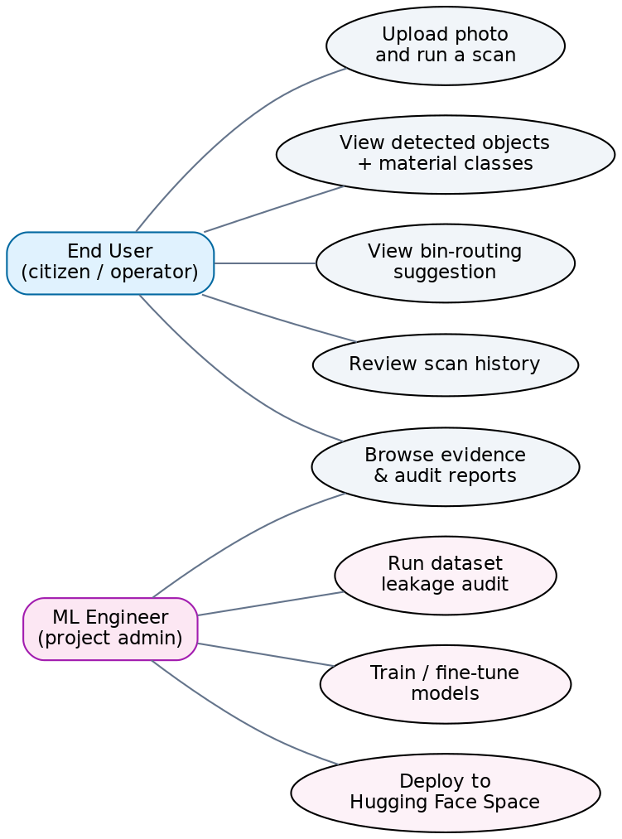
Figure 1. Use case diagram for WasteWise: end-user and ML-engineer actors against the web application and the offline experimentation tooling.

4.3 System Flow and Activity Diagram
Figure 2 traces a single scan request across the three participants in the live system: the end user, the Flask web front-end, and the Python model API that hosts the two-stage pipeline. This mirrors the six numbered steps (S1-S6) exposed directly in the reworked web GUI, so that what the examiner sees on screen during a live demo corresponds one-to-one with a swim lane in this diagram.
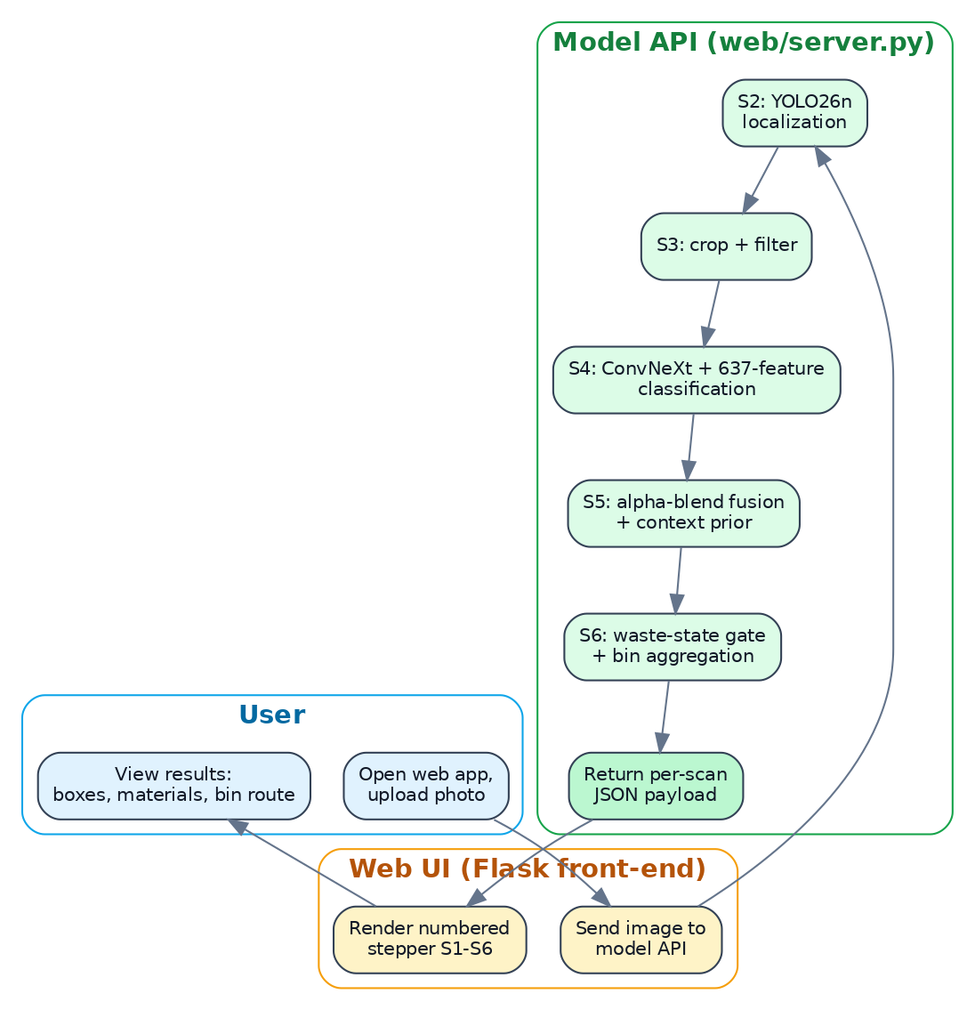
Figure 2. Activity diagram for a single end-to-end scan request, from image upload to the rendered six-step result stepper.

4.4 Experiment and Dataset Artefact Model
WasteWise does not use a relational database; instead, every dataset version and every experiment run is a self-describing folder on disk, which functions as the project's data model. Table 3 documents this artefact schema, which plays the same role an Entity-Relationship Diagram would play in a database-backed system: it defines what a 'dataset', a 'run', and an 'audit' are, and how they reference one another.
Entity | Key attributes | References
Dataset generation | name (e.g. merged_dataset_v5), path, class list, split counts, data.yaml | Produced from one or more Raw Sources; consumed by Run entities.
Raw source | origin (TACO / TrashNet / PlastOPol / Roboflow re-export), licence, acquisition domain (studio vs. field) | Feeds into one or more Dataset generations.
Run | run id/path under runs/, script name, hyperparameters, output metrics (JSON/Markdown), timestamp | References exactly one Dataset generation and one model checkpoint.
Audit | audit id under runs/audits/, method (MD5 / perceptual dHash), quarantine manifest, corrected metrics | References the Dataset generation(s) it inspected and the Run(s) whose metrics it corrects.
Model checkpoint | weights file, architecture, training run reference, promotion status (deployed / rejected / candidate) | Produced by exactly one Run; referenced by the deployed web application.

4.5 Web Application Sitemap
The deployed web application (Section 8.4) is a six-page single-page application. Figure 3 shows the sitemap actually implemented in web/index.html, not an aspirational design: Scan is the live pipeline demo with the numbered stepper; How it works explains the pipeline in plain language; Evidence links every displayed number back to a report in the repository; History lists recent scans; Limits documents measured weaknesses and their fixes (a direct surface for the Failures chapter); and About links to the project repository and the live deployment.
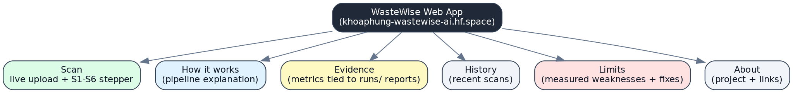
Figure 3. Sitemap of the WasteWise web application.

5. Software Development Methodology

5.1 Candidate Methodologies
Four general software-delivery methodologies were considered against this project's needs before settling on a working approach.
Methodology | Fit for an experiment-driven ML project
Waterfall | Poor fit: assumes requirements and design are fixed up front, but the correct pipeline architecture (classification-first vs. localisation-first) was only known after running both and measuring them.
Spiral | Partial fit: its risk-driven, iterative rings resemble the project's repeated audit-then-fix cycles, but the model is heavier than needed for a single-developer FYP.
Rapid Application Development / Prototyping | Good fit for the web GUI (six-page rework iterated quickly against lecturer feedback) but does not on its own capture the need for statistically defensible evaluation between iterations.
Agile (iterative, short cycles) | Good fit for the engineering cadence, but standard Agile does not by itself specify how a machine-learning change is 'accepted' into the product.

5.2 Selected Methodology and Justification
WasteWise follows an Agile, short-iteration cadence for engineering (Section 1.4's phases were themselves delivered in roughly week-long cycles) combined with an explicit, CRISP-DM-style data-mining discipline (business understanding, data understanding, data preparation, modelling, evaluation, deployment) and, most importantly, a project-specific promotion gate borrowed from continuous-delivery practice: no dataset change, model fine-tune, or serving-configuration change is treated as final until it has been (a) evaluated on a held-out, leakage-checked split and (b) shown not to regress a previously-passing metric beyond a small, pre-registered tolerance. This gate is what actually decided most of the architecture and hyperparameter choices in this report - for example, three separate proposed improvements (a tiled-training retrain, a field-rebalance fine-tune, and a class-agnostic detector head) were built, evaluated against this gate, and rejected in Section 9, while three others (hard-negative mining, a detector confidence retune, and a fusion-weight cap) passed it and were deployed. This hybrid was chosen over plain Agile or plain Waterfall specifically because the project's biggest risks were empirical (does this idea actually generalise) rather than purely schedule risks, so the methodology had to make 'evaluate before you trust it' a first-class step rather than an afterthought.

6. Datasets: Acquisition, Auditing, and Rebuilds

6.1 Raw Sources
- TACO - Trash Annotations in Context (Proenca and Simoes, 2020): crowdsourced, real-world litter photographs with instance segmentation across dozens of fine-grained litter classes; the main source of realistic field imagery and of the source-isolated clean field evaluation split used in Section 8.
- TrashNet (Yang and Thung, 2016): 2,527 single-object, studio-lit images across six categories; used as a classical-ML comparison domain (Section 7) to quantify the studio-to-field generalisation gap.
- PlastOPol (Roboflow Universe export; companion system paper, Environmental Modelling & Software, 2023): 2,418 one-class (litter) real-world images collected via a citizen-science mobile app; added later in the project specifically to expand field-domain training data (Section 9, Failures F11-F15).
- Multiple Roboflow community re-exports and merges of the above, which is precisely what caused the cross-split leakage problem documented in Section 6.4: the same underlying photographs re-enter the project through differently-named community exports.

6.2 Dataset Generations
Datasets were rebuilt three times over the project as quality problems were found, rather than patched in place, so that every generation is independently auditable.
Generation | Representative dataset | Status
Generation 1 | merged_dataset_v3 (114,220 boxes, first Roboflow merge) | Superseded; kept only as historical/lecturer-evidence context.
Generation 2 | tuned_dataset_v1 (evidence-based cleaning pass) | Superseded; EDA charts in Section 6.3 are drawn from this generation.
Generation 3 (active) | external_datasets/super_yolo_dataset (23,929 images / 102,777 boxes, 6 classes); data/merged_dataset_v5 (29,639 crops, 7 classes incl. Background) | Current training source, prior to the leakage-audit clean-split correction in Section 6.4.
Hard-case generation (deployed) | external_datasets/yolo26_hardcase_dataset_v1; data/hard_case_classifier_v1 | Current deployed-model training and clean-eval source (Section 6.4 and Section 8).

6.3 Exploratory Data Analysis
Figure 4 shows the per-class object-count balance for the tuned_dataset_v1 generation. The dataset is imbalanced by construction, because it is a merge of multiple community sources with different per-class prevalence; Branch A (Section 7.2) corrects for this at the crop-sampling stage with a per-class cap rather than by discarding the imbalance information.
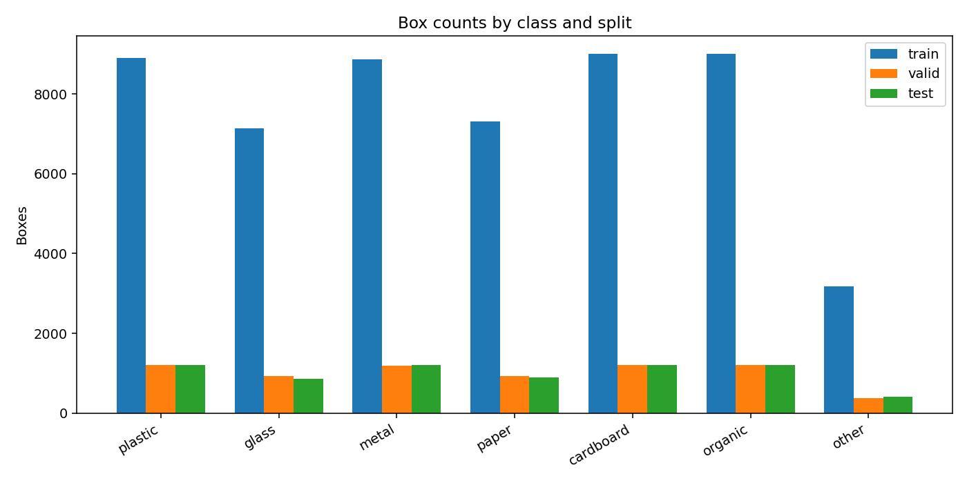
Figure 4. Class balance, tuned_dataset_v1 generation.
Figure 5 and Figure 6 quantify the tiny-object problem that turns out to be the dominant recall limitation of the whole detection branch (Section 8, and Failure F4 in Section 9). A large share of ground-truth boxes cover under 1% of the image area, and organic litter in particular is dominated by very small objects.
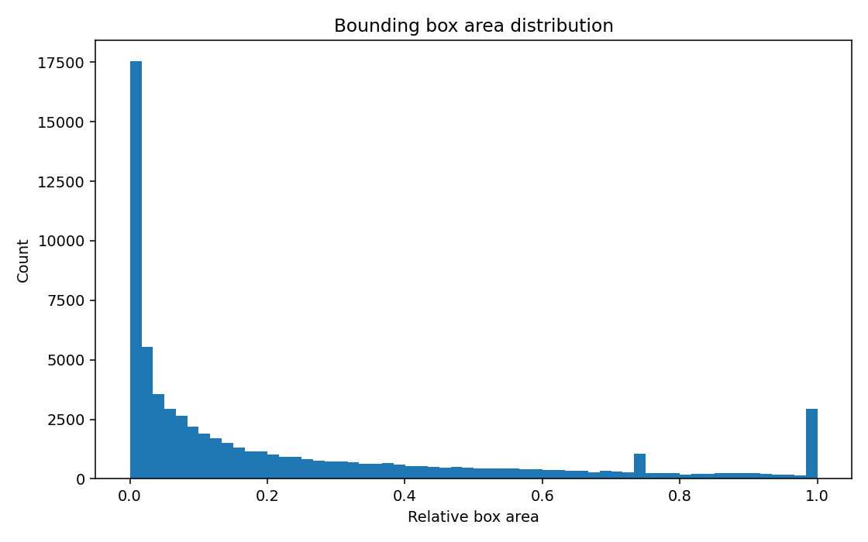
Figure 5. Distribution of ground-truth box area as a percentage of image area.
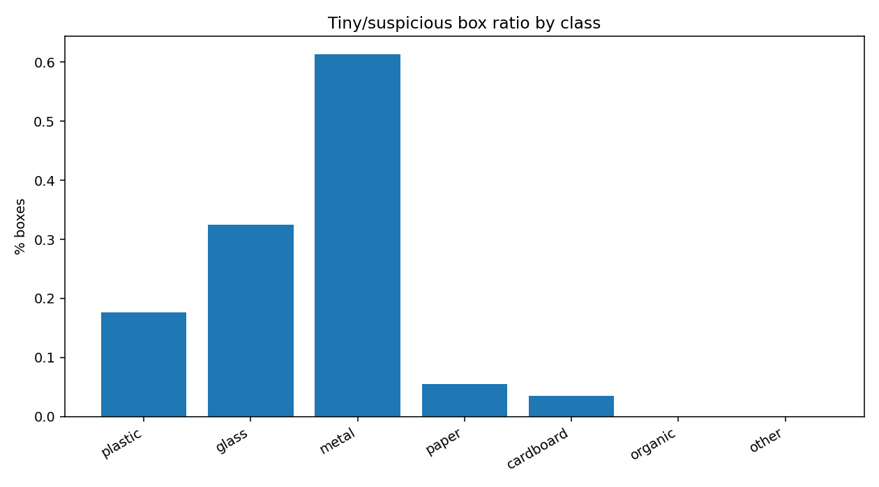
Figure 6. Share of small boxes (under 1% of image area) by class.

6.4 Cross-Split Leakage Audit (Critical Finding)
The single most important dataset finding in this project was not planned as a headline result; it emerged from a systematic risk audit (scripts/audit_model_risks.py) that hashed roughly 79,000 images with both exact (MD5) and perceptual (dHash, Hamming distance <= 4) hashing to check for images that were present in both a training split and an evaluation split under different filenames. This matters because several of the project's raw sources are re-exports of the same underlying TACO photographs through different Roboflow pipelines, which resize and re-encode images (defeating byte-level deduplication) but do not change their visual content.
The audit found that 43% of the classifier's merged_dataset_v5 test split (2,406 of 5,600 images: 1,718 byte-exact duplicates plus roughly 1,196 additional near-duplicates) were copies of training images, meaning the previously reported 94.30% test accuracy for that model was inflated. Detector splits were also affected, at a smaller scale (23.9% of one detector's validation split and 29.5% of its test split). Figure 7 is the actual visual evidence produced by the audit script: real pairs of images the automated check flagged as near-duplicates, manually verified by the author before any split was quarantined.
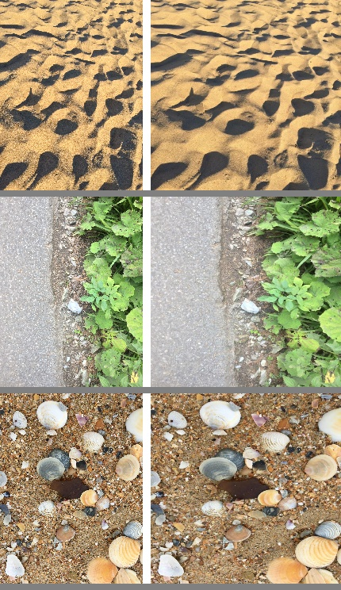
Figure 7. Visual verification of perceptual-hash-flagged near-duplicate image pairs across train/test splits (runs/audits/near_dup_spotcheck.jpg).
The fix (scripts/build_clean_eval_splits.py) quarantines every leaked evaluation image into a separate, clean split without altering the original files, producing external_datasets/yolo26_hardcase_clean_eval and data/merged_dataset_v5_clean_test. Every headline metric in Sections 8-10 of this report is measured on these clean splits, and the correction itself - accuracy moving from 94.30% to a clean 91.77% for the classifier, for instance - is treated as a project result in its own right (Section 9, Failure F1), not as an embarrassment to hide. A second, related leakage problem was found later in a dataset that had been informally treated as an independent "real-world" benchmark (yolo26_balanced_realworld_v2): it was subsequently shown to be 74% byte-identical to the deployed detector's own training data, and was retired from any accuracy claim (Section 9, Failure F10).

7. Methodology

7.1 System Overview: Two Branches
WasteWise runs one shared data pipeline (Section 6) feeding two parallel technical branches that answer different questions, shown in Figure 8. Branch A answers: how far can a fully explainable, mathematically defined feature representation go on this problem, and how compact can that representation be made? Branch B answers: what architecture actually works on unconstrained, cluttered real-world scenes, and can it be deployed as a live system? Branch B is the one served by the live web application; Branch A exists to provide an interpretable, auditable second opinion and a PCA compressibility study, not to compete for deployment.
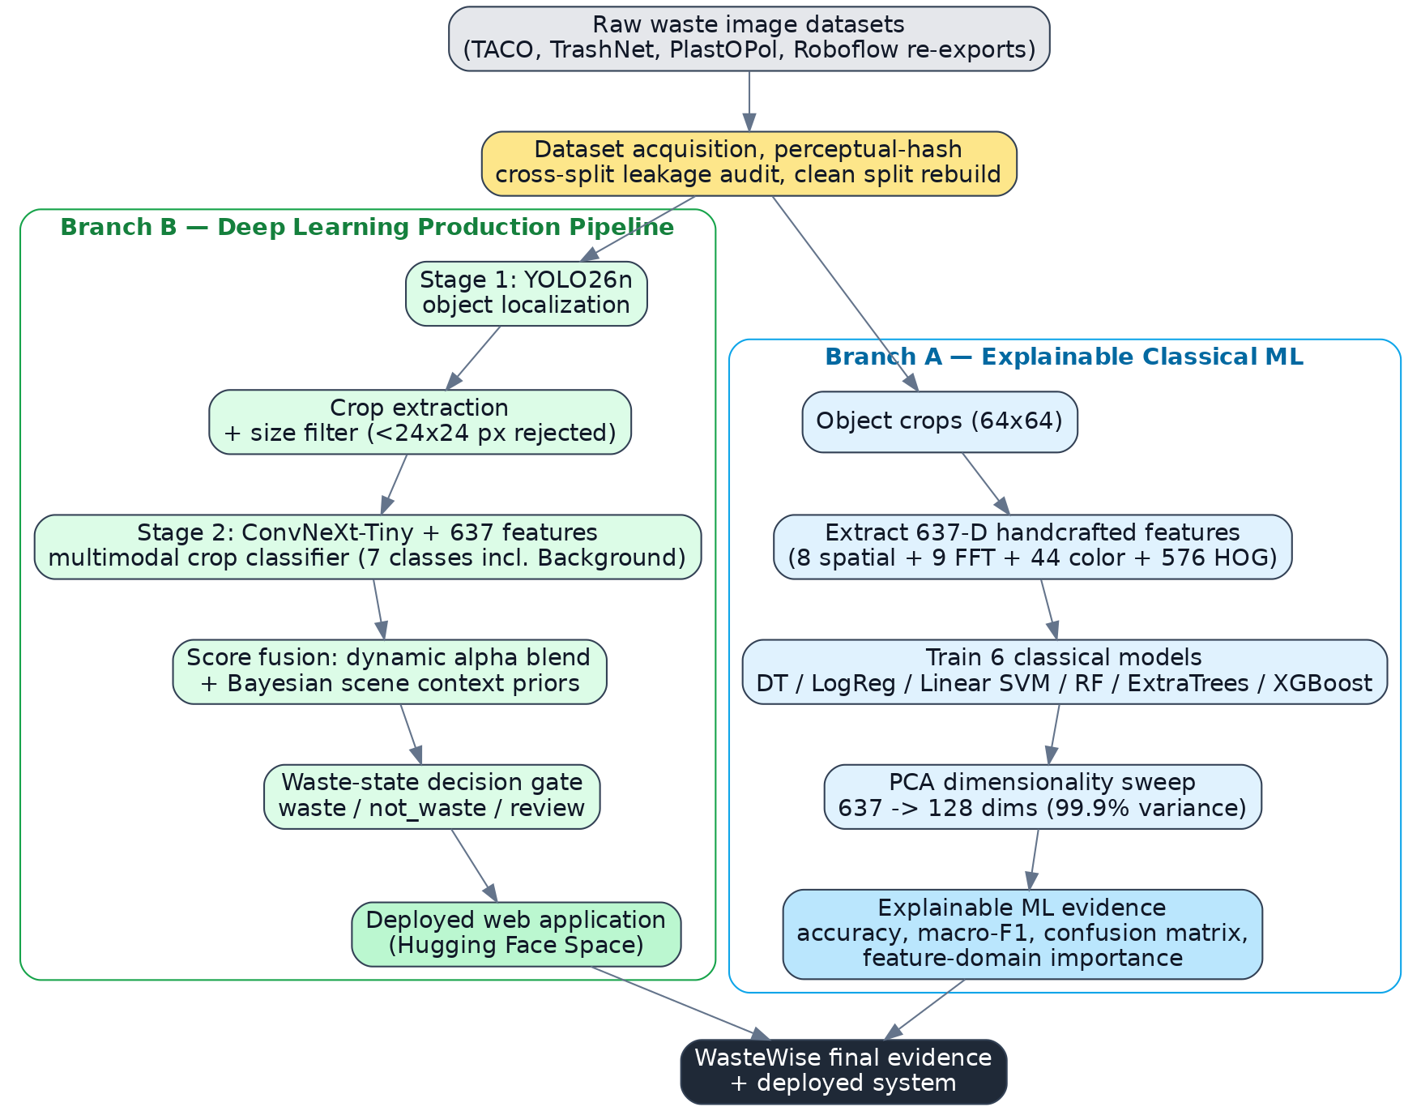
Figure 8. WasteWise overall two-branch architecture, from raw datasets to deployed system.

7.2 Branch A: Explainable Classical Machine Learning
Every object crop (resized to 64x64) is reduced to a fixed 637-dimensional handcrafted feature vector, described in Table 5, computed identically for every crop regardless of downstream model.
Feature group | Dimensions | Description
Spatial | 8 | Mean/standard-deviation/percentile pixel intensity, gradient mean/std, edge density.
Frequency (FFT) | 9 | Radial 2-D FFT energy bins plus a high-frequency energy summary statistic.
Colour | 44 | HSV histograms plus BGR/HSV channel mean and standard deviation.
HOG (shape) | 576 | Histogram of Oriented Gradients (Dalal and Triggs, 2005): local edge-orientation statistics over a fixed cell/block grid.
Total | 637 | Fixed-length, fully interpretable per-crop representation.

Six classical classifiers are trained on an identical feature matrix and identical splits: Decision Tree, Logistic Regression (L2-regularised), Linear SVM (on standardised features), Random Forest (300 trees), ExtraTrees, and XGBoost. Features are standardised with a StandardScaler fitted on the training split only, to avoid test-set information leaking into preprocessing. Sampling uses a balanced per-class cap (recorded per run in class_support.json) so that classes with more raw data do not dominate training. Evaluation reports accuracy, macro-F1, per-model confusion matrices, and a feature-domain importance breakdown (spatial vs. frequency vs. colour vs. HOG), which is the concrete mechanism that makes this branch explainable: a reviewer can ask which feature group actually drives a prediction and get a quantitative answer.
A controlled PCA study (Section 4.2.1 in the underlying experiment log) projects the training features onto 16 to 637 principal components and retrains every model at every dimension, reporting explained variance, accuracy, macro-F1, and per-sample inference latency at each setting, specifically to avoid the cherry-picking failure documented in Section 9 (Failure F3), where an earlier draft of this analysis quoted only the model and dimension that produced the most flattering headline number.

7.3 Branch B: Two-Stage, Localisation-First Production Pipeline
Figure 9 shows the full production pipeline, using the same step numbers (S1-S6) exposed in the reworked web GUI (Section 4.3, Figure 2). The single most important architectural decision in the whole project is the ordering: YOLO localises first, and a dedicated classifier verifies material second. This reversal stops background context (grass, sand, floor) from contaminating a material prediction, and gives the classifier a clean, zoomed crop instead of a whole scene to reason about.
Figure 9. Branch B two-stage production pipeline, steps S1-S6, matching the web application's result stepper.

7.3.1 Stage 1: YOLO Object Proposal (S2)
The deployed detector is YOLO26n (Section 8.3 documents why this was chosen over YOLOv8n and YOLOv11 after a direct benchmark), trained for 100 epochs at image size 640 with a cosine learning-rate schedule. Its role is deliberately limited to proposing boxes: it is trusted for object geometry (mean matched IoU of accepted boxes exceeds 0.90) but explicitly not trusted for the final material label, which is Stage 2's job.

7.3.2 Adaptive Scene Engine (S2)
Two scene-adaptive behaviours sit directly on top of Stage 1's raw output. Small-object recovery: if zero boxes are found at the normal operating confidence, the engine re-runs detection at a much lower confidence and relaxes the Stage 2 acceptance limit, to recover faint or reflective small objects. Dense-clutter mitigation: if a scene returns an unusually large number of candidate boxes, the Stage 2 acceptance limit is tightened instead, to control false alarms in visually busy scenes.

7.3.3 Crop Extraction and Filtering (S3)
Boxes smaller than 24x24 pixels are rejected outright as a physical size filter (they carry too little texture information for Stage 2 to classify reliably); surviving boxes are padded by 10 pixels and cropped. This is the hand-off point between the localisation and classification stages.

7.3.4 Stage 2: Multimodal Crop Verification (S4)
Each surviving crop is classified by a ConvNeXt-Tiny network whose image embedding is concatenated with the same standardised 637-dimensional handcrafted feature vector used in Branch A, before a shared classification head - so the deep image embedding and the explainable handcrafted features vote together inside one network rather than in two separate, hard-to-reconcile models. The output is a 7-class probability vector including Background, which is exactly the mechanism that lets Stage 2 veto a Stage 1 false alarm. Training uses a short frozen-backbone warm-up followed by several epochs of progressive unfreezing; the hard-case retrain on RealWaste- and TACO-derived crops is the model actually deployed (Section 8.2).

7.3.5 Score Fusion and Context Priors (S5)
Stage 1's box confidence and Stage 2's class probability are combined through a dynamic, confidence-dependent alpha blend (final score = alpha times YOLO confidence plus (1 - alpha) times CNN probability), so that a highly confident detector proposal is trusted more on geometry while a weak proposal defers almost entirely to the classifier's texture evidence. An HSV-based scene classifier additionally labels the environment (beach, grass, street, indoor) and multiplies non-background class probabilities by a per-scene prior vector before renormalising, following the contextual-priming principle described by Torralba et al. (2006).

7.3.6 Waste-State Decision Gate (S6)
A final, deliberately rule-based (not learned) gate classifies each verified object as waste, not_waste, or review, and only objects marked waste enter bin-routing aggregation. This is a conservative design choice: Section 9 (Failure F16) documents an attempt to loosen this gate that looked better on a small demo set but measurably cost 15 percentage points of precision on a larger, two-domain check, and was reverted. The gate is treated as a calibrated precision guard, not a stale leftover setting.

7.3.7 Alternative Pipeline Considered: Classification-First with Grad-CAM (Rejected)
Before settling on the localisation-first design, a classification-first alternative was implemented and measured on identical evaluation images: a global scene classifier runs first, and Grad-CAM's gradient-based class-activation map is thresholded to derive an object box, with a YOLO-as-localiser-only variant also tested for comparison. The Grad-CAM baseline reached precision 0.257 and recall 0.073 on a stratified evaluation set, far below the localisation-first pipeline's precision 0.70 / recall 0.57 on the same style of evaluation (Section 8.3.1). This comparison, not intuition, is the quantitative justification for the localisation-first design adopted in Section 7.3, and it is kept in this report specifically so that the design decision is falsifiable rather than asserted.

7.4 Training Setup
Component | Setting
Hardware | Single machine, NVIDIA RTX 3060 (12 GB VRAM).
Detector training | YOLO26n, 100 epochs, image size 640, batch 16, cosine learning-rate schedule, cache disabled (disk space constraint).
Stage 2 classifier training | ConvNeXt-Tiny + 637 features, 3-epoch frozen-backbone warm-up, 7 epochs progressive unfreezing.
Classical ML (Branch A) | Balanced per-class crop cap (e.g. 4,000 train crops/class where available); StandardScaler fit on train split only.
Environment | Python 3.11 virtual environment (.venv311); PyTorch 2.4.1+cu121; all GPU work pinned to this environment after Failure F7 (Section 9).

7.5 Evaluation Protocol
Localisation is evaluated by IoU@0.5 matching against ground-truth boxes, reporting precision, recall, F1, and mean matched IoU. Classification is evaluated with accuracy and macro-F1 on balanced splits. Detectors additionally report mAP@0.5 and mAP@0.5:0.95. Deployment-facing results additionally report model size, latency, and frames per second. Critically, every evaluation is run twice where a leakage risk exists: once on the original split, and once on the audited clean split (Section 6.4), and this report only treats the clean-split number as the number the project stands behind.

8. Results

8.1 Classical Machine Learning Branch Results
Table 8 reports the reference lecturer-facing benchmark (six material classes, balanced 4,000-crop-per-class training cap). XGBoost is the strongest classical model on the 637-D handcrafted feature vector.
Model | Accuracy | Macro-F1
XGBoost | 0.6742 | 0.6506
ExtraTrees | 0.6312 | 0.6113
Random Forest | 0.6317 | 0.6111
Linear SVM | 0.5960 | 0.5642
Logistic Regression | 0.5864 | 0.5558
Decision Tree | 0.5115 | 0.4883

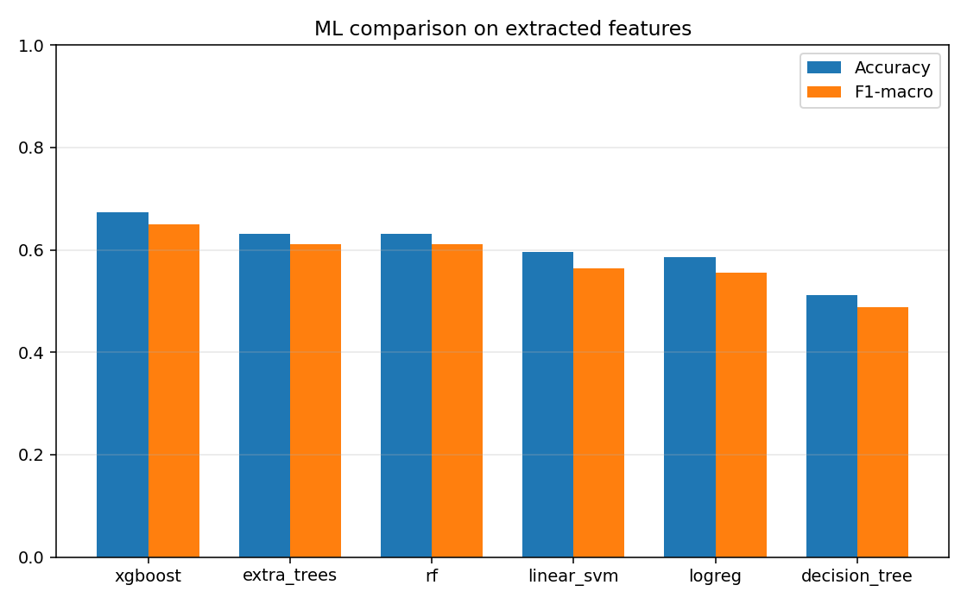
Figure 10. Accuracy and macro-F1 comparison across the six classical models.
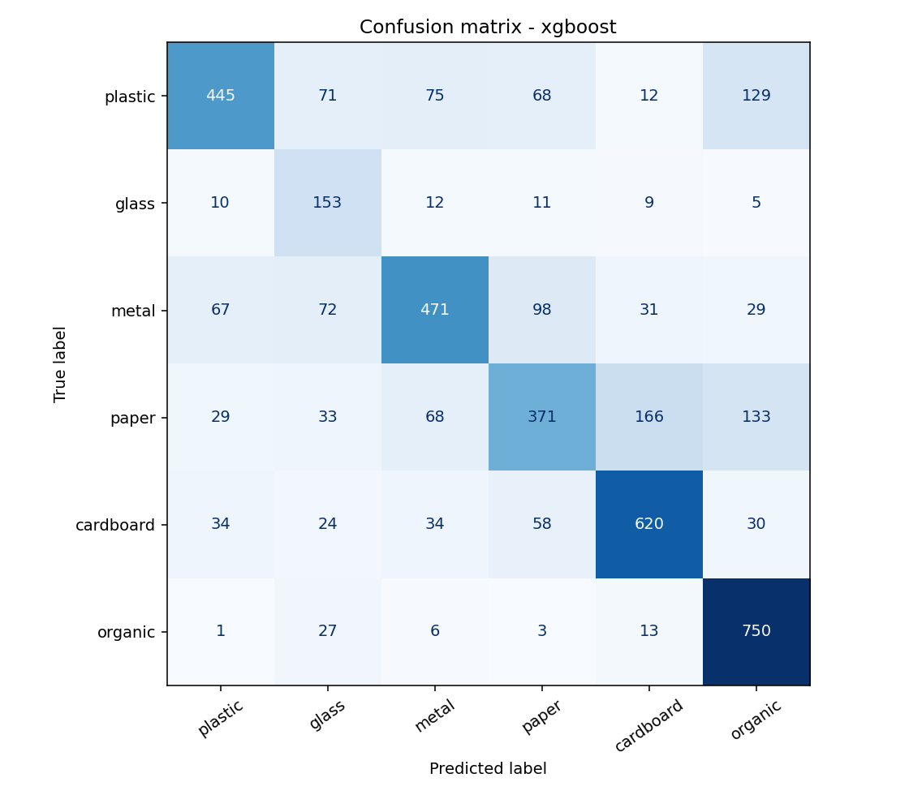
Figure 11. XGBoost confusion matrix, six-class handcrafted-feature benchmark.
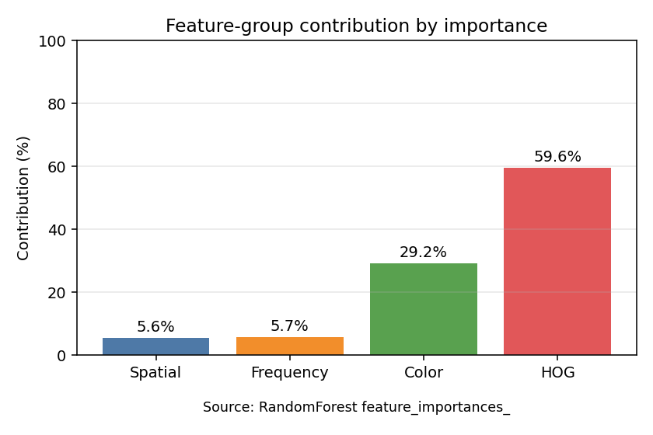
Figure 12. Feature-domain importance: spatial vs. frequency vs. colour vs. HOG contribution to the best model's decisions.
A re-run of the identical pipeline on the newest localisation-aligned dataset (external_datasets/super_yolo_dataset) keeps XGBoost as the best model but at a lower accuracy of 0.5408 and macro-F1 of 0.3691; the test split for this rerun is imbalanced (as few as 9 glass boxes in the test set), so this number is reported as current-dataset evidence rather than a clean balanced benchmark, and the macro-F1 in particular should not be read as directly comparable to Table 8.

8.1.1 PCA Dimensionality Sweep
A controlled sweep retrained the classical models at nine feature dimensions between 16 and 637. Table 9 gives the headline comparison used in this report: Linear SVM loses 2.52 percentage points of accuracy when compressed from 637 to 128 dimensions (99.90% of variance retained), while Logistic Regression loses only 0.62 points at the same compression - so the honest claim is model-specific, not a single "PCA costs about 2%" statement, which is exactly the cherry-picking failure documented in Section 9 (Failure F3).
Model | Components | Explained variance | Accuracy | Macro-F1
Linear SVM | 637 | 100.00% | 62.43% | 0.6235
Linear SVM | 128 | 99.90% | 59.90% | 0.5947
Logistic Regression | 637 | 100.00% | 60.24% | 0.6019
Logistic Regression | 128 | 99.90% | 59.71% | 0.5954

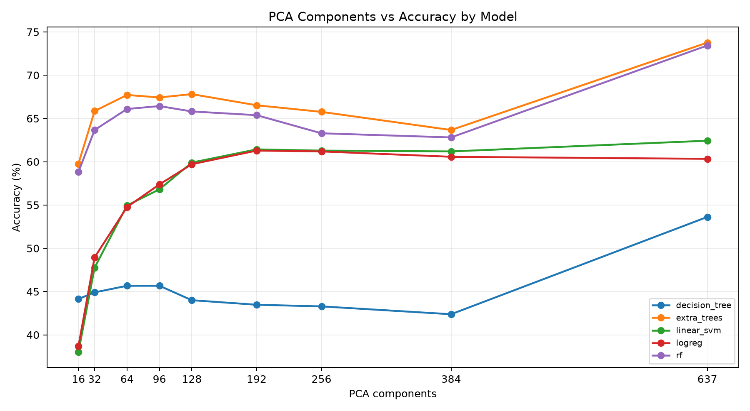
Figure 13. Accuracy vs. number of PCA components, best model per dimension.

8.2 Deep Learning Classification Results
Shallow, equal-budget ANN/CNN baselines (5 epochs) were deliberately kept weak as a fair cross-family comparison point at matched training budget, not as a claim that deep learning underperforms classical ML: a properly trained CNN reaches 77-94% elsewhere in this section. A simple 50/50 soft-voting ensemble of a raw-crop CNN and a handcrafted-feature ANN reached 78.69% accuracy and 78.12% macro-F1, evidence of feature complementarity between the two representations rather than a final deployment direction.
A direct architecture comparison for the Stage 2 classifier role (Table 10) motivated the choice of ConvNeXt-Tiny as the backbone that was then extended into the multimodal design of Section 7.3.4.
Architecture | Accuracy | Model size
EfficientNetB0 | 94.29% | 29.21 MB
ResNet50 | 89.76% | -
MobileNetV2 | 85.43% | -
ConvNeXt-Tiny (+637 features, final) | 92.52% val / 93.88% test (hard-case) | Exported as unified ONNX

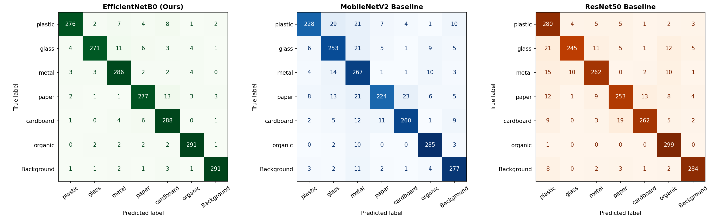
Figure 14. Confusion matrices for the EfficientNetB0 / MobileNetV2 / ResNet50 architecture comparison.
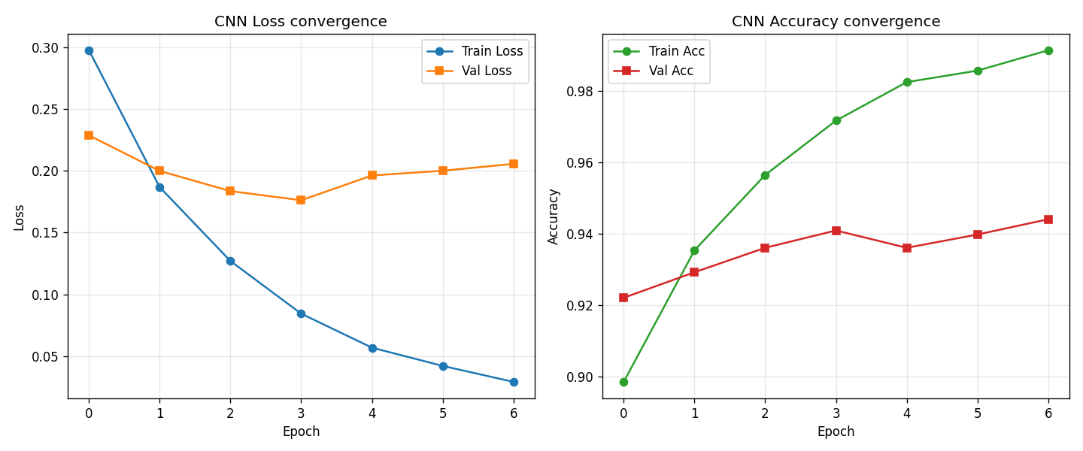
Figure 15. Training loss and accuracy curves, tuned EfficientNetB0 classifier.
The final deployed classifier generation fuses a ConvNeXt-Tiny image embedding with the standardised 637 handcrafted features inside one network (Section 7.3.4). Trained on merged_dataset_v5 (7,000 balanced train crops, 2,100 validation crops), it reaches 92.52% validation accuracy. Retraining the identical architecture on a hard-case dataset drawn from RealWaste and official TACO crops lifted realistic-imagery robustness to 93.88% test accuracy (0.9398 macro-F1). After the leakage audit (Section 6.4) corrected this to a clean 92.93%, a further train/serve-skew fix (Section 9, Failure F4b) - fine-tuning on a mixture of ground-truth crops and the detector's own predicted crops - raised accuracy on the detector's own crop distribution from 76.91% to 88.88%, while clean-crop accuracy improved further to 93.77%; this last figure is the number the deployed system is actually running.
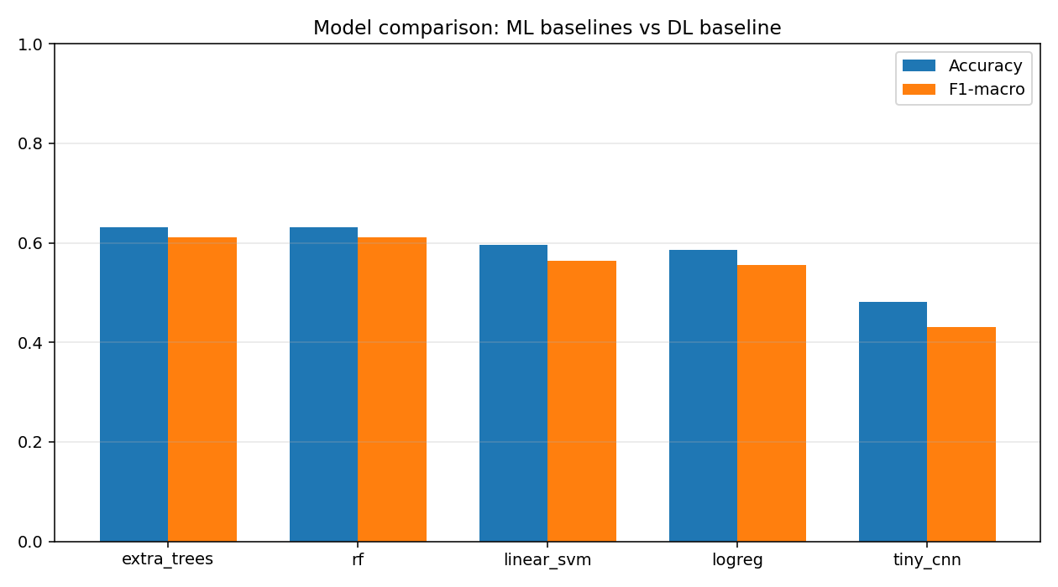
Figure 16. Summary comparison of the classical ML branch against the deep-learning classification branch.

8.3 Detection and Localisation Results
Table 11 compares the three detector architectures benchmarked in this project on identical data. YOLO26n was retained: the architecture swap alone produced only a marginal gain, and the far larger effect came from training for longer with a cosine learning-rate schedule (Section 9, Failure F4), which is reported honestly rather than attributed to the newer architecture.
Detector | Precision | Recall | mAP50 | mAP50-95
YOLOv8n (tuned dataset) | - | - | - | -
YOLOv11 (production baseline) | 0.745 | - | 0.669 | -
YOLO26n (30-epoch baseline) | 0.757 | 0.592 | 0.672 | 0.505
YOLO26n (100-epoch retrain, val) | 0.788 | 0.634 | 0.707 | 0.536
YOLO26n (100-epoch retrain, CLEAN val - deployed) | 0.777 | 0.650 | 0.721 | 0.542
YOLO26n (retrain, clean TEST - unseen capture batches) | 0.590 | 0.456 | 0.474 | 0.348

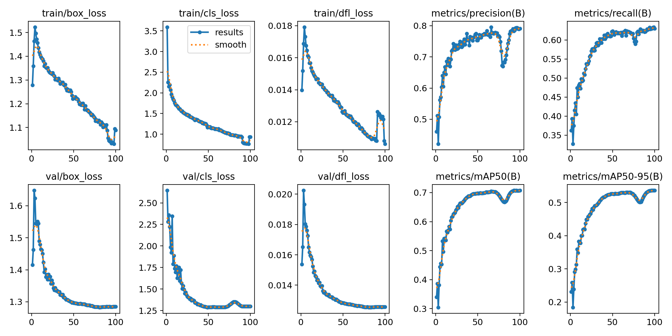
Figure 17. Training curves (box loss, classification loss, precision, recall, mAP) for the deployed YOLO26n detector.
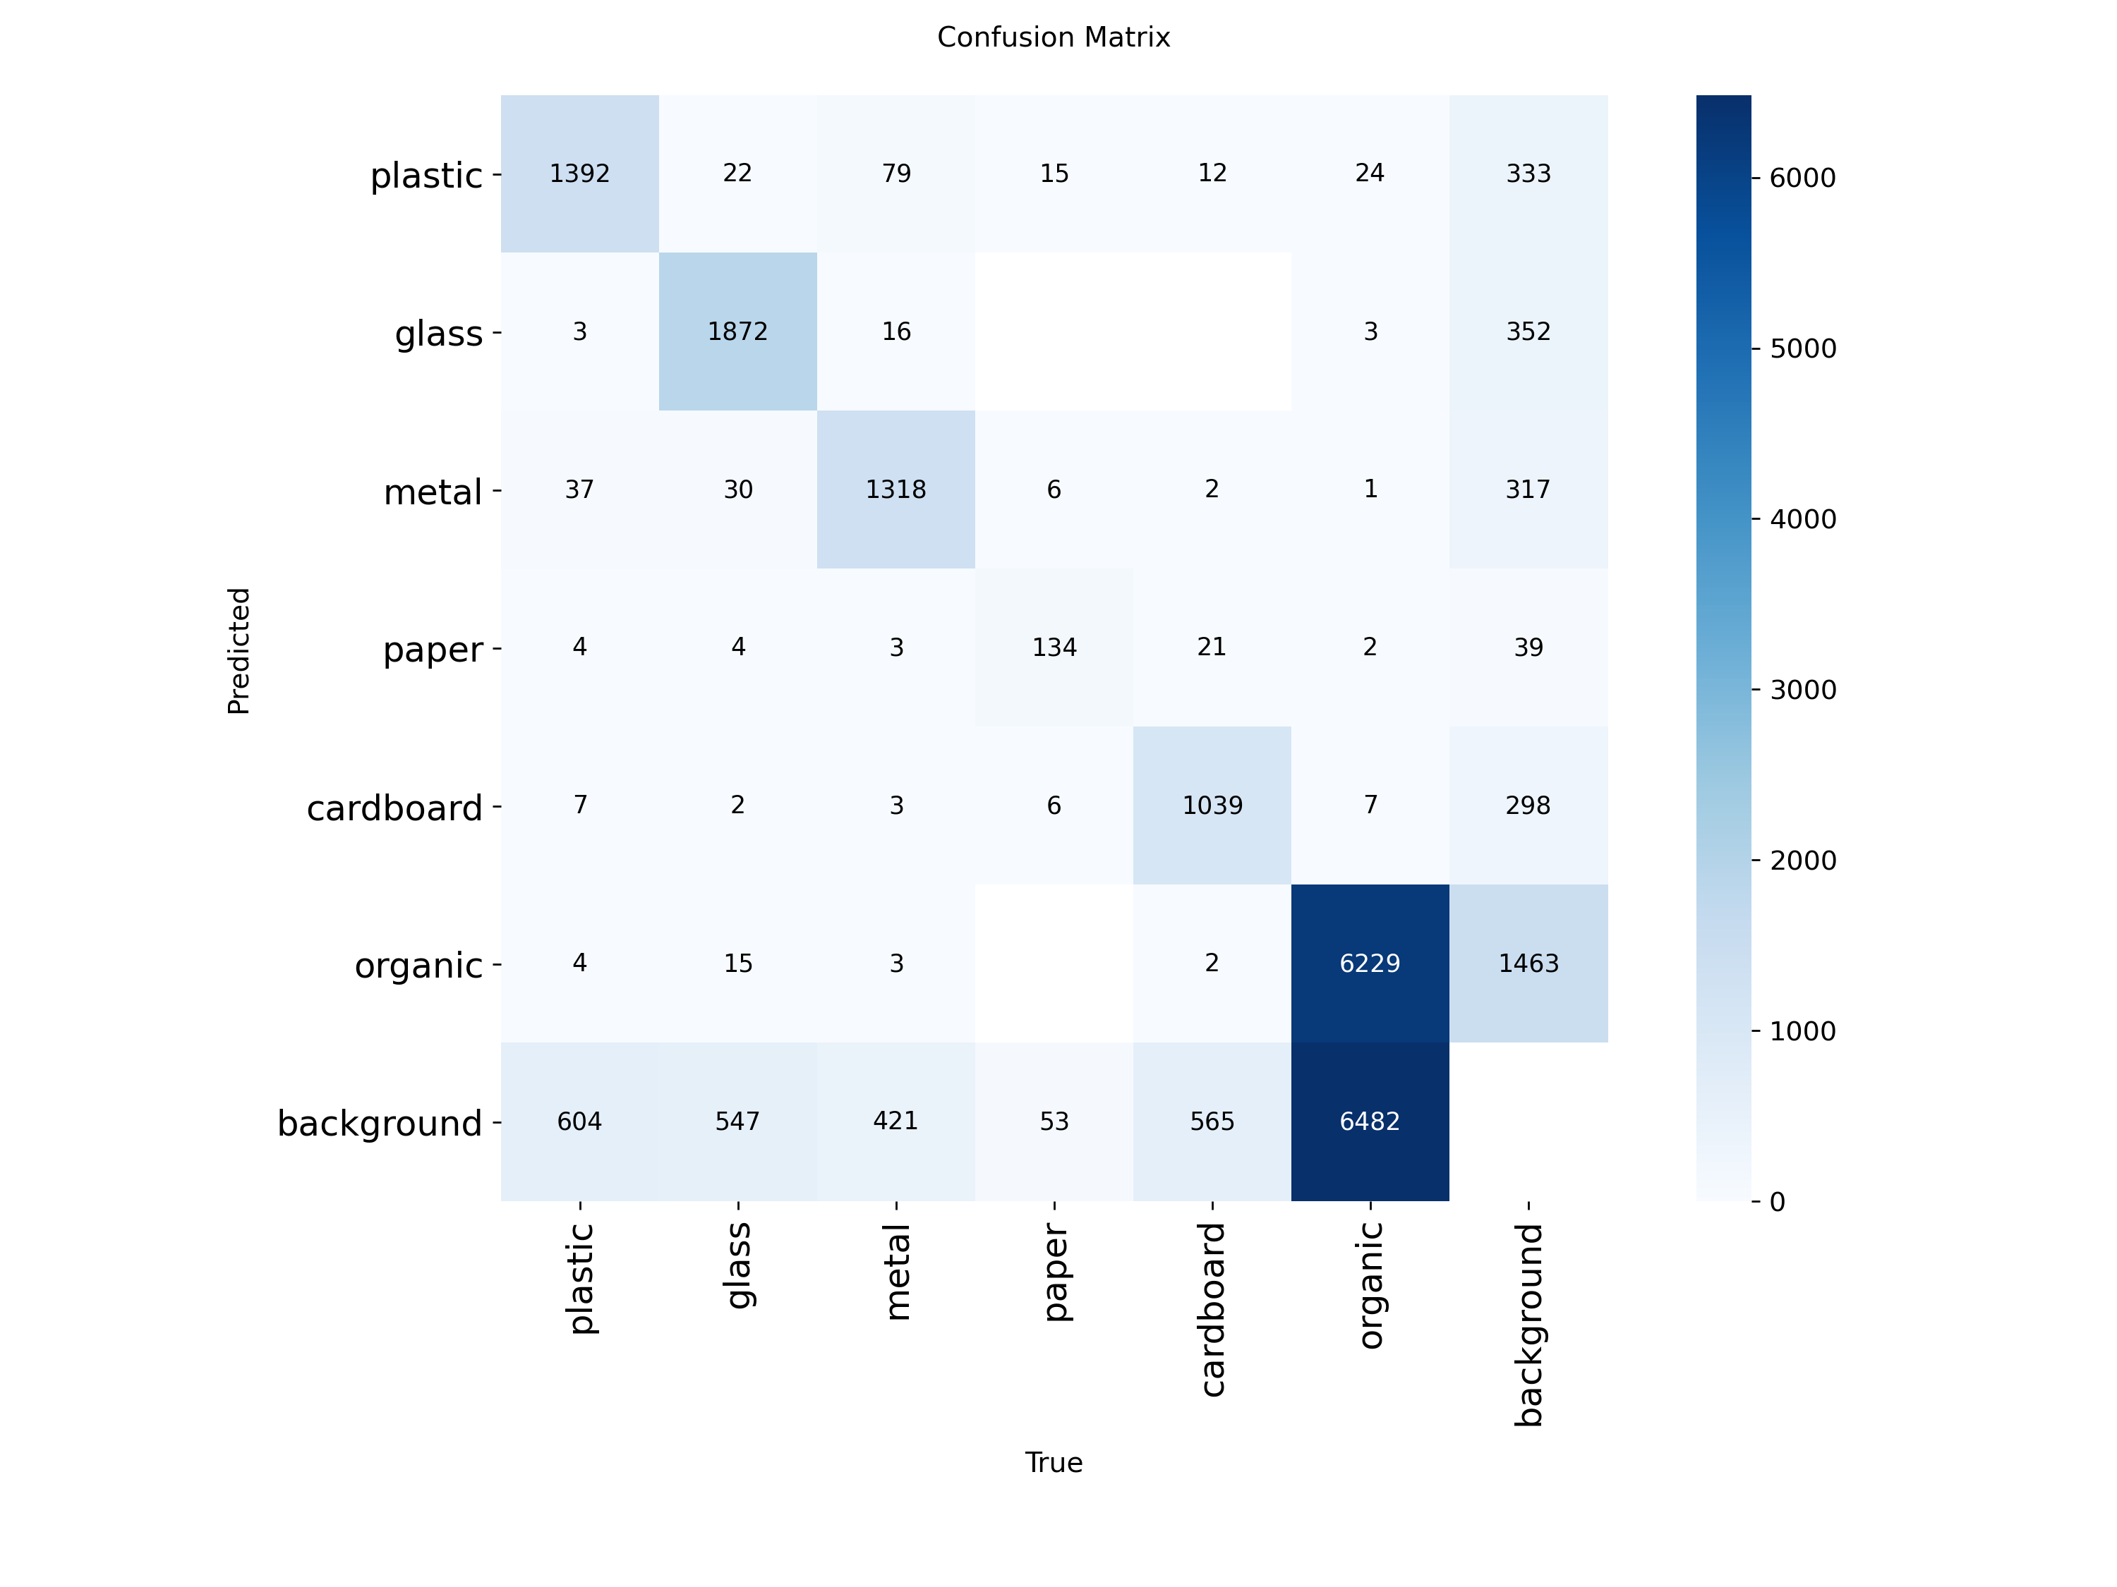
Figure 18. Deployed detector confusion matrix (six material classes plus background).
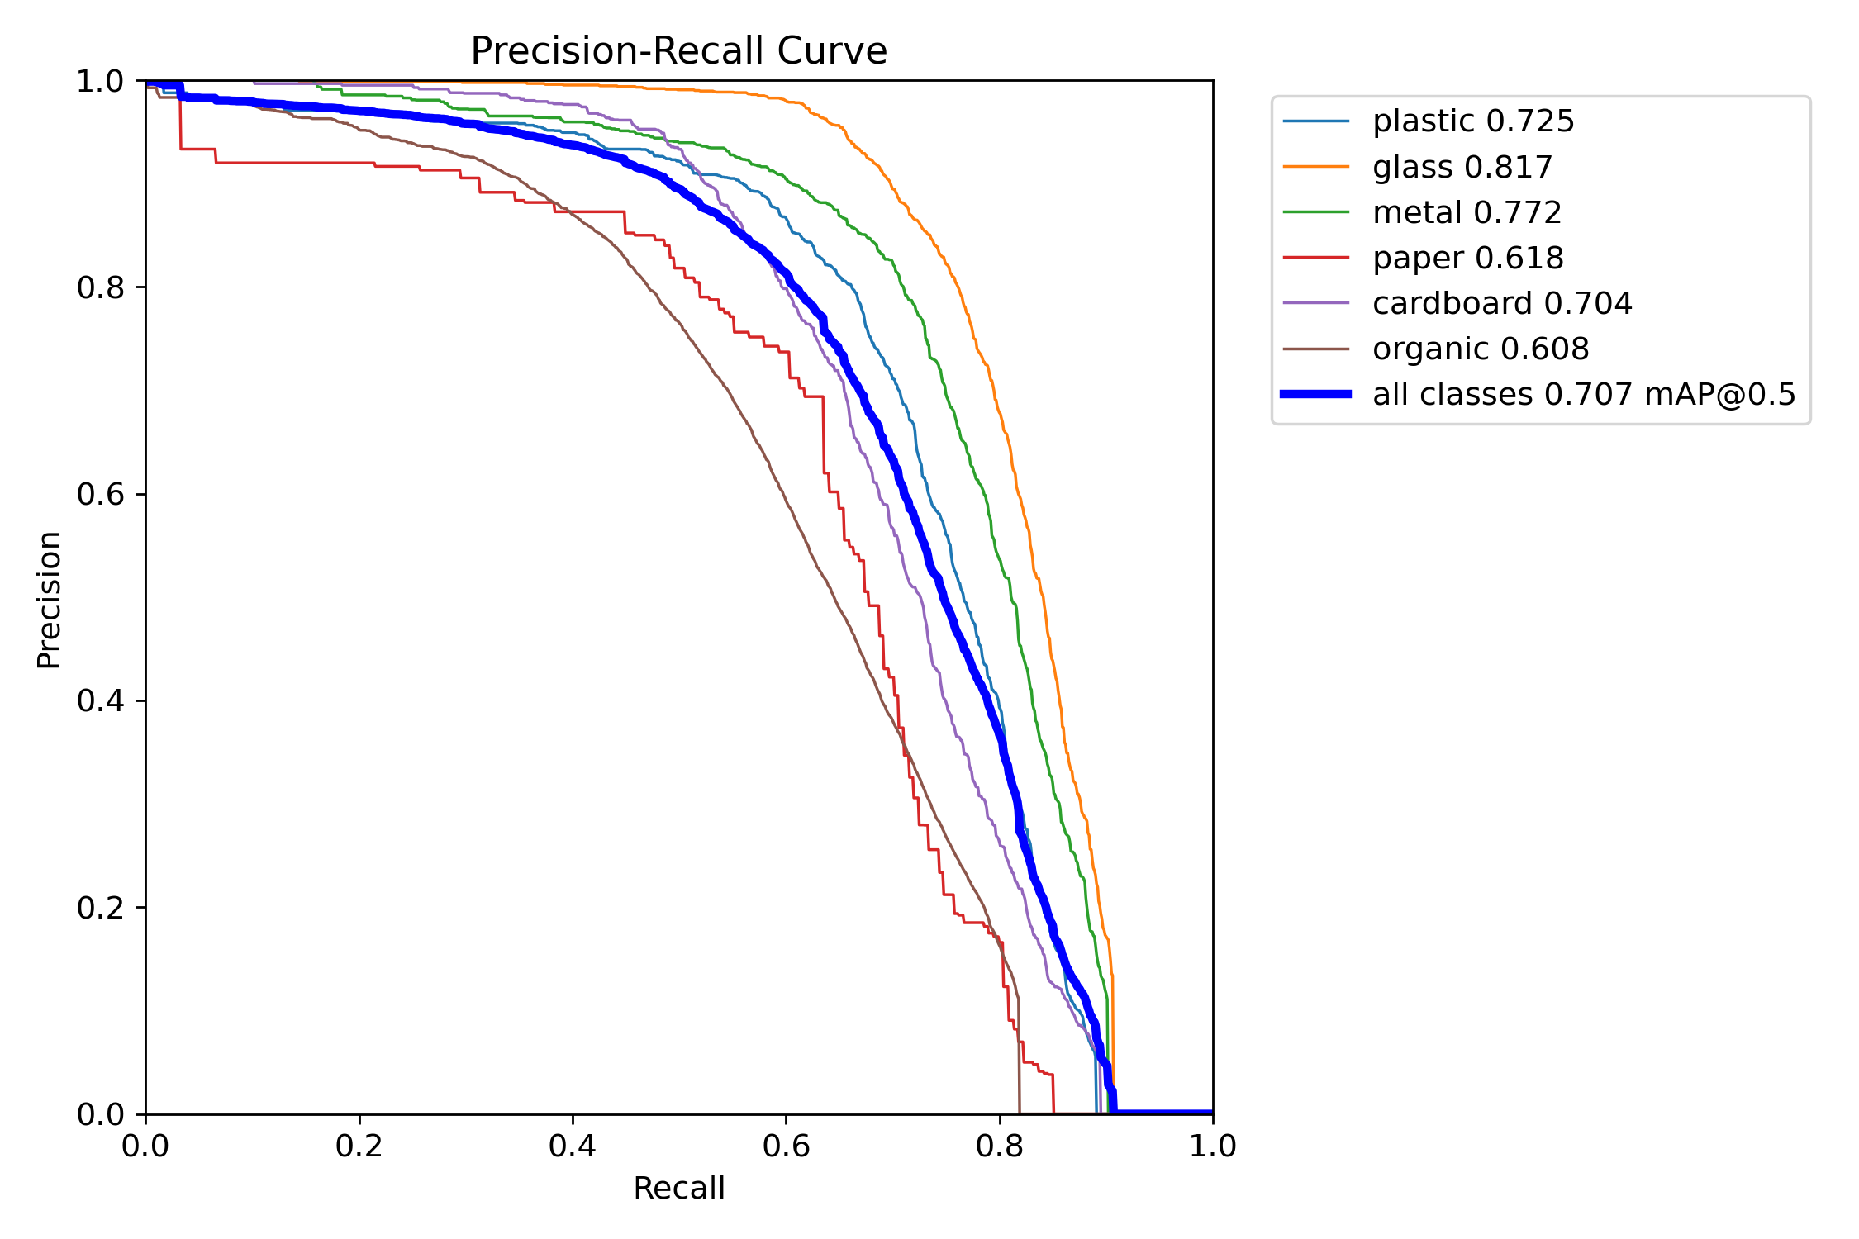
Figure 19. Precision-recall curve, deployed YOLO26n detector.
The val-to-test gap (mAP50 0.721 clean-val vs. 0.474 clean-test) is honest evidence of batch-level domain shift on genuinely unseen TACO capture sessions rather than a leaked or inflated validation number - the clean validation split is, if anything, slightly harder than the original validation split, since the quarantined images were disproportionately difficult scenes. A confidence-threshold sweep (Table 12) shows the deployed detector's precision/recall operating point is a deliberate, tuned choice rather than a framework default.
Confidence threshold | Precision | Recall | Notes
0.30 (early default) | 0.759-0.861 | 0.517-0.592 | Original untuned operating range.
0.10 | - | - | First retune (Section 9, Failure F5); nearly triples small-object recall relative to 0.30.
0.04 (deployed) | - | - | Final retune (Section 9, Failure F13): lifts field recall +8.1pp and studio recall +5.3pp with no architecture change.

8.3.1 Localisation Rework: Grad-CAM Baseline vs. YOLO Localisation
As introduced in Section 7.3.7, a classification-first Grad-CAM localisation baseline was implemented and evaluated on identical stratified test images against a YOLO-as-localiser-only variant. Table 13 is the quantitative basis for keeping the localisation-first design.
Localiser | Precision | Recall | Mean matched IoU
Grad-CAM baseline | 0.2568 | 0.0728 | 0.7127
YOLO, conf=0.25 | 0.6352 | 0.5670 | 0.9012
YOLO, conf=0.30 (300-image final check) | 0.6999 | 0.5729 | 0.9057
YOLO, conf=0.40 (high-precision setting) | 0.8035 | 0.5148 | 0.9050

8.4 End-to-End Production Pipeline Results
A 100-image validation sweep of the full deployed pipeline (Stage 1 + adaptive engine + Stage 2 + fusion + gate) produced 348 YOLO proposals, of which 295 were accepted after Stage 2 verification, at 238.08 ms per image on CPU (4.20 FPS) - fast enough for the deployed Hugging Face Space, which runs on CPU-only hosting. Figure 20 shows one real, end-to-end pipeline output on a hard, cluttered indoor scene, exactly as produced by the deployed model, not a curated illustration.
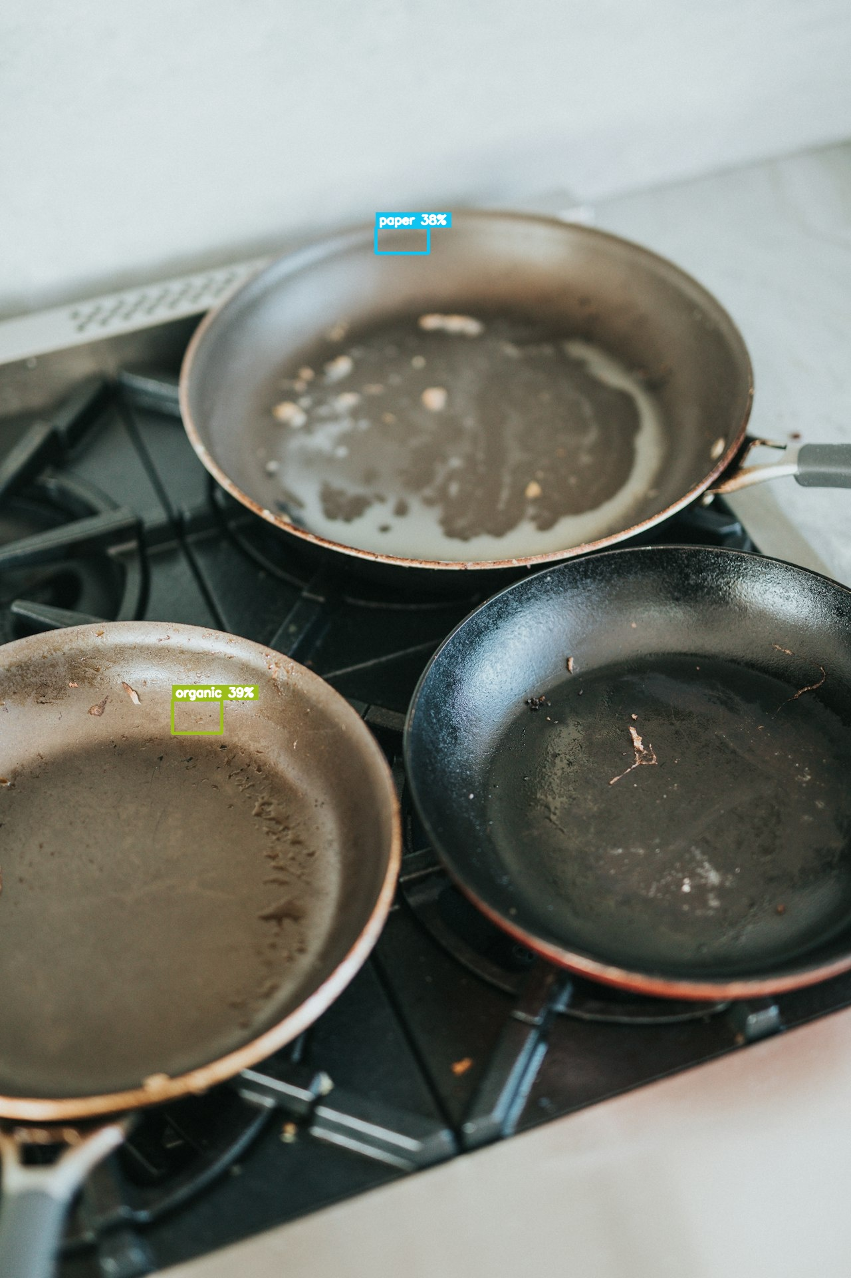
Figure 20. End-to-end pipeline output on a cluttered indoor kitchen scene: detected boxes, verified material classes, and bin routing.
The adaptive hybrid switcher (Section 7.3.2) was exercised across scene types of increasing difficulty during this sweep, automatically engaging small-object recovery mode on sparse outdoor scenes and dense-clutter mitigation on crowded indoor scenes, without any manual per-image configuration.

9. Failures, Root Causes, and Fixes
This chapter is an honest engineering log of everything that went wrong over the course of the project, kept deliberately separate from the Results chapter so that negative and null results are not diluted or hidden among successes. Each entry follows the same structure: what the symptom or motivation was, what the root cause turned out to be, how it was measured, and what was done about it - including the several cases where the correct decision was to reject a proposed fix after measuring it honestly.

9.1 Summary Table
ID | Failure | Severity | Outcome
F1 | Evaluation data leakage across dataset splits | Critical | Quarantined clean splits built; every headline metric re-measured (Section 6.4).
F2 | Cross-dataset validation script silently broken (reported 17.83% with missing classes) | High | Fixed: rewritten domain-split logic; honest studio-to-field gap ~28-40pp measured.
F3 | PCA report cherry-picked its headline compression number | Medium | Fixed: sweep widened to 9 dimensions; best-model-per-dimension reporting adopted.
F4 | Detector recall limited by tiny objects, not class confusion | High | Diagnosed via confusion matrix + box-size analysis; 100-epoch retrain fixed convergence; 960px and sliced-inference alternatives tested and not adopted.
F4b | Stage 2 train/serve skew: 92.93% on GT crops but only 76.91% on the detector's own crops | High | Fixed: fine-tuned on a mixed GT + detector-crop dataset; production accuracy raised to 88.88%, clean accuracy to 93.77%.
F4c | Tile-augmented training tested as a further tiny-object fix | Info | Rejected: regressed clean-test mAP50 and collapsed organic recall 5x; not deployed.
F5 | Detector confidence operating point never tuned (used framework default) | Medium | Fixed: swept and set; later re-tuned again after F9.
F6 | Minor label/data hygiene issues (corrupt JPEGs, stray polygon labels) | Low | Quantified and auto-corrected; no further action needed.
F7 | Engineering/environment failures (wrong Python env, disk-full cascade, CUDA OOM, multiprocessing hangs) | Medium | Root-caused; fixed procedures documented and enforced (Section 7.4).
F8 | Architecture swap YOLOv11 to YOLO26n | Info | Measured: marginal gain alone; convergence and data quality dominate (Section 8.3).
F9 | Serving resolution mismatch: 640-trained detector served at 960 | Medium | Fixed: serving image size corrected to match training size; re-validated on two eval domains.
F10 | "Real-world" benchmark dataset found to be 74% leaked from training data | High | Retired from all accuracy claims; field work gated on a genuinely external, source-isolated dataset instead.
F11 | Field-rebalance fine-tune (oversampling existing field data) | Info | Rejected: gain within noise (+1.3pp), studio regression (-2.3pp); established honest field baseline (recall 0.505).
F12 | Class-agnostic detector head + new field data (PlastOPol) | Info | Initially promoted, then reverted (see F13) after an unfair operating-point comparison was found.
F13 | Detector confidence lever re-examined at matched operating points | High | Deployed: conf 0.10 to 0.04 lifts field recall +8.1pp and studio recall +5.3pp with no architecture change; F12 promotion reverted.
F14 | Glass misclassified as plastic in the field: detector's material vote overrode a confident classifier | High | Fixed: fusion alpha cap lowered from 0.70 to 0.40; small studio cost (-0.7pp macro-F1), fixes the field failure mode.
F15 | Field small-object recall still low (~0.43) | High | Promoted: hard-negative mining fine-tune using new PlastOPol data; +17.3pp recall on held-out field data, studio preserved.
F16 | Waste-state gate loosening tested to reduce over-cautious 'review' labels | Info | Rejected, reverted: looked good on a 6-image demo but cost ~15pp precision on a 270-image two-domain check.

9.2 Selected Failures in Detail

9.2.1 F1 - Evaluation Data Leakage (Critical)
No visible symptom prompted this investigation; all metrics looked acceptable. It was found by a systematic, self-initiated risk audit, not by an external reviewer. Root cause: several raw sources are re-exports of the same TACO photographs through different Roboflow pipelines, which re-encode and resize images, defeating byte-level (MD5) deduplication while leaving the visual content unchanged; the same photograph could therefore land in a training split under one filename and a test split under another. Measured impact ranged from 16-30% for detector splits up to 43% for one classifier test split. Fix: scripts/build_clean_eval_splits.py quarantines every leaked evaluation image into dedicated clean splits, and every metric in this report is measured on those clean splits. This is discussed at length in Section 6.4 because it is the project's strongest piece of methodological evidence: a self-found and self-corrected measurement bug.

9.2.2 F4 / F4b - Tiny Objects and Train/Serve Skew (High)
Detector recall (0.59) was initially assumed to reflect weak classification, but the confusion matrix showed cross-class errors at or below 11%; the real failure mode was objects predicted as background. Miss rate tracked box size, not class frequency: organic litter is the largest class by box count yet the worst detected, because its median object covers roughly 1.4% of the image. A longer, cosine-scheduled retrain fixed an under-converged 30-epoch baseline; a 960px fine-tune and sliced (SAHI-style) inference were both tested and both rejected after honest measurement (a wash on validation, small and inconsistent gains on test, with a precision cost for slicing). Separately, the deployed classifier scored 92.93% on clean ground-truth crops but only 76.91% on the detector's own predicted crops - the actual input distribution in production - a 16-point gap invisible in any GT-only benchmark. Fine-tuning on a mixed GT-plus-detector-crop dataset closed most of this gap (88.88% on detector crops) while further improving clean accuracy (93.77%).

9.2.3 F10 - A "Real-World" Benchmark That Was Not Real-World (High)
A dataset informally named and treated as a real-world false-positive benchmark was investigated before committing to a field-data fine-tuning plan built on it. It turned out to be constructed by rebalancing and hash-renaming the deployed detector's own studio-heavy training data: 74% of its test images were byte-identical to that training data, and zero were genuine TACO field images. It was retired from every accuracy claim, and a genuinely external, source-isolated field evaluation set was built from official TACO annotations instead (Section 6). The lesson recorded for the project was explicit: a dataset's name is not evidence of its provenance, and any "real-world" or "balanced" derived set must be leakage-audited before being trusted as a benchmark.

9.2.4 F13 / F14 - Getting the Deployed Operating Point Right (High)
An earlier promotion of a class-agnostic detector head (F12) was reverted after re-checking it at a fair, matched confidence threshold against the existing six-class detector: most of the apparent field-recall gain turned out to come from simply lowering the confidence threshold (an allowed, free lever), not from the architecture change. The confidence threshold was retuned instead (0.10 to 0.04), lifting field recall by 8.1 points and studio recall by 5.3 points with no architecture change at all. Separately, field reports of glass being labelled plastic were traced to the score-fusion stage: the detector is plastic-biased on field imagery and its vote, at the original fusion weight, could override a confident and objectively correct classifier call. Capping the fusion weight fixed the field failure mode at a small, measured cost in studio conditions.

9.2.5 F16 - A Rejected Gate Change (Info, but methodologically important)
A change that loosened the waste-state decision gate looked convincing on a six-image demo set (confidently classified metal cans stopped being marked 'review'). A larger, two-domain precision check (120 field plus 150 studio images) showed the change nearly doubled the number of boxes labelled 'waste', but only about 48% of the new promotions were correctly localised objects, costing roughly 15 percentage points of precision. The change was reverted. This failure is recorded specifically as a methodological warning: a small demo can flatter a change that a larger, matched-operating-point check reveals to be a regression, and this project's promotion-gate discipline (Section 5.2) exists to catch exactly this pattern.

10. Product Evaluation

10.1 Strengths
- Every headline number in this report is backed by a script and a run folder in the project repository, with dated commit history, and can be reproduced by re-running the corresponding script.
- The project caught its own most damaging measurement bug (cross-split data leakage) through a self-initiated audit rather than an external review, and corrected every affected number rather than quietly keeping the more flattering figures.
- The two-stage, localisation-first architecture is justified by a direct, matched-condition comparison against a classification-first alternative, not by design intuition alone.
- The explainable classical-ML branch gives a fully interpretable second opinion (feature-importance analysis) alongside the deep-learning branch, satisfying the project objective of explainability without sacrificing the production branch's accuracy.
- A working, live, end-to-end web demo exists and is the same system the offline numbers describe, not a separate illustrative mock-up.
- A disciplined promotion-gate process rejected three proposed improvements that did not survive honest measurement (tiled training, field-rebalance fine-tuning, an ungated gate loosening), which is itself evidence of a trustworthy evaluation process.

10.2 Limitations and Challenges
- Domain shift is the dominant error source: the gap between studio-style training data and real field imagery is far larger than any model-architecture choice measured in this project.
- Localisation recall has a ceiling around 0.57-0.65 at the deployed operating point; small, transparent, and heavily occluded litter remains the primary undetected category, and the adaptive recovery mode mitigates this per-scene rather than solving it generally.
- Some reported ML comparisons (for example the newest-dataset classical-ML rerun) have thin test support for minority classes, which the report flags explicitly rather than presenting as a clean balanced benchmark.
- The waste-state gate is a hand-tuned rule layer, not a learned model, pending a dataset with genuine contamination/state labels, which does not currently exist for this problem.
- All training ran on a single consumer GPU (RTX 3060, 12 GB); larger backbones and transformer-based detectors were out of budget and remain unexplored.
- Redeployment of the latest fixes (Section 9, Failures F13-F15) to the public Hugging Face Space demo should be verified before any live presentation, since several fixes were validated offline shortly before submission.

11. Conclusion and Future Work

11.1 Knowledge, Experience, and Insights
The most transferable lesson from this project is methodological rather than architectural: an evaluation number is only as trustworthy as the audit that has been run against it, and the discipline of re-measuring after every dataset or model change caught more real problems (data leakage, a broken cross-domain script, a cherry-picked PCA headline, a mismatched serving resolution, a fusion bug) than any single modelling improvement did. A second, more technical insight is that the ordering of a multi-stage pipeline is itself a hypothesis that should be tested, not assumed - the localisation-first vs. classification-first comparison in Section 8.3.1 turned what could have been a design-by-intuition choice into a measured one.

11.2 Achievement Assessment
Measured against the objectives in Section 1.2: an explainable classical-ML baseline was built and benchmarked (Objective 1); a two-stage production pipeline was built, deployed, and shown to outperform a classification-first alternative on matched evaluation data (Objective 2); every dataset used was audited for leakage, imbalance, and label noise, with the leakage finding becoming the project's central piece of evidence (Objective 3); the studio-to-field domain gap was quantified rather than assumed, and used to direct a targeted PlastOPol field-data expansion (Objective 4); the pipeline was deployed as a working web application with a live model API (Objective 5); and a sixteen-entry failure log was maintained throughout, including several honestly rejected fixes (Objective 6). The main shortfall against the original ambition is localisation recall on small and occluded objects, which remains a measured, open limitation rather than a resolved one.

11.3 Future Work
- Expand field-domain training data further using additional external, source-isolated litter datasets, following the same dHash leakage-audit procedure established in Section 6.4, since Failures F11-F15 show new field data - not resampling of existing data - is the only lever that has moved field recall.
- Replace the rule-based waste-state gate with a learned model once a dataset with genuine cleanliness/contamination labels becomes available.
- Investigate transformer-based or larger convolutional detector backbones under a larger compute budget, now that a solid, leakage-audited baseline exists to compare against.
- Extend the explainable classical-ML branch's feature-importance analysis into a user-facing explanation panel in the web application, so end users - not only the project author - can see why a material label was assigned.
- Add a lightweight contamination-state classifier trained on a purpose-collected small dataset, replacing the current conservative heuristic gate discussed in Section 7.3.6.

References
Akyon, F. C., Altinuc, S. O., and Temizel, A. (2022) 'Slicing Aided Hyper Inference and Fine-tuning for Small Object Detection', 2022 IEEE International Conference on Image Processing (ICIP), pp. 966-970.
Breiman, L. (2001) 'Random Forests', Machine Learning, 45(1), pp. 5-32.
Chen, T. and Guestrin, C. (2016) 'XGBoost: A Scalable Tree Boosting System', Proceedings of the 22nd ACM SIGKDD International Conference on Knowledge Discovery and Data Mining, pp. 785-794.
Dalal, N. and Triggs, B. (2005) 'Histograms of Oriented Gradients for Human Detection', 2005 IEEE Computer Society Conference on Computer Vision and Pattern Recognition (CVPR), vol. 1, pp. 886-893.
Jocher, G. and Qiu, J. (2024) Ultralytics YOLO11 (version 11.0.0) [software]. Available at: https://github.com/ultralytics/ultralytics
Jolliffe, I. T. (2002) Principal Component Analysis. 2nd edn. New York: Springer.
Liu, Z., Mao, H., Wu, C.-Y., Feichtenhofer, C., Darrell, T., and Xie, S. (2022) 'A ConvNet for the 2020s', Proceedings of the IEEE/CVF Conference on Computer Vision and Pattern Recognition (CVPR), pp. 11976-11986.
Pearson, K. (1901) 'On Lines and Planes of Closest Fit to Systems of Points in Space', Philosophical Magazine, 2(11), pp. 559-572.
Proenca, P. F. and Simoes, P. (2020) 'TACO: Trash Annotations in Context for Litter Detection', arXiv preprint arXiv:2003.06975.
Environmental Modelling & Software (2023) 'The PlastOPol system for marine litter monitoring by citizen scientists', Environmental Modelling & Software, DOI: 10.1016/j.envsoft.2023.105784.
Roboflow Universe (2023) PlastOPol Litter Detection Dataset. Available at: https://universe.roboflow.com/ (accessed 2026).
Selvaraju, R. R., Cogswell, M., Das, A., Vedantam, R., Parikh, D., and Batra, D. (2017) 'Grad-CAM: Visual Explanations from Deep Networks via Gradient-based Localization', Proceedings of the IEEE International Conference on Computer Vision (ICCV), pp. 618-626.
Tan, M. and Le, Q. (2019) 'EfficientNet: Rethinking Model Scaling for Convolutional Neural Networks', Proceedings of the 36th International Conference on Machine Learning (ICML), pp. 6105-6114.
Torralba, A., Oliva, A., Castelhano, M. S., and Henderson, J. M. (2006) 'Contextual Guidance of Eye Movements and Attention in Real-World Scenes: The Role of Global Features in Object Search', Psychological Review, 113(4), pp. 766-786.
Ultralytics (2025) Ultralytics YOLO26: The New Standard for Edge-First Vision AI [online]. Available at: https://docs.ultralytics.com/models/yolo26
Woo, S., Debnath, S., Hu, R., Chen, X., Liu, Z., Kweon, I. S., and Xie, S. (2023) 'ConvNeXt V2: Co-designing and Scaling ConvNets with Masked Autoencoders', Proceedings of the IEEE/CVF Conference on Computer Vision and Pattern Recognition (CVPR), pp. 16133-16142.
Yang, M. and Thung, G. (2016) 'Classification of Trash for Recyclability Status', CS229 Project Report, Stanford University.

Appendix A. Master Model-Comparison Table
Branch | Best model | Metric | Value | Evaluation split
Classical ML | XGBoost | Accuracy / Macro-F1 | 0.6742 / 0.6506 | Reference 6-class, 4k/class cap
Classical ML (PCA, 128-D) | Linear SVM | Accuracy | 0.5990 (-2.52pp vs. 637-D) | Controlled PCA sweep
DL classification (architecture comparison) | EfficientNetB0 | Accuracy | 0.9429 | Balanced 7-class crops
DL classification (deployed, final) | ConvNeXt-Tiny + 637 features | Accuracy | 0.9388 test / 0.9377 clean (post-audit) | Hard-case retrain, clean split
DL classification (production distribution) | ConvNeXt-Tiny + 637 features (crop-mix fine-tune) | Accuracy | 0.8888 | Detector's own predicted crops
Detection | YOLO26n (100-epoch retrain) | Precision / Recall / mAP50 | 0.777 / 0.650 / 0.721 | Clean validation split
Detection (unseen batches) | YOLO26n (100-epoch retrain) | mAP50 | 0.474 | Clean, source-isolated test split
Localisation architecture comparison | YOLO (localiser-only), conf=0.30 | Precision / Recall / IoU | 0.6999 / 0.5729 / 0.9057 | 300-image stratified check vs. Grad-CAM baseline

Appendix B. Repository Structure and Reproduction Commands

B.1 Repository Layout
- assets/ - curated images for demos and report evidence
- data/ - classification datasets (gitignored)
- docs/ - reports, failure log, dataset/training notes, lecturer notes
- external_datasets/ - YOLO-format detection datasets (gitignored)
- models/ - stable model artefacts for app/report use
- runs/ - experiment outputs, audits, and evidence artefacts (tracked in Git)
- scripts/ - training, evaluation, audit, and deployment scripts
- web/ - static frontend and Python model API (Hugging Face Space)

B.2 Environment
python -m venv .venv311
.\.venv311\Scripts\Activate.ps1
pip install -r requirements.txt

B.3 Key Commands
Purpose | Script
Detector training (100-epoch, 640px) | scripts/train_hardcase_long.py
Leakage / bias / label-noise audit | scripts/audit_model_risks.py
Build quarantined clean eval splits | scripts/build_clean_eval_splits.py
Clean-split detector validation | scripts/validate_detector_clean.py
Stage 2 fine-tune with promote gate | scripts/finetune_stage2_on_detector_crops.py
Confidence threshold sweep | scripts/yolo_precision_threshold_sweep.py
Cross-domain generalisation study | scripts/cross_dataset_validation.py
PCA feature-compression sweep | scripts/pca_feature_model_sweep.py
Deploy web app + models to Hugging Face Space | scripts/deploy_hf_space.py

Repository: github.com/khoaph0712/Final-Year-Project-PDK | Live demo: khoaphung-wastewise-ai.hf.space

