WasteWise — Final Model Results
Visual results pack for lecturer review and sign-off, before the final report is locked
Student: Khoa Phung — July 2, 2026
Every number and chart below is frozen from a saved run artifact in the repository (evidence path given per section). Items marked DECISION need your approval; everything else is proposed as final.

1. Data and EDA snapshot
The final models are trained on the audited dataset generation: merged_dataset_v5 (29,639 balanced crops, 7 classes incl. Background) for classification, super_yolo_dataset (23,929 images, 102,777 boxes, 6 classes) for localization, plus hard-case sets (12,600 balanced hard-case train crops; 3,301 gate train images). They exist because the EDA below exposed what was wrong with the raw merge: 7,460 invalid label rows, 5,862 duplicate images, tiny-box noise, and glass having only 200 test boxes.
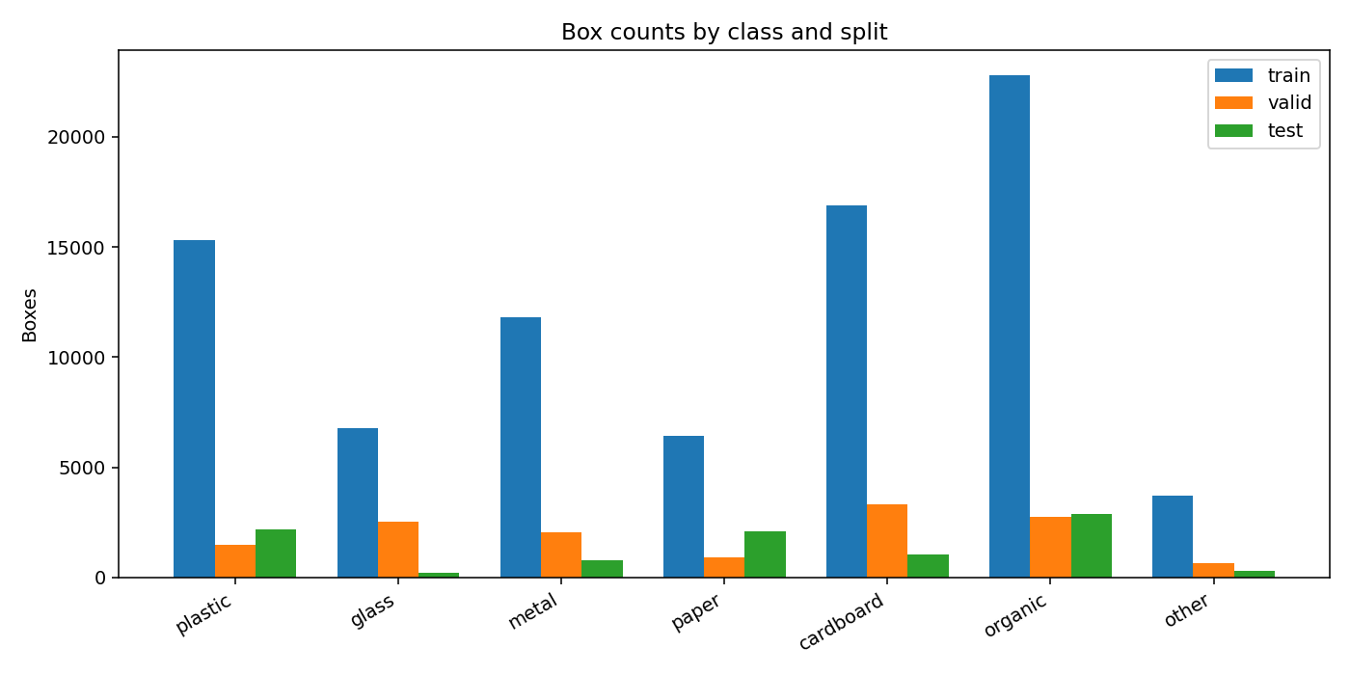
Figure 1. EDA — raw class balance of the merged baseline across train/valid/test. Organic and cardboard dominate; glass test support is nearly absent. This chart triggered the tuned rebuild.
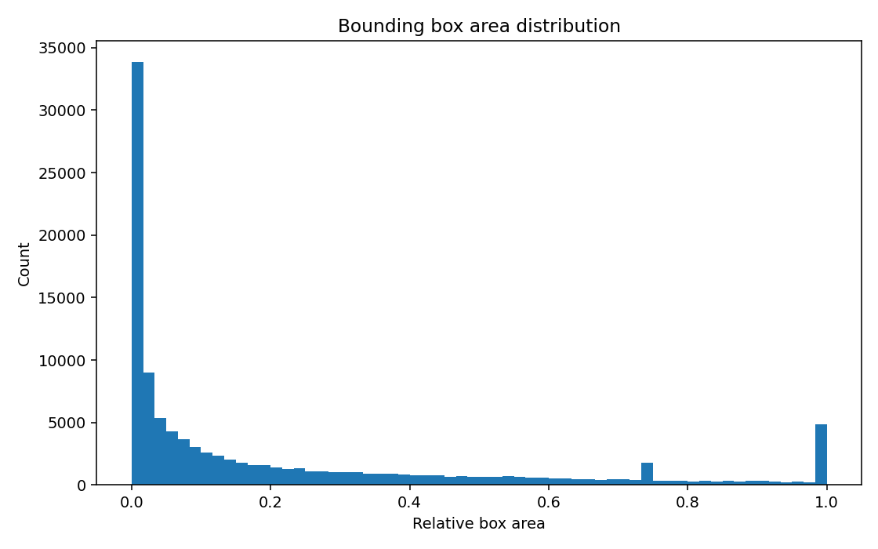
Figure 2. EDA — bounding-box area histogram. The long tail of tiny boxes (< 10 px / < 0.0002 relative area) was filtered out: 1,537 boxes dropped.
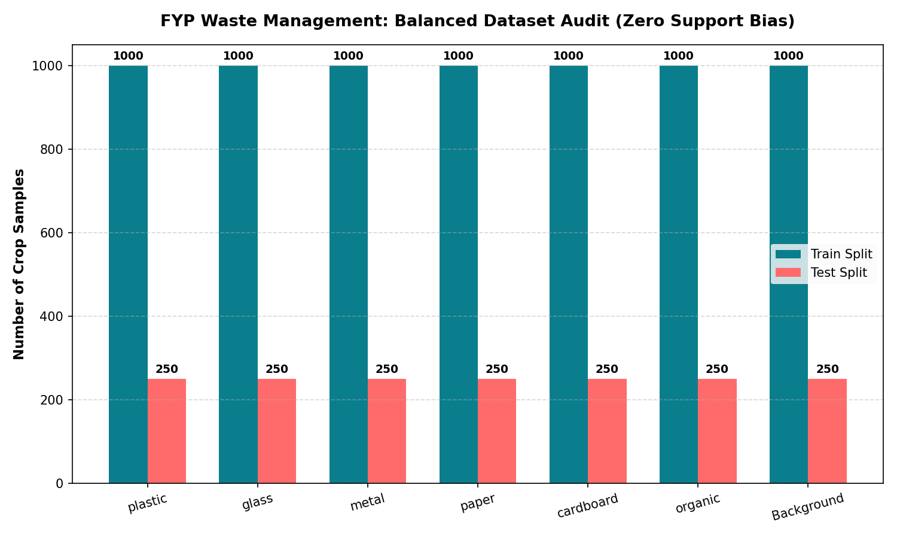
Figure 3. EDA — per-class support after balanced capping, the sampling used by all final model comparisons.
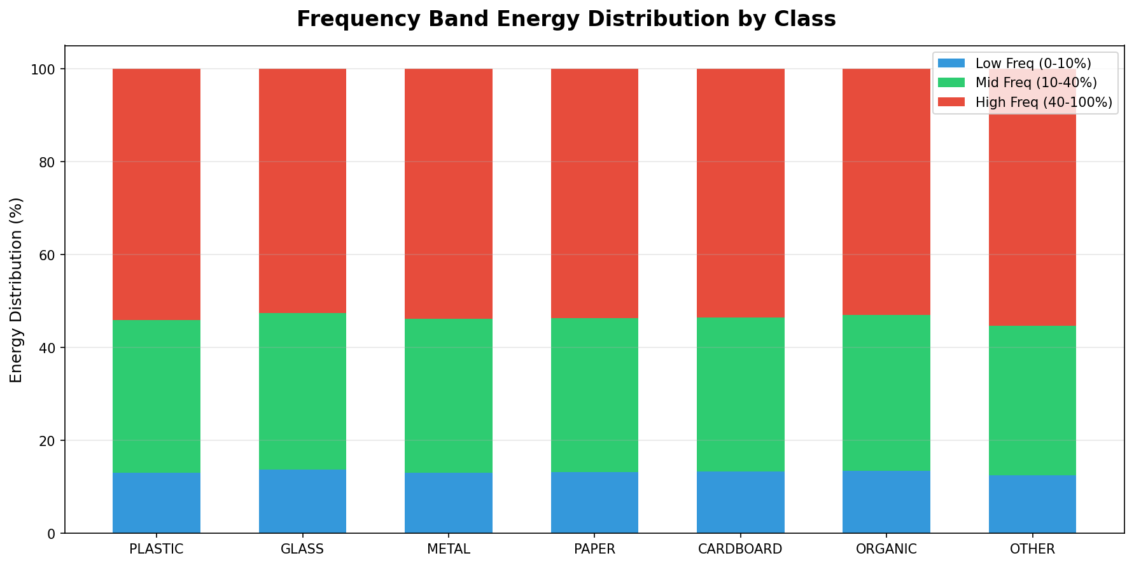
Figure 4. EDA — frequency-domain histogram per class (low/mid/high band energy). Organic and paper carry more high-band energy than glass/plastic; this justifies the 9 FFT features.
Table 1. Frozen dataset numbers behind the final models.
Dataset | Size | Role
merged_dataset_v3 (raw merge) | 114,220 boxes | Baseline; audited, then superseded
tuned_dataset_v1 | 31,379 images / 67,385 boxes | Cleaned rebuild; glass test 200 → 863
merged_dataset_v5 | 29,639 crops, 7 classes | Final classification data
super_yolo_dataset | 23,929 images / 102,777 boxes | Final localization data
hard_case_classifier_v1 | 12,600 / 2,680 / 2,696 | Hard-case retraining (RealWaste + TACO)

2. Classical ML branch (637 handcrafted features)
Proposed final headline: XGBoost, accuracy 0.6742, macro-F1 0.6506, balanced lecturer split (4,000 train crops/class, 6 classes). Evidence: runs/ml/feature_ml_lecturer_6class_4k. The current-dataset rerun (0.5408 / 0.3691) stays as a caveated secondary result — its test split has only 9 glass boxes.
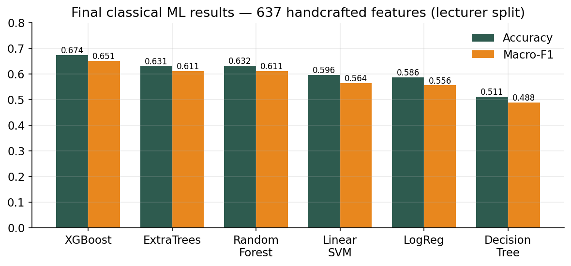
Figure 5. Final classical ML comparison — accuracy and macro-F1 for all six models on the 637-D features.
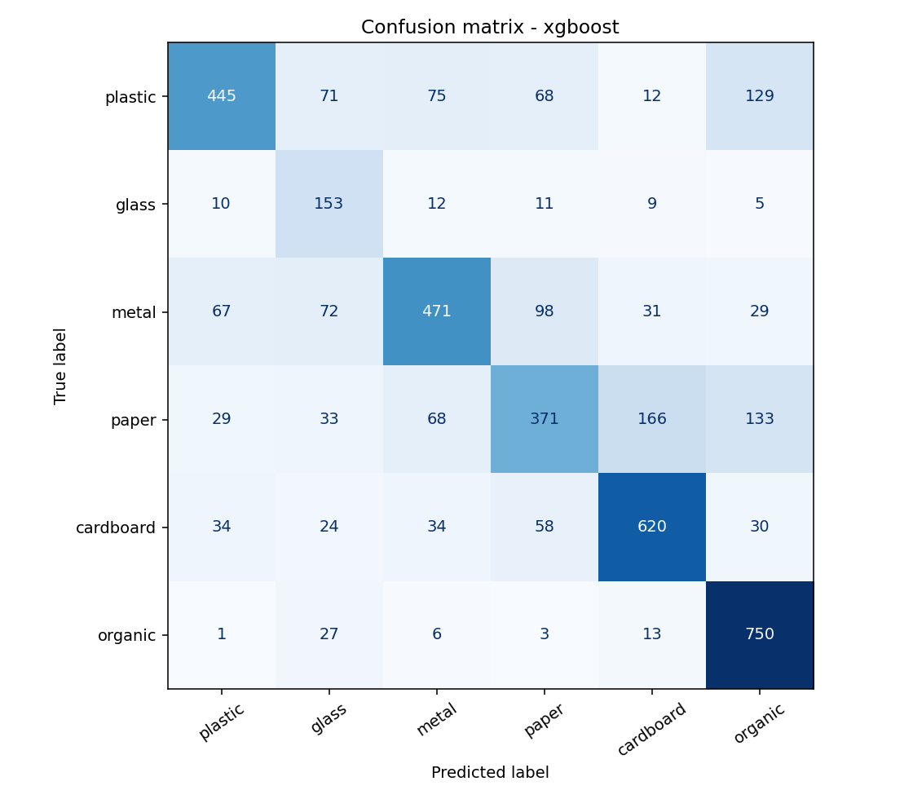
Figure 6. Confusion matrix of the final ML model (XGBoost). Main leakage: paper ↔ cardboard and plastic ↔ glass.
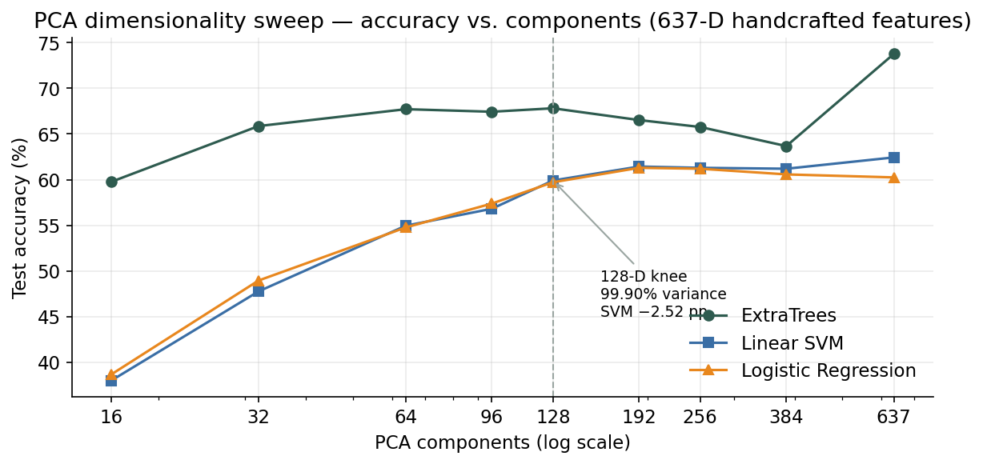
Figure 7. PCA sweep — accuracy vs. components for three model families. The 128-D knee keeps 99.90% variance; the cost is model-specific (SVM −2.52 pp, LogReg −0.62 pp, trees −6 to −8 pp). Evidence: runs/ml/pca_feature_model_sweep.
DECISION 1: Approve XGBoost 0.6742 / 0.6506 as the headline ML number, rerun as caveated secondary, and the model-specific PCA wording?

3. Stage 2 crop classifier (deep learning)
Four trained models exist; one must be named final. The proposed final is the hard-case ConvNeXt (93.88% test), which is better than the currently deployed tuned model (92.52% val):
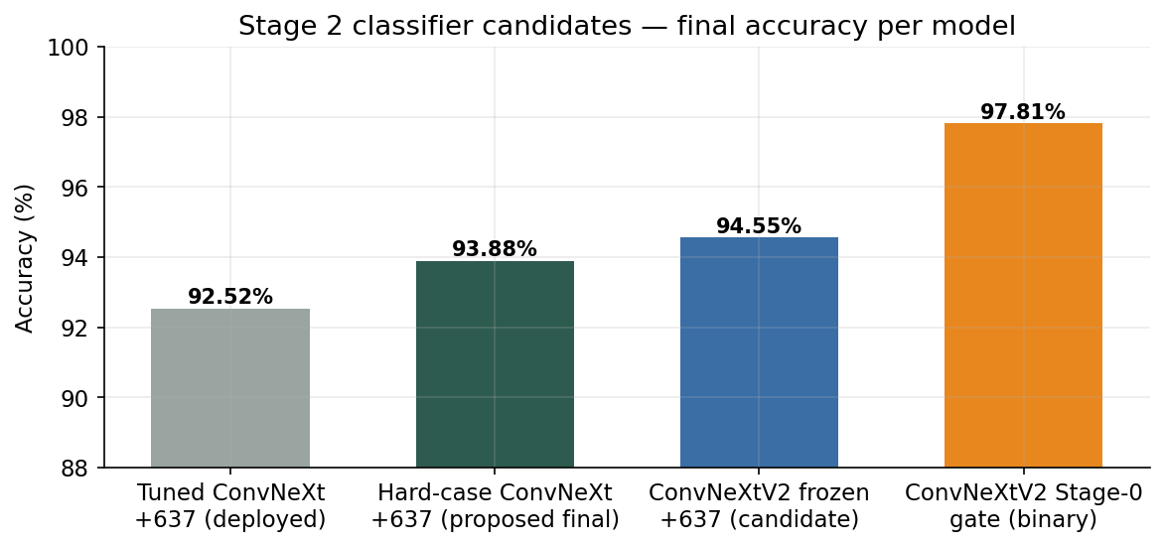
Figure 8. Classifier candidates — final accuracy per model. Green = proposed final; gray = currently deployed; blue/orange = upgrade candidates reported separately.
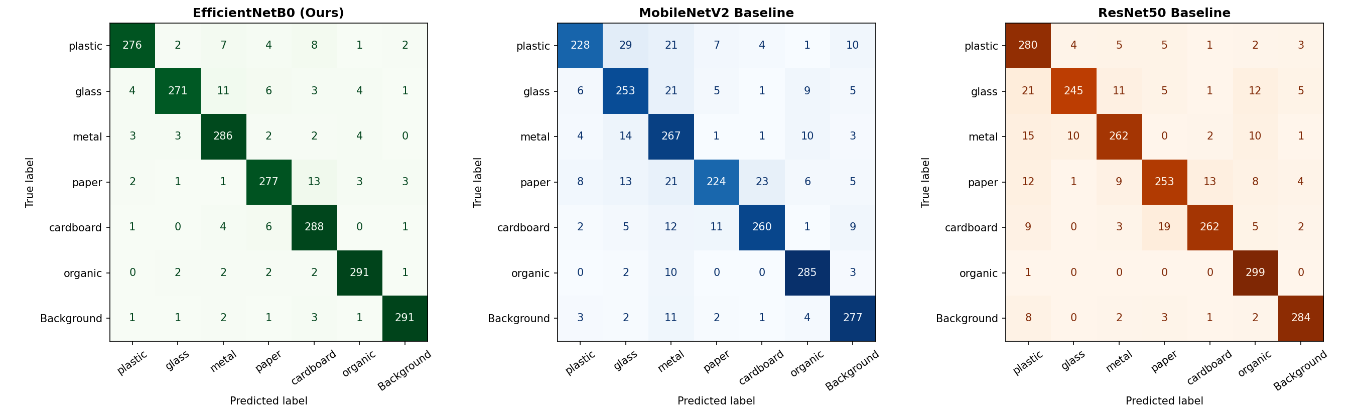
Figure 9. Supporting evidence — confusion matrices of the earlier Stage 2 architecture comparison (MobileNetV2 / ResNet50 / EfficientNetB0, 85.43% / 89.76% / 94.29%), which selected the EfficientNet/ConvNeXt direction.
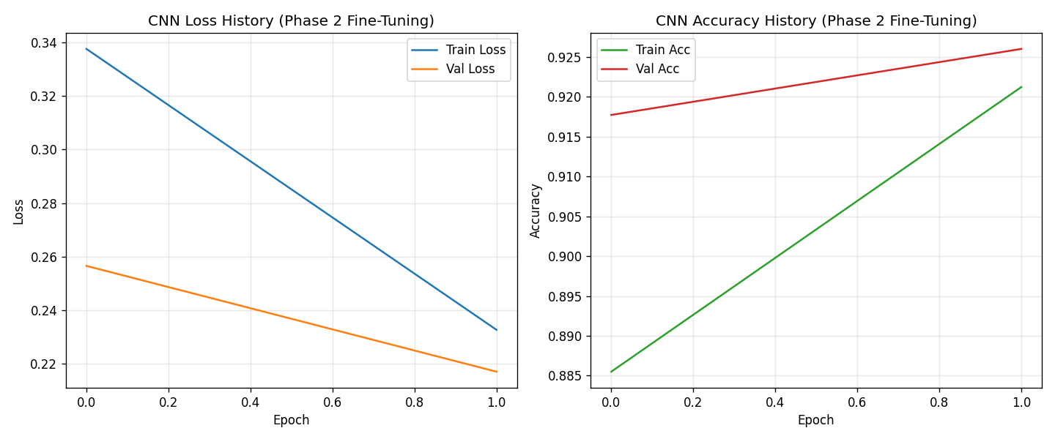
Figure 10. Training curves of the EfficientNetB0 baseline (94.29% test, 29.21 MB → 4.83 MB quantized).
Table 2. Classifier candidates. Evidence: runs/dl/convnext_ensemble_tuned, convnext_hardcase_tuned, convnextv2_material_stage1_benchmark, convnextv2_stage0_trash_gate.
Candidate | Result | Split | Deployed? | Proposed role
ConvNeXt-Tiny + 637 (tuned) | 92.52% acc | val (2,100) | YES (web API) | Currently deployed
ConvNeXt-Tiny + 637 (hard-case) | 93.88% / 0.9398 F1 | test (2,696) | no | PROPOSED FINAL
ConvNeXtV2 frozen + 637 + MLP | 94.55% / 0.9459 F1 | test (2,696) | no | Upgrade candidate
ConvNeXtV2 Stage-0 gate (binary) | 97.81% / 0.9777 F1 | test (319) | no | Gate, reported separately

DECISION 2: Final classifier = hard-case ConvNeXt (93.88%, recommended) or the deployed tuned ConvNeXt (92.52%)? Update the web deployment to match?

4. Detector and localization operating point
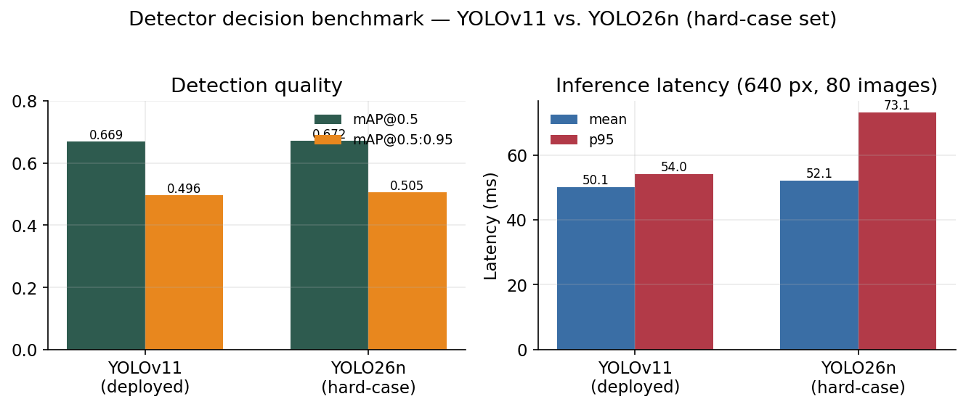
Figure 11. Detector decision — YOLOv11 (deployed) vs. newly trained YOLO26n: near-identical quality, worse p95 latency for YOLO26n. Proposal: keep YOLOv11. Evidence: runs/detect/yolo11_vs_yolo26_benchmark.json.
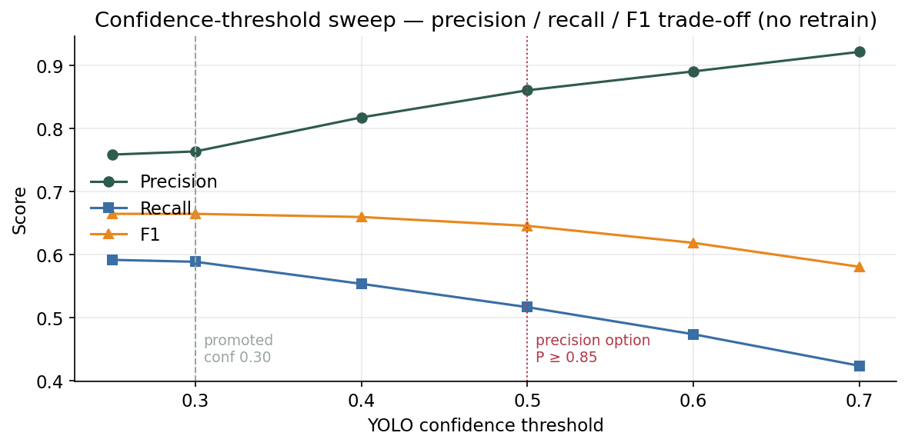
Figure 12. Threshold engineering — precision/recall/F1 vs. confidence. conf 0.30 is the promoted best-F1 point; conf 0.50 is the config-only lever to reach precision ≥ 0.85. Evidence: runs/detect/precision_threshold_sweep.
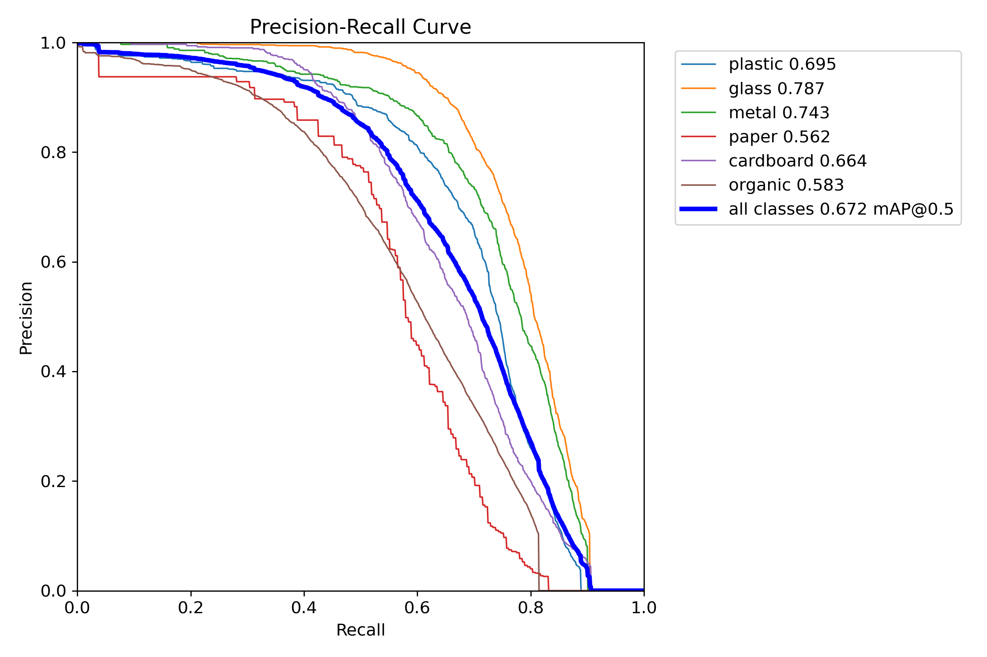
Figure 13. Per-class precision-recall curves of the hard-case detector. Glass and plastic remain the hardest classes.
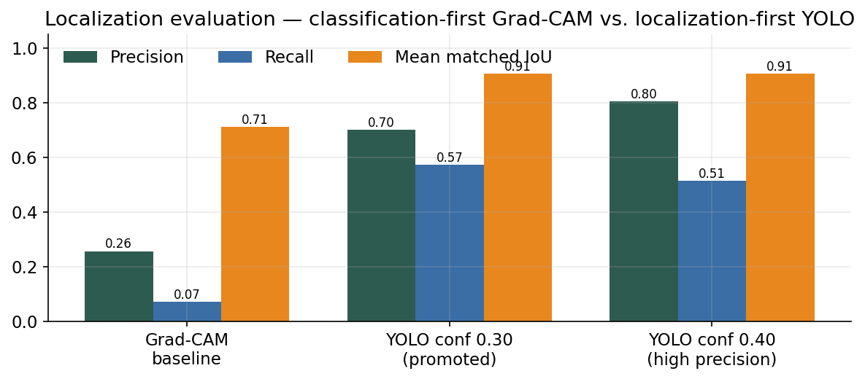
Figure 14. Final localization evaluation (300 stratified images, 1,152 GT boxes) — the Grad-CAM classification-first baseline collapses; YOLO conf 0.30 is promoted (P 0.6999 / R 0.5729 / F1 0.6301 / IoU 0.9057). Evidence: runs/dl/localization_rework.
DECISION 3: Confirm YOLOv11 as final detector and conf 0.30 as the promoted operating point (conf 0.40–0.50 documented for precision-critical use)?

5. End-to-end production numbers and generalization
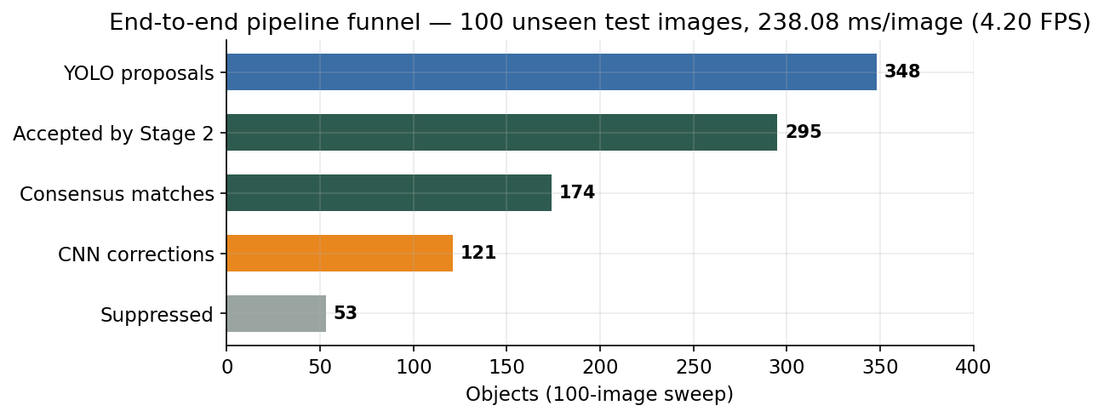
Figure 15. End-to-end funnel on 100 unseen images: 348 proposals → 295 accepted; 59.0% consensus, 41.0% CNN corrections, 53 suppressed. Latency 238.08 ms/image CPU (4.20 FPS). Evidence: runs/detect/yolo_efficientnet_pipeline.
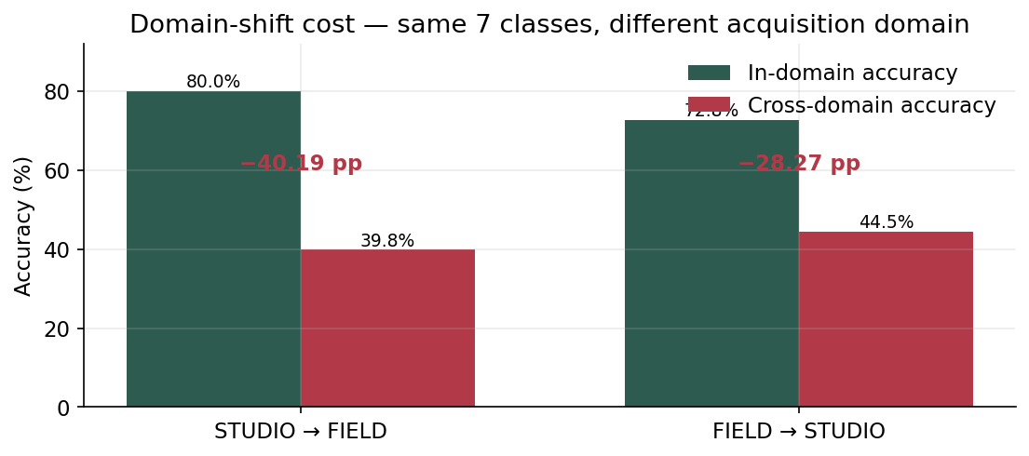
Figure 16. Honest generalization cost — training domain vs. test domain with identical classes. The 40.19 pp studio→field drop is the project's stated main limitation. Evidence: runs/dl/cross_dataset_validation.
- Edge budget: quantized EfficientNetB0 TFLite = 4.83 MB (6.0× smaller), 362.43 FPS synthetic.
- Hard-case walkthrough (reflective plastic): 0 boxes at conf 0.30 → adaptive recovery at conf 0.05 → 3 boxes → final Plastic 84% with Beach context prior.
DECISION 4: Approve these as the final production-evidence numbers (no rerun needed)?

6. Sign-off summary
Table 3. Decisions needed before the report is locked.
# | Decision | Recommendation
1 | ML headline number + PCA wording | XGBoost 0.6742 / 0.6506; PCA claim stated per-model (SVM -2.52 pp at 128-D)
2 | Final Stage 2 classifier | Hard-case ConvNeXt, 93.88% test; update deployment to match
3 | Detector + operating point | Keep YOLOv11; conf 0.30 promoted, conf 0.40-0.50 documented
4 | End-to-end evidence | Freeze 100-image sweep + latency numbers
5 | Generalization caveat | Report the 40.19 pp studio-to-field gap as a stated limitation

Once approved, the final report will present exactly one final number per branch, with all alternatives moved to supporting-evidence sections.

