WasteWise — Methodology Clarification & Workflows
Response to lecturer feedback: (1) clarify all methodologies used, with drawn workflows; (2) GUI restructured to follow the workflow step by step
Student: Khoa Phung — July 3, 2026

1. Overall workflow
The project runs one shared data pipeline and two method branches. Branch A is the explainable classical ML pipeline (handcrafted features → classical models → PCA). Branch B is the deep-learning production pipeline (YOLO localization first, crop verification second). The same 637 handcrafted features appear in both branches: in Branch A they are the entire representation; in Branch B they are fused with the ConvNeXt embedding inside the Stage 2 classifier.
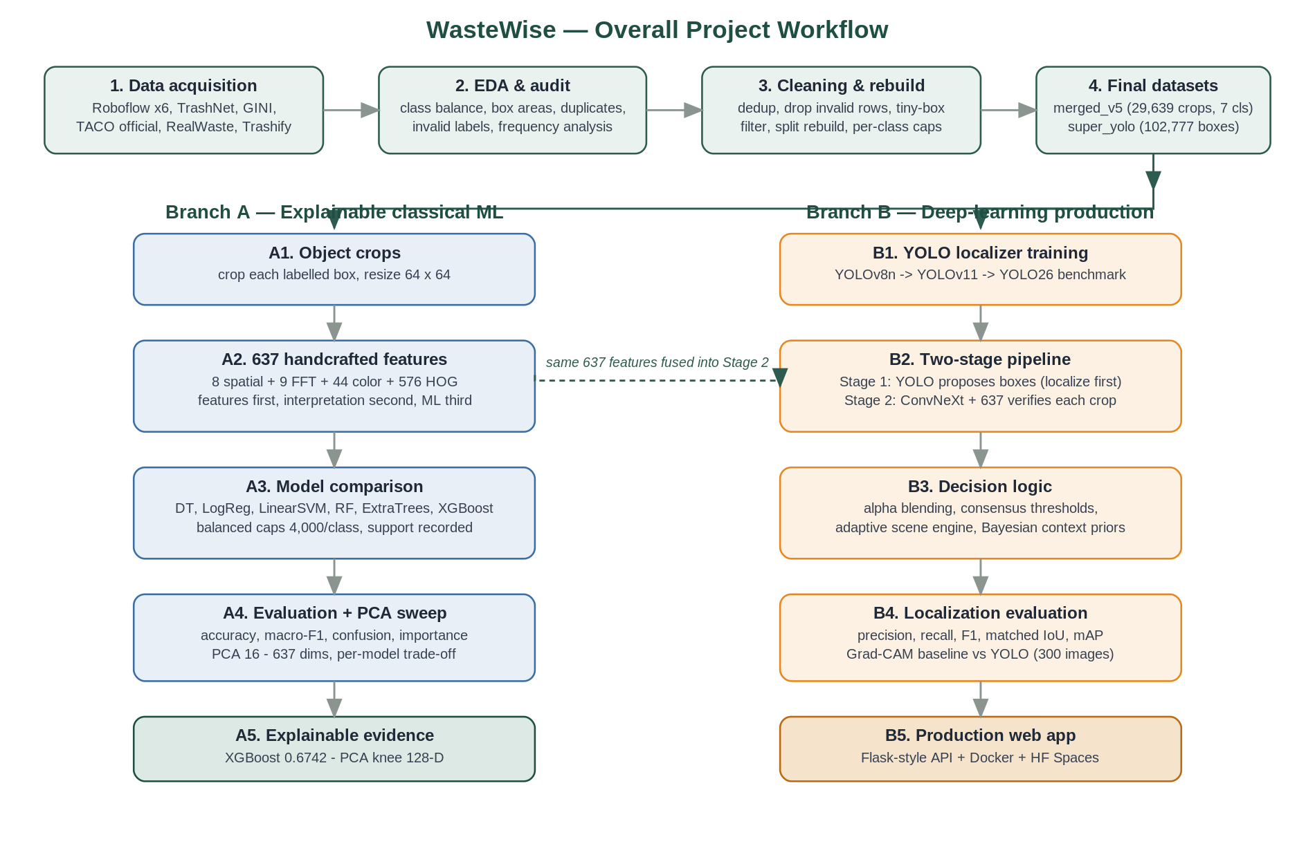
Figure 1. Workflow 1 — overall project workflow: shared data pipeline (top), explainable ML branch (left), deep-learning production branch (right).

2. Data methodology
Table 1. Data-processing methods used and their purpose.
Method | What it does | Why it is used
Multi-source merge with source tags | Merges 6 Roboflow sources + TrashNet + GINI + TACO + RealWaste, keeping the source prefix in every filename | Preserves data provenance so results can be analyzed per source (lecturer requirement)
EDA audit | Counts classes per split, box-area histograms, invalid label rows, unreadable images | Finds structural problems before any training; produced the evidence for the rebuild
Perceptual-hash deduplication | Hashes every image and groups exact duplicates | Removed 5,862 duplicate images that would leak between train and test
Tiny-box filter | Drops boxes smaller than 10 px or relative area < 0.0002 | Sub-10 px boxes carry label noise, not signal (1,537 dropped)
Split rebuild by dominant class | Re-assigns images to train/valid/test by their dominant class | Fixes broken support (glass test boxes: 200 → 863)
Per-class capping (balanced sampling) | Caps each class at N crops (typically 1,000–4,000 train), records class_support.json | Makes model comparisons fair under imbalance; keeps honest support visible
Frequency-domain analysis | Average FFT spectra and radial band energy per class | Justifies the 9 FFT features; follows the lecturer's spatial → frequency → comment → ML order

3. Branch A methodology — explainable classical ML
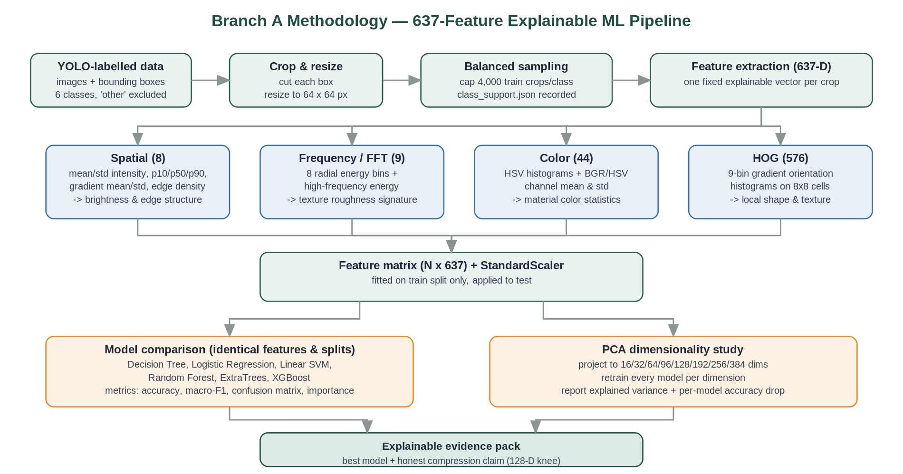
Figure 2. Workflow 2 — Branch A: crops → 637 handcrafted features (four explainable groups) → six-model comparison → PCA study.

3.1 The 637-dimensional feature vector
Table 2. Every feature is mathematically defined and individually explainable.
Group | Count | Definition | What it captures
Spatial | 8 | mean/std intensity; 10th/50th/90th intensity percentiles; Sobel gradient mean/std; Canny edge density | Brightness distribution and edge structure of the crop
Frequency (FFT) | 9 | 2-D FFT magnitude summed in 8 radial rings + total high-frequency energy | Texture roughness: organic waste is broadband, smooth plastic is low-frequency
Color | 44 | HSV channel histograms plus BGR and HSV per-channel mean and std | Material color statistics (brown cardboard, green/brown glass, etc.)
HOG | 576 | 9-orientation gradient histograms over 8×8-px cells with block normalization (Dalal & Triggs 2005) | Local shape and texture: edges of cans, bottle silhouettes, crumple patterns

3.2 Models compared
Six classical classifiers are trained on the identical feature matrix and splits: Decision Tree, Logistic Regression (L2), Linear SVM (on standardized features), Random Forest (300 trees), ExtraTrees, and XGBoost. Features are standardized with a StandardScaler fitted on the training split only. Sampling uses balanced per-class caps with support recorded in class_support.json. Evaluation reports accuracy, macro-F1, per-model confusion matrices, and feature-domain importance (spatial vs. frequency vs. color vs. HOG).

3.3 PCA dimensionality methodology
PCA is fitted on the training features; both splits are projected to 16, 32, 64, 96, 128, 192, 256, 384 dimensions; every model is retrained per dimension. The study reports explained variance, accuracy, macro-F1, and per-sample latency, and states the compression cost per model — linear models lose ~0.6–2.5 pp at 128-D while tree ensembles lose 6–8 pp, so no single 'PCA costs X%' claim is made.

4. Branch B methodology — two-stage production pipeline
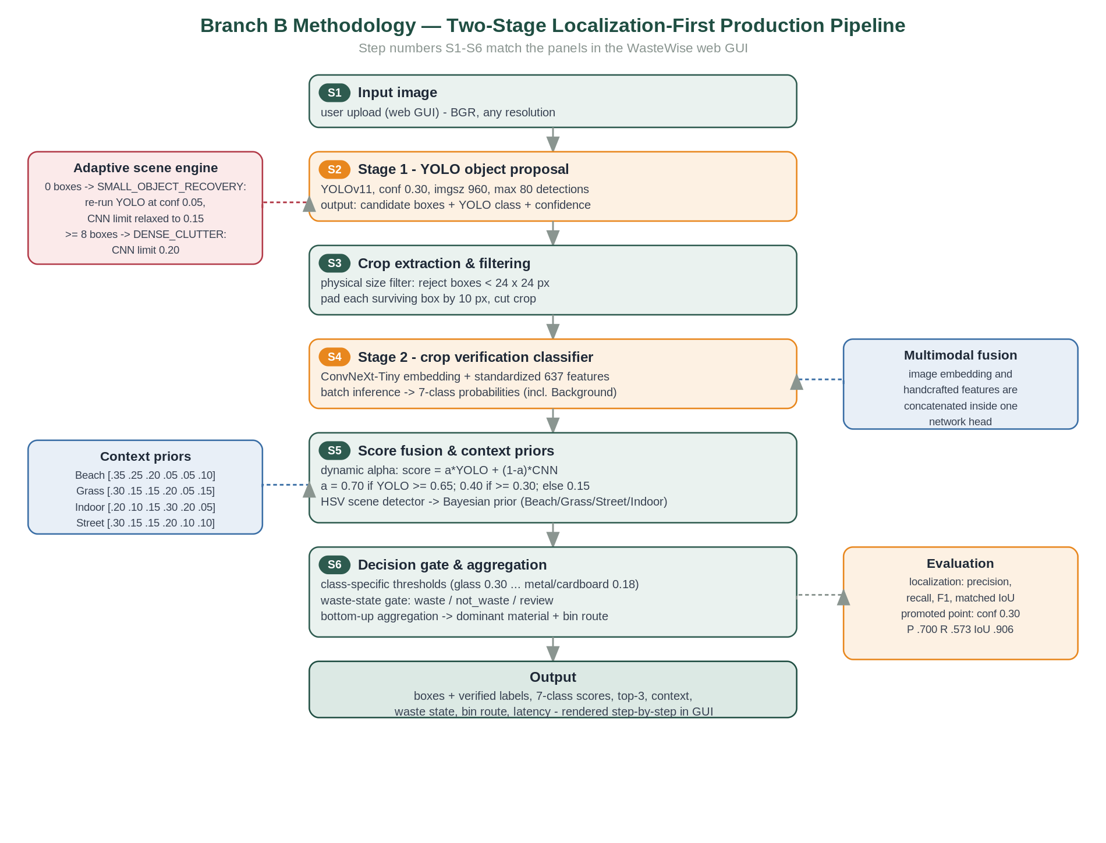
Figure 3. Workflow 3 — Branch B: the production pipeline. Step numbers S1–S6 are the same numbers shown in the reworked GUI.

4.1 Stage 1 — YOLO object proposal (S2)
A YOLOv11 detector (trained 30 epochs on the 23,929-image super dataset; benchmarked against YOLO26n and kept) runs at conf 0.30, image size 960, max 80 detections. Its role is deliberately limited to proposing boxes: mean matched IoU of accepted boxes is 0.906, so YOLO is trusted for geometry, not for the final label.

4.2 Adaptive scene engine (S2)
- SMALL_OBJECT_RECOVERY: if 0 boxes are found at conf 0.30, YOLO re-runs at conf 0.05 and the CNN acceptance limit is relaxed to 0.15 — recovers reflective/small objects.
- DENSE_CLUTTER_MITIGATION: if ≥ 8 boxes are found, the CNN acceptance limit tightens to 0.20 to control false alarms in cluttered scenes.

4.3 Crop extraction and filtering (S3)
Boxes smaller than 24 × 24 px are rejected (physical size filter); surviving boxes are padded by 10 px and cropped. This is the hand-off from localization to classification.

4.4 Stage 2 — multimodal crop verification (S4)
Each crop is classified by a ConvNeXt-Tiny network whose image embedding is concatenated with the standardized 637 handcrafted features before the classification head — the deep model and the explainable features vote inside one network. The output is a 7-class probability vector including Background, which lets Stage 2 veto YOLO false alarms. Training uses a 3-epoch frozen-backbone warm-up followed by 7 epochs of progressive unfreezing (RTX 3060); the hard-case retrain on RealWaste + TACO crops is the proposed final model (93.88% test accuracy).

4.5 Score fusion and context priors (S5)
Dynamic alpha blending. Final score = α·YOLO + (1−α)·CNN, with α depending on YOLO confidence: α = 0.70 if YOLO ≥ 0.65; α = 0.40 if YOLO ≥ 0.30; α = 0.15 otherwise. High-confidence YOLO geometry is trusted; weak proposals defer to the CNN's texture evidence.
Bayesian context priors. An HSV scene detector classifies the environment (Beach, Grass, Street, Indoor). Non-background class probabilities are multiplied by the context prior vector and renormalized — e.g., Beach = [0.35, 0.25, 0.20, 0.05, 0.05, 0.10] over plastic/glass/metal/paper/cardboard/organic — following Torralba's contextual-priming principle.

4.6 Decision gate and aggregation (S6)
Class-specific acceptance thresholds (plastic 0.25, glass 0.30, metal 0.18, paper 0.20, cardboard 0.18, organic 0.22) reject weak labels into 'review'. A waste-state gate marks each object waste / not_waste / review, and only 'waste' objects enter bin routing. Bottom-up aggregation (area- and confidence-weighted) produces the dominant material and the final bin route.

4.7 Evaluation methodology
Localization is evaluated by IoU@0.5 matching against ground-truth boxes on 300 stratified test images: precision, recall, F1, and mean matched IoU. The classification-first Grad-CAM alternative was implemented and measured with identical metrics (P 0.257 / R 0.073) — the quantitative justification for the localization-first design. Classification is evaluated with accuracy/macro-F1 on balanced splits; detectors additionally report mAP@0.5 and mAP@0.5:0.95; deployment reports model size, latency, and FPS.

5. GUI reworked to follow the workflow
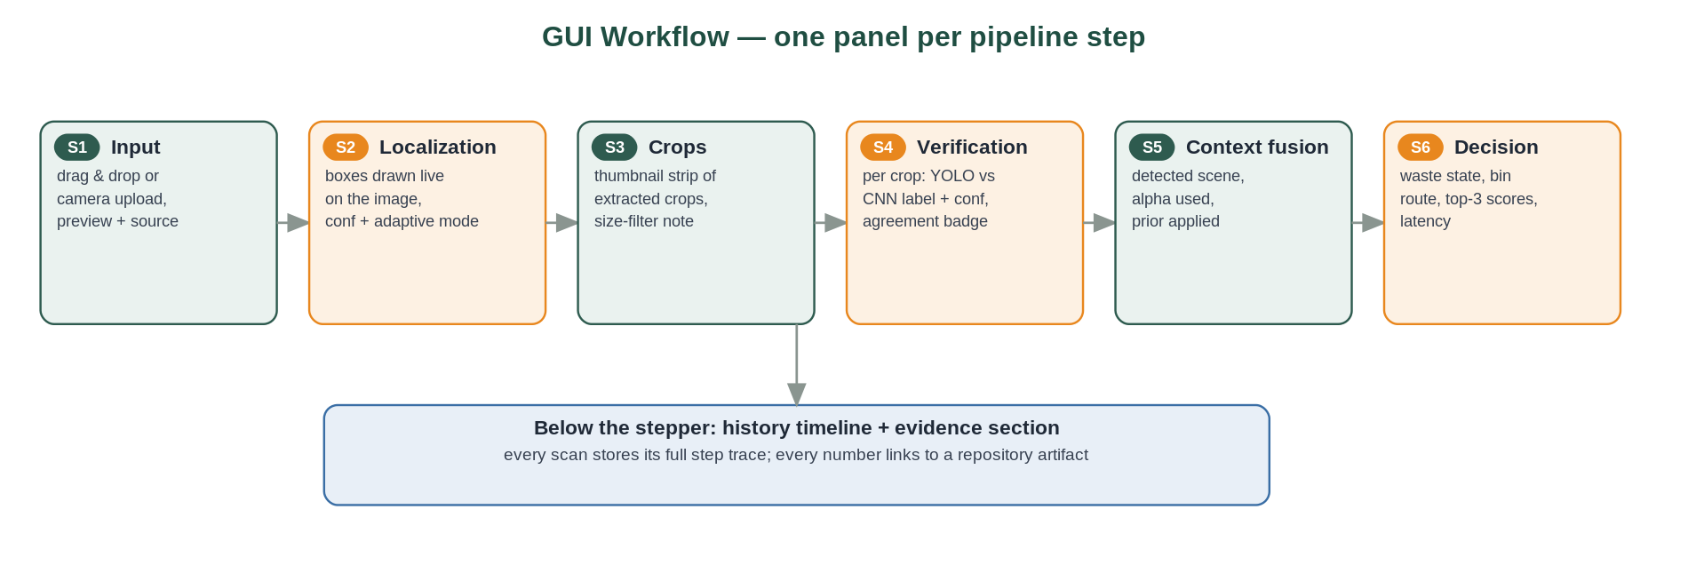
Figure 4. Workflow 4 — the reworked GUI: one panel per pipeline step, numbered S1–S6 to match Workflow 3.
The web GUI now renders the scan as a numbered step sequence that mirrors Workflow 3 exactly. Each step shows the real data produced at that stage of the current scan — not a static description:
- S1 Input: uploaded image preview, source, and resolution.
- S2 Localization: YOLO boxes drawn on the image; box count, confidence threshold used, and the adaptive-engine mode badge (normal / small-object recovery / dense clutter).
- S3 Crops: a thumbnail strip of the actual extracted crops with the YOLO label and confidence under each, plus the size-filter count.
- S4 Verification: for every verified crop: YOLO's label vs. the CNN's label with both confidences, the blending weight α, and an agree/corrected badge.
- S5 Context fusion: the detected scene context, the prior vector applied, and the fused result per crop.
- S6 Decision: waste state, dominant material, bin route, top-3 predictions, all seven class scores, and latency.
Implementation: web/server.py now returns a per-scan workflow payload (per-crop thumbnails as base64, α values, adaptive mode, prior used, filter counts) and web/index.html + app.js render the numbered stepper; the pipeline diagram (Workflow 3) is embedded above the stepper so the panels can be read against the methodology.

6. All methodologies at a glance
Table 3. Every method used in WasteWise, where it lives, and its evidence.
Method | Branch / step | Evidence path
EDA audit + dedup + tiny-box filter | Data | runs/dataset_eda, docs DATASET_EDA_AND_TUNING_REPORT
Balanced per-class sampling | Data / A3 | class_support.json in every run folder
Frequency-domain analysis (FFT) | Data / A2 | data/frequency_analysis
637 handcrafted features (spatial/FFT/color/HOG) | A2, fused into S4 | scripts/feature_ml_analysis.py
Six-model classical comparison | A3 | runs/ml/feature_ml_lecturer_6class_4k
PCA dimensionality study | A4 | runs/ml/pca_feature_model_sweep
YOLO detection training (v8/v11/26) | B1 / S2 | runs/detect, models/trained/yolov11_detector
Adaptive scene engine | S2 | web/server.py; milestones report §4.4
Physical size filter + crop padding | S3 | web/server.py
ConvNeXt + 637 multimodal fusion classifier | S4 | runs/dl/convnext_hardcase_tuned
Dynamic alpha blending | S5 | web/server.py; weekly report 2026-05-21
Bayesian context priors (HSV scene) | S5 | web/server.py; milestones report
Class thresholds + waste-state gate | S6 | web/server.py
IoU@0.5 localization evaluation | B4 | runs/dl/localization_rework
Grad-CAM classification-first baseline | B4 (rejected) | runs/dl/localization_rework/gradcam_baseline_stratified60
Quantization / ONNX export | B5 | scripts/export_tflite.py, export_ensemble_onnx.py

