FINAL YEAR PROJECT REPORT

WasteWise: Project Milestones and Production Build-Up Report
  - From dataset acquisition and feature engineering to ML benchmarks, DL localization, web API, and deployment evidence
Project: WasteWise automated waste classification and localization
Prepared for: FYP milestone / final production evidence package
Prepared on: 2026-06-26
Workspace: C:\FYP
Primary evidence: docs\, runs\, scripts\, web\, models
Report stance: ML branch is final explainable evidence; DL branch is localization-first classification evidence. Old Grad-CAM classification-first work is retained as experiment history.

Current project position
WasteWise has matured into a two-branch evidence package. The ML branch is the explainable classification proof using 637 handcrafted features and PCA. The DL branch is the production-facing 2-stage hierarchical pipeline (YOLO localization followed by crop classification verification).

Area | Final position | Strongest evidence
Dataset foundation | Current datasets separated by task. | Classification: `data/merged_dataset_v5` with 29,639 images. Localization: `external_datasets/super_yolo_dataset` with 23,929 images and 102,777 boxes.
Explainable ML | Final academic ML branch. | 637-D features; current-dataset XGBoost 0.5408 accuracy / 0.3691 F1; legacy lecturer XGBoost 0.6742 / 0.6506.
PCA compression | Valid compact-feature evidence. | 637 to 128 components keeps 99.90% variance; Linear SVM accuracy drops 62.43% to 59.90% (2.52 pp).
DL classification | Classifier/gate and hard-case material model. | Hard-case ConvNeXt: 93.88% test accuracy / 0.9398 macro F1. ConvNeXtV2+637 MLP: 94.55% test accuracy / 0.9459 macro F1.
DL localization | 2-stage hierarchical pipeline evidence. | YOLO conf=0.30 + crop verification on 300 images: precision 0.6999, recall 0.5729, F1 0.6301, mean IoU 0.9057.
Production | Web scanner deployed. | Hugging Face Space update `khoaphung/wastewise-ai` and web API.

1. Chronological Milestones
The project moved from raw waste image collection into a final production story through ten practical milestones. Each milestone below names what was built, what was learned, and which local artifact proves it.
No. | Milestone | Built / learned | Evidence
1 | Problem framing | Defined WasteWise as waste material recognition plus localization for sorting guidance. | README.md; docs\PIPELINE_DIAGRAMS.md
2 | Raw data intake | Collected/registered Roboflow-style merged data, TrashNet-style classification data, TACO-style litter data, RealWaste, Outerview, and hard-case sources. | docs\02_dataset_training\external_dataset_registry.json
3 | EDA and cleaning | Found invalid YOLO rows, duplicates, tiny boxes, and split imbalance. Built tuned non-destructive dataset copies. | docs\02_dataset_training\DATASET_EDA_AND_TUNING_REPORT.md
4 | Source-level audit | Separated source identity and trained per-source ANN/CNN baselines when standalone classes were valid. | docs\02_dataset_training\SOURCE_LEVEL_DATASET_ANALYSIS.md
5 | Handcrafted ML | Built 637-D feature extractor from spatial, FFT, color, and HOG domains, then trained classical models. | runs\ml\feature_ml_lecturer_6class_4k; runs\ml\feature_ml_super_yolo_6class_4k
6 | PCA study | Measured how far 637 features could be compressed without losing the report claim. | runs\ml\pca_feature_model_sweep\PCA_Model_Sweep_Report.md
7 | Legacy DL baselines | Compared ANN/CNN, MobileNetV2, ResNet50, EfficientNetB0, and old YOLO-first crop verification. | runs\dl\comparison_models; runs\comparisons\model_comparison
8 | DL rework | Changed final DL story to 2-stage hierarchical pipeline (localization-first, classification-second). | docs\01_final_report\WORKFLOW_APPROACHES_AND_DL_REWORK.md
9 | Hard-case improvement | Downloaded hard-case datasets, retrained material classifier, resumed YOLO, and benchmarked YOLO11 vs YOLO26. | docs\02_dataset_training\MODEL_IMPROVEMENT_PLAN.md; runs\detect\yolo11_vs_yolo26_benchmark.json
10 | Production surfaces | Built web scanner/API and deployed Space update. | web\README.md; scripts\deploy_hf_space.py

2. Dataset And Data Number Evidence
WasteWise now treats classification and localization datasets separately because each task needs different labels. Classification uses image/crop class support, while localization needs bounding boxes and IoU evaluation.
Dataset / source | Path | Size | Role / risk
Current classification | data\merged_dataset_v5 | 29,639 images, 7 classes incl. Background | Stage 1/classifier evidence; more balanced than older merged split.
Current localization | external_datasets\super_yolo_dataset | 23,929 images, 102,777 boxes, 6 classes | Stage 2 localization evidence; test support is imbalanced.
Hard-case classifier | data\hard_case_classifier_v1 | 16,539 linked records; train 12,600 / val 2,680 / test 2,696 used in classifier result | Real-world hard-case material classifier.
YOLO26 hard case | external_datasets\yolo26_hardcase_dataset_v1 | 20,593 train / 3,450 val / 1,275 test images | Detector hard-case training/evaluation export.
TACO official | external_datasets\hard_case_full\taco_official | 1,500 images / records downloaded | Litter detection/segmentation source; sparse class mapping risk.
RealWaste | external_datasets\hard_case_full\realwaste_hf_uci | 4,752 records / images | Landfill-style classification hard cases.
Outerview | external_datasets\hard_case_full\outerview_global_trash_debris | 25,000 metadata rows, 23,297 extracted images | OOD review pool; label trust risk.

Task dataset | Split / class | Count
merged_dataset_v5 | Train images | 24,039
merged_dataset_v5 | Test images | 5,600
merged_dataset_v5 | Background total | 4,300
merged_dataset_v5 | Cardboard total | 4,225
merged_dataset_v5 | Glass total | 4,300
merged_dataset_v5 | Metal total | 4,030
merged_dataset_v5 | Organic total | 4,300
merged_dataset_v5 | Paper total | 4,300
merged_dataset_v5 | Plastic total | 4,184
super_yolo_dataset | Images | 23,929
super_yolo_dataset | Boxes | 102,777
super_yolo_dataset | Current ML train crops | 24,000
super_yolo_dataset | Current ML test crops | 2,232

Dataset caveat that must stay in the final thesis
The newest `super_yolo_dataset` ML test split is not a clean balanced benchmark: glass has only 9 test boxes, cardboard 35, and organic 46. This explains the lower current-dataset macro-F1 and prevents overstating the result.

3. Explainable Machine Learning Branch
The ML branch is built for auditability. Every object crop becomes a deterministic handcrafted vector instead of raw pixels. That vector then feeds classical models whose results can be compared with accuracy, F1, confusion matrices, and feature importance.
Feature group | Count | Reason in this project
Spatial / edge | 8 | Brightness, intensity percentiles, gradient mean/std, and edge density.
Frequency / FFT | 9 | Radial frequency bins plus high-frequency energy for texture and clutter response.
Color | 44 | HSV histograms and BGR/HSV statistics for material color cues.
HOG | 576 | Dominant local gradient orientation and shape texture.
Total | 637 | Fixed explainable vector used by ML, PCA, and hybrid DL work.

Current super_yolo_dataset ML model | Accuracy | F1-macro | Interpretation
XGBoost | 0.5408 | 0.3691 | Best current-dataset ML result.
Random Forest | 0.5063 | 0.3456 | Tree baseline and feature-importance source.
ExtraTrees | 0.5045 | 0.3414 | Robust noisy-feature baseline.
Linear SVM | 0.4628 | 0.3159 | Scaled linear margin baseline.
Logistic Regression | 0.4494 | 0.3054 | Linear probability baseline.
Decision Tree | 0.3750 | 0.2631 | Simple interpretable threshold baseline.

Legacy lecturer ML model | Accuracy | F1-macro | Interpretation
XGBoost | 0.6742 | 0.6506 | Best legacy lecturer-facing result.
Random Forest | 0.6317 | 0.6111 | Useful feature-importance baseline.
ExtraTrees | 0.6312 | 0.6113 | Strong ensemble baseline.
Linear SVM | 0.5960 | 0.5642 | High-dimensional margin baseline.
Logistic Regression | 0.5864 | 0.5558 | Standardized linear baseline.
Decision Tree | 0.5115 | 0.4883 | Low-complexity interpretability baseline.

Feature-importance result
In the current super_yolo_dataset run, HOG dominates the random-forest feature importance at 59.5808%, followed by color at 29.2090%, frequency at 5.6582%, and spatial features at 5.5520%. This is consistent with waste material differences being driven by shape/texture plus color.

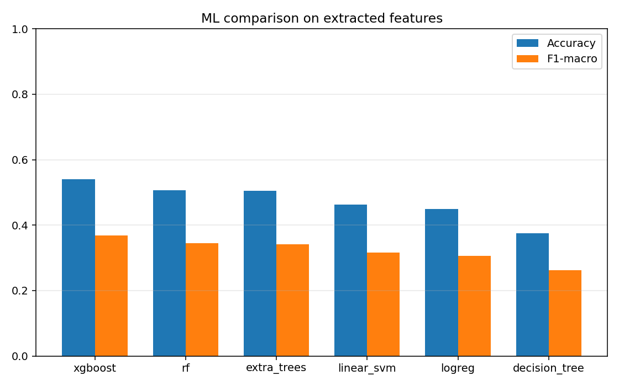
Figure 1. Current-dataset handcrafted-feature ML model comparison.
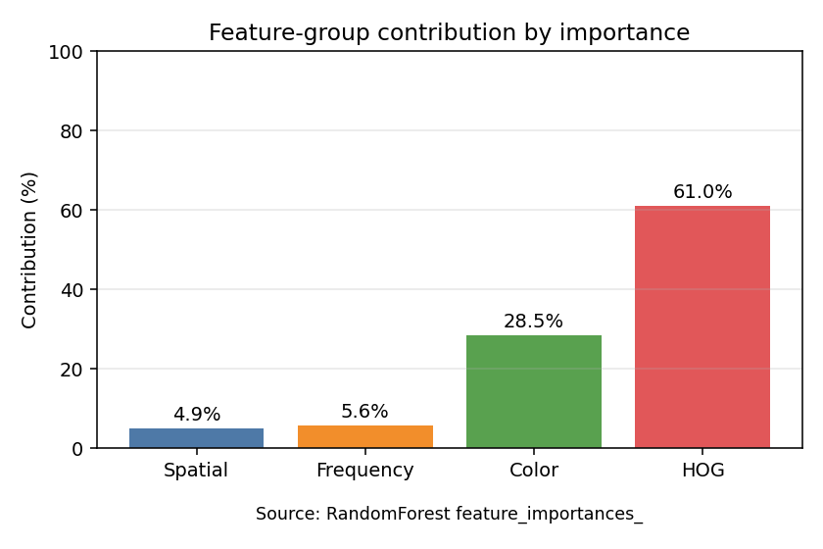
Figure 2. Current-dataset feature-domain importance.

4. PCA Compression Evidence
PCA was used to test whether the 637 handcrafted features can be compressed for smaller storage and faster inference. The important report rule is to cite the controlled classical-model sweep when claiming the small 637-to-128 loss.
Evidence | Model | Components | Explained variance | Accuracy | F1-macro | Drop
Controlled ML | Linear SVM | 637 | 100.00% | 62.43% | 0.6235 | 0.00 pp
Controlled ML | Linear SVM | 128 | 99.90% | 59.90% | 0.5947 | 2.52 pp
Controlled ML | LogReg | 637 | 100.00% | 60.24% | 0.6019 | 0.00 pp
Controlled ML | LogReg | 128 | 99.90% | 59.71% | 0.5954 | 0.52 pp
ANN-only legacy | MLP | 637 | 100.00% | 73.24% | 0.7319 weighted | 0.00 pp
ANN-only legacy | MLP | 128 | 99.90% | 68.71% | 0.6863 weighted | 4.53 pp

Correct thesis wording
Say: 'For Linear SVM in the controlled ML sweep, PCA from 637 to 128 components preserved 99.90% explained variance and reduced accuracy by 2.52 percentage points.' Do not generalize that exact drop to every model.

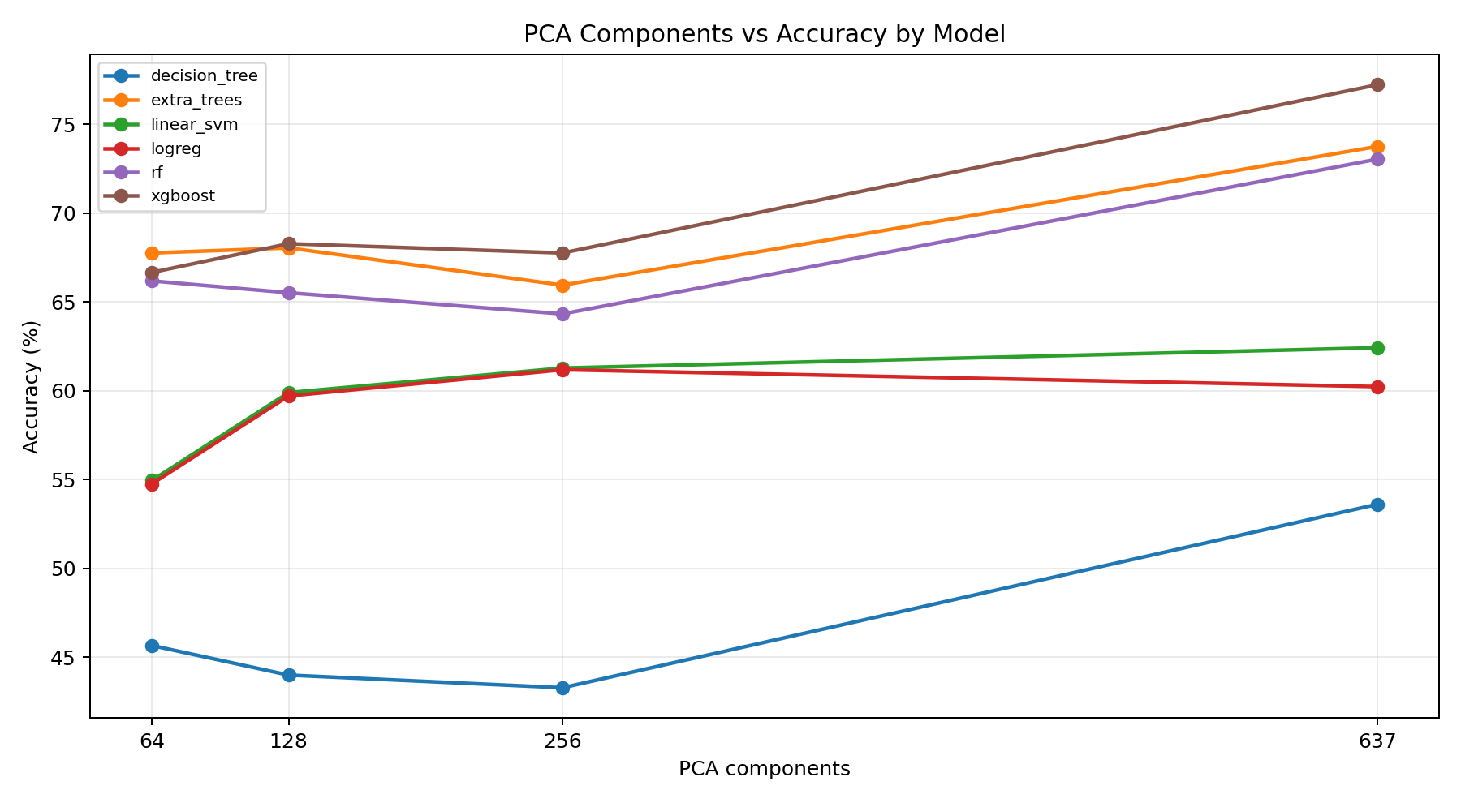
Figure 3. PCA component count versus classical-model accuracy.

5. Deep Learning Branch And Benchmark Results
The DL branch became production-facing after the project separated material classification from localization. Old YOLO-first work stays as experiment history; the final DL story uses a classification/gate stage and then a localization-only stage.
Experiment | Metric result | Decision
ML vs tiny CNN baseline | Tiny CNN accuracy 0.4813 / F1 0.4303; ML ExtraTrees and RF around 0.631 accuracy. | ML stayed the primary explainable branch.
Architecture comparison | EfficientNetB0 94.29%; ResNet50 89.76%; MobileNetV2 85.43%. | EfficientNetB0 justified as compact high-accuracy classifier evidence.
Hard-case ConvNeXt | Test accuracy 93.88%; macro F1 0.9398. | Promote after local API smoke tests.
ConvNeXtV2 + 637 MLP | Test accuracy 94.55%; macro F1 0.9459; 1,405-D combined feature vector. | Best material-stage benchmark currently present.
Stage 0 trash gate | Test accuracy 97.81%; macro F1 0.9777 across trash/not_trash/hand/bin. | Useful front-door filter before material routing.

Deep model | Accuracy | Size | CPU latency | Use
MobileNetV2 | 85.43% | 20.07 MB | 253.5 ms | Lightweight baseline.
ResNet50 | 89.76% | 161.52 MB | 163.1 ms | Large baseline; high size cost.
EfficientNetB0 | 94.29% | 29.21 MB | 288.6 ms | Primary historical classifier choice.
ConvNeXt hard-case | 93.88% | PyTorch .pth | not listed here | Current hard-case tuned classifier.
ConvNeXtV2 + 637 MLP | 94.55% | joblib head | 68.53 ms mean CPU | Current strongest material benchmark.

YOLO detector benchmark | mAP50 | mAP50-95 | Precision | Recall | Mean latency
old_yolo11 | 0.6693 | 0.4961 | 0.7447 | 0.5930 | 50.14 ms
new_yolo26n | 0.6723 | 0.5054 | 0.7569 | 0.5922 | 52.11 ms

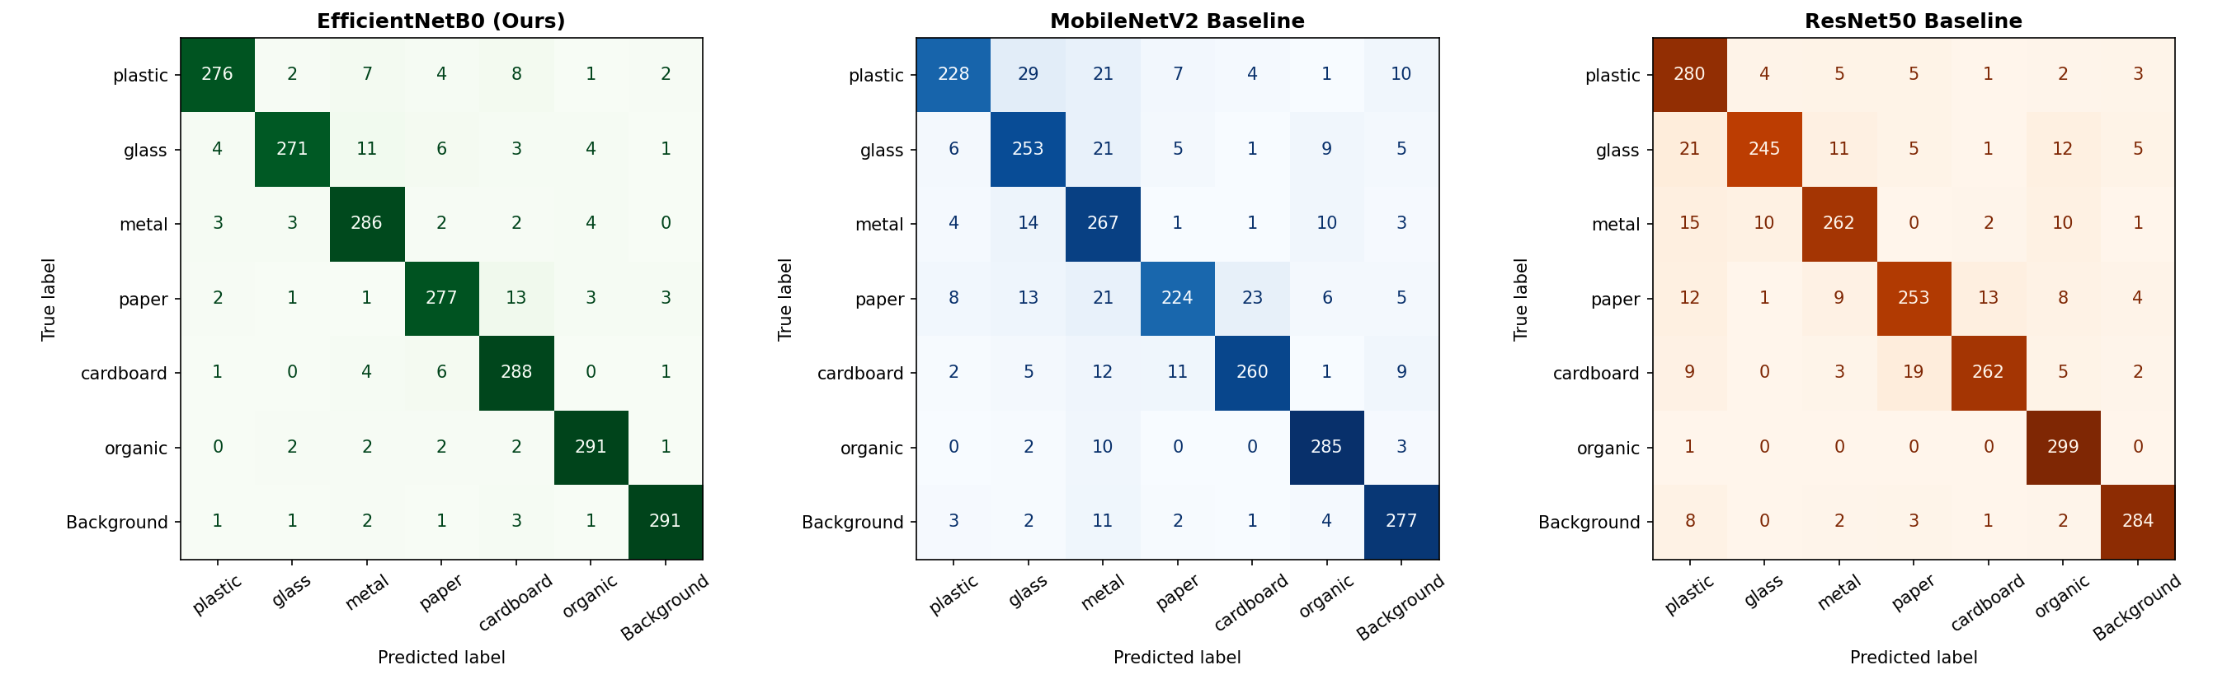
Figure 4. DL architecture confusion-matrix grid.

6. Final DL Workflow: Classification First, Localization Second
The current final DL workflow answers two questions separately: first, what class evidence is visible; second, where object evidence appears. YOLO is used as the Stage 2 box localizer, not as the final material classifier.
Stage | Implementation | Metric
Stage 0 | Trash-state gate: trash, not_trash, hand, bin. | Accuracy / macro F1.
Stage 1 | Material classifier/gate using ConvNeXt/EfficientNet and handcrafted features. | Accuracy, macro F1, calibration, class confusion.
Stage 2 | YOLO localization-only module or Grad-CAM baseline. | Precision, recall, F1, matched IoU, TP/FP/FN.
Decision logic | Review gate for uncertain or out-of-distribution scans. | Wrong confident route reduction.

Stage 2 localizer | Images | GT boxes | Pred boxes | TP | FP | FN | Precision | Recall | F1 | Mean IoU
Grad-CAM baseline | 60 | 261 | 74 | 19 | 55 | 242 | 0.2568 | 0.0728 | 0.1134 | 0.7127
YOLO conf=0.25 | 60 | 261 | 233 | 148 | 85 | 113 | 0.6352 | 0.5670 | 0.5991 | 0.9012
YOLO conf=0.30 | 300 | 1,152 | 943 | 660 | 283 | 492 | 0.6999 | 0.5729 | 0.6301 | 0.9057
YOLO conf=0.35 | 300 | 1,152 | 815 | 617 | 198 | 535 | 0.7571 | 0.5356 | 0.6274 | 0.9043
YOLO conf=0.40 | 300 | 1,152 | 738 | 593 | 145 | 559 | 0.8035 | 0.5148 | 0.6275 | 0.9050

Promoted localization setting
`--localizer yolo --yolo-conf 0.30` is promoted because it gives the best F1 and recall among the 300-image threshold checks while keeping mean matched IoU above 0.90.

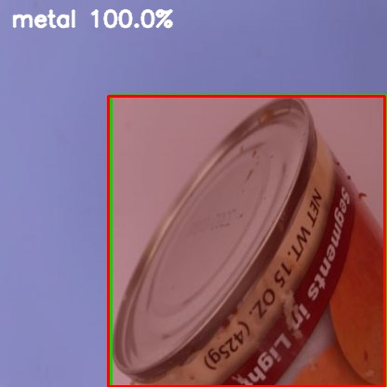
Figure 5. Example localization-first crop-verification output.

7. Production Build-Up
Production is represented by a web/API scanner for public demonstration. The web scanner is the primary production path because it is tied to local PyTorch/YOLO model artifacts and Hugging Face Space deployment notes.
Surface | Built | Current production note
Web scanner | Plain HTML/CSS/JS frontend with Python model API in `web/server.py`. | Uses uploads, no static demo samples; saves browser History; local model API falls back only when unavailable.
Backend models | ConvNeXt + 637-feature classifier, scaler, YOLO detector, crop verification, review gate. | YOLO settings restored to `imgsz=960`, `max_det=80`, crop verification 80.
Hugging Face Space | Space `khoaphung/wastewise-ai` updated. | Review-gate update deployed at commit `7a8af57ec3c3efc5fa468d08c0f79c5e5b1f8f46`.

- Local production smoke path: run `web/server.py --port 4178`, upload real images, and verify material, confidence, route, waste state, and review flag.
- Deployment path: run `scripts/deploy_hf_space.py` after replacing stable model artifacts and checking `/api/health`.

8. Literature, Books, Datasets, And Technical References
This section links the local implementation choices to primary papers, dataset pages, official docs, and reference books. These are not substitutes for local run metrics; they explain why the selected methods are technically relevant.
Reference | Why it matters to WasteWise | URL
YOLO original paper | Single-stage real-time object detection foundation. | https://arxiv.org/abs/1506.02640
Ultralytics YOLO11 docs | Localizer family used in the project and cited as software/docs rather than a formal YOLO11 paper. | https://docs.ultralytics.com/models/yolo11/
Ultralytics YOLO26 docs | New detector family benchmarked locally against YOLO11. | https://docs.ultralytics.com/models/yolo26/
ConvNeXt | Modern ConvNet backbone family used for material classifier direction. | https://arxiv.org/abs/2201.03545
EfficientNet | Architecture-comparison baseline and historical tuned classifier. | https://arxiv.org/abs/1905.11946
ResNet | Deep residual baseline in architecture comparison. | https://arxiv.org/abs/1512.03385
MobileNet | Mobile/edge classification baseline. | https://arxiv.org/abs/1704.04861
HOG | 576 of 637 handcrafted ML features come from HOG texture/shape descriptors. | https://lear.inrialpes.fr/people/triggs/pubs/Dalal-cvpr05.pdf
SIFT | Classical local-feature context for handcrafted vision descriptors. | https://www.cs.ubc.ca/~lowe/papers/ijcv04.pdf
TACO | Real-world litter detection/segmentation source and YOLO hard-case source. | https://arxiv.org/abs/2003.06975
TrashNet | Classic clean-background waste classification reference dataset. | https://github.com/garythung/trashnet
RealWaste | Real landfill-style hard-case classification source. | https://archive.ics.uci.edu/dataset/908/realwaste
ZeroWaste | Industrial cluttered waste detection/segmentation context. | https://arxiv.org/abs/2106.02740
Hugging Face Docker Spaces | Deployment surface for web/API production demo. | https://huggingface.co/docs/hub/spaces-sdks-docker
Ultralytics TFLite export | Model export path relevant to mobile/edge deployment. | https://docs.ultralytics.com/integrations/tflite/
Szeliski CV book | General computer vision theory reference. | https://szeliski.org/Book/
Deep Learning book | General deep learning theory reference. | https://www.deeplearningbook.org/
TinyML book | Reference for mobile/edge ML constraints. | https://www.oreilly.com/library/view/tinyml/9781492052036/

9. Local Artifact Evidence Index
Artifact | Path | Use
README | README.md | Current high-level project positioning, dataset paths, branch split, and commands.
Workflow decision | docs\01_final_report\WORKFLOW_APPROACHES_AND_DL_REWORK.md | Explains current ML final branch and DL localization-first classification hierarchical pipeline.
Project tracker | docs\NOTION_PROJECT_TRACKER.md | Status board, task board, and final report wording.
Cleanup notes | docs\PROJECT_STRUCTURE_AND_CLEANUP.md | Canonical folders, active datasets, and current result folders.
Dataset EDA | docs\02_dataset_training\DATASET_EDA_AND_TUNING_REPORT.md | Baseline/tuned dataset cleaning and class-balance evidence.
External registry | docs\02_dataset_training\external_dataset_registry.json | Downloaded/candidate external datasets, sizes, risks, and actions.
Source-level dataset analysis | docs\02_dataset_training\SOURCE_LEVEL_DATASET_ANALYSIS.md | Lecturer-directed source-level EDA and per-source ANN/CNN runs.
Model improvement plan | docs\02_dataset_training\MODEL_IMPROVEMENT_PLAN.md | Hard-case data, classifier retraining, YOLO resume, and Hugging Face deployment notes.
Current ML rerun | runs\ml\feature_ml_super_yolo_6class_4k\REPORT.md | Newest-dataset 637-feature ML run on super_yolo_dataset.
Legacy ML run | runs\ml\feature_ml_lecturer_6class_4k\REPORT.md | Lecturer-facing legacy merged_dataset_v3 637-feature ML benchmark.
PCA sweep | runs\ml\pca_feature_model_sweep\PCA_Model_Sweep_Report.md | Controlled 637-to-PCA component sweep across classical models.
DL localization sweep | runs\dl\localization_rework\THRESHOLD_SWEEP_300.md | 300-image Stage 2 localization threshold comparison.
Hard-case classifier | runs\dl\convnext_hardcase_tuned\RESULT.json | ConvNeXt hard-case classifier accuracy and macro-F1.
ConvNeXtV2 material benchmark | runs\dl\convnextv2_material_stage1_benchmark\RESULT.json | ConvNeXtV2 + 637-feature MLP benchmark and latency.
Stage 0 gate | runs\dl\convnextv2_stage0_trash_gate\RESULT.json | Trash/not-trash/hand/bin gate model metrics.
YOLO11 vs YOLO26 benchmark | runs\detect\yolo11_vs_yolo26_benchmark.json | Hard-case detector comparison with mAP and latency.
Web app | web\README.md | Local model API, scanner workflow, and deployment scope.

10. Final Production Checklist
Checklist item | Status | Evidence / next proof
Dataset registry complete | Mostly done | Current registry names full hard-case downloads and candidate datasets.
ML explainability branch | Done | Feature extraction, model comparison, PCA, confusion matrices, feature importance.
DL classifier benchmark | Done | Hard-case ConvNeXt and ConvNeXtV2+637 MLP benchmark artifacts.
DL localization benchmark | Done | 300-image threshold sweep with promoted conf=0.30.
YOLO26 promotion decision | Measured, not automatically promoted | YOLO26n improves mAP slightly but mean CPU latency is slightly slower than old YOLO11 in the local 80-image benchmark.
Web deployment | Done / needs final smoke before demo | Hugging Face Space update recorded; run local API and 10 real uploads before presentation.
Large artifact storage | Open | Keep model binaries outside Git; use release, Drive, or Hugging Face artifact workflow.

Final report wording
Use this concise position: 'WasteWise final evidence separates explainable ML classification from DL localization. The ML branch reports accuracy, macro-F1, PCA, and feature importance. The DL branch reports localization precision, recall, F1, and matched IoU for the 2-stage hierarchical pipeline. The alternative classification-first Grad-CAM pipeline is retained as experiment comparison.'

