WasteWise - Diem can hoi giang vien huong dan
6 diem chua nhat quan / chua ro rang giua Final Report va cac tai lieu, log ky thuat cua chinh du an - kem bang chung trich tu file goc.
Tai lieu nay khong phai de "bat loi" bao cao - tat ca cac diem duoi day deu xuat phat tu chinh cac file trong repo (Final Report, README, Failures log). Muc dich la de em chu dong hoi co/thay truoc khi nop, thay vi bi hoi bat ngo trong buoi bao ve.

1. Ba con so "accuracy cuoi cung" khac nhau cho cung mot model, chua ro so nao la chinh thuc
Final Report (ban REVISED) chot o Abstract va muc 6.4: ConvNeXt dat 92.52% val / 93.88% test sau khi hard-case retrain. Day la so duoc dung xuyen suot bao cao.
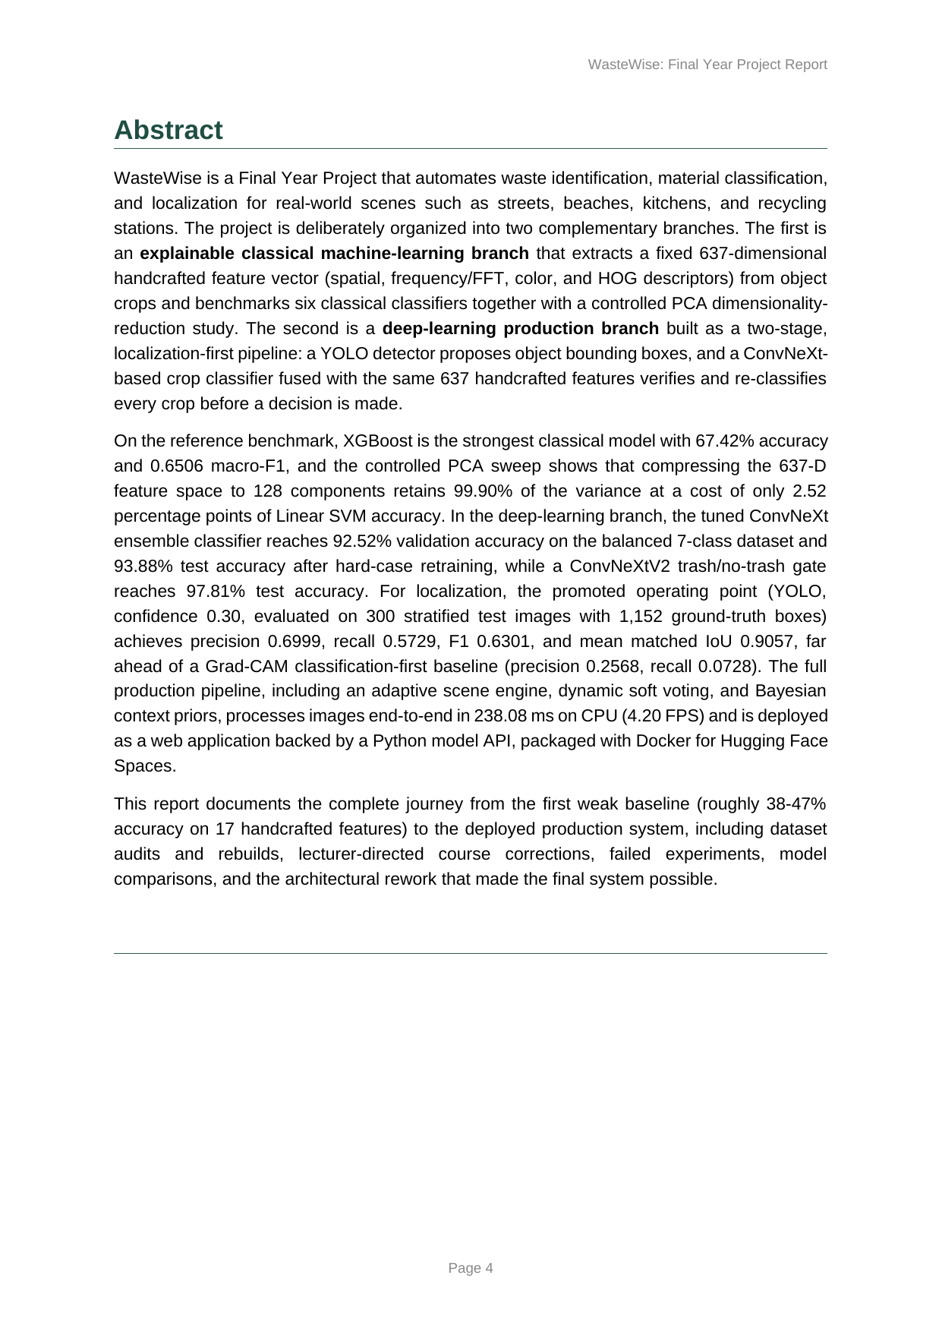
Anh 1 - Trang 4 (Abstract) cua WasteWise_FYP_Final_Report_REVISED.docx: so 92.52% / 93.88% duoc neu la ket qua chinh.
Nhung file WasteWise_Final_Model_Results.docx (2/7, tai lieu xin duyet truoc khi khoa bao cao) lai de ngo DECISION 2: chon hard-case ConvNeXt (93.88%) hay ban dang deploy thuc te (92.52%) - va hoi co can cap nhat lai web deployment cho khop khong. Khong thay bang chung quyet dinh nay da duoc chot truoc khi Final Report REVISED (4/7) ra doi.
Sau do, FAILURES_AND_FIXES.md (muc F1, audit ro ri du lieu ngay 2-3/7) do lai dung model 93.88% nay tren tap test da lam sach (loai anh trung) va ra so 92.93% - thap hon so report dang dung. Roi mot fine-tune khac nua (F4b, 3/7) tao ra ban deploy thu ba voi 93.77% (tren crop sach) / 88.88% (tren crop thuc te do YOLO cat ra) - con so nay duoc README.md goi la so nen trich dan ("QUOTE THIS"), nhung lai khong xuat hien trong Final Report.
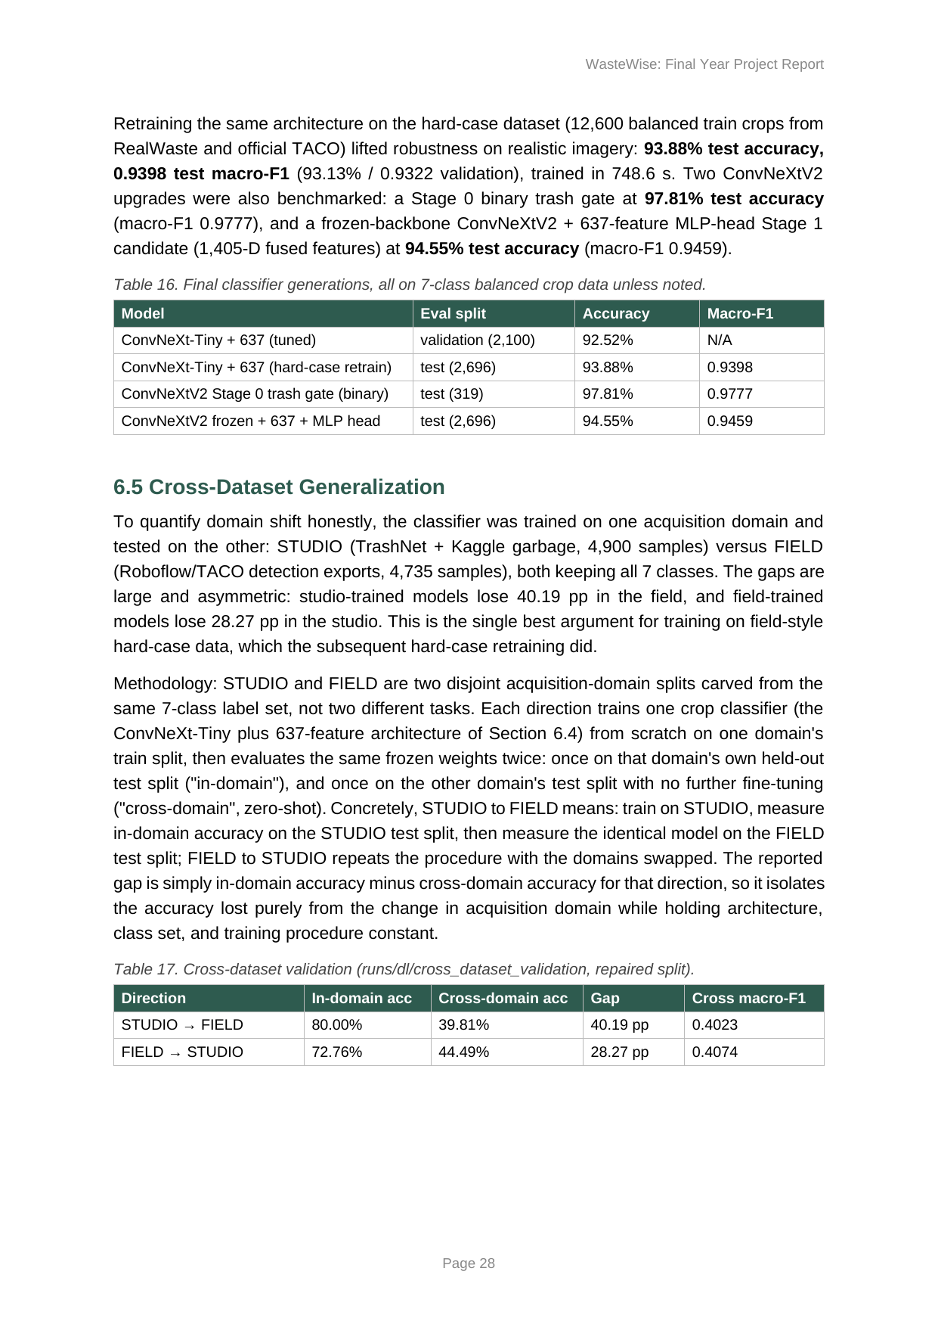
Anh 2 - Trang 28 cua Final Report, doan neu 93.88% test / 0.9398 macro-F1 la ket qua hard-case retraining.
Cau hoi goi y cho giang vien: trong 4 con so (92.52% / 93.88% / 92.93% / 93.77%), so nao nen la so "chinh thuc" trong bao cao, va bao cao co can ghi ro moi quan he giua cac so nay khong?

2. Final Report hoan toan khong nhac den viec audit ro ri du lieu (data leakage) giua cac tap train/test
README.md va tai lieu chuan bi demo cho giang vien (docs/03_lecturer_notes/DEMO_PREP_2026_07_03.md) deu noi day la "bang chung manh nhat", "dieu gay an tuong nhat voi hoi dong": dung perceptual hash (dHash) quet ~79.000 anh, phat hien 43% anh trong tap test cua classifier trung voi anh train, tu sua lai so lieu (94.30% -> 91.77%).
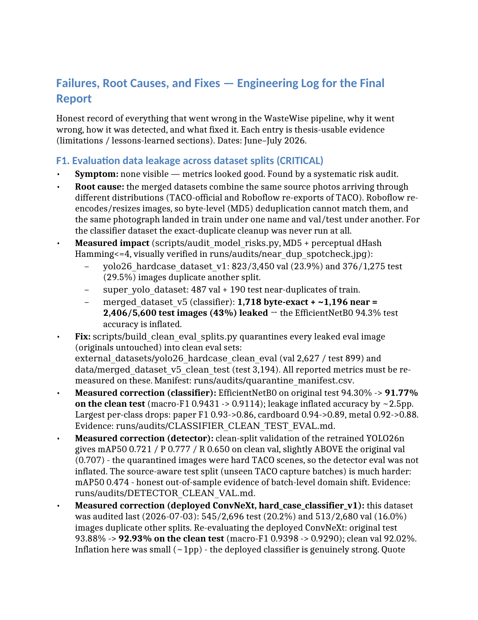
Anh 3 - Trang 1 cua FAILURES_AND_FIXES.md, muc F1: mo ta day du phat hien ro ri du lieu va cach khac phuc (script, so lieu, file bang chung).
Bang chung anh goc do chinh script tao ra (runs/audits/near_dup_spotcheck.jpg) - anh xac minh truc quan cac cap anh gan-trung lap ma audit tim thay:
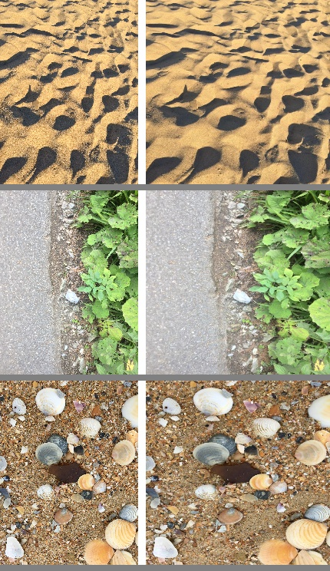
Anh 4 - runs/audits/near_dup_spotcheck.jpg: bang chung truc quan cac anh trung lap giua train/test do audit phat hien.
Nhung tim tu khoa "quarantine", "dHash", "perceptual", "audit_model_risks" trong toan bo file WasteWise_FYP_Final_Report_REVISED.docx: 0 ket qua. Bao cao hoan thanh ngay 4/7, tuc la SAU KHI audit nay da xong (2-3/7), nhung cau chuyen audit - duoc chinh em coi la diem manh nhat - lai khong co trong ban bao cao se nop.
Cau hoi goi y cho giang vien: cau chuyen audit ro ri du lieu co bat buoc phai dua vao chuong 3 (Datasets) hoac chuong 11 (Discussion) cua Final Report khong, hay chi can trinh bay mieng khi bao ve?

3. Muc 7.3 cua bao cao dung mot bo du lieu "real-world" ma sau do chinh du an phat hien la ro ri 74%
Muc 7.3 cua Final Report so sanh YOLOv11 (dang deploy) voi YOLO26n tren bo balanced_realworld_v2, ket luan day la "canh bao": kien truc moi + du lieu moi khong tu nhien tot hon.
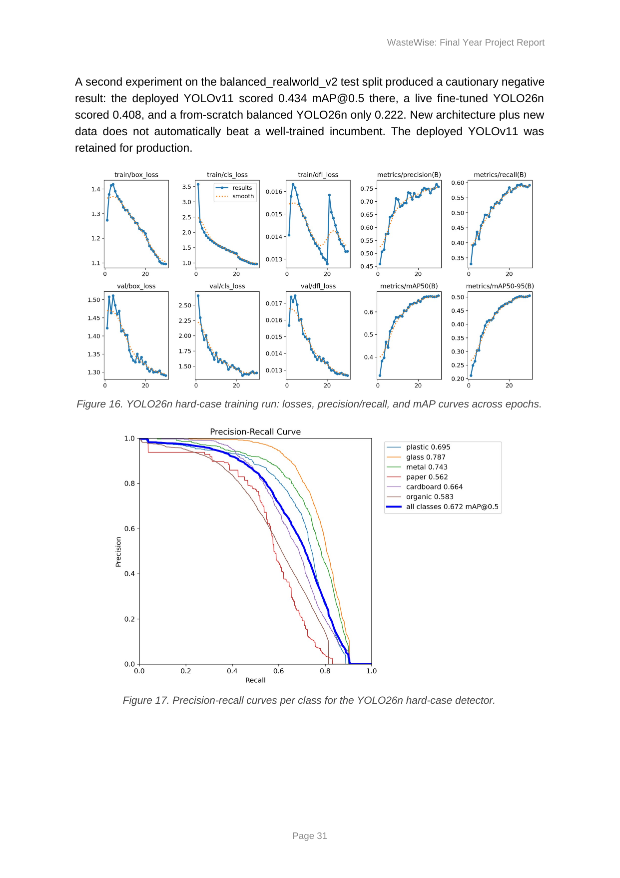
Anh 5 - Trang 31 Final Report: doan dung balanced_realworld_v2 lam bang chung "cautionary negative result".
Nhung FAILURES_AND_FIXES.md muc F10 (5/7, sau khi report da viet xong) phat hien: bo nay duoc tao ra bang cach lay lai chinh du lieu train cua yolo26_hardcase_dataset_v1 roi doi ten file, nen 53/72 (74%) anh test cua no trung byte-for-byte voi anh TRAIN cua detector dang deploy - tuc day khong phai du lieu moi, khong phai "real-world" doc lap, va bi chinh du an "retired from any accuracy claim".
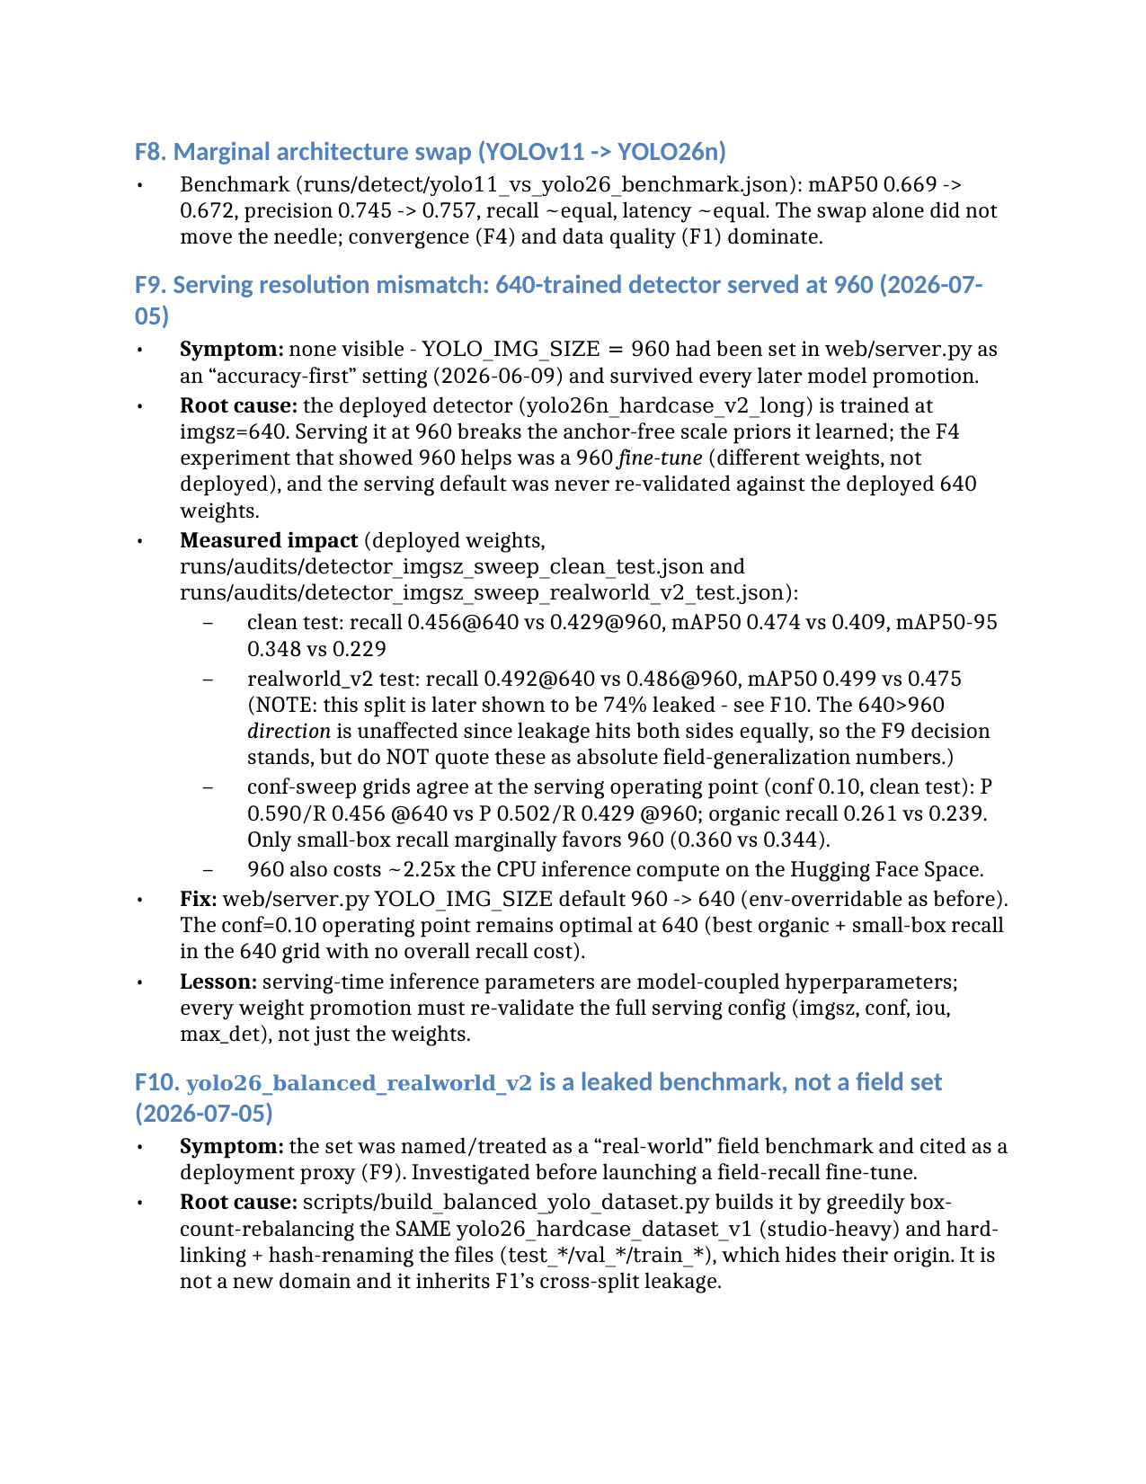
Anh 6 - FAILURES_AND_FIXES.md muc F10: ket luan balanced_realworld_v2 la benchmark bi ro ri, khong phai bo field-data.
Tai lieu docs/PROJECT_STRUCTURE_AND_CLEANUP.md hien van con mo ta bo nay la "Current real-life false-positive benchmark dataset" - mau thuan truc tiep voi ket luan F10.
Cau hoi goi y cho giang vien: muc 7.3 co can them ghi chu/loai bo vi bo du lieu dung de so sanh da bi chung minh la khong hop le khong?

4. Nguong confidence 0.30 trong bao cao khong khop voi cau hinh thuc te dang chay
Bao cao (muc 4.3.1 va cac bang o chuong 7-8) mo ta "the promoted operating point" cua YOLO la confidence 0.30, va moi so lieu localization duoc trich dan o muc nay.
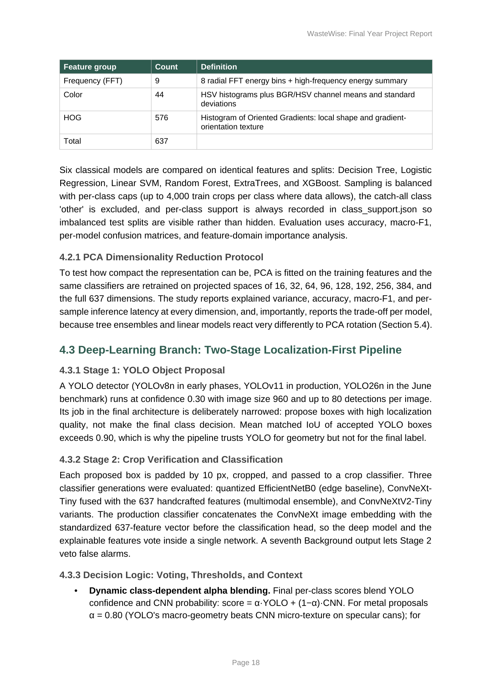
Anh 7 - Trang 18 Final Report: "A YOLO detector ... runs at confidence 0.30 ...".
Nhung theo FAILURES_AND_FIXES.md, nguong conf thuc te da doi nhieu lan sau do: F5 (0.30->0.10, 4/7), roi F13 (0.10->0.04, 5/7) - trong khi nguong "gate" quyet dinh waste/not_waste van giu 0.30 rieng biet. Day la hai khai niem khac nhau (nguong nhan box vs. nguong gate) nhung bao cao chi nhac mot so 0.30 ma khong phan biet, va khong neu la nguong nhan box da doi.
Cau hoi goi y cho giang vien: bao cao co can cap nhat de phan biet ro "confidence nhan box" (da doi 0.30->0.10->0.04) va "gate quyet dinh waste" (van 0.30) khong?

5. Chua ro ban demo truc tuyen (Hugging Face Space) da cap nhat cac fix moi nhat hay chua
README.md dan link demo truc tuyen: https://khoaphung-wastewise-ai.hf.space. Nhung FAILURES_AND_FIXES.md co nhieu muc ghi ro trang thai "Pending: HF Space redeploy" (F13, F14) va "HF redeploy pending" (F15) - deu la cac fix duoc danh gia quan trong (field recall +8-17pp, sua loi glass->plastic).
Neu nhung fix nay (den ngay 5/7) chua duoc day len Space, thi ban demo co/thay xem truc tiep co the khong phan anh model "dang deploy" ma bao cao mo ta.
Viec can lam truoc buoi gap: kiem tra lai xem da redeploy Hugging Face Space chua; neu chua, noi ro voi giang vien ban demo hien tai dang chay config nao.

6. So lop (class) cua nhanh YOLO: 6 hay 7, "other" hay "Background"?
Tai lieu phan hoi giang vien cu (docs/03_lecturer_notes/GIANG_VIEN_PHAN_HOI.md, 14/5) ghi: YOLO/DL detector train voi nc=7 (gom ca lop "other"), con nhanh ML classical chi dung 6 lop (loai "other").
Final Report hien tai (muc 1.3) lai mo ta khac: YOLO chi dung 6 lop vat lieu (khong co "other"/"Background"); con nhanh classification (crop classifier) moi dung 7 lop, voi lop thu 7 goi la "Background" (dung de loai bo bao dong gia cua YOLO) - vai tro va ten goi khac voi "other" o tai lieu cu.
Co kha nang day chi la do du an da thay doi cach chia lop theo thoi gian (tu nc=7 sang nc=6 cho YOLO), va tai lieu cu chua duoc cap nhat - khong phai loi sai, nhung nen xac nhan lai de khong bi hoi nguoc lai la "tai lieu nao dung".
Cau hoi goi y cho giang vien: xac nhan cach chia lop hien tai (YOLO 6 lop vat lieu, classifier 7 lop gom Background) la ban cuoi cung, va tai lieu phan hoi cu co can cap nhat lai khong.

Tom tat nhanh de mang theo
Bang duoi liet ke tung diem, file bang chung cu the (co the mo truc tiep tren may), de tien tra cuu khi giang vien hoi lai.
# | Diem chua ro | File bang chung
1 | 3-4 so accuracy classifier khac nhau, chua chot so chinh thuc | Final_Report_REVISED.docx (tr.4,28); Final_Model_Results.docx; FAILURES_AND_FIXES.md F1/F4b
2 | Bao cao khong nhac audit ro ri du lieu (leakage) | FAILURES_AND_FIXES.md F1; runs/audits/near_dup_spotcheck.jpg; README.md
3 | Muc 7.3 dung benchmark sau nay bi phat hien ro ri 74% | Final_Report_REVISED.docx (tr.31); FAILURES_AND_FIXES.md F10
4 | Conf 0.30 trong bao cao loi thoi so voi deploy thuc te (da doi 0.10->0.04) | Final_Report_REVISED.docx (tr.18); FAILURES_AND_FIXES.md F5/F9/F13
5 | Chua ro demo online da cap nhat fix moi nhat chua | README.md; FAILURES_AND_FIXES.md F13/F14/F15 ("redeploy pending")
6 | So lop YOLO 6 vs 7 khac nhau giua tai lieu cu va report | GIANG_VIEN_PHAN_HOI.md; Final_Report_REVISED.docx (muc 1.3)

