WasteWise Project Tracking Report
  - Final Year Project: automated waste classification, feature-based ML, and classification-first localization
Current project position
Current datasets are `external_datasets/super_yolo_dataset` for YOLO localization and `data/merged_dataset_v5` for classification. Older `merged_dataset_v3` results remain useful historical ML evidence, but they should not be described as the newest dataset.

Area | Current status | Main evidence
Dataset | Use newest datasets for current tracking. | super_yolo_dataset: 23,929 images / 102,777 boxes; merged_dataset_v5: 29,639 classification images.
ML | Keep as main explainable pipeline, but rerun if all final metrics must use newest data. | Legacy/stable lecturer artifact: 637 handcrafted features; XGBoost accuracy 0.6742, F1-macro 0.6506.
PCA | Completed but final claim must match artifact. | 637 -> 128 components keeps 99.90% variance; current artifact shows 4.53 pp accuracy drop.
DL classification | Use as comparison / gate, not final localization metric. | EfficientNetB0 crop classifier 94.29% in architecture comparison.
DL localization | Improved after Stage 2 rework. | YOLO localization-only conf=0.35: precision 0.7614, recall 0.5134, mean IoU 0.9004.
Mobile | Implementation exists, physical validation still required. | Expo app, TFLite model assets, scan/history/settings UI.

1. Project Goal And Scope
WasteWise is an FYP system for automated waste recognition and sorting. The work now separates explainable Machine Learning evidence from Deep Learning localization evidence, so each branch can be reported honestly and evaluated with the right metric.
- Primary ML goal: classify waste object crops using lecturer-explainable handcrafted features.
- Primary DL goal after rework: perform classification first, then localize objects as a localization-only task.
- Deployment direction: mobile/edge-ready inference with sorting guidance, history, and settings.

2. Dataset Tracking
Newest datasets detected in the workspace are listed below. These should be treated as the current dataset sources for the report. Older dataset names are retained only when a specific saved experiment was produced from them.
YOLO class | Train boxes | Val boxes | Test boxes | Total boxes
plastic | 18,418 | 1,568 | 1,668 | 21,654
glass | 7,186 | 2,488 | 9 | 9,683
metal | 8,785 | 1,800 | 542 | 11,127
paper | 4,731 | 188 | 1,347 | 6,266
cardboard | 7,433 | 1,614 | 35 | 9,082
organic | 32,171 | 12,748 | 46 | 44,965
Total boxes | 78,724 | 20,406 | 3,647 | 102,777

Dataset | Split | Images | Notes
external_datasets/super_yolo_dataset | train | 19,559 | YOLO-format images with label files.
external_datasets/super_yolo_dataset | val | 3,266 | YOLO-format images with label files.
external_datasets/super_yolo_dataset | test | 1,104 | YOLO-format images with label files.
data/merged_dataset_v5 | train | 24,039 | Classification-folder dataset; includes Background.
data/merged_dataset_v5 | test | 5,600 | Balanced 800 images per class.

merged_dataset_v5 class | Train images | Test images | Total
Background | 3,500 | 800 | 4,300
cardboard | 3,425 | 800 | 4,225
glass | 3,500 | 800 | 4,300
metal | 3,230 | 800 | 4,030
organic | 3,500 | 800 | 4,300
paper | 3,500 | 800 | 4,300
plastic | 3,384 | 800 | 4,184
Total | 24,039 | 5,600 | 29,639

Reporting note
The newest YOLO dataset is imbalanced, especially in validation/test class distribution. The newest classification dataset is much more balanced and includes a Background class. Legacy ML metrics from `merged_dataset_v3` should be labelled as legacy unless rerun on the newest dataset.

3. Machine Learning Pipeline
The ML branch is the most explainable and stable part of the project. It uses object crops from YOLO labels, resizes crops internally, extracts a fixed 637-D vector, then compares classical ML models.
Dataset alignment note
The model scores below come from saved lecturer-facing artifacts, not a fresh rerun on `super_yolo_dataset` or `merged_dataset_v5`. To make the final thesis fully newest-dataset-aligned, rerun feature extraction and ML model comparison on the newest selected dataset.

Feature group | Count | Purpose
Spatial | 8 | Intensity, gradients, edge density.
Frequency / FFT | 9 | Radial frequency energy and high-frequency texture.
Color | 44 | HSV histograms plus BGR/HSV mean and standard deviation.
HOG | 576 | Local shape and gradient-orientation texture.
Total | 637 | Fixed handcrafted representation for explainable ML.

Model | Accuracy | F1-macro | Decision
XGBoost | 0.6742 | 0.6506 | Best lecturer-facing ML result.
Random Forest | 0.6317 | 0.6111 | Useful for feature importance.
ExtraTrees | 0.6312 | 0.6113 | Strong high-dimensional tree baseline.
Linear SVM | 0.5960 | 0.5642 | Margin-based baseline.
Logistic Regression | 0.5864 | 0.5558 | Linear standardized baseline.
Decision Tree | 0.5115 | 0.4883 | Simple interpretable baseline.

Feature importance group | Importance
HOG | 59.5808%
Color | 29.2090%
Frequency | 5.6582%
Spatial | 5.5520%

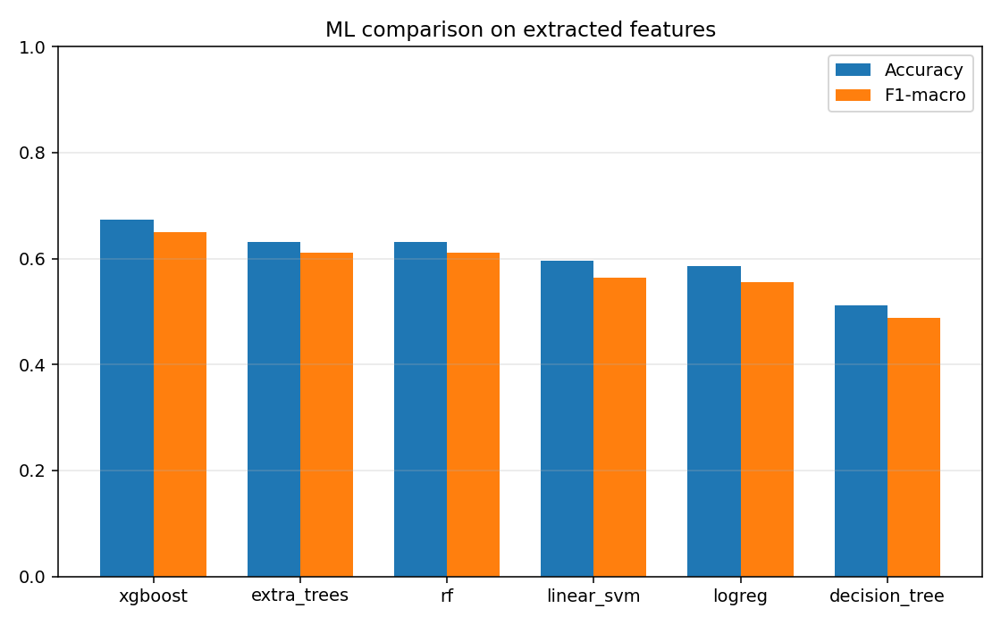
Figure 1. Classical ML model comparison.
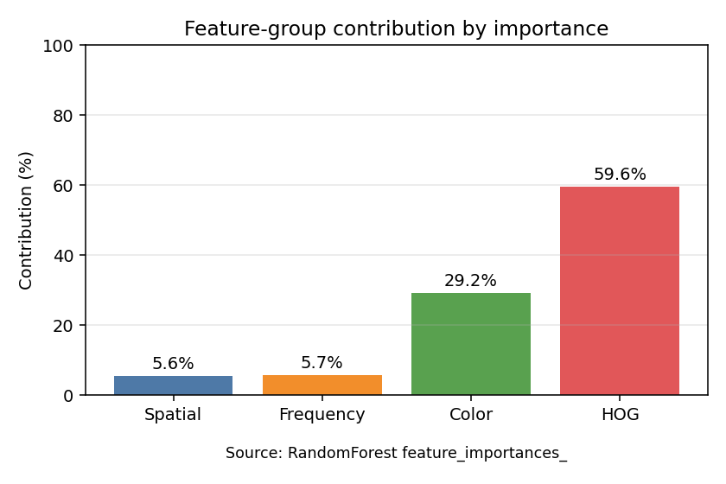
Figure 2. Feature group / domain importance.

4. PCA Dimensionality Reduction
Components | Explained variance | Accuracy | Weighted F1 | Latency
637 | 100.00% | 73.24% | 0.7319 | 0.0533 ms
64 | 99.78% | 67.48% | 0.6736 | 0.0284 ms
128 | 99.90% | 68.71% | 0.6863 | 0.0314 ms
256 | 99.97% | 66.95% | 0.6691 | 0.0296 ms

PCA claim control
Current artifact shows 637 -> 128 drops accuracy from 73.24% to 68.71%, a 4.53 percentage-point drop. If slides need to say around 2%, rerun PCA or replace with the matching artifact.

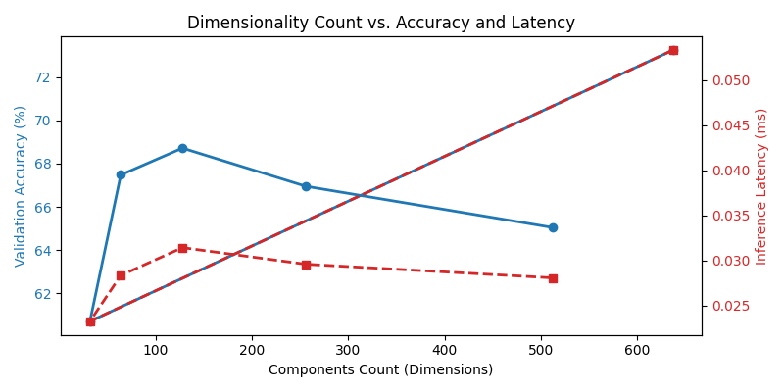
Figure 3. PCA component count vs accuracy and latency.

5. Deep Learning Experiments
Experiment | Result | Use in final report
ANN/CNN crop baselines | Tuned ANN accuracy 0.4057; tuned CNN accuracy 0.4413. | Baseline evidence only.
CNN + ANN soft voting | 50/50 ensemble accuracy 78.69%, macro F1 78.12%. | Shows feature complementarity.
Architecture comparison | EfficientNetB0 94.29%; ResNet50 89.76%; MobileNetV2 85.43%. | Supports EfficientNetB0 as classifier/gate.
Old 2-stage pipeline | YOLO localization -> EfficientNetB0 verification; 100-image sweep had 295 accepted from 348 proposals. | Experimental evidence; not final direction.

Deep model | Accuracy | Size | Latency
MobileNetV2 | 85.43% | 20.07 MB | 253.5 ms
ResNet50 | 89.76% | 161.52 MB | 163.1 ms
EfficientNetB0 | 94.29% | 29.21 MB | 288.6 ms

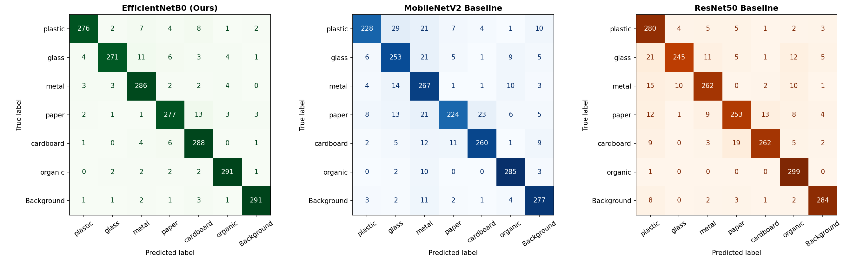
Figure 4. Deep model confusion matrix grid.

6. Final DL Rework: Classification First, Localization Second
The new DL requirement is reversed from the old YOLO-first pipeline. Stage 1 classifies or gates the image first. Stage 2 performs localization only. The class decision and box localization are tracked separately.
Stage | Role | Current implementation
Stage 1 | Classification / image-level gate | EfficientNetB0 classifier predicts image/crop class and diagnostic confidence.
Stage 2 | Localization only | YOLO model is used only to output bounding boxes; YOLO class is not the final classifier.
Evaluation | Localization metrics | IoU@0.5 matching, precision, recall, mean matched IoU.

Stage 2 localizer | Precision | Recall | Mean IoU | TP | FP | FN
Grad-CAM baseline | 0.2568 | 0.0728 | 0.7127 | 19 | 55 | 242
YOLO localization-only, conf=0.25 | 0.6352 | 0.5670 | 0.9012 | 148 | 85 | 113
YOLO localization-only, conf=0.35 | 0.7614 | 0.5134 | 0.9004 | 134 | 42 | 127

Recommended DL localization setting
`--localizer yolo --yolo-conf 0.35` gives the best quick-check balance: higher precision, still useful recall, and high localization IoU.

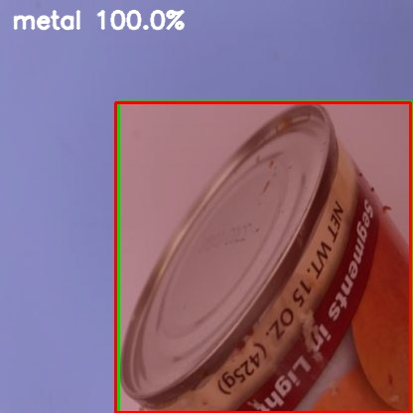
Figure 5. Example classification-first / YOLO localization-only output.

7. Mobile Application Tracking
Component | Status
Framework | Expo Dev Client / React Native mobile app in `mobile/`.
Inference | Vision Camera + `react-native-fast-tflite` + YOLO post-processing.
Model assets | `best_float16.tflite`, `best_float32.tflite`, `best_metadata.json`.
User features | Live scan, result page, history, settings, sorting guidance, leaderboard skeleton.
Validation gap | Physical Android device or emulator runtime validation still required.

8. Reproducible Commands
Task | Command / path
Feature ML run | .\.venv311\Scripts\python.exe scripts\feature_ml_analysis.py --data merged_dataset_v3\data.yaml --out runs\ml\feature_ml_lecturer_6class_4k --exclude-classes other --max-per-class-train 4000 --max-per-class-test 800
Current YOLO dataset | external_datasets\super_yolo_dataset\data.yaml
Current classification dataset | data\merged_dataset_v5\data.yaml
PCA experiment | .\.venv311\Scripts\python.exe scripts\train_pca_ann.py
DL localization rework | .\.venv311\Scripts\python.exe scripts\classification_to_localization_pipeline.py --max-images 60 --sample-mode stratified --seed 42 --localizer yolo --yolo-conf 0.35 --out-dir runs\dl\localization_rework\yolo_conf035_stratified60_final
Mobile static check | cd mobile && node .\node_modules\typescript\bin\tsc --noEmit

9. Artifact Index
Area | Key artifact
Workflow summary | docs\01_final_report\WORKFLOW_APPROACHES_AND_DL_REWORK.md
Current workflow/report notes | docs\01_final_report\WORKFLOW_APPROACHES_AND_DL_REWORK.md
Newest YOLO dataset | external_datasets\super_yolo_dataset
Newest classification dataset | data\merged_dataset_v5
ML lecturer run | runs\ml\feature_ml_lecturer_6class_4k\REPORT.md
PCA report | runs\dl\pca_experiments\PCA_Dimensionality_Report.md
ML vs DL comparison | runs\comparisons\model_comparison\REPORT.md
DL architecture comparison | runs\dl\comparison_models\model_comparison_report.md
DL localization improved | runs\dl\localization_rework\yolo_conf035_stratified60_final\REPORT.md
Mobile model assets | mobile\assets\model

10. Next Actions
- Keep ML pipeline as the main explainable result and avoid changing its artifact paths unless rerunning all tables.
- Decide whether to keep PCA artifact as-is or rerun if the final presentation must claim about 2% accuracy loss.
- Use the classification-first YOLO-localization run for DL localization evidence.
- Run mobile app on a physical Android device or emulator and record FPS, detection stability, and model toggle behavior.
- Add final thesis text explaining why classification accuracy and localization metrics are reported separately.

