|  |
| --- |
|  |
| **RTL_EXERCISE_1 BOUND FLASHER** |
|  |
| |  |  | | --- | --- | | Author | Phạm Đức Anh Khoa | | Date | 2023/02/18 | | Version | 1.0 | |
|  |
|  |

|  |
| --- |
|  |

Contents

1. Interface 2

2. Functional implementation. 3

3. Internal implementation. 5

3.1. Overall. 5

3.2. State Machine 6

4. History 7

# 1. Interface

|  |
| --- |
| reset  flick  Lamp [15:0]  clk  16 |
| **bound_flasher**  Figure 1: the figure of Bound Flasher System |

|  |  |  |  |
| --- | --- | --- | --- |
| Signal | Width | In/Out | Description |
| clk | 1 | In | Clock signal |
| flick | 1 | In | Flick signal for lamp state changing |
| reset | 1 | In | Active reset to go back to initial state |
| Lamp | 16 | Out | Lamp after bound flasher processing |

Table 1: Description of signals in Bound Flasher

# 2. Functional implementation.

* Implement a 16-bits LEDs system
* System’s Operation base on three input signal
  + Reset
  + Clock
  + Flick
* The system specification
* Clock signal is provided for system inspire of function status. The function operate state’s transition at positive edge of the clock signal.
* Reset signal:
* POS-EDGE Reset = 1: System is restarted to Initial State.
* NEG-EDGE Reset = 0: Nothing
* Flick signal: special input for controlling state transfer.

At the initial state, all lamps are OFF. If flick signal is ACTIVE (set 1), the flasher start operating:

1. The lamps are turned ON gradually from lamp[0] to lamp[5].
2. The lamps are turned OFF gradually from lamp[5] (max) to lamp[0] (min).
3. The lamps are turned ON gradually from lamp[0] to lamp[10].
4. The lamps are turned OFF gradually from lamp[10] (max) to lamp[5] (min).
5. The lamps are turned ON gradually from lamp[5] to lamp[15].
6. Finally, the lamps are turned OFF gradually from lamp[15] to lamp[0], return to initial state. Additional condition: - At each kickback point (lamp[5] and lamp[10]), if flick signal is ACTIVE, the lamps will turn OFF gradually again to the min lamp of the previous state, then continue operation as above description. For simple, kickback point is considered only when the lamps are turned ON gradually, except the first state.

* Some insulations:
* Chart, line chart

  Description automatically generated

# 3. Internal implementation.

## 3.1. Overall.

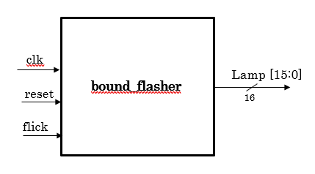

Figure 3.1: Block diagram of Bound Flasher

|  |  |  |  |  |  |
| --- | --- | --- | --- | --- | --- |
| Signal | Width |  | | In/Out | Description |
| clk | 1 |  | | In | Clock signal |
| flick | 1 |  | | In | Flick signal for lamp state changing |
| reset | 1 |  | | In | Active reset to go back to initial state |
| Lamp | 16 |  | | Out | Lamp after bound flasher processing |
|  | | |  | | | |

Table 3.1: Block diagram of Bound Flasher Description

## 3.2. State Machine

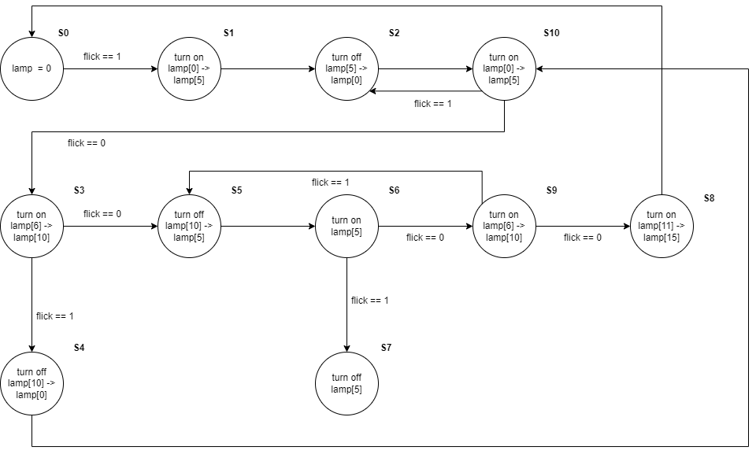

Figure 3.2: State Machine of Bound Flasher

# 4. History

|  |  |  |  |
| --- | --- | --- | --- |
| Date | Author | Modified part | Description |
| 2022/02/14 | Khoa Pham | Design | Implement state machine |
| 2022/02/16 | Khoa Pham | Design | Fix some error in changing state |
| 2022/02/18 | Khoa Pham | Design | Minor changes to code |
| 2022/02/18 | Khoa Pham | Design specification | Complete report |