Maui's dolphin:
Conservation status: critically endangered with around 100 instants left
Picture:
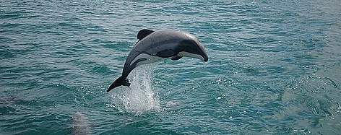
Ability: healing

Steller's Sea Cow:
Conservation status: extinct since 1768
Picture:
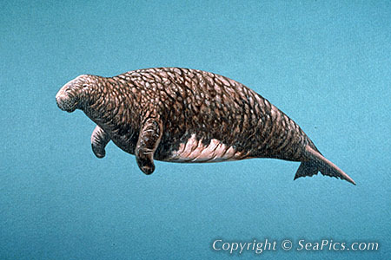
Ability: buff attributes by roaring
Meiolania:
Conservation status: extinct 2,000 years ago
Picture:
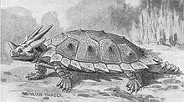
Ability: frozen breath which damage and slow enemies

Reasons for choosing these animals and their abilities:
+ They should not do what the Hydrobot is capable of doing himself
+ One from ice age, one recently become extinct and one going to be extinct: to provide most educational value

Discussion: Is the word "fossil" only applied for ice age animals' remnants? For non ice age animals, should it be bone or something?

Fossil: for animals died at least 10.000 years ago.
Plan: Obtain pieces of strange rocks from
+ Shipwreck chests.
+ Bring back trash to factory -> announcing you have obtained a strange rock. Bot brings that rock to a built lab to analyze. Lab analyzes strange rocks -> bones (for recently extinct animals) or fossils (for ice age animals)
+ Recycled resources and strange rocks from factory automatically adds to Bot’s inventory (?) because having to go to the factories for retrieving everything and then bring to the lab can be very tiring.
+ The way buildings are built: menu? Click and drag? Or just hot keys? My plan: menu but no click and drag, just drop the building right under where the bot stands, pop up if not enough space.

