A Leakage-Aware Hybrid CNN-GNN-Attention Protocol for Hydrothermal Alteration Mapping and Automated Geological Logging in a Porphyry System
Hamidreza Amirinasab¹*, Amirhossein Najafabadipour², Gholamreza Rahimipour³, Hamidreza Nikkhah⁴, Amirreza Amirinasab⁵
¹ Department of Mining Engineering, Shahid Bahonar University of Kerman, Kerman, Iran.
Email: hamidrezaamirinasab@eng.uk.ac.ir; ORCID: 0009-0009-0527-1858
² Department of Mining Engineering, University of Jiroft, Jiroft, Iran.
Email: najafabadipour@ujiroft.ac.ir; ORCID: 0000-0003-3411-8122
³ Department of Mining Engineering, Shahid Bahonar University of Kerman, Kerman, Iran.
Email: rahimipour@uk.ac.ir; ORCID: 0000-0002-2732-2099
⁴ Department of Mining Engineering, University of Jiroft, Jiroft, Iran.
Email: nikkhahhamidreza609@gmail.com; ORCID: 0009-0006-7867-7873
⁵ Department of Mining Engineering, Vali-e-Asr University of Rafsanjan, Rafsanjan, Iran.
Email: amirrezaamirinasab@gmail.com; ORCID: 0009-0009-1189-797X
* Corresponding author.
Institutional email: hamidrezaamirinasab@eng.uk.ac.ir
Due to possible interruptions in university email services, please direct time-sensitive correspondence to: khodehamidresa@gmail.com

Abstract
Machine learning models trained on drillhole geochemical data are increasingly used for hydrothermal alteration mapping, but reported accuracy is often inflated by undetected spatial data leakage, since geospatial mining datasets carry strong spatial autocorrelation that random cross-validation ignores. We present a hybrid CNN-GNN-Attention framework for alteration classification at the Saridoon porphyry copper deposit (Kerman, Iran), built on a leakage-aware protocol: borehole-grouped cross-validation, per-fold scaling, training-only graph construction, and evaluation against a spatially distal holdout. We propose this protocol as a baseline for any geospatial machine learning model built on drillhole, soil, or surface geochemical data, not only for alteration mapping. Feature ablation across geochemistry-only, coordinate-only, and combined inputs shows that the graph neural network branch loses roughly half its cross-validation performance on the distal holdout, versus 25–30% for the geochemistry-driven branches, pointing to reliance on local spatial proximity rather than transferable geochemical signal. This points to a practical limit on where the model's confidence can currently be trusted: infill support within an actively drilled deposit, rather than extrapolation into unsampled ground. We frame the protocol as a foundation for using model confidence as a consistency check on geological logging, including checks against a verified reference dataset.

Keywords
Porphyry copper; Hydrothermal alteration; Geospatial machine learning; Data leakage; Hybrid deep learning; Automated geological logging

1. Introduction
Porphyry copper systems supply most of the world's copper, along with substantial molybdenum, gold, and silver, and their exploration is a cornerstone of the global mineral industry. Hydrothermal alteration mapping is the primary tool for delineating the zoned footprint of these systems, yet the boundaries between alteration facies are gradational and laterally variable by nature. Manual core logging remains the industry standard. It is also subjective, slow, and prone to missing the subtle transitional intervals that often matter most for understanding the full extent of a system [1,2]. As exploration pushes toward deeper and geochemically more complex targets, the case has grown considerably for automated, reproducible, and geologically interpretable methods that can extract meaningful patterns from large multi-element geochemical datasets [3,4].
Machine learning (ML) has shown real promise for rapid alteration mapping [5,6]. Most existing studies, however, still treat ML models as black boxes, optimizing for predictive accuracy over geological insight [7,8]. Interpretability remains an open problem in geoscientific ML despite steady gains in raw performance [2,5,9]. Few studies have examined where and why a model fails, even though misclassifications in heterogeneous hydrothermal systems likely carry real information about geological complexity [4]. A separate problem compounds this: most published work evaluates performance with random cross-validation, which ignores the spatial autocorrelation built into drillhole data and lets information leak between training and validation folds [10,11]. Reported accuracies are, as a result, frequently over-optimistic and do not reflect true spatial generalization [4,6,9,12].
This problem is not unique to alteration classification. Any geospatial machine learning model trained on drillhole, soil, or surface geochemical data (for prospectivity mapping, grade estimation, or lithological classification alike) carries the same risk whenever validation samples sit spatially close to training samples. A borehole- or block-grouped validation protocol, combined with training-only construction of any spatially informed model component such as a k-nearest-neighbor graph, should be treated as a minimum methodological baseline for this class of problem, not an optional refinement.
Drillhole geochemical datasets bring their own challenges that sharpen these issues: severe class imbalance [13,14] (propylitic alteration accounts for only 0.5% of samples in our dataset), dense sampling near the core of a deposit and sparse coverage at its margins, and alteration assemblages that shift with both depth and space. The push for advanced machine learning on complex geological and hydrogeological data extends well beyond alteration mapping alone: related work has applied deep learning to recover ICP-MS-equivalent elemental concentrations from lower-cost XRF measurements [15], and supervised learning to determine groundwater flow direction in structurally complex mining areas [16], the latter facing spatial-dependence concerns similar to the ones addressed here. Within porphyry alteration classification specifically, we are not aware of a study that combines a rigorous spatial validation protocol with an architecture whose feature ablation can distinguish transferable geochemical learning from reliance on local spatial pattern.
Here, we address this gap with a hybrid CNN-GNN-Attention model trained on 85 drillholes from the Saridoon porphyry copper deposit in southeastern Iran. To keep spatial leakage out of every stage, the protocol combines StratifiedGroupKFold by borehole, per-fold robust scaling, a k-nearest-neighbor graph built only from training samples, and a borehole-aware early-stopping set. Hydrothermal geochemical data is intrinsically spatially autocorrelated, so conventional random validation is optimistic by construction; our framework prioritizes spatial robustness and geological transferability over benchmark-style tuning.
We ask two related questions. First, can feature ablation across architectural branches tell us whether the model learns transferable geochemical relationships or largely memorizes spatial proximity: a distinction that decides whether the model can be trusted on newly logged, previously unsampled intervals? Second, does the model's spatially-aware component behave differently from its geochemistry-driven components when moved from cross-validation to a genuinely distal holdout, and what does that difference mean for where its output can be used?
Answering these questions is a step toward a longer-term goal that motivates this work: using model predictions and their confidence as a consistency check on geological logging, flagging intervals for review and, in principle, cross-referencing contractor-logged data against a verified single-logger reference such as the present dataset. Establishing that a model actually learns geochemistry, and knowing exactly where it stops being trustworthy, has to come before any of that can be built responsibly. The present study is that first step; a deployable review interface is left to future work. All results are reported with the caveats warranted by the limited size and incomplete class coverage of the spatially distal holdout available for external evaluation.

2. Geological Setting and Data

2.1 The Saridoon Porphyry Copper Deposit
The Saridoon deposit is a Miocene porphyry copper system located approximately 3 km northeast of the giant Sarcheshmeh mine, Kerman Province, Iran [3]. It belongs to the same regional metallogenic belt and shares the classic concentric alteration pattern typical of porphyry copper systems worldwide, zoned from an inner potassic core, through a broad phyllic halo, to an outer propylitic zone (Fig. 1) [1,3]. Sericitic and argillic overprints are locally developed within and around this concentric zonation, consistent with later-stage or structurally controlled hydrothermal overprinting documented in other systems of the region.
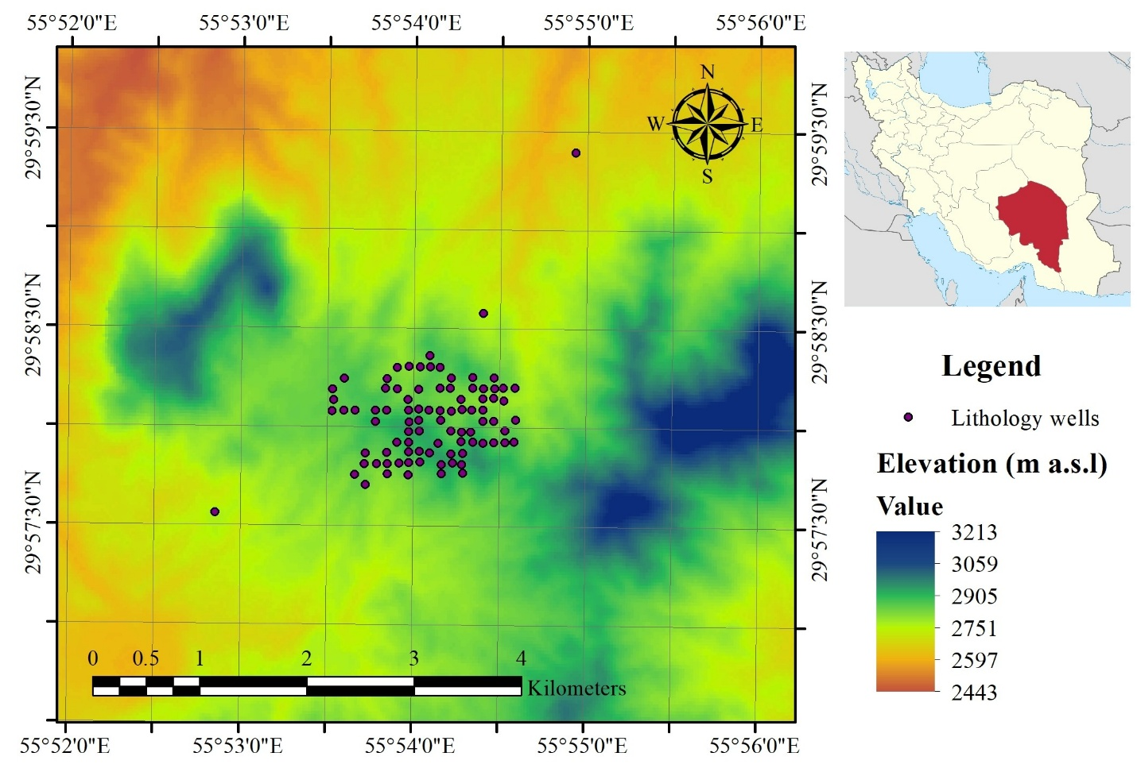
Figure 1. Location map of the Saridoon porphyry copper deposit, Kerman Province, Iran, showing drillhole collar positions for the 85 training/validation boreholes and the three spatially distal blind boreholes (SER_11, SER_68, SER_76).

2.2 Dataset and Preprocessing
The dataset comprises 88 drillholes; 85 are used for training/validation, and three distal holes (SER_11, SER_68, SER_76) are held out as a blind test set. These three boreholes serve as a qualitative stress test of spatial transferability, not a statistically robust benchmark, given the limited number of distal holes available. The three blind boreholes collectively contain 77 samples and cover only a subset of the five alteration classes; per-class metrics are therefore reported only for cross-validation folds and are not evaluated on the spatial holdout. The class composition of the blind set is not disclosed, in keeping with the confidentiality terms under which the dataset was made available.
All alteration labels in this dataset were assigned by a single certified geologist under NICICO's internal logging protocol, which removes inter-logger variability as a confound but also means that the present study cannot assess robustness to logger-to-logger inconsistency, a limitation we return to in Section 6.3. Summary statistics and class frequencies are given in Table 1.
Parameter | Value
Total samples | 6,951
Total boreholes | 88
Elements | 25
Depth range (m) | 3.0 – 1461.0
Elevation range (m a.s.l.) | 1381.2 – 2917.7
Median sample length (m) | 2.00
Table 1. Summary statistics (a) and alteration class distribution (b) for the Saridoon dataset.
(a)
(b) Alteration class distribution.
Class | Code | Count | %
Phyllic | PHY | 5561 | 80.0
Potassic | POT | 820 | 11.8
Sericitic | SER | 446 | 6.4
Argillic | ARG | 90 | 1.3
Propylitic | PRP | 34 | 0.5

Twenty-five elements (Ag, Al, As, Ca, Cd, Co, Cr, Cu, Fe, La, Li, Mg, Mn, Mo, Ni, P, Pb, S, Sb, Sc, Th, V, Y, Yb, Zn) were analyzed by ICP-MS, and elevation (Z_loc) was recorded. All concentrations were log-transformed using:
$$X'=log₁₀\left(X+1\right)\left(1\right)$$
to reduce heteroscedasticity and stabilize variance. During spatial cross-validation, a RobustScaler was fitted on each training fold and applied to its corresponding validation fold. For the final blind evaluation, a single scaler was fitted on the entire 85-hole training set and applied to the blind boreholes to keep scaling consistent without leaking information. A length-weighted assay, C_w = ΣCᵢLᵢ / ΣLᵢ, was tested but did not improve cross-validation or blind performance metrics and was not retained.

3. Geochemical Context and Exploratory Analysis

3.1 Hierarchical Clustering of Elements
An independent geochemical reference frame was established using Ward's method on a Spearman correlation matrix. Spearman was chosen for its robustness to non-normal distributions. The dissimilarity metric was:
$$dᵢⱼ=1-\left|ρᵢⱼ\right|\left(2\right)$$
Ward linkage minimizes the increase in error sum of squares when merging clusters, A and B:
$$ΔESS=\left(\left|A\right|\left|B\right|/\left(\left|A\right|+\left|B\right|\right)\right)·‖x̃_{A}-x̃_{B}‖²\left(3\right)$$
A seven-cluster solution was selected based on dendrogram interpretability and known porphyry mineral associations (Supplementary Table S1, Fig. 2), including a Cu-Mo-Ag cluster and a Cr-dominated outlier. The clustering is used exclusively for post-hoc interpretation and plays no part in model training or feature construction. The dendrogram is not used to order elements for the CNN branch; an alphabetical ordering is used instead, to avoid the leakage that would follow from deriving element order from the full training set (Section 4.1). This geochemical structure broadly matches known porphyry zonation patterns and provides a baseline for later evaluation of model-derived feature relevance; its geological significance is examined in the Discussion alongside the model outputs.
Figure 2. Ward hierarchical clustering dendrogram of the 25 geochemical elements, based on a Spearman correlation dissimilarity matrix (d = 1 − |ρ|). Colored branches mark the seven clusters retained for interpretation (Supplementary Table S1). The dendrogram is used only for post-hoc geochemical grouping and does not inform the element ordering used by the CNN branch (Section 4.1).

3.2 Enrichment Signatures and Z-score Heatmap
Enrichment factors (log₁₀ EF, Fig. 3) offer a first-order view of elemental behavior across alteration facies. The classic zonation pattern is broadly reproduced: the potassic core shows enrichment in Cu, Mo, and Ag; the phyllic halo in S; and the propylitic margin in Cd, Zn, Mn, and Co, in line with well-understood porphyry processes [1,3].
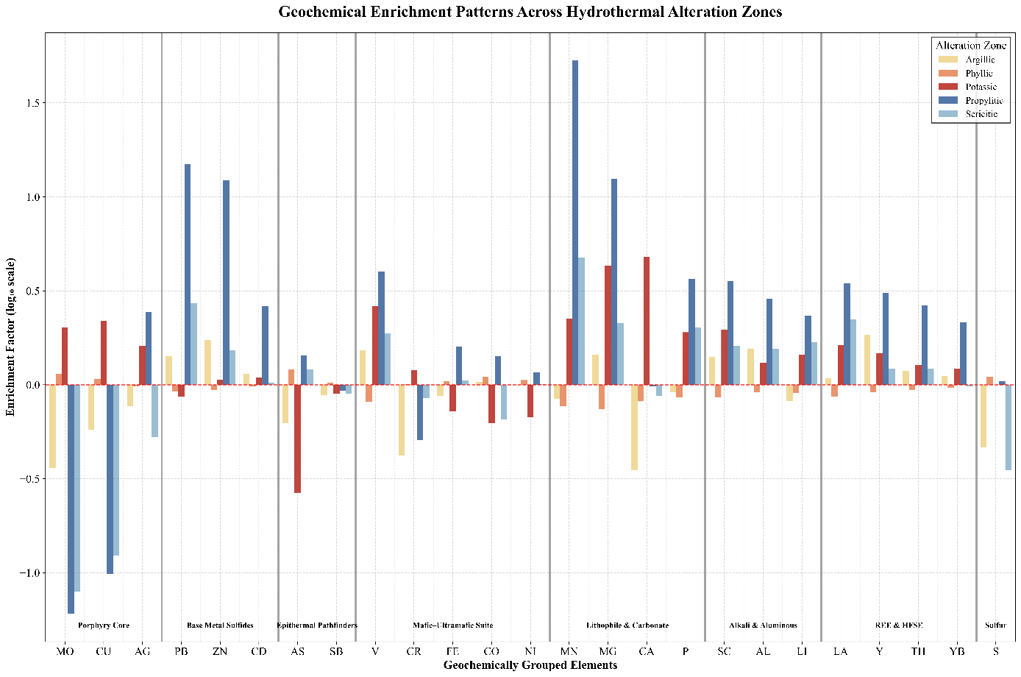
Figure 3. Enrichment factor (log₁₀ EF) profiles for the 25 elements across the five alteration facies, computed as each facies' mean log₁₀-transformed concentration minus the whole-dataset mean log₁₀-transformed concentration. Elements are arranged by conventional geochemical affinity (e.g., porphyry-core, base-metal-sulfide, epithermal-pathfinder groupings) for visual clarity; this grouping is independent of, and need not match, the data-driven Ward clusters shown in Fig. 2 and Supplementary Table S1.
To complement this view, a mean-based Z-score heatmap was constructed (Fig. 4) using log-transformed element concentrations. The Z-score represents, for each element, how many standard deviations the mean log-concentration in a given facies deviates from the global mean. This standardization removes the scale differences among elements and reflects relative enrichment or depletion signatures. Two observations stand out. The propylitic zone shows a multi-element enrichment (Z > +1.5 for Al, Cd, Fe, Mn, Pb, Th, Yb, and Zn). This extended signature matches known associations of the propylitic halo with carbonates, chlorite, and epidote, which scavenge a broad spectrum of trace elements [1,17]. Antimony (Sb) shows its highest relative value in the phyllic zone (Z = +1.69), while remaining near-neutral or slightly negative elsewhere; however, this large Z-score reflects Sb's very low variance across the dataset rather than a large absolute enrichment (raw EF ≈ +0.01 log₁₀ units, versus depletion of similar or larger magnitude in the other four facies). The direction of this contrast is consistent with the established role of Sb as an epithermal pathfinder [17,18], though the small absolute effect size argues for treating it as a minor, secondary observation rather than a primary geochemical signal.
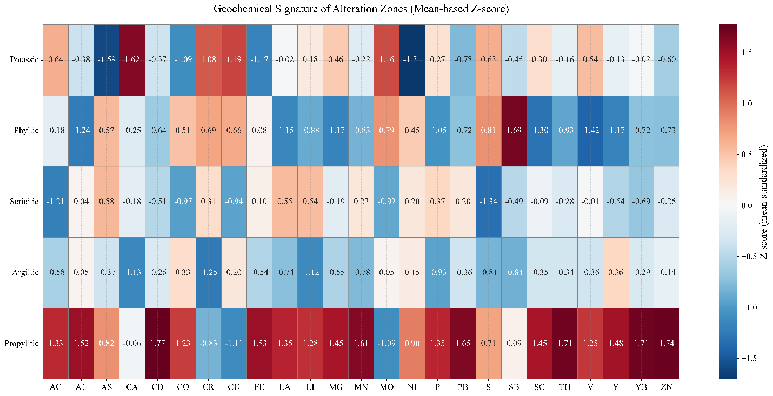
Figure 4. Mean-based Z-score heatmap of log₁₀-transformed element concentrations across the five alteration facies. Each cell shows the number of standard deviations by which the facies-mean log-concentration of an element deviates from the global mean across all facies; warm colors indicate relative enrichment and cool colors relative depletion.
Together, the EF profiles and the Z-score heatmap offer complementary views: the former identifies elements that are abundant in each facies, the latter reveals elements that are distinctive of a facies relative to the whole dataset. Together they establish a geochemical baseline against which the model's learned feature importance can be assessed.
This geochemical zonation is established independently of the deep-learning model and requires no model output to interpret; it serves here as fixed geological context. If a model trained on this dataset has genuinely learned compositional structure, its predictions and errors should respect this zonation rather than the spatial arrangement of the boreholes themselves. Section 4 introduces the hybrid architecture and the feature-ablation protocol used to test this distinction directly, and Section 5 reports what that ablation reveals about which branch of the model actually carries geochemical signal.

4. Methodology

4.1 Hybrid Model Architecture
The model consists of three parallel branches (Fig. 5). CNN branch: non-linear multi-element interaction learner. The input is a 26-D vector (25 elements plus elevation). Because geochemical variables have no natural spatial ordering, the CNN functions here as a parameter-sharing nonlinear interaction approximator, not as a spatial operator.
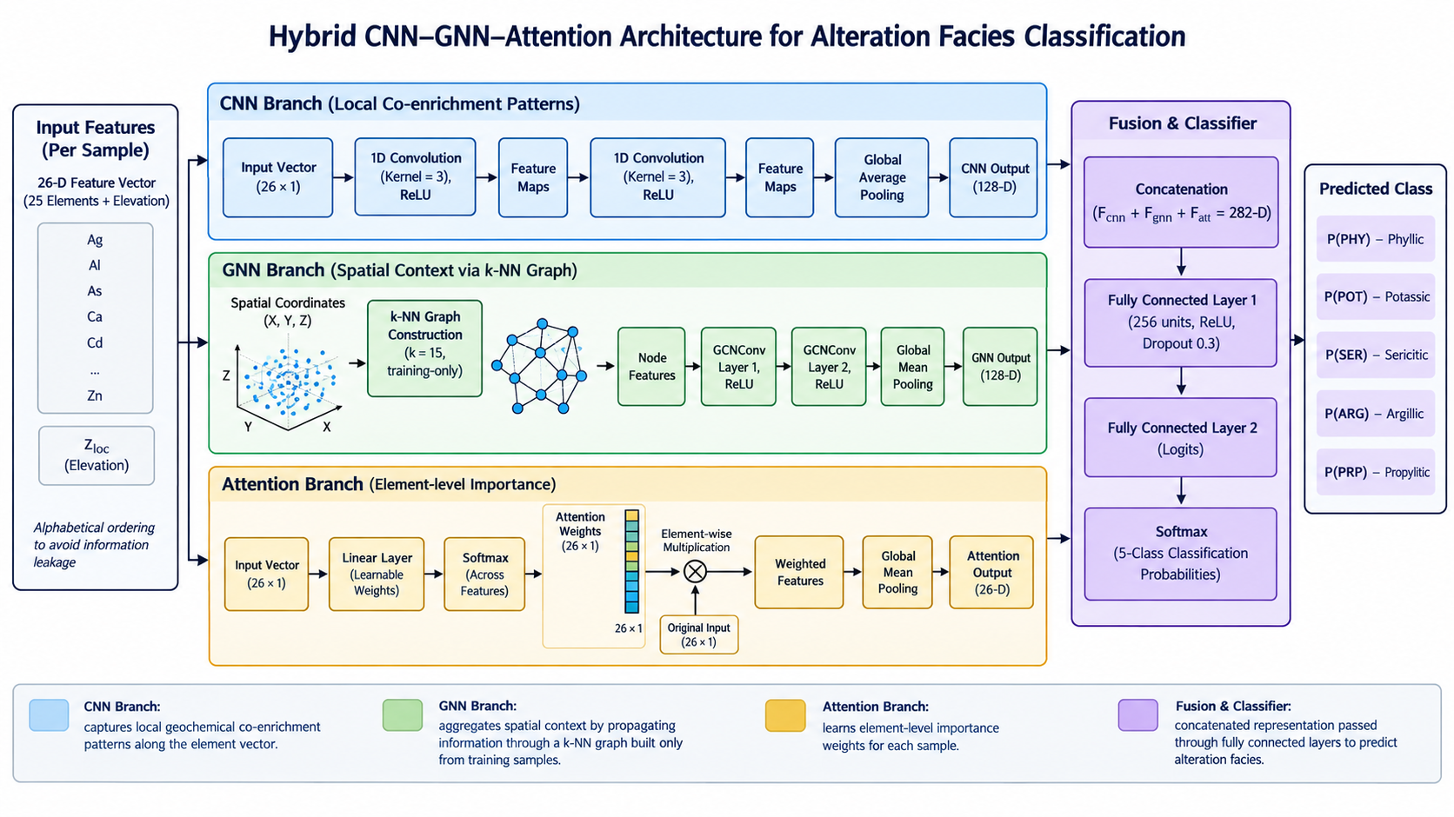
Figure 5. Schematic architecture of the hybrid CNN–GNN–Attention model. Twenty-six input features (25 log-transformed elements plus elevation) feed the CNN and attention branches, while three-dimensional coordinates (X, Y, Z) feed the borehole-aware k-NN graph used by the GNN branch. The three branch outputs (CNN: 128-D; GNN: 128-D; attention-weighted: 26-D) are concatenated and passed to a shared classifier producing the five-class alteration prediction.
An alphabetical ordering is imposed to avoid leakage from any data-driven arrangement. Two 1D convolutional layers (64 and 128 feature maps, kernel = 3, ReLU, no pooling) are followed by global average pooling [9]. Training was repeated with the alphabetical order, five random permutations, and a correlation-sorted order; cross-validated accuracy varied by less than 1% across all orderings. This invariance suggests the CNN branch functions primarily as a parameter-sharing feature transform rather than exploiting positional or local structure, matching the absence of a natural ordering among geochemical variables.
GNN branch: spatial context propagator. For each training fold, a fixed k-nearest-neighbor graph (k = 15) is built exclusively from that fold's training nodes, using Euclidean distance in (X, Y, Z). Edges are unweighted; a sensitivity check with distance-based weights showed a negligible difference (≤ 0.3%), with no systematic trend across k ∈ [10, 25]. Neither the borehole-aware early-stopping nodes nor the validation-fold nodes take part in building this graph, and no edges are formed among early-stopping, validation, or blind nodes themselves: each such held-out sample is instead attached to the fixed training graph purely through outgoing k-NN edges to its nearest training nodes, so that no information flows from held-out samples back into the graph. The same rule applies at final blind evaluation, where each of the three blind boreholes is connected only to the fixed final training graph built from all 85 training boreholes, never to other blind samples.
Two GCNConv layers (128 hidden units each) propagate information through the graph to capture local spatial context. Because sample spacing within a single borehole (median 2.0 m) is far smaller than the typical spacing between boreholes, we tested directly whether the 15 nearest neighbors of a given sample are dominated by same-hole samples rather than genuinely cross-borehole relationships. Across the 85-borehole training set, 14.73 of the 15 nearest neighbors belonged to the same borehole on average, a mean within-borehole proportion of 98.18%; 95.27% of training samples had all 15 nearest neighbors drawn from the same borehole. Because cross-validation folds are grouped by whole borehole rather than by individual sample (Section 4.2), each fold's training graph is built from a subset of complete boreholes, so this within-borehole dominance is expected to hold similarly inside every fold, not only in the full training set used for this diagnostic calculation. This indicates that the constructed k-NN graph is dominated by along-borehole local structure rather than cross-borehole connectivity: the GNN branch should be interpreted primarily as a propagator of local within-borehole spatial context, while its ability to capture transferable cross-borehole relationships remains limited by the graph topology itself. This distinction directly informs the interpretation of the ablation results in Section 4.2.
Attention branch: adaptive feature weighting. A learnable linear layer with softmax produces per-sample attention weights, emphasizing the features that contribute most to the prediction for each sample. These weights are not causal explanations; they reflect internal model weighting and may not correspond directly to geochemical importance [21].
The three outputs (CNN: 128-D, GNN: 128-D, attention-weighted: 26-D) are concatenated and fed to a classifier with one hidden layer (256 units, ReLU, dropout 0.3) and a final softmax over the five alteration classes.

4.2 Experimental Design and Baselines
All models were evaluated under spatial 5-fold cross-validation and the same blind test. Hyperparameters for Random Forest and XGBoost were tuned by grid search inside each fold [19,20]. Search ranges were chosen based on common practice and computational constraints: for Random Forest, n_estimators ∈ {200, 400, 600}, max_depth ∈ {10, 20, 30}, and max_features ∈ {sqrt, log2}; for XGBoost, learning_rate ∈ {0.05, 0.1, 0.2, 0.3}, max_depth ∈ {4, 6, 8, 10}, subsample ∈ {0.7, 0.85, 1.0}, and colsample_bytree ∈ {0.7, 0.85, 1.0}.
The hybrid model used a fixed learning rate of 0.001 (Adam), dropout 0.3, batch size 64, and an early-stopping patience of 20 epochs. Manual class weights (ARG = 4.0, PRP = 5.0, SER = 2.5, POT = 2.0, PHY = 1.0) were applied in the weighted variant [13,14]; an unweighted variant was also evaluated (Section 5.2). Permutation importance for feature j was calculated as [19]:
$$PI_{j}=Accoriginal-Accpermuted\left(j\right)\left(4\right)$$
Applying Equation (4) to the 25 elements and comparing the resulting ranking against the mean attention weights produced by the attention branch yields only weak, non-significant rank agreement (Spearman ρ = 0.226, p = 0.278, n = 25). Several elements return slightly negative importance values, indicating no measurable contribution beyond sampling variation. This quantifies the caveat noted in Section 4.1: the attention weights reflect internal model weighting and do not constitute a ranking of geochemical importance. Accordingly, neither ranking is used here as evidence for element-level geological interpretation.
The hybrid model reaches a blind accuracy of 0.675 and macro F1 of 0.541, somewhat higher than the best tree-based model (XGBoost: 0.67 accuracy, 0.46 macro F1). The large CV-to-blind gap (0.92 → 0.68) fits a spatial distribution shift. Expressed as a relative drop in accuracy from cross-validation to blind evaluation, the pattern is clearly asymmetric across architectures: the GNN-only model loses about 50% of its cross-validation accuracy, against roughly 25–30% for the CNN-only, Random Forest, XGBoost, and hybrid models (Supplementary Table S3).
This asymmetry does not hold as cleanly when the same comparison is run on macro F1 instead of accuracy: the CNN-only branch's blind macro F1 (0.42) is marginally higher than its cross-validation macro F1 (0.40), rather than lower. Given the blind set's small size (n = 77) and incomplete class coverage, we read this as noise from an underpowered comparison rather than a genuine generalization gain, and we report it rather than set it aside. The GNN-only branch's degradation (CV macro F1 0.52 → blind 0.27, a drop of roughly 48%) is consistent across both metrics, which is the pattern the rest of this paper builds on.
Taken together, this points to the GNN branch relying more heavily on local spatial autocorrelation among training samples during cross-validation (an advantage unavailable when generalizing to the spatially distal blind boreholes), while the geochemistry-driven branches degrade more moderately. This bears directly on the intended downstream use: a component that mostly encodes spatial proximity is appropriate for infill logging support within an actively drilled deposit, but its predictions and confidence estimates should not be extrapolated to geologically unsampled terrain without independent validation.
The ‘Z’ in the log+Z and weighted-log+Z scenarios (Supplementary Table S2) denotes the inclusion of elevation (Z_loc, meters above sea level) as an additional input feature alongside the 25 log-transformed element concentrations; it is not a Z-score normalization. Scaling itself is handled separately, by the per-fold RobustScaler described in Section 2.2, applied regardless of scenario. Elevation was included because porphyry alteration assemblages are known to vary with depth as well as laterally (Section 1), so Z_loc could carry geological signal beyond what geochemistry alone captures. At the same time, because elevation is itself a spatial coordinate, including it sits in some tension with this study's leakage-aware framing: unlike compositional geochemistry, Z_loc could in principle let a model shortcut toward position rather than composition. We treat this as a disclosed trade-off rather than an oversight, and the comparison below is in part a check on how much this one feature matters in practice.
Supplementary Table S2 reports the resulting sensitivity of the hybrid model. The log-only scenario (excluding elevation) reaches a marginally higher blind accuracy than log+Z (0.680 vs. 0.675), while log+Z (including elevation) reaches a higher cross-validation macro F1 (0.769 vs. 0.712). We report both figures rather than treating the small blind-accuracy difference as decisive: given the blind set's limited size (n = 77) and incomplete class coverage, a 0.5-point accuracy gap falls within the noise expected from such a small sample, whereas the cross-validation macro F1 gap is measured over five folds and all classes and is the more stable basis available for comparing scenarios. We retained elevation in the final model on this basis, while flagging the trade-off above as a limitation rather than presenting the choice as unambiguous.

5. Results

5.1 Model Performance and Confusion Analysis
The final model (unweighted log+Z) reaches a blind accuracy of 0.675 on the spatially distal holdout (n = 77 samples across three boreholes, covering only a subset of the five alteration classes). Per-class blind metrics are not reported, both because the holdout does not span all classes and because its class composition is confidential. All per-class recall values and the confusion matrix reported below come from pooled out-of-fold predictions across the five cross-validation folds over the 85-hole training set (n = 6,874; the 77 samples of the distal holdout are excluded), and are not blind-set metrics.
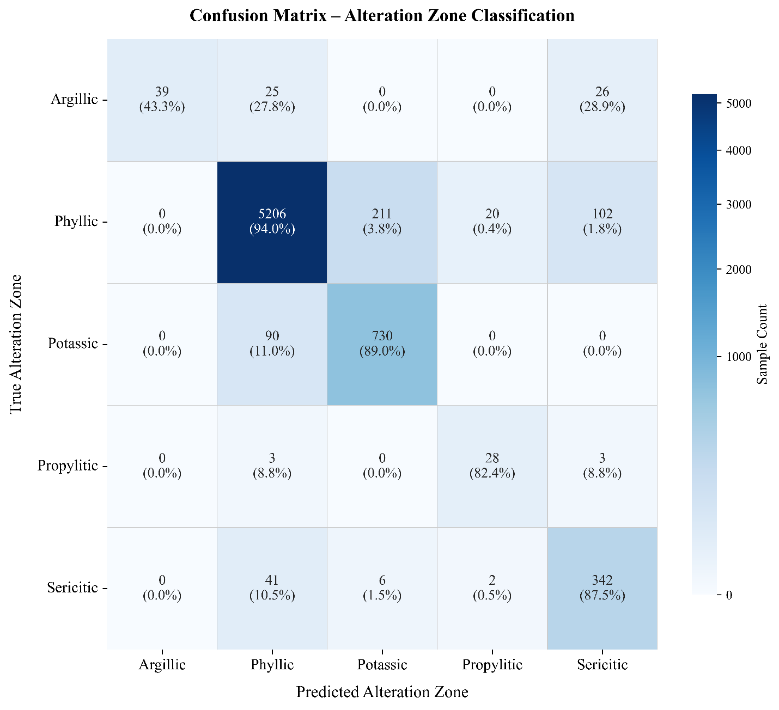
Figure 6. Normalized confusion matrix for alteration zone classification, computed from pooled out-of-fold cross-validation predictions on the 85-borehole training set (n = 6,874). Cells show sample count and row-wise recall percentage; rows correspond to true alteration classes and columns to predicted classes.
The normalized confusion matrix (Fig. 6) reveals a directional error structure rather than a uniform loss of performance across classes. The dominant phyllic class reaches 94.0% CV recall, with its errors directed mainly toward potassic (3.8%) and sericitic (1.8%). Potassic reaches 89.0% CV recall, with 11.0% of its samples classified as phyllic; sericitic reaches 87.5%, with 10.5% classified as phyllic. Propylitic, despite accounting for only 0.5% of the dataset, reaches 82.4% recall, though this estimate rests on only 34 samples. The weakest performance is in the argillic class (43.3% CV recall, n = 90); critically, its errors concentrate almost entirely in sericitic (28.9%) and phyllic (27.8%), with no argillic samples misclassified as potassic or propylitic. This directed pattern suggests that classification difficulty is not explained by class rarity alone but is concentrated at specific facies boundaries where geochemical signatures overlap most. Given the small sample size for argillic, however, this should be read as evidence of localized classification ambiguity rather than a definitive geological explanation. Overall accuracy remains dominated by the phyllic majority class, and the gap between macro F1 and per-class accuracy reflects this imbalance.
Figure 7 illustrates this boundary-driven pattern directly: across a representative subset of training boreholes, misclassified samples (colored ticks) concentrate at contacts between adjacent true alteration zones rather than occurring uniformly within homogeneous intervals.
Figure 7. Vertical cross-section of true alteration zones (colored intervals) with superimposed cross-validation misclassifications (colored ticks, colored by predicted class) for a representative subset of training boreholes, selected to include all boreholes with at least one misclassification plus the three largest error-free boreholes.

5.2 Effect of Class Weighting on Model Performance
The weighted variant improved cross-validation metrics but degraded blind performance (accuracy 0.520, macro F1 0.420). In borehole SER_11, the weighted model assigned almost all samples at the phyllic–sericitic contact to one of the two classes, while the unweighted model produced a gradual probability transition. The unweighted configuration was used for all subsequent analyses.

6. Discussion

6.1 Model Performance and the Challenge of Imbalanced Geological Data
The confusion matrix (Fig. 6) shows a performance gradient that tracks class prevalence closely. Minority classes are not only scarce but also share elemental signatures with adjacent facies, which makes them hard to separate. Overall accuracy is carried by the well-sampled phyllic class, while argillic discrimination stays poor. The gap between cross-validation macro F1 (0.769) and the more modest blind accuracy (0.675) is a reminder that the spatially distal holdout is the more honest indicator of transferability: cross-validation metrics, even when grouped by borehole, remain optimistic wherever spatial autocorrelation is strong.

6.2 The Weighting Paradox and Implications for Geological ML
Class weighting improved cross-validation metrics but hurt blind generalization, a pattern consistent with overfitting to non-representative minority samples [10,13,14]. Similar trade-offs have been noted in other geochemically imbalanced problems. The unweighted model preserved the gradual nature of alteration boundaries, while the weighted model forced sharp contacts. This points to a basic mismatch between standard ML assumptions (discrete, well-separated classes) and geological reality, where facies boundaries are inherently gradational. Aggressive rebalancing may therefore work against the goal it is meant to serve in settings like this one.

6.3 Limitations and Future Work
The study is constrained by a single deposit and a blind set of only three boreholes, which should be read as a case-based spatial stress test rather than a statistically representative evaluation of generalization. The simple k-NN graph and the alphabetical CNN ordering, while justified for leakage prevention, may not capture the full complexity of alteration geometries; sensitivity analyses were performed, but more elaborate architectures could be explored. The GNN branch's dependence on local spatial autocorrelation, quantified in Section 4.2, means that model confidence may not transfer reliably to geologically distinct or previously undrilled regions; applicability is therefore currently limited to infill logging support within a spatially sampled deposit rather than extrapolation into unsampled terrain.
Because all labels originate from a single certified logger, this study cannot evaluate the model's behavior against inter-logger variability. Extending the present protocol to multi-logger or multi-contractor datasets (potentially as a systematic consistency check on contractor-supplied logging) and building a deployable review interface for practical use are directions for future work. All interpretability analyses here are correlational and meant for hypothesis generation; causal claims would need independent validation.
A few geological cautions are worth stating plainly: alteration boundaries are gradational by nature, and the labels themselves carry interpretive uncertainty. Spatial transferability beyond this system remains to be tested. Model disagreement is exploratory and should not replace independent geochemical or mineralogical validation. Future work should extend the present analysis to multi-deposit datasets, bring in formal distribution-shift metrics, and add mineralogical or textural features to better ground the geological meaning of model errors.

7. Conclusion
This study establishes a leakage-aware protocol for hybrid CNN-GNN-Attention alteration classification (borehole-grouped cross-validation, training-only spatial graph construction, and evaluation against a spatially distal holdout) and argues that this class of protocol should serve as a minimum methodological baseline for any geospatial machine learning model built on drillhole, soil, or surface geochemical data, not only for alteration mapping at a single deposit.
Architecture-specific feature ablation shows that the model's spatially-aware component relies disproportionately on local proximity rather than transferable geochemical signal, a distinction that sets a concrete boundary on where its predictions can be trusted: as infill support within an actively drilled deposit, not as a substitute for geological judgment in unsampled ground. Framed this way, the contribution of this work is less about a single accuracy number and more about a tested way of telling when a geochemical model has actually learned geology rather than memorized coordinates: a distinction most published applications of machine learning to alteration mapping do not currently make, and one that has to be resolved before such a model can be trusted to support real logging decisions.
We see this leakage-aware protocol as the underlying layer of a longer-term system aimed at easing the burden of manual core logging at operating porphyry deposits: flagging low-confidence intervals for expert review and, in principle, providing a consistency check against contractor-logged data using a verified single-logger reference such as the present dataset. A deployable review interface, and validation of the protocol against multi-logger and multi-deposit data, remain necessary next steps beyond the scope of the present study.

References
1. Seedorff, E. et al. Porphyry deposits: characteristics and origin of hypogene ore features. Econ. Geol. 100th Anniversary Volume, 251–298 (2005).
2. Cracknell, M. J. & Reading, A. M. Geological mapping using remote sensing data: a comparison of five machine learning algorithms, their response to variations in the spatial distribution of training data and the use of explicit spatial information. Comput. Geosci. 63, 22–33 (2014).
3. Sillitoe, R. H. Porphyry copper systems. Econ. Geol. 105, 3–41 (2010).
4. Reichstein, M. et al. Deep learning and process understanding for data-driven Earth system science. Nature 566, 195–204 (2019).
5. Rodriguez-Galiano, V., Sanchez-Castillo, M., Chica-Olmo, M. & Chica-Rivas, M. Machine learning predictive models for mineral prospectivity: an evaluation of neural networks, random forest, regression trees and support vector machines. Ore Geol. Rev. 71, 804–818 (2015).
6. Sun, T., Chen, F., Zhong, L., Liu, W. & Wang, Y. GIS-based mineral prospectivity mapping using machine learning methods: a case study from Tongling ore district, eastern China. Ore Geol. Rev. 109, 26–49 (2019).
7. Rudin, C. Stop explaining black box machine learning models for high stakes decisions and use interpretable models instead. Nat. Mach. Intell. 1, 206–215 (2019).
8. Molnar, C. Interpretable Machine Learning (Lulu.com, 2020).
9. Zhang, S. et al. Data-driven mineral prospectivity mapping by joint application of unsupervised convolutional auto-encoder network and supervised convolutional neural network. Nat. Resour. Res. 30, 1011–1031 (2021).
10. Chiles, J.-P. & Delfiner, P. Geostatistics: Modeling Spatial Uncertainty (John Wiley & Sons, 2012).
11. Roberts, D. R. et al. Cross-validation strategies for data with temporal, spatial, hierarchical, or phylogenetic structure. Ecography 40, 913–929 (2017).
12. Zhu, X. X. et al. Deep learning in remote sensing: a comprehensive review and list of resources. IEEE Geosci. Remote Sens. Mag. 5, 8–36 (2017).
13. Japkowicz, N. & Stephen, S. The class imbalance problem: a systematic study. Intell. Data Anal. 6, 429–449 (2002).
14. He, H. & Garcia, E. A. Learning from imbalanced data. IEEE Trans. Knowl. Data Eng. 21, 1263–1284 (2009).
15. Najafabadipour, A., Hassanzadeh, F. & Kordestani, M. Advanced deep learning models for predicting elemental concentrations in iron ore mine using XRF data: a cost-effective alternative to ICP-MS methods. Environ. Geochem. Health 47, 104 (2025).
16. Najafabadipour, A. Supervised machine learning-based determination of groundwater flow direction in complex mining areas. Mine Water Environ. (2026).
17. Cooke, D. R., Hollings, P. & Walshe, J. L. Giant porphyry deposits: characteristics, distribution, and tectonic controls. Econ. Geol. 100, 801–818 (2005).
18. Hedenquist, J. W. & Lowenstern, J. B. The role of magmas in the formation of hydrothermal ore deposits. Nature 370, 519–527 (1994).
19. Breiman, L. Random forests. Mach. Learn. 45, 5–32 (2001).
20. Chen, T. & Guestrin, C. XGBoost: a scalable tree boosting system. in Proc. 22nd ACM SIGKDD Int. Conf. Knowledge Discovery and Data Mining 785–794 (2016).
21. Jain, S. & Wallace, B. C. Attention is not explanation. in Proc. 2019 Conf. North American Chapter Assoc. Comput. Linguistics: Human Language Technologies, Vol. 1 (Long and Short Papers) (2019).

Acknowledgements
The authors would like to thank the National Iranian Copper Industries Company (NICICO) for providing the geochemical data used in this study. We also thank Dr. Habibeh Atapour for their insightful comments on the geochemical interpretations.

Author Biography
Hamidreza Amirinasab is a Mining Engineering researcher at Shahid Bahonar University of Kerman, Iran, working on interpretable machine learning methods for mineral exploration. His research interests include exploration geochemistry, geophysics, and the analysis of spatial and borehole data for gold and copper deposits. He has also contributed to teaching and scientific association activities at his university.
Email: hamidrezaamirinasab@eng.uk.ac.ir ; khodehamidresa@gmail.com
ORCID: 0009-0009-0527-1858

Author Contributions
Hamidreza Amirinasab: Conceptualization, Methodology, Software, Formal analysis, Investigation, Writing – original draft, Visualization.
Amirhossein Najafabadipour: Supervision, Methodology, Writing – review & editing.
Gholamreza Rahimipour: Supervision, Resources, Writing – review & editing.
Hamidreza Nikkhah: Investigation, Software, Writing – review & editing.
Amirreza Amirinasab: Investigation, Writing – review & editing.

Declaration of generative AI and AI-assisted technologies in the manuscript preparation process
During the preparation of this work, the authors used ChatGPT (OpenAI), DeepSeek AI, and Claude (Anthropic) in order to translate portions of the manuscript from Persian into English and to improve the linguistic clarity, grammar, and stylistic fluency of the English text. After using these tools, the authors reviewed and edited the content as needed and take full responsibility for the content of the published article.

Competing Interests
The authors declare no competing interests.

Data Availability
The geochemical dataset used in this study is proprietary and belongs to the National Iranian Copper Industries Company (NICICO). Restrictions apply to the availability of these data, which were used under license for the current research. The raw data cannot be shared publicly due to confidentiality agreements. However, the derived data that support the findings of this study (e.g., cross-validation and blind-evaluation performance metrics, confusion-matrix statistics, and feature-ablation results) are available from the corresponding author upon reasonable request and with permission of NICICO.

Code Availability
The source code for the hybrid CNN-GNN-Attention model developed in this study is publicly available at the following repository:
https://github.com/khodehamidresa/hybrid-dl-porphyry-alteration
The repository includes the main model script (model.py), a quick-test script (test_run.py), a requirements file, and a README with documentation and usage instructions.

Funding
This research received no specific grant from any funding agency in the public, commercial, or not-for-profit sectors.

Supplementary Information
The following items accompany this manuscript as Supplementary Information, moved out of the main text to keep the number of main-text display items within the journal's limit of eight figures and tables combined.

Supplementary Table S1. Ward cluster assignments (referenced in Section 3.1)
Cluster | Geochemical Group | Elements
1 | Pb-Zn Sulfide | Pb, Zn
2 | REE + HFSE | La, Th, Y, Yb
3 | Rock-forming & Lithophile | Al, Ca, Li, Mg, Mn, P, Sc, V
4 | Epithermal Pathfinders | As, Cd, Sb
5 | Mafic–Sulfide | Co, Fe, Ni, S
6 | Porphyry Cu–Mo–Ag | Ag, Cu, Mo
7 | Cr-dominated outlier | Cr

Supplementary Table S2. Preprocessing scenarios, hybrid model (referenced in Section 4.2)
Scenario | CV Acc (mean ± sd) | CV Macro F1 | Blind Acc | Blind Macro F1
log+Z (selected) | 0.923 ± 0.024 | 0.769 ± 0.093 | 0.675 | 0.541
log-only | 0.918 ± 0.022 | 0.712 ± 0.085 | 0.680 | 0.520
weighted-log+Z | 0.918 ± 0.016 | 0.785 ± 0.068 | 0.665 | 0.530
weighted-log | 0.908 ± 0.020 | 0.684 ± 0.092 | 0.520 | 0.420
raw | 0.880 ± 0.025 | 0.690 ± 0.100 | 0.580 | 0.450

Supplementary Table S3. Comparison of CNN-only, GNN-only, Random Forest, XGBoost, and the proposed hybrid model under spatial 5-fold cross-validation and blind evaluation, log+Z input (referenced in Section 4.2)
Model | CV Acc (mean ± sd) | CV Macro F1 | Blind Acc | Blind Macro F1
CNN-only | 0.78 ± 0.04 | 0.40 ± 0.06 | 0.55 | 0.42
GNN-only | 0.82 ± 0.03 | 0.52 ± 0.07 | 0.41 | 0.27
Random Forest | 0.88 ± 0.02 | 0.60 ± 0.07 | 0.66 | 0.44
XGBoost | 0.90 ± 0.02 | 0.62 ± 0.06 | 0.67 | 0.46
Hybrid (proposed) | 0.923 ± 0.024 | 0.769 ± 0.093 | 0.675 | 0.541

