# Mobile Web Design Document

The project is a website for a barbering business that can be used by customers, admins, and anonymous users. When a user enters the website, they are taken to the home page, on this page the user can see multimedia in the form of images that have been loaded which depict the different types of haircuts that are on offer along with descriptions and pricings presented in cards so that each haircut is easily distinguishable. The images are optimised for mobiles that have lower processing power by reducing the size of the image, not wasting resources on rendering images that would be too large for a mobile screen. Furthermore, a hamburger button will be implemented in the top right corner of the screen, this button will persist between all pages on the website to ensure that users can always locate this button easily.

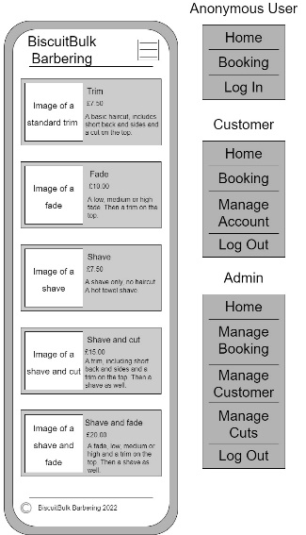

The navigation menu differs depending on which user is logged in when clicking on the hamburger button. If the user is an admin (barber) it contains five sections: home, manage bookings, manage customer, manage cuts, and log out. If the user is a customer there are four sections: home, booking, manage account, and log out. Finally, if it is an anonymous user there are three sections: home, booking, and log in/register. With access to the navigation menu being the hamburger button, a user can access it intuitively throughout the website.

When a user is logging in to the website there are two fields that require input from the user, those being an email address and a password. After inputting the email, the user needs to click the submit button, when this button is hovered over an animation occurs that will change the colour of the button to indicate the user has an option to interact with the button. The password is checked to see if the credentials for the account are valid, if they are the user is logged in to the website and taken back to the home page. If they are invalid the user is informed that the details were invalid and to try logging in again by making text appear on the screen. If the user has forgotten their password there is a link that directs the user to a page allowing them to change their password. On the same page, beneath the log in form there is another form allowing a new user to register. When registering a user must input their first name and surname, their email address, and a password which they must re-enter to confirm that they have typed the password correctly. They must then click the register button which has the same hover animation that the log in form must complete their registration.

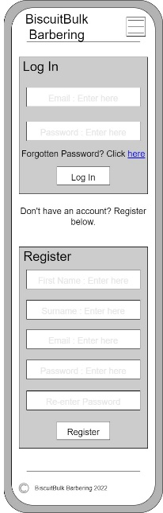

The forgotten password page enables a user to change their password, the user must enter their email and click on the ‘Enter’ button which has the same hover animation mentioned before. After clicking the button, a user would be sent an email allowing them to change their password.

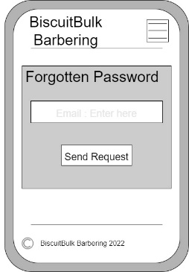

An admin can access the ‘manage bookings’ page, this page enables an admin to overlook the appointments for an entire selected day. The admin uses a dropdown box to select an upcoming day, all time slots for that day are displayed, each time slot is displayed in a card, if the time slot has been booked then the name of the client, the type of haircut and the cost is displayed in the card, there is also a button in the card that when clicked cancels the booking. If the appointment is not booked, then it displays that the slot is free and there are two buttons labelled ‘enable’ and ‘disable’. If the appointment is enabled, then the enable button is unable to be clicked and is greyed out. If the slot is disabled, then the ‘disable’ button is greyed out and can’t be clicked. These buttons also utilise the hover animation to keep the website consistent allowing for an intuitive experience.

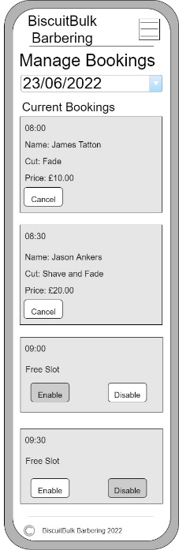

The ‘manage customer’ page has restricted access, only allowing the admin to access the page. Entering the name of a customer and clicking search will allow an admin to check the database of customers for that customer. If they are found their details are loaded for the admin to review, also allowing them to edit any of the fields and click the ‘change’ button to amend the details of that customer in the database.

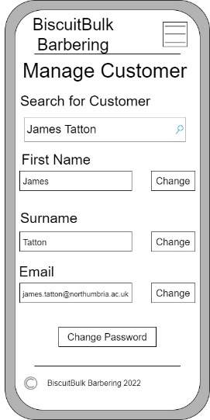

Another restricted page is the ‘manage haircut’ page, this enables an admin to add, edit or remove haircuts that customers can choose from. Using a dropdown box an admin selects a haircut, the details of that haircut are loaded into text boxes where the admin can edit the fields. Beneath the text boxes, there are two buttons one labelled ‘update’ the other labelled ‘remove’. When clicked the update button will update the table with the edited details and the remove button will remove the haircut from the table. Beneath this is the feature to create a new haircut and add it to the database, the admin fills in the text boxes with the: name of the haircut, price of the cut, and a description of the cut. Then clicking on the ‘create’ button will run add the new haircut to the database. All buttons on this page will utilise the hover animation to indicate that a user can interact with the button.

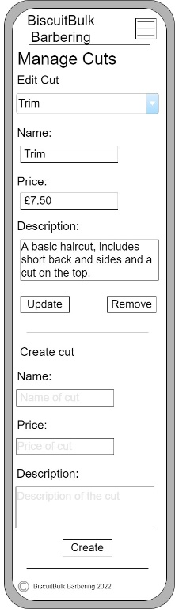

A page exclusive to the customer accounts is the ‘manage account’ page, on this page a customer can retrieve their name and email associated with the account and display it on the screen. Beneath the details of their account there is a ‘change password’ button allowing the customer to change their password. This page also displays the users upcoming booking, this gives the date, time, type of cut, and price of their upcoming booking. The buttons on this page also utilise the hover animation to ensure consistency for users.

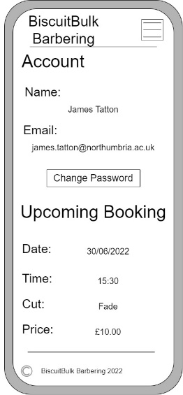

The ‘Change Password’ page has a form that requires three fields, a field that takes the users old password, this is to ensure that the actual user is changing the password. Following this they are asked to enter the new password and then re-enter the password to ensure they have entered it correctly, then click on a submit button labelled ‘Change Password’, this uses the hover animation.

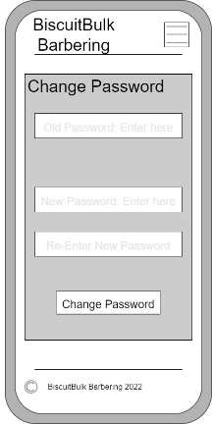

The booking page can be accessed by both an anonymous user and a customer. A user will use a dropdown box to select which barber they wish to book an appointment with, then the user is asked to select a date using a calendar, after selecting a date the user will choose a time from the available time slots left for that day and use a dropdown box again to select a type of haircut. The price of the haircut will then be displayed beneath this informing the user how much they will be paying for the haircut. If the user has clicked on one of the cards from the home page to book an appointment, then this dropdown box will be preloaded appropriately. If the user has been directed from the navigation menu, then the user must choose which sort of haircut they would like. The user must then click on the ‘Confirm Booking’ button to go to the payment page.

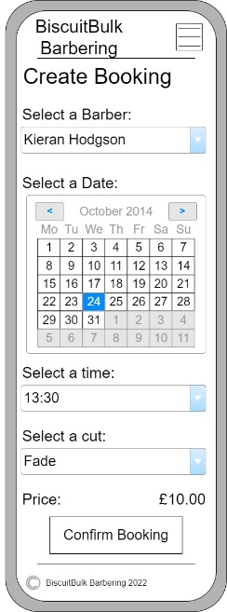

The payment page displays the details of the booking that the customer is about to pay for including date and time of booking, type of cut, price of cut, and the barber. Beneath these details is a button that will allow the customer to pay for their haircut via PayPal, after the payment has been successfully processed, the customer is directed to the home page again and an alert is given to the user that the payment was successful.

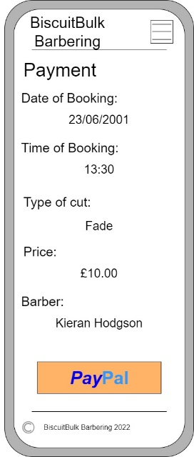

When designing the website, a choice of a greyscale colour theme has been used to portray to users a more sophisticated and professional theme for the website, furthermore these colours have been implemented throughout the website to ensure that users can be familiar with the website with repeated visits. When implementing buttons, the size of the buttons were increased slightly from the original conception to allow for mobile users to click on them easier given a mobile user has a lower accuracy because of the tapping on the screen over the user of a mouse.

This is a link to a prototype that has been made for the website: <https://invis.io/8R12PWUQVXGM>