Lenel Attendance Report Manager
Quick Start Guide — v2.0
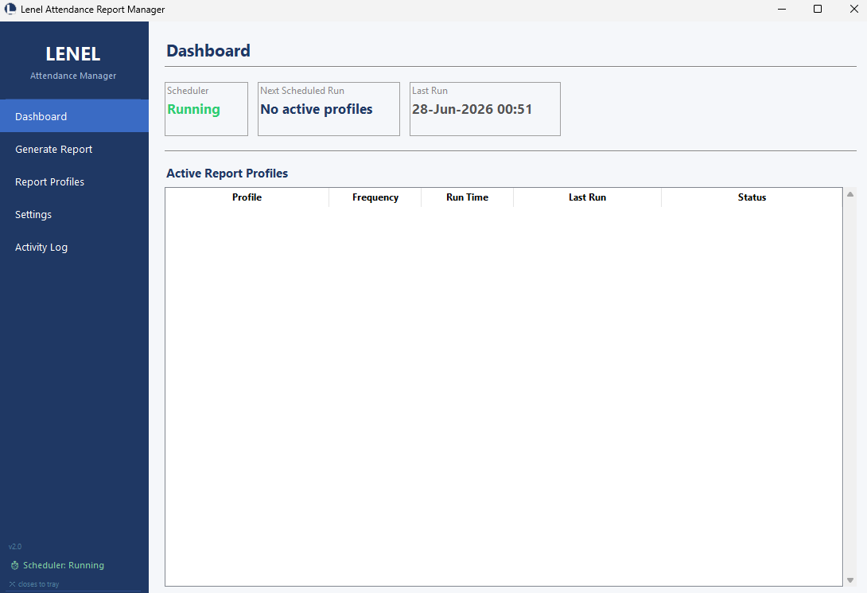
Developed by Khodor Ghalayini

1. What Does This Application Do?
The Lenel Attendance Report Manager connects to the Lenel OnGuard access-control database on this PC, reads every card-swipe event, and produces professional attendance reports in Excel and PDF format.
First Punch In | Earliest entry swipe of the day per employee
Last Punch Out | Latest exit swipe of the day per employee
Effective Hours | Total time inside the office (breaks excluded)
Total Hours | First entry to last exit (includes breaks)
Remarks | Missing punches, out-of-office >2 hours, unpaired swipes

Reports can be:
- Generated manually for any date range with one click
- Sent automatically by email on a daily, weekly, or monthly schedule
- Filtered by company, different profiles for different recipient groups
- Saved locally even when email delivery fails

2. Before You Begin
Make sure the following are in place before launching the app:
Lenel OnGuard | Installed and running on this PC
SQL Server Express | Running (check Services → SQL Server (SQLEXPRESS))
Files | LenelAttendance.exe and LenelAttendanceSvc.exe in the same folder
Administrator | Required to install the Windows Service

3. First-Time Setup
Follow these steps in order the first time you run the application.
Step 1 Install the Code Signing Certificate (One-Time)
Before launching the app for the first time, install the certificate so Windows recognises the publisher and no security warnings appear.
1 | Double-click LenelAttendance_CodeSign.cer
2 | Click Install Certificate → Local Machine → Next
3 | Select "Place all certificates in the following store" → Browse
4 | Choose Trusted Publishers → OK → Next → Finish
5 | Repeat steps 2–4 and choose Trusted Root Certification Authorities

✔ | This is a one-time step per machine. The certificate is valid until 2031. Once installed, neither exe will trigger a security warning on this PC.
Step 2 Launch the Application
Double-click LenelAttendance.exe.
ℹ | The app is signed by Khodor Ghalayini. If you see a UAC prompt it will show the publisher name, click Yes to proceed.

Step 3 Test the Database Connection
Go to Settings → Database.
SQL Server | localhost
Database Name | AccessControl
Authentication | windows
UTC Offset | UAE/Oman = 4 | KSA/Qatar/Lebanon = 3 | Egypt = 2

Click Test Connection. You should see: Connection successful.
ℹ | If the connection fails, open Windows Services (Win + R → services.msc) and confirm SQL Server (SQLEXPRESS) is Running.

[ 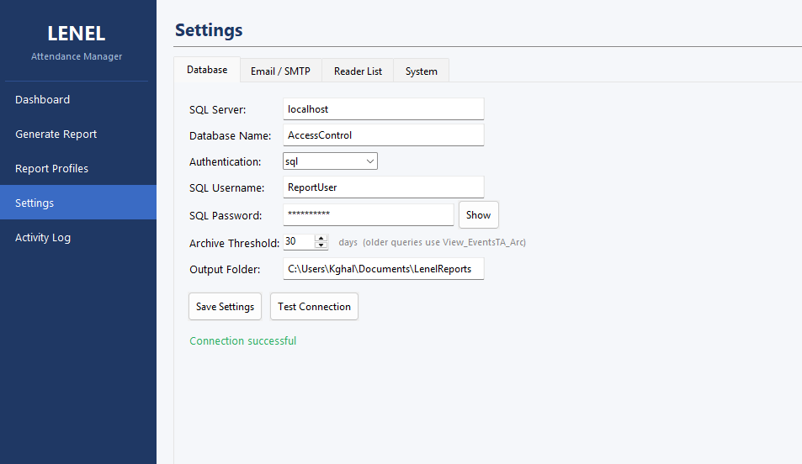
Step 4 Configure Reader Mapping
Go to Settings → Reader List.
- Click Refresh from DB — this loads all readers that have had card-swipe activity

ℹ | The app uses the Punch Type column from the database view (Entered / Exited) to determine entry and exit — no manual mapping is needed.

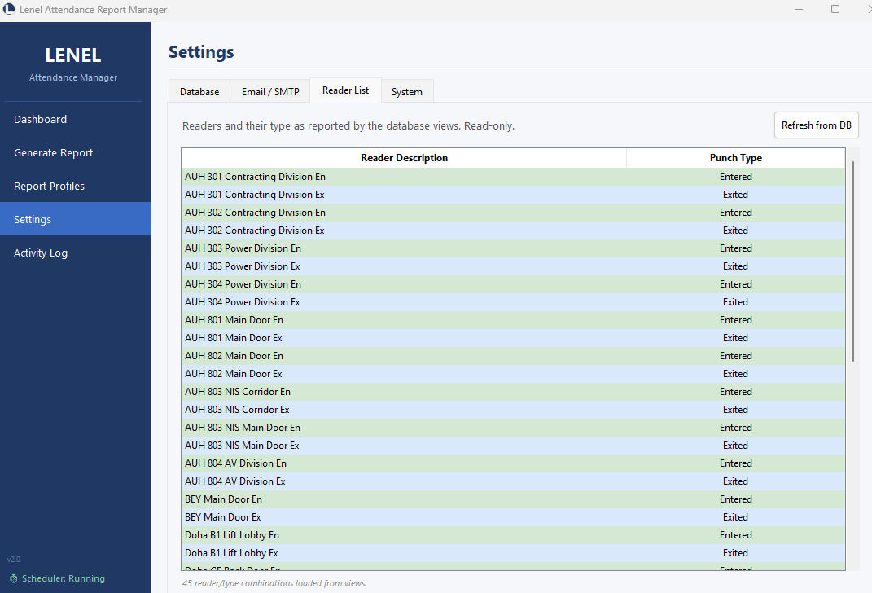
Step 5 Configure Email (SMTP)
Go to Settings → Email / SMTP.
SMTP Server | e.g. smtp.office365.com or smtp.gmail.com
Port | 587 (STARTTLS) — recommended for most providers
Username | Your email address
Password | Email password or App Password (Gmail requires an App Password)
From Address | The sender address that appears on reports

Click Save, then Test SMTP to verify it works.
ℹ | Gmail users: Go to Google Account → Security → 2-Step Verification → App Passwords and create one for Mail. Use that instead of your regular password.

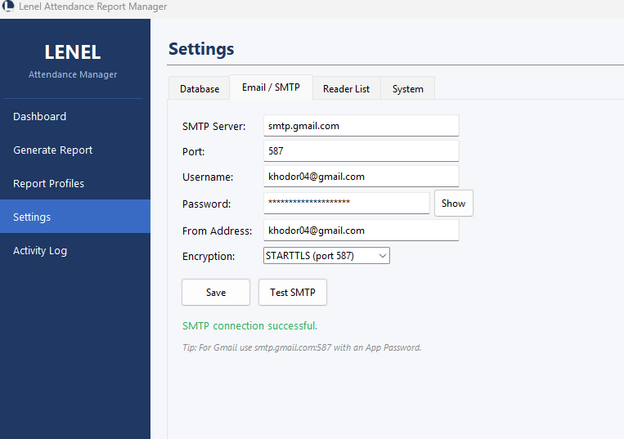
Step 6 Create a Report Profile
Go to Report Profiles → New Profile.
Profile Name | Internal label, e.g. "Maire Daily"
Report Title | Appears as heading in the report, e.g. "Maire Attendance Report"
Email Subject | {title} for {date} → resolves to "Maire Attendance Report for 28-Jun-26"
Output Folder | Base folder. A subfolder named after the profile is created automatically.
Company Filter | Select one or more companies, or leave blank for all employees
Frequency | Daily / Weekly / Monthly
Run Time | 07:00 — the time the report will be generated and emailed
Recipients | Comma-separated email addresses

Click Save. The profile appears in the list and on the Dashboard.
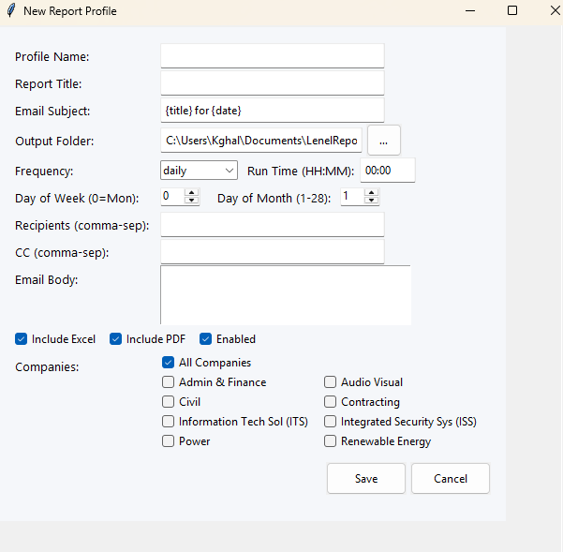
📁 | Each profile saves its reports into a dedicated subfolder: Documents\LenelReports\Maire Daily\ so reports from different profiles never mix.

Step 7 Install the Windows Service
Go to Settings → System → Windows Service.
- Click Install Service
- Wait for the status to show Running ✓ (green)

✔ | The Windows Service runs 24/7 in the background — even when no user is logged in. This is the recommended way to ensure reports are always generated on schedule.

⚠ | Administrator rights are required. If the button fails, right-click LenelAttendance.exe and choose Run as administrator, then try again.

Step 8 Run a Test Report
Go to the Dashboard.
- Find your new profile in the list
- Click Run Now
- Watch the status update — it should say Success (N records)

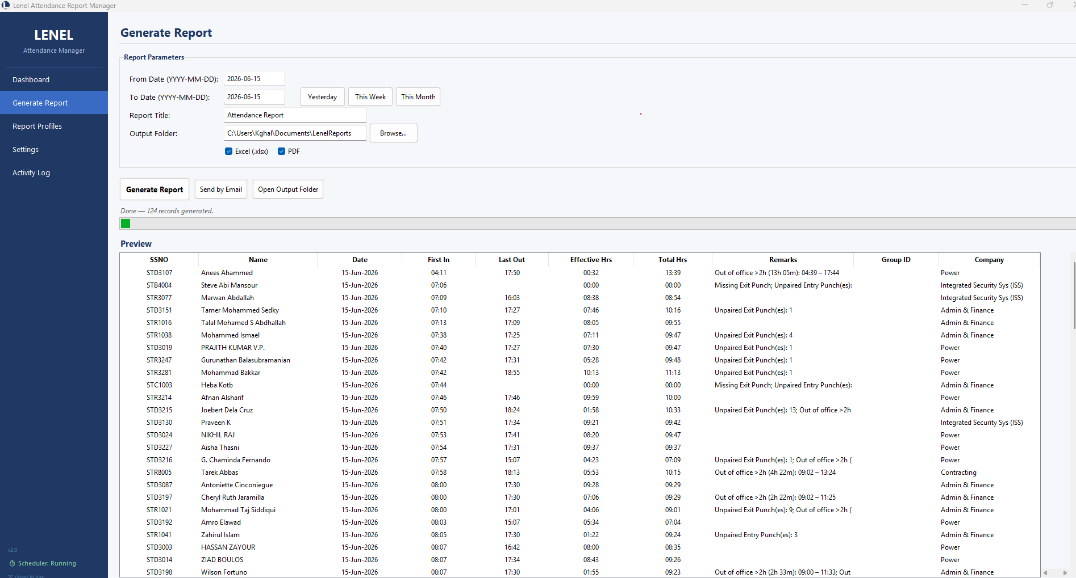
ℹ | Check the Activity Log tab for a detailed trace of what happened — events fetched, records calculated, file saved, email sent.

4. What Happens In Different Scenarios?
A. The Application Window Is Closed
Clicking the ✕ button does NOT exit the application. It hides the window to the Windows system tray (bottom-right notification area).
The scheduler continues running in the background. Nothing is interrupted.
To reopen the window | Double-click the tray icon, or right-click → Open Lenel Attendance
To fully exit the app | Right-click the tray icon → Exit
If app is fully exited | Scheduled reports will NOT run until the app is reopened

✔ | Best practice: install the Windows Service (Step 6 above). The service runs even when the app is fully closed or the user is logged out.

B. An Email Fails to Send
The application automatically retries failed emails up to 3 times, waiting 30 seconds between each attempt.
Attempt 1 fails | Logs WARNING → waits 30 seconds → retries
Attempt 2 fails | Logs WARNING → waits 30 seconds → retries
Attempt 3 fails | Logs ERROR → gives up
Report file | Always saved locally regardless of email outcome

ℹ | To see email failure details: go to Activity Log → filter Level = ERROR. The full error message (wrong password, server timeout, etc.) is recorded there.

If email consistently fails, go to Settings → Email → Test SMTP to diagnose the problem.
C. The PC Restarts
Windows Service installed | Service starts automatically with Windows — no action needed
Auto-Start at Login enabled | App launches automatically when the user logs in
Neither installed | App must be opened manually after each restart

✔ | The Windows Service is the most reliable option — it starts before any user logs in.

D. A Scheduled Report Did Not Run
Check the following in order:
- 1. Settings → System → Windows Service — confirm status is Running ✓
- 2. Activity Log — search for the profile name to see if it ran and what happened
- 3. Profile settings — confirm Run Time is correct (24-hour format, e.g. 07:00)
- 4. Profile enabled — make sure the Enabled toggle is on

✔ | Even if a scheduled report is missed, the built-in Auto-Save runs every day at 01:00 and saves all attendance data locally — so no data is ever lost.

E. No Records Appear in a Report
If a report generates 0 records:
- The date range must be a period when employees actually swiped
- The UTC Offset must be correct for your timezone (Settings → Database)
- Check Activity Log for the event count — "N live events fetched"
- If event count is 0, check that Lenel OnGuard has data for that period
F. The Windows Service Shows "Not Installed"
LenelAttendanceSvc.exe must be in the same folder as LenelAttendance.exe.
- Both files must be in the same folder (e.g. C:\Program Files\LenelAttendance\)
- Right-click LenelAttendance.exe → Run as administrator, then install the service

5. Where Are My Files?
Report profiles' reports | Documents\LenelReports\{Profile Name}\ (one subfolder per profile)
Auto-Save daily reports | Documents\LenelReports\Automated Reports\Auto-Save\
Application settings | Same folder as LenelAttendance.exe → lenel_app.db
Activity Log | Stored inside lenel_app.db — view in app under Activity Log tab
Settings backup | Settings → System → Backup & Restore → Export Backup

⚠ | Back up lenel_app.db regularly. It contains all your settings, reader mapping, and report profiles. If lost, everything must be re-entered from scratch.

6. Quick Reference
Manual report | Generate Report tab → set dates → Generate Report
Check for errors | Activity Log tab → filter Level = ERROR
Test email | Settings → Email → Test SMTP
Test DB connection | Settings → Database → Test Connection
Run a profile now | Dashboard → Run Now button next to the profile
Service status | Settings → System → Windows Service → status label
Export settings backup | Settings → System → Backup & Restore → Export Backup
Auto-save folder | Settings → System → Auto-Save Daily Report → Open Folder

Lenel Attendance Report Manager v2.0 — Developed by Khodor Ghalayini

