How to start the api server
Start another terminal (cmd)
remind run [npm install] first
>> cd the backend directory
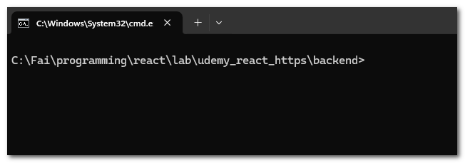
>> node app.js
Then it is running
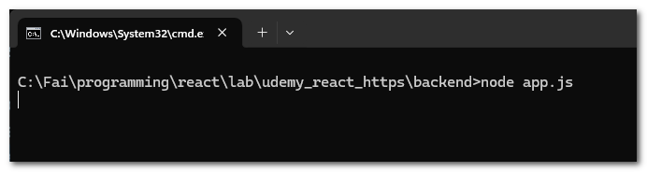

How to run the react
