# Optimizer

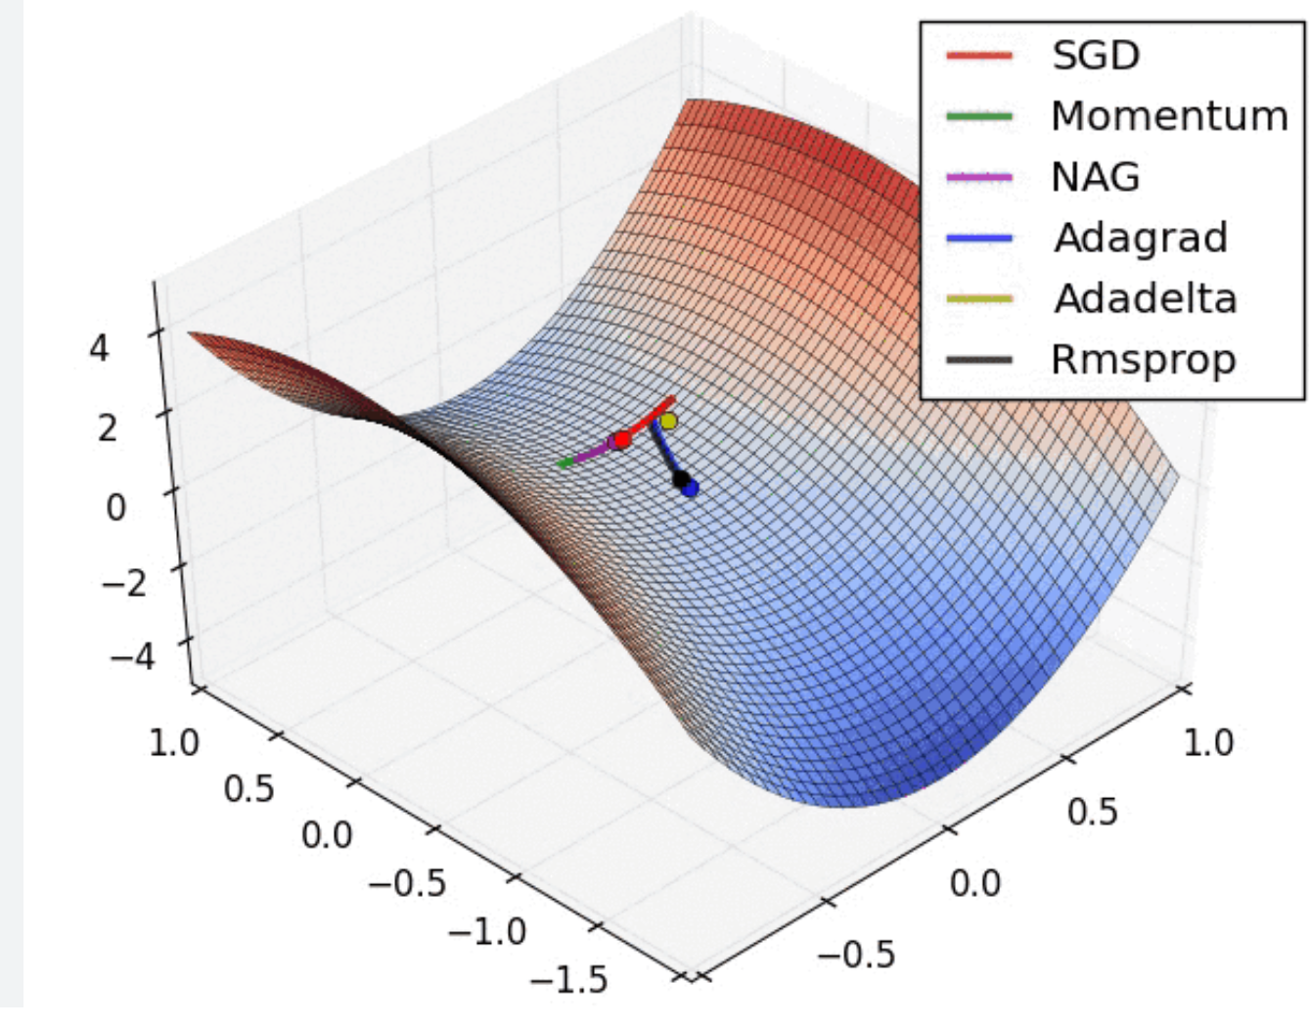

## What is optimizer

Introduction to Optimizers in Machine Learning

"Optimizer" in machine learning is defined as algorithms or methods used to modify specific properties of a neural network, such as weights and learning rates, with the goal of minimizing loss. These algorithms are used during training to adjust the parameters of a model to minimize the loss function. An important optimization algorithm in machine learning is Gradient Descent (GD). GD is commonly used in models like Logistic Regression and Linear Regression. Machine learning is also used to automatically learn optimization algorithms or techniques, a task referred to as meta-learning. Optimization, in general, involves the process of searching for input or parameter values for a function so that the result reaches a minimum or maximum value. Optimizers are often used in machine learning to minimize error functions or maximize production efficiency.

In machine learning, optimizers are algorithms that are used to adjust the weights and biases of a model in order to minimize the error or loss function during the training process. The goal of an optimizer is to find the optimal set of weights and biases that will make the model perform as accurately as possible on the training data.

There are several different types of optimizers that can be used in machine learning, each with its own advantages and disadvantages. Some of the most commonly used optimizers include:

**Gradient Descent:** This is a basic optimization algorithm that iteratively updates the weights and biases in the direction of the steepest descent of the loss function. There are different variations of gradient descent, such as batch gradient descent, stochastic gradient descent, and mini-batch gradient descent.

**Stochastic Gradient Descent (SGD):** is a variant of the traditional Gradient Descent (GD) optimization algorithm commonly used in machine learning. The main difference between SGD and GD lies in the way they update the model parameters during the training process.

**Momentum:** is a technique used in optimization algorithms, particularly in the context of training machine learning models. It is often applied to variants of gradient-based optimization methods, such as Stochastic Gradient Descent (SGD). The purpose of momentum is to accelerate the convergence of the optimization process and enhance the ability of the algorithm to navigate through local minima.

**AdaGrad:** AdaGrad is an optimizer that adapts the learning rate during training. It decreases the learning rate for parameters that are frequently updated and increases the learning rate for parameters that are infrequently updated. This helps to converge faster on the optimal solution.

**RMSprop:** RMSprop is another optimizer that adapts the learning rate during training. It uses a moving average of squared gradients to divide the learning rate. This helps to prevent the learning rate from decreasing too quickly and allows the optimizer to converge faster.

**Adam:** Adam (Adaptive Moment Estimation) is a combination of AdaGrad and RMSprop. It incorporates both the adaptive learning rate of AdaGrad and the moving average of squared gradients of RMSprop. Adam is considered to be one of the most effective optimizers in machine learning.

In summary, optimizers play a fundamental role in the training of machine learning models by guiding the iterative process of adjusting model parameters to minimize a given loss function. The choice of optimizer and its hyperparameters can significantly impact the performance and efficiency of the training process.

## Optimization algorithms

### **Gradient Descent (GD**)

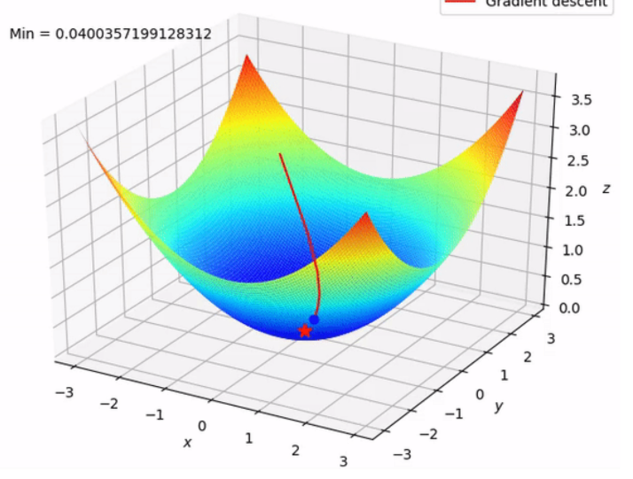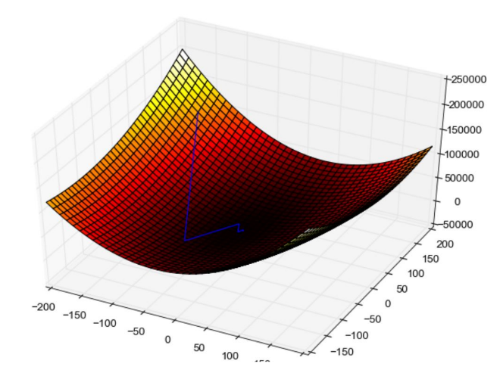

Gradient Descent is an optimization algorithm widely used in machine learning and related fields. The goal of gradient Descent is to find the smallest value of a number by adjusting its parameters through iterations.

This algorithm works by calculating the gradient of the function (partial derivative with respect to each parameter), indicating the direction and rate of increase of the function. Then it does not move against this gradient to decrease the value of the function.

**Advantage:**

**Versatility:**Gradient Descent is a versatile optimization algorithm that can be applied to a wide range of machine learning models, including linear regression, logistic regression, and neural networks.

**Global Optimization:**In theory, given enough time and an appropriate learning rate, Gradient Descent can converge to the global minimum of the cost function, allowing it to find the optimal set of parameters.

Intuitiveness:The concept of moving in the direction opposite to the gradient is intuitive and aligns with the idea of "descending" towards the minimum of the cost function.

**Disadvantage:**

Sensitivity to Learning Rate:The choice of the learning rate is crucial. If it's too small, the algorithm may converge very slowly; if it's too large, the algorithm might overshoot the minimum and fail to converge.

Local Minima:Gradient Descent can get stuck in local minima or saddle points in the cost function, especially in non-convex optimization problems.

Computational Intensity:For large datasets, computing the gradient over the entire dataset in each iteration can be computationally intensive. Stochastic Gradient Descent (SGD) and Mini-batch Gradient Descent are often used to address this.

Non-Differentiable Cost Functions:Gradient Descent relies on the gradient of the cost function, and if the cost function is not differentiable, the algorithm may not be applicable.

**Formula:**

CODE EXAMPLE:

### **Momentum**

To address the limitations of the Gradient Descent algorithm, people use Gradient Descent with Momentum. Gradient Descent with Momentum is an optimization technique used in the training process of machine learning models, especially in updating the weights of neural networks. This technique is designed to accelerate convergence and avoid unwanted oscillations during the optimization process.

The mechanism of Gradient Descent with Momentum is based on accumulating momentum from previous gradients to update the weights. Instead of relying solely on the current gradient to adjust the weights, Gradient Descent with Momentum calculates the weight changes based on the current gradient and the accumulated momentum from previous steps.

**Advantage:**

The optimal algorithm solves the problem: Gradient Descent does not reach the global minimum point but only stops at the local minimum.

**Disadvantage:**

**Overshooting**:In some cases, especially when dealing with noisy or erratic gradients, momentum can cause the optimization algorithm to overshoot the minimum and introduce oscillations. This overshooting effect might hinder convergence.

**Dependence on Hyperparameter**:The performance of the momentum technique depends on the appropriate choice of the hyperparameter . If the momentum term is set too high, it can lead to overshooting, and if it's set too low, it might not effectively smooth out oscillations.

**Sensitivity to Learning Rate:**Momentum interacts with the learning rate , and the combination of momentum and learning rate requires careful tuning. If the learning rate is too high, it can exacerbate overshooting issues, and if it's too low, momentum might not have a significant impact.

**Not Suitable for All Problems**:While momentum is effective in many scenarios, it might not be as beneficial for all optimization problems. Some problems or specific data characteristics may not align well with the assumptions of momentum, and in such cases, alternative optimization techniques may be more suitable.

**The formula:** for updating weights using Gradient Descent with Momentum is often expressed as follows:

Δ*w*(*t*)=*α*⋅Δ*w*(*t*−1)−*η*⋅∇*J*(*w*)

• Δw(t) is the weight update step at time t

• Δw(t−1) is the momentum accumulated from the previous step.

• α is the momentum coefficient, usually a value between 0 and 1 to adjust the influence of cumulative momentum.

• η is the learning rate.

• ∇J(w) is the gradient of the loss function J with weight w. technical gradient with momentum

### **Stochastic Gradient Descent (SGD)**

Stochastic Gradient Descent (SGD) is a variant of the traditional Gradient Descent optimization algorithm commonly used in machine learning. Unlike regular Gradient Descent, which processes the entire training dataset in each iteration, SGD updates the model parameters using only a single randomly chosen data point or a small batch of data points for each iteration. This stochastic nature of the updates introduces randomness and can be computationally more efficient, especially for large datasets.

**Advantage:**

**Efficiency**:SGD is computationally more efficient, especially for large datasets, as it processes only a subset of the data in each iteration.

**Generalization:**The stochastic updates and the noise introduced by using mini-batches can help SGD generalize better, especially in the presence of noisy data.

**Online Learning**:Well-suited for online learning scenarios where data is continuously streaming, and the model needs to adapt to new information.

**Disadvantage:**

**Learning Rate Tuning:**The learning rate needs to be carefully tuned. Too high a learning rate can cause divergence, while too low a learning rate may result in slow convergence.

**Non-Convex Optimization:**May struggle with non-convex optimization landscapes, such as finding global minima in complex loss functions.

Despite its limitations, SGD is a popular and widely used optimization algorithm, and many advanced variants, such as mini-batch SGD and SGD with momentum, have been developed to address some of its challenges.

**The formula:**

### **Adagrad**

Unlike previous algorithms where the learning rate is almost the same during the training process (learning rate is constant), Adagrad considers learning rate as a parameter. That is, Adagrad will let the learning rate change after each time t.

**Advantage:**

**Adaptive Learning Rates:** Adagrad adjusts the learning rate for each parameter individually based on its historical gradient. This means that parameters with frequent updates will have smaller learning rates, while parameters with infrequent updates will have larger learning rates. This adaptive learning rate scheme allows Adagrad to effectively handle sparse data and converge faster in certain scenarios.

**Automatic Feature Scaling:** Adagrad eliminates the need for manual feature scaling. By adapting the learning rate for each parameter, it implicitly performs feature scaling. This is particularly useful when dealing with features that have different scales or when working with high-dimensional datasets.

**Efficient Sparse Data Handling:** Adagrad is well-suited for problems that involve sparse data, such as text classification or recommender systems. It effectively allocates more learning time to infrequent features and less learning time to frequent features, making it more efficient in handling sparse inputs.

**Convergence on Sparse Data:** Due to its adaptive learning rate strategy, Adagrad tends to converge faster on sparse datasets compared to traditional optimization algorithms. It allows the model to focus more on the informative features and quickly discard less relevant ones, resulting in faster convergence and improved performance.

**Robustness to Hyperparameter Choices:** Adagrad is relatively less sensitive to the choice of hyperparameters compared to other optimization algorithms. It automatically adapts the learning rate based on the gradients encountered during training, reducing the need for extensive hyperparameter tuning.

**Disadvantage:**

One major disadvantage is the accumulation of squared gradients in the denominator of the learning rate update. As training progresses, the sum of squared gradients keeps increasing, which can lead to a diminishing learning rate. This can cause the learning process to slow down significantly, especially in later stages of training.

Another disadvantage of Adagrad is its inability to differentiate between different types of parameters. It treats all parameters equally, regardless of their importance or sensitivity. This can result in inefficient learning, as some parameters might require larger learning rates while others might benefit from smaller ones. Adagrad's uniform treatment of parameters can limit its effectiveness in certain scenarios.

Additionally, Adagrad's accumulation of squared gradients can lead to numerical instability. Since the squared gradients are added up over time, they can become very large and result in numerical overflow or instability issues. This can negatively impact the convergence and overall performance of the model.

In conclusion, Adagrad offers advantages such as automatic learning rate adaptation and reduced manual tuning effort. However, it also has disadvantages including the potential for a diminishing learning rate, inefficient treatment of parameters, and numerical instability. It is important to consider these factors when deciding whether to use Adagrad in a machine learning task.

**The formula:**

In there:

• n : constant

• gt : gradient at time t

• ϵ: error avoidance factor (divided by sample equals 0)

• G: is a diagonal matrix where each element on the diagonal (i,i) is the square of the parameter vector derivative at time t.

### **RMSprop**

**Advantage:**

**RMSprop (Root Mean Square Propagation)** is an optimization algorithm used in machine learning, particularly in training deep neural networks. It addresses some of the limitations of the widely used gradient descent algorithm.

**Adaptive Learning Rate:**RMSprop adapts the learning rate for each parameter based on the magnitude of the recent gradients. This adaptive learning rate can be beneficial in scenarios where different parameters may have varying scales.

**Mitigating Vanishing/Exploding Gradients:**By utilizing a moving average of squared gradients, RMSprop can help mitigate the vanishing and exploding gradient problems. It can prevent the learning rates for certain parameters from becoming too small or too large.

**Stability in Non-Stationary Objectives**:RMSprop's adaptive learning rate can be advantageous in scenarios where the objective function's landscape changes over time. It helps provide stability in the presence of non-stationary data distributions.

No Manual Learning Rate Tuning:

Unlike traditional Gradient Descent where tuning the learning rate can be critical, RMSprop automates this process, making it less sensitive to the initial choice of the learning rate.

**Disadvantage:**

**Accumulation of Squared Gradients:**The accumulating square of gradients in the denominator can lead to a rapidly decreasing learning rate over time. This may cause the learning process to slow down too much, especially in the later stages of training.

**No Momentum Term**:RMSprop doesn't include a momentum term in its update rule, which can affect its ability to maintain momentum in the optimization process. This is in contrast to methods like Momentum and Adam that include momentum terms to improve convergence.

**Hyperparameter Sensitivity:**RMSprop still has hyperparameters that need to be set, such as the decay rate for the moving average of squared gradients. The sensitivity to hyperparameters means that some manual tuning may still be required.

Not Well-Suited for All Problems:

While RMSprop is effective in many cases, it might not be the best choice for all optimization problems. The performance can depend on the specific characteristics of the data and the problem at hand.

**The formula:**

**Adam**

In analogy to physical phenomena, envision Momentum as a ball swiftly descending a slope, and consider Adam as akin to a hefty ball endowed with friction. The Momentum aspect propels it energetically, enabling it to traverse local minima swiftly and reach the global minimum. However, Adam, resembling a ball with friction, exhibits a more controlled behavior. It navigates efficiently to the global minimum, and once it arrives, the presence of friction prevents excessive oscillations, facilitating a steadier convergence without prolonged back-and-forth movement.

**Advantage:**

**Adaptive Learning Rates**:Adam adapts the learning rates for each parameter individually based on both the first-order (mean) and second-order (uncentered variance) moments of the gradients. This adaptability is beneficial in situations where different parameters have different scales or when dealing with sparse data.

**Combination of Momentum and RMSprop**:Adam combines the benefits of Momentum and RMSprop. It utilizes the momentum term to carry the information from past gradients and the RMSprop-like adaptive learning rates to provide stable and efficient updates. This combination often results in improved convergence.

**Bias Correction**:Adam incorporates bias correction terms to mitigate the bias introduced in the estimation of the first and second moments, particularly in the early iterations. This correction helps improve the accuracy of the moment estimates.

**Effective in Practice:**Adam is widely used in practice and often performs well across various types of machine learning tasks and architectures. Its versatility makes it a popular choice for many researchers and practitioners.

**Disadvantage:**

**Ensitivity to Hyperparameters:**Like many optimization algorithms, Adam has hyperparameters that need to be set, including the learning rate The performance of Adam can be sensitive to the choice of these hyperparameters, and some manual tuning may be required.

**Memory Requirements:**Adam requires storing and updating additional moments for each parameter, which increases memory requirements. This can be a concern, especially when dealing with large neural networks or in memory-constrained environments.

**Less Suitable for Noisy Objectives:**In some cases, Adam might not perform as well when dealing with objectives that are highly noisy or have a large amount of variance. Other optimization algorithms, like SGD with momentum, might be more suitable in such scenarios.

**Not Robust to Outliers:**Adam can be sensitive to the presence of outliers in the gradient estimates. Outliers may disproportionately influence the moment estimates, potentially affecting the optimization process.

**The formula:**

**TABLE OF COMPARISON:**

|  |  |  |  |  |
| --- | --- | --- | --- | --- |
| **Algorithm** | **Characteristics** | **Advantages** | **Disadvantages** | **Use Cases** |
| **Gradient Descent** | - Iteratively updates model parameters in the direction of steepest descent | - Simple and easy to implement | - Can get stuck in local minima | Linear regression, logistic regression, and other convex optimization problems |
| **Stochastic Gradient Descent** | - Randomly selects a subset of training examples at each iteration | - Efficient for large datasets | -High variance in parameter updates | Large-scale machine learning tasks, especially when dealing with high-dimensional data |
| **Momentum** | - Accumulates a velocity term to accelerate gradient updates | -Faster convergence for flat or small gradient surfaces | -Can overshoot the optimal solution due to momentum | Training deep neural networks |
| **Adagrad** | - Adapts the learning rate for each parameter based on its historical gradients | - Effective for sparse data and problems with a wide range of gradients | - Learning rate may become too small over time, causing slow convergence | Natural language processing, recommendation systems, and other applications with sparse data |
| **RMSprop** | - Adapts the learning rate based on the average of squared gradients | - Prevents the learning rate from getting too large | - Requires tuning of hyperparameters | Image classification, object detection, and other deep learning tasks |
| **Adam** | - Combines the ideas of Momentum and RMSprop, incorporating both momentum and adaptive learning rate | - Efficient and effective in a wide range of problems | - Includes additional hyperparameters to tune | General-purpose optimization algorithm suitable for a variety of machine learning tasks, including deep learning, natural language processing, etc. |

# Continual Learning and Test Production

## Continual learning

### Continuous learning is the idea of updating your model as new data becomes available; this makes your model keep up with current data distributions.

### Once your model is updated, it cannot be blindly released to production. It needs to be tested to ensure that it is safer and better than the current model being produced. Therefore, the Test Production stage is needed

### **Why we need Continual Learning?**

**Dynamic Environments:**Many real-world environments are dynamic, and the distribution of data can change over time. Continual learning enables models to adapt to these changes without requiring retraining on the entire dataset.

**Resource Efficiency**:In scenarios where collecting and labeling large datasets is resource-intensive or costly, continual learning allows models to incrementally acquire knowledge over time. This is particularly advantageous in situations where obtaining a new labeled dataset for every change in the environment is impractical.

Adaptability to New Tasks:Continual learning allows models to adapt to new tasks and challenges as they arise. This is crucial in applications where the tasks are not known in advance, and the model needs to continuously learn and update its knowledge.

**Online Learning:**In online learning scenarios, data arrives sequentially, and the model needs to adapt to new examples in real-time. Continual learning is well-suited for applications such as online recommendation systems, fraud detection, and autonomous systems.

**Memory and Storage Constraints:**For memory-constrained systems or devices, retraining a model from scratch with an expanding dataset may not be feasible. Continual learning enables models to update their knowledge efficiently, retaining important information while adapting to new data.

**Avoidance of Catastrophic Forgetting:**Traditional machine learning models may suffer from catastrophic forgetting, where learning new information erases knowledge acquired from previous tasks. Continual learning methods aim to mitigate this issue, ensuring that models retain and build upon their past experiences.

**Transfer Learning Across Tasks:**Continual learning supports the concept of transfer learning, where knowledge gained from solving one task is leveraged to improve performance on a related task. This enables models to benefit from previously acquired skills and accelerates learning on new tasks.

**Long-Term Autonomy in AI Systems:**In applications such as robotics, autonomous vehicles, and other AI-driven systems, continual learning is essential for maintaining long-term autonomy. These systems need to adapt to changing environments, new tasks, and evolving conditions over time.

Human-Like Learning:Continual learning is inspired by the way humans learn and adapt throughout their lives. Human cognition involves a continual process of acquiring new knowledge while retaining and building upon existing knowledge.

Overall, continual learning addresses the limitations of static, batch learning approaches, making machine learning models more adaptive, efficient, and capable of handling the evolving nature of real-world data and tasks. It is particularly relevant in applications where the environment is non-stationary, and the model needs to continuously evolve its understanding.

**The main steps of Continual Learning typically include:**

**Data Preparation:**Prepare diverse and representative data to feed into the model, ensuring it covers various tasks or environments that the model may encounter during continual learning.

**Build Initial Model**:Construct an initial model or use an existing one to initiate the continual learning process. This model could be pre-trained or start from a random state, depending on the specific requirements of the task.

**Prepare Continual Learning Environment**:Define how the model will interact with the continual learning environment. This involves determining how new data will be provided to the model and how the model will face new tasks.

Task Classification or Data Splitting:Identify specific tasks or split the data into subsets relevant to each task. This may involve classifying classes, tasks, or different data domains.

**Independently Train for Each Task:**Train the model independently for each task or subset of data. The goal is for the model to learn representations that perform well for each specific task.

**Manage Interference and Catastrophic Forgetting:**Implement strategies such as regularization, rehearsal, or architectural modifications to manage issues related to task interference and catastrophic forgetting, where the model forgets information from previous tasks.

**Combine Knowledge**:If applicable, combine knowledge from previous tasks into the learning process of new tasks. This may involve transfer learning, utilizing knowledge from one dataset for one task to support another.

**Evaluate and Monitor Performance:**Monitor the model's performance on each specific task and evaluate its ability during continual learning. This helps assess transferability and knowledge retention.

**Repeat the Process for Each Subsequent Task:**Iterate through the above steps for each new task or dataset that the model will encounter during continual learning.

The continual learning process is iterative and ongoing, allowing the model not only to learn from new tasks but also to retain knowledge from previously learned tasks. The specific strategies may vary depending on the requirements of the particular problem and the characteristics of the data.

## Test Production

Test Production in machine learning is a crucial process to ensure that a machine learning model operates accurately and effectively before deploying it into a real-world environment. It plays a vital role in evaluating the model's quality, confirming its functionality, and assessing its performance before actual deployment in production.

The Test Production process typically begins after the model has been trained and validated on training and test data. However, the key difference lies in deploying the model into the actual production environment to assess its stability, performance, and its ability to operate with new data, which may not necessarily resemble the data used during training.

Some important steps in the Test Production process include:

**Prepare New Data:**New real-world data for production may differ from the data used during training. Therefore, preparing and cleaning new data for testing the model is extremely important.

**Deploy the Model:**The model is deployed into the real-world environment to test its operation. This involves configuring the necessary infrastructure and connecting it to the system for the model to process real-time data or meet production environment requirements.

**Performance Testing:**The model is evaluated for performance in the real-world environment, collecting metrics such as accuracy, classification, or other performance indicators depending on the type of machine learning problem.

**Monitoring and Updating:**The Test Production process doesn't stop after deploying the model. Continuous monitoring of the model's performance in the real-world environment and updating the model as needed are crucial steps to maintain and improve performance over time.

**Security and Compliance:**Data security and compliance with legal regulations are crucial factors in the Test Production process, especially when the model processes personal or sensitive data.

The Test Production process not only helps assess the model but also aids in improving and optimizing it to reflect its best capabilities in a real-world environment. The accuracy and performance of the model in production can significantly impact business outcomes and end-user experiences. Therefore, conducting Test Production carefully and comprehensively is essential.