

**<<Cyber Booking Management >>**

**Software Design Document**

**Members:**

**- Trần Lê Minh Hoàng**

**- Huỳnh Thái Phong**

**- Ngô Nguyễn Xuân Linh**

**- Lê Thành Nhân**

– Da Nang, September 2021 –

**Table of Contents**

* I. Overview 6

1. Code Packages/Namespaces 6

2. Database Schema 6

II. Code Designs 8

1. Authorization / Login 8

a. Class Diagram 8

b. Class Specifications 8

c. Sequence Diagram(s) 10

d. Database queries 10

2. Authorization / Register 11

a. Class Diagram 11

b. Class Specifications 11

c. Sequence Diagram(s) 12

d. Database queries 12

3. User / Update Profile 13

a. Class Diagram 13

b. Class Specifications 13

c. Sequence Diagram(s) 14

d. Database queries 14

4. Recharge / Recharge & CreateRechargeReceipt 14

a. Class Diagram 14

b. Class Specifications 15

c. Sequence Diagram(s) 15

d. Database queries 15

5. Recharge / Paid 16

a. Class Diagram 16

b. Class Specifications 16

c. Sequence Diagram(s) 16

d. Database queries 16

6. Cyber / View Cyber List 17

a. Class Diagram 17

b. Class Specifications 17

c. Sequence Diagram(s) 17

d. Database queries 18

7. Cyber / View Cyber Detail 18

a. Class Diagram 18

b. Class Specifications 18

c. Sequence Diagram(s) 18

d. Database queries 19

8. Cyber/ Create Cyber 19

a. Class Diagram 19

b. Class Specifications 19

c. Sequence Diagram(s) 20

d. Database queries 20

9. Cyber/ Update Cyber 21

a. Class Diagram 21

b. Class Specifications 21

c. Sequence Diagram(s) 21

d. Database queries 22

10. Service / View Service Detail 22

a. Class Diagram 22

b. Class Specifications 22

c. Sequence Diagram(s) 23

d. Database queries 23

11. Service/ Create Service 23

a. Class Diagram 23

b. Class Specifications 24

c. Sequence Diagram(s) 24

d. Database queries 25

12. Service/ Update Service 25

a. Class Diagram 25

b. Class Specifications 25

c. Sequence Diagram(s) 26

d. Database queries 26

13. Booking/ Book (Create BookingReceipt) 26

a. Class Diagram 26

b. Class Specifications 26

c. Sequence Diagram(s) 27

d. Database queries 27

14. Search/ SearchCyber 28

a. Class Diagram 28

b. Class Specifications 28

c. Sequence Diagram(s) 29

d. Database queries 29

15. Search/ SearchBookingReceipt 30

a. Class Diagram 30

b. Class Specifications 30

c. Sequence Diagram(s) 31

d. Database queries 31

16. Receipt/ ViewReceipt 32

a. Class Diagram 32

b. Class Specifications 32

c. Sequence Diagram(s) 33

d. Database queries 33

17. Delete User & Manager 33

a. Class Diagram 33

b. Class Specifications 33

c. Sequence Diagram(s) 34

d. Database queries 34

18. Service/Delete Service 34

a. Class Diagram 34

b. Class Specifications 34

c. Sequence Diagram(s) 35

d. Database queries 35

19. Cyber/Delete Cyber 35

a. Class Diagram 35

b. Class Specifications 36

c. Sequence Diagram(s) 36

d. Database queries 36

20. Authorization / Remember account 36

a. Class Diagram 36

b. Class Specifications 36

c. Sequence Diagram(s) 37

d. Database queries 38

21. Filter / Filter 38

a. Class Diagram 38

b. Class Specifications 38

c. Sequence Diagram(s) 38

d. Database queries 38

22. Admin / Web’s statistic 39

a. Class Diagram 39

b. Class Specifications 39

c. Sequence Diagram(s) 39

d. Database queries 39

III. Database Tables 40

1. User 40

2. Manager 40

3. Cyber 40

4. Service 41

5. Wallet 41

6. Payment 41

7. Recharge_Receipt 41

8. Booking_Receipt 41

9. User_Favorite 42

10. City 42

11. Admin_Notification 42

# I. Overview

## 1. Code Packages/Namespaces

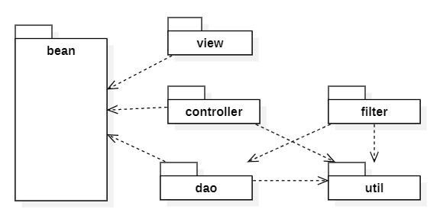

***Package descriptions & package class naming conventions***

|  |  |  |
| --- | --- | --- |
| **No** | **Package** | **Description** |
| 01 | DBContext | Connect database |
| 02 | Models | Contain entities |
| 03 | Controller | Contain Controllers |
| 04 | DAO | Forward data from database to Controller.  Handle information. |
| 05 | Filter | Forward page |
| 06 | View | Contain html file, css file, js file, … |

## 2. Database Schema

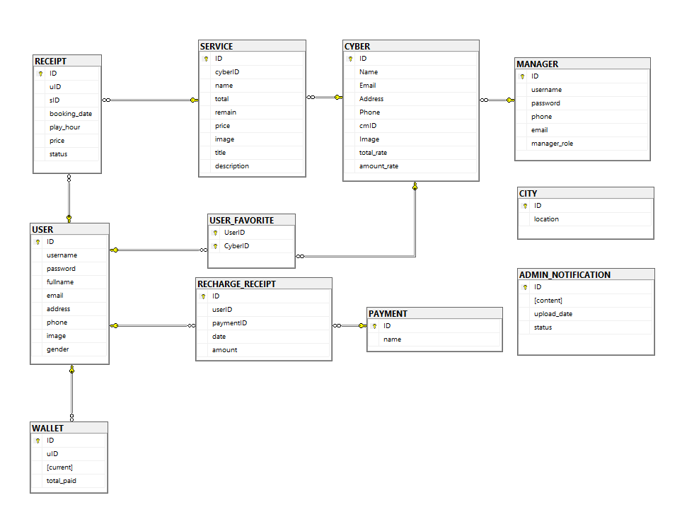

***Table descriptions & package class naming conventions are as below***

|  |  |  |
| --- | --- | --- |
| **No** | **Table** | **Description** |
| 01 | USER | - Contain information of Users  - Primary keys: [Id] |
| 02 | MANAGER | - Contain information of Manager, be distinguish by [Role]  - Primary keys: [Id] |
| 03 | WALLET | - Contain wallet information of each User  - Primary keys: [Id]  - Foreign keys: [uID] = [USER.Id] |
| 04 | CYBER | - Contain Cybers Information  - Primary keys: [Id]  - Foreign keys: [cmID] = [MANAGER].[Id] on delete cascade |
| 05 | SERVICE | - Contain Service Information  - Primary keys: [Id]  - Foreign keys: [cyberId] = [CYBER].[ID] on delete cascade |
| 06 | RECEIPT | - Contain receipt information after user books a service  - Primary keys: [Id]  - Foreign keys: [userId] = [USER].[Id] on delete cascade |
| 07 | USER_FAVORITE | - Contain all Cyber that is user likes  - Keys: [uId, cID]  - Foreign keys: [cId] = [CYBER].[Id],  [uId] = [USER].[Id] |
| 08 | PAYMENT | - Contain payment method  - Primary keys: [Id] |
| 09 | RECHARGE_RECEIPT | - Contain receipt information after User recharge  - Primary keys: [Id]  - Foreign keys: [userId] = [USER].[Id] on delete cascade |
| 10 | CITY | - Contain city  - Primary keys: [Id] |
| 11 | ADMIN_NOTIFICATION | - Contain admin notification  - Primary keys: [Id] |

# II. Code Designs

## 1. Authorization / Login

### a. Class Diagram

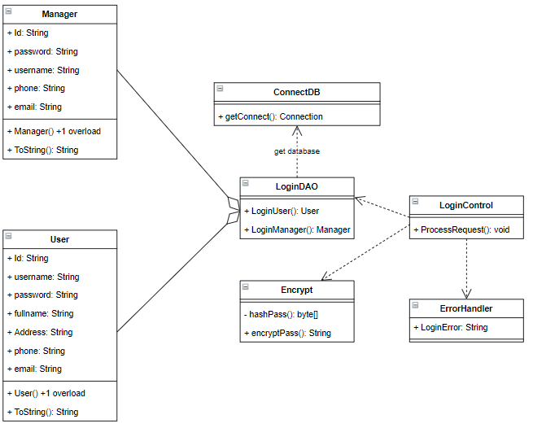

### b. Class Specifications

#### User

|  |  |  |
| --- | --- | --- |
| **No** | **Method** | **Description** |
| 01 | String ToString() | -Print attribute of User in console. |

#### Manager

|  |  |  |
| --- | --- | --- |
| **No** | **Method** | **Description** |
| 01 | String ToString() | Print attribute of Manager in console. |

#### ConnectDB

|  |  |  |
| --- | --- | --- |
| **No** | **Method** | **Description** |
| 01 | void getConnect() | Connect to database |

#### LoginDAO

|  |  |  |
| --- | --- | --- |
| **No** | **Method** | **Description** |
| 01 | User LoginUser() | - Check if User existed in database. If existed, return that User.  - Input: Username : String,  Password : String.  - Output: new User(Id, username, password, fullname, address, phone, email); |
| 02 | Manager LoginManager() | - Check if Manager existed in database. If existed, return that User.  - Input: Username : String,  Password : String.  - Output: new Manager (Id, username, password, address, phone, email); |

#### Encrypt

|  |  |  |
| --- | --- | --- |
| **No** | **Method** | **Description** |
| 01 | byte[] Hashpass() | - Hash password to char array  - Input: password : char[], salt : byte, iteration : int, keyLength : int.  - Output: array of char after hash password. |
| 02 | String EncryptPass() | - Encrypt password  - Input : password: String();  - Output: String of encrypted password. |

#### LoginControl

|  |  |  |
| --- | --- | --- |
| **No** | **Method** | **Description** |
| 01 | void ProcessRequest() | - Get username and password from jsp page and check if this user is existed in database, if existed forward to home page, if not, display error from Errorhandler class.  - Input: request : HttpServletRequest,  response : HttpServletResponse. |

### c. Sequence Diagram(s)

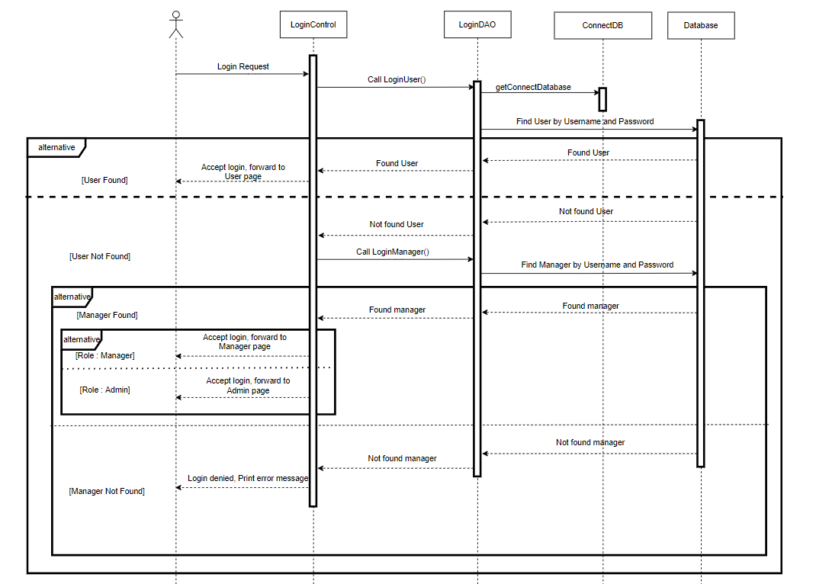

### d. Database queries

* Get User by Username and password:



* Get Manager by Username and password:



## 2. Authorization / Register

### a. Class Diagram

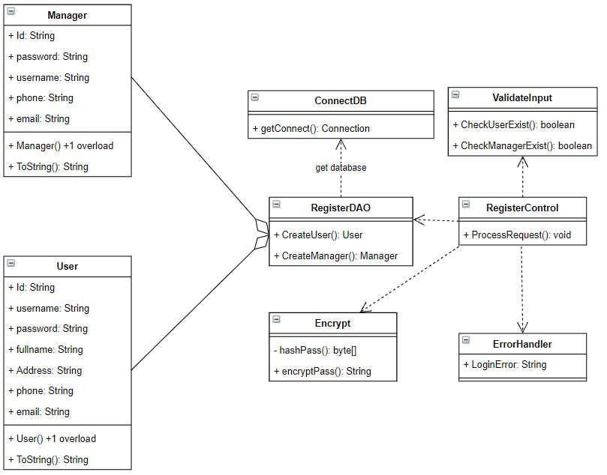

### b. Class Specifications

#### RegisterDAO

|  |  |  |
| --- | --- | --- |
| **No** | **Method** | **Description** |
| 01 | void CreateUser() | - Create new User in database.  - Input: fullname : String, username : String, password : String |
| 02 | void CreateManager() | - Create new Manager in database.  - Input: fullname : String, username : String, password : String |

#### RegisterControl

|  |  |  |
| --- | --- | --- |
| **No** | **Method** | **Description** |
| 01 | void ProcessRequest() | - Get information from jsp page and call CreateUser() or CreateManager() to create new user or manager in database.  - Input: request : HttpServletRequest,  response : HttpServletResponse. |

#### ValidateInput

|  |  |  |
| --- | --- | --- |
| **No** | **Method** | **Description** |
| 01 | Bool checkUserExist() | - Check if there is any user in database has username like input username  - Input: username : String;  - Output: if not exist -> true, else -> false |
| 01 | Bool checkManagerExist() | - Check if there is any manager in database has username like input username  - Input: username : String;  - Output: if not exist -> true, else -> false |

### c. Sequence Diagram(s)

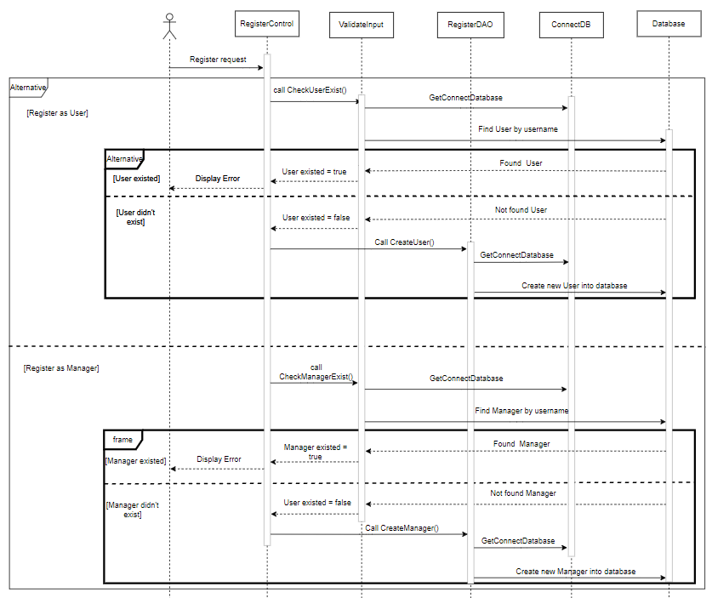

### d. Database queries

* Create new User



* Create new Manager



## 3. User / Update Profile

### a. Class Diagram

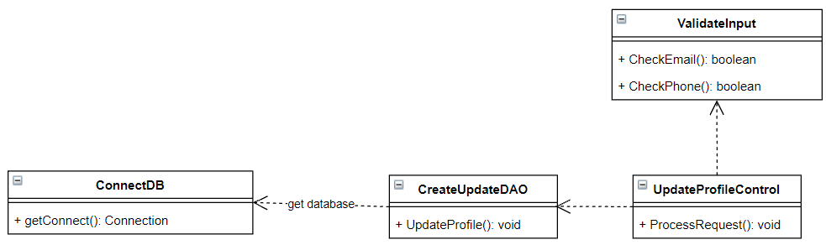

### b. Class Specifications

#### CreateUpdateDAO

|  |  |  |
| --- | --- | --- |
| **No** | **Method** | **Description** |
| 01 | void UpdateProfile() | - Update user information and save it into database  - Input: String id,  String fullname,  String email,  String phone,  String address,  String image,  String gender. |

#### UpdateProfileControl

|  |  |  |
| --- | --- | --- |
| **No** | **Method** | **Description** |
| 01 | void ProcessRequest() | - Get and validate information from jsp page, then call UpdateProfile() to update user information.  - Input: request : HttpServletRequest,  response : HttpServletResponse. |

#### ValidateInput

|  |  |  |
| --- | --- | --- |
| **No** | **Method** | **Description** |
| 01 | Bool checkEmail() | - Check if email matches the correct format.  - Input: email : String;  - Output: if match -> true, else -> false |
| 01 | Bool checkPhone() | - Check if phone number matches correct format.  - Input: phone: String;  - Output: if match -> true, else -> false |

### c. Sequence Diagram(s)

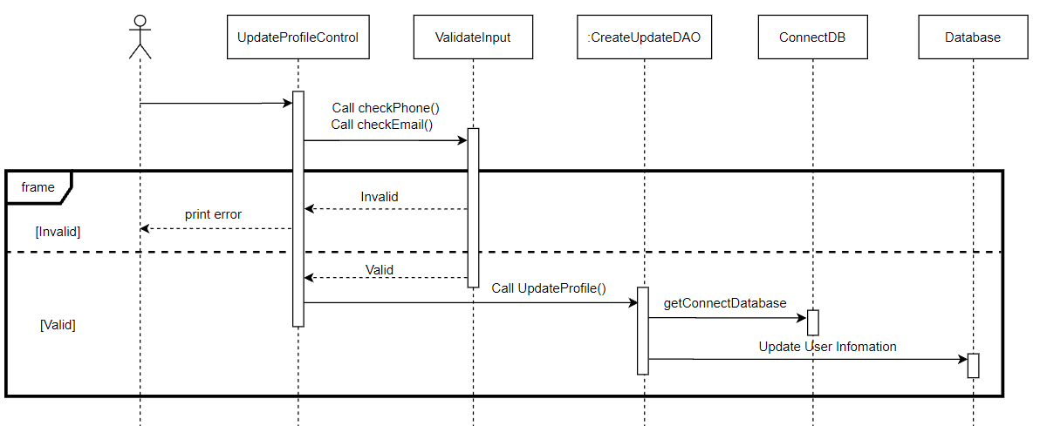

### d. Database queries

* Update User Information

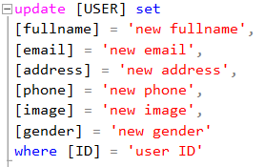

## 4. Recharge / Recharge & CreateRechargeReceipt

### a. Class Diagram

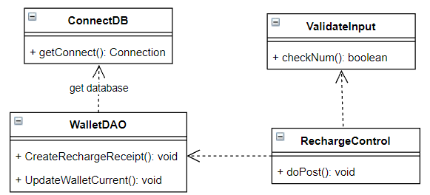

### b. Class Specifications

#### WalletDAO

|  |  |  |
| --- | --- | --- |
| **No** | **Method** | **Description** |
| 01 | void CreateRechargeReceipt() | - Create recharge receipt after user recharge.  - Input: String userID,  String paymentID,  String date,  double amount |
| 02 | Void UpdateWalletCurrent() | - Update the current money in user wallet.  - Input: String walletID, double moneyChange |

#### RechargeControl

|  |  |  |
| --- | --- | --- |
| **No** | **Method** | **Description** |
| 01 | void ProcessRequest() | - Get data form jsp page, check valid the input amount, then start update the user wallet and create receipt.  - Input: request : HttpServletRequest,  response : HttpServletResponse. |

#### ValidateInput

|  |  |  |
| --- | --- | --- |
| **No** | **Method** | **Description** |
| 01 | Bool checkNum () | - Check if input amount is number and larger than 0  - Input: amount : String;  - Output: true / false |

### c. Sequence Diagram(s)

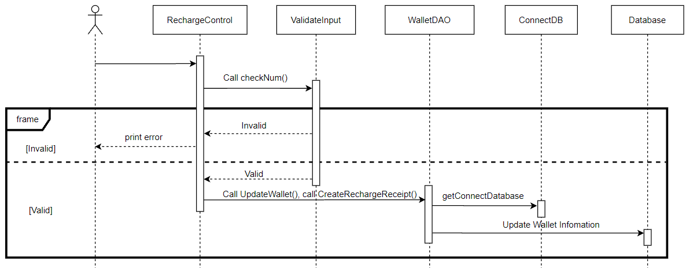

### d. Database queries

* Update Wallet current:



* Create new recharge receipt:



## 5. Recharge / Paid

### a. Class Diagram

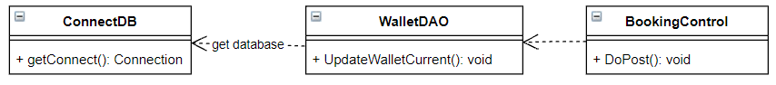

### b. Class Specifications

#### WalletDAO

|  |  |  |
| --- | --- | --- |
| **No** | **Method** | **Description** |
| 02 | Void UpdateWalletCurrent() | - Update the current money in user wallet.  - Input: String walletID, double moneyChange |

#### BookingControl

|  |  |  |
| --- | --- | --- |
| **No** | **Method** | **Description** |
| 01 | void DoPost() | - After user booking a service, system will paid for that service by using user’s wallet.  - Input: request : HttpServletRequest,  response : HttpServletResponse. |

### c. Sequence Diagram(s)

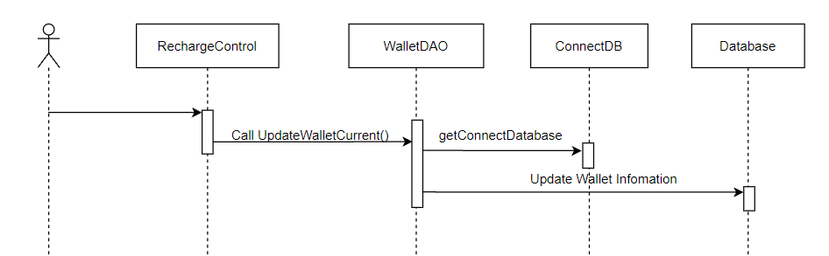

### d. Database queries

* Update Wallet current:



## 6. Cyber / View Cyber List

View Cyber List on the Home page of User.

### a. Class Diagram

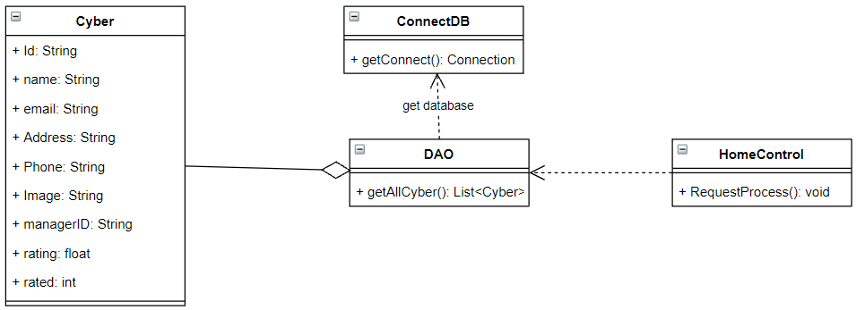

### b. Class Specifications

#### DAO

|  |  |  |
| --- | --- | --- |
| **No** | **Method** | **Description** |
| 01 | List<Cyber> getAllCyber() | - Get all Cyber in the database |

#### HomeControl

|  |  |  |
| --- | --- | --- |
| **No** | **Method** | **Description** |
| 01 | void ProcessRequest() | - Get list of cybers form the database and push that list on the jsp page.  - Input: request : HttpServletRequest,  response : HttpServletResponse. |

### c. Sequence Diagram(s)

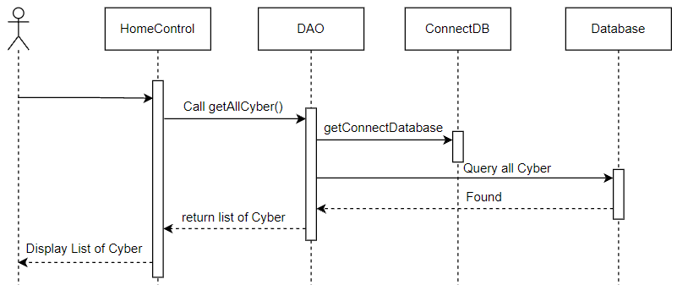

### d. Database queries

* Get all Cyber



## 7. Cyber / View Cyber Detail

### a. Class Diagram

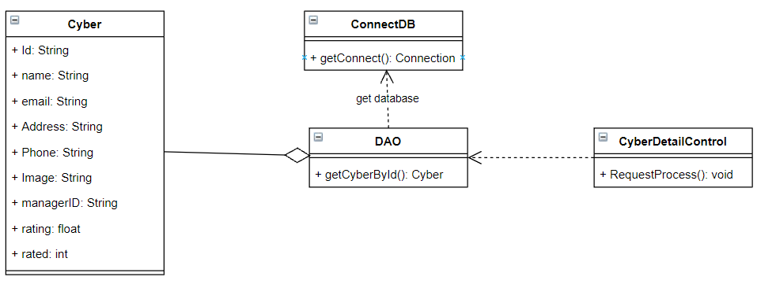

### b. Class Specifications

#### DAO

|  |  |  |
| --- | --- | --- |
| **No** | **Method** | **Description** |
| 01 | Cyber getCyberById() | - Get Cyber by cyberID from the database |

#### HomeControl

|  |  |  |
| --- | --- | --- |
| **No** | **Method** | **Description** |
| 01 | void ProcessRequest() | - Get cybers from the database by input UserID and push that cyber to the jsp page.  - Input: request : HttpServletRequest,  response : HttpServletResponse. |

### c. Sequence Diagram(s)

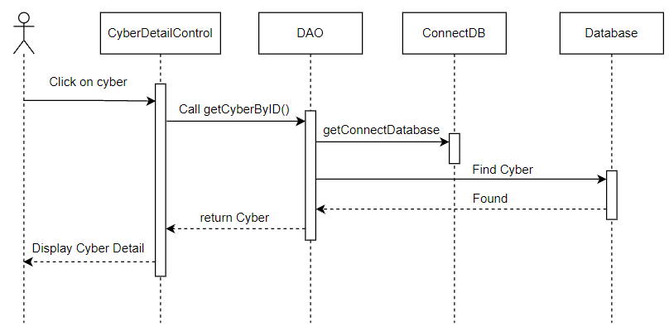

### d. Database queries

* Get all Cyber



## 8. Cyber/ Create Cyber

### a. Class Diagram

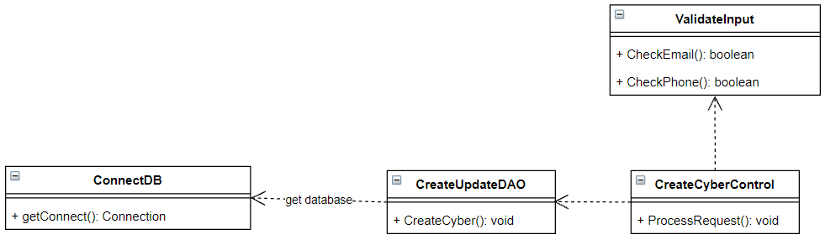

### b. Class Specifications

#### CreateUpdateDAO

|  |  |  |
| --- | --- | --- |
| **No** | **Method** | **Description** |
| 01 | CreateCyber() | - Add new Cyber into database  - Input: String name,  String address,  String email,  String phone,  String managerID,  String image |

#### UpdateCyberControl

|  |  |  |
| --- | --- | --- |
| **No** | **Method** | **Description** |
| 01 | void ProcessRequest() | - Get and validate information from jsp page, then call CreateCyber() to add new Cyber.  - Input: request : HttpServletRequest,  response : HttpServletResponse. |

#### ValidateInput

|  |  |  |
| --- | --- | --- |
| **No** | **Method** | **Description** |
| 01 | Bool checkEmail() | - Check if email matches the correct format.  - Input: email : String;  - Output: if match -> true, else -> false |
| 01 | Bool checkPhone() | - Check if phone number matches correct format.  - Input: phone: String;  - Output: if match -> true, else -> false |

### c. Sequence Diagram(s)

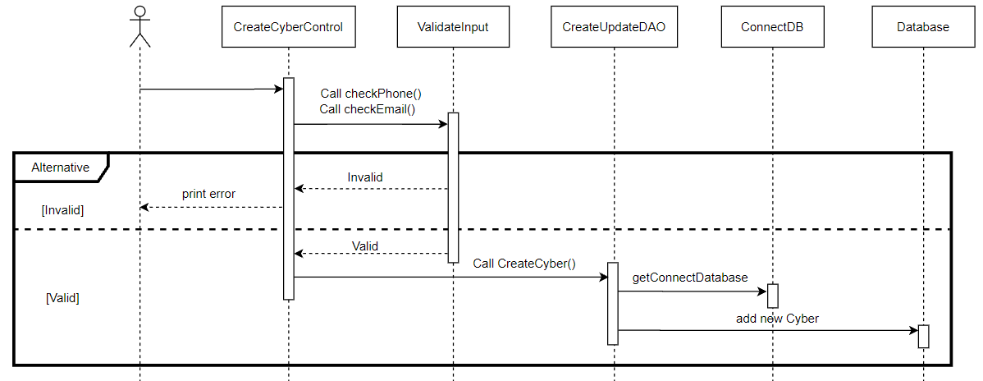

### d. Database queries

-Create new Cyber:



## 9. Cyber/ Update Cyber

### a. Class Diagram

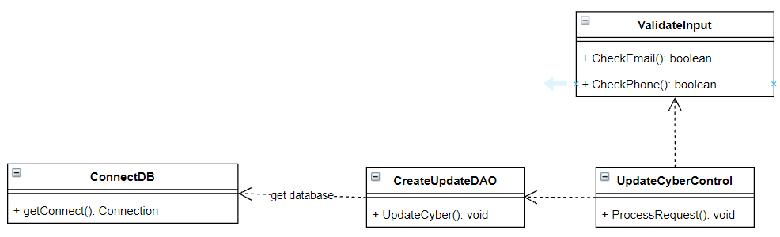

### b. Class Specifications

#### CreateUpdateDAO

|  |  |  |
| --- | --- | --- |
| **No** | **Method** | **Description** |
| 01 | UpdateCyber() | - Update Cyber information in the database  - Input: String ID,  String name,  String address,  String email,  String phone |

#### UpdateCyberControl

|  |  |  |
| --- | --- | --- |
| **No** | **Method** | **Description** |
| 01 | void ProcessRequest() | - Get and validate information from jsp page, then call UpdateCyber() to update Cyber information.  - Input: request : HttpServletRequest,  response : HttpServletResponse. |

#### ValidateInput

|  |  |  |
| --- | --- | --- |
| **No** | **Method** | **Description** |
| 01 | Bool checkEmail() | - Check if email matches the correct format.  - Input: email : String;  - Output: if match -> true, else -> false |
| 01 | Bool checkPhone() | - Check if phone number matches correct format.  - Input: phone: String;  - Output: if match -> true, else -> false |

### c. Sequence Diagram(s)

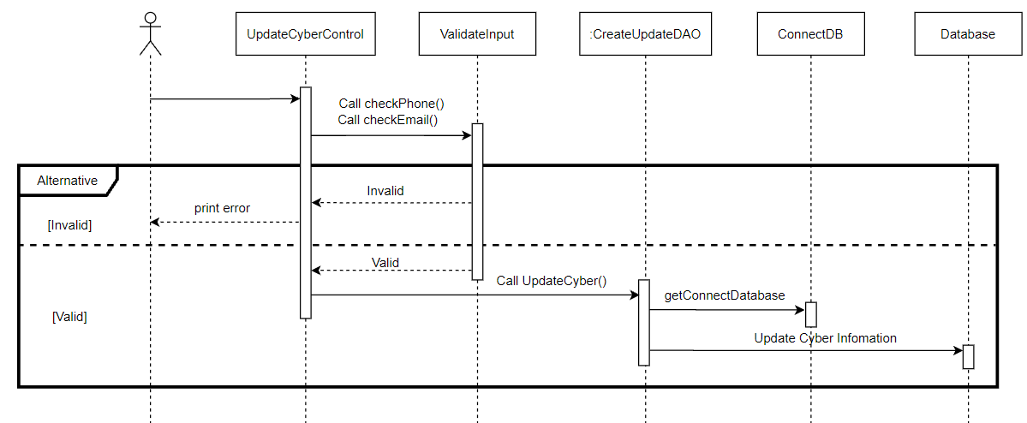

### d. Database queries

-Update Cyber by cyber ID:

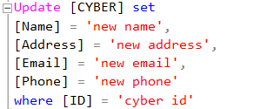

## 10. Service / View Service Detail

### a. Class Diagram

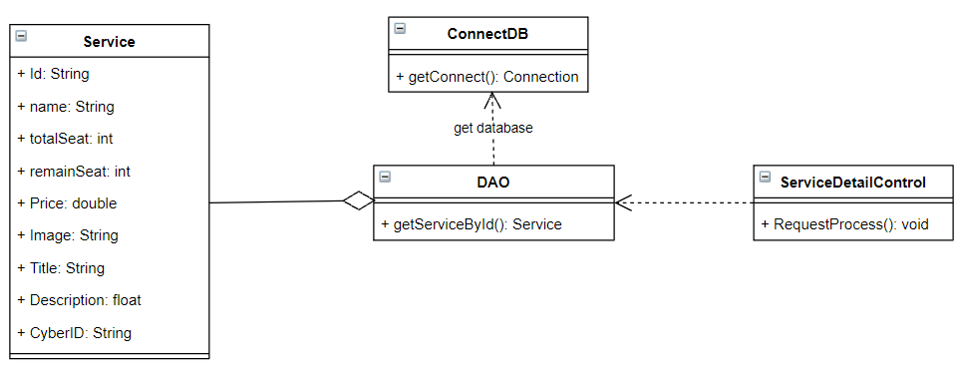

### b. Class Specifications

#### DAO

|  |  |  |
| --- | --- | --- |
| **No** | **Method** | **Description** |
| 01 | Cyber getServiceById() | - Get Service by ServiceID from the database |

#### HomeControl

|  |  |  |
| --- | --- | --- |
| **No** | **Method** | **Description** |
| 01 | void ProcessRequest() | - Get Service from the database by input ServiceID and push that Service to the jsp page.  - Input: request : HttpServletRequest,  response : HttpServletResponse. |

### c. Sequence Diagram(s)

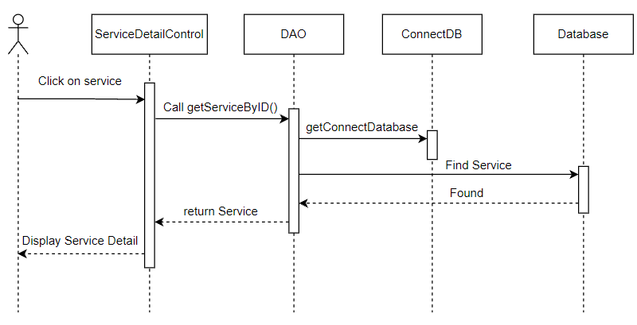

### d. Database queries

-Get Service by service ID:



## 11. Service/ Create Service

### a. Class Diagram

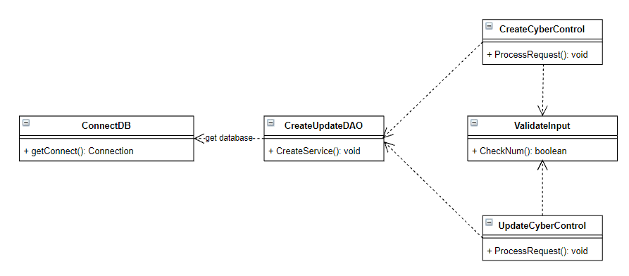

### b. Class Specifications

#### CreateUpdateDAO

|  |  |  |
| --- | --- | --- |
| **No** | **Method** | **Description** |
| 01 | CreateService() | - Create new Service of certain Cyber.  - Input: String CyberID,  String name,  double price,  int TotalSeat |

#### UpdateCyberControl

|  |  |  |
| --- | --- | --- |
| **No** | **Method** | **Description** |
| 01 | void ProcessRequest() | - Get and validate information from jsp page, add new service when update Cyber information.  - Input: request : HttpServletRequest,  response : HttpServletResponse. |

#### CreateCyberControl

|  |  |  |
| --- | --- | --- |
| **No** | **Method** | **Description** |
| 01 | void ProcessRequest() | - Get and validate information from jsp page, add new service when create new Cyber.  - Input: request : HttpServletRequest,  response : HttpServletResponse. |

#### ValidateInput

|  |  |  |
| --- | --- | --- |
| **No** | **Method** | **Description** |
| 01 | Bool checkNum() | - Check the number of service’s seats and the price of the service is valid or not. (All of them are larger than 0 and must be number)  - Input: email : String;  - Output: if is valid -> true, else -> false |

### c. Sequence Diagram(s)

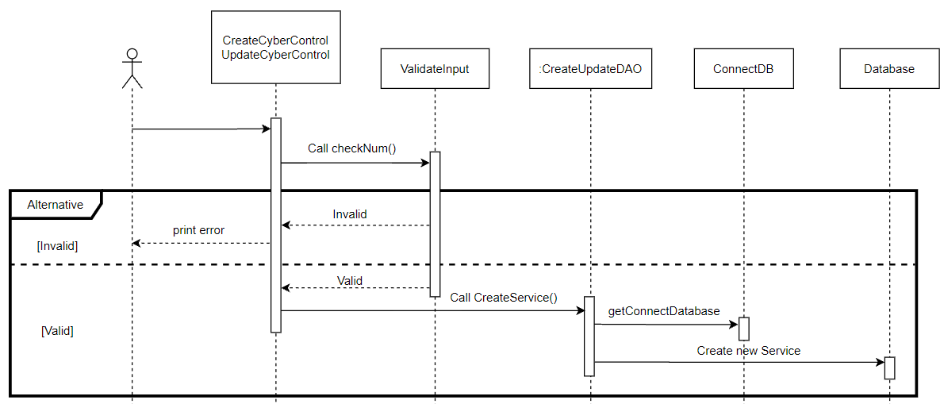

### d. Database queries

-Update Service by service ID:



## 12. Service/ Update Service

### a. Class Diagram

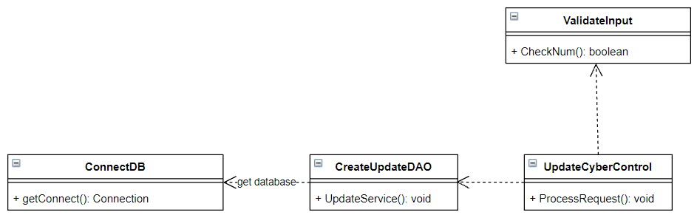

### b. Class Specifications

#### CreateUpdateDAO

|  |  |  |
| --- | --- | --- |
| **No** | **Method** | **Description** |
| 01 | UpdateService() | - Update Service information in the database  - Input: String ID,  String name,  double price,  int newTotalSeat,  int newRemain |

#### UpdateCyberControl

|  |  |  |
| --- | --- | --- |
| **No** | **Method** | **Description** |
| 01 | void ProcessRequest() | - Get and validate information from jsp page, then call UpdateService() to update Service information.  - Input: request : HttpServletRequest,  response : HttpServletResponse. |

#### ValidateInput

|  |  |  |
| --- | --- | --- |
| **No** | **Method** | **Description** |
| 01 | Bool checkNum() | - Check the number of service’s seats and the price of the service is valid or not. (All of them are larger than 0 and must be number)  - Input: email : String;  - Output: if is valid -> true, else -> false |

### c. Sequence Diagram(s)

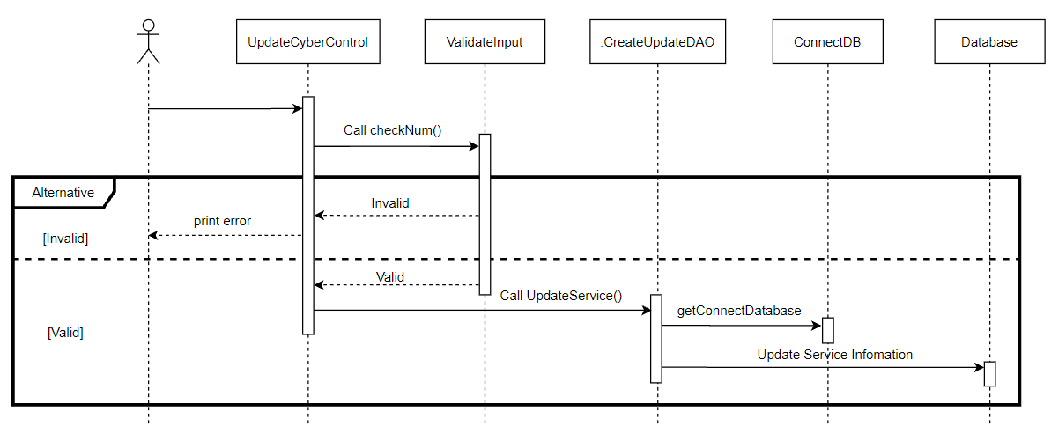

### d. Database queries

-Update Service by service ID:

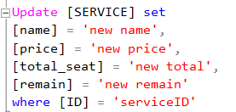

## 13. Booking/ Book (Create BookingReceipt)

### a. Class Diagram

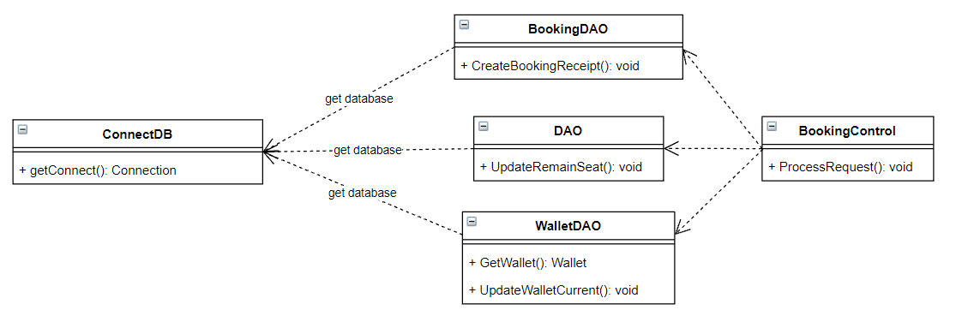

### b. Class Specifications

#### DAO

|  |  |  |
| --- | --- | --- |
| **No** | **Method** | **Description** |
| 01 | UpdateRemainSeat() | - Update remain seats of the booked service  - Input: String ServiceID, int changeAmount (-1) |

#### BookingDAO

|  |  |  |
| --- | --- | --- |
| **No** | **Method** | **Description** |
| 01 | CreateBookingReceipt() | - Create booking receipt  - Input: String userID,  String serviceID,  int playHour,  double totalPaid |

#### WalletDAO

|  |  |  |
| --- | --- | --- |
| **No** | **Method** | **Description** |
| 01 | GetWallet() | - Get User’s wallet  - Input: String userID  -Output: Wallet userWallet |
| 02 | UpdateCurrentWallet() | - Detail at II.5 Recharge/Paid. |

#### BookingControl

|  |  |  |
| --- | --- | --- |
| **No** | **Method** | **Description** |
| 01 | void ProcessRequest() | - get request from jsp page and do execute all function above to complete booking task.  - Input: request : HttpServletRequest,  response : HttpServletResponse. |

### c. Sequence Diagram(s)

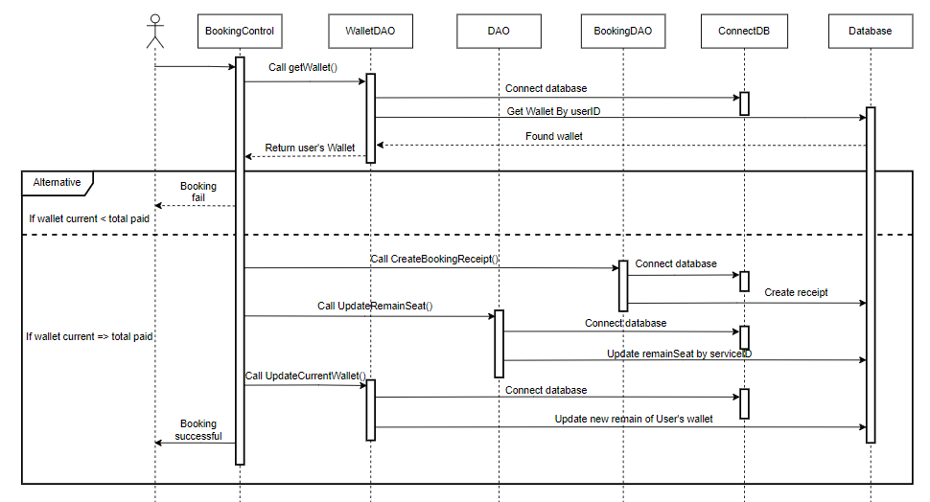

### d. Database queries

-Create Booking receipt:

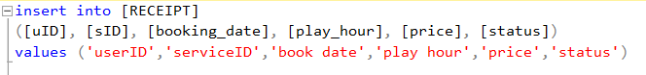

## 14. Search/ SearchCyber

### a. Class Diagram

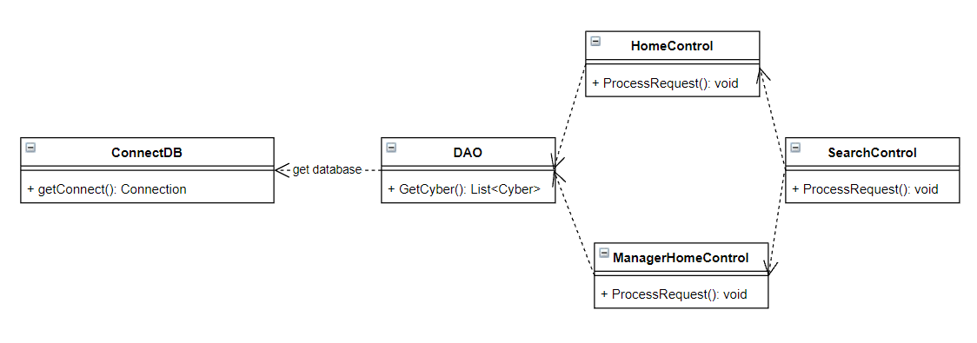

### b. Class Specifications

#### DAO

|  |  |  |
| --- | --- | --- |
| **No** | **Method** | **Description** |
| 01 | List<Cyber> GetCyber() | - Get cyber contain search string in name  - Input: String searchString. |

#### SearchControl

|  |  |  |
| --- | --- | --- |
| **No** | **Method** | **Description** |
| 01 | void ProcessRequest() | - get search string from jsp page and check if it is User or Manager to forward to the correct controller  - Input: request : HttpServletRequest,  response : HttpServletResponse. |

#### HomeControl

|  |  |  |
| --- | --- | --- |
| **No** | **Method** | **Description** |
| 01 | void ProcessRequest() | - SearchControl will forward to this if User is searching Cyber  - Input: request : HttpServletRequest,  response : HttpServletResponse. |

#### ManagerHomeControl

|  |  |  |
| --- | --- | --- |
| **No** | **Method** | **Description** |
| 01 | void ProcessRequest() | - SearchControl will forward to this if Manager is searching Cyber  - Input: request : HttpServletRequest,  response : HttpServletResponse. |

### c. Sequence Diagram(s)

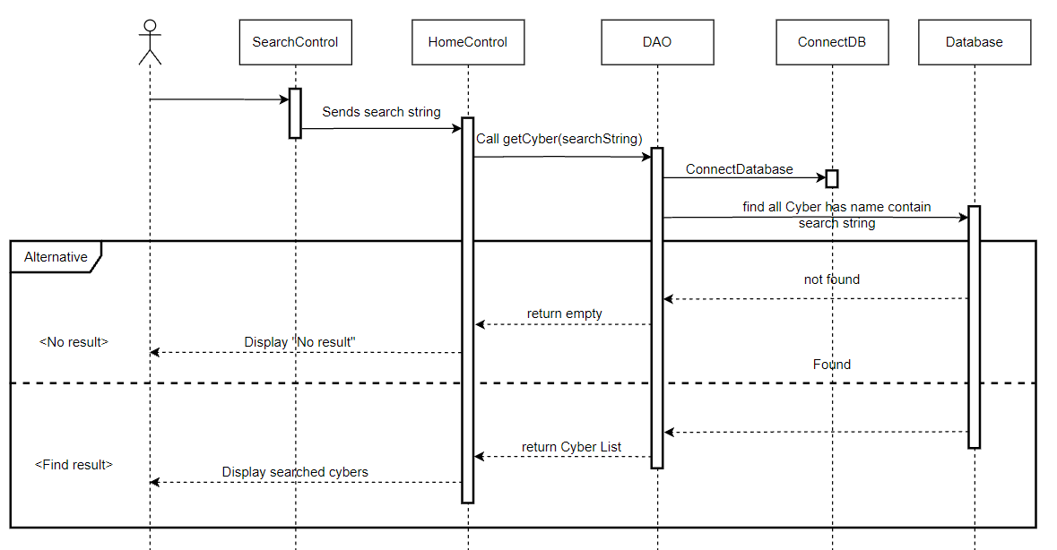

SearchCyber sequence diagram for User

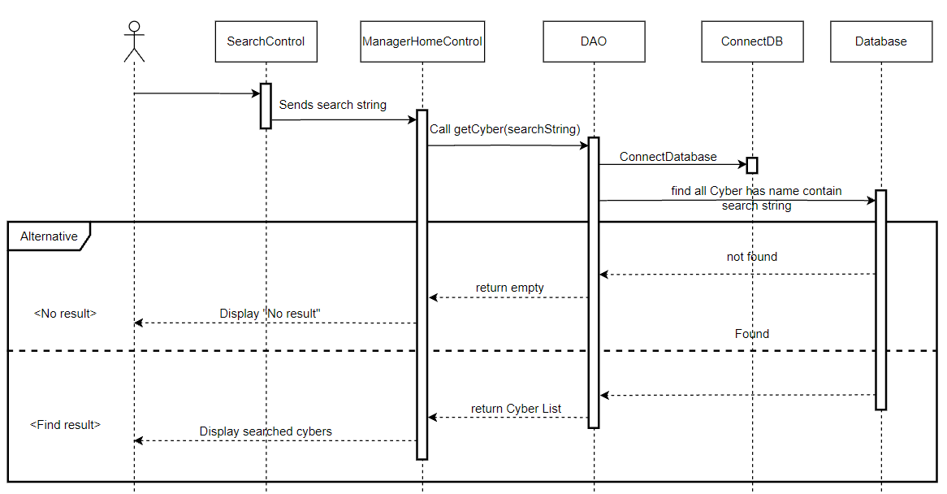

SearchCyber sequence diagram for Cyber Manager

### d. Database queries

-Get Cyber has name contain search string:



## 15. Search/ SearchBookingReceipt

### a. Class Diagram

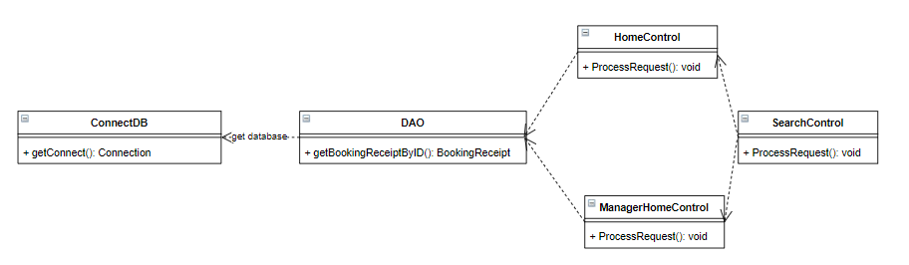

### b. Class Specifications

#### DAO

|  |  |  |
| --- | --- | --- |
| **No** | **Method** | **Description** |
| 01 | BookingReceipt getBookingReceiptByID () | - Get Booking receipt by receipt ID  - Input: String searchString. |

#### SearchControl

|  |  |  |
| --- | --- | --- |
| **No** | **Method** | **Description** |
| 01 | void ProcessRequest() | - get search string from jsp page and check if it is User or Manager to forward to the correct controller  - Input: request : HttpServletRequest,  response : HttpServletResponse. |

#### HomeControl

|  |  |  |
| --- | --- | --- |
| **No** | **Method** | **Description** |
| 01 | void ProcessRequest() | - SearchControl will forward to this if User is searching Receipt  - Input: request : HttpServletRequest,  response : HttpServletResponse. |

#### ManagerHomeControl

|  |  |  |
| --- | --- | --- |
| **No** | **Method** | **Description** |
| 01 | void ProcessRequest() | - SearchControl will forward to this if Manager is searching Receipt  - Input: request : HttpServletRequest,  response : HttpServletResponse. |

### c. Sequence Diagram(s)

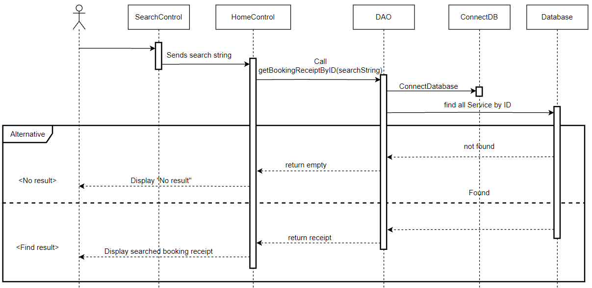

Search Booking Receipt sequence diagram for User

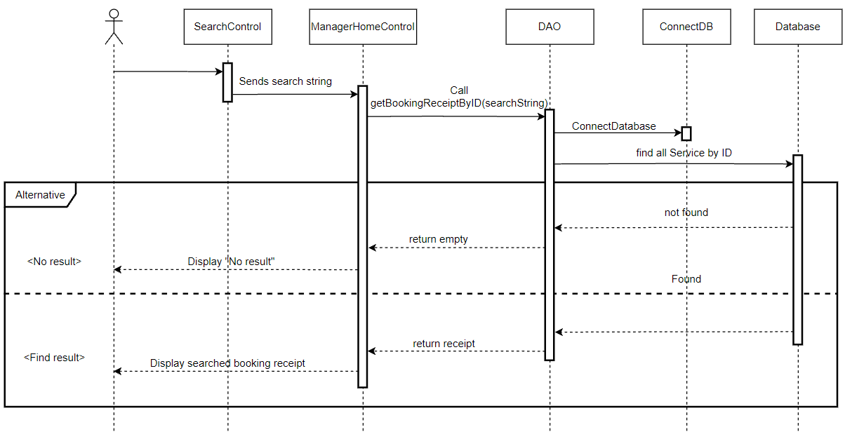

Search Booking Receipt sequence diagram for Cyber Manager

### d. Database queries

-Get Booking receipt by ID:



## 16. Receipt/ ViewReceipt

### a. Class Diagram

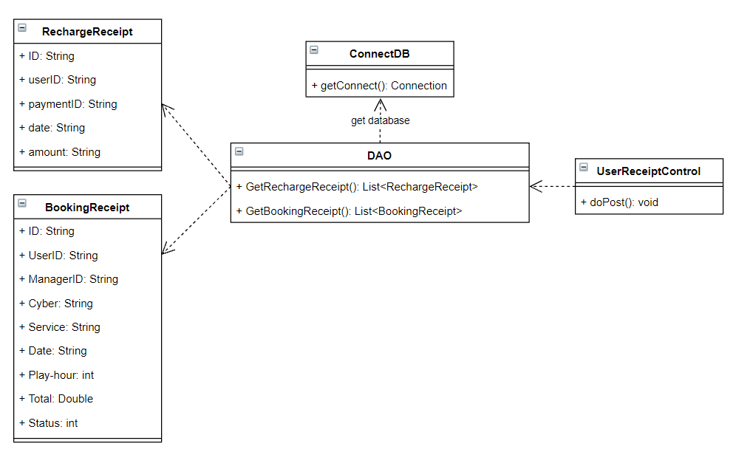

### b. Class Specifications

#### DAO

|  |  |  |
| --- | --- | --- |
| **No** | **Method** | **Description** |
| 01 | List<BookingReceipt> getBookingReceipt() | - Get all user Booking receipts by user’s id  - Input: String userID.  -Output: List of user’s Booking receipts |
| 02 | List<RechargeReceipt> getRechargeReceipt() | - Get all user Recharge receipts by user’s id  - Input: String userID.  -Output: List of user’s Recharge receipts |

#### DeleteControl

|  |  |  |
| --- | --- | --- |
| **No** | **Method** | **Description** |
| 01 | void doPost() | - Gets all User’s receipts and pushes them to user interface.  - Input: request : HttpServletRequest,  response : HttpServletResponse. |

### c. Sequence Diagram(s)

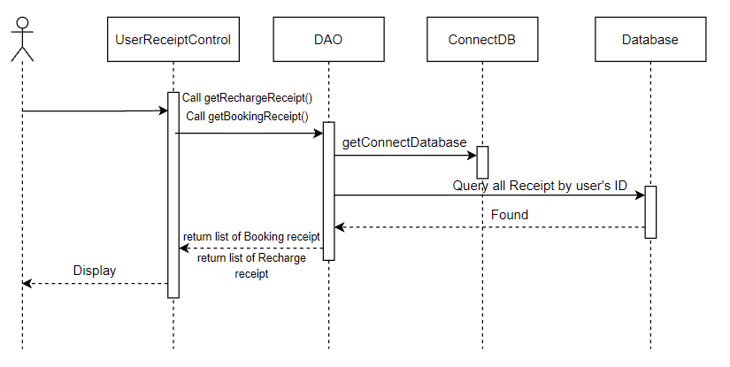

View Receipt sequence diagram for User

### d. Database queries

- Get Booking receipt by user ID: 

- Get Recharge receipt by user ID: 

## 17. Delete User & Manager

### a. Class Diagram

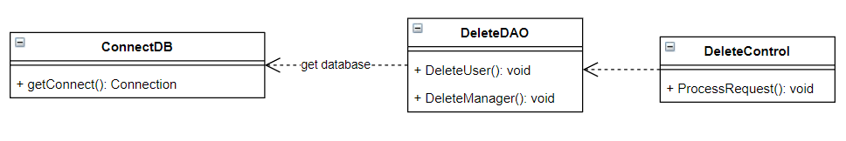

### b. Class Specifications

#### DeleteDAO

|  |  |  |
| --- | --- | --- |
| **No** | **Method** | **Description** |
| 01 | Void DeleteUser() | - Remove User from database  - Input: String userID. |
| 02 | Void DeleteManager() | - Remove Manager from database  - Input: String mangerID. |

#### DeleteControl

|  |  |  |
| --- | --- | --- |
| **No** | **Method** | **Description** |
| 01 | void doPost() | - Get delete request and delete a User or Manager  - Input: request : HttpServletRequest,  response : HttpServletResponse. |

### c. Sequence Diagram(s)

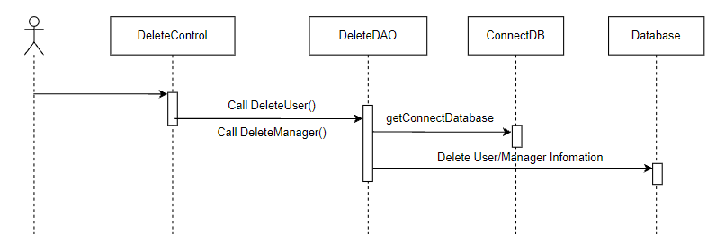

Delete User/Manager sequence diagram

### d. Database queries

- Delete User



- Delete manager



## 18. Service/Delete Service

### a. Class Diagram

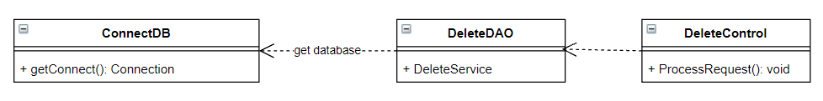

### b. Class Specifications

#### DeleteDAO

|  |  |  |
| --- | --- | --- |
| **No** | **Method** | **Description** |
| 01 | Void DeleteService() | - Remove Service from database  - Input: String serviceID. |

#### DeleteControl

|  |  |  |
| --- | --- | --- |
| **No** | **Method** | **Description** |
| 01 | void doPost() | - Get delete request and delete a User or Manager  - Input: request : HttpServletRequest,  response : HttpServletResponse. |

### c. Sequence Diagram(s)

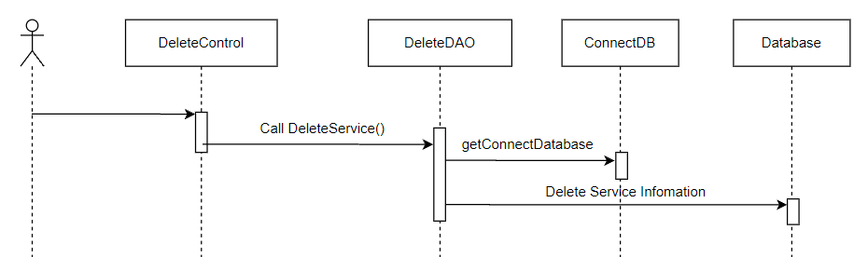

Delete Service sequence diagram

### d. Database queries

- Delete Service



-Trigger when delete a service, all booking receipts which haven’t used will refund to user

create trigger [dbo].[del_Service] on [dbo].[SERVICE] for DELETE as

Begin

update [BOOKING_RECEIPT]

Set

[status] = -1

where [status] = 0 and [BOOKING_RECEIPT].[Sevice] in (Select Cast([ID] as nvarchar(3))+'-'+[name] from deleted)

end

create trigger updateWallet_after_CancelReceipt on [BOOKING_RECEIPT] after UPDATE as

Begin

declare @uID int;

Select @uID = [uID] from inserted

update [WALLET]

set [current] = [current] + (select [price] from inserted where [status] = -1)

where [uID] = @uID

end

## 19. Cyber/Delete Cyber

### a. Class Diagram

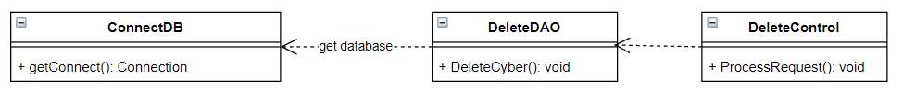

### b. Class Specifications

#### DeleteDAO

|  |  |  |
| --- | --- | --- |
| **No** | **Method** | **Description** |
| 01 | Void DeleteCyber() | - Remove Cyber from database  - Input: String CyberID. |

#### DeleteControl

|  |  |  |
| --- | --- | --- |
| **No** | **Method** | **Description** |
| 01 | void doPost() | - Get delete request and delete a User or Manager  - Input: request : HttpServletRequest,  response : HttpServletResponse. |

### c. Sequence Diagram(s)

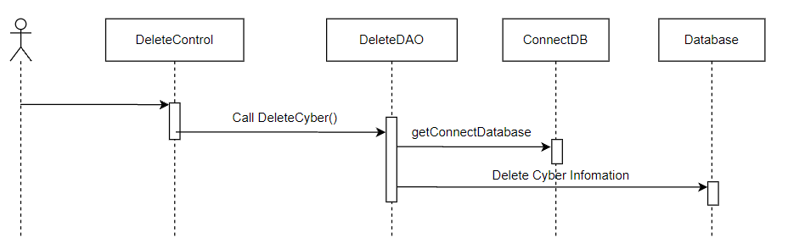

Delete Cyber sequence diagram

### d. Database queries

- Delete Service



## 20. Authorization / Remember account

### a. Class Diagram

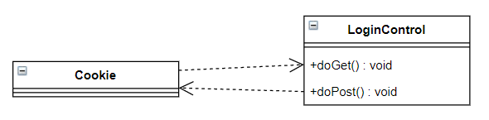

### b. Class Specifications

#### LoginControl

|  |  |  |
| --- | --- | --- |
| **No** | **Method** | **Description** |
| 01 | void doGet() | - If username and password are existed in Cookie, gets them add auto fill in username and password textbox on login page.  - Input: request : HttpServletRequest,  response : HttpServletResponse. |
| 02 | void doPost() | - Login account, if “Remember me” box is checked, add that username and password and save them in Cookie.  - Input: request : HttpServletRequest,  response : HttpServletResponse. |

### c. Sequence Diagram(s)

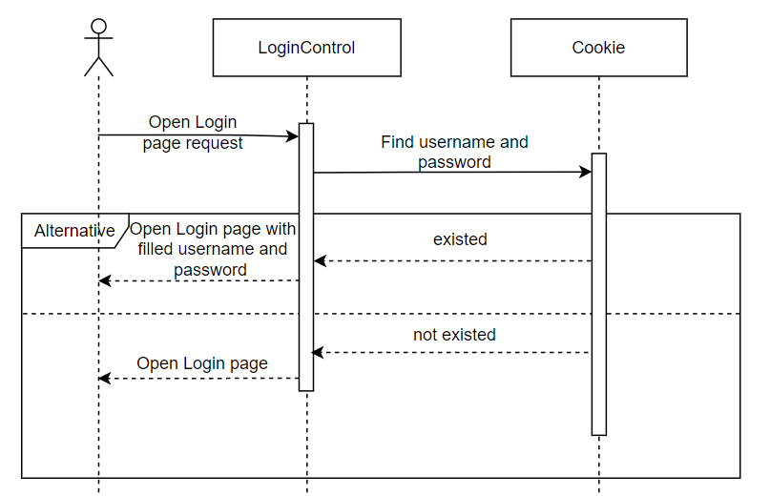

Sequence diagram when open a login page with a remembered account

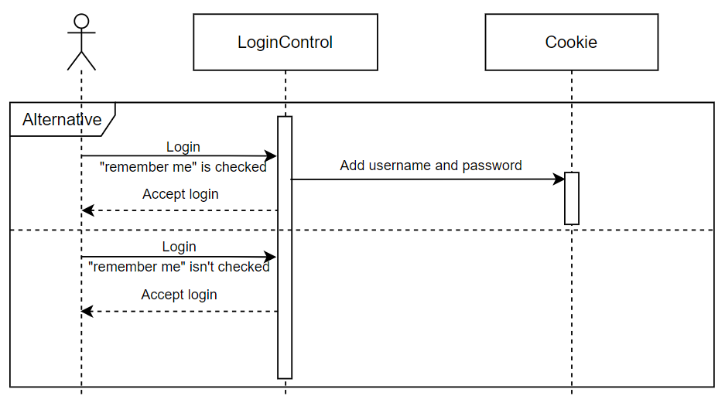

Sequence diagram when check “remember me” check box during log in

### d. Database queries

<<None>>

## 21. Filter / Filter

### a. Class Diagram

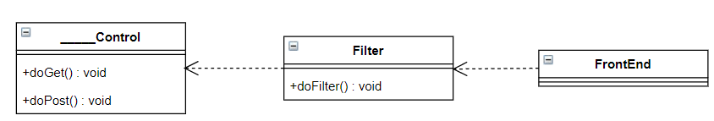

### b. Class Specifications

#### Filter

|  |  |  |
| --- | --- | --- |
| **No** | **Method** | **Description** |
| 01 | void doFilter() | - check if session has already had a account, allows access to the page. If not, send back the request to login account |

### c. Sequence Diagram(s)

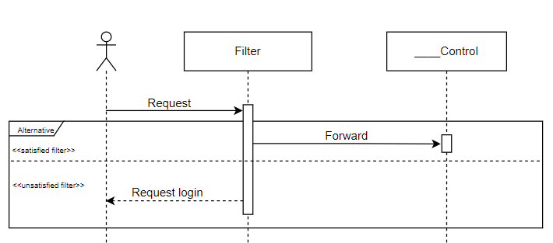

Sequence diagram when open a login page with a remembered account

### d. Database queries

<<None>>

## 22. Admin / Web’s statistic

### a. Class Diagram

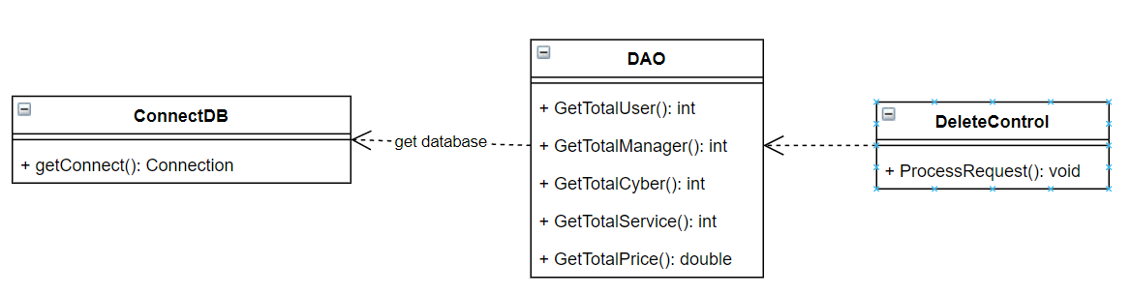

### b. Class Specifications

#### AdminHomeControl

|  |  |  |
| --- | --- | --- |
| **No** | **Method** | **Description** |
| 01 | void ProcessRequest() | - Get information from database and push them to admin page.  - Input: request : HttpServletRequest,  response : HttpServletResponse. |

#### DAO

|  |  |  |
| --- | --- | --- |
| **No** | **Method** | **Description** |
| 01 | Int GetTotalUser() | - Get number of Users who sign up to use the website. |
| 02 | Int GetTotalManager() | - Get number of Manager |
| 03 | Int GetTotalCyber() | - Get number of Cyber that connect with the website. |
| 04 | Int GetTotalService() | - Get number of Service |
| 05 | Double GetTotalPrice() | - Get total price of used booking-receipt |

### c. Sequence Diagram(s)

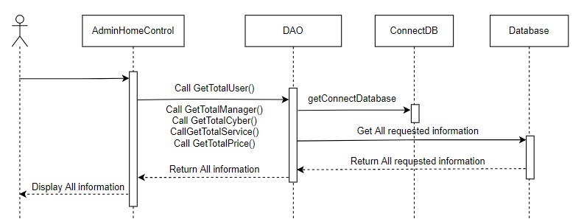

Sequence diagram of loading Web’s statistic page

### d. Database queries

- Get number of Users: select count(ID) from [USER]

- Get number of Managers: select count(ID) from [MANAGER]

- Get number of Cybers: select count(ID) from [CYBER]

- Get number of Service: select count(ID) from [SERVICE]

- Get total price of used Booking-receipt:

select sum(price) from [BOOKING_RECEIPT] where [status] = 1

# III. Database Tables

## 1. User

|  |  |  |  |  |  |  |  |
| --- | --- | --- | --- | --- | --- | --- | --- |
| **#** | **Field name** | **Type** | **Size** | **Unique** | **Not Null** | **PK/FK** | **Notes** |
| 1 | ID | Int |  |  | ✓ | PK |  |
| 2 | Username | Varchar | 255 |  | ✓ |  |  |
| 3 | Password | Varchar | 255 |  | ✓ |  | Encrypted password |
| 4 | Fullname | Nvarchar | 255 |  | ✓ |  |  |
| 5 | Email | Varchar | 50 |  |  |  |  |
| 6 | address | Nvarchar | 255 |  |  |  |  |
| 7 | Phone | Varchar | 15 |  |  |  |  |
| 8 | Image | Varchar | Max |  |  |  |  |
| 9 | Gender | Varchar | 10 |  |  |  |  |

## 2. Manager

|  |  |  |  |  |  |  |  |
| --- | --- | --- | --- | --- | --- | --- | --- |
| **#** | **Field name** | **Type** | **Size** | **Unique** | **Not Null** | **PK/FK** | **Notes** |
| 1 | ID | Int |  |  | ✓ | PK |  |
| 2 | Username | Varchar | 255 |  | ✓ |  |  |
| 3 | Password | Varchar | 255 |  | ✓ |  | Encrypted password |
| 5 | Email | Varchar | 50 |  |  |  |  |
| 7 | Phone | Varchar | 15 |  |  |  |  |
| 8 | Role | int |  |  |  |  | 0 is admin, 1 is Cyber Manager |

## 3. Cyber

|  |  |  |  |  |  |  |  |
| --- | --- | --- | --- | --- | --- | --- | --- |
| **#** | **Field name** | **Type** | **Size** | **Unique** | **Not Null** | **PK/FK** | **Notes** |
| 1 | ID | Int |  |  | ✓ | PK |  |
| 2 | Name | Varchar | 255 |  | ✓ |  |  |
| 3 | Email | Varchar | 50 |  |  |  |  |
| 4 | Address | Nvarchar | 255 |  | ✓ |  |  |
| 5 | Phone | Varchar | 15 |  |  |  |  |
| 6 | Image | Varchar | Max |  |  |  |  |
| 7 | Total_rate | Float |  |  |  |  | Total rating score |
| 8 | Amount_rated | Int |  |  |  |  | Amount of user rated the cyber |
| 9 | cmID | Int |  |  | ✓ | FK | cmID = [Manager].[ID]  on delete cascade |

## 4. Service

|  |  |  |  |  |  |  |  |
| --- | --- | --- | --- | --- | --- | --- | --- |
| **#** | **Field name** | **Type** | **Size** | **Unique** | **Not Null** | **PK/FK** | **Notes** |
| 1 | ID | Int |  |  | ✓ | PK |  |
| 2 | Name | Varchar | 255 |  |  |  |  |
| 3 | Total | Int |  |  |  |  | Total seats |
| 4 | Remain | Int |  |  |  |  | Amount of seats after users booked |
| 5 | Price | Money |  |  |  |  | Price/h |
| 6 | Image | Varchar | Max |  |  |  |  |
| 7 | title | nvarchar | 225 |  |  |  |  |
| 8 | Description | Nvarchar | Max |  |  |  |  |
| 9 | cyberID | Int |  |  | ✓ | FK | cyberID = [Cyber].[ID]  on delete cascade |

## 5. Wallet

|  |  |  |  |  |  |  |  |
| --- | --- | --- | --- | --- | --- | --- | --- |
| **#** | **Field name** | **Type** | **Size** | **Unique** | **Not Null** | **PK/FK** | **Notes** |
| 1 | ID | Int |  |  | ✓ | PK |  |
| 2 | uID | Int |  |  | ✓ | FK | uID = [User].[ID]  on delete cascade |
| 3 | Current | Money |  |  |  |  | Current money in user wallet |
| 4 | Total_paid | Money |  |  |  |  |  |

## 6. Payment

|  |  |  |  |  |  |  |  |
| --- | --- | --- | --- | --- | --- | --- | --- |
| **#** | **Field name** | **Type** | **Size** | **Unique** | **Not Null** | **PK/FK** | **Notes** |
| 1 | ID | Int |  |  | ✓ | PK |  |
| 2 | Name | Varchar | 255 |  |  |  |  |

## 7. Recharge_Receipt

|  |  |  |  |  |  |  |  |
| --- | --- | --- | --- | --- | --- | --- | --- |
| **#** | **Field name** | **Type** | **Size** | **Unique** | **Not Null** | **PK/FK** | **Notes** |
| 1 | ID | Int |  |  | ✓ | PK |  |
| 2 | UserID | int |  |  | ✓ | FK | UserID = [User].[ID]  on delete cascade |
| 3 | PaymentID | nvarchar | 50 |  | ✓ |  |  |
| 4 | date | varchar | 15 |  | ✓ |  |  |
| 5 | amount | Money |  |  | ✓ |  | Amount of recharged money |

## 8. Booking_Receipt

|  |  |  |  |  |  |  |  |
| --- | --- | --- | --- | --- | --- | --- | --- |
| **#** | **Field name** | **Type** | **Size** | **Unique** | **Not Null** | **PK/FK** | **Notes** |
| 1 | ID | Int |  |  | ✓ | PK |  |
| 2 | UserID | Int |  |  | ✓ | FK | UserID = [User].[ID]  on delete cascade |
| 3 | ManagerID | Nvarchar(30) |  |  | ✓ |  |  |
| 4 | Cyber | Nvarchar(30) |  |  | ✓ |  |  |
| 5 | Service | Int |  |  | ✓ |  |  |
| 6 | date | varchar | 15 |  | ✓ |  |  |
| 7 | Play_hours | Int |  |  | ✓ |  |  |
| 8 | Price | Int |  |  | ✓ |  |  |
| 9 | Status | Int |  |  | ✓ |  | 0 is available, 1 is unavailable, -1 is canceled |

## 9. User_Favorite

|  |  |  |  |  |  |  |  |
| --- | --- | --- | --- | --- | --- | --- | --- |
| **#** | **Field name** | **Type** | **Size** | **Unique** | **Not Null** | **PK/FK** | **Notes** |
| 1 | UserID | Int |  |  | ✓ | PK, FK | UserID = [User].[ID]  on delete cascade |
| 2 | CyberID | int |  |  | ✓ | PK, FK | cyberID = [Cyber].[ID] |

## 10. City

|  |  |  |  |  |  |  |  |
| --- | --- | --- | --- | --- | --- | --- | --- |
| **#** | **Field name** | **Type** | **Size** | **Unique** | **Not Null** | **PK/FK** | **Notes** |
| 1 | ID | Int |  |  | ✓ | PK |  |
| 2 | Name | Varchar | 50 |  | ✓ |  |  |

## 11. Admin_Notification

|  |  |  |  |  |  |  |  |
| --- | --- | --- | --- | --- | --- | --- | --- |
| **#** | **Field name** | **Type** | **Size** | **Unique** | **Not Null** | **PK/FK** | **Notes** |
| 1 | ID | Int |  |  | ✓ | PK |  |
| 2 | Content | Nvarchar | Max |  | ✓ |  |  |
| 3 | Upload_date | Varchar | 15 |  | ✓ |  |  |
| 4 | Status | Int |  |  | ✓ |  | 1 is displaying, 0 is used |