

**<<website review movies>>**

**Software Requirement Specification**

**Table of Contents**

**I. Overview 2**

1. Introduction 2

2. System Functions 3

3. Common Requirements 4

**II. Functional Requirements 5**

1. <<Feature Name 1>> 5

2. <<Feature Name 2>> 5

# I. Overview

## 1. Introduction

Product Perspective: In modern life, people's demand to watch movies increases, which means more and more movies are released. Movies that are released will inevitably inevitably have some movies that are poorly reviewed and not suitable for viewers. Viewers don't want to spend large sums of money and their precious time on a movie they don't like. Our solution was to create a movie review website.

Product Features: The released movies will be given their comments by quality reviewers. Accompanying it is the basic information of the movie such as the movie's release date, director, actors, trailer, ...

The movie is rated by reviewers on a 10 scale

Everyone can give their opinion and comment on that movie reviews.

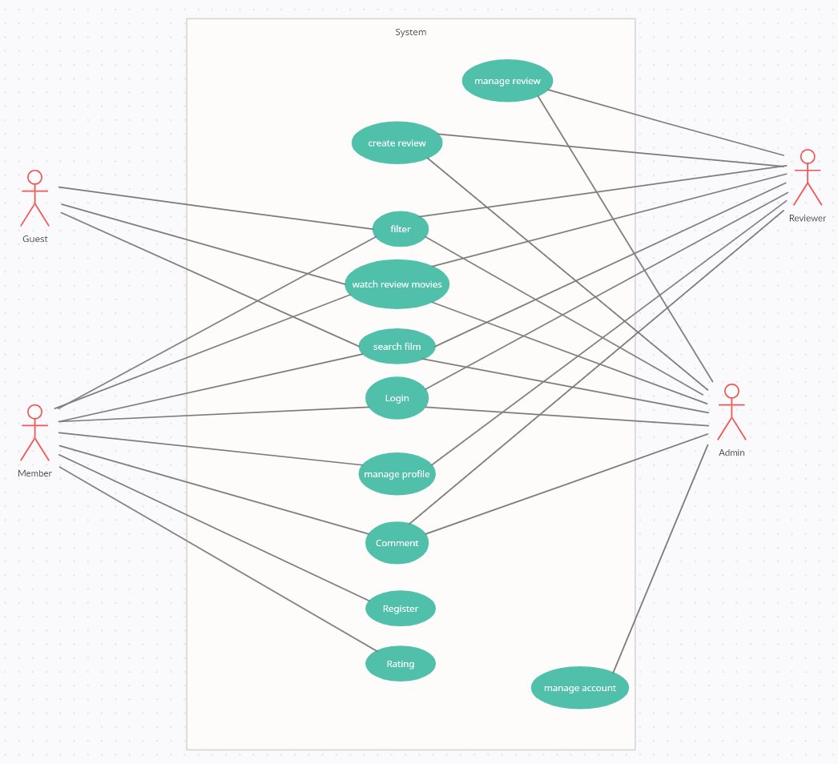

## 2. System Functions

#### a. Screen Flow

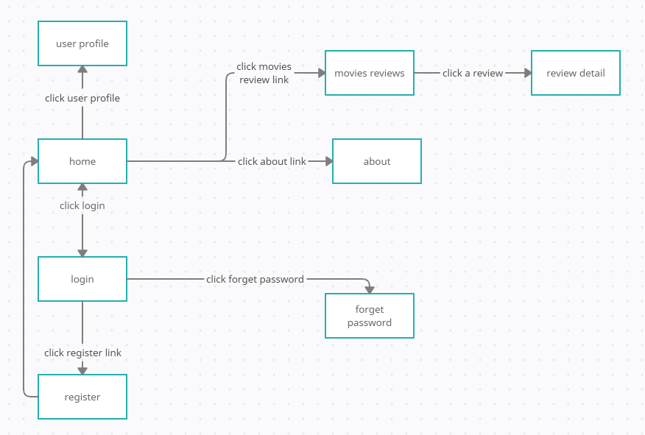

#### b. Screen Details

*[Provide the descriptions for the screens in the Screens Flow above]*

|  |  |  |  |
| --- | --- | --- | --- |
| **#** | **Feature** | **Screen** | **Description** |
| 1 | Overview | Home | Overview the website |
| 2 | Website introduction | About |  |
| 3 | Login | Login | Login |
| 4 | Register member | Register | Create account and informations for member |
| 5 | Recover password | Forget password | recover password when forgot |
| 6 | Display user | User profile |  |
| 7 | Edit user | User profile | Edit user profile |
| 8 | Filter movie | Movies review | Filter by category, years |
| 9 | Search movie | Movies review | Search by name |
| 10 | Rating the review | Review detail | Rate the review from 1 to 10 points |
| 11 | Comment the review | Review detail | Personal rating of the review and delete their own comment |
| 12 | Rating | Review detail | Rating the review |

#### c. User Authorization

|  |  |  |  |  |
| --- | --- | --- | --- | --- |
| **Feature** | **Admin** | **Reviewer** | **Member** | **Guest** |
| Login | ✓ | ✓ | ✓ |  |
| Logout | ✓ | ✓ | ✓ |  |
| Register |  |  |  | ✓ |
| View User profile |  |  | ✓ |  |
| Edit Profile |  |  | ✓ |  |
| View All User | ✓ |  |  |  |
| Delete User | ✓ |  |  |  |
| View All Reviewer | ✓ |  |  |  |
| Delete Reviewer | ✓ |  |  |  |
| View Movie Review | ✓ | ✓ | ✓ | ✓ |
| Search, Filter Movie Review | ✓ | ✓ | ✓ | ✓ |
| Edit Movie Review | ✓ | ✓ |  |  |
| Delete Movie Review | ✓ | ✓ |  |  |
| Leave Comment | ✓ | ✓ | ✓ |  |
| Delete Your Own Comment | ✓ | ✓ | ✓ |  |
| Delete Comment On Your Own Review | ✓ | ✓ |  |  |
| Delete All Comment | ✓ |  |  |  |

#### d. Non-Screen Functions

|  |  |  |  |
| --- | --- | --- | --- |
| **#** | **Feature** | **System Function** | **Description** |
| 1 | Login/forgot password | validadeInput | validate input and redirect to homepage or admin page according to user’s role |
| 2 | Score rating | scoreRating | calculate the score of rating |

## Common Requirements

- Each page must load within 2 seconds.

- Website  
 - Language: Java core MVC

# **II. Functional Requirements**

## **1. Authentication**

### **a. Login**

1. Function trigger:

 Trigger when user click on Sign in button on Login page

2. Function description:

Roles: Admin, Reviewer, User

After click login, system will check the role then forwards to the correct page. Add that User/Admin/Manager to Session.

Data processing: transfer data to backend through Servlet

3. Screen layout:

.Function details:

· Validate data from form in jsp page

· Transfer data to backend, check username and password in database. If valid except login, else denied.

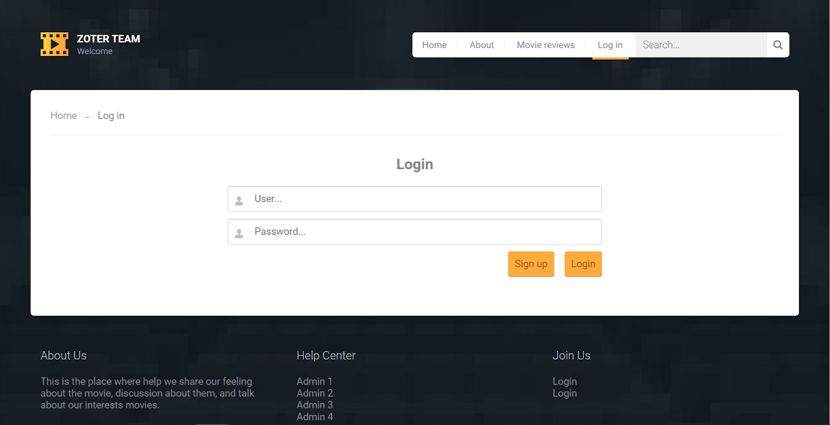

### **b. Register**

1. Function trigger:

· Trigger when user click on Register button

2. Function description:

· Roles: Guest

· After click register, user will enter the account and their own email to create account

· Data processing: transfer data to backend through Servlet

3. Screen layout:

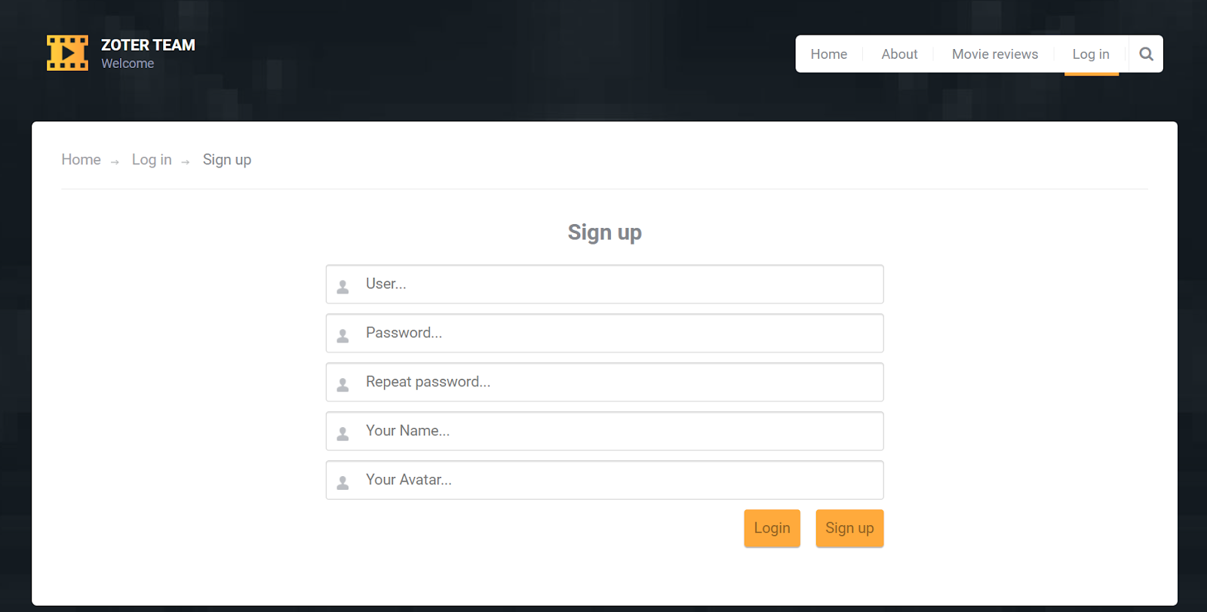

4. Function details:

· Validate data from form in jsp page

· Transfer data to backend, create new Member if data is valid.

### **c. Logout**

1. Function trigger:

· Trigger when user click on Logout button

2. Function description:

· Roles: Admin, Cyber manager, User

· After click Logout, remove session, forward to Login page.

· Data processing: transfer data to backend through Servlet

## **2. User Profile**

### **a. View**

## 1. Function trigger:

## · Trigger when user click on My Account button

## 2. Function description:

## · Roles: Member, Reviewer, Admin

## · System will get information of user from Session and push them to the website.

## · Data processing: transfer data to backend through Servlet

## 3. Screen layout: not yet

## 

### **b. Edit**

## 1. Function trigger:

## · Trigger when user click on Edit Profile button

## 2. Function description:

## · Roles: User, Reviewer, Admin

## · System will get inputted data and update the user in the database base on user ID

## · Data processing: transfer data to backend through Servlet

## 3. Screen layout:

## 

## 4. Function details:

## · Validate data from form in jsp page

## · Transfer data to backend, update User in the database if all data is valid.

## **3. Manage :**

### **a. View All user**

1. Function trigger:

·When admin click on button “manage user”

2. Function description:

· Roles: Admin

· When admin click on button “manage user”. list of user will be got from database and push to website from backend.

· Data processing: transfer data to backend through Servlet

3. Screen layout:

· <No image yet>

### **b. Delete user**

1. Function trigger:

· When delete request send to back-end

2. Function description:

· Roles: Admin

· When admin send delete user request, back-end will remove user from database.

· Data processing: transfer data to backend through Servlet

3. Screen layout:

· <No image yet>

### **c. Delete movie review:**

1. Function trigger:

· When delete request send to back-end

2. Function description:

· Roles: Admin

· When admin send delete user request, back-end will remove movie review

· Data processing: transfer data to backend through Servlet

3. Screen layout:

· <No image yet>

### **d. Edit movie reviewer:**

1. Function trigger:

· When Admin or reviewer click edit button in movie review page

2. Function description:

· Roles: Admin, Reviewer

· System will get inputted data and update the movie review information in the database

· Data processing: transfer data to backend through Servlet

3. Screen layout:

· <No image yet>