GENERAL CONFEDERATION OF LABOR OF VIETNAM

**TON DUC THANG UNIVERSITY**

**FACULTY OF INFORMATION TECHNOLOGY**



FINAL REPORT

**MOBILE APPLICATION DEVELOPMENT**

*Instructing Lecturer*: **LÊ VĂN VANG**

*Student’s name*: **LÊ CÔNG MINH KHÔI – 519H0181**

**NGUYỄN HẢI DUY – 520H0623**

*Class***: 19H50203**

**20H50304**

*Course***: 24**

**HO CHI MINH CITY, 2023**

GENERAL CONFEDERATION OF LABOR OF VIETNAM

**TON DUC THANG UNIVERSITY**

**FACULTY OF INFORMATION TECHNOLOGY**



FINAL REPORT

**MOBILE APPLICATION DEVELOPMENT**

*Instructing Lecturer*: **LÊ VĂN VANG**

*Student’s name*: **LÊ CÔNG MINH KHÔI – 519H0181**

**NGUYỄN HẢI DUY – 520H0623**

*Class***: 19H50203**

**20H50304**

*Course***: 24**

**HO CHI MINH CITY, 2023**

ACKNOWLEDGEMENT

I’m so grateful for the enthusiastic support of the teachers and classmates supported me throughout the semester and completed this report.

# **THE PROJECT WAS COMPLETED AT TON DUC THANG UNIVERSITY**

I pledge that this is a product of our own project and is under the guidance of Mr. Vang. The content of research, results in this subject is honest and not published in any form before. The data in the tables used for the analysis, comment, and evaluation were collected by the authors themselves from various sources indicated in the reference section.

In addition, many comments and assessments as well as data from other authors and organizations have been used in the project, with references and annotations.

**If any fraud is found, I am fully responsible for the content of my project.** Ton Duc Thang University is not involved in any copyright infringement or copyright infringement in the course of implementation (if any).

*Ho Chi Minh, January 4th, 2022*

*Duy, Khôi*

*(Lê Công Minh Khôi)*

*(Nguyễn Hải Duy)*

EVALUATION OF INSTRUCTING LECTURER

**Confirmation of the instructor**

_______________________________________________________________________________________________________________________________________________________________________________________________________________________________________________________________________________________________________________________________________________________________________________________________________________

Ho Chi Minh City, 2022

(sign and write full name)

**The assessment of the teacher marked**

_______________________________________________________________________________________________________________________________________________________________________________________________________________________________________________________________________________________________________________________________________________________________________________________________________________

Ho Chi Minh City, 2022

(sign and write full name)

SUMMARY

This is the final report of the MOBILE APPLICATION DEVELOPMENT subject including exercises to test the students' ability.

TABLE OF CONTENTS

ACKNOWLEDGEMENT i

THE PROJECT WAS COMPLETED AT TON DUC THANG UNIVERSITY ii

EVALUATION OF INSTRUCTING LECTURER iii

SUMMARY iv

TABLE OF CONTENTS 1

PROJECT 2

1. INTRODUCTION 2

2. TECHNOLOGY USED 2

3. APPLICATION FUNTIONS 2

a. Login and register an account 2

b. Create, View and manage your gallery 3

c. Smart photo search 4

d. Share photos with everyone 4

e. Image storage and backup 4

PROJECT

1. INTRODUCTION

The photo sharing social network application is a free application that uses the most advanced technologies to help users create, manage, share and store their photos. We believe that our application will become a useful tool for those who are passionate about photography and want to share and communicate with each other through photos.

1. TECHNOLOGY USED

* Firebase authentication for manage user credential.
* Firebase storage to upload images.
* Firestore to manage what images belong to what user.

1. APPLICATION FUNTIONS
2. Login and register an account

Users can create a new account on the application using an email address or log in with a Gmail or Facebook account. Users can use this account to access the application and perform activities such as creating albums, uploading photos and sharing photos. In addition, you can edit and view your personal information.

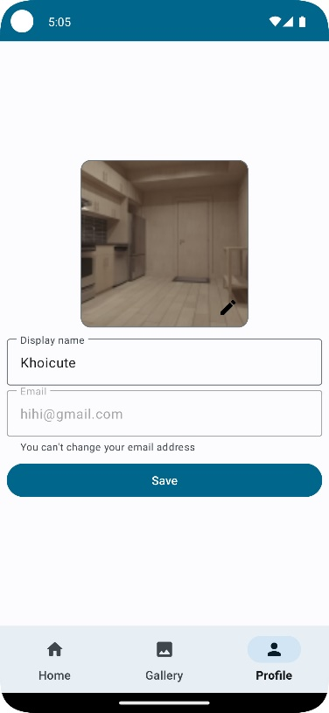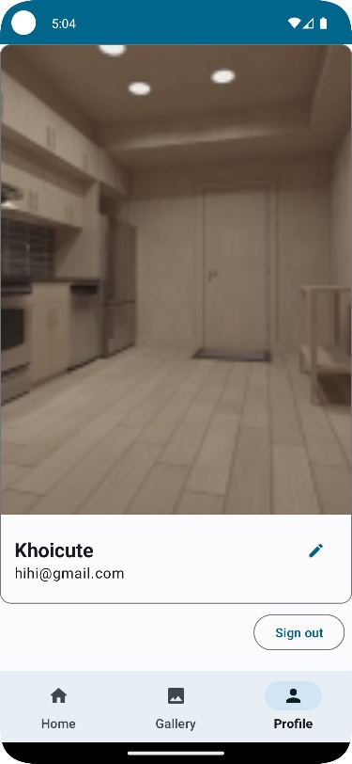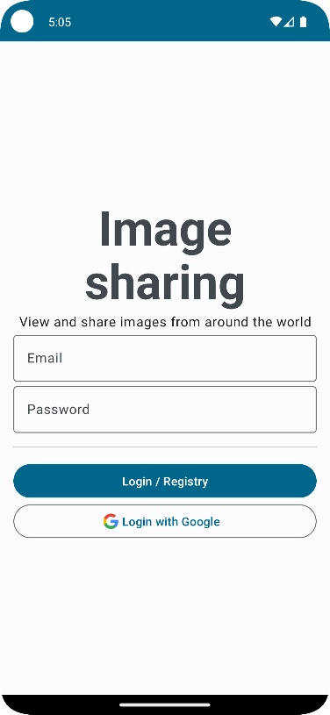

1. Create, View and manage your gallery

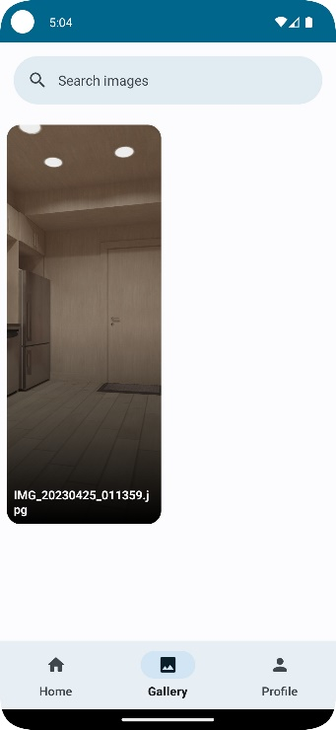After logging in, users can choose to create a new album. Users can create and manage multiple albums, edit album information such as album name, album description, and album cover image. Users can add or delete any photos they want. Albums and photos are displayed in a grid format, so users can easily view and arrange photos.

1. Smart photo search

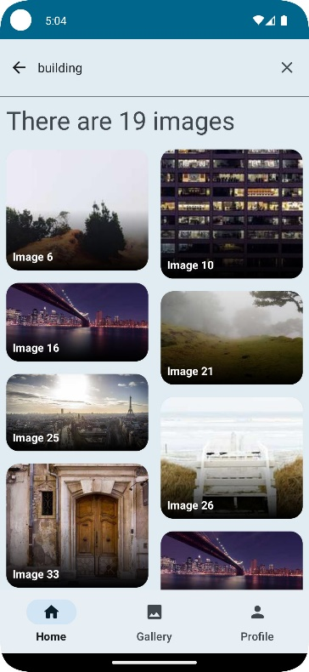Image search using Machine Learning is an advanced feature that helps users find and discover similar images more easily, quickly and accurately. With this function, users can search for images using an existing photo or take a new photo. We use Machine Learning technology to analyze image features and compare with our database of images to find similar images.

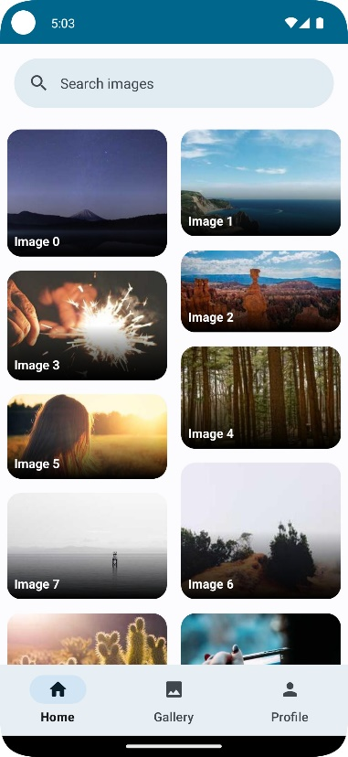

1. Share photos with everyone

You can see everyone's photos and share your photos to their own accounts or to other accounts on the application.

1. Image storage and backup

Photos uploaded to the application are stored on Firebase Cloud Storage to ensure that users' photos are stored and managed in a safe and reliable manner. In addition, we also provide a backup feature to help users store their photos on their devices.