

UNIVERSITY OF GREENWICH
COMP1649 – Human Computer Interaction and Design
Coursework

Student name | Lieu Vinh Khoi
ID number (00xxxxxxx) | 001391472
Lecturer/Tutor name | Nguyen Kim Khanh
Student submission date | December 5th 2024

Table of Contents
1 Introduction 11
2 Background literature 11
2.1 HCI Research 11
2.2 HCI Theory 11
2.2.1 Cognitive Psychology 11
2.2.2 Interaction Design Theory 12
2.2.3 Usability Goals 13
2.2.4 User Experience Goals 13
2.2.5 Modes of Interaction 14
2.2.6 Types of Interaction 14
2.2.7 Design Principles 15
2.2.8 Usability Principles (Nielsen, 1994) 16
2.2.9 Approaches for Designing Interactions 17
2.2.10 Design Pattern 17
2.2.11 Anti-patterns and Dark Patterns 20
2.2.12 Persuasive Design and Emotional Interaction 20
2.2.13 Human Data Interaction (HDI) Principles 21
2.2.14 Designing HCI Studies 22
2.3 Search Strategy and Process 22
3 Product Design 23
3.1 Conceptual Design 23
3.1.1 User Requirements 23
3.1.2 Problems and Solutions 23
3.1.3 Hierarchical Model 23
3.1.4 Conceptual Model 24
3.1.5 Metaphors 25
3.2 Design Principles 27
4 Prototype 31
4.1 Low-fidelity Prototype 31
4.2 Mid-fidelity Prototype 39
4.2.1 Welcome Screen 39
4.2.2 Sign-Up and Sign-In Screen 40
4.2.3 Sign-Up and Sign-In Error Screen 41
4.2.4 Home Page Screen 41
4.2.5 Route Selection Screen 42
4.2.6 Route Selection Error Screen 42
4.2.7 Auto Tracking Screen 43
4.2.8 Route Start Confirmation Screen 44
4.2.9 Travel Route Tracking Screen 44
4.2.10 Screen When Stopping Tracking The Moving Route 45
4.2.11 Voice Commands While Tracking The Screen 46
4.2.12 Music Screen While Tracking The Screen 46
4.2.13 Travel Route Completion Screen 47
4.2.14 Tracking Record History Screen 47
4.2.15 Music Manager Screen Wireframe 48
4.2.16 Music Library Screen 48
4.2.17 Music Player Screen 49
4.2.18 Show Lyrics Screen 50
4.2.19 Account Management Screen 50
4.2.20 Update Account Screen 51
4.2.21 Update Account Notification Screen 51
4.2.22 Setting Screen 52
4.3 Mid-fidelity Prototype Evaluation 53
5 Research Study 57
5.1 Conduct Survey Purpose 57
5.2 Objectives 57
5.3 Hypotheses 57
5.4 Target Audience 58
5.5 Methodology 58
5.6 Survey Design 58
5.7 Conclusion 59
6 Conclusion 64
References 65
Appendices 66

List of Figures
Figure 1. Display only important information on the screen while tracking the driving route. 12
Figure 2. Easily listen to music without having to navigate through other pages while tracking your driving route 13
Figure 3. Integrate voice commands with touch-based 14
Figure 4. Five main types of interactions are applied in Azudent 15
Figure 5. Bottom navigation 18
Figure 6. Music player card 18
Figure 7. Infinite scroll to download more songs or tracking records 18
Figure 8. Search bars in Azuden 19
Figure 9. Account Registration 19
Figure 10. Input fields hint text 20
Figure 11. AI assistant guides user's driving route 21
Figure 12. Legibility and Ethical Consideration 22
Figure 13.Hierarchical Model 23
Figure 14. Flowchart of the Conceptual Model for the Azuden. 24
Figure 15. The functions, buttons, and icons are displayed more clearly on the Home page. 27
Figure 16. Feedback provided through a success message after updating user information. 28
Figure 17. Prominent buttons and icons in the app 28
Figure 18. Prominently display music icon in navigation bar with navigation to music page. 29
Figure 19. Constraints are applied to ensure users select a departure point before proceeding. 29
Figure 20. Consistent home screen design with navigation buttons for user interaction. 30
Figure 21. Mobile Screen WireFrame 31
Figure 22. Welcome Screen WireFrame 31
Figure 23. Sign In and Sign Up Screen WireFrame 32
Figure 24. Home Screen WireFrame 32
Figure 25. Route Selection Screen Wireframe 33
Figure 26. Route Start Confirmation Screen Wireframe 33
Figure 27. Travel Route Tracking Screen Wireframe 34
Figure 28. Music Screen While Tracking The Route 34
Figure 29. Travel Route Completion Screen Wireframe 35
Figure 30. Tracking Record History Screen Wireframe 35
Figure 31. Music Player Screen Wireframe 36
Figure 32. Music Library Screen Wireframe 36
Figure 33. Music Player Screen Wireframe 37
Figure 34. Show Lyrics Screen Wireframe 37
Figure 35. Account Management Screen 38
Figure 36. Update Account Screen Wireframe 38
Figure 37. Setting Screen Wireframe 39
Figure 38. Azuden icon before accessing the app 39
Figure 39. App welcome screens showcasing travel and music features. 40
Figure 40. Azuden app's sign-in and sign-up screens for user authentication and registration. 40
Figure 41. Azuden app's sign-in and sign-up error screens for user authentication and registration. 41
Figure 42. Azuden app's home page offers personalized GPS tracking, music services, and trip records. 41
Figure 43. Route selection interface in the Azuden app for trip planning and tracking. 42
Figure 44. Route selection error interface in the Azuden app for trip planning and tracking 43
Figure 45. Auto tracking screen 43
Figure 46. The trip confirmation screen displays route details, user info, and options to proceed or return. 44
Figure 47. A live trip tracking screen displays route details and metrics, with a placeholder car icon used during development. 45
Figure 48. Screen When Stopping Tracking The Moving Route 45
Figure 49. Voice commands while tracking 46
Figure 50. Trip tracking screen with a music player for seamless browsing and playback while traveling. 47
Figure 51. Trip completion notification confirming travel history save and offering options to continue or start a new trip. 47
Figure 52. Trip history screen displaying completed journeys with details and options for search and record management. 48
Figure 53. Music management screen with recently played and recommended tracks for personalized listening. 48
Figure 54. Music library with tabs for playlists, artists, albums, and recent tracks. 49
Figure 55. Music playback screen with controls for play, shuffle, repeat, and more. 49
Figure 56. Lyrics display screen with real-time scrolling lyrics and music playback controls. 50
Figure 57. Account management screen with editable user profile details and a "Delete Account" option. 50
Figure 58. Edit phone number screen with a "Save Change" option. 51
Figure 59. Update Account Notification Screen 51
Figure 60. Settings screen with options for app info, contact, privacy, and logout. 52
Figure 61. Display of key trip metrics to maintain user awareness of system status. 53
Figure 62. Navigation bar with intuitive icons matching real-world concepts for a user-friendly interaction. 53
Figure 63. User control elements for navigation and playback, enhancing flexibility and freedom. 53
Figure 64. Consistent design and format for route selection buttons ensures predictability and ease of use. 54
Figure 65. Screen to register a new account. 54
Figure 66. Home screen with clearly labeled main functions, reducing memory load and enhancing recognition. 55
Figure 67. Navigation bar for flexible and efficient access to app sections, suitable for all user levels. 55
Figure 68. Minimalist settings screen with essential options for a clean, user-friendly interface. 56
Figure 69. Clear error message guiding users to correct incomplete information during form submission. 56
Figure 70. Sections for user support and essential app documentation, ensuring easy access to information and help. 57
Figure 71. Data analysis for question 1 59
Figure 72. Data analysis for question 2 59
Figure 73. Data analysis for question 3 60
Figure 74. Data analysis for question 4 60
Figure 75. Data analysis for question 5 60
Figure 76. Data analysis for question 6 61
Figure 77. Data analysis for question 7 61
Figure 78. Data analysis for question 8 61
Figure 79. Data analysis for question 9 62
Figure 80. Data analysis for question 10 62
Figure 81. Data analysis for question 11 62
Figure 82. Data analysis for question 12 63
Figure 83. Question 1 66
Figure 84. Question 2 66
Figure 85. Question 3 66
Figure 86. Question 4 67
Figure 87. Question 5 67
Figure 88. Question 6 67
Figure 89. Question 8 68
Figure 90. Question 7 68
Figure 91. Question 9 68
Figure 92. Question 10 69
Figure 93. Question 11 69
Figure 94. Question 12 69

List of Tables
Table 1. Metaphors table 25

Introduction
This report details the development of Azuden, a mobile application designed for Android and iOS platforms to enhance the riding experience of motorcyclists by playing music while tracking their routes. The design process incorporated human-computer interaction (HCI) principles, extensive user research, wireframing, and prototyping using Axure to ensure the application met real-world user needs. The document outlines the application’s goals, research findings, design decisions, and challenges encountered during development, providing insight into how Azuden progressed from prototype to completion.

Background literature

HCI Research
During the development of the Azuden application, human-computer interaction (HCI) research has provided key insights for designing and integrating functions to enhance user experiences. Research by (Kingsley et al., 2020) discusses the application of augmented reality (AR) for delivering real-time alerts and contextual information, thereby improving safety and situational awareness for users during movement. Similarly, (Kumnova and Imsirovic, 2019) highlight how music integration within HCI applications can enhance user engagement and boost motivation, making the experience more enjoyable and immersive. In addition, (Leung et al., 2007) evaluate haptically augmented touchscreen graphical user interface (GUI) elements under cognitive load, demonstrating that intuitive touch controls, including haptic feedback, can reduce user cognitive strain and enhance interaction in dynamic environments. Finally, (Greasley and Lamont, 2011) emphasize the importance of visual cues and their role in guiding user interactions effectively, helping to minimize distractions and maintain user focus on primary tasks.
From these findings, several key requirements for Azuden can be established. The application should include a simple, user-friendly interface with large buttons for easy function switching, integrate music seamlessly to enhance user engagement and incorporate clear visual cues to assist users without increasing cognitive load. These elements collectively aim to provide motorcyclists with a safe, intuitive, and engaging experience, combining route tracking and music playback effectively.

HCI Theory
- Cognitive Psychology
Cognitive psychology focuses on understanding the mental processes involved in perception, memory, decision-making, and problem-solving. It highlights how users process information and how cognitive limitations should be considered in design. As (Norman, 2013) discussed, the goal is to minimize the cognitive load by designing interfaces that match human mental capabilities, thus improving usability. In practical terms, this means interfaces should not overwhelm users with too much information and should help them focus on essential tasks. This concept is essential when designing systems like Azuden, which need to balance multiple tasks such as route navigation and music playback.
In my project: Azuden applies cognitive psychology by ensuring that the interface presents only relevant information, avoiding unnecessary clutter. The app helps motorcyclists focus on two main tasks—route navigation and music control—by simplifying the interface and using clear visual cues. For example, Azuden displays only the most critical navigation information on the screen, minimizing distractions while allowing users to make quick decisions during their ride.
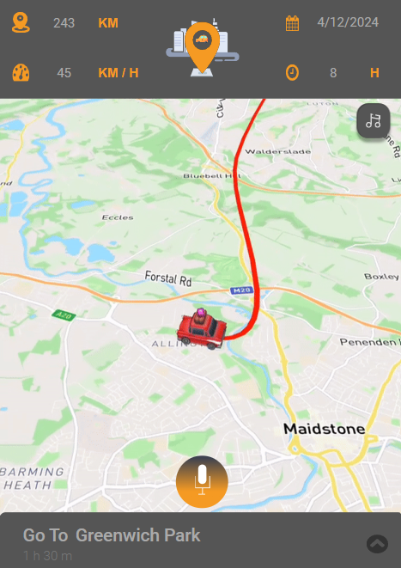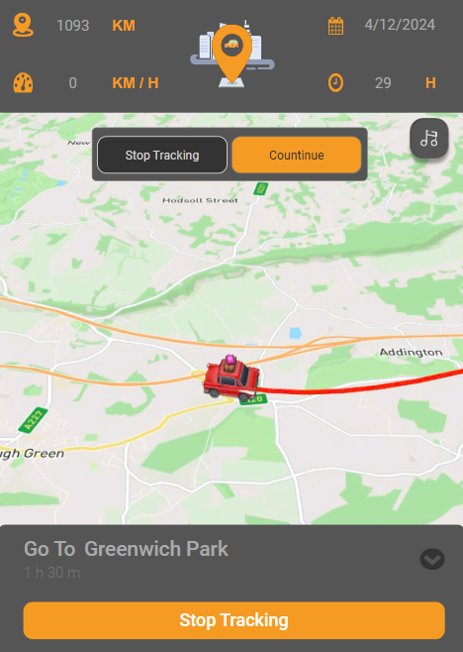
Figure 1. Display only important information on the screen while tracking the driving route.
- Interaction Design Theory
Interaction design theory focuses on creating interfaces that facilitate effective communication between users and systems, emphasizing usability and intuitive user experiences. It draws on cognitive psychology, system design, and user-centered design principles to ensure that interactions are seamless and efficient. According to (Preece et al., 2015), successful interaction design aims to build systems where users can easily anticipate how the system will respond to their actions, thus reducing confusion and frustration.
In this theory, prototypes play a crucial role in testing and refining designs. (Preece et al., 2015) categorize prototypes into three types:
- Low-Fidelity Prototypes: These are simple, inexpensive models used early in the design process. They are often paper sketches or basic wireframes that allow designers to explore and test basic concepts without investing heavily in detail. Low-fidelity prototypes focus on functionality and layout rather than aesthetics, enabling quick iterations based on user feedback.
- Mid-Fidelity Prototypes: These prototypes are more detailed than low-fidelity ones, often created using digital tools to represent the basic layout and interaction flow of the interface. While they may lack final design elements, such as color schemes or images, mid-fidelity prototypes help designers refine user interactions and test specific aspects of usability.
- High-Fidelity Prototypes: These are nearly complete versions of the final product, designed to closely resemble the end-user interface. High-fidelity prototypes include detailed graphics, interactive elements, and accurate representations of user tasks. They allow for comprehensive testing of user interactions and provide a clearer understanding of the system's functionality and design.
In my project: these interaction design principles and prototyping phases will play a crucial role in shaping the user interface. While high-fidelity prototypes could be used in the future to finalize the design, the primary focus for Azuden will be on creating low-fidelity and mid-fidelity prototypes in the early stages. This approach allows for gathering valuable user feedback and refining the design to better meet the needs of motorcyclists.
- Usability Goals
Usability goals are critical for designing systems that are effective, efficient, safe, and easy to learn. These goals aim to enhance user satisfaction by minimizing the effort required to complete tasks while ensuring the system can be used safely and without error. According to (Nielsen, 1994), a system should allow users to perform tasks with minimal cognitive load, errors, and confusion. These usability goals will be applied in Azuden by ensuring the system is easy to use, efficient in navigating routes, and minimizes distractions during music playback.
In my project: Azuden prioritizes usability by providing a streamlined interface that allows users to both track their routes and control their music without confusion. The app minimizes cognitive load by presenting only the most important information and using simple, error-free interactions. For example, users can easily switch between tracking and music without having to navigate through other, more complex pages, ensuring a seamless experience.
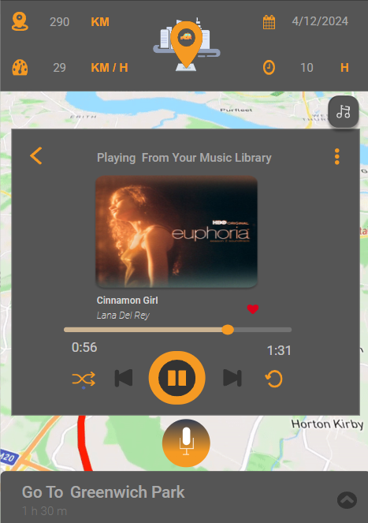
Figure 2. Easily listen to music without having to navigate through other pages while tracking your driving route
- User Experience Goals
User experience goals focus on making systems enjoyable and engaging. Unlike usability goals, which prioritize functional efficiency, user experience (UX) goals aim to create positive emotional responses. As discussed (Hassenzahl, 2010), successful UX design not only fulfills functional requirements but also addresses users' emotional and psychological needs.
In my project: Azuden incorporates UX design by creating a visually appealing and enjoyable experience for motorcyclists. Features like personalized music controls and smooth, non-intrusive navigation enhance the user’s emotional connection with the app. The integration of engaging visuals and rewarding interactions ensures that Azuden is not only functional but also enjoyable for users, increasing their overall satisfaction.
- Modes of Interaction
According to (Norman, 2013), touch-based interactions are among the most intuitive modes for mobile devices. Azuden leverages touch interfaces, enabling users to swipe, tap, and interact with large buttons for music controls and route selection. Touch gestures facilitate hands-free navigation, enhancing safety and user control during rides. Additionally, Azuden incorporates voice-based interactions, allowing motorcyclists to use voice commands to toggle music or stop tracking without taking their hands off the handlebars. This combination of touch and voice-based interactions minimizes distractions, ensuring a smooth, intuitive experience while riding.
In my project: Azuden uses touch and voice interactions to enhance the user experience by providing more intuitive ways to control the app. For example, the driver can simply say “Stop tracking” to end the ride or “Turn off the music” to stop the music without having to look at or touch the screen. Integrating voice commands with touch gestures like this makes Azuden both safer and more user-friendly, allowing the user to focus on the road.
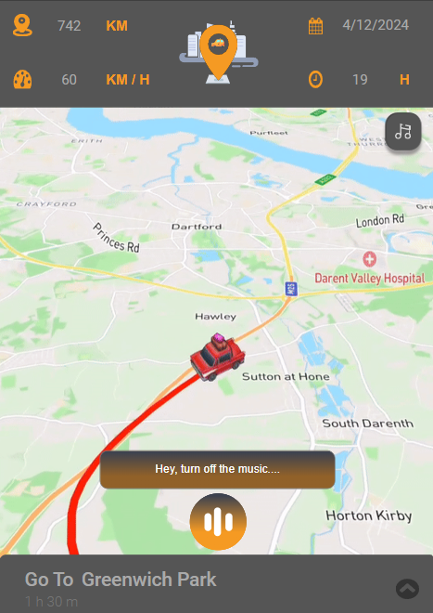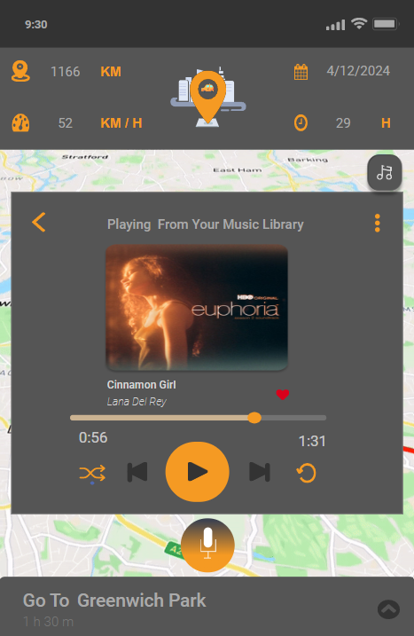
Figure 3. Integrate voice commands with touch-based
- Types of Interaction
Interaction types are fundamental to determining how users interact with an application. According to (Cooper et al., 2014), there are five key types of interaction: instructing, conversing, manipulating, exploring, and responding. Each of these interaction types shapes the way users engage with the system:
- Instructing: This type of interaction involves users providing specific commands or instructions to the system to act (Cooper et al., 2014).
- Conversing: Conversing refers to interaction through communication, typically in the form of prompts, notifications, or dialogues (Cooper et al., 2014).
- Manipulating: Manipulation refers to users interacting with objects or elements within the interface, such as adjusting settings or controlling media (Cooper et al., 2014).
- Exploring: Exploring involves users discovering new content, maps, or destinations by browsing through the system (Cooper et al., 2014).
- Responding: This type refers to how the system responds to users' actions, providing feedback or reacting to the user’s input (Cooper et al., 2014).
In my project: Azuden combines all five types of interactions to create an intuitive and dynamic user experience. For example, users can instruct the app to stop tracking their driving route using voice commands, conversing via notifications or reminders, manipulating music controls, exploring different routes suggested by the system when selecting a tracking route or view trip records, and responding when tracking the travel route is finished, ensuring they can complete their tasks efficiently and safely while driving.
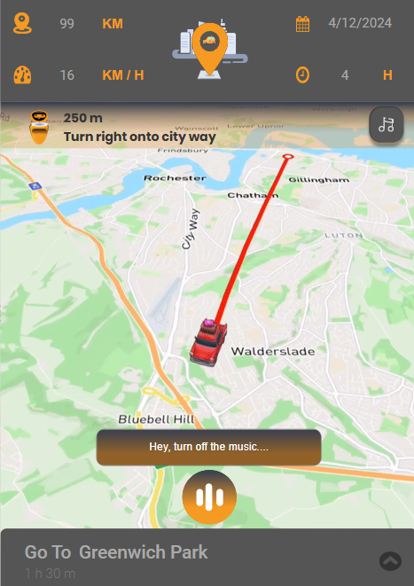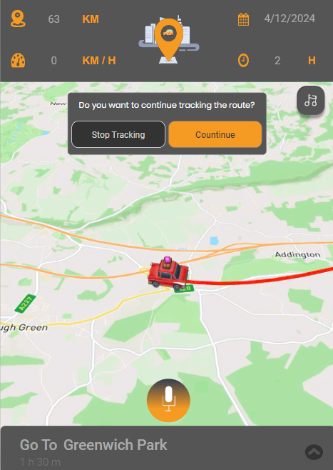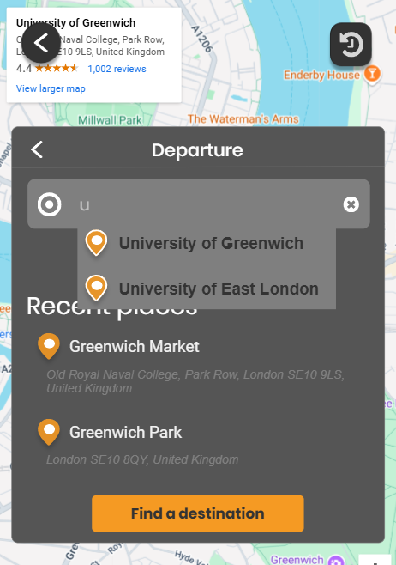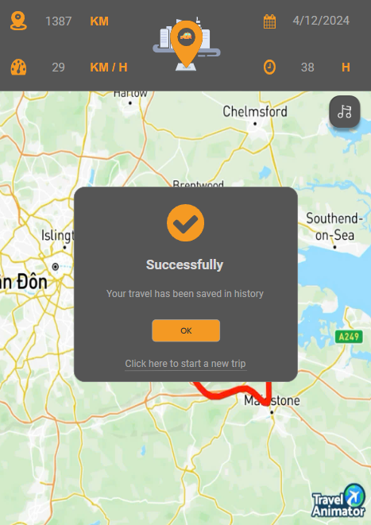
Figure 4. Five main types of interactions are applied in Azudent
- Design Principles
Norman’s design principles are fundamental guidelines for creating intuitive, user-friendly interfaces. These principles, as outlined by (Norman, 2013), help designers ensure that systems align with users' cognitive abilities and expectations. The six key principles are:
- Visibility: The design should make the available actions visible to users. It should be clear what can be done at any given moment (Norman, 2013).
- Feedback: The system should provide immediate, informative feedback in response to users' actions, so they know their input was recognized and understand the result of their actions (Norman, 2013).
- Constraints: Design should limit possible actions to prevent errors and reduce confusion. Constraints guide users toward the correct actions and prevent them from making mistakes (Norman, 2013).
- Consistency: The interface should use similar elements and behaviors consistently across different parts of the system. This allows users to apply prior knowledge and expectations to new contexts (Norman, 2013).
- Mapping: There should be a natural relationship between controls and their effects. Users should easily understand the relationship between actions and outcomes (Norman, 2013).
- Affordance: Elements of the interface should suggest their functionality. For example, buttons should look clickable, and sliders should look draggable, guiding users intuitively (Norman, 2013).
The application of these design principles in the Azuden project will be illustrated in section 3.2 Design Principles.
- Usability Principles (Nielsen, 1994)
Nielsen’s usability principles provide a comprehensive framework for ensuring effective and efficient interface design. These principles, outlined by (Nielsen, 1994), focus on creating systems that are easy to use, minimize errors, and enhance the overall user experience. The 10 usability heuristics are as follows:
- Visibility of System Status: The system should always keep users informed about what is going on, through appropriate feedback within a reasonable time (Nielsen, 1994).
- Match Between System and the Real World: The system should use language and concepts familiar to the user, following real-world conventions, making information appear in a natural and logical order (Nielsen, 1994).
- User Control and Freedom: Users should be able to easily undo or redo actions, providing them with the freedom to explore and correct mistakes without consequences (Nielsen, 1994).
- Consistency and Standards: The system should follow platform conventions and be consistent in its design so that users don’t have to wonder whether different words, situations, or actions mean the same thing (Nielsen, 1994).
- Error Prevention: It’s better to prevent problems from occurring in the first place rather than just offering good error messages (Nielsen, 1994).
- Recognition Rather Than Recall: Minimize the user’s memory load by making objects, actions, and options visible. The user should not have to remember information from one part of the dialogue to another (Nielsen, 1994).
- Flexibility and Efficiency of Use: The system should cater to both novice and expert users. It should allow users to tailor frequent actions and use accelerators for advanced users (Nielsen, 1994).
- Aesthetic and Minimalist Design: Interfaces should not contain irrelevant information that could distract the user. The design should be clean and simple to help users focus on what is important (Nielsen, 1994).
- Help Users Recognize, Diagnose, and Recover from Errors: Error messages should be expressed in plain language, indicating the problem and suggesting a solution. These should help users recover from mistakes efficiently (Nielsen, 1994).
- Help and Documentation: While the system should be usable without documentation, it may still be necessary to provide help and documentation for users. Any help should be easy to search and focus on the user’s task (Nielsen, 1994).
The application of these usability principles in Azuden will be illustrated in section 4.3 Mid-fidelity Prototype Evaluation.
- Approaches for Designing Interactions
Approaches for designing interactions, including User-Centered Design (UCD), Human-Centered Design (HCD), and Participatory Design (PD), all focus on optimizing the user experience by continuously involving users in the design process. According to (Gould and Lewis, 1985), UCD is a design methodology that emphasizes the needs, preferences, and limitations of users, involving iterative testing and refinement based on user feedback. (Löwgren and Stolterman, 2004) explain that HCD involves iterative cycles of design, prototyping, and testing, ensuring the system fits into the user’s context and goals. Finally, (Schuler and Namioka, 1993) argue that Participatory Design (PD) encourages direct user involvement from the start, leading to designs that better meet users’ needs.
In my project: these methodologies are applied by involving motorbike riders throughout the design and testing phases. Feedback from an initial survey guided the design, particularly in simplifying controls and prioritizing safety. This iterative, user-driven process ensures that Azuden’s interface is intuitive, effective, and tailored to meet the real-world needs of motorcyclists.
- Design Pattern
Design patterns are standardized solutions to recurring problems in interface design, intended to improve usability and user experience. According to (Cooper et al., 2014), design patterns are essentially reusable and adaptable strategies that designers can apply to solve common interaction problems. These patterns serve as a blueprint for organizing and structuring interfaces in a way that users find intuitive and easy to navigate. They help streamline the design process by providing a framework for consistency, efficiency, and user-friendly design. Examples of commonly used design patterns include pagination, forms, navigation menus, and search bars, all of which aim to improve the user’s interaction with the system.
In my project: several design patterns were integrated to improve the application's usability:
- Navigation bar (bottom navigation)

Figure 5. Bottom navigation
In Figure 5, this pattern enables users to quickly and seamlessly access key features. The navigation bar, usually present across the app, allows users to effortlessly switch between pages such as Home, GPS Tracking, Music, Account, and Setting, ensuring that key functions are always readily accessible.
- Music player card
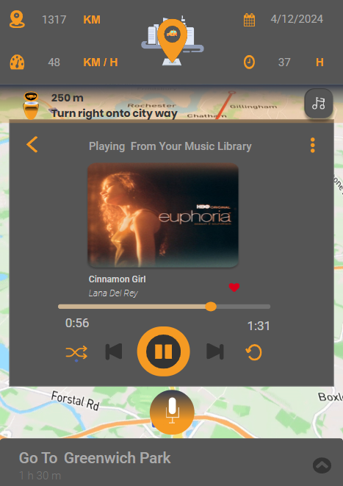
Figure 6. Music player card
Figure 6 shows that each song can be displayed as a card with the song name, album art, and music control buttons (play, pause, change). This makes it easy for users to identify and interact with their favorite songs while driving.
- Infinite scroll to download more songs or tracking records
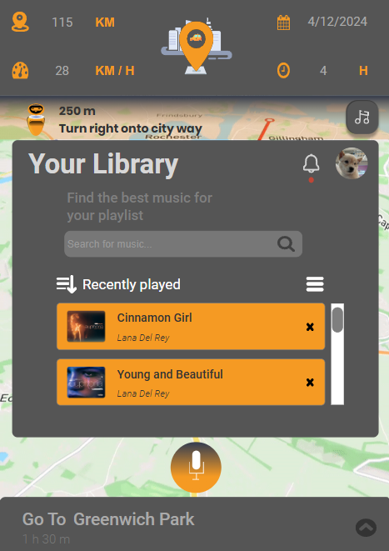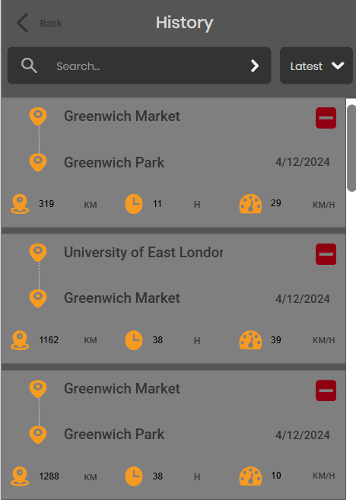
Figure 7. Infinite scroll to download more songs or tracking records
Figure 7 shows the scroll bar pattern when the user scrolls to find favorite songs or tracking records in Azuden, the application can use infinite scroll to continuously load new songs or tracking records without having to switch to other pages.
- Search bar
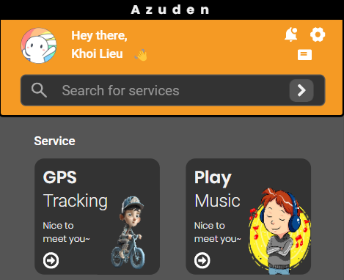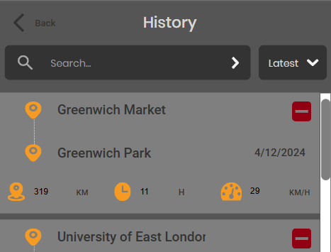
Figure 8. Search bars in Azuden
Figure 8 shows two examples of search bars as design patterns in user interfaces. The first image features a simple search bar for quick queries, commonly found in many apps for easy access to information. The second image displays a search bar with advanced filters, allowing users to refine search results. Both designs enhance usability by helping users find information efficiently.
- Account Registration
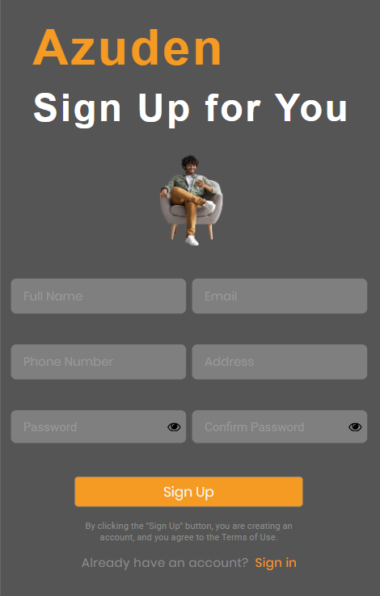
Figure 9. Account Registration
Figure 9 shows the registration form design pattern for Azuden. It includes fields for essential user information, such as name, email, and password, with a simple and clean layout to guide users through the account creation process. The form design ensures clarity and ease of use, following standard UI conventions to minimize errors and enhance the overall user experience.
- Input Prompt (Hint Text)
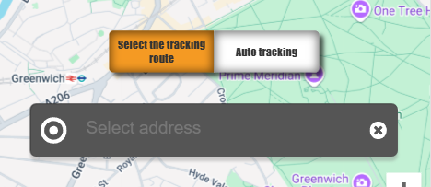
Figure 10. Input fields hint text
Figure 10 shows the use of input fields with hint text in Azuden's design. The hint text provides clear instructions or examples for each input field, ensuring that users understand what information is required. This design pattern helps improve usability by offering immediate guidance, reducing errors, and enhancing the overall user experience during form submission.
- Anti-patterns and Dark Patterns
Anti-patterns and dark patterns refer to design practices that may deceive or confuse users into performing actions they did not intend. (Gray et al., 2018) describe how dark patterns exploit cognitive biases, creating user experiences that manipulate users for the benefit of the system owner.
In my project: Azuden avoids dark patterns by ensuring that all interactions are transparent and that users have control over their actions. For instance, music selections and route adjustments are clear and user-initiated, without any deceptive tactics or hidden actions.
- Persuasive Design and Emotional Interaction
Persuasive design focuses on influencing users’ behaviors and attitudes by triggering emotional responses, often to motivate users to take specific actions or engage with a system in meaningful ways. According to (Fogg, 2002), persuasive technologies aim to change users' thoughts, actions, and emotions through carefully crafted design elements that appeal to their psychological needs and desires. In Azuden, persuasive design will be implemented by creating an emotionally engaging experience, encouraging users to interact with both the navigation and music controls, and providing motivational feedback throughout their journey.
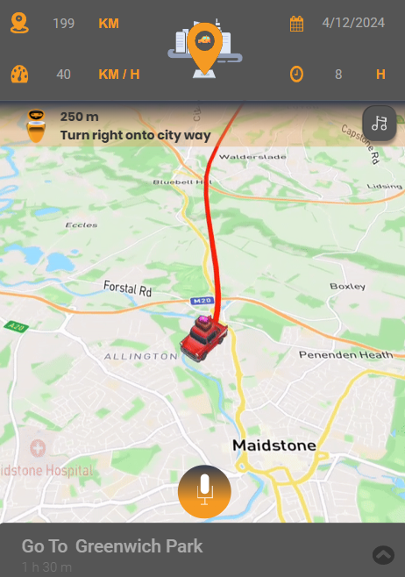
Figure 11. AI assistant guides user's driving route
In my project: As shown in the interface Figure 11, Azuden integrates an AI-powered assistant that guides users through their driving route using both textual and voice instructions. This AI not only provides navigational guidance but also offers positive reinforcement and encouragement, making the experience more engaging. For instance, the AI might say, “Have a nice trip!” or provide reminders like, “Remember to take a break soon for safety!” These verbal cues aim to enhance user motivation, creating an emotional connection with the system. By making the process feel rewarding and supportive, Azuden encourages users to stay focused on the road while ensuring their experience is safe, enjoyable, and emotionally satisfying.
- Human Data Interaction (HDI) Principles
Human Data Interaction (HDI) focuses on how humans interact with data and how data is presented in an understandable, transparent, and ethical manner. According to (Preece et al., 2015), HDI principles aim to enhance the user's engagement with data by ensuring that it is legible, the user has agency over their data, the interaction is negotiable, and ethical considerations are always respected. These principles help in creating a user-friendly and respectful data environment.
- Legibility refers to the clarity and accessibility of data. It ensures that data is presented in a format that users can easily understand (Preece et al., 2015).
- Agency empowers users with control over their data, allowing them to make informed decisions about how their data is collected, used, and shared (Preece et al., 2015).
- Negotiability involves users being able to negotiate or modify how their data is used, enhancing transparency and trust (Preece et al., 2015).
- Ethical considerations focus on ensuring that data collection, processing, and usage adhere to ethical guidelines, protecting users’ privacy, and ensuring fairness in how data is handled (Preece et al., 2015).
In my project: Azuden applies these HDI principles to ensure a seamless and ethical user experience. For example, the app presents data clearly through a simple, easy-to-read interface, allowing riders to track their routes and music without confusion (Legibility) in Figure 12. Users have control over what data is collected, such as deciding whether to share their location to track their ride (Agency). While Azuden allows users to control data collection, it currently does not provide a feature for users to adjust or withdraw their consent to data use (Negotiability). Finally, the app ensures that all personal data is handled by privacy regulations, ensuring that no sensitive information is shared without the user’s explicit consent (Ethical Considerations) in Figure 12.
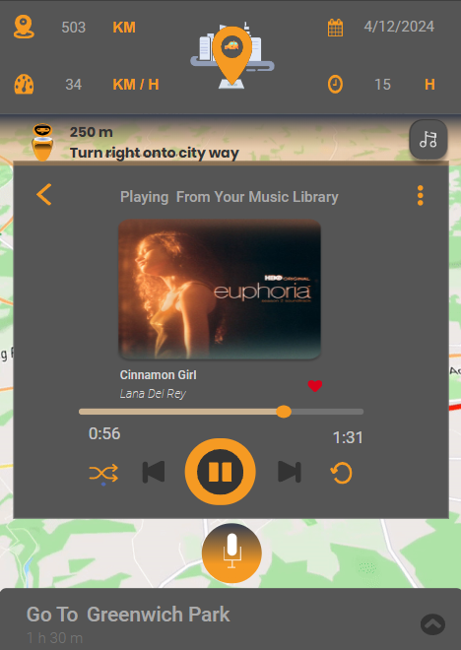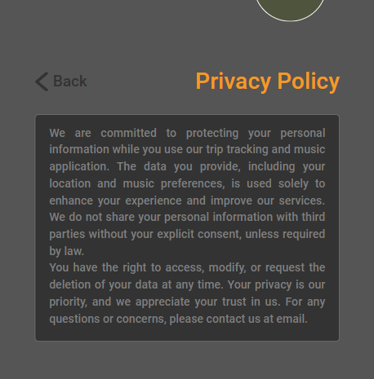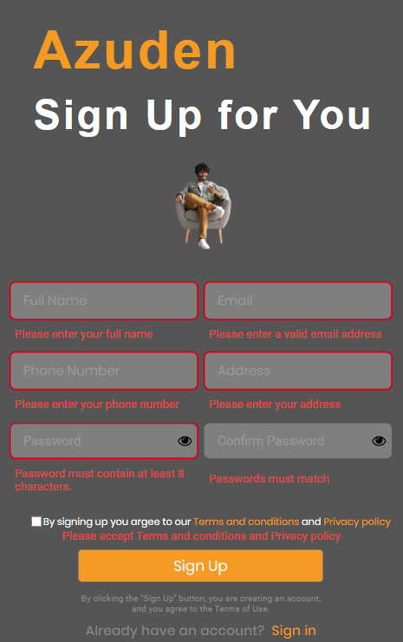
Figure 12. Legibility and Ethical Consideration
- Designing HCI Studies
Designing HCI studies requires clear objectives, controlled variables, and rigorous evaluation methods. (Dumas and Redish, 1999) outline a systematic approach to usability testing, which involves defining usability goals, setting up studies, and analyzing results to improve the design. These methods will be applied to evaluate Azuden’s usability, ensuring that user feedback directly informs design improvements.
In my project: Azuden will conduct HCI studies through user surveys and usability testing to assess the effectiveness of music control and tracking features. These surveys will gather user feedback, which will be used to refine and improve the app’s interface, ensuring it is user-friendly and meets the practical needs of motorcyclists. The design of these HCI studies will be detailed and presented in section 5. Research Study.

Search Strategy and Process
A systematic approach was used to gather academic sources, utilizing databases like Google Scholar, IEEE Xplore, ACM Digital Library, and SpringerLink. These were selected to cover relevant literature on HCI in mobile applications for motorcyclists, safety features, music integration, and haptic feedback. The search terms are provided in the appendix (see Appendices).

Product Design
This app for motorcyclists combines GPS-based ride tracking with music streaming. Users can select routes, review trip history, and enjoy music through customizable playlists, favorites, and simple song switching. Account management ensures secure handling of personal information, while settings provide feedback options and privacy policy details. It emphasizes a safe, enjoyable.

Conceptual Design
- User Requirements
The Azuden application aims to enhance the motorcyclist experience by seamlessly integrating route tracking and music playback. Key user requirements include a distraction-minimized interface for safe travel, easy access to core features like GPS navigation and music with minimal interactions, and responsive controls with clear notifications for smooth transitions. Users also need customizable options for routes, music playlists, and app settings, while ensuring data security and privacy for account management and travel history. These requirements ensure a user-friendly, engaging, and safe experience tailored to motorcyclists.
- Problems and Solutions
The primary problem was developing a mobile application that allows users to track their travel routes and listen to music while ensuring safety, minimizing distractions, and maintaining performance during GPS and music usage. To address user distraction, a simplified interface with large buttons, voice commands, and intuitive navigation was implemented, allowing for easy and safe interactions while on the move. System optimization ensured seamless transitions and efficient operation of GPS tracking alongside music playback, enhancing overall user experience and safety.
- Hierarchical Model
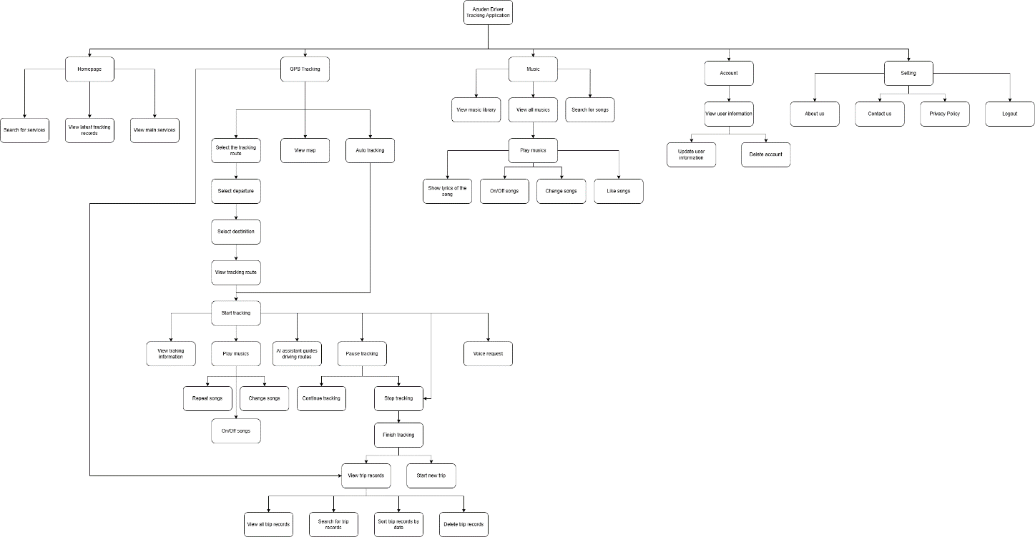
Figure 13.Hierarchical Model
Figure 13 illustrates the hierarchy of the Azuden Driver Tracking App, highlighting the organized flow of the app’s main features and functions. The structure starts with the home page, leading to four main sections: GPS Tracking, Music, Account, and Settings. In the GPS Tracking section, users can track routes listen to music while driving, and view maps, from this section, users can navigate to the Tracking Records section to view previous route tracking history including details such as trip duration, distance, and route. The Music section allows for music selection and playback. The Account section manages user information. The Settings section includes system-related sections such as About Us, Contact Us, Privacy Policy, and Logout. The hierarchical structure emphasizes streamlined navigation, offering users a clear, organized flow for accessing features, ensuring minimal distraction and intuitive usability while driving.
- Conceptual Model
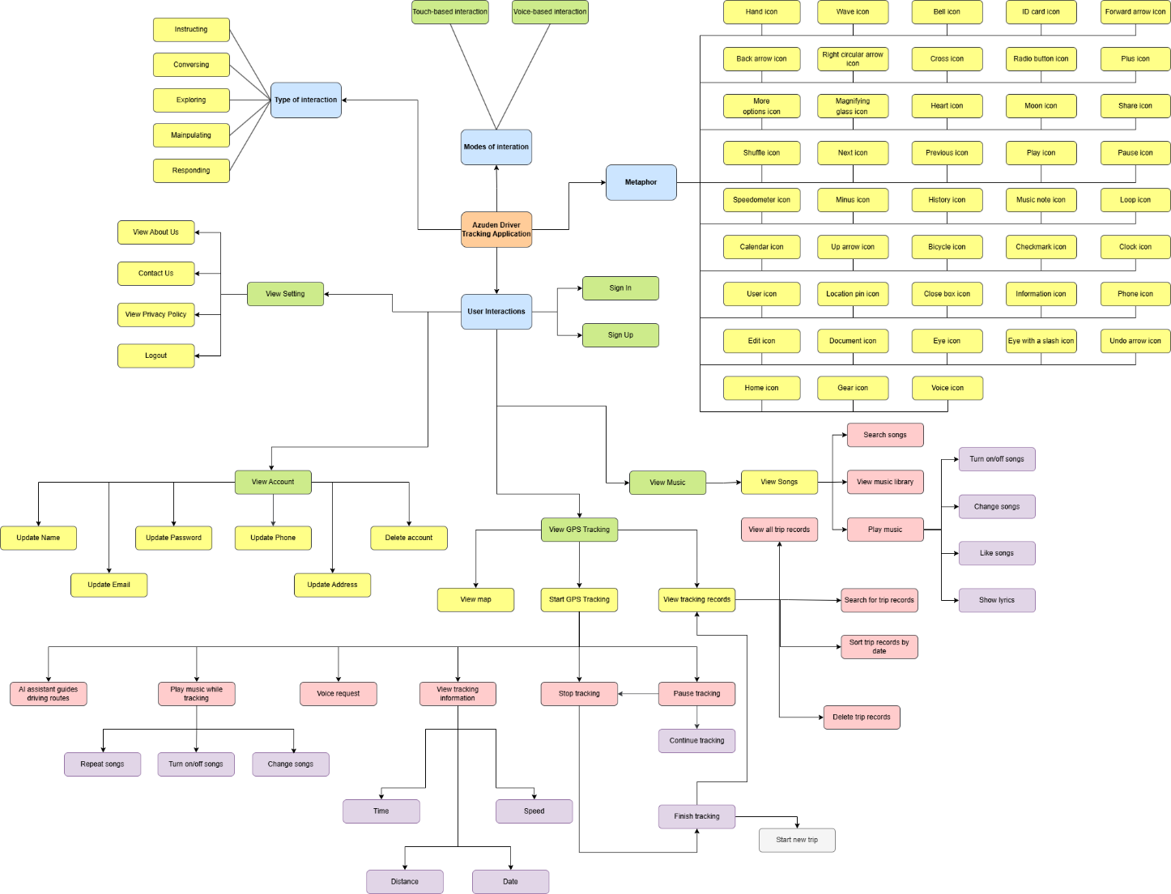
Figure 14. Flowchart of the Conceptual Model for the Azuden.
Figure 14 is a conceptual model of the Azuden application, showcasing its core components, including interaction types, modes of interaction, user interactions (such as settings, accounts, GPS tracking, music,...), and metaphors represented by various icons. The model highlights how users interact with features like music playback, trip tracking, and account updates, emphasizing seamless integration of music and GPS functions for a streamlined user experience.

- Metaphors
The Metaphors section in Table 1 highlights icons used in the Azuden App to visually represent features and actions. These icons help users quickly understand and navigate functions, enhancing app intuitiveness and ease of use.
Table 1. Metaphors table
Icon | Description
 | Hand icon - represents interaction, such as tapping the screen
 | Wave icon - used for greetings or welcoming animations
 | Bell icon - indicates notifications or alerts
 | ID card icon - represents user identification or profile details
 | Forward arrow icon - access or move forward in navigation
 | Back arrow icon - navigate back to the previous screen
 | Right circular arrow icon - navigate to the page the icon belongs to.
 | Cross icon - cancel or close the current action
 | Radio button icon - select a location to start moving
 | Plus icon - add a new item or entry
 | More options icon (three dots) - access additional menu options
 | Magnifying glass icon - search within the app or list
 | Heart icon - mark as favorite or like
 | Moon icon - toggle night mode or dark theme
 | Share icon - share content with others
 | Shuffle icon - enable random playback order
 | Next icon - skip to the next item
 | Previous icon - return to the previous item
 | Play icon - start playback
 | Pause icon - pause playback
 | Speedometer icon - displays speed or performance metrics
 | Minus icon - remove or reduce an item or value
 | History icon - access to travel history page
 | Music note icon - access or control music features
 | Loop icon - repeat content or function continuously
 | Calendar icon - schedule or view dates and events
 | Up arrow icon - scroll or move upward
 | Bicycle icon - display speed and vehicles moving on the route
 | Checkmark icon - confirm completion or selection
 | Clock icon - display or manage time-related features
 | User icon - view or manage user profile
 | Location pin icon - mark or identify a location
 | Close box icon – delete or hide an item
 | Information icon - display detailed information or help
 | Phone icon - make a call or access contact options
 | Edit icon - modify or update content
 | Document icon - open or view documents and records
 | Eye icon - view content or make visible
 | Eye with a slash icon - hide content or make invisible
 | Undo arrow icon - logout
 | Home icon - navigate to the home screen
 | Gear icon - access settings or configuration options
 | Voice icon - Voice commands while driving

Design Principles
The system is designed according to the user interface design principles proposed by Don Norman.
- Visibility
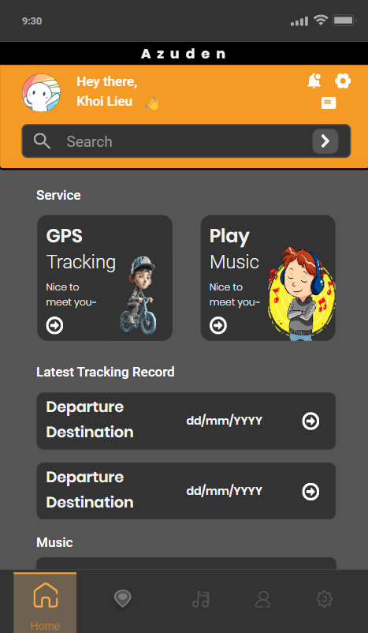
Figure 15. The functions, buttons, and icons are displayed more clearly on the Home page.
Figure 15 shows that functions, buttons, and icons in the Azuden application are always carefully placed in appropriate and clear positions, helping users to easily operate and choose immediately.

- Feedback
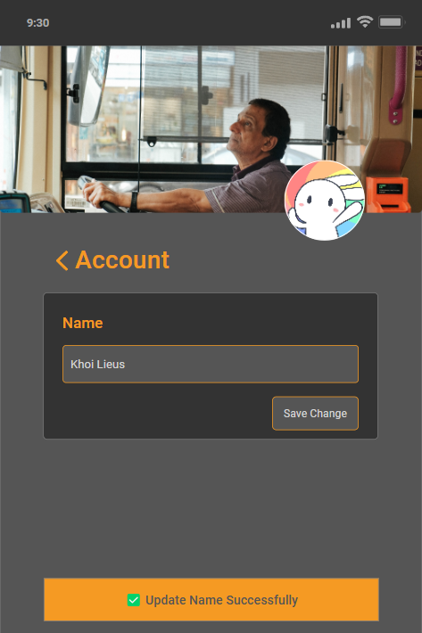
Figure 16. Feedback provided through a success message after updating user information.
Figure 16 illustrates Don Norman's feedback principle. Upon updating their name, users receive immediate confirmation with a "Update Name Successfully" message, ensuring clarity and confidence in their action.
- Affordance
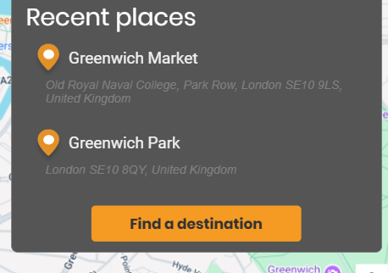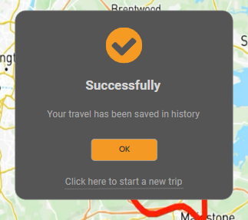
Figure 17. Prominent buttons and icons in the app
Figure 17 shows that the buttons, and icons in the Azuden application are all designed with prominent and suitable colors, the hints or signs in this design show that users can easily recognize to use them.

- Mapping
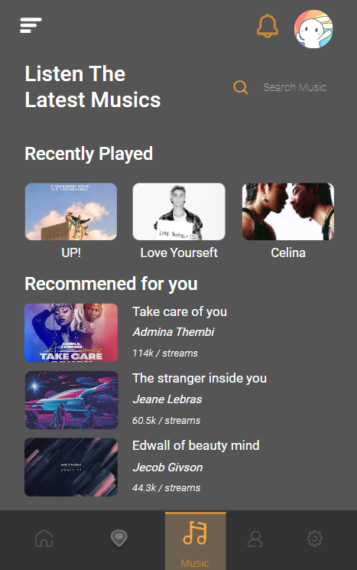
Figure 18. Prominently display music icon in navigation bar with navigation to music page.
Figure 18 illustrates Don Norman's mapping principle. The highlighted music icon in the navigation bar while the displayed music screen, provides a clear and logical connection between the control (music icon) and its result (navigation to the music page). This mapping ensures users can easily understand and predict the outcome of their navigation actions.
- Constraints
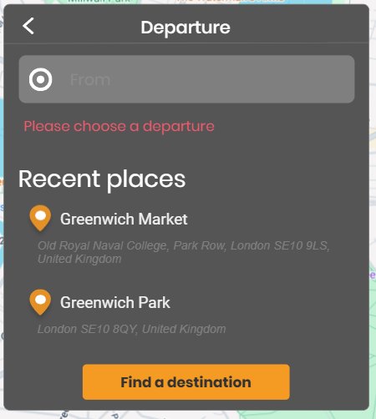
Figure 19. Constraints are applied to ensure users select a departure point before proceeding.
Figure 19 demonstrates Don Norman's constraints principle. When users attempt to proceed to the destination selection without choosing a departure point, the system restricts this action and displays a prompt, "Please choose a departure." This constraint ensures users follow the correct process and prevents potential errors by guiding them through the required steps.
- Consistency
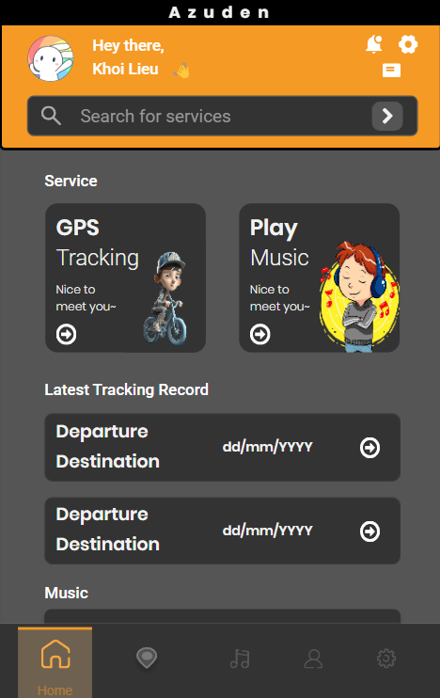
Figure 20. Consistent home screen design with navigation buttons for user interaction.
Figure 20 illustrates Don Norman's consistency principle, which ensures that design elements are uniform and predictable across an application. In the Azuden app, the consistency principle is reflected in the uniform layout of screens and the use of consistent visual elements, such as button styles, icons, and typography, throughout the app. For example, the same button design is used for primary actions across different sections, such as GPS tracking and playing music. This consistency helps users quickly recognize familiar elements, promoting ease of use and reducing the need to relearn interaction patterns, thus enhancing the overall user experience.

Prototype
- Low-fidelity Prototype
- Mobile Screen
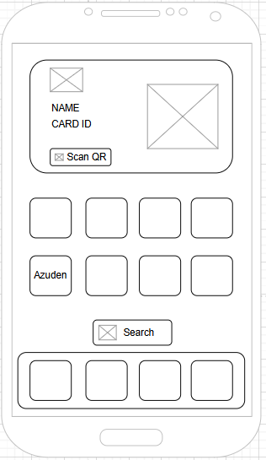
Figure 21. Mobile Screen WireFrame
- Welcome Screen
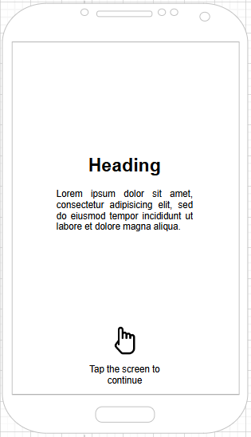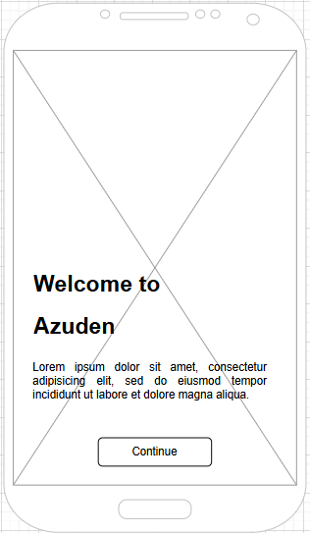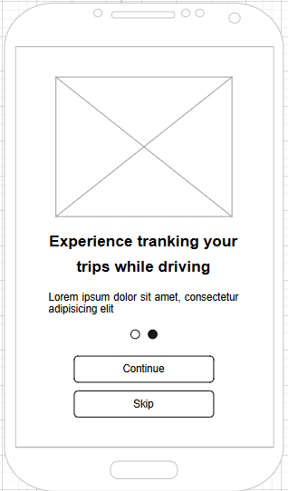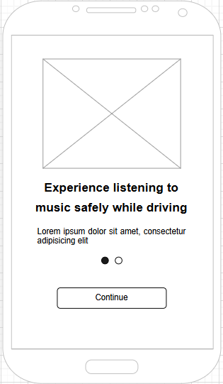
Figure 22. Welcome Screen WireFrame
- Sign In and Sign Up Screen
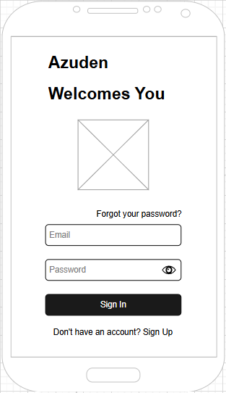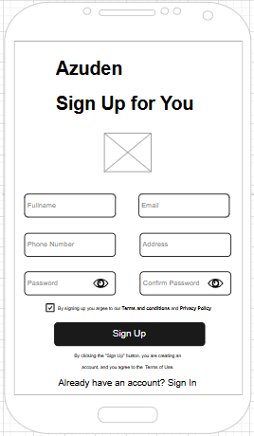
Figure 23. Sign In and Sign Up Screen WireFrame
- Home Screen
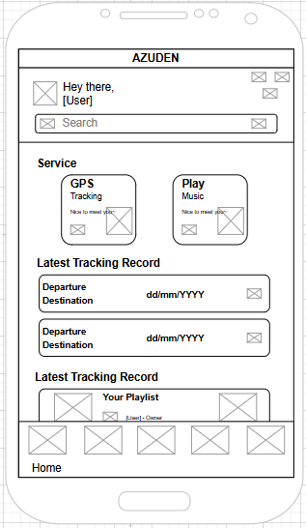
Figure 24. Home Screen WireFrame
- Route Selection Screen
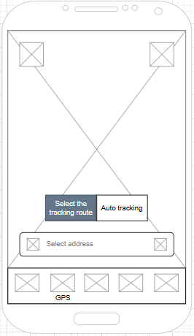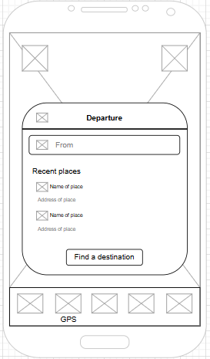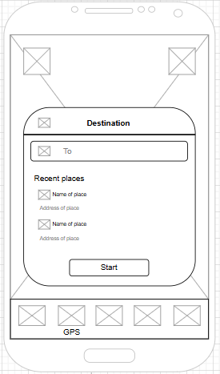
Figure 25. Route Selection Screen Wireframe
- Route Start Confirmation Screen
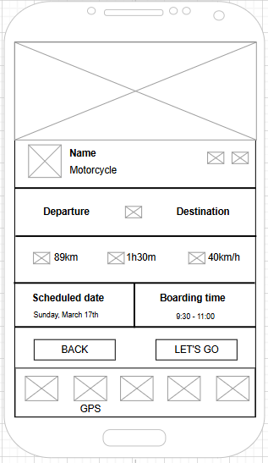
Figure 26. Route Start Confirmation Screen Wireframe
- Travel Route Tracking Screen
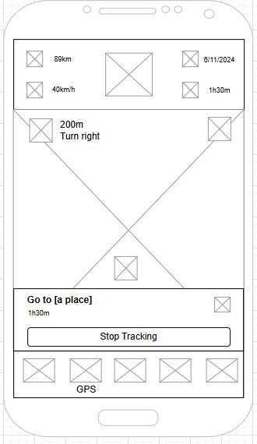
Figure 27. Travel Route Tracking Screen Wireframe
- Music Screen While Tracking The Route
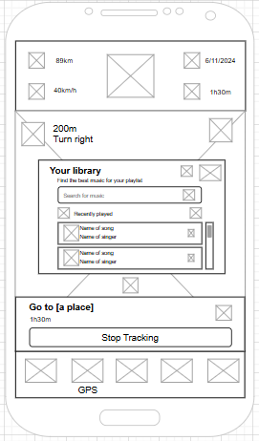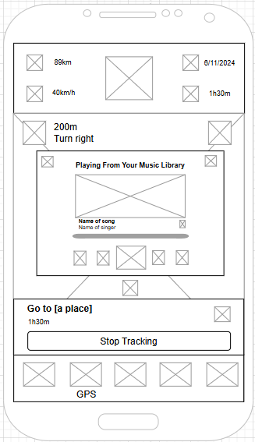
Figure 28. Music Screen While Tracking The Route
- Travel Route Completion Screen
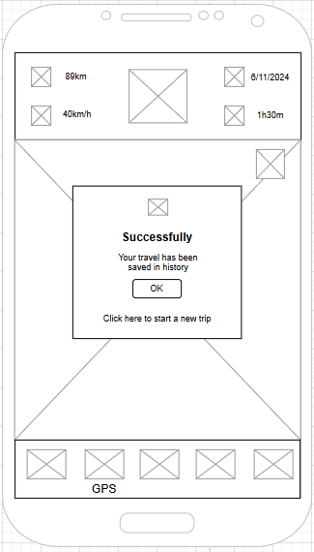
Figure 29. Travel Route Completion Screen Wireframe
- Tracking Record History Screen
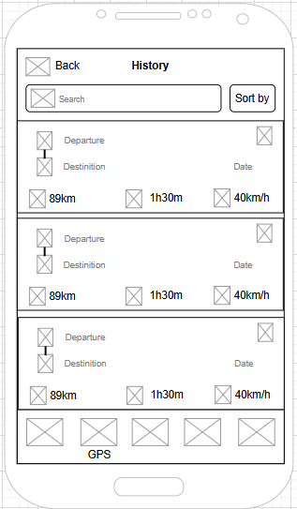
Figure 30. Tracking Record History Screen Wireframe
- Music Manager Screen Wireframe
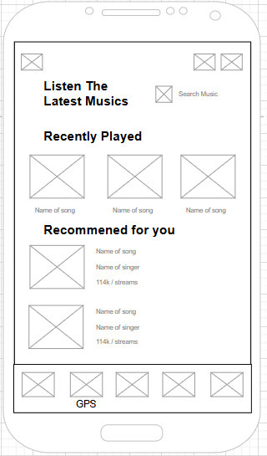
Figure 31. Music Player Screen Wireframe
- Music Library Screen
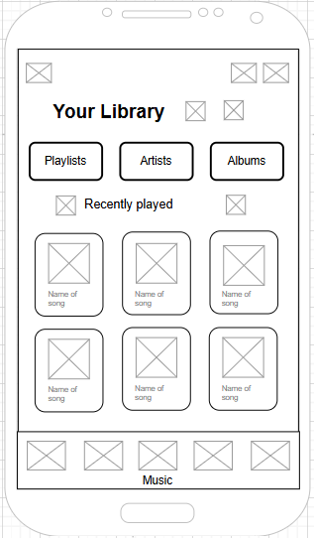
Figure 32. Music Library Screen Wireframe
- Music Player Screen
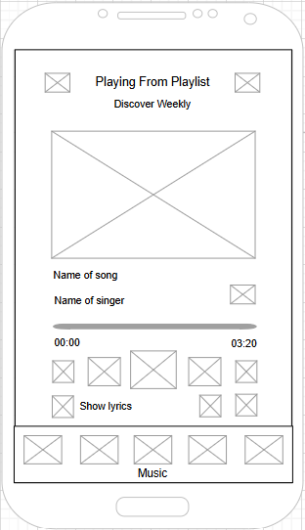
Figure 33. Music Player Screen Wireframe
- Show Lyrics Screen
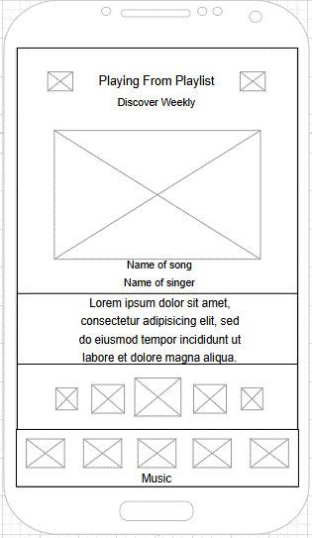
Figure 34. Show Lyrics Screen Wireframe
- Account Management Screen
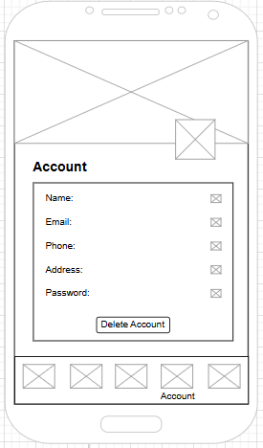
Figure 35. Account Management Screen
- Update Account Screen
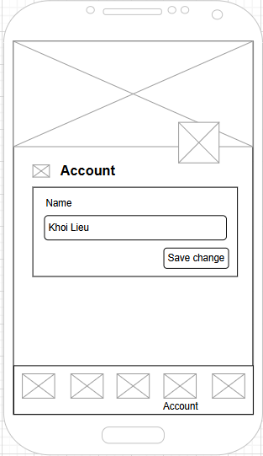
Figure 36. Update Account Screen Wireframe
- Setting Screen
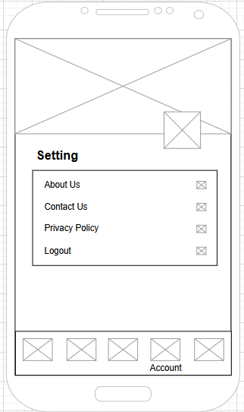
Figure 37. Setting Screen Wireframe
- Mid-fidelity Prototype
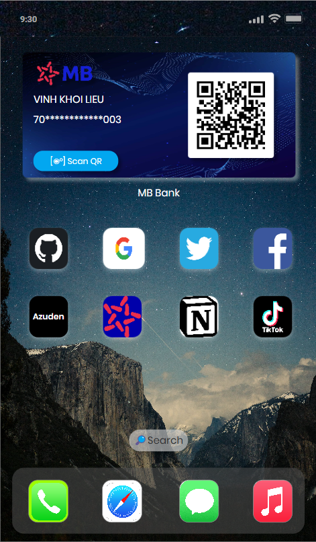
Figure 38. Azuden icon before accessing the app
Figure 38 shows the user’s phone screen before launching the app.
- Welcome Screen
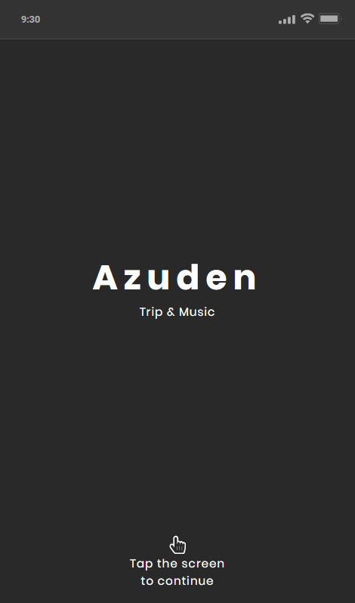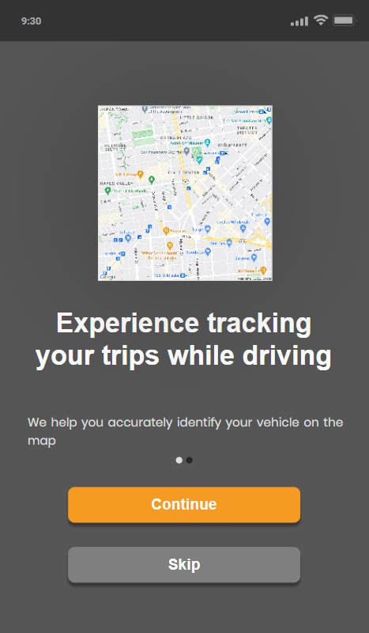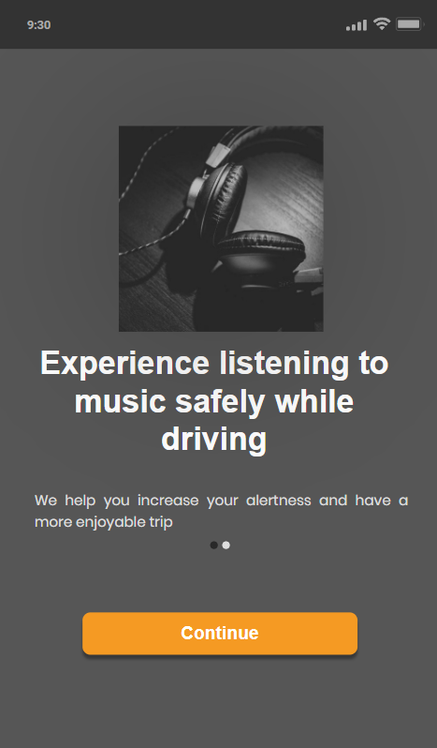
Figure 39. App welcome screens showcasing travel and music features.
Figure 39 showcases a series of prototype welcome screens for the Azuden application. The screens introduce users to the app's primary features, beginning with a minimalist initial screen featuring the Azuden logo and tagline "Trip & Music." Subsequent screens offer an overview of the app's functionality, including daily travel management, real-time trip tracking on a map, and enhancing safety through music playback while driving. The navigation buttons allow users to continue or skip the introductory guide, ensuring a user-friendly onboarding experience.
- Sign-Up and Sign-In Screen
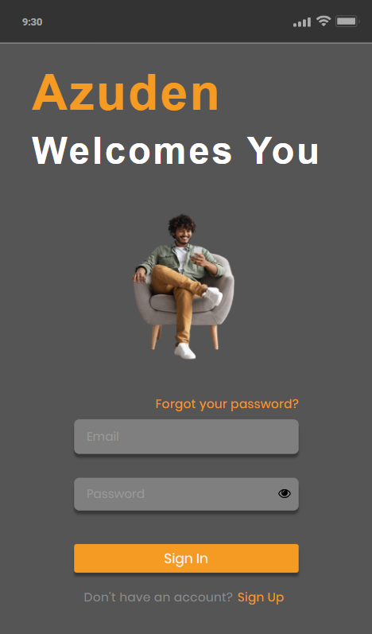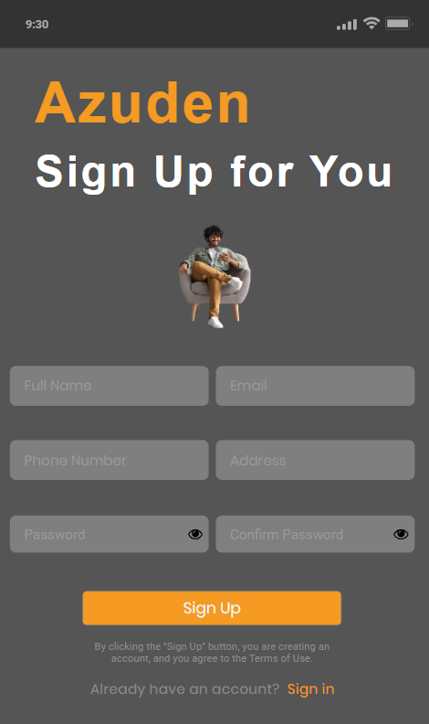
Figure 40. Azuden app's sign-in and sign-up screens for user authentication and registration.
Figure 40 presents the Azuden app's sign-in and sign-up screens. The sign-in page features input fields for email and password, along with options for password recovery and account registration. The sign-up screen allows users to register with fields for full name, email, phone number, address, and password confirmation. Both screens incorporate consistent branding with a central image and welcoming text, offering a streamlined user experience for account access and creation.
- Sign-Up and Sign-In Error Screen
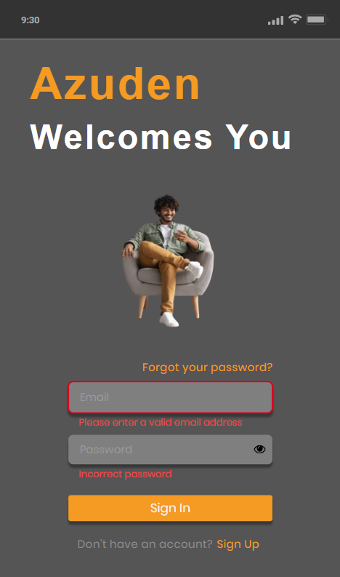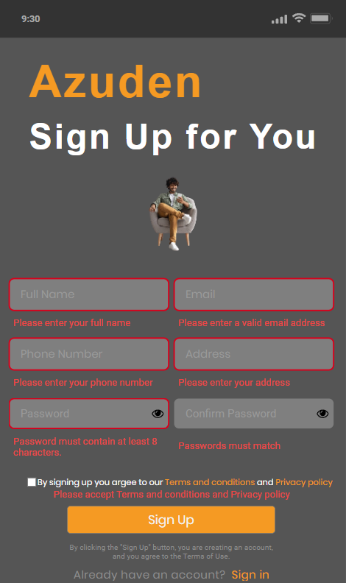
Figure 41. Azuden app's sign-in and sign-up error screens for user authentication and registration.
Figure 41 presents the error screens for the Azuden app's sign-up and sign-in processes. The sign-up error screen displays a message indicating an issue with the registration process, prompting users to correct their information, such as incomplete or incorrect fields. Similarly, the sign-in error screen informs users when the provided credentials are incorrect. Both screens use clear and concise messaging to guide users in resolving the issue, ensuring a user-friendly experience while maintaining a consistent design that aligns with the rest of the app.
- Home Page Screen
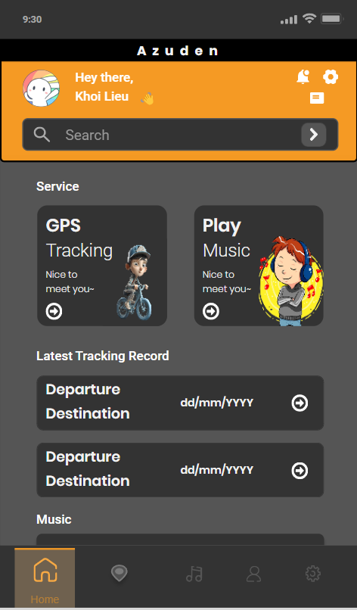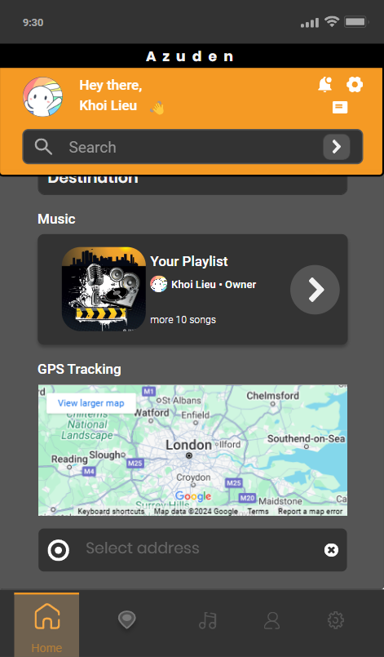
Figure 42. Azuden app's home page offers personalized GPS tracking, music services, and trip records.
Figure 42 displays the Azuden app's home page prototype, featuring a personalized greeting for the user, along with quick access to essential services such as GPS tracking and music playback. The upper section of the page provides a user profile, search bar, and settings icon, enhancing accessibility. Below, distinct cards offer GPS Tracking and Play Music options, each accompanied by a friendly introductory message. The middle section highlights recent tracking records, listing departure and destination details. Further down, users can access their customized music playlists and a GPS map with address input functionality for precise navigation. The interface is designed to streamline interaction and provide a comprehensive user experience.
- Route Selection Screen
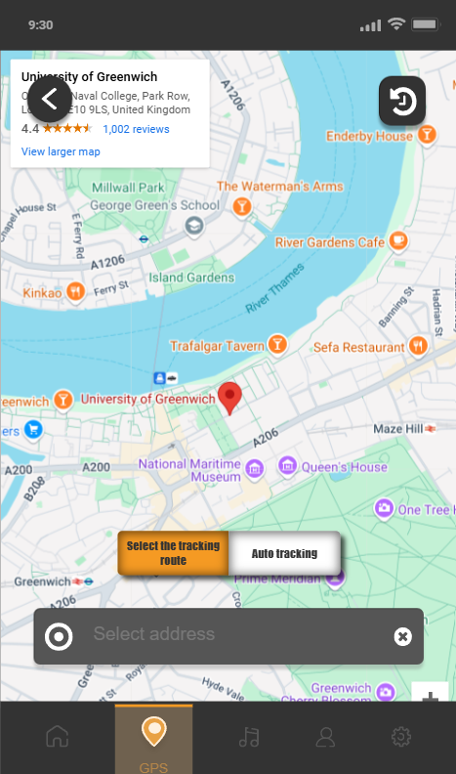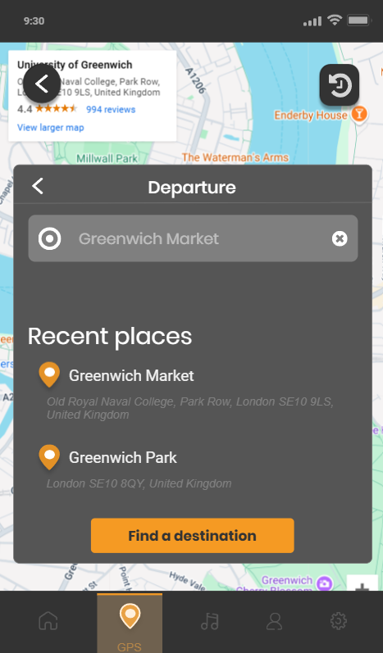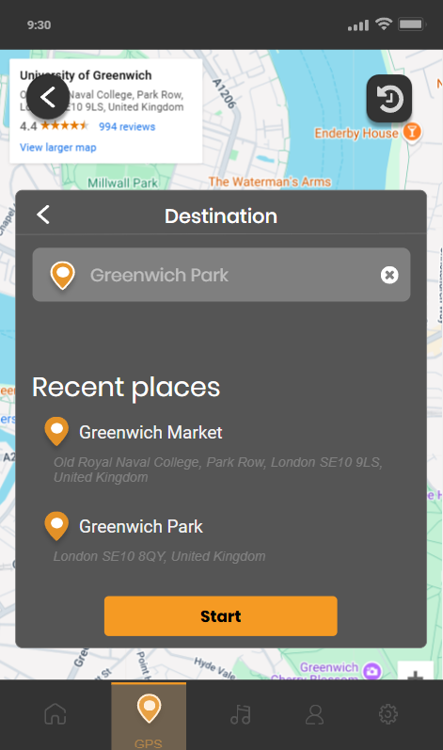
Figure 43. Route selection interface in the Azuden app for trip planning and tracking.
Figure 43 illustrates the route selection process for starting trip tracking within the Azuden app. The first screen presents a map interface for setting departure and destination points, displaying user location and relevant landmarks. Subsequent screens allow users to search for destinations, view recent places, and confirm route selections. This streamlined design emphasizes ease of navigation and route planning, facilitating a smooth start to trip tracking for motorcyclists.
- Route Selection Error Screen
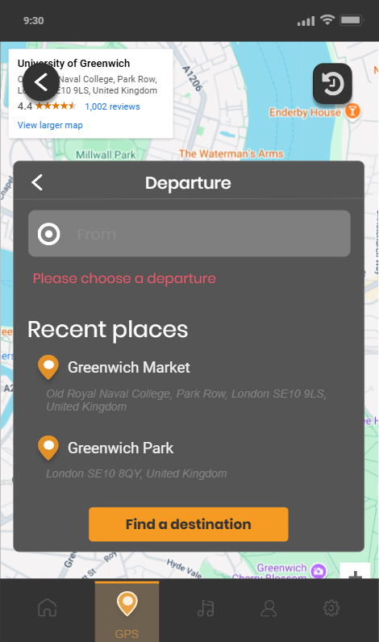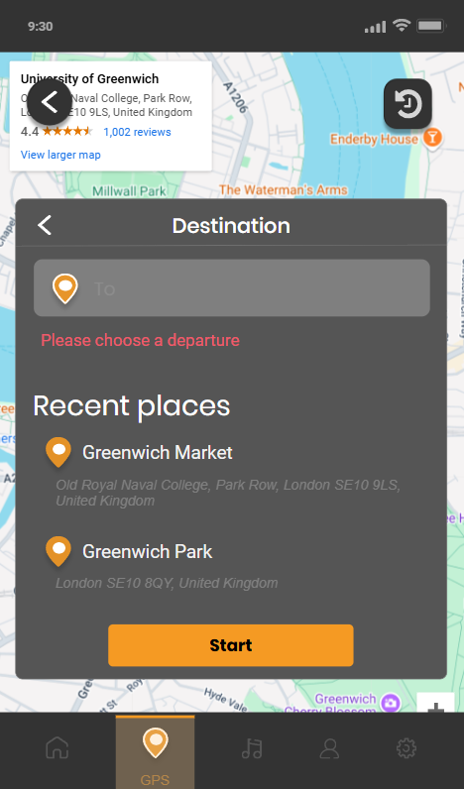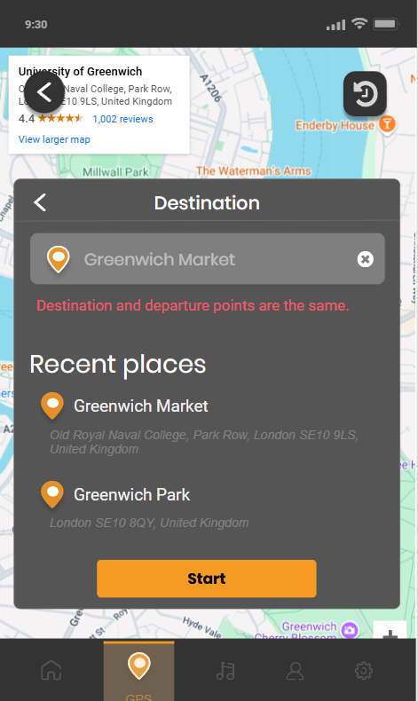
Figure 44. Route selection error interface in the Azuden app for trip planning and tracking
Figure 44 presents the Route Selection Error Screen of the Azuden app. This screen appears when the user encounters an issue while selecting their route, such as invalid input or a failure to retrieve the route. It displays a clear error message, informing users of the problem and providing guidance to correct it, such as re-entering the departure or the destination. The design maintains consistency with the rest of the app, using simple icons and easy-to-read text to ensure a seamless, intuitive experience, even when an error occurs. This approach minimizes user frustration and supports quick resolution of issues.
- Auto Tracking Screen
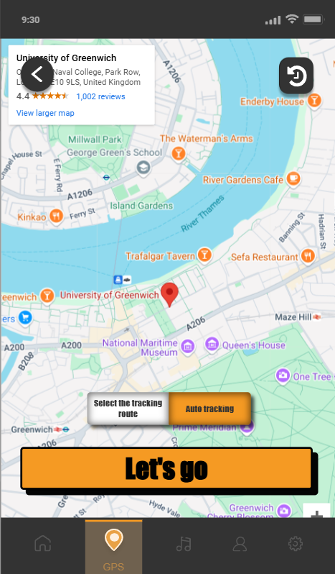
Figure 45. Auto tracking screen
Figure 45 illustrates the Azuden app’s Auto Tracking Screen. The screen displays the user’s real-time tracking, with a map showing the current route, and location. The key feature is a large, prominently designed button that allows the user to immediately initiate a driving route tracking. The design focuses on providing concise action events with minimal distractions, ensuring a smooth experience for drivers who want to start tracking their driving route immediately.
- Route Start Confirmation Screen
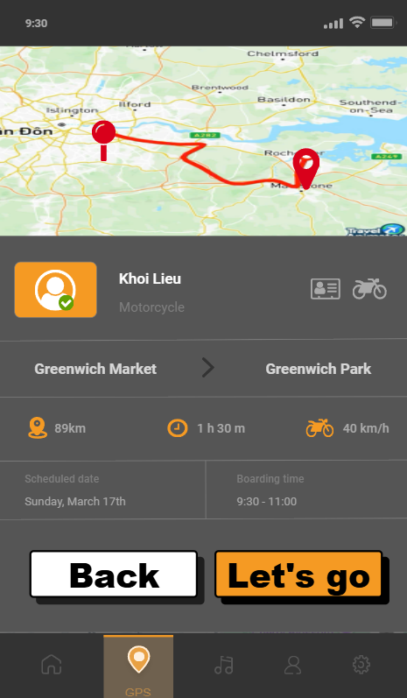
Figure 46. The trip confirmation screen displays route details, user info, and options to proceed or return.
Figure 46 presents the confirmation screen for trip details before starting journey tracking in the Azuden app. It displays a route map, user profile, and essential trip data, including departure and destination points, estimated distance, travel time, and average speed. Additionally, it features a scheduled date and boarding time section. Two buttons, "Back" and "Let's go," allow users to either review or proceed with their planned trip, ensuring a comprehensive overview and control for an optimized travel experience.
- Travel Route Tracking Screen
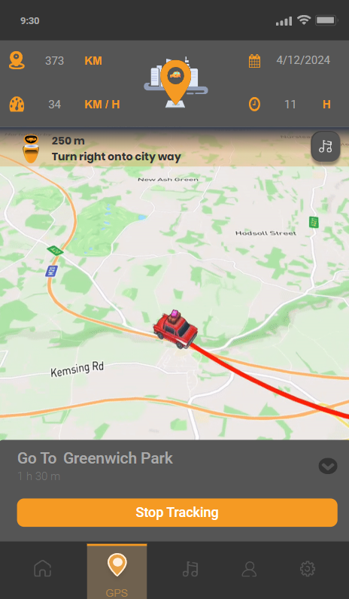
Figure 47. A live trip tracking screen displays route details and metrics, with a placeholder car icon used during development.
Figure 47 depicts the live trip tracking screen of the Azuden app, designed primarily for motorcyclists. The interface shows a route map, and key metrics like distance traveled, speed, duration, and an estimated completion time. While the display currently features a car icon to represent the user's position, this is due to development challenges in sourcing a suitable motorcycle icon for route simulation. The interface includes a “Stop Tracking” button for users to control their trip-tracking experience, and an AI assistant to interact and assist users in tracking their driving routes.
- Screen When Stopping Tracking The Moving Route
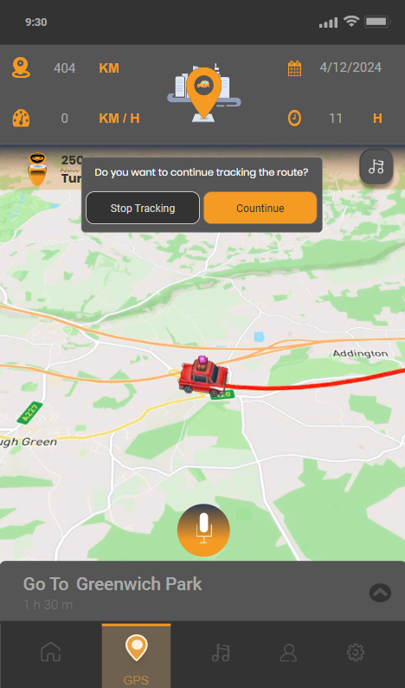
Figure 48. Screen When Stopping Tracking The Moving Route
Figure 48 illustrates the screen when stopping the tracking of the moving route in the Azuden app. The screen features a modal reminder that notifies the user they have stopped moving. The modal includes a message indicating that the tracking has been paused and prompts the user to either resume or end the tracking session. This reminder ensures that users are aware of their current tracking status, providing clear guidance for further action and preventing confusion while interacting with the app. The design is simple, with a focus on maintaining clarity and ease of use.
- Voice Commands While Tracking The Screen
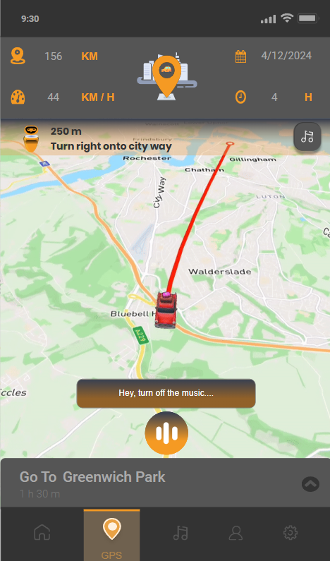
Figure 49. Voice commands while tracking
Figure 49 illustrates the Voice Commands While Tracking the Screen of the Azuden app. The screen shows a tracking screen with options for voice interaction. Users can issue voice commands, such as "Turn off the music..." or "Play music," while the app continues to display real-time location and route information. This feature allows riders to control key app functions hands-free, enhancing safety by minimizing the need for manual interaction with the device while on the move. The design prioritizes ease of use, ensuring that voice commands are responsive and intuitive during navigation.
- Music Screen While Tracking The Screen
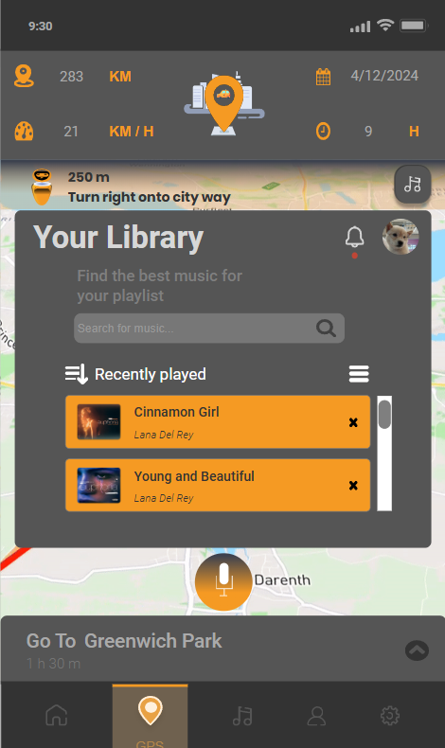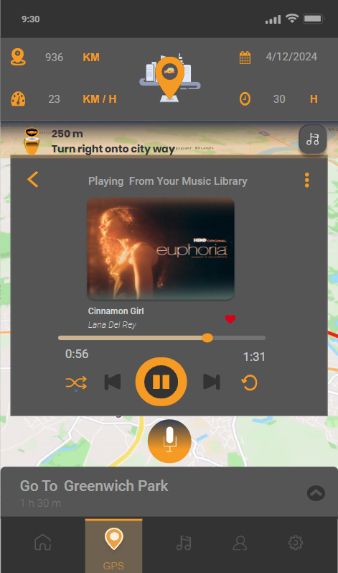
Figure 50. Trip tracking screen with a music player for seamless browsing and playback while traveling.
Figure 50 shows the trip tracking screen with an integrated music player in the Azuden app. Tapping the music icon brings up a library interface for browsing and selecting recently played songs. The playback screen offers controls for pausing, skipping, and volume adjustment, enhancing user convenience and safety by enabling music enjoyment during travel.
- Travel Route Completion Screen
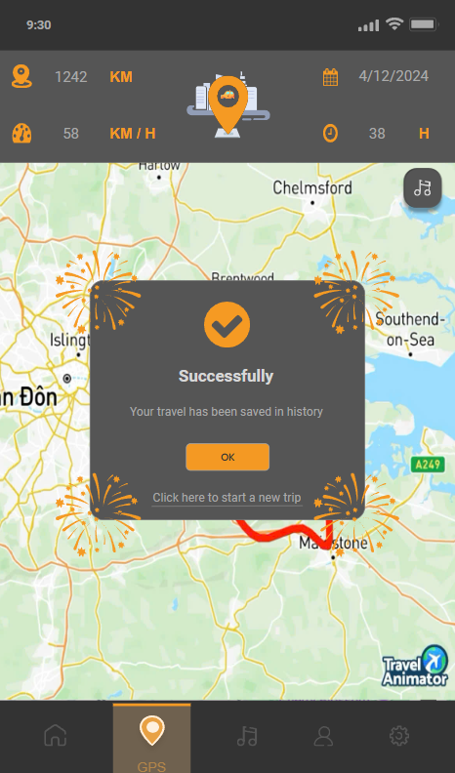
Figure 51. Trip completion notification confirming travel history save and offering options to continue or start a new trip.
Figure 51 illustrates the completion screen of the trip tracking feature in the Azuden app. Upon finishing a trip, a popup notification confirms that the travel record has been successfully saved in the user's history. The popup provides an "OK" button to acknowledge the message and an option to start a new trip, ensuring a smooth transition for continued use.
- Tracking Record History Screen
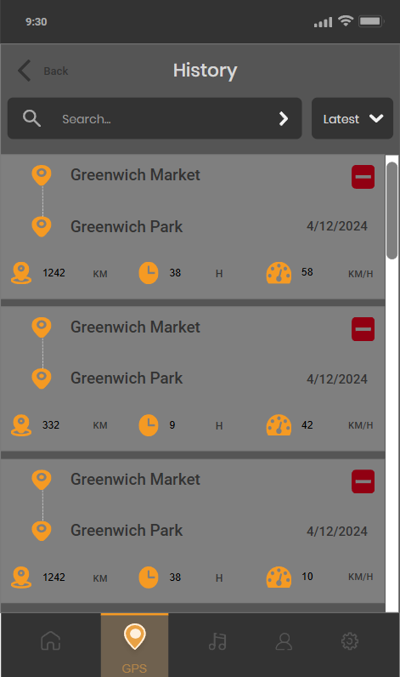
Figure 52. Trip history screen displaying completed journeys with details and options for search and record management.
Figure 52 shows the trip history screen in the Azuden app, displaying a list of completed journeys. Each entry includes key details such as departure and destination points, travel date, distance traveled, duration, and average speed. A search bar allows users to quickly find specific trips, while each history item features a delete button for record management. This interface ensures easy access and management of travel records for users.
- Music Manager Screen Wireframe
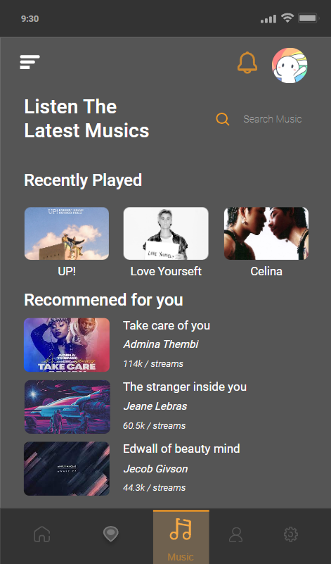
Figure 53. Music management screen with recently played and recommended tracks for personalized listening.
Figure 53 presents the Azuden app's music management screen, featuring a section for recently played tracks to give users quick access to their favorite songs. Below, tailored music recommendations are displayed, including play count details. A search bar allows for easy discovery of new music, enhancing user engagement through personalized listening and exploration options.
- Music Library Screen
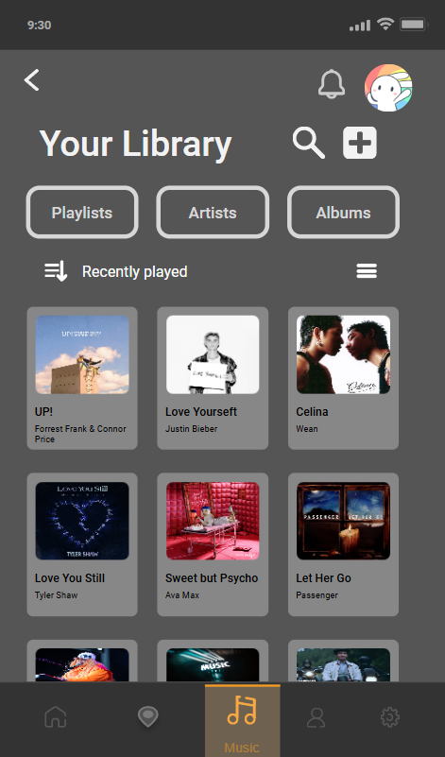
Figure 54. Music library with tabs for playlists, artists, albums, and recent tracks.
Figure 54 shows the music library screen in the Azuden app, allowing users to manage their music collections. It includes tabs for browsing by playlists, artists, and albums, providing a tailored experience. Below, the "Recently played" section displays a grid of recently accessed songs for easy playback. The interface also features search and add options, enhancing the user's ability to organize and explore their music library efficiently.
- Music Player Screen
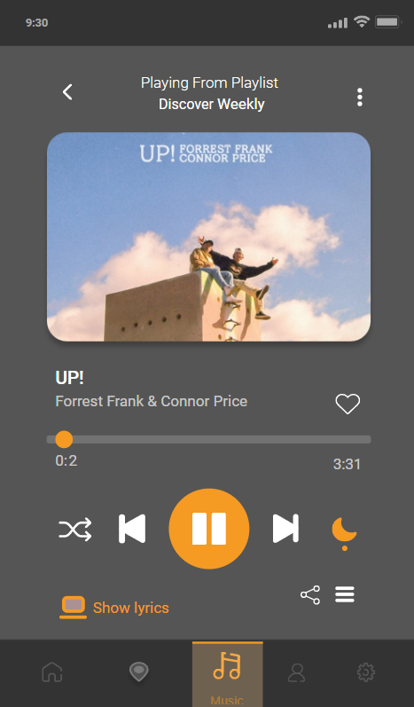
Figure 55. Music playback screen with controls for play, shuffle, repeat, and more.
Figure 55 displays the music playback screen in the Azuden app, featuring a song from a playlist with controls for play/pause, skip, shuffle, and repeat. Users can like the track, adjust playback, view lyrics, and access sharing options. This interface offers a seamless and engaging listening experience.
- Show Lyrics Screen

Figure 56. Lyrics display screen with real-time scrolling lyrics and music playback controls.
Figure 56 presents the lyrics display screen in the Azuden app's music player. While a song is playing, lyrics scroll beneath the playback controls, allowing users to follow along in real-time. The interface retains essential music controls, including play/pause, skip, shuffle, and repeat, ensuring a seamless listening and viewing experience.
- Account Management Screen
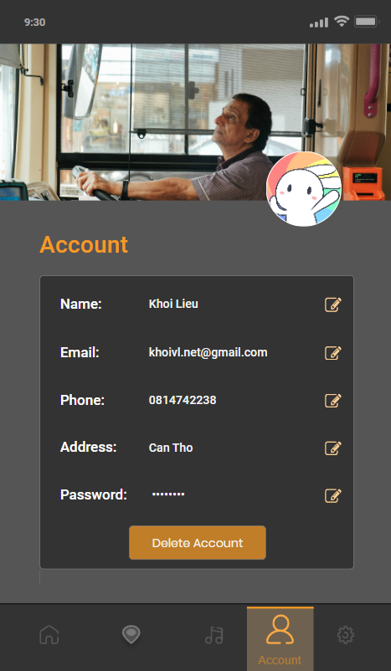
Figure 57. Account management screen with editable user profile details and a "Delete Account" option.
Figure 57 displays the account management screen in the Azuden app. It provides users with their profile details, including name, email, phone number, address, and password, all of which can be edited using the adjacent icons. A prominent "Delete Account" button is available for account removal. The interface ensures users have easy access to manage their personal information securely.
- Update Account Screen
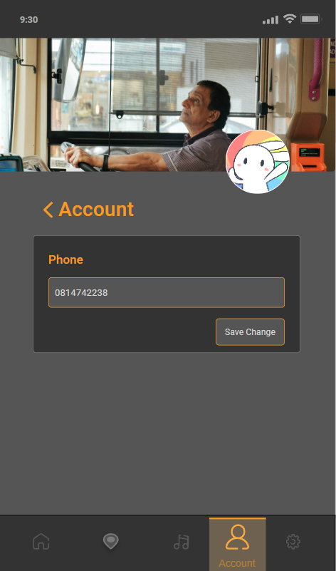
Figure 58. Edit phone number screen with a "Save Change" option.
Figure 58 shows the personal information update screen in the Azuden app. The interface allows users to edit their phone number with a simple input field and a "Save Change" button. The back arrow offers easy navigation to return to the previous account management screen, providing a straightforward and secure way to update personal details.
- Update Account Notification Screen
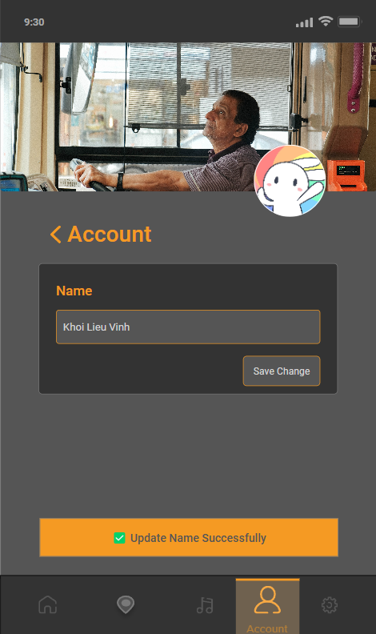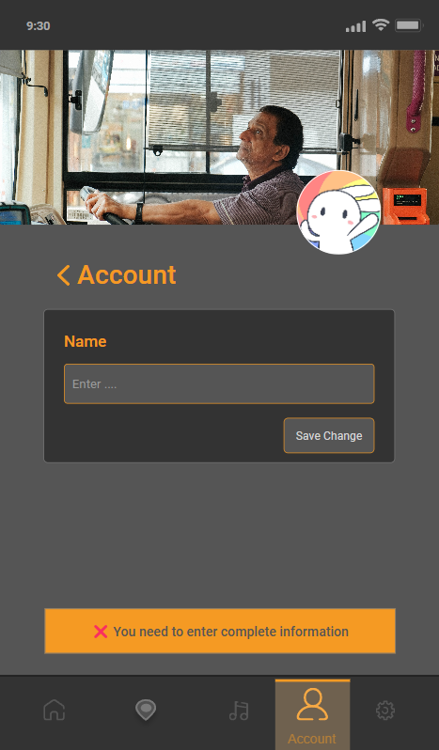
Figure 59. Update Account Notification Screen
Figure 59 illustrates the Update Account Notification screen in the Azuden app. The screen displays a notification confirming the successful update of user information. In the case of an error, an alternative message is shown, indicating that the update process has failed and suggesting the user try again later. The notification system is designed to provide clear, concise feedback, ensuring users are informed of the success or failure of their account updates.
- Setting Screen
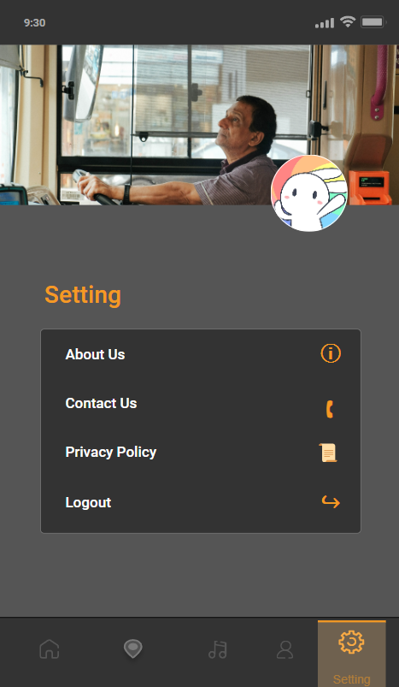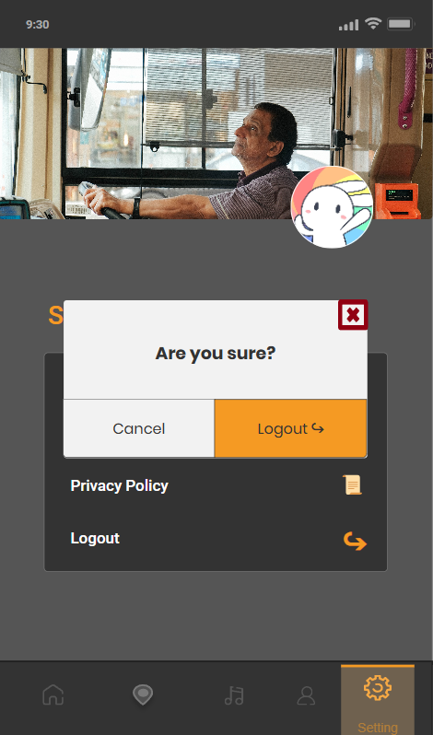
Figure 60. Settings screen with options for app info, contact, privacy, and logout.
Figure 60 displays the settings screen in the Azuden app, offering options such as "About Us," "Contact Us," "Privacy Policy," and "Logout," each paired with a corresponding icon for clarity. When the user taps on "Logout," a modal appears to confirm the action, asking the user to confirm whether they want to log out of their account. This additional confirmation step ensures that users do not accidentally log out, providing a more secure and user-friendly experience.

- Mid-fidelity Prototype Evaluation
This assessment of the mid-fidelity prototypes applies (Nielsen, 1994) usability principles as benchmarks to evaluate the user experience and design effectiveness of the application.
- Visibility of system status

Figure 61. Display of key trip metrics to maintain user awareness of system status.
Figure 61 shows Nielsen's principle of visibility of system status in action. Key trip information such as distance (KM), average speed (KM/H), date, and travel duration is displayed. This ensures users are consistently aware of the current system status and trip progress, providing immediate and understandable feedback throughout their journey.
- Match between the system and the real world

Figure 62. Navigation bar with intuitive icons matching real-world concepts for a user-friendly interaction.
Figure 62 shows a navigation bar that illustrates Nielsen's match between the system and the real world. The icons used for navigation, such as Home, GPS Tracking, Music, Account, and Settings, employ universally recognized symbols and labels that align with users' real-world experiences and expectations. This intuitive design ensures users can easily understand and interact with the navigation bar, making their journey through the app seamless and predictable.
- User control and freedom

Figure 63. User control elements for navigation and playback, enhancing flexibility and freedom.
Figure 63 illustrates Nielsen's user control and freedom. The first image shows music playback controls, including options for shuffle, skip, pause/play, and other features, enabling users to navigate and control their music experience with flexibility. The second image features "Back" and "Let's go" buttons, offering users the freedom to either proceed or return, ensuring they have control over their navigation choices and actions within the app.

- Consistency and standards
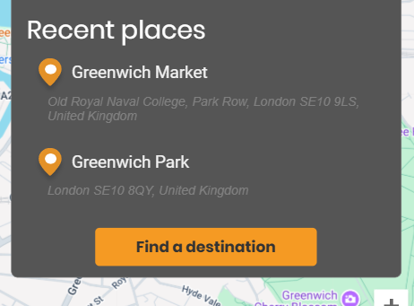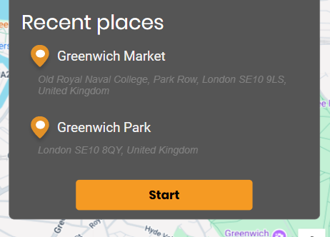
Figure 64. Consistent design and format for route selection buttons ensures predictability and ease of use.
Figure 64 illustrates Nielsen’s consistency and standards principles, which focus on the consistency of buttons in the interface. Buttons for actions such as “Find destination” and “Start” are designed with the same size, shape, and color scheme across different screens to select routes to track as the user drives. This uniformity in button design allows users to easily identify their functions, ensuring a smooth and predictable interaction experience. By maintaining consistent button styles, the application reduces cognitive load and enhances usability, allowing users to focus on the task at hand without confusion.
- Error prevention
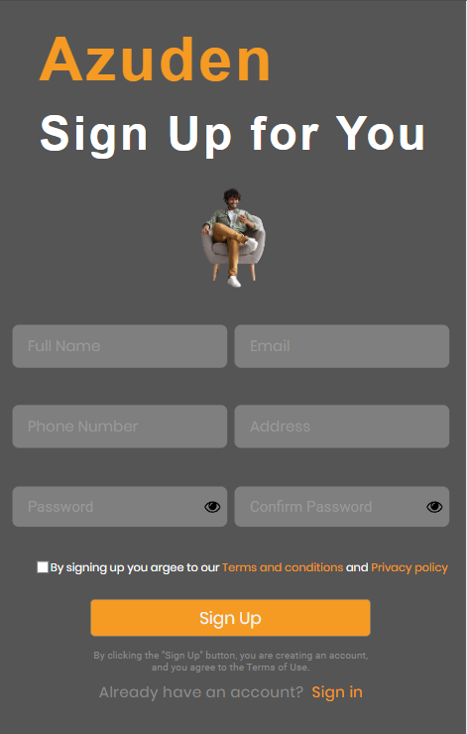
Figure 65. Screen to register a new account.
Figure 65 illustrates Nielsen’s error prevention principle. In this interface, the prompt text below the “Sign Up” button reminds the user that when they click the Sign-Up button, they are creating a new account and agreeing to the system’s Terms of Use. This proactive measure encourages users to check the checkbox to accept the terms of use when using the system. By prompting users to accept the system’s Terms of Use, the application reduces the likelihood of errors when clicking the Sign Up button. This approach helps prevent potential errors and improves the overall accuracy of user interactions.
- Recognition rather than recall
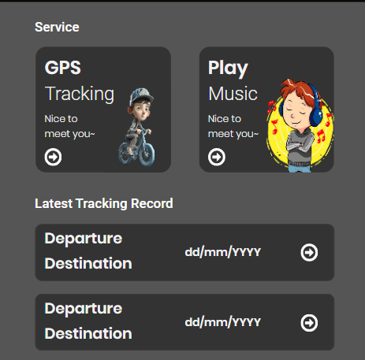
Figure 66. Home screen with clearly labeled main functions, reducing memory load and enhancing recognition.
Figure 66 illustrates Nielsen's recognition rather than recall principle. The home screen prominently displays the latest tracking record, allowing users to easily recognize their most recent trip without needing to remember specific details or actions. This feature minimizes cognitive load by presenting familiar, labeled information in a clear and accessible format. By featuring the latest tracking record front and center, the app ensures that users can quickly access their previous trip details with minimal effort, enhancing usability and streamlining the navigation process.
- Flexibility and efficiency of use
Figure 67. Navigation bar for flexible and efficient access to app sections, suitable for all user levels.
Figure 67 demonstrates Nielsen's flexibility and efficiency of use. The navigation bar provides intuitive icons that allow users, including new and experienced ones, to easily access and switch between different app sections.
- Aesthetic and minimalist design
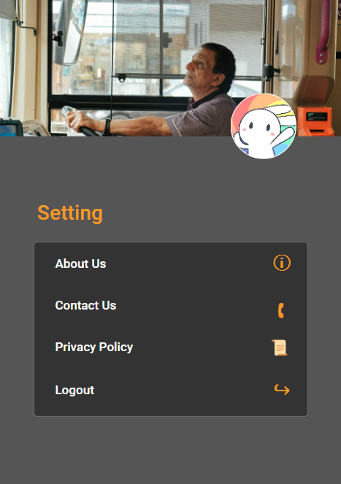
Figure 68. Minimalist settings screen with essential options for a clean, user-friendly interface.
Figure 68 illustrates Nielsen's aesthetic and minimalist design. The settings screen features a clean, uncluttered layout with a minimalist design, displaying only essential options such as "About Us," "Contact Us," "Privacy Policy," and "Logout." The use of icons and simple labels provides a visually pleasing interface.
- Help users recognize, diagnose, and recover from errors
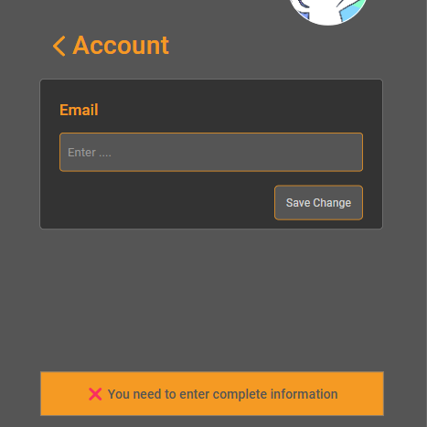
Figure 69. Clear error message guiding users to correct incomplete information during form submission.
Figure 69 illustrates Nielsen's help users recognize, diagnose, and recover from errors. When a user attempts to save changes without entering complete information, the system provides a clear error message at the bottom of the screen, indicating the issue and guiding the user to take corrective action.
- Help and documentation
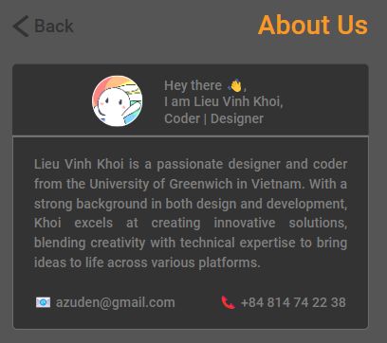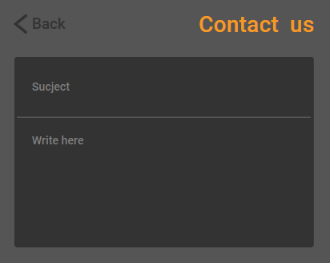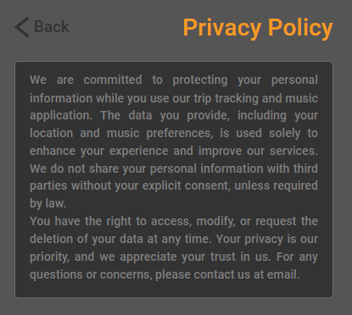
Figure 70. Sections for user support and essential app documentation, ensuring easy access to information and help.
Figure 70 demonstrates Nielsen's help and documentation. The "About Us," "Contact Us," and "Privacy Policy" sections provide essential information to assist users in understanding the app's purpose, reaching out for support, and knowing their data privacy rights. These elements ensure users have access to relevant documentation and support options when needed.

Research Study
- Conduct Survey Purpose
The purpose of this survey is to evaluate the usability and user experience of the Azuden application prototype in a real-world context. Specifically, the survey aims to assess the effectiveness of the app’s design in facilitating music playback while route tracking, focusing on user distraction, interface intuitiveness, and overall comfort while riding. The survey data will help determine how well the app meets its goal of enhancing the rider's experience with minimal disruption and increased safety.
- Objectives
The primary objectives of the survey are:
- To assess how easily and efficiently users can switch between the music playback and GPS route tracking features without distraction.
- To evaluate the effectiveness of the user interface design that integrates music and GPS tracking during motorcycle rides to improve and support the iterative design process.
- To measure the usability and satisfaction levels with different app functions, such as music selection, notifications, and customization options.
- To evaluate the effectiveness of integrating music and GPS tracking in terms of user comfort and motivation during motorcycle travel.
- Hypotheses
- Hypothesis 1: Users will experience the Azuden app interface easily and efficiently, allowing them to switch between music listening and route tracking functions without any hassle or excessive distraction while riding their motorbike.
- Hypothesis 2: The integration of music listening and route tracking functions on the Azuden app will enhance the user experience, create a sense of comfort and help them maintain motivation while traveling on a motorbike compared to using only the route tracking function alone.
- Target Audience
The survey will target individuals who frequently use mapping or navigation services, particularly motorcyclists, as they are the primary user group for the Azuden app. The sample size will include 10 participants who are active users of mapping or route-tracking apps and have experience with mobile music apps. Participants will be recruited through social media platforms and specialized forums focused on travel, commuting, and navigation.
- Methodology
The survey will be conducted using an online questionnaire to collect feedback from participants. The questions will focus on different aspects of the Azuden app’s functionality, including the usability of the interface, the effectiveness of music and route tracking integration, and user satisfaction. The participants will be asked to complete tasks on the Azuden app prototype, providing feedback on their experiences with the app’s core features.
- Survey Design
The survey design will consist of a set of questions based on the hypotheses outlined above. For each hypothesis, questions will be used to assess user experience, ease of use, and satisfaction. The following survey questions will be included:
- For Hypothesis 1:
- On a scale of 1 to 5 (1 being very difficult, 5 being very easy), how would you rate the ease of use of the Azuden app interface when switching between music playback and route tracking functions?
- Do you find the application's interface distracting while riding a motorcycle? (1 being not distracting at all, 5 being very distracting).
- How would you rate the ease of finding and playing music within the app while tracking your route? (1 being very difficult, 5 being very easy).
- For Hypothesis 2:
- On a scale of 1 to 5, how satisfied are you with the GPS tracking feature of the Azuden app?
- Do you find the notifications and alerts of the app clear and helpful while traveling? (1 being not clear at all, 5 being very clear).
- On a scale of 1 to 5, how satisfied are you with the ability to adjust and customize settings within the app?
- How effective do you find Azuden in combining music playback and route tracking functions? (1 being not effective, 5 being very effective).
- Does the app meet your needs and provide comfort while riding your motorcycle? (1 being not comfortable, 5 being very comfortable).
This is my survey link: https://forms.gle/Vrtxk6NMKUHUagVz6
- Conclusion
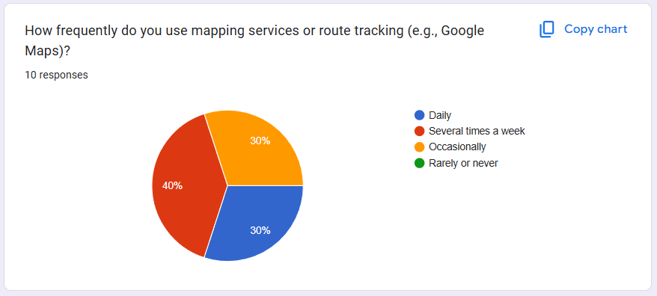
Figure 71. Data analysis for question 1
40% of users rely on mapping services daily, while 30% use them several times a week or occasionally, indicating frequent usage.
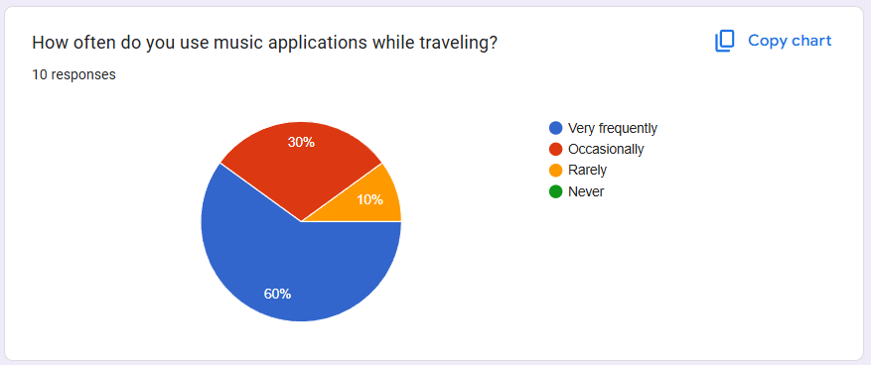
Figure 72. Data analysis for question 2
60% use music apps very frequently, showing music's importance during travel.
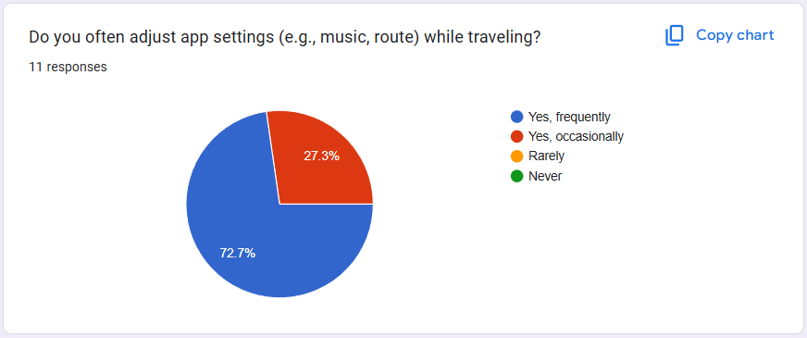
Figure 73. Data analysis for question 3
72.7% frequently adjust app settings, highlighting the need for quick access options.
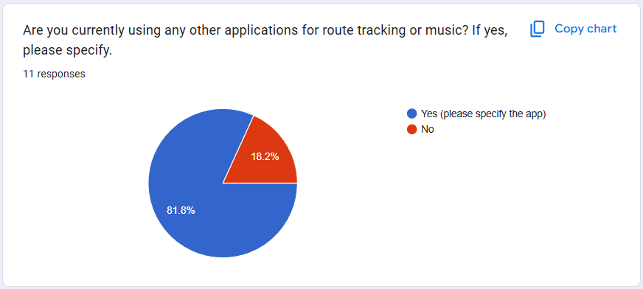
Figure 74. Data analysis for question 4
81.8% do not use other apps for tracking or music, suggesting Azuden could become a primary solution.
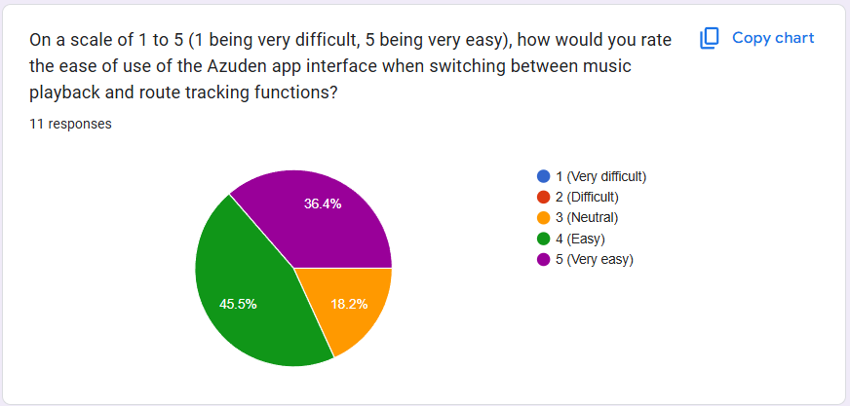
Figure 75. Data analysis for question 5
82% found it easy or very easy to switch between music and route tracking, showing a user-friendly interface.
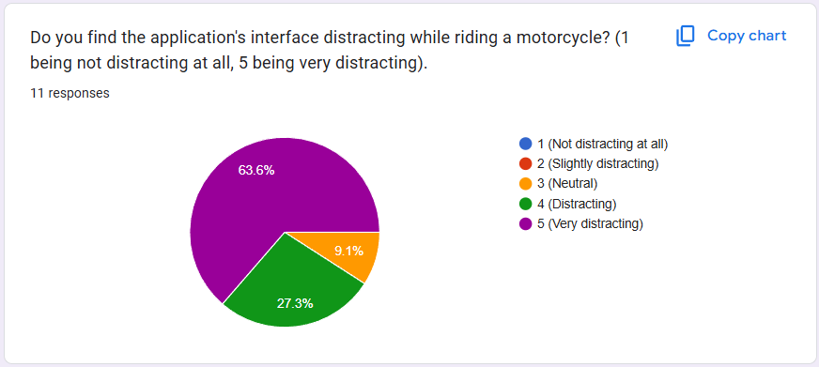
Figure 76. Data analysis for question 6
63.6% found the interface very distracting while riding, indicating a safety concern.
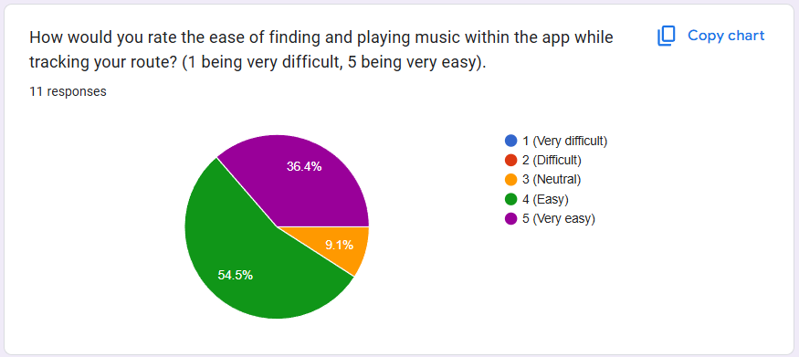
Figure 77. Data analysis for question 7
54.5% rated it very easy, with 36.4% finding it easy, indicating good accessibility.
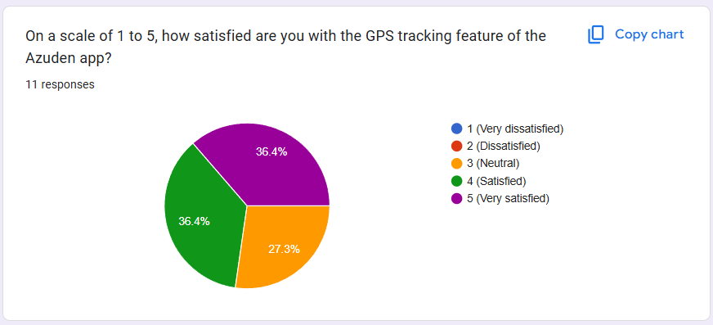
Figure 78. Data analysis for question 8
36.4% were very satisfied, with 27.3% satisfied, showing positive feedback overall.
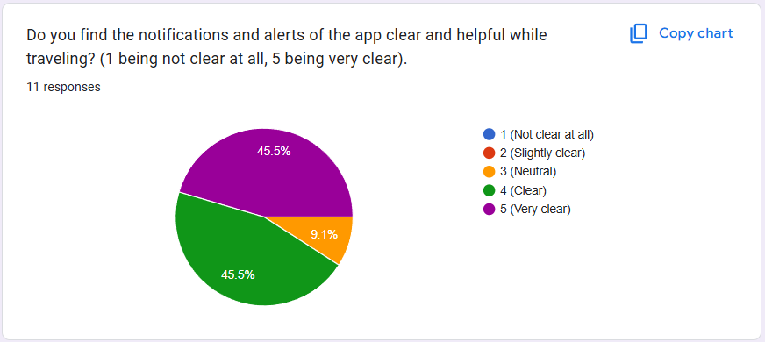
Figure 79. Data analysis for question 9
45.5% found notifications clear, and another 45.5% rated them very clear.
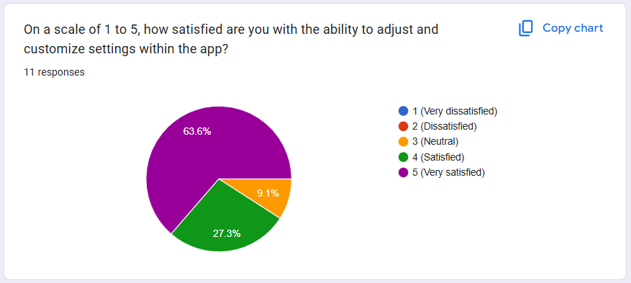
Figure 80. Data analysis for question 10
63.6% were very satisfied with customization features, highlighting strong user experience.
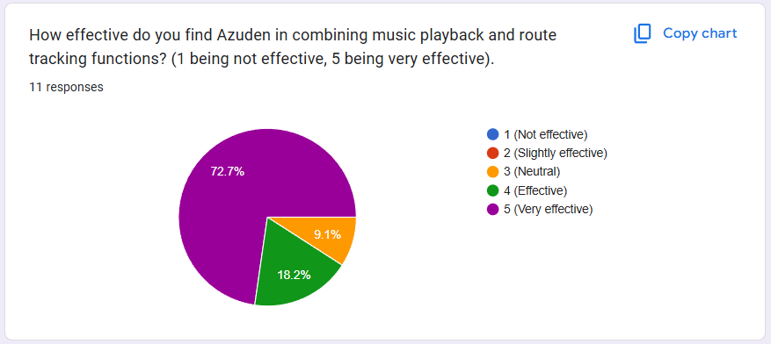
Figure 81. Data analysis for question 11
72.7% of respondents rated Azuden as "Very effective" in combining music playback and route tracking, with 18.2% finding it "Effective." Only 9.1% were "Neutral," indicating strong positive feedback overall.
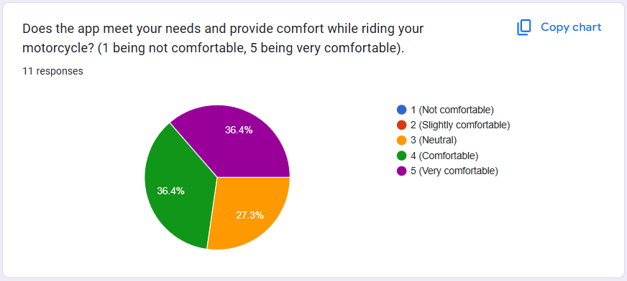
Figure 82. Data analysis for question 12
36.4% of respondents found the app "Very comfortable," and another 36.4% rated it "Comfortable" while riding. 27.3% were "Neutral," suggesting overall satisfaction with some room for improvement.

Conclusion
The development of the Azuden application has provided valuable insights into improving the motorcyclist’s experience by seamlessly integrating music playback with GPS route tracking. This integration aims to enhance the rider's journey by offering entertainment while ensuring they can stay on track with their routes. However, several limitations and constraints emerged during the research and prototyping process. One significant challenge was designing an interface that minimizes user distraction while maintaining rider safety during travel. Striking a balance between functionality and simplicity in such a dynamic, real-time environment required continuous iterative testing and adjustments.
A key area for improvement is the reduction of physical interaction with the app while riding. While the app’s current design minimizes distractions, it is evident that further steps are needed to enhance safety. Integrating voice command functionality could significantly address this issue by allowing users to control music and navigate the app hands-free. This voice-activated feature would ensure that riders can adjust settings or respond to notifications without taking their hands off the handlebars, improving both convenience and safety.
Additionally, user recruitment presented some constraints, as the sample size was limited, which may affect the generalizability of the feedback. To address this, further usability testing with a broader demographic of riders is necessary. Expanding the user base will help validate design choices and ensure that the app meets a wider range of motorcyclists' needs. Future improvements should also explore the integration of AI-driven recommendations for music and route selection, as well as refining data handling practices for improved security and privacy.
As the project moves forward, the focus should remain on optimizing user engagement, enhancing safety features, and adapting the app to the dynamic needs of motorcyclists in real-world conditions. Voice commands, in particular, should be prioritized in future iterations to ensure a truly hands-free and safe experience for all users.

References
Cooper, A., Reimann, R., Cronin, D., Noessel, C., 2014. About Face: The Essentials of Interaction Design. Wiley.
Dumas, J.S., Redish, J., 1999. A Practical Guide to Usability Testing, Human/computer interaction. Intellect.
Fogg, B., 2002. Persuasive Technology: Using Computers to Change What We Think and Do. Ubiquity 3. https://doi.org/10.1145/763955.763957
Gould, J.D., Lewis, C., 1985. Designing for usability: key principles and what designers think. Communications of the ACM 28, 300–311.
Gray, C., Kou, Y., Battles, B., Hoggatt, J., Toombs, A., 2018. The Dark (Patterns) Side of UX Design. https://doi.org/10.1145/3173574.3174108
Greasley, A.E., Lamont, A., 2011. Exploring engagement with music in everyday life using experience sampling methodology. Musicae Scientiae 15, 45–71.
Hassenzahl, M., 2010. Experience Design: Technology for All the Right Reasons, Synthesis lectures on human-centered informatics. Morgan & Claypool.
Kingsley, C., Thiry, E., Flowers, A., Jenkins, M., 2020. Augmented Riding: Multimodal Applications of AR, VR, and MR to Enhance Safety for Motorcyclists and Bicyclists. Presented at the HCI International 2020–Late Breaking Papers: Virtual and Augmented Reality: 22nd HCI International Conference, HCII 2020, Copenhagen, Denmark, July 19–24, 2020, Proceedings 22, Springer, pp. 356–367.
Kumnova, G., Imsirovic, A., 2019. Designing an Infotainment System for Electric Motorcycles: Enhancing User Experience for Urban Commuting without Compromising Safety.
Leung, R., MacLean, K., Bertelsen, M.B., Saubhasik, M., 2007. Evaluation of haptically augmented touchscreen gui elements under cognitive load. Presented at the Proceedings of the 9th international conference on Multimodal interfaces, pp. 374–381.
Löwgren, J., Stolterman, E., 2004. Thoughtful Interaction Design: A Design Perspective on Information Technology. MIT Press.
Nielsen, J., 1994. Usability engineering. Morgan Kaufmann.
Norman, D., 2013. The Design of Everyday Things: Revised and Expanded Edition. Basic Books.
Preece, J., Sharp, H., Rogers, Y., 2015. Interaction Design: Beyond Human-Computer Interaction. Wiley.
Schuler, D., Namioka, A., 1993. Participatory design: Principles and practices. CRC press.

Appendices
- Questions about user habits and service usage
- Question 1:
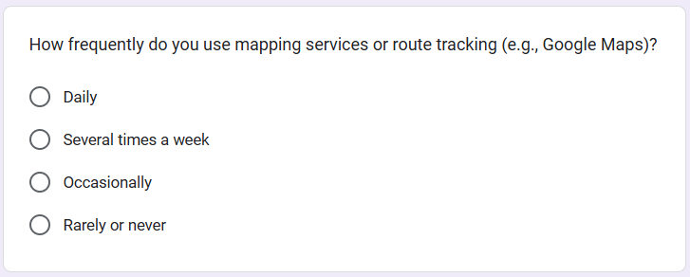
Figure 83. Question 1
- Question 2:
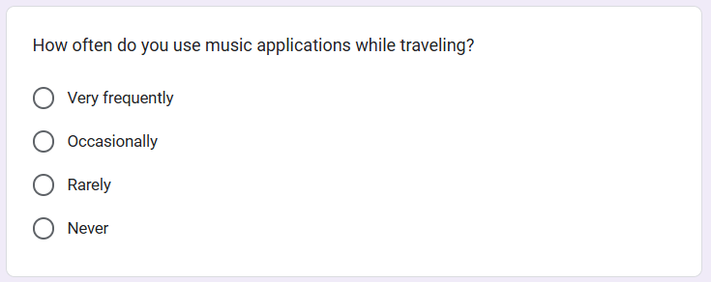
Figure 84. Question 2
- Question 3:
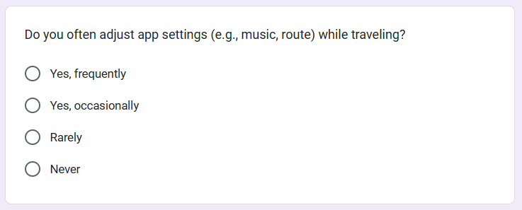
Figure 85. Question 3
- Question 4:
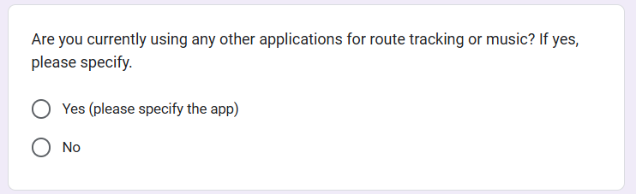
Figure 86. Question 4
- Quantitative questions for evaluating the Azuden application
- Question 5:
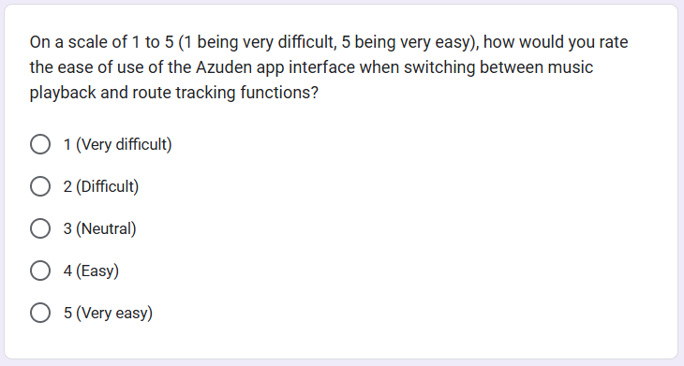
Figure 87. Question 5
- Question 6:
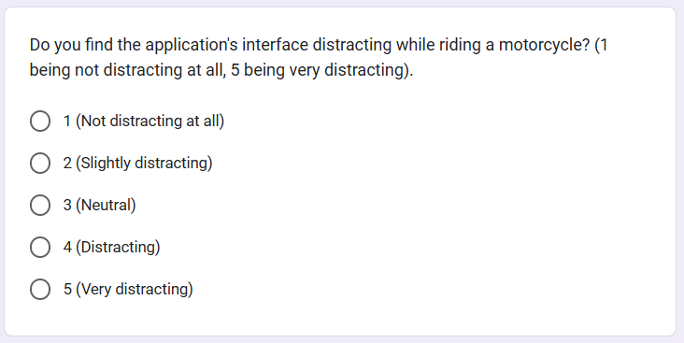
Figure 88. Question 6
- Question 7:
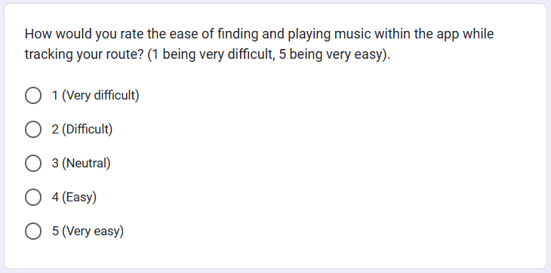
Figure 89. Question 8
- Question 8:
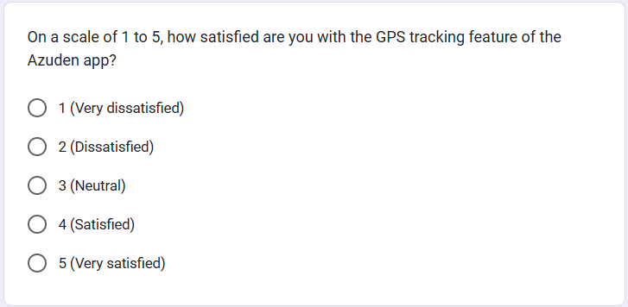
Figure 90. Question 7
- Question 9:
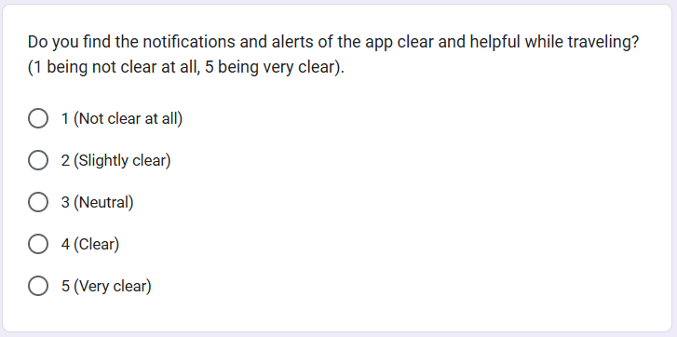
Figure 91. Question 9
- Question 10:
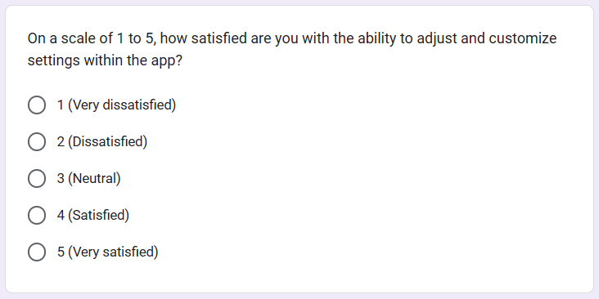
Figure 92. Question 10
- Question 11:
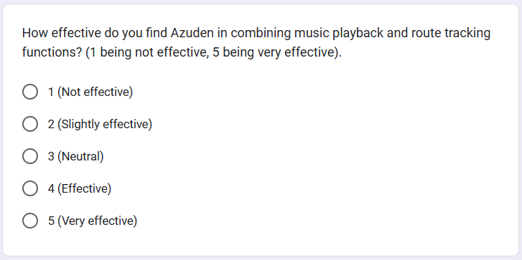
Figure 93. Question 11
- Question 12:
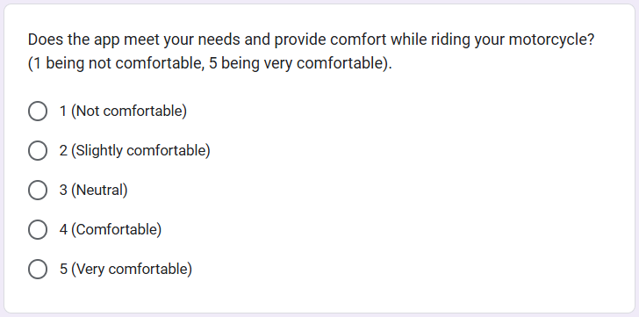
Figure 94. Question 12

- Search terms
- Human-Computer Interaction (HCI)
- Human-computer interaction in mobile applications for motorcyclists
- Usability of HCI systems for driving safety
- User-centered design in mobile applications
- Cognitive Psychology in HCI
- Cognitive load theory in mobile applications
- Mental workload in driving apps
- Reducing cognitive strain in dynamic user interfaces
- Cognitive psychology and user interface design
- Music Integration in HCI Applications
- Music and user engagement in mobile apps
- Impact of music on cognitive load in driving
- Integrating music in navigation systems for motorcyclists
- Enhancing user experience with music in HCI applications
- Touch and Voice Interaction
- Voice interaction in navigation systems
- Touch-based interfaces for mobile apps
- Multi-modal interactions in mobile applications
- Voice commands for mobile app accessibility
- Interaction Design Theory
- Prototyping in interaction design
- Low-fidelity, mid-fidelity, and high-fidelity prototypes in HCI
- Usability testing in mobile interaction design
- Design patterns in mobile apps
- User Experience (UX) Design
- UX design principles for mobile navigation apps
- Improving user experience in navigation apps for motorcyclists
- Visual cues in user experience design
- Designing engaging mobile apps for motorcyclists
- Safety and Distraction Minimization
- Safety features in mobile apps for drivers and motorcyclists
- Minimizing distractions for drivers through HCI design
- Reducing cognitive distractions in mobile applications

- Usability Principles (Nielsen, 1994)
- Nielsen's usability heuristics in mobile apps
- Usability evaluation for navigation systems
- Visibility of system status in mobile applications
- Match between system and the real world in navigation apps
- Augmented Reality (AR) for Navigation
- Augmented reality in navigation systems for motorcyclists
- AR-based real-time feedback for driving safety
- Augmented reality in human-computer interaction
- Prototyping and Usability Testing
- Prototyping methods in HCI research
- User feedback and design iteration in mobile app development
- Usability testing for motorcyclist apps
- Feedback loops in mobile app prototyping

