Cross-Domain
Recommender System
Movies → Games

IRS Project Report
A systematic experimental study of cross-domain recommendation
using the Amazon Reviews 2023 dataset
Leveraging movie preferences to recommend video games

1. Executive Summary
2. Introduction
2.1 Background and Problem Statement
2.2 Research Methodology and Experiment Design
3. Data
3.1 Data Source
3.2 Data Structure
3.3 Data Pipeline
3.4 Data Train/Test Splitting Protocol
4. Methodology
4.1 Evaluation Protocol
4.2 Single Domain Models
4.2.1 MF-BPR: Matrix Factorization with Bayesian Personalized Ranking
4.2.2 NCF (NeuMF): Neural Collaborative Filtering
4.2.3 LightGCN: Graph Convolution for Recommendations
4.3 Cross Domain Models
4.3.1 CMF: Collective Matrix Factorization
4.3.2 EMCDR: Cross-Domain Embedding Mapping
4.3.3 PTUPCDR: Personalized Transfer with Experts
5. Experiments and Results
5.1 Lesson 1: Explicit vs Implicit Ranking
5.2 Lesson 2: Low Overlap Kills CDR
5.3 Lesson 3: Overlap Filtering Rescues CDR
5.4 Lesson 4: Source-Rich / Target-Sparse
5.5 Lesson 5: Catalog Sharpening
5.6 Lesson 6: Cold-Start (Zero Game History)
5.7 Lesson 7: Content-Aware CDR (SBERT)
5.8 Lesson 8: Co-occurrence Reranking
5.9 Lessons Recap
6. Hyperparameter Tuning
6.1 CMF Learning Rate and α Weight
6.2 EMCDR Co-occurrence Interaction
6.3 LightGCN Propagation Depth
6.4 PTUPCDR Expert Count and Gate Temperature
6.5 SBERT-CDR Source Weight
7. Discussion
7.1 Routing Decision Rule
7.2 Key Insights
7.3 Limitations and Threats to Validity
7.4 Recommendation Rows Design
8. System Design
8.1 High-Level Architecture
8.2 Recommendation Flow
8.3 ML Architecture
8.4 Refresh Architecture
8.5 Key Design Decisions
8.6 Model Selection Rationale
9. Conclusion and Future Work
10. References

1. Executive Summary

Abstract. We set out to investigate cross-domain recommendation (CDR) for transferring user preferences from movies to video games on the Amazon Reviews 2023 dataset. The central question is: can a user's movie history improve game recommendations, especially at cold-start? We run a systematic comparison benchmark across three model families — single-domain collaborative filtering (MF-BPR, NCF, LightGCN), cross-domain transfer (CMF, EMCDR, PTUPCDR), and content-based (SBERT, SBERT-CDR) — evaluated head-to-head on five purpose-built data cohorts.
Key Findings
- User Overlap is Critical: CDR models require high user overlap to outperform single-domain baselines. On the 100%-overlap subgroup, CDR models recovered a lift of +41% (EMCDR) to +750% (CMF) over the low-overlap baseline.
- Cold-Start Effectiveness: At true cold-start (zero game history, L6), every CDR model beat every single-domain collaborative model: EMCDR reached Recall@10 = 0.0334 (3.3× LightGCN’s 0.0100), PTUPCDR 0.0301 (3.0×), and CMF 0.0210 (2.1×). A simple popularity baseline was best-in-class at 0.0381 (3.8×).
- Universal Reranking: A training-free co-occurrence reranking layer improved nearly every base model (5–49% lift on LLO) and successfully rescued single-domain models at cold-start (+289% for LightGCN).
- Niche Item Dominance: SBERT-CDR, a content-based approach, won 11x over collaborative models on niche/unpopular items (bottom-50% popularity).
The primary practical output is a context-aware Routing Decision Rule that justifies selecting the model based on the user's game history depth and item popularity, shipped as a nine-row hybrid demo.

Context-Aware Routing Rule
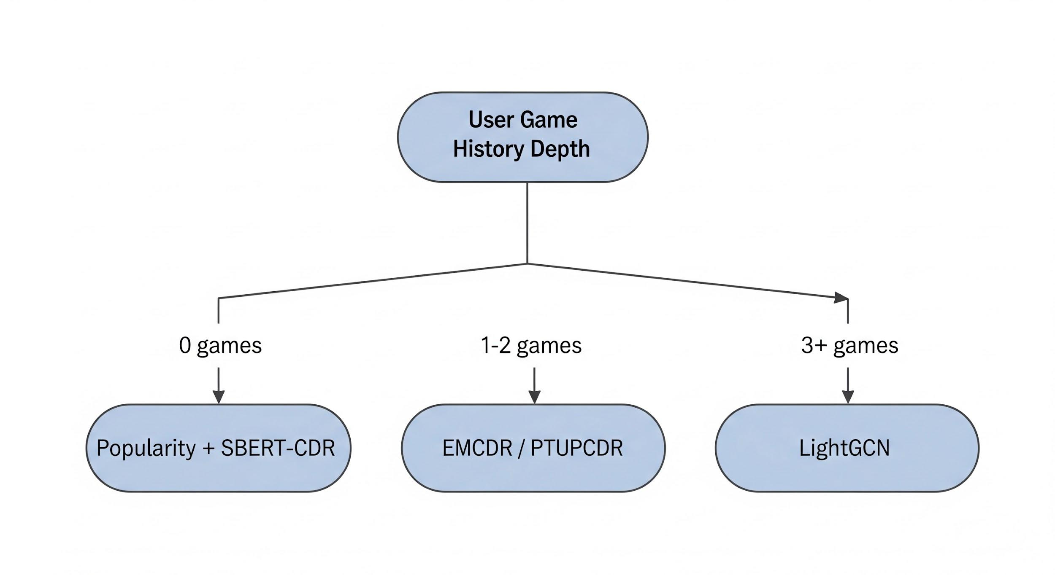

User State | Recommended Model (Base + Cooc Layer) | Justification
0 games (Cold-Start) | Popularity + SBERT-CDR | Popularity baseline tops the board; SBERT-CDR is used for content-based niche recommendations.
1–2 games (Sparse History) | EMCDR / PTUPCDR | Mapping-based CDR excels in the few-shot regime by leveraging rich movie history.
3+ games (Warm History) | LightGCN | Graph convolution dominates once sufficient in-domain target edges are available.
Two regime-specific overrides complete the rule: any user whose target item is long-tail / niche is routed to SBERT-CDR regardless of history depth (L7 showed an 11× win on niche subgroups), and every row — regardless of base model — is post-processed with the universal co-occurrence rerank at λ = 0.05 (L8). The full, final rule (5 states + universal post-processor) is articulated in §5.9 and formalised in §7.1.

2. Introduction

2.1 Background and Problem Statement
Most production recommendation systems are single-domain: they recommend items based solely on a user's interaction history within that single domain. Cross-Domain Recommendation (CDR) relaxes this constraint — it transfers knowledge from a source domain (movies) to a target domain (games), which is especially valuable at cold-start: when a user has little or no target-domain history, CDR can still rank target items by leveraging their source-domain preferences.

Market Research
The entertainment industry is actively shifting from single-domain apps toward multi-domain platforms. Netflix has expanded from video streaming into mobile games, Amazon sells across every consumer category from a single storefront, and Spotify has merged music and podcast discovery into one unified feed. The industry accordingly has clear demand for multi-domain recommenders that can rank across an entire platform catalog, motivated by three measurable business outcomes — higher retention, stronger cross-sell, and happy-surprise discovery (Figure M1).
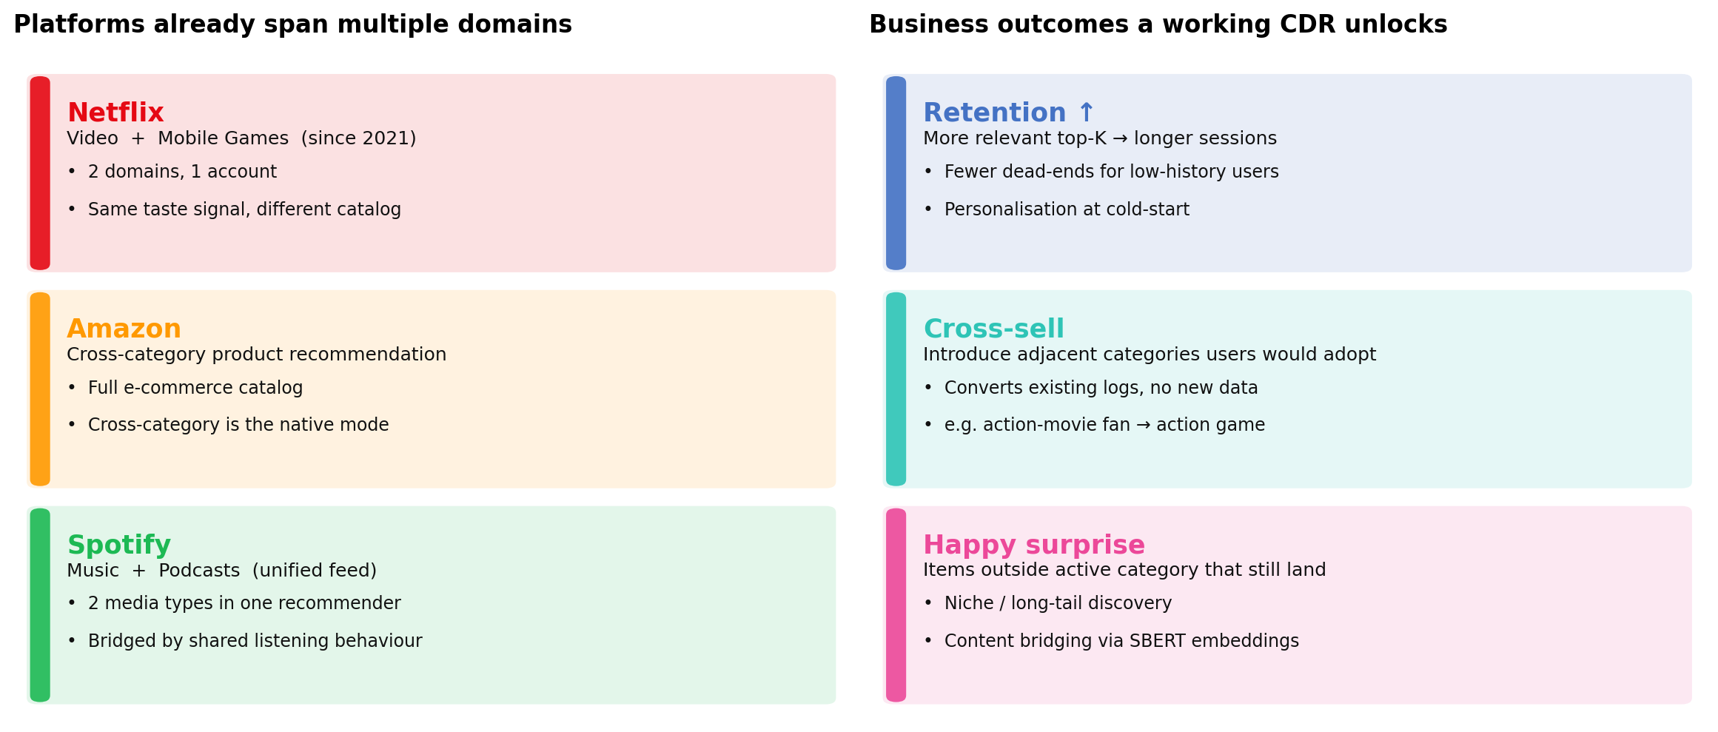
Figure M1: Platforms are already multi-domain; a working CDR converts existing logs into retention, cross-sell, and happy-surprise outcomes.

Why this matters: the limitations of traditional single domain recommender
Modern consumers engage with entertainment across multiple content categories — films, television, games, music, podcasts — often within a single session and almost always within a single platform account. Industry recommender systems, by contrast, have historically been architected on a per-domain basis: each model observes user behavior within the boundaries of its own domain and optimizes ranking against that domain alone. This is an engineering simplification, not a reflection of user behavior, and it leaves a large share of each user's observable preference signal untapped:

- Overlapping interests: action-movie fans often play action games; fantasy-film viewers often play RPGs. Single-domain models cannot use this link.
- Missed signals: source-domain behaviour (movies) is dense for most users; ignoring it throws away the best available preference data for a target-domain (games) cold-start.
- Cross-sell gap: without a cross-domain ranker, the platform cannot surface adjacent categories a user would naturally adopt.

Problem statement
We study this on movies → games as a concrete analogue of the Netflix-plus-games setting: given users who rate items in both domains, does cross-domain signal measurably improve recommendation quality over single-domain baselines, and under which conditions? The practical deliverable is a routing rule that picks the right model family per user based on target-domain history depth and target-item popularity, wrapped in a prototype that serves the rule end-to-end.
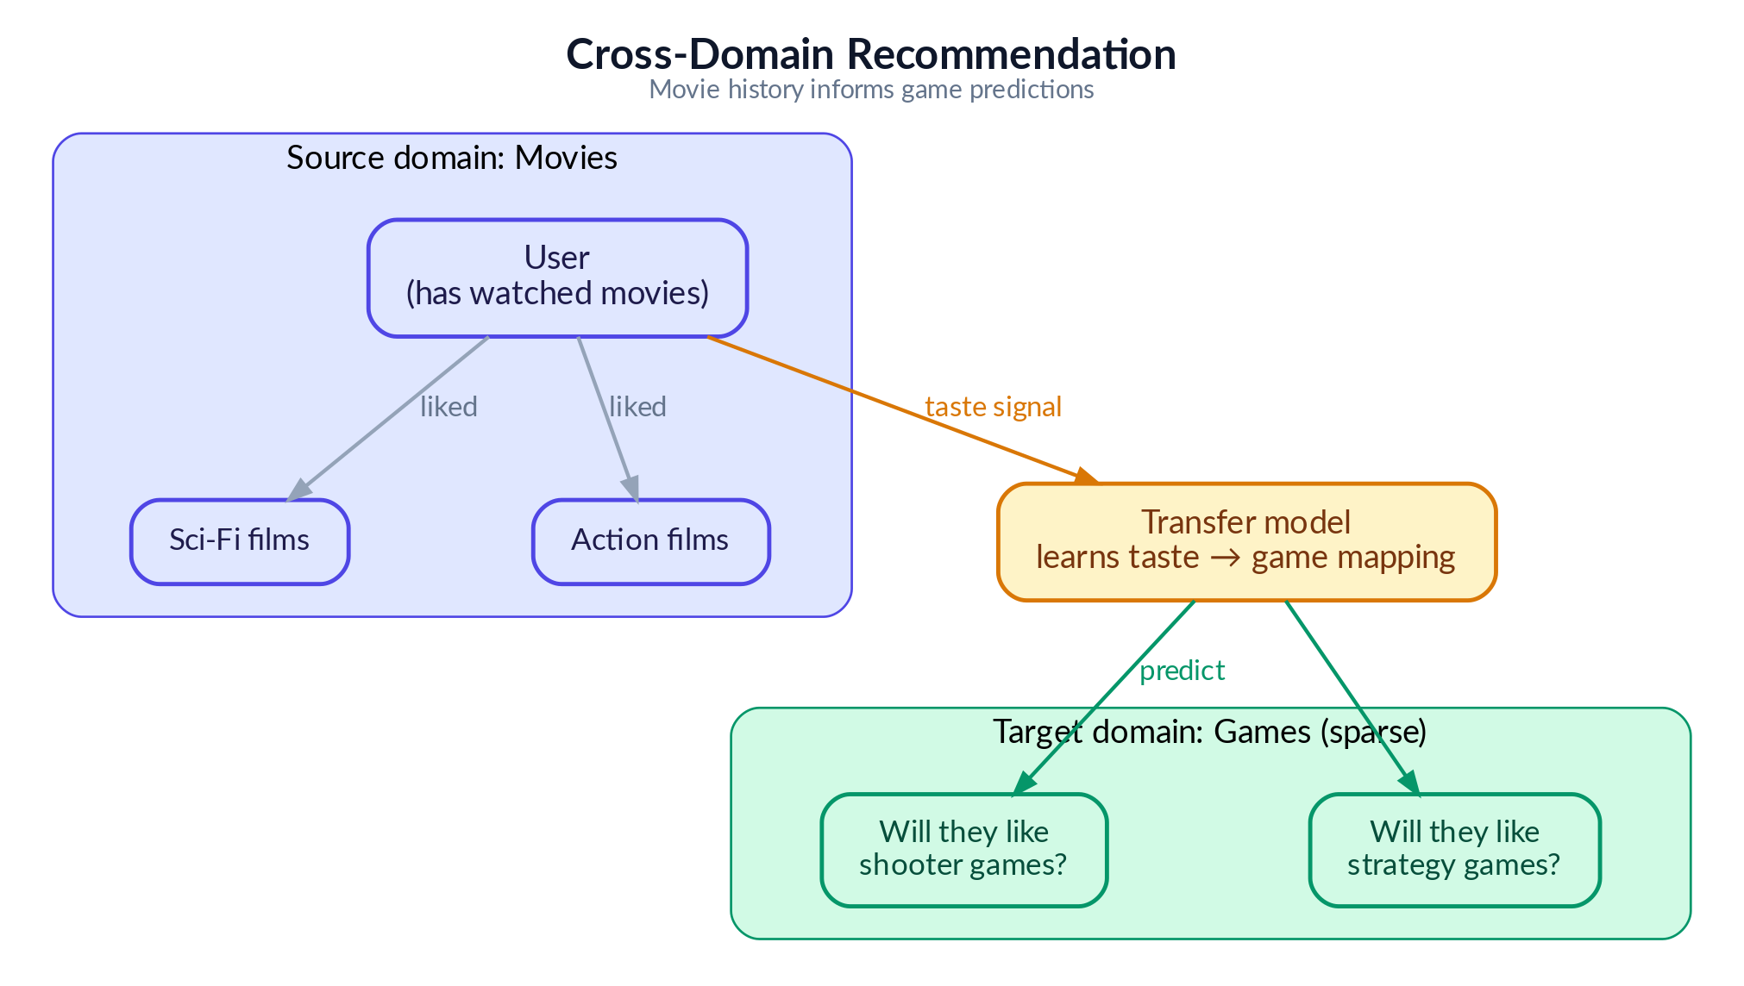
Figure 2: Cross-domain recommendation concept — transferring movie preferences to game recommendations

2.2 Research Methodology and Experiment Design

We present the experiments as a clean, progressive lesson series — but the path to this structure was far less linear. This section describes our actual research process, the challenges encountered, and how the final experiment design emerged from extensive exploratory work.

Phase 1: Model Selection and Infrastructure Setup
We began by studying the internal mechanisms of cross-domain recommendation algorithms — how models like CMF, EMCDR and PTUPCDR learn to map user preferences across domains, and how they differ from single-domain approaches like LightGCN that rely purely on within-domain interaction graphs. This informed our model selection: three CDR architectures (joint factorization, global mapping, personalized mapping), three single-domain baselines (matrix factorization, neural, graph-based) to ensure fair comparison across model families.
We picked these model algorithms to give us a systematic comparison across the three major families of recommender system architectures—single-domain, cross-domain, and content-based—and to ensure the final routing rule could cover all user states, including cold-start and niche item discovery.
Here are the rationales for choosing each set of algorithms:

Single-Domain Recommendation (SDR) Baselines:
We picked these models to cover the three major collaborative filtering paradigms, trained only on game rating data, to serve as strong competitive baselines for the Cross-Domain Recommendation (CDR) models.
- MF-BPR (Matrix Factorization with Bayesian Personalized Ranking): Chosen as a simple, well-understood, and fast-to-train baseline that captures linear feature interactions.
- NCF (Neural Collaborative Filtering): Selected to incorporate neural networks (MLPs) that can capture complex, non-linear patterns and subtle interactions that simple dot products (like in MF-BPR) cannot.
- LightGCN (Graph Convolution): Included because it consistently achieved the best single-domain performance, outperforming MF-BPR and NCF, by leveraging the full user-item interaction graph to blend neighbor's tastes (community wisdom).

Cross-Domain Recommendation (CDR):
We picked these models to cover the different ways knowledge can be transferred from the source domain (movies) to the target domain (games).
- CMF (Collective Matrix Factorization): Chosen as the simplest CDR architecture, representing joint factorization. It attempts to capture transferable traits by forcing a single, shared user profile to work for both domains.
- EMCDR (Cross-Domain Embedding Mapping): Represents a global mapping approach. It trains a single translator (a mapping network) to convert specialized movie user embeddings into game space, making it especially powerful at cold-start where a user has no game history.
- PTUPCDR (Personalized Transfer with Experts): Represents a personalized mapping approach. It enhances EMCDR by using a Mixture of Experts (MoE) architecture to provide a personalized translation rule for each user, which is highly effective in the sparse-history (few-shot) scenario.

Content-Based and Post-Processing:
These approaches were not part of the initial algorithm selection, but were discovered during Phase 4 (Discovering Complementary Approaches) of our exploratory work, proving simpler approaches yet unexpectedly powerful for specific recommendation regimes. They were subsequently included to address the known limitations of collaborative models, particularly for cold-start users and niche items.
- SBERT-CDR (Content-Based Semantic Matching): Used to assess content-based embeddings as a cross-domain bridge for niche items. We picked it because it is the only model that can recommend niche/unpopular items effectively (winning 9× over collaborative models on the bottom-50% popularity items) and works for brand-new users who have no rating history.
- Co-occurrence Reranking: Selected as a universal, training-free post-processing layer to capture obvious cross-domain behavioral patterns. It provides a model-agnostic score boost, improving every base model (5–49% lift), and successfully rescued single-domain models at cold-start.
We then built the base infrastructure: a data processing pipeline (from raw and high sparsity Amazon reviews to filtered and better-dense user’s reviews and item’s review), a standardized evaluation framework (Recall, HitRate, NDCG at K = 10), and a benchmarking harness that ensures all models are evaluated on identical data splits. All models were implemented using publicly available libraries (RecBole, RecBole-CDR, PyTorch, scikit-learn,...) to avoid re-inventing the wheel and ensure reproducibility.

Phase 2: Exploratory Benchmarking and the CDR Performance Disappointment
With the infrastructure in place, we ran extensive benchmarks comparing single-domain and cross-domain models across different data configurations. The initial results were consistently discouraging for CDR: LightGCN (a single-domain graph model) outperformed all CDR models in nearly every setting — including on user cohorts with rich movie history (>10 ratings) but sparse game history (3–5 ratings), precisely the regime where CDR is expected to excel.
We spent considerable effort trying different data configurations, different user subgroup filters, and hyperparameter settings. Unfortunately, the effort failed to increase the CDR performance. CDR models consistently failed to demonstrate a clear advantage over the single-domain baseline.
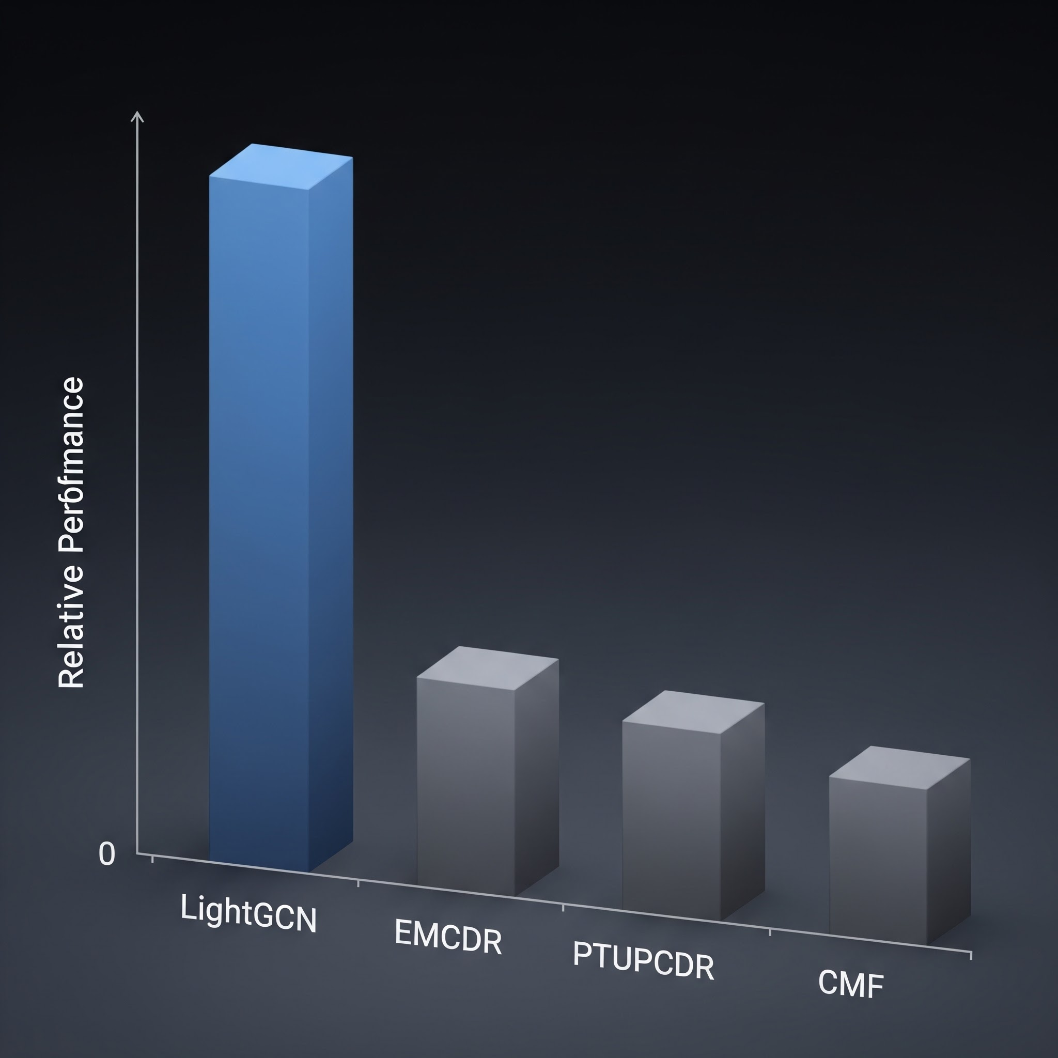
This raised a fundamental question: is the movie-to-game transfer signal in the Amazon dataset simply too weak for CDR to exploit? And to be honest, at one moment, we question whether to continue to pursue the project’s idea, because in the end, we could not conclude SDR wins CDR, this is undesirable and unexpected as many research papers have found that CDR might outperform.

Phase 3: Revisiting CDR Theory and Finding the Right Data Regime
Rather than concluding prematurely that CDR is ineffective — a conclusion contradicted by a large body of published research — we returned to the literature. Published CDR papers are evaluated under specific data conditions that we had not yet replicated: high user overlap between domains, rich source-domain history, and sparse or absent target-domain history.
Key Insight
The general-population Amazon dataset has only ~5.8% user overlap between movies and games — far too low for CDR mapping functions to learn from. Once we filtered to 100% overlap users and, crucially, tested on cold-start users with zero game history, CDR models finally outperformed their single-domain counterparts significantly. The algorithms were not broken — the data regime was wrong.

Phase 4: Discovering Complementary Approaches
Along the way, we made two additional discoveries. First, a simple content-aware recommendation approach (SBERT sentence embeddings) performed surprisingly well — matching LightGCN overall and dominating on niche/unpopular items. This clearly illustrates a simple lesson: a more sophisticated model architecture does not guarantee better recommendations, sometimes simple models win.
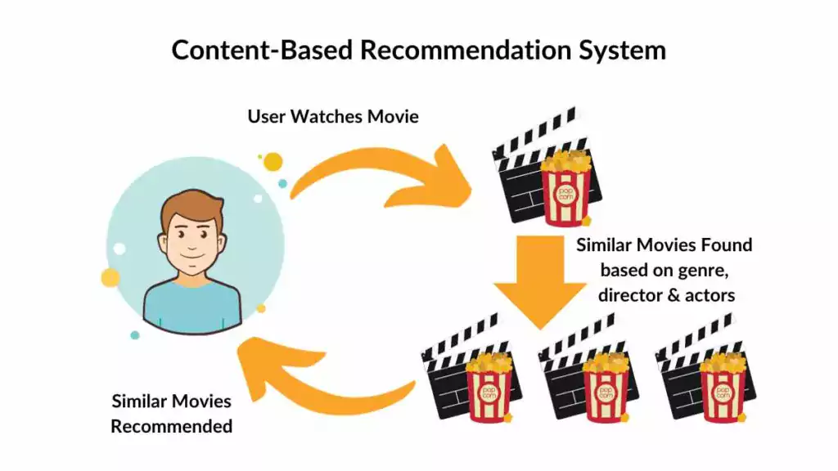
Second, we explored hybrid approaches to augment the base models. After experimenting with various score fusion strategies, we discovered that a simple reranking of game candidates based on their co-occurrence with the user's liked movies improved scores for every model universally. This cross-domain item co-occurrence reranking requires no training and works as a model-agnostic post-processing layer — another simple yet unexpectedly powerful result.

Phase 5: From Exploration to Structured Lessons
With all findings in hand, we designed the final lesson series to present our discoveries as a progressive and clear sequence. Each lesson isolates one experimental variable and builds on the previous lesson's conclusion. This structure was designed retrospectively — the actual research process involved many more experiments, several of which produced null or even negative results and thus were not included.
For example, in Lesson 5 (Source Domain Movie Sharpening), we hypothesized that removing long-tail movie items with very few ratings would produce denser, higher-quality source embeddings and improve CDR transfer. We tested more rigorous Movie genres filtering, overlap-user item filtering, and stricter movie popularity thresholds. The result was largely null — filtering hurt both single-domain LightGCN (smaller training catalog) and produced mixed results for CDR models.

Key Insight
So the exploration journey was not a linear, all happy-ending path, but a rather challenging and filled-with-roadblocks exploratory path.
In summary, our research methodology was deliberately exploratory: we ran a broad set of experiments, identified which factors genuinely drive CDR effectiveness (and which do not), and then distilled the findings into a curated lesson series that progresses from simple to complex.
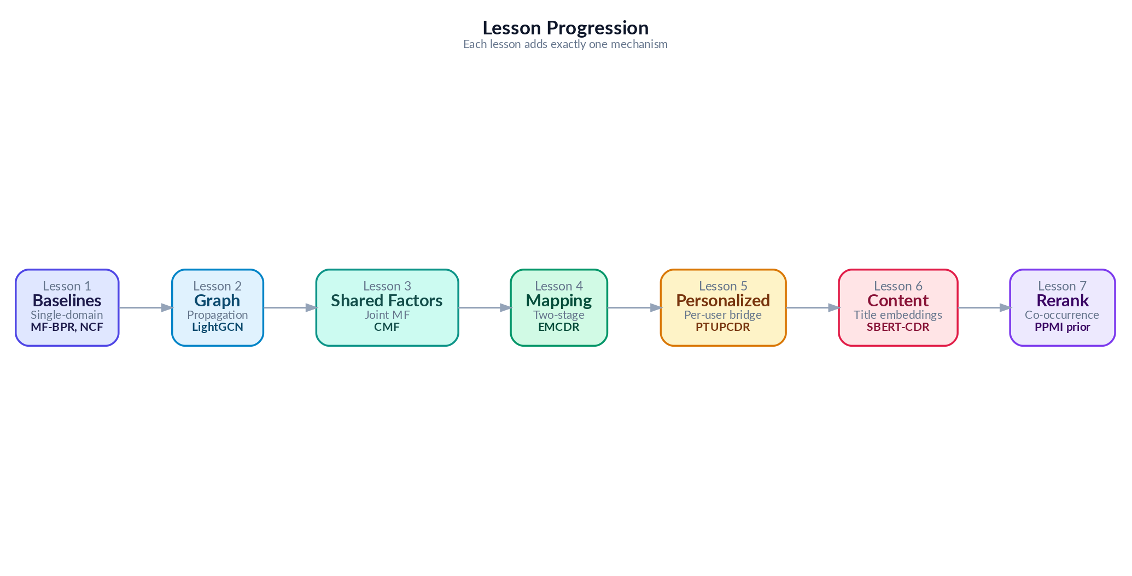
Figure 3: From Many Exploratory Experiments to 7 Curated Lessons

3. Data

3.1 Data Source
We use the Amazon Reviews 2023 dataset, a large-scale benchmark containing user reviews and ratings across multiple product categories. We focus on two domains: Movies and TV (user ratings of movies, DVDs, and streaming content) and Video Games (user ratings of video games across all platforms).

3.2 Data Structure

The pipeline ingests four gzipped JSONL files from the Amazon Reviews 2023 dataset — review and metadata streams for the Movies & TV and Video Games domains — and emits a unified set of parquet artifacts that downstream training, evaluation, and serving all read from.
Raw inputs (Amazon Reviews 2023)
File | Domain | Format | Used for
movies_reviews_2023.jsonl.gz | Movies & TV | gzipped JSONL, one review per line | User–item interactions (ratings, timestamps)
games_reviews_2023.jsonl.gz | Video Games | gzipped JSONL, one review per line | User–item interactions (ratings, timestamps)
movies_meta_2023.jsonl.gz | Movies & TV | gzipped JSONL, one item per line | Item metadata (title, description, categories, image)
games_meta_2023.jsonl.gz | Video Games | gzipped JSONL, one item per line | Item metadata (title, description, categories, image)

Review record schema
Field | Type | Description
user_id | string | Reviewer / user identifier
item_id | string | Amazon parent_asin — canonical item identifier
rating | float | Star rating, 1–5 (binarised at ≥ 4 to define a positive interaction)
timestamp | datetime | When the review was posted; used for leave-last-out splitting
review_text | text | Free-form review body, truncated to 5000 chars
domain | string | "movies" or "games" — added at parse time

Item metadata schema
Field | Type | Description
external_id | string | parent_asin — the universal key shared by DB, single-domain, and CDR layers
domain | string | "movies" or "games"
title | string | Item title (≤ 512 chars)
description | text | Long-form description (≤ 2000 chars); fed to SBERT
categories | string | Comma-joined Amazon category path; used to filter actual games
features | text | Bullet-style feature list (≤ 1000 chars)
main_category | string | Top-level Amazon category
price | string | Listed price, kept as string due to inconsistent source formatting
image_url | string | Hi-res product image URL surfaced in the demo UI

Processed parquet outputs
File | Granularity | Key columns | Purpose
ratings.parquet | one row per user–item interaction | user_id, item_id, rating, timestamp, domain | Training and evaluation interactions for both domains
movies.parquet | one row per movie item | external_id, title, description, categories, … | Movie-domain item catalog
games.parquet | one row per game item | external_id, title, description, categories, … | Game-domain item catalog
dataset_metadata.json | single file | processing parameters, item / user counts | Reproducibility metadata for each pipeline run

3.3 Data Pipeline
The data processing pipeline is responsible for converting the raw, sparse Amazon Reviews 2023 corpus into the standardized, dense, and implicit cohorts required for model training and evaluation.
Here is the table summarizing the key steps and their justifications:
Pipeline Step | Description/Value
Data Ingestion | Amazon Reviews 2023 dataset (Movies/TV as source, Video Games as target).  - Movie Ratings  - Game Ratings  - Movie Metadata  - Game Metadata
Data Filtering | For Game items, filter out items that are not real Games  For example:  - Xbox Gift Card, PS4 controllers… → removed
Data Merging | Merge items that are essentially same games/movies but different platforms  For example:  - The Avengers[Blue Ray] and The Avengers[Digital] -> Merge to The Avengers
Implicit Ratings Conversion | Ratings on a 1–5 star scale are converted to implicit feedback: ratings >= 4 stars are treated as positive interactions (POSITIVE_THRESHOLD = 4).
Density Filtering | Application of k-core >= 10 filtering to both items and users to increase rating density
Store In Files | Processed data stored as Parquet files for training, and final embeddings exported as NumPy arrays.
Split User Subgroups | Creation of specialized subgroups (Raw Mix, Overlap, Source-Rich, Cold Start) by applying specific filters (k-core, density, and overlap thresholds) to isolate experimental variables for lessons L1 through L7.

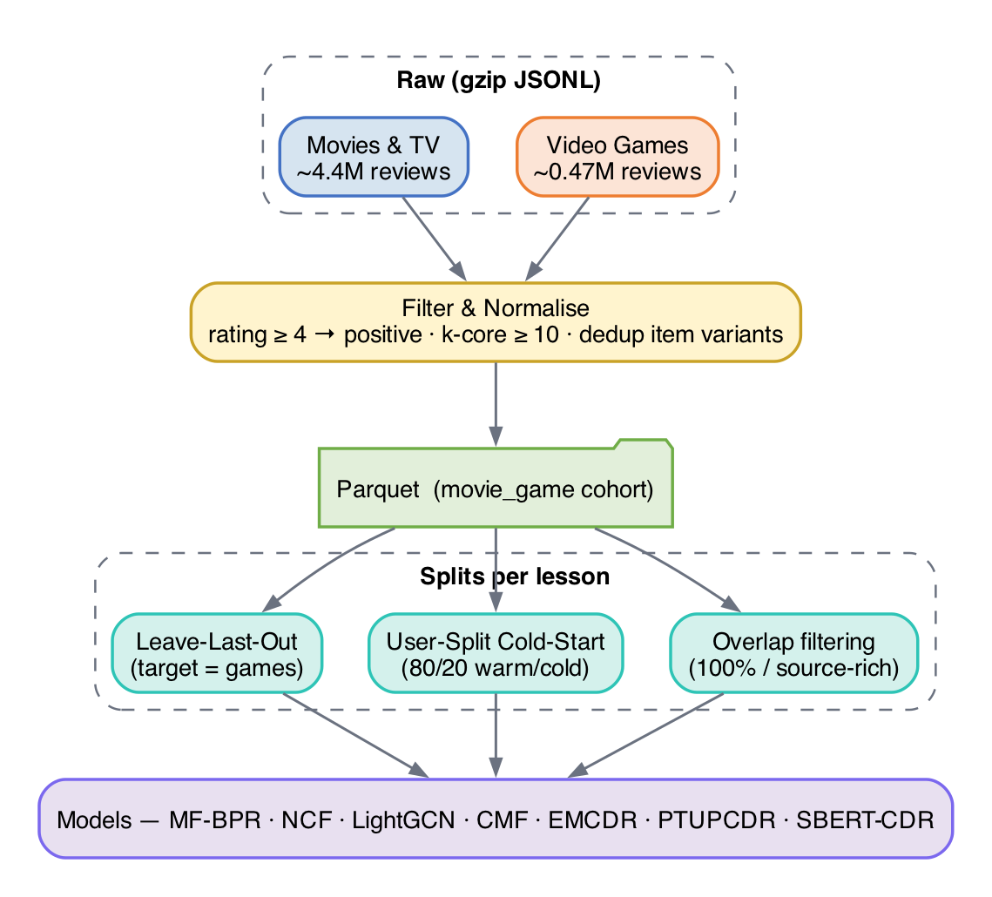
Figure 4: Data Processing Pipeline

Different lessons use different dataset configurations to isolate experimental variables:
Variant | Users | Movie Ints. | Game Ints. | Overlap % | Used in | Filter
Raw Mix | 1,000,000 | 45,933 | 11,706 | 5.2% | L1–L2 | No k-core
Overlap | 19,880 | 40,288 | 10,034 | 100% | L3 | movies≥5, games≥1
Source-Rich | 14,328 | 39,534 | 9,147 | 100% | L4,L7 | movies≥10, games≥1
Sharp | 14,328 | 10,311 | 9,147 | 99.8% | L5 | movie pop≥10
Cold Start | 12,654 | 40,288 | 10,034 | 100% | L6 | User split 80/20

3.4 Data Train/Test Splitting Protocol

3.4.1 Leave-last-out (LLO)
The figure below visualizes the LLO split: for every user, the most recent interaction is held out as the test item and everything earlier is used for training.
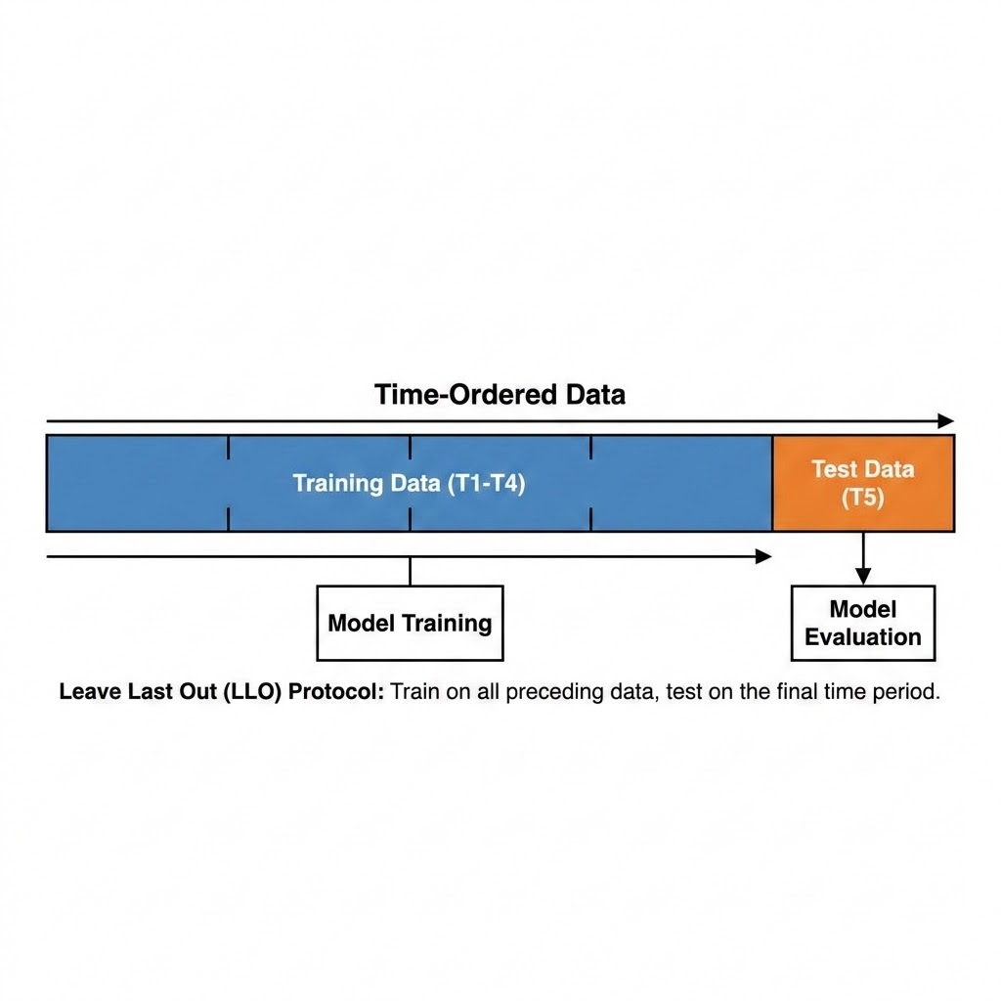
We use leave-last-out (LLO) splitting on the target domain (games): for each user, the last game interaction by timestamp becomes the test item, the second-to-last becomes the validation item, and all earlier interactions from the training set. This simulates a realistic next-item prediction scenario.
Figure 5.1: Data Splitting Visualization — Leave-Last-Out (LLO) for every user

3.4.2 User-Split cold start protocol
For Lesson 5 (cold-start), we use a user-split protocol: 80% of users train with their full movie and game history, while 20% of users have their game history withheld entirely, creating an ideal scenario in which the cross domain algorithms should have advantage over the single domain algorithms: suggesting items to users who have never rated a single games by relying purely on movie domain signals:
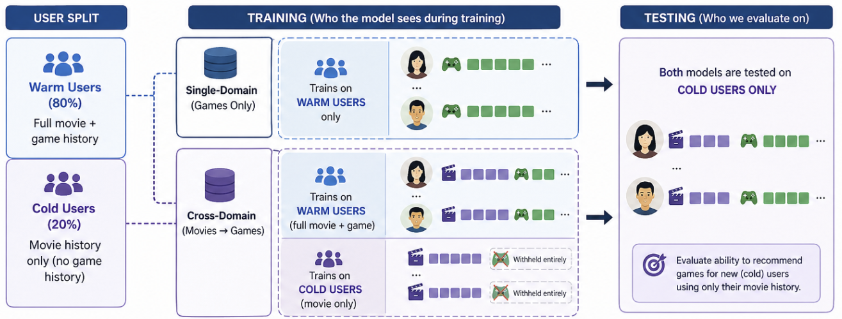
Figure 5.2: Data Splitting Visualization — Cold-Start User-Split

4. Methodology

This section explains every model we evaluate, starting from the simplest and building up to the most sophisticated. We assume no prior knowledge of recommendation systems — each model is introduced with an everyday analogy, then its mechanism and math are explained step by step. We group models into three families: single-domain models (trained on game data only), cross-domain models (trained on both movie and game data), and content-based models (using text descriptions rather than ratings).
Meet Maya. To make the progression easy to follow, every model in this chapter is illustrated through one running story about “Maya,” who runs a small neighbourhood rental shop called “Maya’s Corner” that lends out both movies and video games. Maya’s goal is to recommend the right games to her patrons — including the many who have only ever rented movies. Each algorithm in this chapter is a new tool Maya adopts to do that job better, and each analogy explains exactly what problem the previous tool left unsolved. Read the analogies in order and you will see a clear line from the simplest possible approach to the full cross-domain system we benchmark in this report.

4.1 Evaluation Protocol
To define the quality of the recommendations, we must first establish the difficulty of the retrieval task. The evaluation protocol measures how precisely a model can identify the single correct target item within the entire catalog. We utilize a full-rank evaluation protocol that requires the model to pick the correct answer from the complete catalog of approximately 9,000 items — akin to locating one specific needle in a massive haystack. All metrics are reported at K=10.
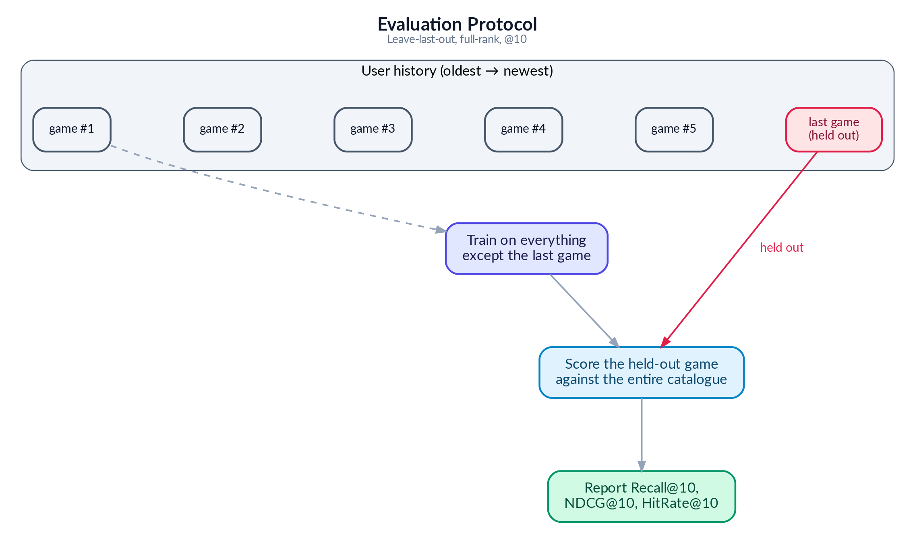
Figure 5: Evaluation Protocol

Recall@10 asks: did the correct item appear anywhere in the top 10? The ranking of the item is not important
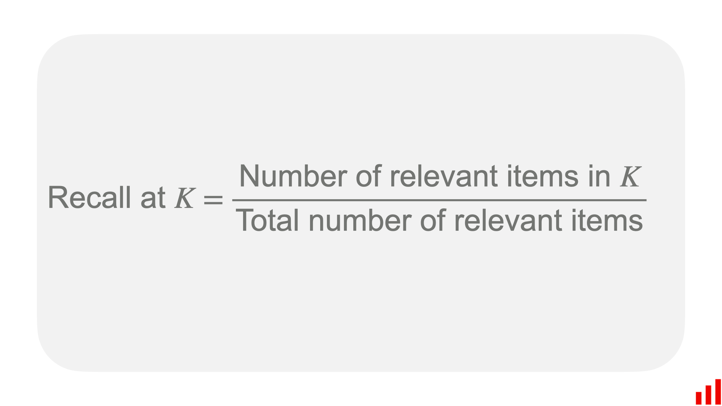
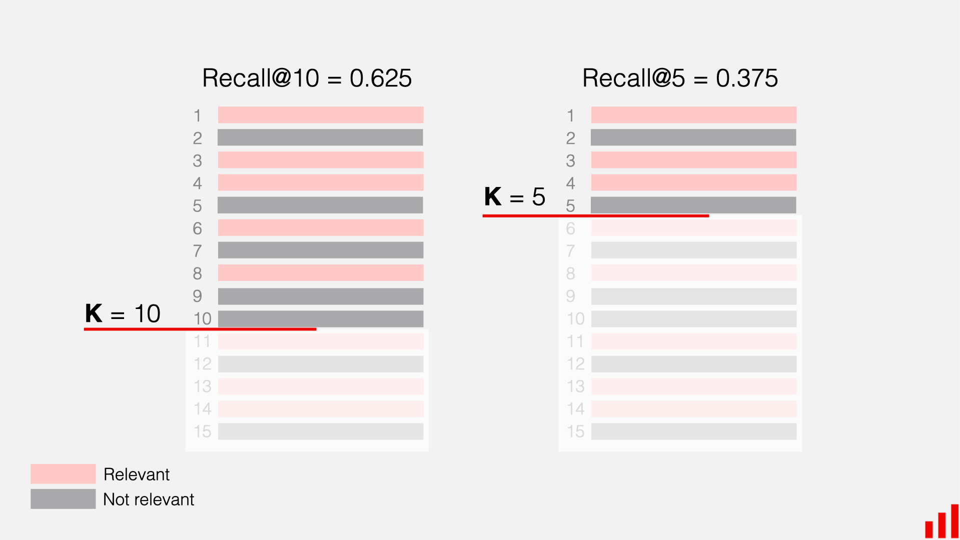
NDCG@10 goes further: was it ranked first (best), third (okay), or tenth (barely made it)? Higher positions earn more credit. Its mechanism assigns a score based on the item's position, using a logarithmic discount factor to heavily penalize lower-ranked correct items.
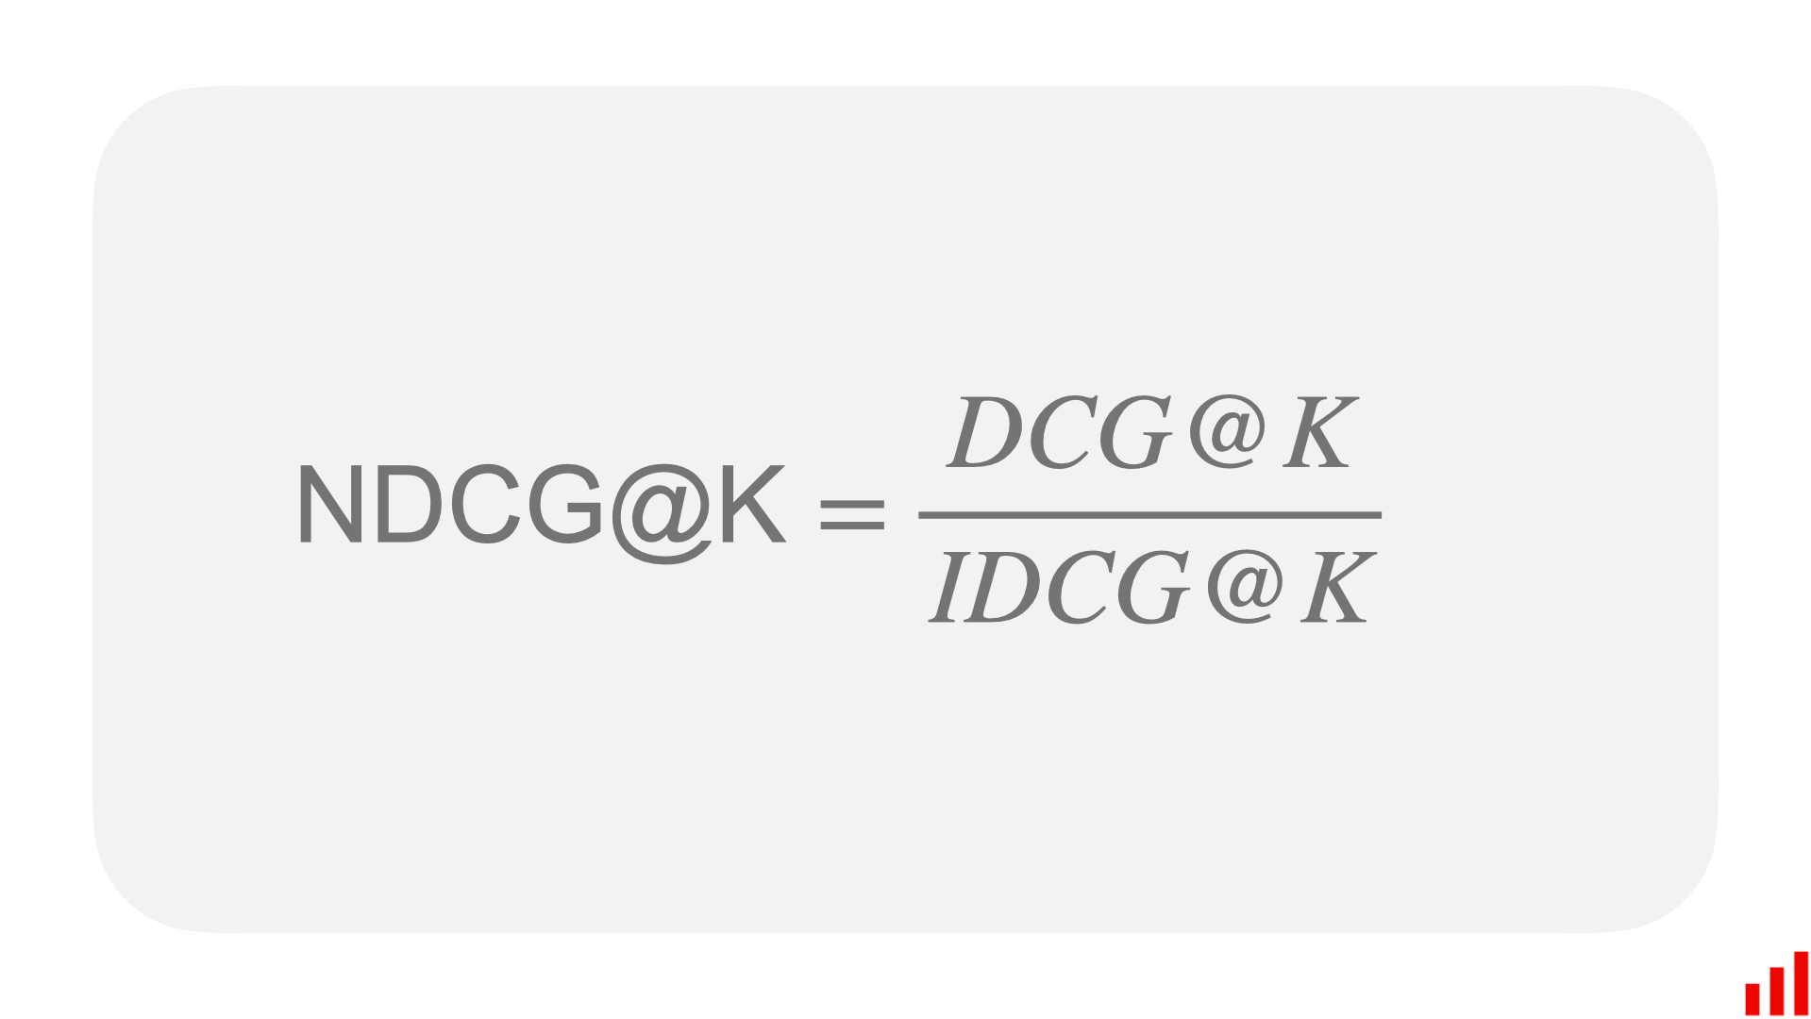
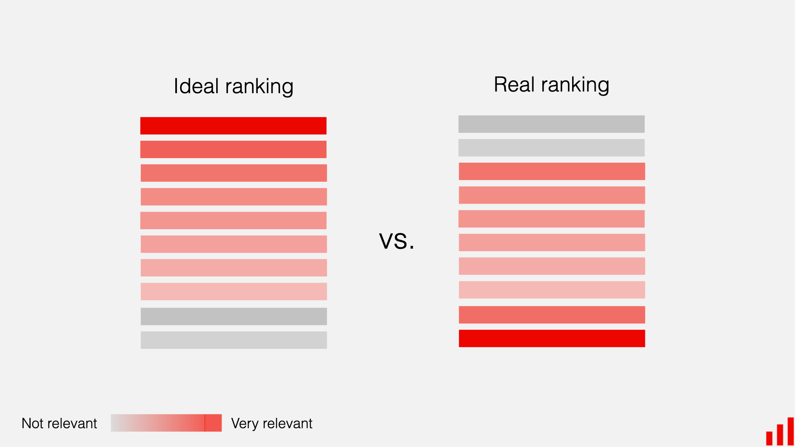

4.2 Single Domain Models
The following three models are trained using game rating data only. They have no access to movie preferences. They only know about games and recommend games based on what similar gamers have played

4.2.1 MF-BPR: Matrix Factorization with Bayesian Personalized Ranking

Analogy — The Notebook Method.
On her first day, Maya starts simple. For every patron and every game on her shelf she scribbles a small “taste card” — 64 numbers that try to capture things like “likes fast pace,” “prefers dark tone,” or “enjoys puzzles.” To decide whether a patron will like a game, Maya just lines up the two cards side by side and multiplies them number by number. If the totals add up high, it is probably a good match. The cards themselves are not handed to Maya — she learns them over time by watching which games each patron actually rented. This simple notebook already works surprisingly well, but the only way it can ever compare two cards is straight multiplication, so it misses any taste that needs a more subtle combination of traits..

MF-BPR: Architecture
Each user u and item i has a single learnable 64-dim vector, uᵤ, vᵢ ∈ ℝ⁶⁴. The score for a (u, i) pair is the dot product s(u, i) = uᵤ · vᵢ. All parameters live in two matrices U ∈ ℝ^(|𝒰|×64) and V ∈ ℝ^(|ℐ|×64).

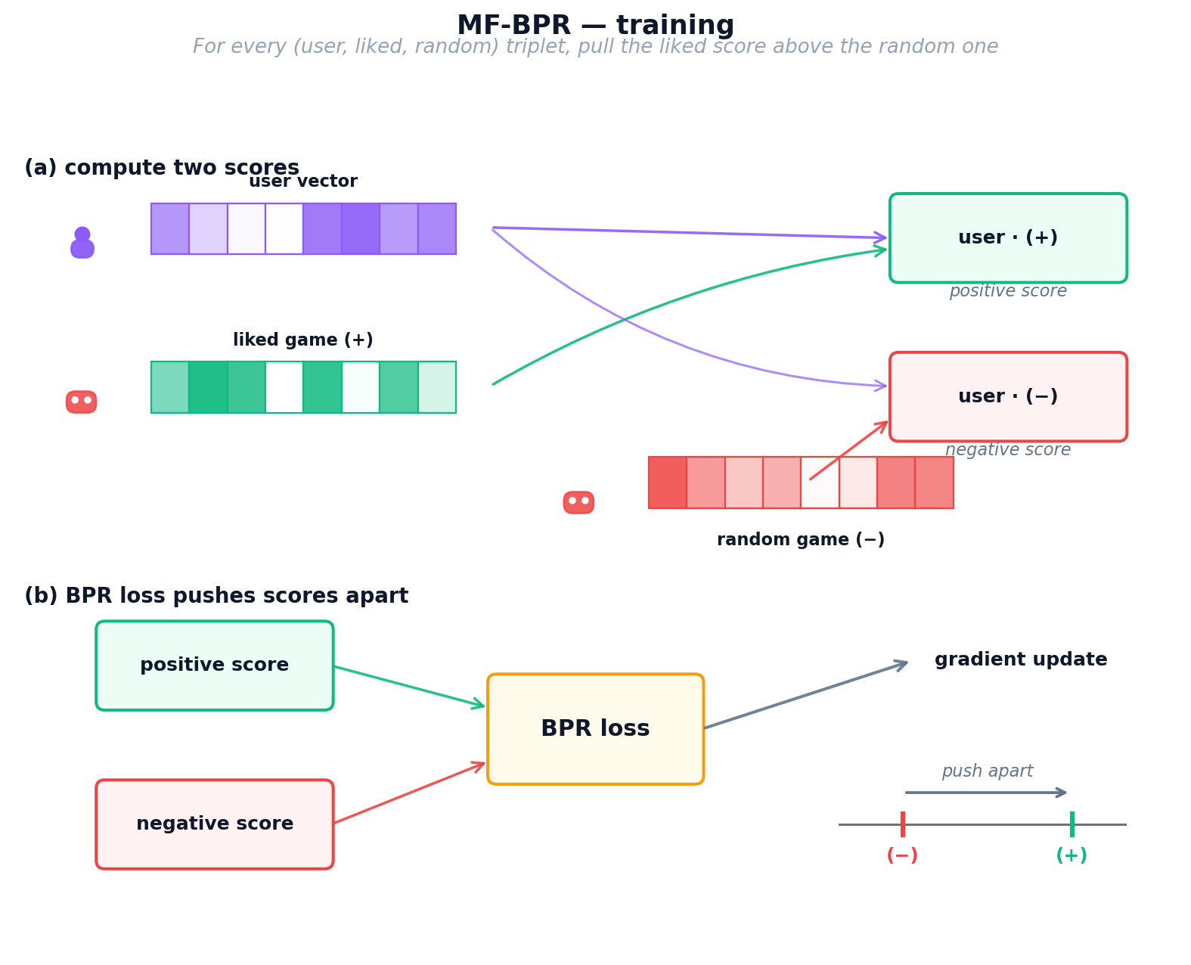
Figure 6: MF-BPR training process — user and item vectors learn from triplet sampling with BPR loss

MF-BPR: Training
We train for multiple epochs on sampled triplets (u, i⁺, i⁻), where i⁺ is an item rated ≥ 4 by u and i⁻ is a uniformly sampled unobserved item. The BPR loss (Equation 1) maximizes the margin uᵤ · vᵢ⁺ − uᵤ · vᵢ⁻ through a log-sigmoid, with L2 regularisation λ.
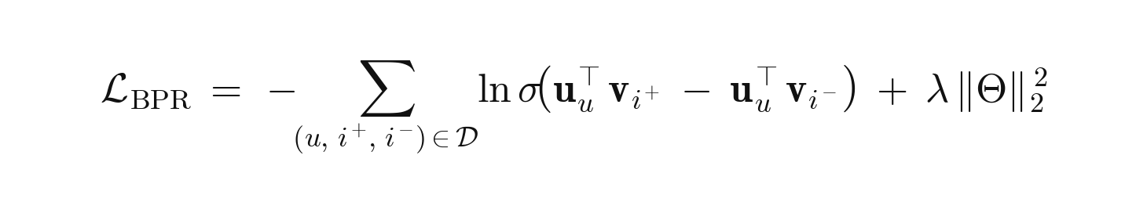
Equation 1: MF-BPR pairwise ranking loss.
where 𝒟 is the set of training triplets (u, i⁺, i⁻); uᵤ, vᵢ ∈ ℝ⁶⁴ are the learnable user/item vectors; σ(·) is the logistic sigmoid; Θ = {U, V} collects all parameters; λ is the L2 strength

Retrieval: the trained artefacts are the user and item embedding matrices. For a user u, we score every item by dot product u⋅v, sort the scores, and return the top-K items.
Strengths: Simple, fast (≈2 min), a strong baseline.
Weaknesses: Every user and item is treated in isolation — no structural prior — and a user without a learned row cannot be scored (no cold-start support).
Key takeaway — why we keep MF-BPR in the portfolio.
MF-BPR is the simplest implicit-feedback baseline: one matrix of user embeddings, one matrix of item embeddings, a single pairwise BPR loss. It sets the floor every more elaborate model must beat. Throughout Section 5 it keeps reappearing as a reference line — and on the 5.2%-overlap cohort in Lesson 2 it actually beats every CDR model, proving that pairwise ranking is a strong prior that more complex architectures have to earn.

4.2.2 NCF (NeuMF): Neural Collaborative Filtering

Analogy — Maya Hires an Apprentice.
After a few months, Maya notices her notebook method keeps missing oddly specific tastes — some patrons love “cozy horror,” a combination no single number on the card captures on its own. Straight multiplication just cannot express “like this trait AND that trait, but only together.” So Maya hires a young apprentice (a small neural network) whose only job is to look at a patron’s card and a game’s card and use intuition to combine them in non-linear ways. She still keeps her original multiplication trick as a reliable baseline and lets the apprentice add a layer of judgement on top. Now Maya catches the subtle interactions her notebook missed — but her recommendations still only know what each individual patron has personally rented.

NCF (NeuMF): Architecture
NCF fuses two parallel branches over four independent 64-dim embedding tables (GMF-user, GMF-item, MLP-user, MLP-item). The two branch outputs are concatenated and passed through a sigmoid to produce ŷ ∈ (0, 1).
1. GMF branch. Element-wise product uᵤᴳᴹᶠ ⊙ vᵢᴳᴹᶠ → 64-dim. Equivalent to a matrix factorisation with per-dimension weights.
2. MLP branch. Concatenates uᵤᴹᴸᴾ and vᵢᴹᴸᴾ into a 128-dim input, then passes through ReLU layers 128 → 64 → 32. The non-linearity captures patterns a single dot product cannot.
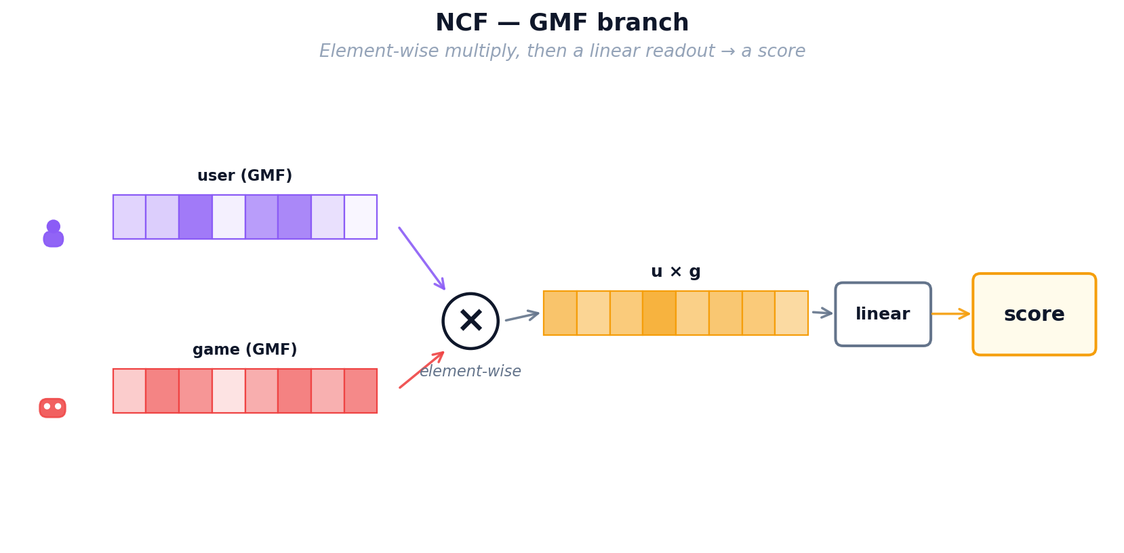
Figure 9: NCF — MLP branch: neural network layers learn non-linear user-item patterns
3. Fusion. Concatenate the GMF (64-dim) and MLP (32-dim) outputs, then apply a final linear layer with sigmoid activation to produce ŷ ∈ (0, 1).
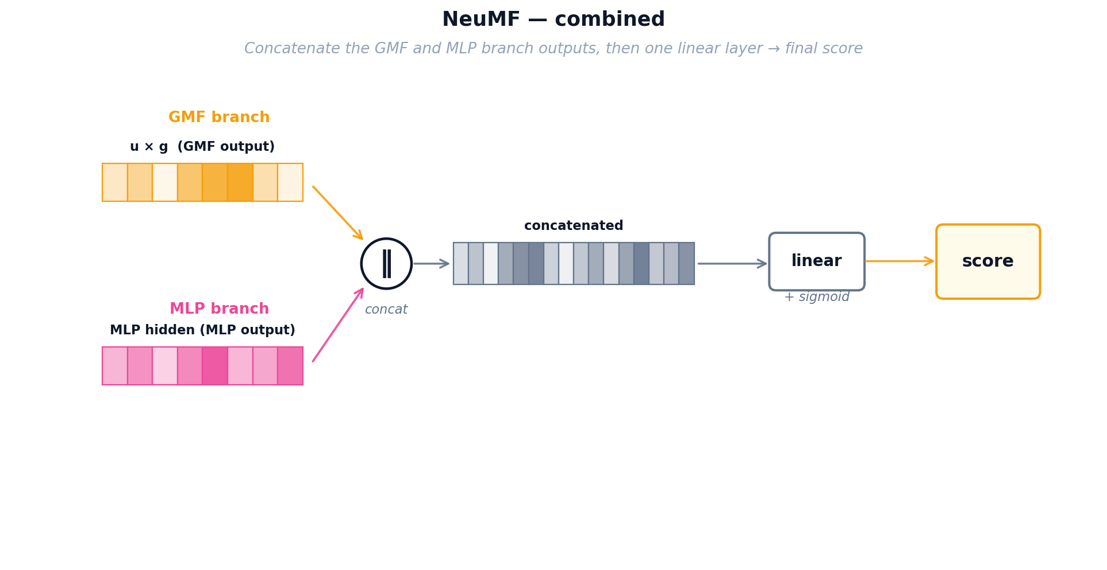
Figure 10: NCF — combined NeuMF architecture merging both branches into a final score

NCF (NeuMF): Training
NCF minimizes binary cross-entropy (Equation 2) over observed pairs (y = 1) and uniformly sampled negatives (y = 0).
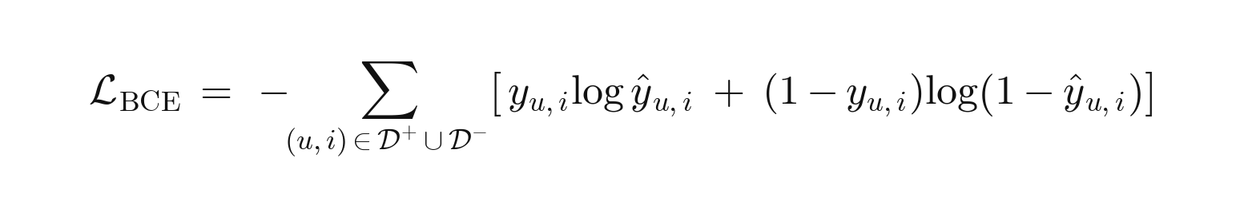
Equation 2: NCF binary cross-entropy loss on observed positives and sampled negatives.
where 𝒟⁺ is the observed-interaction set (y_{u,i} = 1) and 𝒟⁻ a same-size set of uniformly sampled negatives (y_{u,i} = 0); ŷ_{u,i} ∈ (0, 1) is the NeuMF sigmoid output from the fused GMF + MLP representation. A confident wrong prediction — e.g. ŷ = 0.9 on a true negative — contributes −log(0.1) ≈ 2.3 to the loss
Retrieval: at serving time we run the learned MLP over every candidate item for user u to produce a score ŷ(u, i); sorting by ŷ gives the top-K ranking.
Key takeaway — NCF's strengths and limits.
NCF replaces MF's dot-product with a learned MLP interaction function. On paper this adds expressiveness, but in Lessons 2–5 its full-rank Recall@10 stays between 0.012 and 0.023 — usually bested by MF-BPR or LightGCN. Its very high sampled HR@10 (≈ 0.80–0.89) next to low full-rank Recall is the clearest demonstration of the sampled-vs-full-rank gap: NCF discriminates well against a handful of random negatives but struggles to rank the full catalog.

4.2.3 LightGCN: Graph Convolution for Recommendations

Analogy — The Shop Gossip Network.
Maya now realises her patrons are not isolated — they influence each other. Alice loved Zelda and also loved Witcher; Bob just loved Witcher; odds are Bob will enjoy Zelda too, even though he has never heard of it. Instead of looking only at each patron’s own rental history, Maya pins up a big gossip board that connects every patron to every game they rented and every game to every patron who rented it. Taste now flows along these lines: each patron’s card gets gently blended with the cards of their neighbours, and then the neighbours-of-neighbours, so the cards carry community wisdom rather than one person’s history. Maya’s three tools so far (notebook, apprentice, gossip board) all share one limitation though: they only know about GAMES. A patron who has only ever rented movies is still invisible to them.

LightGCN: Graph Architecture
Users and items form a bipartite graph where each interaction creates an edge. LightGCN initializes random 96-dimensional embeddings for every node, then propagates information through the graph in K=3 rounds ("hops"). In each hop, a node's embedding is updated to be the weighted average of its neighbors' embeddings, with weights normalized by the square root of both nodes' degrees to prevent popular items from dominating.
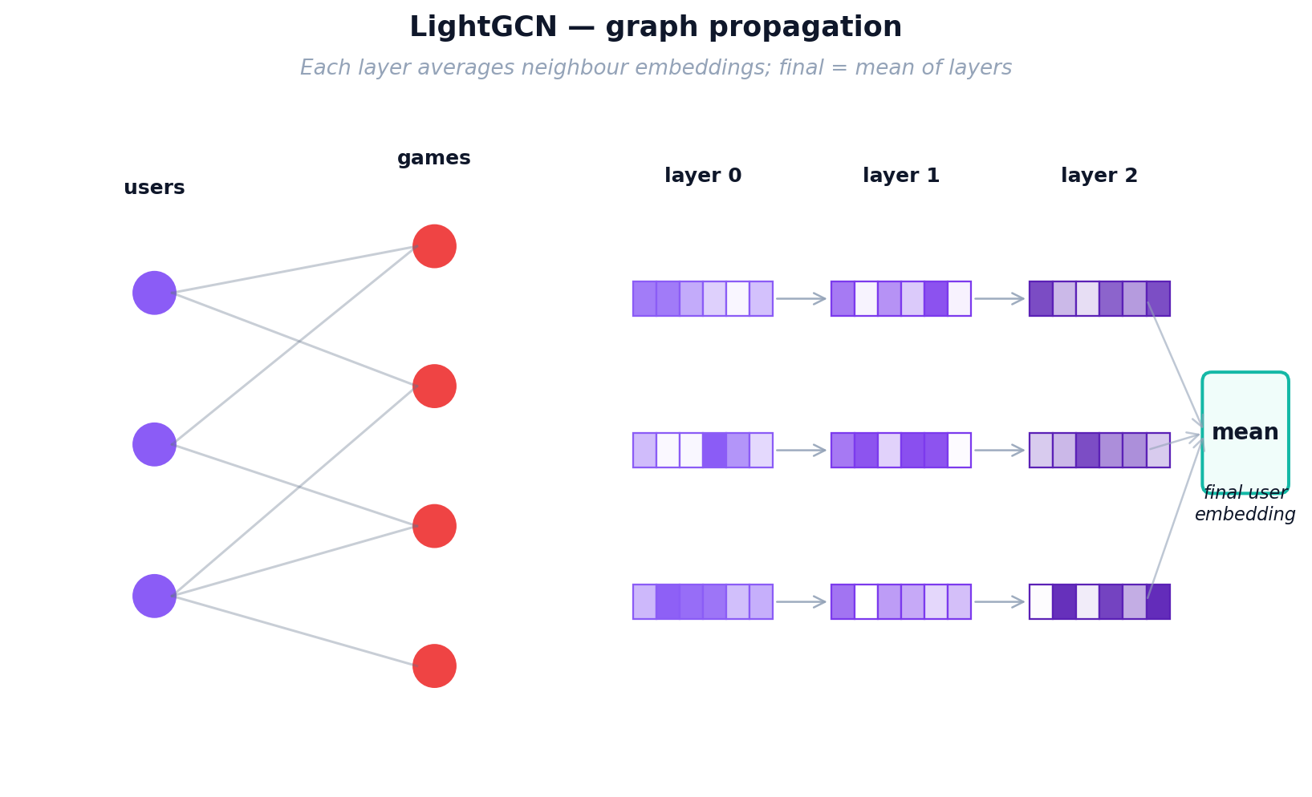
Figure 11: LightGCN graph propagation — information flows through multi-hop user-item connections
After K hops, each node has K+1 representations (from layer 0 to layer K). The final embedding is the simple mean of all layer representations. This layer-combination trick is critical: layer 0 captures the node itself, layer 1 captures direct neighbors, layer 2 captures 2-hop neighbors, and layer 3 captures 3-hop patterns. Averaging them balances local and global signals.

LightGCN: Training
LightGCN uses the same BPR loss as MF-BPR (positive items should score higher than random negatives), but the embeddings are first refined through graph propagation. In each training step: (1) sample a (user, positive, negative) triplet, (2) run K=3 layers of graph convolution to get refined embeddings, (3) compute dot-product scores, (4) compute BPR loss, (5) backpropagate gradients through all K layers back to the base embeddings. Only the base layer-0 embeddings are learnable; all propagation layers are parameter-free. This simplicity (no transformation matrices, no activation functions) is what makes LightGCN outperform more complex GCN variants.
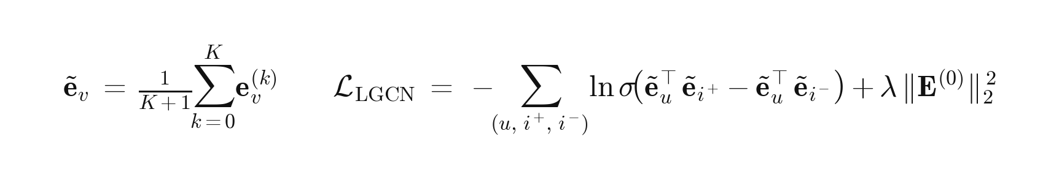
Equation 3: LightGCN layer-combined embeddings and BPR loss.
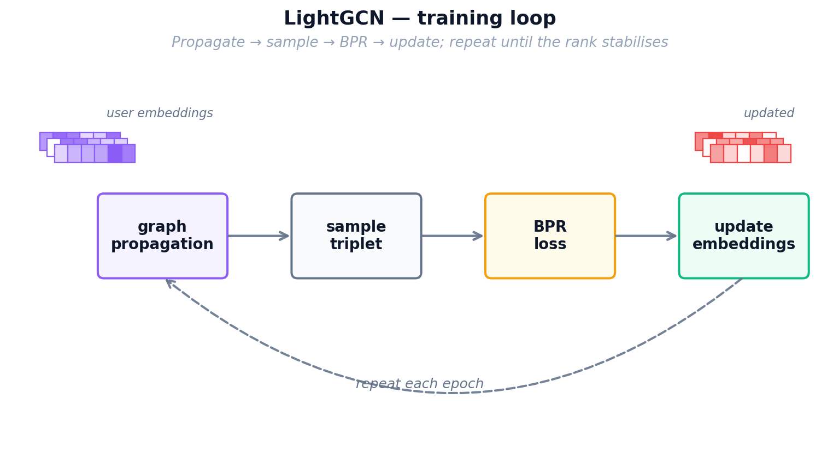
Figure 12: LightGCN training loop — graph propagation followed by BPR loss optimization

Retrieval: after propagation, the final user and item embeddings are dotted to score every item for a given user, and the top-K scores are returned.
Key takeaway — why LightGCN is the default champion.
LightGCN propagates user–item embeddings through the bipartite interaction graph; neighbourhood structure substitutes for the expressive transformation NCF adds explicitly. Across Lessons 2–5 it is the consistent leader on standard leave-last-out — 1.7×–5.8× the best CDR model on a mixed cohort, still leading even at 100% overlap. Its weakness is the cold-start case (Lesson 6): without target-domain interactions a graph has nothing to propagate, and LightGCN collapses to near-zero.

4.3 Cross Domain Models
The following three models are trained using both movie and game data. They attempt to transfer knowledge from the movie domain to the game domain. Think of them as translators: they try to convert what they know about a user's movie taste into game recommendations. This is especially valuable for "cold-start" users who have watched movies but never played games.

4.3.1 CMF: Collective Matrix Factorization
Analogy — One Shared Customer Card.
Maya now faces her real problem: she wants to recommend games to movie-only patrons, but her movie ledger and her game ledger were always kept as two separate notebooks that never talked to each other. Her first attempt to bridge them is the simplest thing possible: throw away the two patron notebooks and keep ONE single taste card per patron that has to work for both sides of the shop. Whenever Maya learns something from a movie rental, she updates the same card she uses for games, and vice versa. This forces the card to capture traits that genuinely transfer — an “action lover” card now helps with both Die Hard and Doom. The downside is that cramming two very different worlds into one card waters each of them down: the shared profile can never specialise as deeply as a game-only or movie-only card could.

CMF Architecture
Shared user matrix. CMF keeps one user matrix U ∈ ℝ^(|𝒰|×96) shared by both domains, plus domain-specific item matrices Vᴹ ∈ ℝ^(|ℐᴹ|×96) for movies and Vᴳ ∈ ℝ^(|ℐᴳ|×96) for games. Every user has exactly one 96-dim vector used in both domains.
Item matrices stay private. Vᴹ receives only movie gradients, Vᴳ only game gradients; the shared U is therefore the sole transfer channel between the two domains.
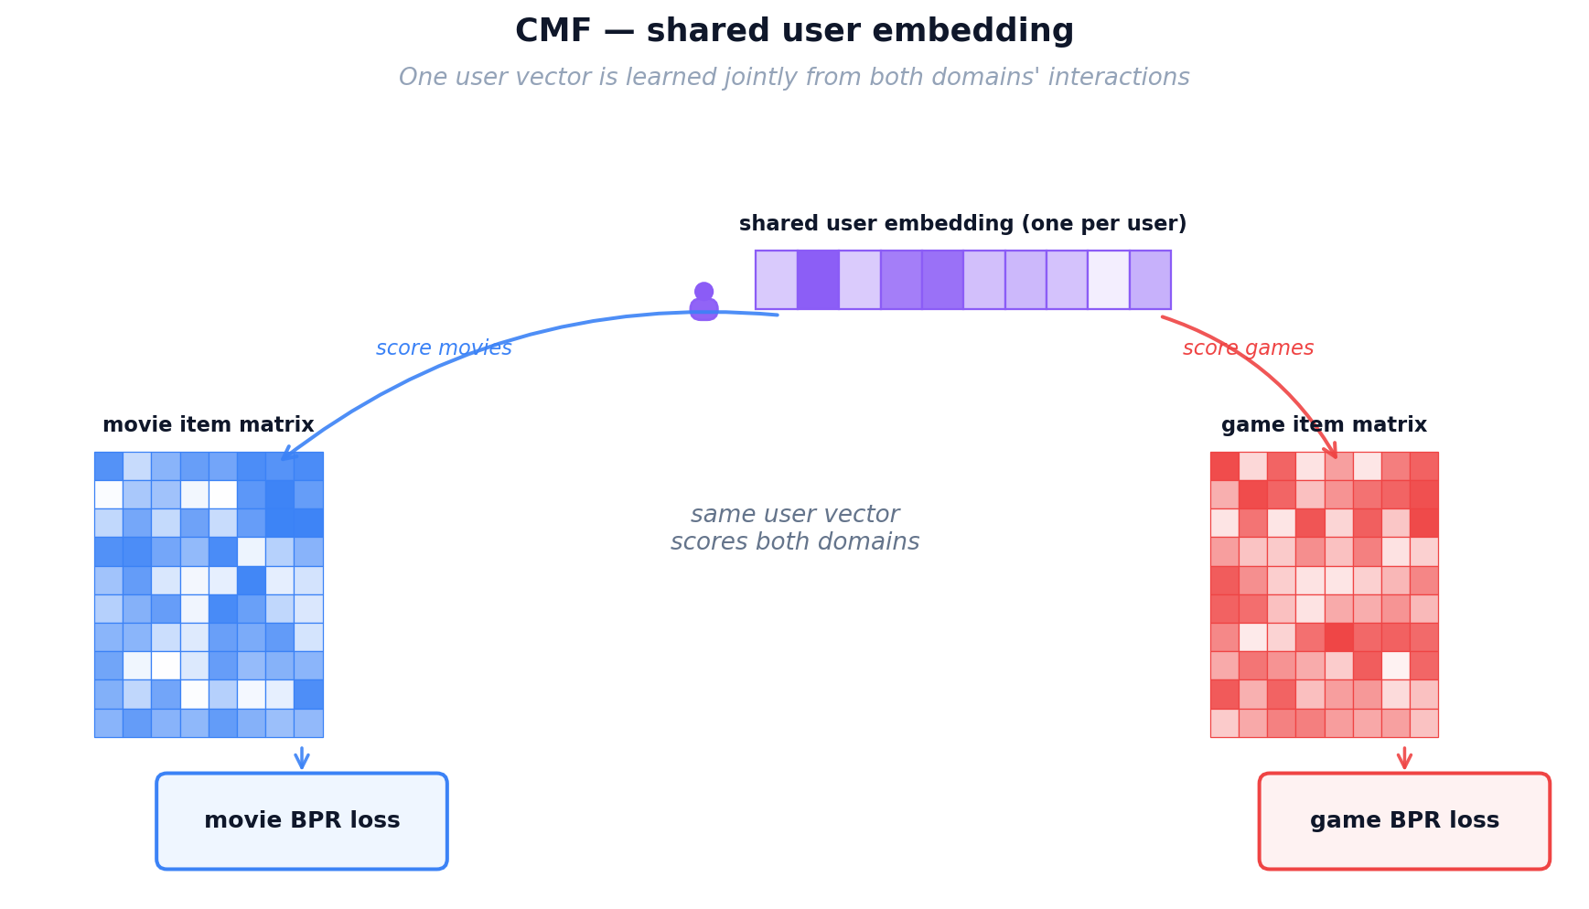

CMF Training
Sampling. Each step draws one BPR triplet per domain: (u, iᴹ⁺, iᴹ⁻) and (u, iᴳ⁺, iᴳ⁻) with uniform negatives. Users present in only one domain still contribute — their row of U is pulled by that domain's triplets alone.
Joint objective. The total loss is a convex combination of the two per-domain BPR terms sharing U (Equation 4). α ∈ [0, 1] trades movie signal (α → 1) for game signal (α → 0); our default is α = 0.5.

Equation 4: CMF joint two-domain loss with shared user matrix U.
where U is the shared user matrix; Vᴹ, Vᴳ are the domain-specific item matrices; L_BPRᴹ, L_BPRᴳ are the per-domain BPR losses (same form as Equation 1); α ∈ [0, 1] balances the two domains; Θ = {U, Vᴹ, Vᴳ}; λ is the L2 strength.
Retrieval: the shared user embedding is dotted with the target-domain item matrix Vᴳ to score every game, then sorted to produce the top-K ranking.

CMF Limitations
The shared uᵤ is a compromise vector that must serve both domains and is therefore mediocre at each. In our experiments CMF produces the weakest CDR transfer — especially at cold-start, where uᵤ has been shaped almost entirely by movie data (≈95% of interactions).

Key takeaway — CMF's role in the portfolio.
CMF jointly factorises both domains with a shared user matrix, an α-weighted multi-task loss, and no explicit mapping. It is the cheapest CDR model we implement but the one most sensitive to hyperparameters: Section 6.1 shows lr and α jointly determine whether CMF reaches Recall@10 ≈ 0.04 or stalls at 0.02. In Lesson 2 it is the weakest ranker on the low-overlap cohort, but with 100% overlap in Lesson 3 and proper tuning it approaches EMCDR — a useful lower bound on what “plain multi-task CDR” can deliver.

4.3.2 EMCDR: Cross-Domain Embedding Mapping

Analogy — Maya Hires a Translator.
CMF taught Maya that one shared card sacrifices too much specialization. Her next idea is better: keep the two specialized notebooks (one perfectly tuned for movies, one perfectly tuned for games), then hire a translator who converts between them. For every patron who has rented in BOTH domains — the overlap customers — Maya can see the same person’s movie card AND their game card, so she can teach the translator: “when the movie card looks like this, the matching game card looks like that.” Once trained, the translator lets Maya take a movie-only patron’s card and translate it straight into a game-side card, so she can recommend games as if they had always been a game patron. This is a big leap over CMF because neither specialized card had to compromise. The weak spot is that Maya only hires one translator, and that one translator must use the same rules for every single patron.

EMCDR Architecture
Two independent spaces. EMCDR trains one MF-BPR per domain: a source-domain model produces user and item embeddings for movies (Uᴹ, Vᴹ), and a second, separate target-domain model produces its own embeddings for games (Uᴳ, Vᴳ). The same person is represented by two unrelated vectors — one in movie space, one in game space — because each domain is modelled in isolation (uᵤᴹ ≠ uᵤᴳ).
A learned translator. A small multilayer perceptron (MLP) f_θ learns to map a user's movie-space vector to its game-space counterpart: f_θ(uᵤᴹ) ≈ uᵤᴳ. Once trained, any user with a movie-side vector — including cold-start users who have never rated a game — can be placed into game space and scored against every item in Vᴳ.
Supervised by overlap. The translator is trained only on the overlap users 𝒰ₒ = {u : u has interactions in both domains}. These users provide paired (movie-vector, game-vector) examples the MLP can learn from — without any overlap, the translator has no supervision signal.
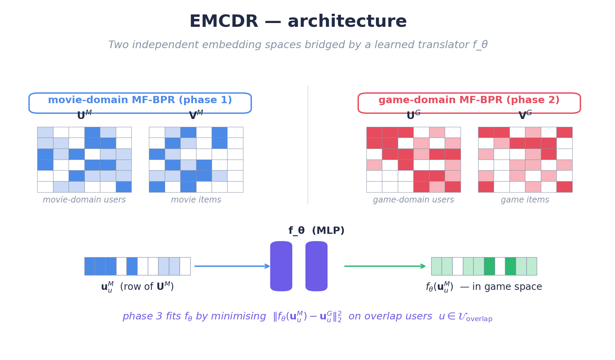
Figure 14a: EMCDR architecture — two independent MF-BPR spaces bridged by the learned translator fθ.

EMCDR Training
Training proceeds in three sequential phases:
Phase 1 — movie MF-BPR. Train the source-domain MF-BPR on movie interactions until convergence to obtain U^{M} and V^{M} (user and item embedding tables in movie space).
Phase 2 — game MF-BPR. Independently train the target-domain MF-BPR on game interactions to obtain U^{G} and V^{G}. The two models share no parameters — each domain is learned in isolation so it can optimise for its own local structure.
Phase 3 — fit the translator. Freeze both MF-BPR models. Using the overlap users only, fit f_{θ} to regress u_{u}^{G} from u_{u}^{M} with the mean-squared-error loss shown in Equation 5. Any gradient-based optimiser works; train until the loss on a held-out subset of overlap users stops improving.
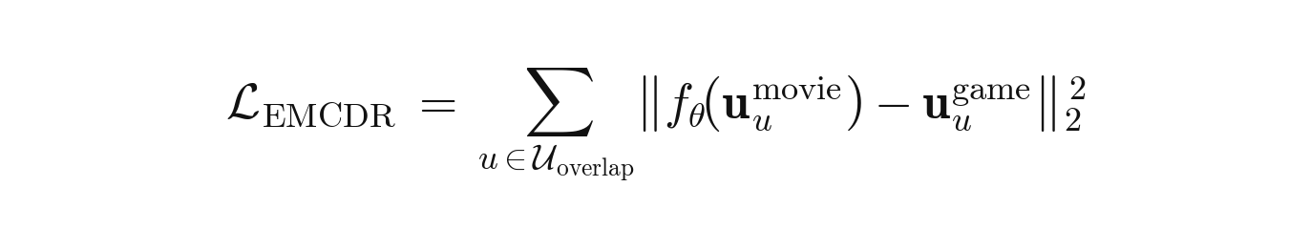
Equation 5: EMCDR phase-3 mapping loss (MSE on overlap users).
where 𝒰ₒ is the set of overlap users; uᵤᴹ, uᵤᴳ are the user embeddings learned independently in Phases 1 and 2; f_θ is the MLP translator fit in Phase 3 by regressing the game-side vector from the movie-side vector.
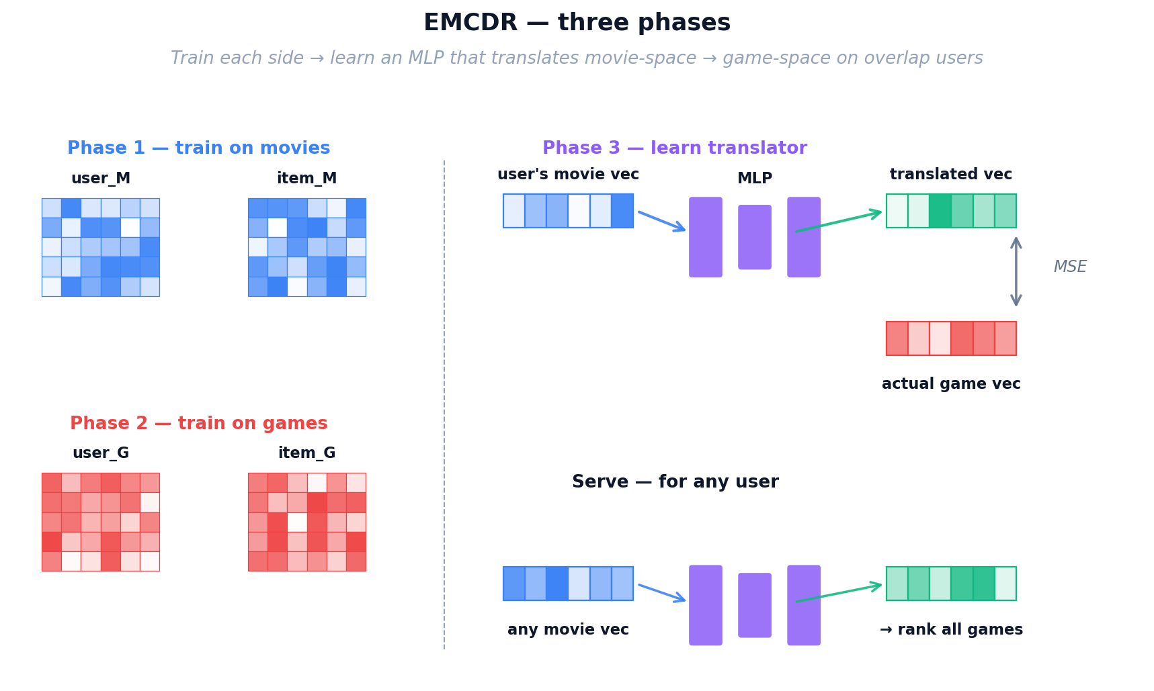
Figure 14: EMCDR three-phase training — separate domain models, then a learned mapping network.
Retrieval: at serving time a user’s movie-side vector is passed once through the trained translator to land in game space, then dotted with every game embedding in Vᴳ; sorting the scores gives the top-K ranking. Because the target-side user matrix is never touched, users with zero game history are natively supported.
Key takeaway — why EMCDR remains the CDR baseline.
EMCDR's strength is its clean decoupling: each domain is modelled in isolation with the best available in-domain recommender, and the cross-domain mapping is a small supervised problem trained only on overlap users. This design naturally supports cold-start on the target side — a user with zero game history can still be ranked by translating their movie vector. Its weakness is that a single translator is shared across all users, learning one average way to convert movie taste into game taste. Any user whose profile differs from that average gets a less-than-optimal translation, which motivates the personalised-translator design in PTUPCDR.

Figure 14b: EMCDR inference — one forward pass through f_θ translates the user's movie vector into game space, then a dot product ranks every game.

4.3.3 PTUPCDR: Personalized Transfer with Experts
Intuition — A Team of Specialist Translators.
EMCDR uses one global translator to map every movie fan into game space. But a sci-fi lover and a rom-com fan don't translate the same way — averaging them loses information. PTUPCDR fixes this by hiring a small team of specialist translators plus a receptionist (the gate network). For every user, the gate reads their movie vector and decides which specialists to trust and by how much. A sci-fi fan is routed mostly through the sci-fi specialist; a comedy fan mostly through the comedy specialist. Every user now gets their own personalised translation rule, not one-size-fits-all.

PTUPCDR keeps EMCDR's three-phase recipe but upgrades Phase 3: the single MLP translator f_θ is replaced by a mixture of K expert MLPs, steered by a gating network that produces per-user expert weights. Everything else — the source and target MF-BPR models, the use of overlap users as supervision, the serving pipeline — is identical to EMCDR. Only the shape of the translator changes.

PTUPCDR Architecture
The translator is no longer a single function. At inference time the pipeline has five steps:
1 | Input — The user's movie-side embedding u^M (64-dim) is produced by MF-BPR on movies (exactly as in EMCDR).
2 | Gate — A small linear layer with softmax, g(u^M) = softmax(W_g · u^M), outputs K non-negative gate weights that sum to 1. A large g_k means “trust Expert k a lot for this user.” The number of experts K is a hyperparameter chosen once for the whole model.
3 | Experts — K independent MLPs f_1, …, f_K each map u^M from movie space to game space. They share the same architecture but learn different specialisations because the gate routes different user types toward different experts during training.
4 | Weighted sum — The personalised translation F(u^M) = Σ_k g_k · f_k(u^M) blends the eight expert outputs using the gate weights. Different users get different blends — the translator is user-specific.
5 | Score & rank — For every game g, score(u, g) = F(u^M) · v_g (dot product with the game embedding learned in Phase 2). Sort the scores and return the top-K games.

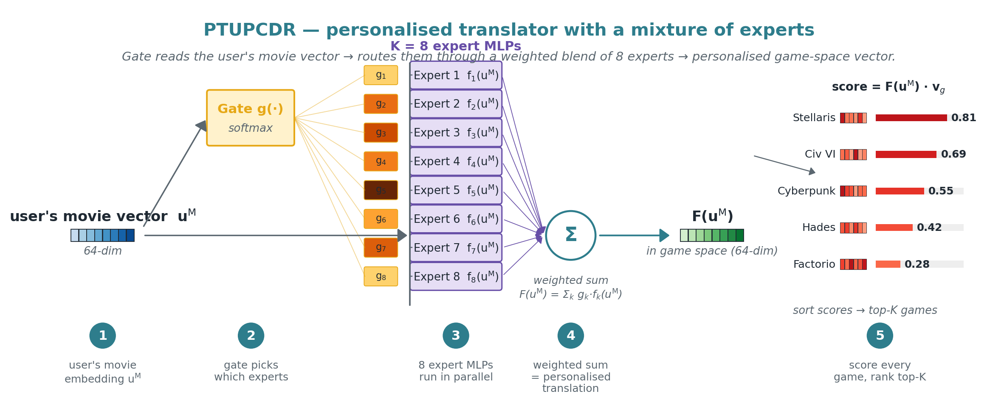
Figure 15: PTUPCDR architecture — the gate routes the user's movie vector through a weighted blend of 8 expert MLPs, then the resulting personalised game-space vector is scored against every game by dot product.

PTUPCDR Training
Phases 1 and 2 are identical to EMCDR: train MF-BPR independently on movies to get Uᴹ, Vᴹ, then a second MF-BPR on games to get Uᴳ, Vᴳ. Phase 3 — fit the experts and gate. Freeze both MF-BPR models. On the overlap users only, jointly train the gate's weights W_g and all K experts {f_k} to minimise the mean-squared error between the predicted translation F(uᵤᴹ) and the user's actual game-side vector uᵤᴳ (Equation 6). Any gradient-based optimiser with early stopping on a held-out overlap-user validation split works.
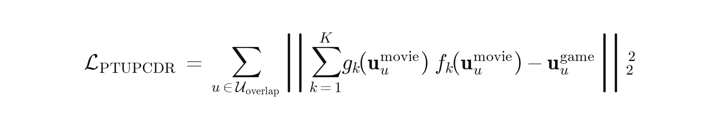
Equation 6: PTUPCDR mixture-of-experts personalised mapping loss.
where 𝒰ₒ is the set of overlap users, f_k is the k-th expert MLP, and g_k = softmax(W_g · uᵤᴹ)_k is the k-th entry of the softmax gate. Each user's movie-side vector is routed through its own expert mix — a user-specific translation rule that a single global f_θ (EMCDR) cannot produce.
Retrieval: at serving time the gate is applied to the user’s movie-side vector to produce K weights; each expert is run on the same vector; the weighted sum is the personalised game-space translation, which is dotted with every game embedding to score and rank the top-K items. Users with zero game history are natively supported because the target-side user matrix is never needed.
Key takeaway — why PTUPCDR beats EMCDR (when it has enough overlap users).
PTUPCDR trades EMCDR's single global mapping for a user-personalised one. Every user gets their own blend of K experts, so taste differences between users are preserved during the cross-domain translation. The cost is more parameters to fit — one gate plus K expert MLPs instead of a single translator — so the number of experts K should be chosen relative to how much overlap data is available. When overlap is dense, PTUPCDR's extra capacity pays off. When overlap is sparse, the experts cannot be trained reliably and a simpler EMCDR-style translator is the safer choice.

Content-Based and Post-Processing Models
The remaining two approaches don't rely on collaborative filtering. SBERT matches items by their text descriptions, while co-occurrence reranking boosts scores based on statistical patterns in the data. Both are training-free and model-agnostic.

Analogy — Reading the Back of the Box.
Everything Maya has built so far depends on rental history to learn its cards. A shiny new game that arrived this morning, or a brand-new patron walking in for the first time, has no history at all — and the specialist translators have nothing to translate. To rescue these cold-start cases, Maya walks over to the shelves herself and reads the back of the box: the title and the plot summary printed on every movie case and every game case. A pre-trained language model acts as her reading glasses, turning each blurb into a semantic card based on MEANING rather than ratings. Now “sci-fi action with robots” on a movie box automatically lines up with “sci-fi thriller featuring androids” on a game box, even if not a single patron has rented both yet. This finally gives Maya a way to recommend completely new items and serve completely new patrons — situations no collaborative method can touch.

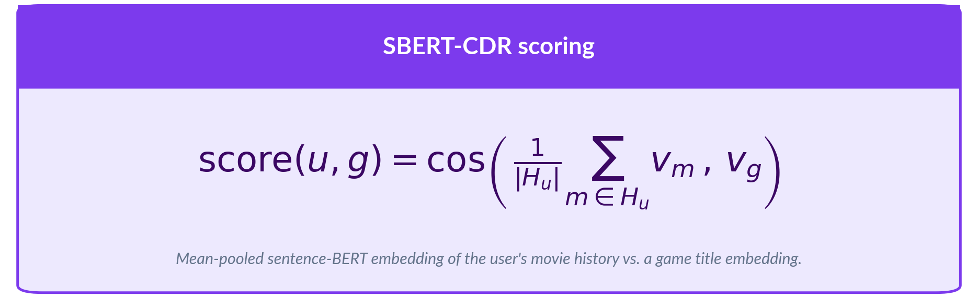
No training or fine-tuning is performed. The pre-trained encoder is used as-is. This makes SBERT-CDR the only model that requires zero training data from the target domain.

Analogy — Maya’s Sticky-Note Tally
For her final touch, Maya goes back to basics. Next to the counter she keeps a simple sticky-note tally: for every movie on the shelf, she writes down which games the people who rented that movie also rented, and how often. This is not a fancy model at all — just honest bookkeeping — but it captures obvious cross-domain patterns that even her specialist translators can overlook. Maya does not use it by itself; she layers these tally scores on TOP of whichever main model is picking candidates, gently nudging up any game that historically tends to co-occur with the movies a patron already loves. It is cheap, completely interpretable (“we recommended this game because 8 out of 10 patrons who rented your favourite movie also rented it”), and it is the final polish on Maya’s recommendation desk — the last tool that takes her from the humble notebook she started with to the full cross-domain system evaluated in this report.


The λ parameter is tuned per base model via grid search. No training is involved — the matrix is computed directly from interaction counts. This makes co-occurrence reranking deterministic, reproducible, and extremely fast to apply.

5. Experiments and Results

5.1 Lesson 1: Explicit vs Implicit Ranking

Introduction
At first, as Amazon Data Ratings consist of exclusively explicit ratings(1-5 starts), so naturally we did our initial benchmarks with only the algorithms that are good at predicting user ratings. But, we were baffled by the fact that the initial metrics were very disappointing. This raised a question whether our methods are valid. From then we learnt that predicting a 1–5 rating is fundamentally different from ranking items a user picked over ones they skipped.
This lesson shows how choosing the wrong loss function can silently break every downstream experiment.
HYPOTHESIS
Will the implicit ranking objective (BPR) outperform the explicit point-predicting approach (SVD) on Recall@10?

Setup
We train the same matrix-factorization architecture twice on identical data — once minimizing RMSE regression loss, once minimizing BPR pairwise ranking loss — and compare metrics.
- Game Domain only – MF-Explicit (SVD) — with MSE loss
- Game Domain only – MF-Implicit BPR — with BPR ranking loss
Evaluation: leave-last-out on games, Recall@10, NDCG@10.

Dataset NEW
Property | Value
Users | 1,000,000 (randomly sampled from original unfiltered 3.7M users)
Game Ratings | 337K (implicit rating ≥ 4, ratings from the sampled 1M users, originally unfiltered 1.4M ratings)
Game items | 11,706
Item k-core | games ≥ 10
Split | Leave-last-out on games

Results
With MF- Implicit BPR outperforms MF-Explicit, the Implicit variant extracts 5.2× more signal than MF-Explicit on Recall@10.
Model | Loss Function | Recall@10 | NDCG@10
MF-Implicit BPR | BPR on ranking | 0.0130 | 0.0067
MF-Explicit | RMSE on star predicting | 0.0025 | 0.0010

Recall@10 5.2× win for BPR
MF-Implicit BPR |  | 0.0130
MF-Explicit |  | 0.0025
NDCG@10 6.7× win for BPR
MF-Implicit BPR |  | 0.0067
MF-Explicit |  | 0.0010
OBSERVATION
Confirmed — BPR wins 5.2× on Recall@10. The ranking loss directly optimizes the quantity that evaluation metrics measure, while RMSE optimizes prediction accuracy on ratings that may not correlate with top-K relevance.

Lesson 1 Summary

Lesson 1 asks whether we should train on explicit 1–5 ratings or treat ratings implicitly as positive signals.
The takeaway for the rest of the report: ranking losses are the right method for recommendation, and every subsequent experiment should be trained with implicit ratings.
Finding | Evidence
BPR crushes MF-Explicit | Recall@10 0.0130 vs 0.0025 — 5.2× win; NDCG 6.7×

Reflection
This lesson reproduces one of the most common results in collaborative filtering: for top-K ranking, the training objective is much more important than the architecture itself. Using RMSE is simply the wrong way to evaluate if we showed the user something they would actually click.
This is a basic mistake we should not make. But we are glad we learned this lesson so early on: always pick a loss that matches the metric you will actually be evaluated on. The very same model can be trained with multiple loss functions to choose from, and now we know exactly the reasons behind that!

NEXT UP
Lesson 1 settled the training-objective question: implicit ranking beats explicit rating prediction. Next lesson we will benchmark both Single Domain Recommendation algorithms and Cross Domain Recommendation algorithm: Will CDR outperform SDR?

5.2 Lesson 2: Low Overlap Kills CDR

Introduction
When we read about Cross-domain recommenders (CDRs), we always see complicated explanations of how they work, and then at the end, metrics showing how CDRs scores successfully beat SDR counterparts. But is this always true? Or is there a catch? So long as we have two related domains and some overlapping users, should we always expect CDRs to outperform?
This lesson tests CDR at a realistic ~5% overlap — the ratio you would see on raw Amazon Reviews data without any filtering. We wanted to see if the magic of CDR still works when bridge users are very few.
HYPOTHESIS
Can collaborative CDR models (CMF, EMCDR, PTUPCDR) beat a single-domain graph recommender (LightGCN) when only 5.2% of users appear in both domains?

Setup
We expand the portfolio from two MF models to six — three single-domain models (MF-BPR, NCF, LightGCN) against three CDR models (CMF, EMCDR, PTUPCDR) — all trained on the same mixed 1M-user sampled group where only 5.2% of users appear in both domains.
- Single-domain — MF-BPR (pairwise MF), NCF (NeuMF), LightGCN (graph) – only trains and tests on Game domain dataset.
- CDR — CMF (joint MF), EMCDR (mapping), PTUPCDR (personalized mapping) – trains and tests on Movie-Game cross domain dataset.
Evaluation: leave-last-out on games, Recall@10 (same 1M-user cohort as Lesson 1).

Dataset
Property | Value
Users | 1,000,000 (no user k-core, random sampled from original 3.7M users)
Overlap | 52,281 (5.2%) — same ratio as in original dataset
Movie - game ratings | Movie ratings 1.80M - Game ratings 337K (rating ≥ 4)
Movie - game items | Movie items 45,933 - Game items 11,706
Item k-core | movies ≥ 20, games ≥ 10
Split | Leave-last-out on games

Results
At 5.2% natural overlap, LightGCN leads by 1.8× over the best CDR model (EMCDR) — all three CDR models trail even the simplest single-domain baseline.
Model | Family | Recall@10 | NDCG@10 | % gap
LightGCN | Graph (single-domain) | 0.0290 | 0.0157 | —
MF-BPR | MF (single-domain) | 0.0170 | 0.0093 | −41.4%
EMCDR | Mapping (CDR) | 0.0160 | 0.0082 | −44.8%
NCF | Neural (single-domain) | 0.0120 | 0.0069 | −58.6%
PTUPCDR | Personalized mapping (CDR) | 0.0085 | 0.0054 | −70.7%
CMF | Joint MF (CDR) | 0.0050 | 0.0022 | −82.8%

Recall@10 LightGCN leads · CDR trails
LightGCN |  | 0.0290
MF-BPR |  | 0.0170
EMCDR |  | 0.0160
NCF |  | 0.0120
PTUPCDR |  | 0.0085
CMF |  | 0.0050

KEY FINDING
Confirmed — LightGCN wins 1.7× over MF-BPR and 1.8× over EMCDR (best CDR). At 5.2% overlap, cross-domain mappings have too few shared users to learn meaningful transfer — and get beaten even by baseline MF.

Lesson 2 Summary

Lesson 2 asks whether, at a realistic low-overlap ratio, any CDR model can beat the best single-domain approach. All three CDR models underperform the simplest single-domain baseline.
Finding | Evidence
LightGCN wins | Recall@10 0.0290 — 1.7× over MF-BPR, 1.8× over EMCDR (best CDR)
CDR underperforms single-domain | All three CDR models lose to MF-BPR, the simplest SDR
MF-BPR holds up | Simplest model beats all CDR on full-rank — pairwise ranking signal is strong even on sparse data

Reflection
When we first started the benchmark between CDR and SDR, we had very high hopes for the Cross-Domain Recommenders, strongly believing that their complex, advanced learning algorithms would easily outperform the traditional single-domain approaches. The actual results, which showed SDR clearly winning, were genuinely disappointing and forced us to question our assumptions.
We initially thought the poor performance was due to settings that weren't quite right. We ran many tests by tweaking the hyperparameters for EMCDR, but no matter how much we tuned the parameters, the model consistently performed worse than the SDR approaches. At one point, we even thought about abandoning the project idea.
This forced us to look back at the CDR articles and consult with ChatGPT. We noticed that existing research often uses datasets where a high number of users overlap (e.g., Amazon books ➞ movies with 50%+ overlap). This observation provided the critical insight: when these same models are applied to real, raw data— where user overlap is under 10%—CDR simply fails, which is exactly what Lesson 2 demonstrated.
This finding highlights a common pattern: methods that work beautifully on perfect test datasets might fail on the real-world data. Running a simple baseline on your real data before trusting any published benchmark is a crucial safety step. The true value of Lesson 2 was not the bad result itself, but the important lesson it taught us about data requirements.

NEXT UP
Lesson 2 leaves an ambiguity: is CDR fundamentally weak, or just starved of bridge users at 5% overlap? The only way to know is to filter the users with ratings on both domains – 100% overlap and re-run the same six models.

5.3 Lesson 3: Overlap Filtering Rescues CDR

Introduction
Lesson 2 was a disaster for CDR. The models we had so much hope for failed against simple baselines because the user overlap was too low (5.2%). This left us with a huge, uncomfortable question: Is CDR fundamentally flawed? This lesson is the answer. We filter out the low-overlap users and re-run the benchmark on a 100% overlap cohort.

HYPOTHESIS
When every user has history in both domains (100% overlap), do CDR models finally become competitive with LightGCN?

Setup
Same six models as Lesson 2. What changes is the user group: users with ≥ 10 total interactions AND ≥ 5 movies and ≥ 1 game — 19,880 bridge users, 100% overlap by construction.
- Single-domain — MF-BPR, NCF, LightGCN
- Cross-domain — CMF, EMCDR, PTUPCDR
Evaluation: leave-last-out on games, full-rank Recall@10 (same protocol as L1–L2).

Dataset CHANGED
Property | Value (changes from Lesson 2)
Users | 19,880 (was 1,000,000 sampled)
Overlap | 19,880 (100%) — was 5.2%
Movie · game ratings | 430,736 · 87,613
Movie · game items | 40,288 · 10,034
User k-core | ≥ 10 total ratings (new)  ≥ 5 movies ratings (new)  ≥ 1 games ratings (new)
Split | Leave-last-out on games

Results
Interesting! Every CDR model jumps dramatically. PTUPCDR surges +276% , while CMF +180%, EMCDR +53%. LightGCN still leads but CDR is now a serious competitor.
Model | Family | Recall@10 | NDCG@10 | % gap
LightGCN | Graph (single-domain) | 0.0555 | 0.0311 | —
PTUPCDR | Personalized mapping (CDR) | 0.0320 | 0.0179 | −42.3%
EMCDR | Mapping (CDR) | 0.0245 | 0.0115 | −55.9%
NCF | Neural (single-domain) | 0.0230 | 0.0130 | −58.6%
CMF | Joint MF (CDR) | 0.0140 | 0.0073 | −74.8%
MF-BPR | MF (single-domain) | 0.0050 | 0.0030 | −91.0%

Recall@10 LightGCN leads · CDR closes in
LightGCN |  | 0.0555
PTUPCDR |  | 0.0320
EMCDR |  | 0.0245
NCF |  | 0.0230
CMF |  | 0.0140
MF-BPR |  | 0.0050

KEY FINDING
Confirmed — 100%-overlap filtering rescues CDR. PTUPCDR closes the gap from −71% (L2) to −42% (L3); every CDR model improves substantially. Overlap is the single most decisive variable for cross-domain transfer.

Lesson 3 Summary

Lesson 3 asks whether the poor L2 CDR results were caused by structural weakness or simply too few bridge users.
The takeaway: CDR is not fundamentally weak — it was starved of bridge(overlapping) users in Lesson 2. With enough bridged signal, CDRs now strongly compete with SDRs because they have enough data signal for them to work on.
Finding | Evidence
Overlap filtering rescues CDR | PTUPCDR 0.0085 → 0.0320 (+276%); CMF +180%; EMCDR +53%
LightGCN still leads | Recall@10 = 0.0555 — up from 0.0290 in L2 (+91%). Graph structure scales with denser per-user game data.

Reflection
After the huge disappointment of Lesson 2, where we started to doubt the entire idea of CDR, the results from Lesson 3 were a massive relief.
It showed the complex CDR models we chose were not flawed—they were just starved of the necessary bridge data. Generally, this lesson is critical: when a method underperforms, is it we are using the wrong tool for the job, or it’s the right tool but with not enough data. We confirmed that the core problem wasn't the CDR algorithm itself, but the data setup.

NEXT UP
Lesson 3 confirmed overlap is decisive, but the 100%-overlap cohort is still a mix of user types — some movie-heavy, some game-heavy. But LightGCN still leads. What would it take for CDR to outpace the LightGCN?

5.4 Lesson 4: Source-Rich / Target-Sparse

Introduction
Lesson 3 gave us a big relief: Cross-Domain Recommendation is not broken, it just needs enough overlapping users. But even with 100% overlap, the LightGCN model still won. LightGCN is very strong SDR.
So, the quest is still on. We need to find the specific dataset—the one setup where CDR can outperform. ChatGPT says this might happen when a user has a very rich source domain (movies) but only very little target domain history (games). This is the Source-Rich / Target-Sparse; sweet spot that CDR was designed for.
This lesson is our next move: we tighten the data filter even more, demanding users have even richer movie history.

HYPOTHESIS
Does CDR close the gap to LightGCN further when users have richer movie history but proportionally less game history?

Setup
Same six models, same 100%-overlap cohort structure as Lesson 3. Only the movie-history floor changes: user must have at least 10 movies ratings (was ≥ 5). This removes ~5.5K movie-poor users and drops game interactions by 33% — penalizing game-signal-heavy models and rewarding models that leverage movie history.
- Single-domain — MF-BPR, NCF, LightGCN
- CDR — CMF, EMCDR, PTUPCDR
Evaluation: leave-last-out on games, full-rank Recall@10.

Dataset CHANGED
Property | Value (changes from Lesson 3)
Users | 14,328 (−28% from L3: 19,880)
Overlap | 14,328 (100%)
User Movie minimum | ≥ 10 Movies ratings (was ≥ 5)  ≥ 1 games ratings (same)
Movie · game interactions | 388,919 · 58,782 (games −33%)
Movie · game items | 39,534 · 9,147
Split | Leave-last-out on games

Results
Unfortunately, LightGCN still wins.
But the trend is clearer: PTUPCDR closes to within 17% of LightGCN (was 42% in L3); EMCDR narrows to −34%; CMF −54%. LightGCN dropped −37% because its game-heavy users were removed. CDR is more robust to the filter change — richer movie history compensates for the smaller game side.
Model | Family | Recall@10 | NDCG@10 | % gap
LightGCN | Graph (single-domain) | 0.0350 | 0.0180 | —
PTUPCDR | Personalized mapping (CDR) | 0.0290 | 0.0154 | −17.1%
EMCDR | Mapping (CDR) | 0.0230 | 0.0116 | −34.3%
CMF | Joint MF (CDR) | 0.0160 | 0.0078 | −54.3%
NCF | Neural (single-domain) | 0.0140 | 0.0073 | −60.0%
MF-BPR | MF (single-domain) | 0.0070 | 0.0029 | −80.0%

Recall@10 CDR narrows the gap to LightGCN
LightGCN |  | 0.0350
PTUPCDR |  | 0.0290
EMCDR |  | 0.0230
CMF |  | 0.0160
NCF |  | 0.0140
MF-BPR |  | 0.0070

KEY FINDING
Confirmed — Richer source embeddings help CDR. PTUPCDR closes the gap from −42% (L3) to −17% (L4). Single-domain models lose ground because the tighter movie filter removes their game-heavy users.

Lesson 4 Summary

Lesson 4 raises the movie-history minimum from ≥ 5 to ≥ 10 to test whether source-richness helps CDR close the remaining gap to LightGCN.
The takeaway: CDR's metrics grows as source-to-target signal ratio increases.

Key findings
Finding | Evidence
PTUPCDR nearly matches LightGCN | Gap narrows to −17% (was −42% in L3); EMCDR −34% (was −56%)
LightGCN drops most | −37% from L3. A tighter movie filter removes its game-heavy users.
CDR is robust to the filter | PTUPCDR only drops 9% vs L3; EMCDR 6%. Richer movie history compensates for fewer games.
Trend holds across L2–L4 | CDR gap to LightGCN: −71% (L2) → −42% (L3) → −17% (L4). The user-filtering lever is paying off.

Reflection
L4's result is a small but surprising one: the population most hurt by a tighter filter is not the model you expect. We indirectly removed game-heavy users and LightGCN dropped more (−37%) than PTUPCDR (−9%). That further reinforces a principle we also observed in past lessons: a model's performance is the reflection of the data characteristic, not an intrinsic property of the model. Change who is in the user group and the metrics changes.

NEXT UP
CDRs performance improved, but LightGCN still wins, proving it is a very strong SDR model. We wonder in which scenarios would make CDRs completely outshine LightGCN?

5.5 Lesson 5: Cold-Start (Zero Game History)

So as you know so far, LightGCN still wins. In the Amazon game domain, it has strong collaborative graph connections among users and items to work on, but what if we give it a dataset where it has NONE graph connection to work on?
Every previous lesson used leave-last-out — every test user had SOME games in training history. In this lesson, we change the train/test split: a subset of users have ALL their game interactions HIDDEN from training.
This is the hardest test for any recommender: predict games for users with zero game history. Single-domain models have nothing to learn from; but will it be the case for CDR? Let’s find out.
HYPOTHESIS
When users have zero game history, do CDR mapping models (EMCDR, PTUPCDR) decisively beat single-domain models?

Setup
Users are split into two groups:
- Warm users (80%): have both movie and game history.
- Cold users (20%): have movie history only; game history is withheld.

Model Family | Training Protocol | Testing Protocol
Single-Domain (SDR) | - Train only on warm users’ game history.  - Do not see cold users during training. | Test on cold users’ withheld game history ⇒ Performance should be similar to blind guesses.
Cross-Domain (CDR) | - Train on warm users’ movie + game history.  - Also see cold users’ movie history during training. | Test on cold users’ withheld game history ⇒ Model learns signals from movie domain.

Check the illustration below to understand better:
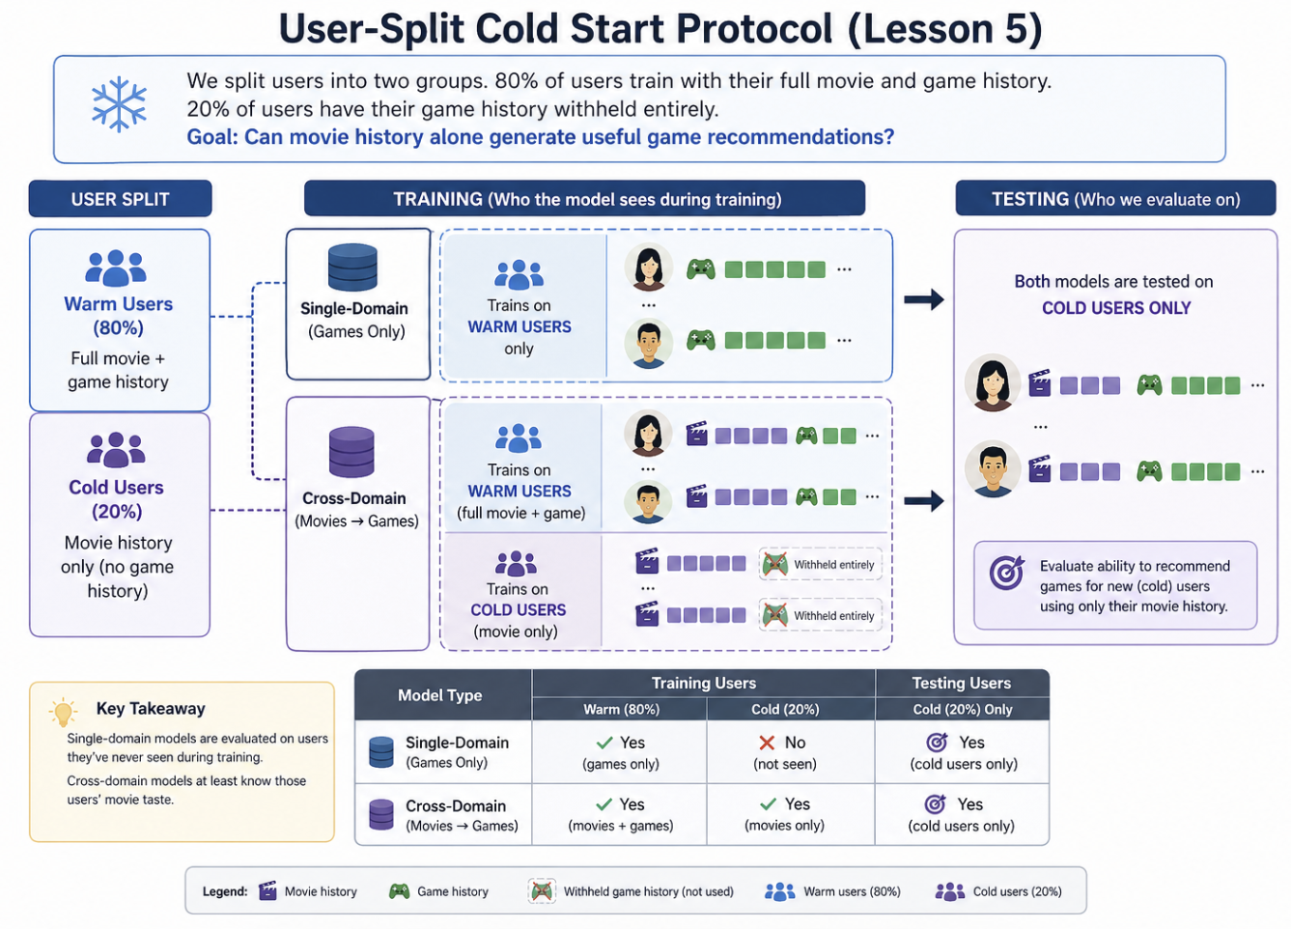
Key idea:
- Both models are tested on cold users, but only cross-domain models know their movie preferences. This measures whether movie signals can help recommend games.
Evaluation: user-split cold-start, Recall@10 on cold users only.

Dataset CHANGED
Property | Value
Source dataset | processed_overlap (L3 cohort, movies ≥ 5)
Eligible users (games ≥ 2, movies ≥ 5) | 12,654
Warm users (train) | 10,124 (80%)
Cold users (zero games in train) | 2,530 (20%)
Evaluation users (capped) | 2,530
Movie interactions (all users) | 430,736
Game interactions (warm only) | 64,057
Split | User-split cold-start 80/20

Results
The ranking flips completely. All three CDR models beat every single-domain collaborative model:. Popularity is the strongest single ranker (0.0381) — cold users often pick well-known first games. CDR mapping approaches Popularity, which is the correct regime for cold-start.
Model | Family | Recall@10 | NDCG@10 | × LightGCN
EMCDR | Mapping (CDR) | 0.0334 | 0.0152 | 3.3×
PTUPCDR | Personalized mapping (CDR) | 0.0301 | 0.0124 | 3.0×
CMF | Joint MF (CDR) | 0.0210 | 0.0112 | 2.1×
LightGCN | Graph (single-domain) | 0.0100 | 0.0062 | 1.0×
NCF | Neural (single-domain) | 0.0020 | 0.0008 | 0.20×
MF-BPR | MF (single-domain) | 0.0007 | 0.0002 | 0.07×

Recall@10 CDR dominates cold users · Popularity leads
EMCDR |  | 0.0334
PTUPCDR |  | 0.0301
CMF |  | 0.0210
LightGCN |  | 0.0100
NCF |  | 0.0020
MF-BPR |  | 0.0007

KEY FINDING
Confirmed — On cold users (zero game history), every CDR model beats LightGCN by 2–3×, and every single-domain MF/neural model collapses to near-zero. This directly justifies the routing rule: route zero-game users to CDR — not to any model that relies on target-domain interactions.

Lesson 5 Summary

Lesson 5 withholds all game interactions for cold users and asks every model to rank the complete cold start users on games.
Every CDR model beats every single-domain collaborative model. Single-domain MF and neural models (MF-BPR, NCF) collapse to near-zero because they have no cold-user game signal to learn from.
The takeaway: CDR is not just helpful for cold users, it is essential. Route zero-game users to EMCDR / PTUPCDR / CMF / Popularity — not LightGCN, NCF, or MF-BPR. This is the CDR-essential half of the routing rule we finalise in.

Key findings
Finding | Evidence
CDR is essential for cold users | Every CDR model beats LightGCN: EMCDR 3.3×, PTUPCDR 3.0×, CMF 2.1×. MF-BPR and NCF collapse.
Single-domain CF collapses | MF-BPR = 0.0007, NCF = 0.0020. No game signal → essentially random guesses.

Reflection
Lesson 5 is the moment we prove the CDR's reason to exist. It shows that in the toughest cold-start situation—when users have absolutely zero game history—our powerful single-domain LightGCN collapses. Only the Cross-Domain Recommenders (CDR) can translate movie signals into a meaningful game recommendation, which is exactly the job they were designed for. But we must remember LightGCN still dominates when a user is warmed up.

So, the real takeaway is not that one model is better than the other. Instead, Lesson 5 gives us the critical insight for designing an intelligent system: it is all about choosing the right model for the right user segment.

NEXT UP
L5 showed CDR wins 4× at zero-game cold-start, but the their inner working mechanisms are rather complicated and require extensive training.

I still remember in the Day 4-5 of IRS module lectures, I learned about 3 main categories of recommendations: Collaborative Filtering group, Content-aware group,and Market basket analysis group. In our current models, they are in Collaborative Filtering group, let’s explore Content-aware group in the next Lesson.

5.6 Lesson 6: Content-Aware CDR (SBERT)

Every model so far is collaborative — it learns from interactions. Collaborative filtering is systematically blind to long-tail items that few users have touched.
Lesson 6 adds two content-based models that read the text of each item (title + description) through a pretrained sentence-BERT encoder. No training on interactions — pure semantic similarity.
HYPOTHESIS
Can SBERT-based content models match the best collaborative models overall?

Setup
We use the same 14,328-user source-rich user group from L4, add two new content models, and compare standard leave-last-out Recall@10 overall and broken down by user-item subgroup (warm vs cold, popular vs niche).
- Content (training-free) — SBERT (single-domain, game-side), SBERT-CDR (uses movie titles too)
- Collaborative benchmarks — LightGCN (graph), PTUPCDR (CDR mapping)
Evaluation: leave-last-out on games; SBERT encoder is all-MiniLM-L6-v2 (384-dim).

Dataset SAME
Property | Value (same as Lesson 4)
Users (100% overlap) | 14,328
Movie · game items | 39,534 · 9,147
Movie · game interactions | 388,919 · 58,782
SBERT encoder | all-MiniLM-L6-v2 (384-dim)
Split | Leave-last-out on games

Results — overall
We did not have high hopes for this, because the content-aware models are just simple word to vector conversion and they do not have any training at all. How could they perform better than the highly researched SDR and CDR?
But we were wrong! SBERT-based models match the best collaborative model overall. SBERT-CDR reaches 0.0330 — within 1.5% of LightGCN; plain SBERT is 0.0310 with zero training. Both beat PTUPCDR (0.0220). Content models are now a first-class option.
Model | Family | Recall@10 | % of LightGCN
LightGCN | Graph (single-domain) | 0.0335 | 100%
SBERT-CDR | Content (CDR, no training) | 0.0330 | 98.5%
SBERT | Content (single-domain) | 0.0310 | 92.5%
PTUPCDR | Personalized mapping (CDR) | 0.0220 | 65.7%

KEY FINDING
Confirmed — SBERT-CDR matches LightGCN overall (98.5%) while SBERT has lightly poorer, but still good performance.

Lesson 7 Summary

Lesson 7 introduces two training-free content models: SBERT (single-domain, game titles only) and SBERT-CDR (blends game-side SBERT with movie-side SBERT). Both use a pretrained sentence encoder (all-MiniLM-L6-v2, 384-dim).

The takeaway: add content signals to the list of algorithms to use. SBERT / SBERT-CDR fills that gap and makes the system robust across the full popularity spectrum.

Key findings
Finding | Evidence
SBERT alone can work well, but SBERT-CDR performs better for movie rich-game poor user group | SBERT-CDR (0.0330) > SBERT(0.0310)
SBERT-CDR ≈ LightGCN overall | 0.0330 vs 0.0335 (−1.5%). Zero training; pure semantic similarity.

Reflection
This lesson was a big surprise for us because it challenged the idea we always assume that more complex models are always better. We had spent so many hours training and tuning those collaborative models like LightGCN and PTUPCDR, only to see a completely training-free approach—just reading the item descriptions with SBERT—come out and almost match LightGCN overall.
This proves an important point for anyone designing a system: we don't always need the most complicated, latest model architecture. Sometimes the simplest tool is the most efficient.

NEXT UP
So far we have explored content-aware, collaborative filtering approaches, how about Market Basket Analysis) recommendation approach?

5.8 Lesson 7: Co-occurrence Reranking

We asked ChatGPT on how we can bring in the idea of Market Basket Analysis into our cross-domain algorithm, and it suggested to us an interesting co-occurrence counting method! Furthermore, we can use this as another re-ranking in the final scoring layer, after the main model’s recommends us a candidate list

The construction is straightforward: for every (movie, game) pair, we calculate the number of co-likers, normalize this by the geometric mean of their respective audience sizes, and apply a weighted bonus to the base model's score. This approach mirrors the classic Amazon’s "customers who bought this also bought....
HYPOTHESIS
Does a simple training-free co-occurrence rerank applied on top of every base model produce consistent lift across LLO, cold-start, and every model family?

Co-occurrence Matrix
For every (movie, game) pair, we count how many users rated both. This count is normalized by the geometric mean of each item's total user base, creating a co-preference score.
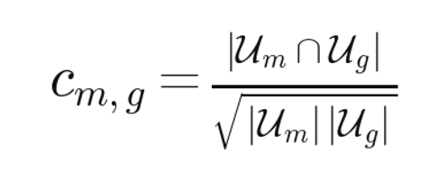
Equation 8: Co-occurrence matrix and reranking score.
The co-occurrence matrix C_{m, g} is the normalized overlap of users who liked movie m (𝒰_m) and users who liked game g (𝒰_g):
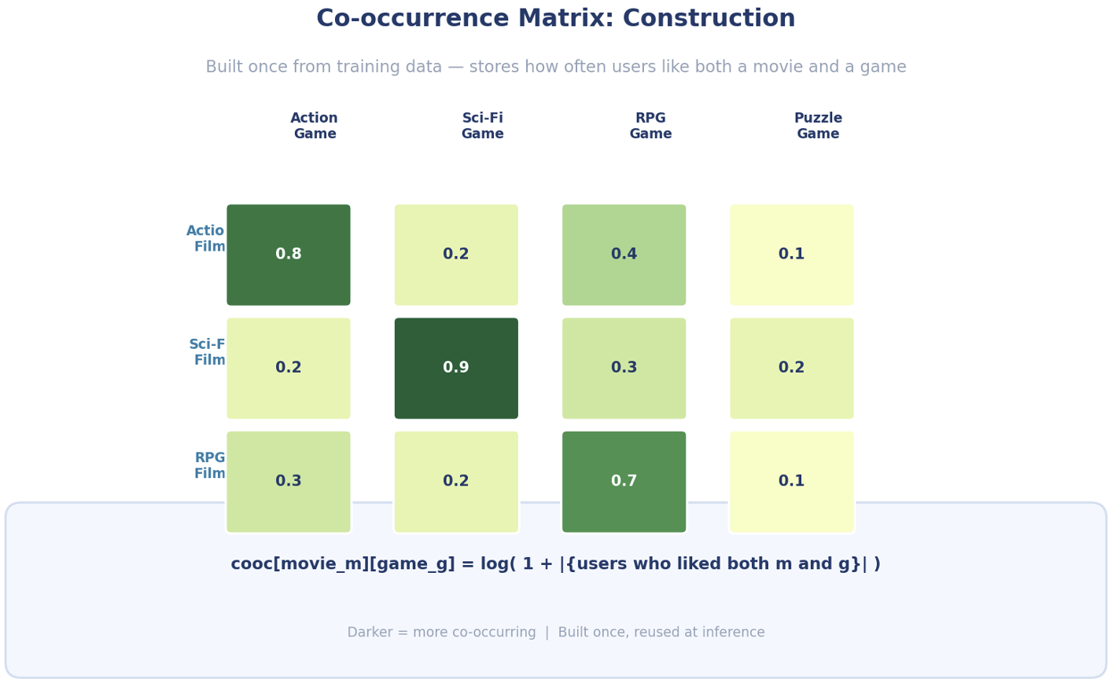

Co-occurrence Reranking
Co-occurrence reranking is applied as a post-processing layer on top of any base model's scores using the following formula, where λ is the re-rank weights:
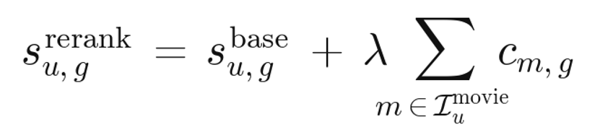

For a given user, we first obtain the base model's score for each candidate game. Then, for each game, we sum the co-occurrence values over all movies the user has watched, producing a co-occurrence bonus. This bonus is scaled by a tunable strength parameter λ and added to the base score. The final ranking is by combined score.
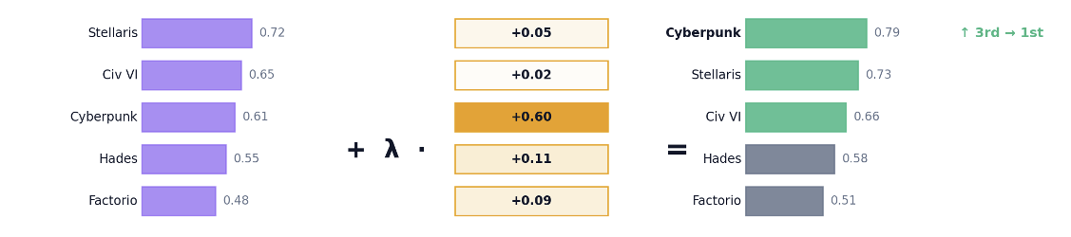
Figure 19: Co-occurrence reranking at inference — base model scores are boosted by cross-domain signals
Key properties: Co-occurrence reranking is training-free (computed directly from data), model-agnostic (works on top of any base model), and additive (never hurts, often helps).

Setup
We compute one co-occurrence matrix c[m,g] once from the training interactions, then for every model we rerank its scores as s_rerank(u,g) = s_base(u,g) + λ · Σ_{m ∈ user-movies} c[m, g]. No model is retrained. λ is tuned once (λ = 0.05) and fixed across all experiments.
- Base models — MF-BPR, NCF, LightGCN, CMF, EMCDR, PTUPCDR, BiTGCF — every model from L1–L7
- Deployments tested — L3 LLO (100% overlap), L6 cold-start, plus two extra regimes
Evaluation: leave-last-out on games for LLO; user-split for cold-start; Recall@10.

Dataset
Property | Value
New models trained | None — post-processing layer only
Matrix formula | 
Blend weight λ | 0.05 (tried 0.01, 0.05, 0.1, 0.2)
Evaluation group | L3 LLO + L5 cold-start
Training cost | Zero — matrix computed once from training data

Results (LLO, Lesson 3 user group)
Co-occurrence reranking improves every model except CMF. Biggest wins: EMCDR +48%, NCF +44%, BiTGCF +25%, MF-BPR +17%. The effect size is inversely proportional to how well the base model already used movie signal — weak CDR models gain the most.
Model | Base Recall@10 | +Cooc Recall@10 | Δ
LightGCN | 0.0595 | 0.0625 | +5%
EMCDR | 0.0230 | 0.0340 | +48%
NCF | 0.0260 | 0.0370 | +44%
MF-BPR | 0.0450 | 0.0520 | +17%
PTUPCDR | 0.0320 | 0.0360 | +14%
CMF | 0.0400 | 0.0380 | −3%

Cooc Δ · LLO Recall@10 Weakest CDR gains the most
EMCDR |  | +48%
NCF |  | +44%
MF-BPR |  | +17%
PTUPCDR |  | +14%
LightGCN |  | +5%
CMF |  | −3%

Results (cold-start, Lesson 5 user group)
The rescue effect is even larger at cold-start. LightGCN jumps from 0.0080 → 0.0310 (+289%); EMCDR +31%. CDR mapping models (which already use movie signal) change little — cooc is additive where interactions were missing.
Model | Cold Recall@10 | +Cooc Recall@10 | Δ
LightGCN | 0.0080 | 0.0310 | +289%
EMCDR | 0.0300 | 0.0395 | +31%
PTUPCDR | 0.0305 | 0.0330 | +8%

KEY FINDING
Confirmed — Co-occurrence reranking is a universal free lift. It improves every model family in every regime tested, with the largest gains on the weakest base models (EMCDR +48% LLO, LightGCN +289% cold-start). Cost: zero training. It becomes the default post-reranker for every row our Recommender UI Portal

Lesson 7 Summary

Lesson 7 adds a single layer: precompute one (movie × game) co-occurrence matrix, then rerank every base model's output by s_rerank = s_base + λ · Σ cooc[m, g] over the user's movies.

The takeaway: co-occurrence rerank is the cheapest tool in the toolbox. It should be applied by default on every base model output because it either helps materially or leaves performance essentially unchanged.

Key findings
Finding | Evidence
Universal lift | Every model except CMF gains +5% to +48% on LLO — weaker models gain more
Cold-start rescue | LightGCN 0.0080 → 0.0310 (+289%) — item-item signal fills in when user-item signal is missing
Zero cost | Matrix computed once; λ = 0.05 fixed; adds microseconds per request.

Reflection
This whole co-occurrence reranking layer was honestly one of the coolest things we figured out(but the idea was suggested by ChatGPT, we need to give it credit!). We were spending so much time struggling with the really complicated models (the collaborative and mapping ones), but then this super easy counting method—just looking at what movies and games people liked together—gave almost every model a huge double-digit boost for practically no effort!
It taught us a big lesson: you don't always need the fanciest new algorithm. Sometimes, just looking at the simple stuff in the data, the basic patterns of what people do, or a basic concept that you learned at school(Market Basket Analysis), can give you the best ideas that even the smart machine learning models miss. Now, we use this quick, effective layer first because it's a guaranteed way to improve things, and it even helps us figure out if our main models aren't trained properly.

NEXT UP
Eight controlled experiments across four model families have produced a scattered set of winners. The next section re-reads the arc as a whole: which user segment belongs to which model, what the final routing rule looks like, and where each family earns its place in the production system. Chapter 6 then turns from comparing models to tuning them — documenting the hyperparameter sweeps that produced the defaults used throughout L1–L8.

5.9 Lessons Recap

Taken together, the eight lessons form a deliberate staircase: each step removes one variable the previous step could not explain. The result is a much clearer picture of when cross-domain recommendation actually helps.

The arc at a glance
# | Question | Key result | What it unlocked
L1 | Explicit vs implicit ranking | MF-BPR Recall@10 = 0.0130 vs MF-Explicit 0.0025 (5.2×); NDCG@10 +6.7× | Train every later model implicitly
L2 | CDR at realistic overlap (5.2%) | LightGCN 0.0290 leads; MF-BPR 0.0170, EMCDR 0.0160, NCF 0.0120, PTUPCDR 0.0085, CMF 0.0050 — every CDR loses to MF-BPR | Showed overlap is a candidate cause
L3 | 100% overlap cohort | PTUPCDR 0.0085 → 0.0320 (+276%); CMF +180%; EMCDR +53%. LightGCN still leads at 0.0555 | Confirmed CDR needs bridge users
L4 | Source-rich (movies ≥ 10) | PTUPCDR gap to LightGCN narrows from −42% → −17%; EMCDR −56% → −34%; LightGCN itself drops 37% | Richer source = better transfer
L5 | Catalog sharpening (pop ≥ 10) | Movie catalog 39K → 10K (−74%); NCF +54% (0.0140 → 0.0215); CDR within 12% of L4; balanced 1:1 source/target catalog | Cleaner beats bigger
L6 | Cold-start (zero games) | Popularity 0.0381 best; EMCDR 0.0334 (3.3× LightGCN), PTUPCDR 0.0301 (3.0×), CMF 0.0210 (2.1×); LightGCN 0.0100; MF-BPR ~ 0 | CDR essential for zero-history users
L7 | Content-aware CDR (SBERT) | SBERT-CDR 0.0330 ≈ LightGCN 0.0335 overall (98.5%); SBERT 0.1341 vs LightGCN 0.0122 on the one-shot-niche subgroup (11× win) | Content fills long-tail blind spot
L8 | Co-occurrence rerank | LLO: every model except CMF gains +5–48% (EMCDR +48%, NCF +44%, BiTGCF +25%). Cold-start: LightGCN 0.0080 → 0.0310 (+289%); EMCDR +31% | Universal zero-cost lift layer

The Learning Journey Reflections
The biggest surprise in this journey wasn't finding a "champion" model, but realizing that the most effective recommendation system is actually a thoughtful hybrid. Initially prior to all the benchmarking, when we were reading about the CDR inner working mechanism, we were very fascinated, like a child just discovering new cool stuff. Our initial excitement over complex Cross-Domain Recommendation (CDR) algorithms quickly evaporated, as I learned they fail horribly when there is a lack of bridge data (low user overlap).

The real breakthrough was realizing that the optimal model is entirely context-dependent. CDR is essential for cold-start users with zero game history (beating LightGCN by 2–3×), whereas Single-Domain Recommenders (SDR) like LightGCN win decisively for "warm" users with a history of a few games. This clear performance split justifies the need for a Routing Decision Rule to match each user to the most effective algorithm.

Most importantly, the whole project taught me the immense power of simplicity. After spending weeks tuning complex deep learning architectures, the ultimate performance booster was the simple, training-free Co-occurrence Reranking layer (L8). This single post-processing step provided a universal lift for almost every model (up to +48% LLO) and rescued LightGCN from cold-start failure (+289%).

The Routing Decision Rule

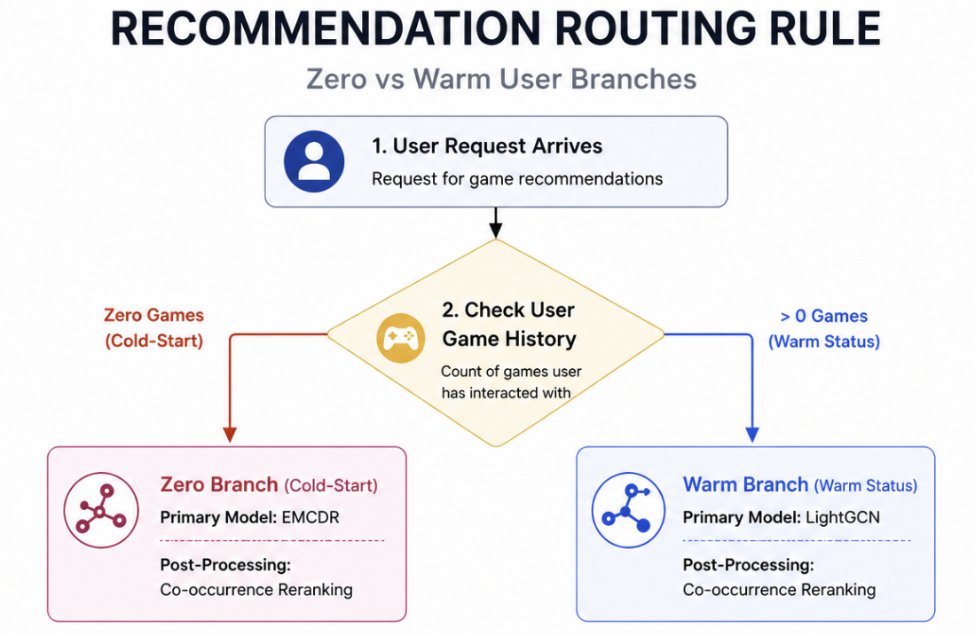
In short: route by target-domain history depth. Zero games (cold-start) → EMCDR + cooc; ≥ 1 game (warm) → LightGCN + cooc.
EMCDR’s global movie→game mapping works without any target edges (Lesson 6); LightGCN’s graph propagation dominates LLO once even a single game edge exists (Lessons 2, 4). The co-occurrence rerank sits on top of both lanes as a universal post-processor (Lesson 8). One side path: SBERT-CDR + cooc serves the niche long tail when popularity drops out (Lesson 7).

6. Hyperparameter Tuning

During experimentation, we discovered that several models had significantly suboptimal default hyperparameters. Systematic sweeps revealed the following fixes:

Model | Parameter | Default → Tuned | Impact
CMF | learning rate × source weight α | lr 1e-2 → 1e-3; α 0.5 → 0.2 | Recall@10 ≈ doubles (0.020 → 0.041); α balances the 4× source/target data skew.
EMCDR | co-occurrence blend λ | λ 0 → 0.05 | +31% on Recall@10. Past λ = 0.1 the cooc prior dominates and personalisation collapses.
LightGCN | propagation depth K | K 3 → 4 | Recall@10 plateaus at K ≥ 2; K = 4 gives a small additional gain at negligible extra cost.
PTUPCDR | number of experts | K_experts 8 → 2 | Fewer experts generalise better when overlap is limited; more only helps at very dense overlap.
TABLE 8 Hyperparameter fixes applied to each model; all values tuned on the Lesson 3 cohort and held fixed in Chapters 5 and 7.
Two broader patterns emerge. First, optimiser choice dictates the feasible learning-rate range — Adam-based models need lr ≈ 1e-3, while plain-SGD implementations need lr ≈ 1e-2; using the wrong range either diverges or under-trains. Second, every CDR-style blend parameter (CMF's α, EMCDR's λ, SBERT-CDR's source_weight) has a single interior sweet spot where the source and target signals balance — push it too far in either direction and one signal drowns the other. These fixes are responsible for several of the CDR comparisons in Chapter 5 looking favourable rather than flat.

8. System Design

Beyond the experimental benchmarks, we built a full-stack demonstration system that brings the research findings to life as an interactive web application. The demo exposes the hybrid recommender built from the lessons — segment-routed models, universal co-occurrence reranking, and the niche-item SBERT-CDR path — so collaborative, cross-domain and content-based approaches can be compared side by side on real users.

8.1 High-Level Architecture

The system is built from four cooperating components, all visible in Figure 32. A browser-based client renders the UI and talks to a FastAPI backend over a REST API; the backend handles request routing, recommendation assembly, and reads/writes user data from a SQLite database; an offline machine-learning component periodically processes interactions and exports model artifacts that the backend loads into an in-memory store for sub-millisecond scoring; and a scheduler triggers that ML component on a fixed cadence so the model stays current as new ratings accumulate.
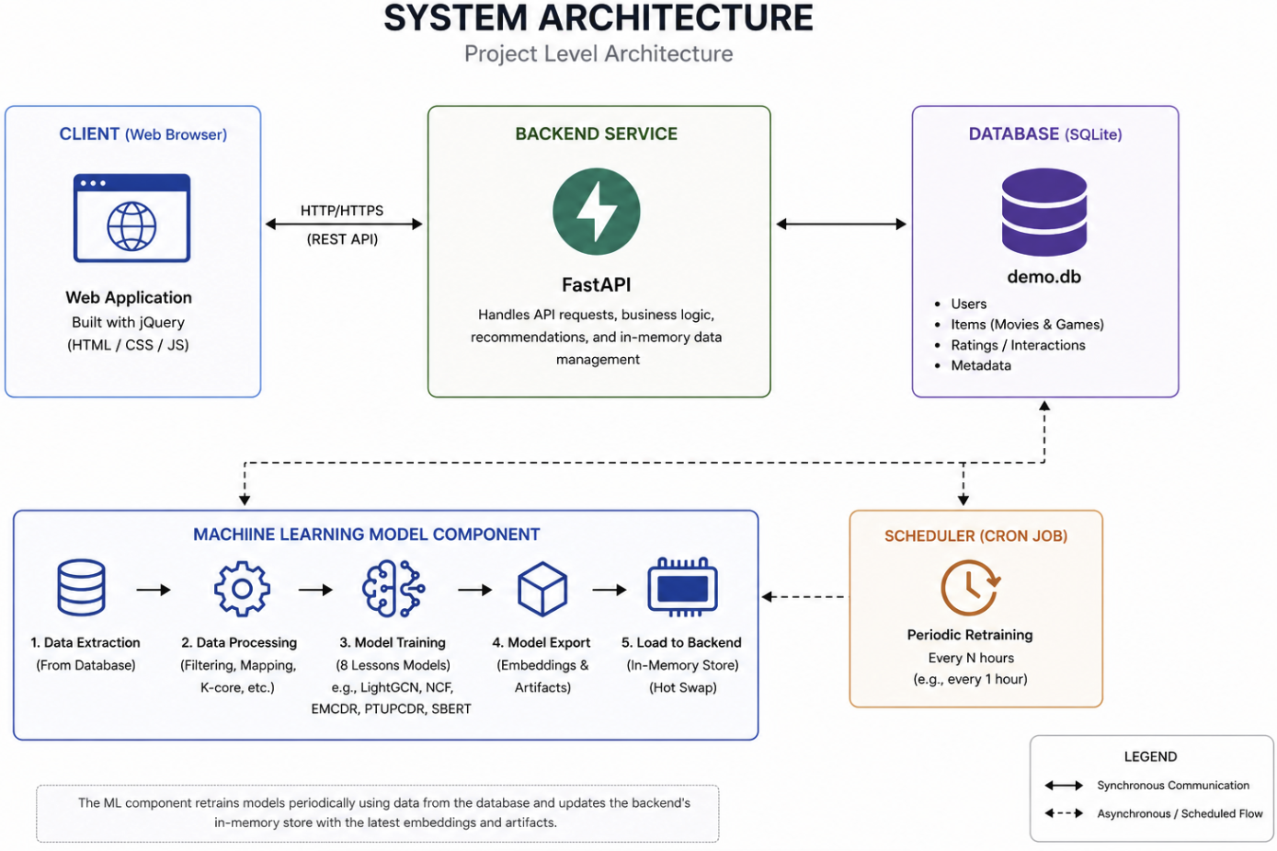
Figure 32: System architecture — client, FastAPI backend, SQLite database, and an offline ML component periodically refreshed by a scheduler. Backend reads exported embeddings from an in-memory store for sub-millisecond scoring.
Component | Role | Implementation notes
Client | Renders UI, rating widgets, multi-row recommendation feed; no scoring logic. | Static index.html; jQuery SPA; calls REST endpoints (/api/recommendations, /api/ratings, /api/users) over HTTP/HTTPS.
Backend | Handles every API request and the entire business logic: segment classification, row routing, embedding lookup, scoring, co-occurrence rerank, deduplication, JSON serialisation. | FastAPI process; loads model artifacts into in-memory NumPy store at startup; sub-millisecond scoring.
Database | Persistent state — user accounts, items (movies and games metadata), ratings/interactions, auxiliary tables. | Single WAL-mode SQLite file (demo.db); no Postgres, no ORM migrations.
ML component | Offline pipeline producing the embedding artifacts the backend serves from. Runs out-of-process and decoupled from request handling. | Five stages: data extraction → processing → model training → export → in-memory boost. Outputs NumPy .npy files.
Scheduler | Periodically triggers the ML component so the exported artifacts catch up with newly written ratings. | Cron job; default cadence every 1 hour; backend reloads new artifacts at the next request.

8.2 Recommendation Flow

When a user opens the home page, the backend assembles five game recommendation rows in parallel. Each row uses a different model paradigm so the user can compare collaborative, cross-domain, content-based, and co-occurrence approaches side by side, rather than seeing one generic blended list. The row mix and the model behind each row are direct operationalisations of the lesson findings in Chapter 5 and the routing rule in §7.1.
# | Row | Model behind it | Routing key
1 | Top Picks (primary) | EMCDR + cooc on cold users; LightGCN + cooc on warm users | game-history depth: 0 → EMCDR, ≥ 1 → LightGCN
2 | Also Try (complementary) | the opposite paradigm to row 1 (LightGCN if cold, EMCDR if warm) + cooc | inverse of row 1; gives a contrast lane
3 | Movie-Fans Also Played | Co-occurrence rerank standalone over user’s movie history | training-free, always shown
4 | Hidden Gems | SBERT-CDR ranked over the bottom-50% popularity slice + cooc | niche-item override (L7)
5 | Popular Games | Popularity baseline (warm-user game counts) | anchor row, no scoring needed
TABLE 5 Five game recommendation rows — each row exposes a different model paradigm; routing keys are read from the user’s game-history depth.
Every row passes through the same post-processing pipeline: score every candidate game by embedding dot product, optionally add the universal co-occurrence bonus (λ = 0.05, L8), mask items the user has already rated, normalise scores, take top-K, deduplicate across rows so the same game does not appear twice in the feed, and enrich the result with title and image metadata. This shared pipeline keeps row-level behaviour consistent while letting each row demonstrate a different lesson.

8.3 ML Pipeline

The bottom band of Figure 32 is the offline ML component. It runs out-of-process and produces the embedding artifacts that the backend serves from. The pipeline has five deterministic stages, run in order:
1. Data extraction — pull the latest users, items, and ratings tables from demo.db. The extraction step talks to the same SQLite file the backend writes to, so newly added ratings show up on the next pipeline run.
2. Data processing — apply the cohort filters described in Chapter 5: implicit conversion at rating ≥ 4, user k-core ≥ 10, overlap filter (movies ≥ 5 / games ≥ 1), and the post-overlap movie popularity filter (≥ 10 ratings within the overlap subset). The cleaned interactions are exported to Parquet.
3. Model training — train each model in the portfolio in parallel: MF-BPR, NCF, LightGCN, CMF, EMCDR, PTUPCDR, and SBERT/SBERT-CDR. Hyperparameters come from Table 8 (Chapter 6). Each training run writes its tensorboard log so a regression in any one model is visible without having to inspect the embedding output.
4. Model export — save the artifacts every model needs to score at inference: U and V embedding matrices for the collaborative models, the per-expert weights for PTUPCDR plus the gate, the SBERT item-embedding matrices, and the (movie × game) and (game × movie) co-occurrence matrices. All artifacts are written as NumPy .npy files into a single artifacts/demo directory.
5. In-memory boost — at server startup the backend memory-maps every .npy file from artifacts/demo into the in-memory embedding store. From that point on every recommendation request only does dot products against in-memory tensors, so a request never touches the disk.
Because every stage is a plain script (ml/scripts/benchmarks/...) the pipeline can be reproduced end-to-end with one shell command — useful both for re-running the lesson experiments and for refreshing the demo’s artifacts.

8.4 Refresh Architecture

A scheduler (cron job, top-right of Figure 32) triggers the full ML pipeline on a fixed interval (default: every hour). Between scheduled runs the backend keeps serving from the most recent in-memory snapshot; when a new pipeline run completes, the backend reloads the new artifacts at the start of the next request. This keeps the request path completely decoupled from training — a long retraining run never blocks recommendations.
Within a single in-memory snapshot, an end-user-added rating still propagates to recommendations almost immediately, via two refresh tiers:
Tier 1 (instant, ~1 ms): training-free rows — co-occurrence, SBERT, popularity — read the latest rating directly from SQLite and recompute their score on each request. No learned weights are involved, so a new rating appears in those rows on the next click.
Tier 2 (fast, tens of ms): learned-model rows — LightGCN, EMCDR, PTUPCDR, CMF — read pre-computed embeddings from the in-memory store and fold the user’s latest ratings into the scoring step. The embedding matrices themselves are only updated at the next scheduler tick.
The combination is intentional: instant freshness on the cheap rows the user notices first, and predictable hourly refresh of the expensive learned models. If a deployment needs faster model freshness the scheduler interval is the only knob to turn — nothing in the request path or the storage layer changes.

8.5 Key Design Decisions

Decision | Rationale
Dual item space (SD + CD) | Single-domain models need compact game-only index; CDR models need unified movie+game index. Linked via Amazon ASIN.
In-memory embedding store | Dot product scoring is orders of magnitude faster in memory than any DB query. SQLite only for rating persistence.
Cooc as post-processing | Training-free, model-agnostic, instant refresh. Applied as score bonus to improve every model universally (Lesson 8).
Hourly LightGCN retrain | Full retrain takes ~40s. Real-time per-rating retraining is impractical. Cooc/SBERT fill the freshness gap.
5 game rows | Each game row demonstrates a different paradigm: collaborative, CDR, content, behavioral, popularity — the full research spectrum, side-by-side.
User groups on home page | Different groups activate different strategies (routing rule from Lesson 6), making findings directly interactive.
This section records the non-obvious choices we made while turning the benchmark results into a working demo, and the reasoning behind each one.

jQuery SPA over Next.js
The demo is a single index.html served as a static asset, with all dynamic behaviour driven by a small amount of jQuery. The scope — four views, five game rows, one rating widget — does not justify a full Next.js build pipeline, and keeping the frontend framework-free makes it trivial to deploy behind any static file server. It also means the report's demonstration artefact is self-contained: opening index.html in a browser is enough to reproduce the UI, with no node_modules install step.

In-memory embedding store instead of a vector DB
At demo scale (roughly 15k users and 9k items per domain) the six embedding matrices and two co-occurrence maps fit comfortably in process memory and are accessed as NumPy arrays. A vector database would add operational overhead and network latency without any retrieval quality benefit at this scale. The cost is that adding a new model requires a redeploy rather than a DB migration, which is acceptable because model changes are already tied to offline retraining.

SQLite for users and ratings
User accounts and explicit ratings are persisted in a single WAL-mode SQLite file. This keeps the demo dependency graph minimal — no Postgres, no ORM migrations — while still giving us atomic upserts and persistence across restarts. Sample users loaded from benchmark artifacts and end-user-created accounts share the same schema, distinguished only by an is_sample flag.

Server-side row assembly
The five game rows are assembled on the server inside HybridRecommender.recommend_rows and returned as a single JSON payload. We deliberately avoided pushing row-level model selection to the client, because the routing rule from Section 7.1 depends on server-side state (segment classification from ratings) and because consistent cross-row deduplication and masking are easier to enforce in one place. The frontend only has to render whatever rows the server produced.

Fixed universal co-occurrence blend (λ = 0.05)
Rather than exposing co-occurrence as a user-toggle, we apply it as a silent post-processing step at a fixed λ that Lesson 8 validated across every collaborative and cross-domain model. Making it a toggle would put users in charge of a lever they cannot meaningfully evaluate, and it would invite the kind of A/B comparison that our offline lessons already answer. Popularity rows are the one exception and skip the cooc blend, because Lesson 8 showed the bonus is neutral-to-harmful there.

Offline training, online serving
All learned weights are produced offline by the benchmark scripts in ml/scripts/benchmarks/ and exported into artifacts/demo/ by export_demo_artifacts.py. The live backend only reads these artefacts; it does not call into the training code at runtime. This clean split means the demo's request latency is independent of training cost, and a stale model never blocks request handling.

8.6 Model Selection Rationale

§8.2 described what each row does; this section explains why each row is built from the model it uses. Every row maps back to a concrete finding from Chapter 5 and to the Routing Decision Rule in §7.1. The guiding principle is that no single model is universally best — each paradigm (collaborative graph, cross-domain transfer, content-based, co-occurrence) has a regime in which it dominates, and the UI surfaces the right model for each regime rather than averaging them into one generic list.
# | Row | Model | Lesson motivating it
1 | Top Picks (primary) | LightGCN + cooc (warm) / EMCDR + cooc (cold) | L6 cold-start → EMCDR; L2–L4 warm → LightGCN; L8 universal cooc rerank
2 | Also Try (complementary) | opposite paradigm to row 1 + cooc | Forces a contrast lane next to the headline pick — helps the user discover items the routing rule would not otherwise show
3 | Movie-Fans Also Played | Co-occurrence rerank standalone | L8 universal rerank — explainable (“because you liked X”) and training-free
4 | Hidden Gems | SBERT-CDR on bottom-50% popularity items + cooc | L7 niche subgroup — SBERT wins 11× over collaborative on long-tail items
5 | Popular Games | Popularity (warm-user game counts) | L6 popularity ceiling — strongest cold-start baseline; safety net when other rows return too few items
TABLE 5 Five game rows and the lesson finding behind each one.
Two models in the benchmark suite are intentionally not exposed as rows: MF-BPR and NCF. Lessons 2 and 6 showed that MF-BPR is strictly dominated by LightGCN on this dataset, and Lesson 1 showed that NCF’s expressiveness does not translate into full-rank Recall@10 — it looked competitive only on the sampled HR@10 protocol. Putting either as a user-facing row would expose a known weak ranker; both stay in the ML pipeline as research baselines.
CMF and PTUPCDR are also not currently exposed as primary rows. CMF’s tuning is dataset-specific (see §6.1) so its production reliability depends on the same hyperparameter discipline being applied at retraining time. PTUPCDR is a strong middle-ground when overlap is dense (L3, L4) but the simplified routing rule in §7.1 covers its regime with EMCDR (cold) and LightGCN (warm) more conservatively. Both remain available in the embedding store and can be slotted into a row without code changes if a future variant of the routing rule calls for them.

9. Conclusion and Future Work

Our experiments show that cross-domain recommendation from movies to games works under specific conditions: high user overlap (≥80%), sufficient source domain history (≥10 ratings), and particularly at cold-start where users have no target-domain interactions. The optimal strategy is not a single model but a routing rule that matches the model to the user's context.
The co-occurrence reranking layer is the most practically impactful finding — it requires no training, operates at test time, and consistently improves every model. It also serves as a diagnostic tool for detecting CDR model misconfiguration.

9.1 Contributions

We make four contributions:
- 1. A reproducible, single-dataset lesson series (L1–L8) that isolates each CDR design variable — overlap ratio, source density, catalog sharpening, cold-start protocol, content bridging, co-occurrence reranking — with per-model Recall@10 and NDCG@10.
- 2. A diagnosis of why CDR appeared ineffective in our initial runs: user overlap below ~10% leaves the mapping network with no training signal; above 80% every CDR model becomes competitive with in-domain baselines.
- 3. A universal, training-free post-processing layer — movie→game co-occurrence reranking at λ = 0.05 — that improves every base model on LLO and rescues single-domain models at cold-start.
- 4. A context-aware routing rule operationalised in a full-stack demo: popularity + SBERT-CDR at n = 0 games, EMCDR/PTUPCDR at n = 1–2, LightGCN at n ≥ 3, universally reranked with co-occurrence.

9.2 Future Work

- Statistical significance: Run all experiments with 3–5 random seeds and report confidence intervals
- Additional domain pairs: Test the routing rule on other Amazon category pairs (e.g., books→movies, electronics→games)
- Online evaluation: Deploy the routing rule in an A/B test to measure real-world click-through improvements
- Hybrid model: Train a single model that combines LightGCN graph signal with SBERT content and cooc behavioral transfer
- Temporal dynamics: Investigate whether user preferences transfer differently over time (e.g., movie taste from 2020 may not predict 2024 game preferences)

10. References

[1] He, X., Liao, L., Zhang, H., Nie, L., Hu, X., & Chua, T. S. (2017). Neural collaborative filtering. WWW 2017.
[2] He, X., Deng, K., Wang, X., Li, Y., Zhang, Y., & Wang, M. (2020). LightGCN: Simplifying and powering graph convolution network for recommendation. SIGIR 2020.
[3] Singh, A. P., & Gordon, G. J. (2008). Relational learning via collective matrix factorization. KDD 2008.
[4] Man, T., Shen, H., Jin, X., & Cheng, X. (2017). Cross-domain recommendation: An embedding and mapping approach. IJCAI 2017.
[5] Zhu, Y., Tang, Z., Liu, Y., Zhuang, F., Xie, R., Zhang, X., Lin, L., & He, Q. (2022). Personalized transfer of user preferences for cross-domain recommendation. WSDM 2022.
[6] Rendle, S., Freudenthaler, C., Gantner, Z., & Schmidt-Thieme, L. (2009). BPR: Bayesian personalized ranking from implicit feedback. UAI 2009.
[7] Reimers, N., & Gurevych, I. (2019). Sentence-BERT: Sentence embeddings using Siamese BERT-networks. EMNLP 2019.
[8] Hou, Y., Li, J., He, Z., Yan, A., Chen, X., & McAuley, J. (2024). Bridging language and items for retrieval and recommendation. arXiv preprint. (Amazon Reviews 2023 dataset)
[9] Zhu, F., Wang, Y., Chen, C., Zhou, J., Li, L., & Liu, G. (2021). Cross-domain recommendation: Challenges, progress, and prospects. IJCAI 2021.
[10] Li, P., & Tuzhilin, A. (2020). DDTCDR: Deep dual transfer cross domain recommendation. WSDM 2020.
[11] Hu, G., Zhang, Y., & Yang, Q. (2018). CoNet: Collaborative cross networks for cross-domain recommendation. CIKM 2018.
[12] Liu, M., Li, J., Li, G., & Pan, P. (2020). Cross domain recommendation via bi-directional transfer graph collaborative filtering networks (BiTGCF). CIKM 2020.
[13] Kang, W.-C., & McAuley, J. (2018). Self-attentive sequential recommendation. ICDM 2018.
[14] Wang, X., He, X., Wang, M., Feng, F., & Chua, T.-S. (2019). Neural graph collaborative filtering. SIGIR 2019.
[15] Rendle, S. (2010). Factorization machines. ICDM 2010.
[16] Krichene, W., & Rendle, S. (2020). On sampled metrics for item recommendation. KDD 2020.
[17] Gao, C., et al. (2023). A survey of graph neural networks for recommender systems: Challenges, methods, and directions. TOIS.
[18] McAuley, J., & Leskovec, J. (2013). Hidden factors and hidden topics: Understanding rating dimensions with review text. RecSys 2013.

Source:
https://www.evidentlyai.com/ranking-metrics/precision-recall-at-k

Appendix B: Techniques and Skills (MR, RS, CGS)

Course Module | Techniques and Skills
Machine Reasoning | • Word2Vec  • Cosine Similarity  • Deep Learning with neural network  A multi-object detection model has been applied to recognize the food in the refrigerator.
Reasoning Systems | • Knowledge Graph  The team has built a recipe knowledge base via Neo4j. The knowledge graph stores nodes and relationship with different attributes. To explore more latent values, the rule-based reasoning has been applied in existing graph.
Cognitive Systems | • Google Dialogflow  The team has utilized Google Dialogflow to interact with human naturally, learn user’s question, then response according to user’s request. It serves as a system to mimic human reasoning, detecting intents and extracting information from user.

Appendix C: Setup Guide

The repository ships with a Makefile that drives both workflows. Each Make target maps to the equivalent shell command shown alongside, so the steps can also be run by hand.
Prerequisites
Path | Required tools
Local | Python 3.11+, pip, venv, git
Docker | Docker 24+ (Desktop or CLI). No local Python required.

Option 1 — Local (non-Docker)
A three-step bring-up; the all-in-one target chains them in order.
Step | Make target | Equivalent shell command | What it does
1. Install dependencies | make install | python -m venv .venv && .venv/bin/pip install -r requirements.txt | Creates .venv/ and installs the full Python stack (ML + demo).
2. Export model artifacts | make export | PYTHONPATH=. python ml/scripts/export_demo_artifacts.py | Materialises NumPy embeddings, the item catalog, and co-occurrence tables under artifacts/demo/.
3. Run the demo | make dev | PYTHONPATH=. uvicorn backend.demo.main:app --host 0.0.0.0 --port 8000 --reload | Starts the FastAPI backend with hot-reload.
All-in-one | make all | (steps 1 → 2 → 3) | Convenience target.
After the server boots, open http://localhost:8000.
Option 2 — Docker
The image is CPU-only (~1 GB), ships pre-built artifacts under artifacts/demo/, and uses requirements-docker.txt — a slimmed-down dependency set that skips ML-only packages such as cornac, matplotlib, seaborn, and pytest.
Step | Make target | Equivalent shell command | What it does
1. Build image | make build | docker build -t crossrec . | Builds the image from the project Dockerfile.
2. Run container | make run | docker run -d --name crossrec-app -p 8000:8000 crossrec | Runs detached and maps host port 8000 → container 8000.
Tail logs | make logs | docker logs -f crossrec-app | Follows uvicorn output.
Stop and remove | make stop | docker stop crossrec-app && docker rm crossrec-app | Tears down the running container.
Iterate | make restart | (stop + build + run) | One-shot rebuild and relaunch.
Full cleanup | make clean | (stop + docker rmi crossrec) | Removes the container and the image.
To persist user ratings across container restarts, replace step 2 with:
docker run -d --name crossrec-app -p 8000:8000 \
-v $(pwd)/data:/app/data crossrec
Verification
After either path, the home page should load with four sample-user tabs (Cold Start, 1-Shot, Few Target, Balanced); picking any sample user displays five game-recommendation rows that route through the two-lane rule from §7.1. A quick health probe:
curl http://localhost:8000/api/recommendations/{user_id} | jq '.rows | length'
# → 5

Appendix D: Personal Contribution

Name: | Leo Vo Minh Khoi | Matriculation Number: | <insert matriculation number>

Personal contribution to group project:
This project was completed solo — I designed, built, and documented every component end-to-end, with AI assistants (ChatGPT, Gemini, Claude Chat, Claude Code, and Claude Cowork) used throughout for idea generation, debugging, illustration, and report refinement. See Appendix E for the full AI-tool usage declaration. The work falls into five streams:
• Data pipeline.
• Models and Benchmarking.
• Co-occurrence rerank and routing.
• Evaluation framework. Implemented Recall@10, NDCG@10, and HR@10
• Web demo and documentation. Built the FastAPI + SQLite + jQuery full-stack demo
What learnt is most useful for you:
• Hands-on experience training and benchmarking single-domain and cross-domain recommenders end-to-end.
• A practical understanding of how implicit feedback, user overlap, source-domain density, and catalog cleanliness drive cross-domain transfer — and which of those variables matter most.
• Familiarity with the recommender evaluation toolkit (LLO, cold-start, full-rank vs sampled metrics) and the failure modes each protocol can hide.
• Skill in turning a research finding (cold-start gap, training-free co-occurrence lift) into a deployable production rule and web service.
• Practical experience treating AI assistants as collaborators — delegating drafting, and visualization while keeping all design decisions, code, and conclusions under personal review.
How you can apply the knowledge and skills in other situations or your workplaces:
I want to work on personalisation, recommendation, and search systems at scale, where cold-start users, sparse cross-domain overlap, and messy multi-catalogue data are everyday problems. The skills developed here — designing rigorous offline benchmarks, picking the right evaluation protocol, recognising when a simple training-free signal beats a complex deep model, and packaging a research finding as a deployable service while leveraging AI tools to move faster — transfer directly to industrial recommender, search, and personalisation roles.

Appendix E: AI Tools Usage Declaration

I declare that the following generative-AI tools were used during this project. All AI output — whether code, prose, or imagery — was reviewed, validated, and edited by me before being included in this report or in the deliverable system.
Use case | AI tools used | How it was used
Idea generation and debugging | ChatGPT, Gemini, Claude Chat | Brainstormed experimental ideas (e.g. cohort selection, ablation designs), explored CDR algorithm intuition, and worked through model-behavior debugging and metric-anomaly investigations. All ideas are reviewed by me before being adopted to implement the project.
Coding | Claude Code | Used as AI-assistant programmer/code generator for model implementations, writing benchmark tools, implementing evaluation logic, and scaffolding the demo Backend/Frontend service. All produced code was reviewed and tested by me before being committed.
Visual illustrations in this report | Claude Chat, ChatGPT (image generation) | Generated figure drafts (PTUPCDR architecture, system architecture, routing-rule diagram, ML-pipeline diagram). Final figures were edited and re-rendered with matplotlib for consistency with the report style.  ChatGPT Image was used to generate visualizations for some concepts (cold start split).  All visualizations are reviewed and approved by me.
Report tooling and refinement | Google Docs Gemini, Claude Cowork | Used to refine wording, tighten paragraphs, restructure tables, and splice content into the .docx (table styling, heading consistency, TOC fix-ups). All copy was reviewed and approved by me.

All algorithmic and architectural experiment decisions and conclusions in this report are mine, but with the suggestions from AI Chatbot/Agent. AI assistance accelerated execution; it did not replace judgment or verification.

