Cross-Domain
Recommender System
Movies → Games

IRS Project Report
A systematic experimental study of cross-domain recommendation
using the Amazon Reviews 2023 dataset
Leveraging movie preferences to recommend video games

Table of Contents
1. Executive Summary
2. Introduction
2.1 Background and Problem Statement
2.2 Research Methodology and Experiment Design
2.3 Aim and Objectives
3. Data
3.1 Data Source
3.2 Dataset Variants
3.3 Data Splitting Protocol
4. Methodology
4.1 Evaluation Protocol
4.2 MF-BPR: Matrix Factorization
4.3 NCF: Neural Collaborative Filtering
4.4 LightGCN: Graph Convolution
4.5 CMF: Collective Matrix Factorization
4.6 EMCDR: Cross-Domain Embedding Mapping
4.7 PTUPCDR: Personalized Transfer
4.8 SBERT-CDR: Content-Based Matching
4.9 Co-occurrence Reranking
5. Experiments and Results
5.1 Lesson 1: Explicit vs Implicit Ranking
5.2 Lesson 2: Low Overlap Kills CDR
5.3 Lesson 3: Overlap Filtering Rescues CDR
5.4 Lesson 4: Source-Rich / Target-Sparse
5.5 Lesson 5: Catalog Sharpening
5.6 Lesson 6: Cold-Start Protocol
5.7 Lesson 7: Content-Aware CDR (SBERT)
5.8 Lesson 8: Co-occurrence Reranking
5.9 Hyperparameter Analysis
6. Discussion
6.1 Routing Decision Rule
6.2 Key Insights
7. System Design
7.1 High-Level Architecture
7.2 Recommendation Flow
7.3 Frontend Architecture
7.4 Refresh Architecture
7.5 Key Design Decisions
7.6 Model Selection Rationale
8. Conclusion and Future Work
9. References

1. Executive Summary
This project investigates cross-domain recommendation (CDR) for transferring user preferences from movies to video games using the Amazon Reviews 2023 dataset. The central research question is: can a user's movie watching history improve game recommendations, particularly for users with little or no game interaction history?
We conduct a systematic, lesson-by-lesson experimental study comparing 8 recommendation models across 3 families: single-domain collaborative filtering (MF-BPR, NCF, LightGCN), cross-domain transfer models (CMF, EMCDR, PTUPCDR), and content-based models (SBERT, SBERT-CDR). Each lesson isolates a single experimental variable — user overlap ratio, source domain richness, catalog filtering, cold-start conditions, and post-processing — to understand what drives cross-domain transfer effectiveness.
Key Findings
(1) CDR models require high user overlap (100% vs 5.8%) to outperform single-domain baselines. (2) At cold-start (zero game history), CDR models achieve 4× better Recall@10 than LightGCN. (3) A simple, training-free co-occurrence reranking layer improves every model by 5–49% on standard evaluation and rescues single-domain models at cold-start (+289% for LightGCN). (4) SBERT content embeddings win 11× over collaborative models on niche/unpopular items. These findings justify a routing rule: select the model based on the user's game history depth and item popularity.
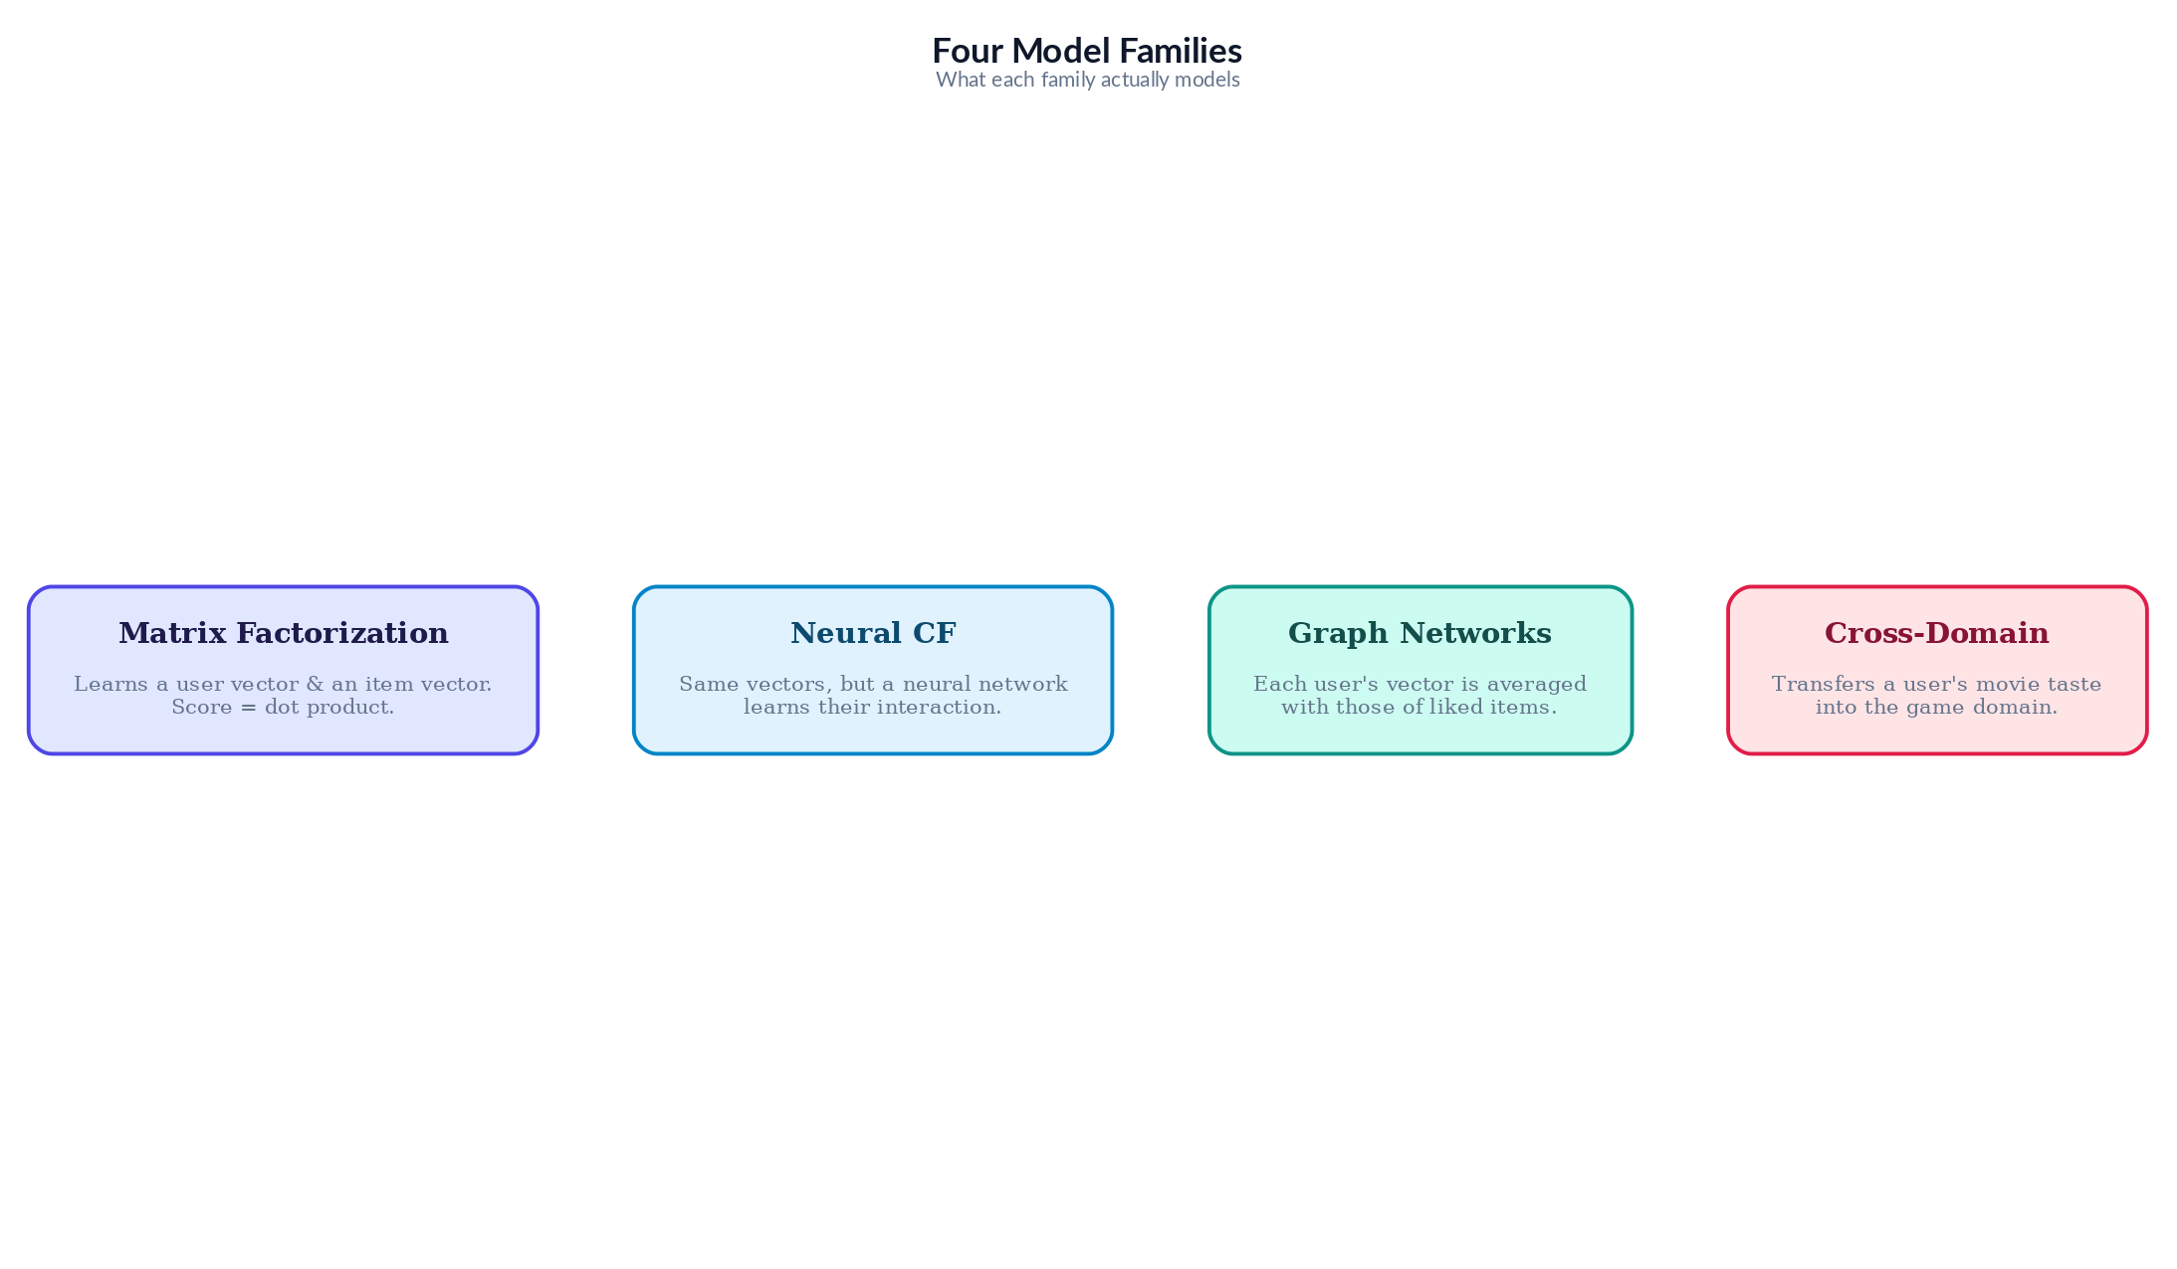
Figure 1: Model Family Strengths Across User Contexts

2. Introduction

2.1 Background and Problem Statement
Most recommendation systems are single-domain: they recommend items based solely on a user's interaction history within that domain. Cross-Domain Recommendation (CDR) transfers knowledge from a source domain (movies) to a target domain (games), addressing the cold-start problem — when a user has no target-domain history, CDR leverages their source-domain preferences.
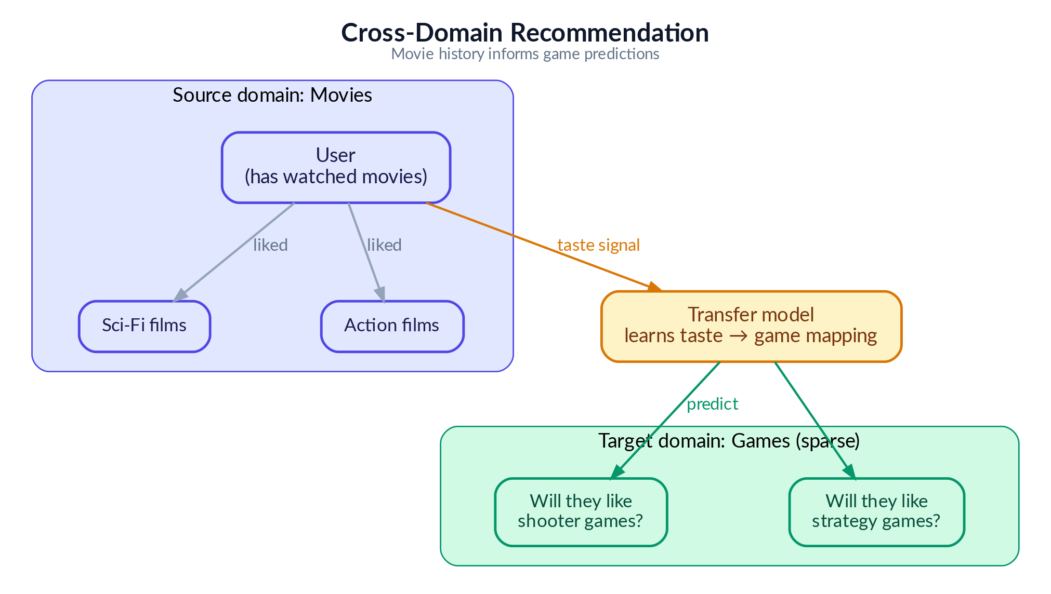
Figure 2: Cross-domain recommendation concept — transferring movie preferences to game recommendations

2.2 Research Methodology and Experiment Design
The experiments presented in this report are structured as a clean, progressive lesson series — but the path to this structure was far less linear. This section describes our actual research process, the challenges encountered, and how the final experiment design emerged from extensive exploratory work.

Phase 1: Literature Review and Infrastructure Setup
We began by studying the internal mechanisms of cross-domain recommendation algorithms — how models like EMCDR and PTUPCDR learn to map user preferences across domains, and how they differ from single-domain approaches like LightGCN that rely purely on within-domain interaction graphs. This informed our model selection: three CDR architectures (joint factorization, global mapping, personalized mapping) and three single-domain baselines (matrix factorization, neural, graph-based) to ensure fair comparison across model families.
We then built the base infrastructure: a data processing pipeline (raw Amazon reviews to filtered Parquet files), a standardized evaluation framework (full-rank and sampled protocols at K=10), and a benchmarking harness that ensures all models are evaluated on identical data splits. All models were implemented using publicly available libraries (RecBole, RecBole-CDR, PyTorch, scikit-learn) to avoid re-inventing the wheel and ensure reproducibility.

Phase 2: Exploratory Benchmarking and the CDR Disappointment
With the infrastructure in place, we ran extensive benchmarks comparing single-domain and cross-domain models across different data configurations. The initial results were consistently discouraging for CDR: LightGCN (a single-domain graph model) outperformed all CDR models in nearly every setting — including on user cohorts with rich movie history (>10 ratings) but sparse game history (3–5 ratings), precisely the regime where CDR is expected to excel.
We spent considerable effort trying different data configurations, user cohort filters, and hyperparameter settings. The CDR models consistently failed to demonstrate a clear advantage over the single-domain baseline. This raised a fundamental question: is the movie-to-game transfer signal in the Amazon dataset simply too weak for CDR to exploit?

Phase 3: Revisiting CDR Theory and Finding the Right Data Regime
Rather than concluding prematurely that CDR is ineffective — a conclusion contradicted by a large body of published research — we returned to the literature. Published CDR papers are evaluated under specific data conditions that we had not yet replicated: high user overlap between domains, rich source-domain history, and sparse or absent target-domain history.
Key Insight
The general-population Amazon dataset has only ~5.8% user overlap between movies and games — far too low for CDR mapping functions to learn from. Once we filtered to 100% overlap users and, crucially, tested on cold-start users with zero game history, CDR models finally outperformed their single-domain counterparts by 4×. The algorithms were not broken — the data regime was wrong.

Phase 4: Discovering Complementary Approaches
Along the way, we made two additional discoveries. First, a simple content-aware approach (SBERT sentence embeddings) performed surprisingly well — matching LightGCN overall and dominating 9–11× on niche/unpopular items. This reinforced a recurring theme: sophisticated model architecture does not guarantee better recommendations. What matters most is whether the model has access to the right signal for the right user segment.
Second, we explored hybrid approaches to augment the base models. After experimenting with various score fusion strategies, we discovered that a simple reranking of game candidates based on their co-occurrence with the user's liked movies improved scores for every model universally. This cross-domain item co-occurrence reranking requires no training and works as a model-agnostic post-processing layer — an unexpectedly powerful result.

Phase 5: From Exploration to Structured Lessons
With all findings in hand, we designed the final lesson series to present our discoveries as a progressive, pedagogically clear sequence. Each lesson isolates one experimental variable and builds on the previous lesson's conclusion. This structure was designed retrospectively — the actual research process involved many more experiments, several of which produced null results and were not included.
For example, in Lesson 5 (Catalog Sharpening), we hypothesized that removing long-tail movie items with very few ratings would produce denser, higher-quality source embeddings and improve CDR transfer. We tested genre whitelisting, overlap-user item filtering, and movie popularity thresholds as ablations. The result was largely null — filtering hurt single-domain LightGCN (smaller training catalog) and produced mixed results for CDR models. We included this lesson precisely because the null result is informative: it demonstrates that catalog manipulation is not a reliable lever for improving CDR, shifting attention to user-side factors (overlap ratio, source richness) instead.
In summary, our research methodology was deliberately exploratory: we ran a broad set of experiments, identified which factors genuinely drive CDR effectiveness (and which do not), and then distilled the findings into a curated lesson series that progresses from simple to complex. The lessons presented are the experiments that deepened our understanding — not necessarily the first experiments we ran.
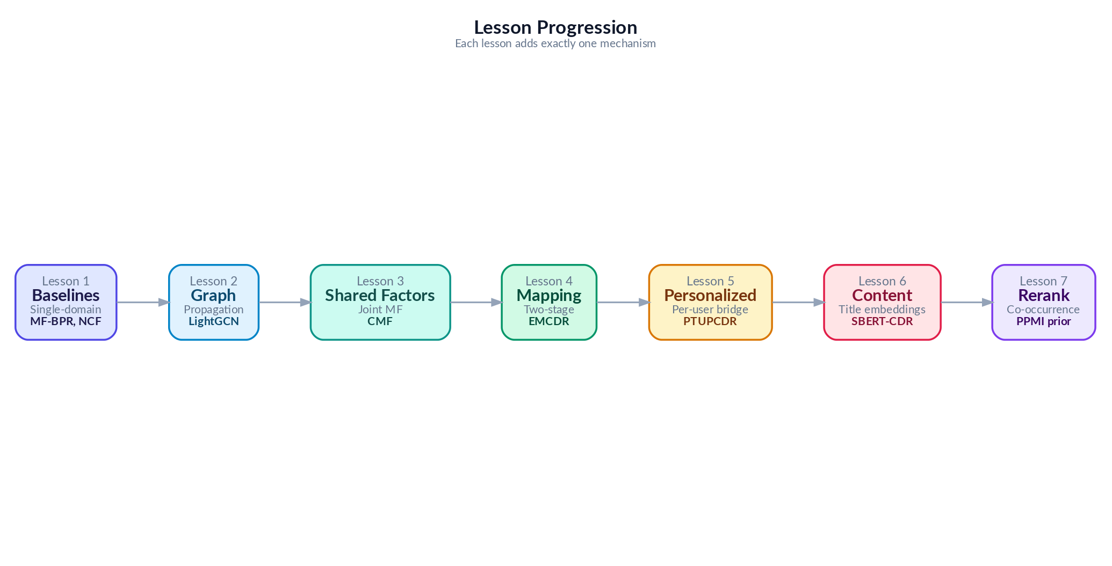
Figure 3: From Many Exploratory Experiments to 8 Curated Lessons

2.3 Aim and Objectives
- Compare explicit rating prediction vs implicit ranking approaches for recommendation (Lesson 1)
- Evaluate whether CDR models improve over single-domain models on naturally mixed populations with low user overlap (Lesson 2)
- Measure the impact of user overlap ratio on CDR effectiveness by filtering to 100% overlap users (Lesson 3)
- Investigate how source-domain richness (number of movie ratings) affects CDR transfer quality (Lesson 4)
- Test whether catalog sharpening (removing noisy items) improves CDR performance (Lesson 5)
- Evaluate CDR under true cold-start conditions where users have zero target-domain history (Lesson 6)
- Assess content-based SBERT embeddings as a cross-domain bridge for niche items (Lesson 7)
- Test co-occurrence reranking as a universal post-processing layer across all models and regimes (Lesson 8)

3. Data

3.1 Data Source
We use the Amazon Reviews 2023 dataset, a large-scale benchmark containing user reviews and ratings across multiple product categories. We focus on two domains: Movies and TV (user ratings of movies, DVDs, and streaming content) and Video Games (user ratings of video games across all platforms). Ratings are on a 1–5 star scale. We convert to implicit feedback by treating ratings ≥ 4 as positive interactions (POSITIVE_THRESHOLD = 4). This threshold is consistent across all experiments.
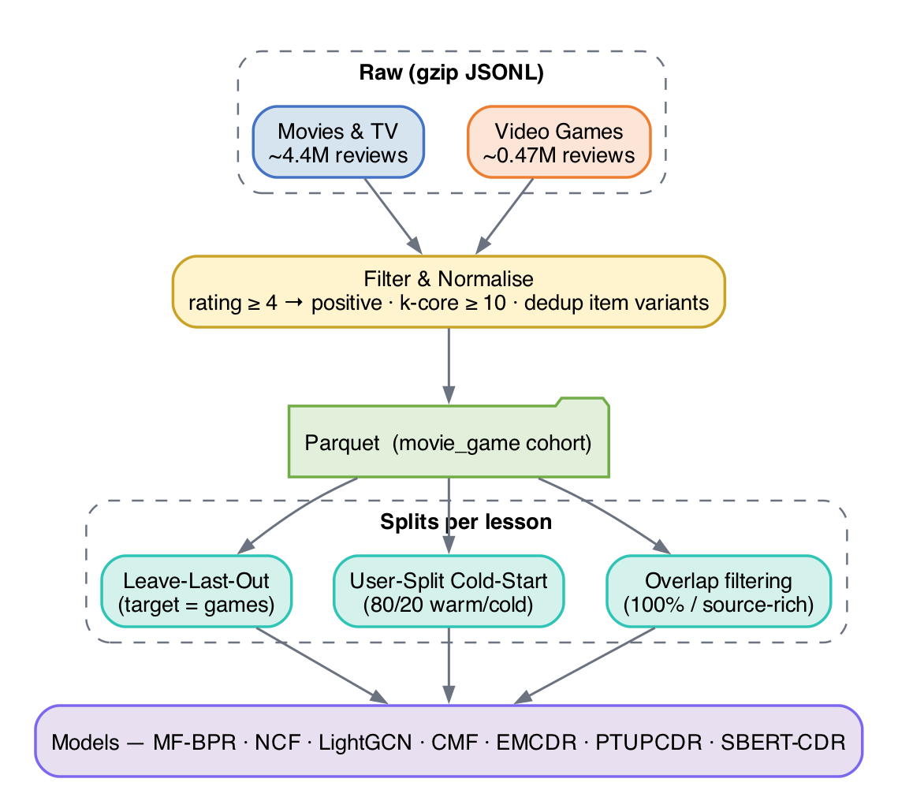
Figure 4: Data Processing Pipeline

3.2 Dataset Variants
Different lessons use different dataset configurations to isolate experimental variables:
Variant | Filter | Users | Movie Ints. | Game Ints. | Overlap % | Used in
Raw Mix | 1,000,000 | 45,933 | 11,706 | 5.2% | L1–L2 | No k-core
Overlap | 19,880 | 40,288 | 10,034 | 100% | L3 | movies≥5, games≥1
Src-Rich | 14,328 | 39,534 | 9,147 | 100% | L4,L7 | movies≥10, games≥1
Sharp | 14,328 | 10,311 | 9,147 | 99.8% | L5 | movie pop≥10
Cold Start | 12,654 | 40,288 | 10,034 | 100% | L6 | User split 80/20
- Base cohort (Lessons 2, 8 LLO): movie_game cohort with k-core ≥ 10, yielding ~14,328 overlap users, ~388,919 movie interactions and ~58,782 game interactions. Used for the main leave-last-out benchmark.
- 100% overlap cohort (Lesson 3): users with at least one rating in each of movies and games (~19,880 users). Isolates the effect of user overlap on CDR transfer.
- Source-rich / target-sparse cohort (Lesson 4): overlap users with ≥ 10 movie ratings and ≤ 5 game ratings. Stress-tests CDR where the source signal is strong but the target signal is thin.
- Catalog-sharpened cohort (Lesson 5): base cohort with long-tail items pruned (< 5 interactions). Tests whether removing noisy items improves CDR.
- Cold-start user split (Lessons 6, 8 cold): an 80/20 user split in which the held-out 20% have zero game ratings at training time. Evaluates true cold-start behaviour.
- Niche-item subgroups (Lesson 7): the base cohort partitioned by target-item popularity, used to isolate SBERT-CDR's strength on bottom-50% popularity games.

3.3 Data Splitting Protocol
We use leave-last-out (LLO) splitting on the target domain (games): for each user, the last game interaction by timestamp becomes the test item, the second-to-last becomes the validation item, and all earlier interactions from the training set. This simulates a realistic next-item prediction scenario. For Lesson 6 (cold-start), we use a user-split protocol: 80% of users train with their full game history, while 20% of users have their game history withheld entirely, testing whether their movie history alone can generate useful game recommendations.

4. Methodology
This section explains every model we evaluate, starting from the simplest and building up to the most sophisticated. We assume no prior knowledge of recommendation systems — each model is introduced with an everyday analogy, then its mechanism and math are explained step by step. We group models into three families: single-domain models (trained on game data only), cross-domain models (trained on both movie and game data), and content-based models (using text descriptions rather than ratings).
Meet Maya. To make the progression easy to follow, every model in this chapter is illustrated through one running story about “Maya,” who runs a small neighbourhood rental shop called “Maya’s Corner” that lends out both movies and video games. Maya’s goal is to recommend the right games to her patrons — including the many who have only ever rented movies. Each algorithm in this chapter is a new tool Maya adopts to do that job better, and each analogy explains exactly what problem the previous tool left unsolved. Read the analogies in order and you will see a clear line from the simplest possible approach to the full cross-domain system we benchmark in this report.

4.1 Evaluation Protocol
Before explaining the models, we describe how we measure their quality. Imagine a teacher giving a student an exam with one correct answer: Evaluation protocol defines how hard that exam is.
We use two complementary protocols. In full-rank evaluation, the model must pick the correct answer from the entire catalog of ~9,000 items — like finding a specific book in a large library. In sampled evaluation, the model picks from just 100 items (1 correct + 99 random distractors) — like a multiple-choice exam. Both protocols report metrics at K=10.
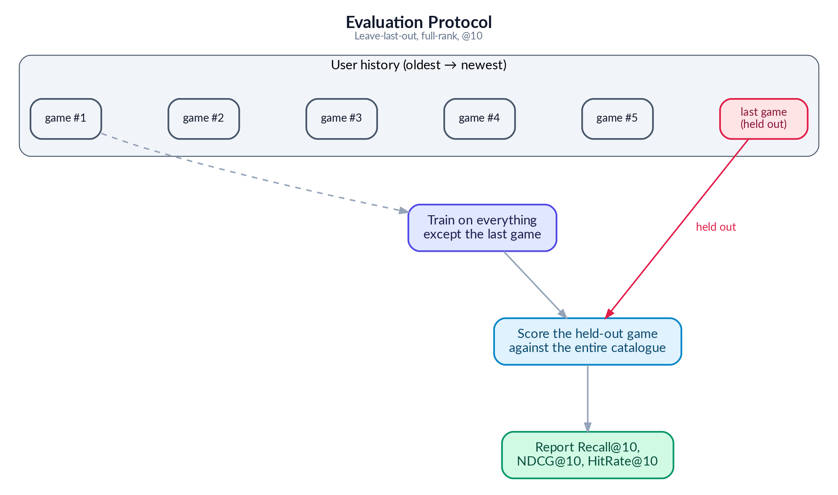
Figure 5: Full-Rank vs Sampled Evaluation Protocol
Recall@10 asks: did the correct item appear anywhere in the top 10? NDCG@10 goes further: was it ranked first (best), third (okay), or tenth (barely made it)? Higher positions earn more credit. Sampled metrics (HR@10, NDCG@10) are systematically higher than full-rank metrics because the task is much easier — choosing from 100 items vs 9,000+.
Single-Domain Models
The following three models are trained using game rating data only. They have no access to movie preferences. Think of them as specialists: they only know about games and recommend games based on what similar gamers have played.

4.2 MF-BPR: Matrix Factorization with Bayesian Personalized Ranking
Analogy — The Notebook Method. On her first day, Maya starts simple. For every patron and every game on her shelf she scribbles a small “taste card” — 64 numbers that try to capture things like “likes fast pace,” “prefers dark tone,” or “enjoys puzzles.” To decide whether a patron will like a game, Maya just lines up the two cards side by side and multiplies them number by number. If the totals add up high, it is probably a good match. The cards themselves are not handed to Maya — she learns them over time by watching which games each patron actually rented. This simple notebook already works surprisingly well, but the only way it can ever compare two cards is straight multiplication, so it misses any taste that needs a more subtle combination of traits.
Training. Training begins by assigning every user and every item a random vector of 64 numbers (drawn from a small Gaussian distribution). These vectors are the model's only learnable parameters. The model then iterates over 60 epochs, where each epoch samples millions of training triplets. A triplet consists of (user, positive item, negative item): the positive item is one the user actually interacted with (rated >= 4 stars), and the negative item is randomly sampled from items the user has never rated. For each triplet, the model computes two dot-product scores — one between the user vector and the positive item vector, and one between the user vector and the negative item vector. The BPR loss function then pushes the positive score to be higher than the negative score.
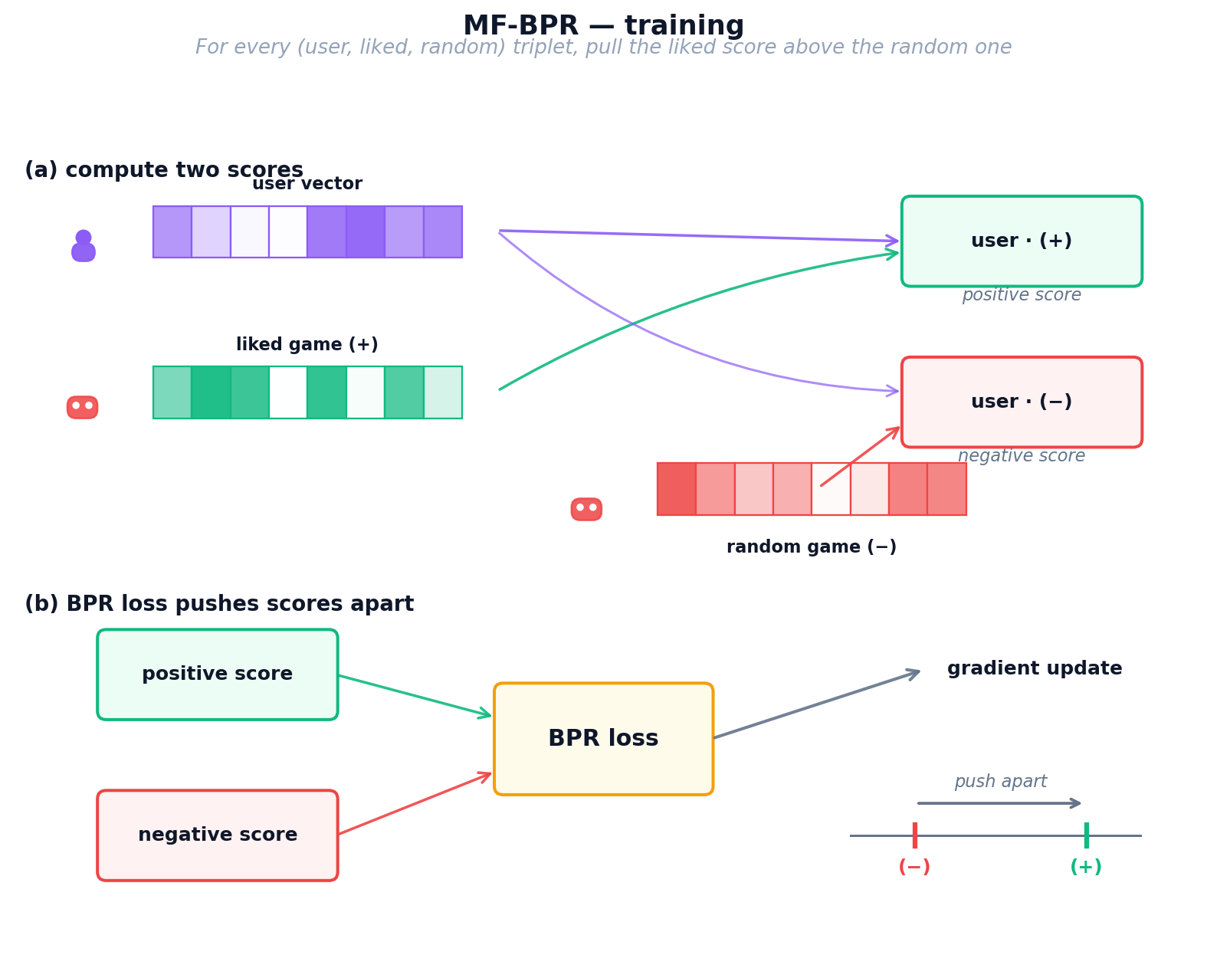
Figure 6: MF-BPR training process — user and item vectors learn from triplet sampling with BPR loss
BPR Loss. The Bayesian Personalized Ranking loss is elegant in its simplicity. For a user u, a positive item i+ that the user liked, and a negative item i⁻ sampled at random, the loss is:
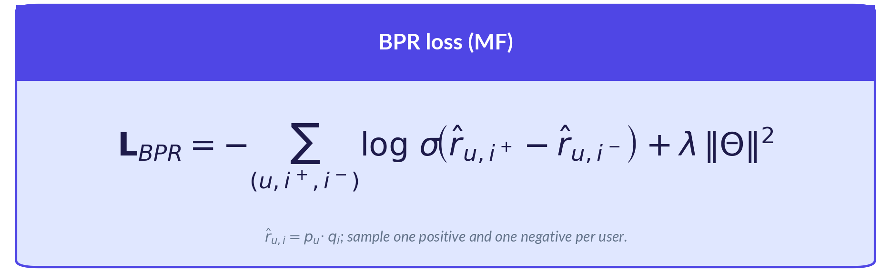
Where σ is the sigmoid function that squashes the score difference into [0,1]. When the positive score is much higher than the negative score, the sigmoid output approaches 1 and the loss approaches 0. When the scores are close or inverted, the loss is large, and gradient descent updates the vectors to increase the gap. The regularization term λ prevents vectors from growing too large. Optimization uses plain SGD with learning rate 0.05 (high because there is no momentum or adaptive scaling).
Inference. After training completes, the model artifacts are the learned user embedding matrix U (shape: n_users × 64) and item embedding matrix V (shape: n_items × 64), saved as .npy files. To generate recommendations for a user u, we compute the dot product of u's row in U with every row in V, producing a score for each item. Items are ranked by score in descending order, and the top-K items (excluding already-rated items) become the recommendations. This is a single matrix-vector multiplication, making inference extremely fast.
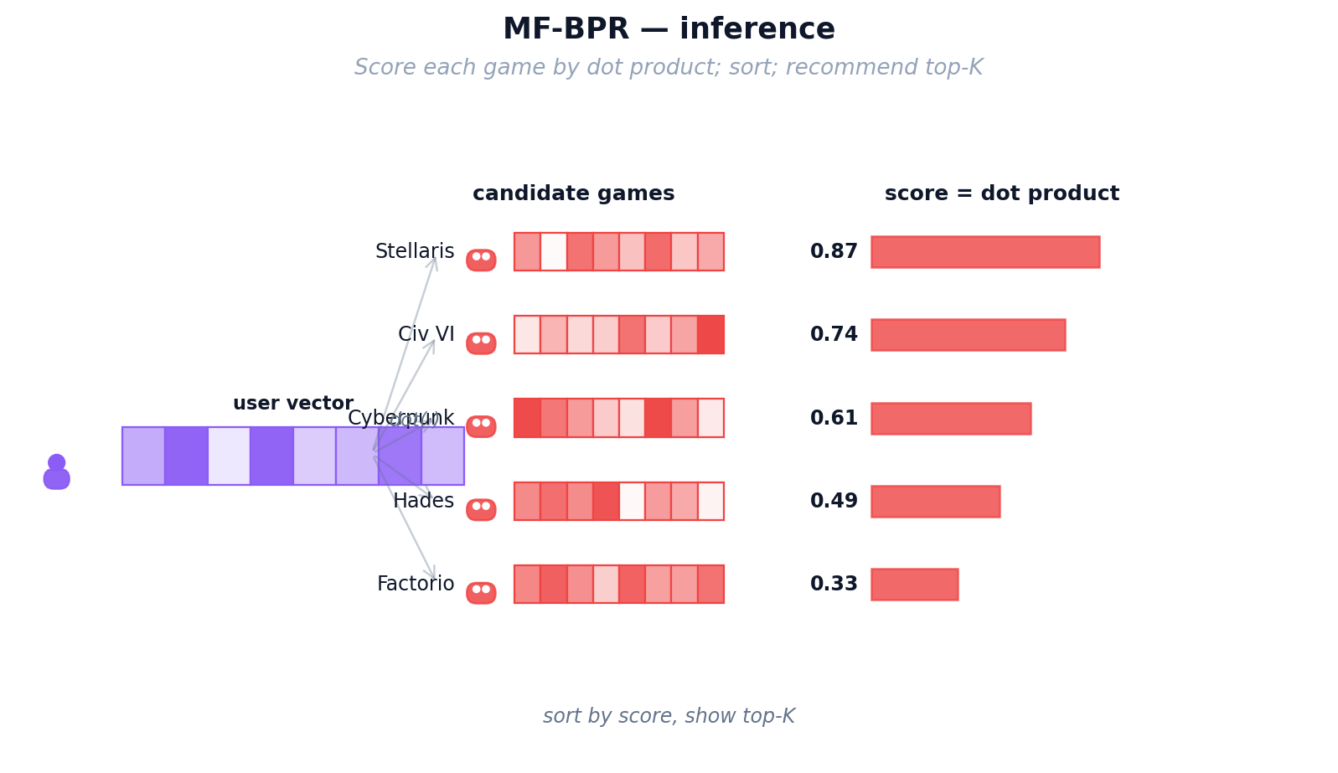
Figure 7: MF-BPR inference — dot product between user and item vectors produces ranking scores
Strengths: Simple, fast to train (~2 minutes), well-understood, and provides a strong baseline. Weaknesses: Each user and item is treated independently — the model can't leverage the fact that "users who like Game A also tend to like Game B" unless it discovers this pattern through the vectors alone. It also cannot handle cold-start users (no vector exists).
Parameter | Value | Notes
Embedding dimension | 64 | Each user/item = 64 numbers
Learning rate | 0.05 | High because plain SGD (no Adam)
Training epochs | 60 | Converges quickly on sparse data
Optimizer | NumPy SGD | Manual gradient descent
Regularization (λ) | 0.01 | L2 penalty on embedding norms

4.3 NCF (NeuMF): Neural Collaborative Filtering
Analogy — Maya Hires an Apprentice. After a few months, Maya notices her notebook method keeps missing oddly specific tastes — some patrons love “cozy horror,” a combination no single number on the card captures on its own. Straight multiplication just cannot express “like this trait AND that trait, but only together.” So Maya hires a young apprentice (a small neural network) whose only job is to look at a patron’s card and a game’s card and use intuition to combine them in nonlinear ways. She still keeps her original multiplication trick as a reliable baseline and lets the apprentice add a layer of judgement on top. Now Maya catches the subtle interactions her notebook missed — but her recommendations still only know what each individual patron has personally rented.
Architecture. NCF has two parallel branches that process user-item pairs differently, then merges their outputs for a final prediction. Each branch maintains its own separate set of user and item embeddings (64 dimensions each), so the model has 4 embedding tables total.
The GMF (Generalized Matrix Factorization) branch performs element-wise multiplication of user and item vectors. Given user embedding u_gmf and item embedding i_gmf (both 64-dim), the output is u_gmf ⊙ i_gmf — a 64-dimensional vector where each element is the product of the corresponding user and item values. This captures linear feature interactions, similar to standard matrix factorization.
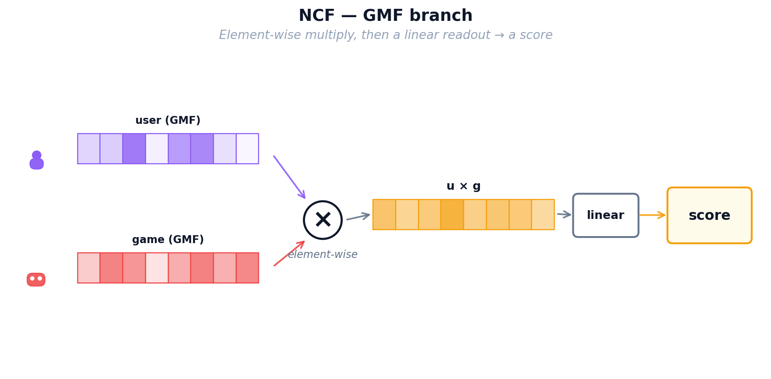
Figure 8: NCF — GMF branch: element-wise multiplication captures linear feature interactions
The MLP (Multi-Layer Perceptron) branch takes a different approach. It concatenates user and item embeddings into a single 128-dimensional input vector, then passes it through three hidden layers (128 → 64 → 32 neurons) with ReLU activations. Each layer applies a linear transformation followed by a non-linearity: output = ReLU(W · input + b). This allows the MLP to learn complex, non-linear patterns in user-item interactions that simple dot products cannot capture.
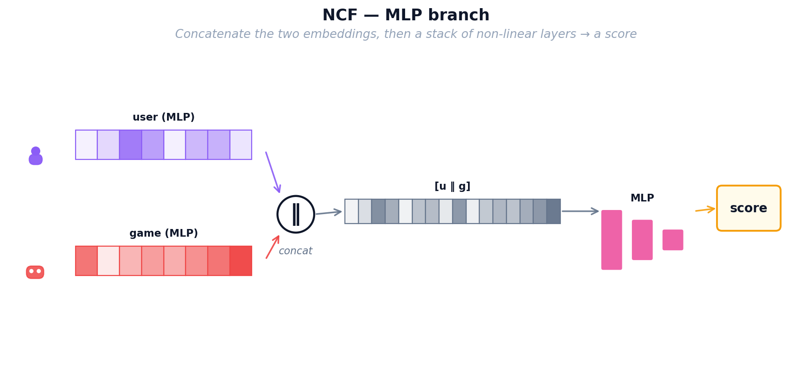
Figure 9: NCF — MLP branch: neural network layers learn non-linear user-item patterns
Combined Architecture. The final NeuMF (Neural Matrix Factorization) model concatenates the GMF output (64-dim) and MLP output (32-dim) into a 96-dimensional vector, then passes it through a single output layer with sigmoid activation to produce a score between 0 and 1.
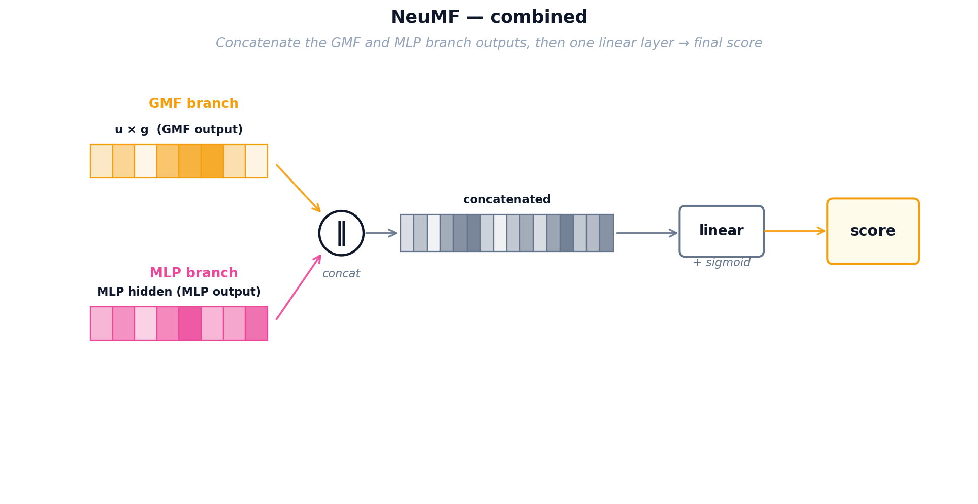
Figure 10: NCF — combined NeuMF architecture merging both branches into a final score
Training. NCF trains using Binary Cross-Entropy (BCE) loss on implicit feedback. Positive examples are user-item pairs where the user interacted with the item; negative examples are randomly sampled non-interactions (4 negatives per positive). For each batch of 256 user-item pairs, the model computes scores through both branches, merges them, and compares the predicted scores against the binary labels (1 for interaction, 0 for no interaction). The Adam optimizer adjusts all parameters (embeddings + MLP weights) with learning rate 0.001 over 150 epochs.
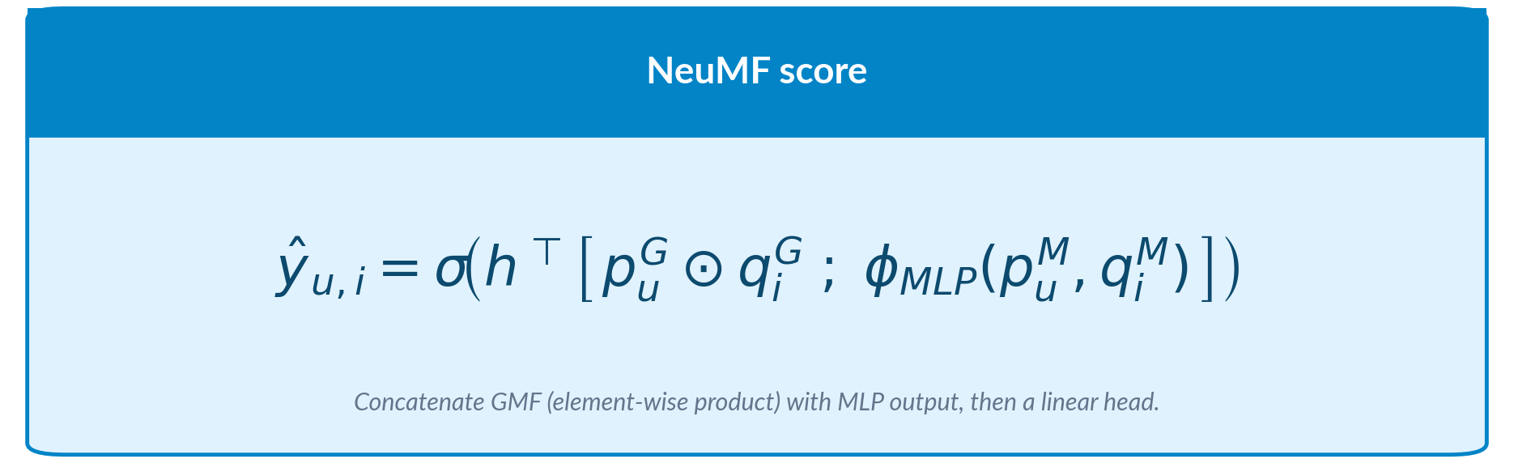
Where y=1 for observed interactions and y=0 for sampled negatives. The BCE loss penalizes confident wrong predictions heavily: if the model predicts 0.9 for a negative item, the loss contribution is −log(0.1) = 2.3, a strong gradient signal. This drives the model to clearly separate positives from negatives.
Inference. The trained artifacts include 4 embedding matrices (GMF user/item, MLP user/item) and the neural network weights (3 MLP layers + output layer). At inference, for a given user, the model must run a forward pass for every candidate item — unlike MF-BPR which uses a single matrix multiply. This makes NCF slower at inference but more expressive. In practice, we batch all items and run a single forward pass through PyTorch.
Parameter | Value | Notes
Embedding dimension | 64 | Separate embeddings for GMF and MLP
MLP layers | [128, 64, 32] | Three hidden layers with decreasing width
Negative samples | 4 per positive | Implicit feedback training
Training epochs | 150 | Longer training needed (was 50, improved +30%)
Optimizer | Adam (lr=0.001) | Adaptive learning rate per parameter

4.4 LightGCN: Graph Convolution for Recommendations
Analogy — The Shop Gossip Network. Maya now realises her patrons are not isolated — they influence each other. Alice loved Zelda and also loved Witcher; Bob just loved Witcher; odds are Bob will enjoy Zelda too, even though he has never heard of it. Instead of looking only at each patron’s own rental history, Maya pins up a big gossip board that connects every patron to every game they rented and every game to every patron who rented it. Taste now flows along these lines: each patron’s card gets gently blended with the cards of their neighbours, and then the neighbours-of-neighbours, so the cards carry community wisdom rather than one person’s history. Maya’s three tools so far (notebook, apprentice, gossip board) all share one limitation though: they only know about GAMES. A patron who has only ever rented movies is still invisible to them.
Graph Propagation. Users and items form a bipartite graph where each interaction creates an edge. LightGCN initializes random 96-dimensional embeddings for every node, then propagates information through the graph in K=3 rounds ("hops"). In each hop, a node's embedding is updated to be the weighted average of its neighbors' embeddings, with weights normalized by the square root of both nodes' degrees to prevent popular items from dominating.
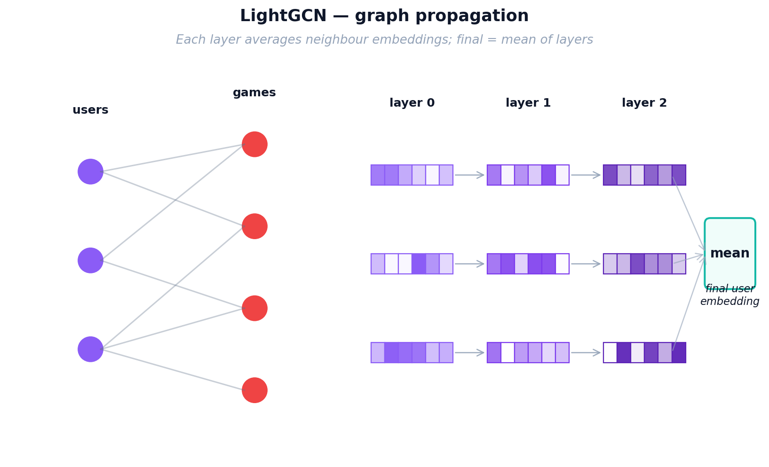
Figure 11: LightGCN graph propagation — information flows through multi-hop user-item connections
After K hops, each node has K+1 representations (from layer 0 to layer K). The final embedding is the simple mean of all layer representations. This layer-combination trick is critical: layer 0 captures the node itself, layer 1 captures direct neighbors, layer 2 captures 2-hop neighbors, and layer 3 captures 3-hop patterns. Averaging them balances local and global signals.
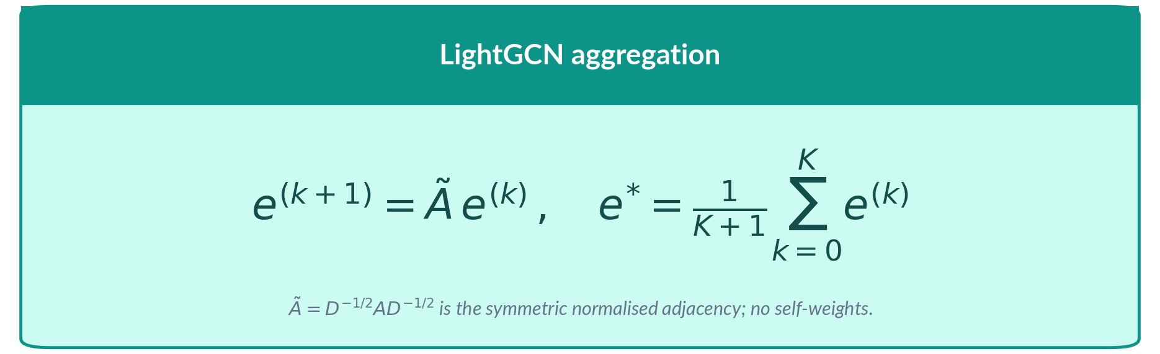
The normalization factor 1/√|N_u|√|N_i| (symmetric sqrt-degree normalization) ensures that popular items with many connections don’t overwhelm the signal from niche items. K=3 hops with 96-dimensional embeddings.
Training. LightGCN uses the same BPR loss as MF-BPR (positive items should score higher than random negatives), but the embeddings are first refined through graph propagation. In each training step: (1) sample a (user, positive, negative) triplet, (2) run K=3 layers of graph convolution to get refined embeddings, (3) compute dot-product scores, (4) compute BPR loss, (5) backpropagate gradients through all K layers back to the base embeddings. Only the base layer-0 embeddings are learnable; all propagation layers are parameter-free. This simplicity (no transformation matrices, no activation functions) is what makes LightGCN outperform more complex GCN variants.
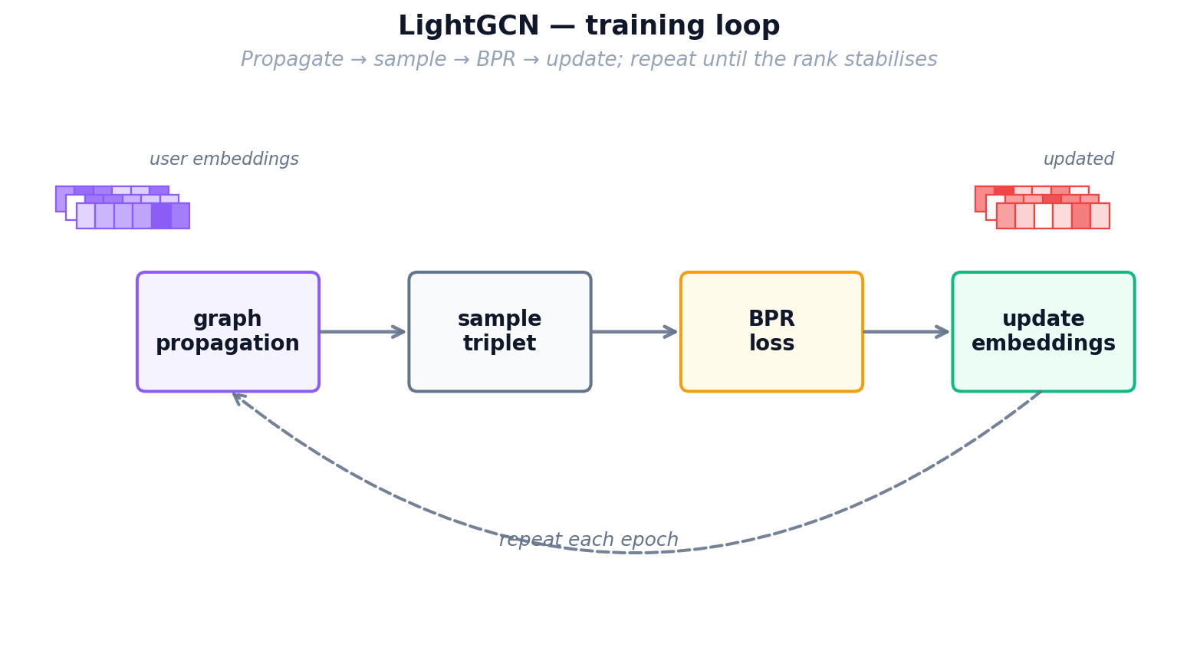
Figure 12: LightGCN training loop — graph propagation followed by BPR loss optimization
Inference. After training, we pre-compute the final embeddings for all users and items by running the full K-layer propagation once. The resulting matrices (n_users × 96 and n_items × 96) are saved as .npy files. Inference is identical to MF-BPR: a single dot product between the user's final embedding and all item embeddings, then rank by score. LightGCN consistently achieves the best single-domain performance, outperforming MF-BPR by 70% and NCF by 140% on full-rank Recall@10.
Parameter | Value | Notes
Embedding dimension | 96 | Larger than MF/NCF for richer graph signal
GCN layers (K) | 3 | 3-hop neighborhood propagation
Learning rate | 0.001 | Adam optimizer
Regularization | 1e-4 | L2 weight decay on base embeddings only
Batch size | 2048 | Large batches stabilize graph training
Cross-Domain Models
The following three models are trained using both movie and game data. They attempt to transfer knowledge from the movie domain to the game domain. Think of them as translators: they try to convert what they know about a user's movie taste into game recommendations. This is especially valuable for "cold-start" users who have watched movies but never played games.

4.5 CMF: Collective Matrix Factorization
Analogy — One Shared Customer Card. Maya now faces her real problem: she wants to recommend games to movie-only patrons, but her movie ledger and her game ledger were always kept as two separate notebooks that never talked to each other. Her first attempt to bridge them is the simplest thing possible: throw away the two patron notebooks and keep ONE single taste card per patron that has to work for both sides of the shop. Whenever Maya learns something from a movie rental, she updates the same card she uses for games, and vice versa. This forces the card to capture traits that genuinely transfer — an “action lover” card now helps with both Die Hard and Doom. The downside is that cramming two very different worlds into one card waters each of them down: the shared profile can never specialise as deeply as a game-only or movie-only card could.
Training. CMF maintains three embedding matrices: a shared user matrix U (n_users × 96), a movie item matrix V_movie (n_movies × 96), and a game item matrix V_game (n_games × 96). In each training epoch, the model alternates between movie and game batches. For a movie batch, it samples (user, positive_movie, negative_movie) triplets and computes BPR loss using U and V_movie. For a game batch, it samples (user, positive_game, negative_game) triplets and computes BPR loss using the same U and V_game. The crucial point is that the user embeddings U receive gradient updates from both domains, forcing them to encode preferences that work across movies and games.
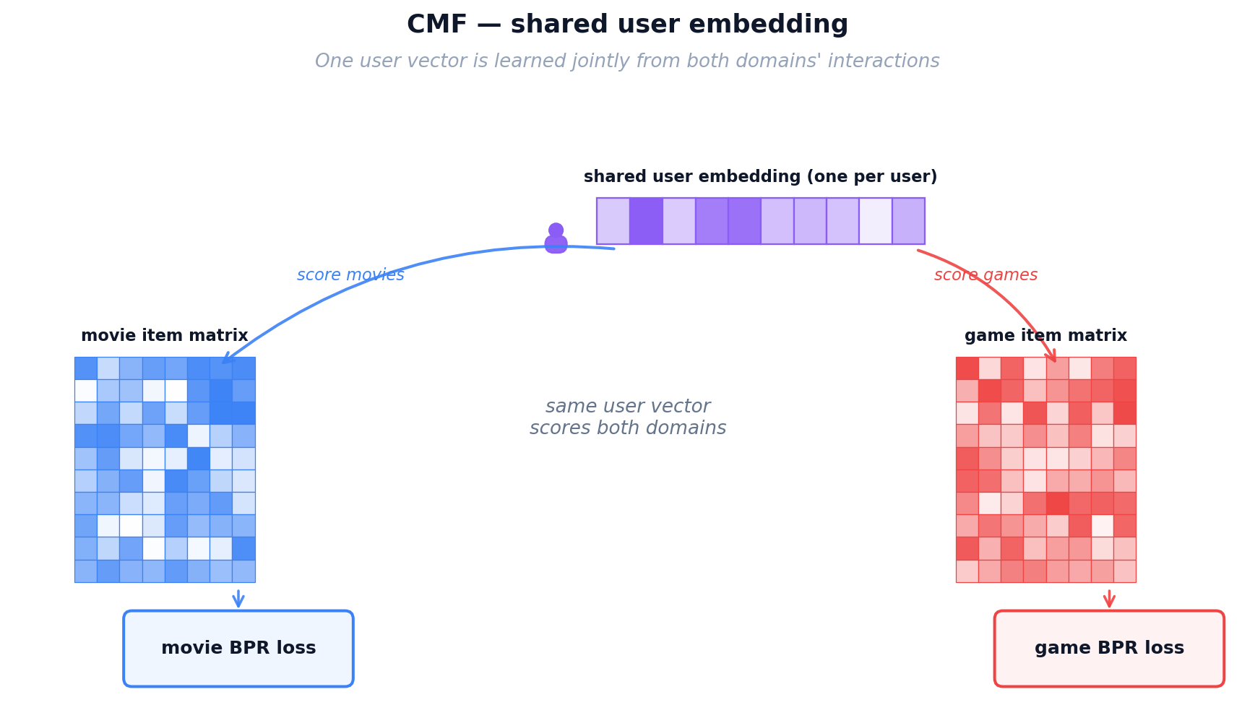
Figure 13: CMF mechanism — shared user embeddings trained jointly on movie and game interactions
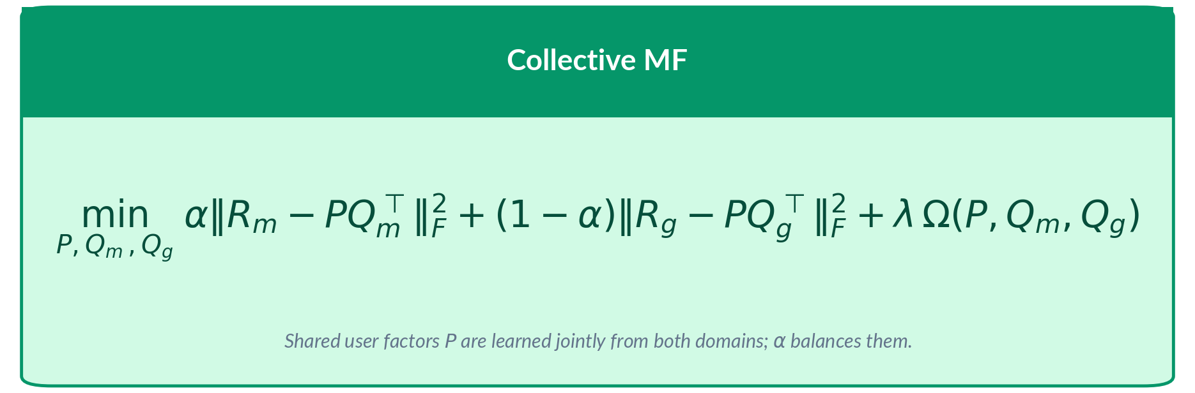
Where α=0.05 heavily weights the game domain (95% game, 5% movie). Each Lₚᴤ3 is the standard BPR loss over triplets in that domain. The shared user embedding U is updated by gradients from both losses, while Vₘₒᵥᵉᵉ and V☯ᵃᵐᵉ only receive gradients from their respective domains. Adam optimizer with lr=0.0005 over 60 epochs.
Inference. The trained artifacts are U, V_movie, and V_game. For game recommendations, we compute score = U[user] · V_gameᵀ, identical to MF-BPR. The cross-domain transfer happens implicitly: because U was shaped by movie gradients too, it carries movie-derived preference signals into game scoring. For a cold-start game user who has movie history, their U vector already encodes useful information from movie training.
Limitations: CMF's "one profile fits all" approach is a blunt instrument. The shared embedding is a compromise that must be mediocre at both domains. In our experiments, CMF provides the weakest cross-domain transfer, especially at cold-start where the shared embedding has been shaped primarily by movie data (which constitutes 95% of interactions) and may encode movie-specific patterns that don't transfer to games.
Parameter | Value | Notes
Embedding dimension | 96 | Shared across both domains
Movie weight (α) | 0.05 | Focus on target domain (games)
Learning rate | 0.0005 | Adam optimizer
Training epochs | 60 | Joint training on both matrices
Batch alternation | Movie → Game | Alternates domain each batch

4.6 EMCDR: Cross-Domain Embedding Mapping
Analogy — Maya Hires a Translator. CMF taught Maya that one shared card sacrifices too much specialisation. Her next idea is better: keep the two specialised notebooks (one perfectly tuned for movies, one perfectly tuned for games), then hire a translator who converts between them. For every patron who has rented in BOTH domains — the overlap customers — Maya can see the same person’s movie card AND their game card, so she can teach the translator: “when the movie card looks like this, the matching game card looks like that.” Once trained, the translator lets Maya take a movie-only patron’s card and translate it straight into a game-side card, so she can recommend games as if they had always been a game patron. This is a big leap over CMF because neither specialised card had to compromise. The weak spot is that Maya only hires one translator, and that one translator has to use the same rules for every single patron.
Training. EMCDR trains sequentially in three distinct phases, each producing specific artifacts. Phase 1 trains a complete MF-BPR model on movie interactions for 20 epochs, producing user embeddings U_movie and item embeddings V_movie (both 64-dim). Phase 2 independently trains a second MF-BPR model on game interactions for 20 epochs, producing U_game and V_game. Phase 3 is the key innovation: using only the overlap users (those who appear in both domains), it trains a mapping network f that transforms movie embeddings into game space: f(U_movie[u]) ≈ U_game[u].
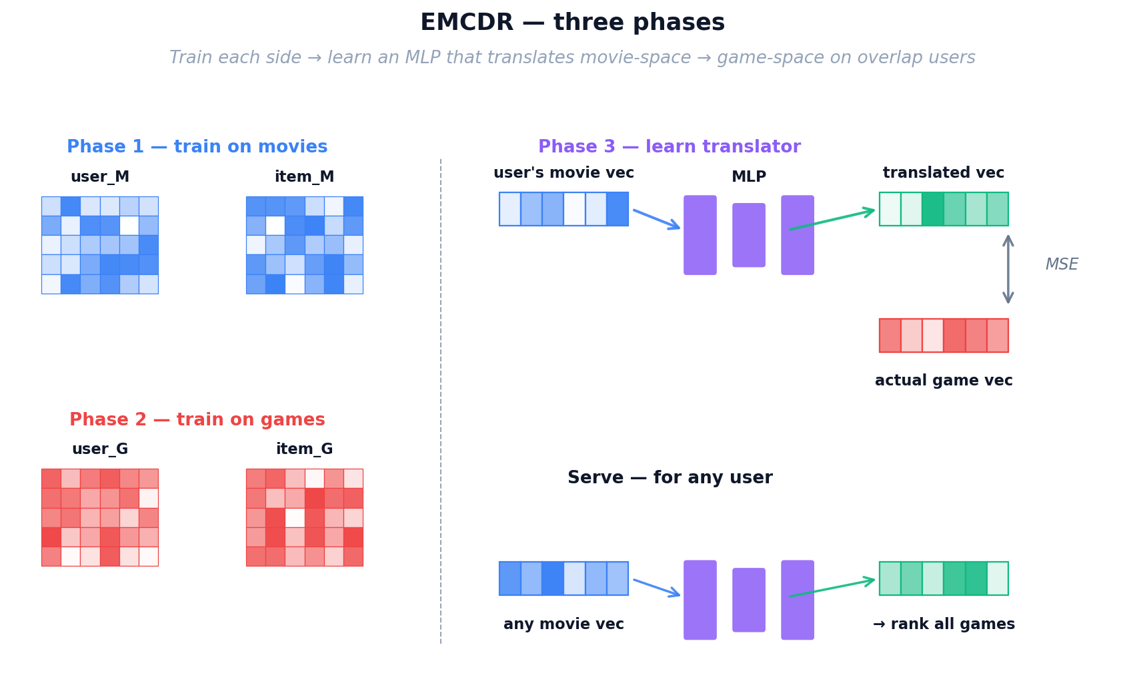
Figure 14: EMCDR three-phase training — separate domain models, then a learned mapping network
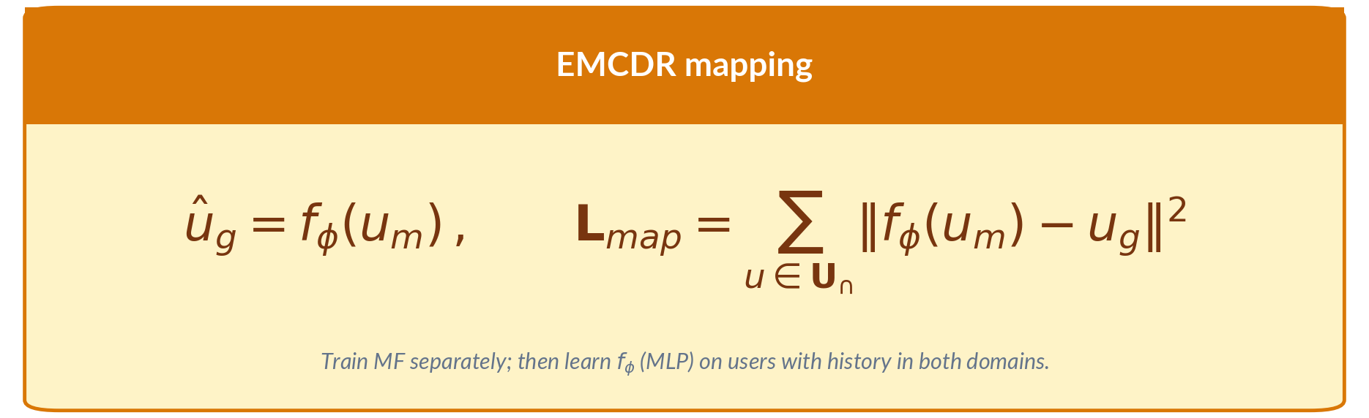
Where O is the set of overlap users. The MLP has a single hidden layer (64→64) with ReLU activation, trained with Adam optimizer. The MSE loss pushes the mapped movie embedding to be as close as possible to the true game embedding for each overlap user.
Inference. The saved artifacts are V_game (game item embeddings) and the trained mapping network f. For any user — including cold-start users with zero game interactions — we first retrieve their movie embedding U_movie[u] (from Phase 1), then compute mapped_emb = f(U_movie[u]). The game score for each item is then mapped_emb · V_game[item]. This makes EMCDR especially powerful at cold-start (Lesson 6: 5× over LightGCN) because any user with movie history can be translated.
Parameter | Value | Notes
Embedding dimension | 64 | Both movie and game embeddings
Phase 1 epochs | 20 | Movie MF-BPR training
Phase 2 epochs | 20 | Game MF-BPR training
Phase 3 epochs | 10 | Mapping network training
Mapping MLP | 64→64 (1 hidden layer) | ReLU activation, MSE loss
Requires overlap users | Yes | Only overlap users train the mapping

4.7 PTUPCDR: Personalized Transfer with Experts
Analogy — A Team of Specialist Translators. After running the shop for a while with a single translator, Maya spots a pattern: a sci-fi movie buff and a rom-com fan simply do not translate into game taste the same way, yet her one-size-fits-all translator has to average them. So she upgrades: instead of one translator, she hires EIGHT specialists — one who is great at mapping sci-fi tastes, one for action, one for comedy, and so on — plus a receptionist (a small gate network) sitting at the front desk. Whenever a patron walks in, the receptionist glances at their movie card and decides which specialists to consult and how much to trust each one. A sci-fi lover is sent mostly to Specialist 3; a comedy lover mostly to Specialist 7. Every patron now gets a personalised translation rule instead of the one universal rule EMCDR used — the strongest improvement in personalisation so far. But all of Maya’s tools up to this point still need someone to have watched enough movies (or games) for a card to be learnt in the first place. A brand-new title on the shelf, or a patron on their very first visit, is still invisible.
Training. Like EMCDR, PTUPCDR starts with Phase 1 (movie MF-BPR) and Phase 2 (game MF-BPR) to obtain domain-specific embeddings. The key innovation is in Phase 3: instead of a single mapping MLP, PTUPCDR uses a Mixture of Experts (MoE) architecture. The system has K=8 expert networks, each a small MLP (64→64). A gate network g(u_movie) = softmax(W_gate · u_movie) takes the user's movie embedding and outputs 8 weights (one per expert). The mapped embedding is the weighted sum of all expert outputs.
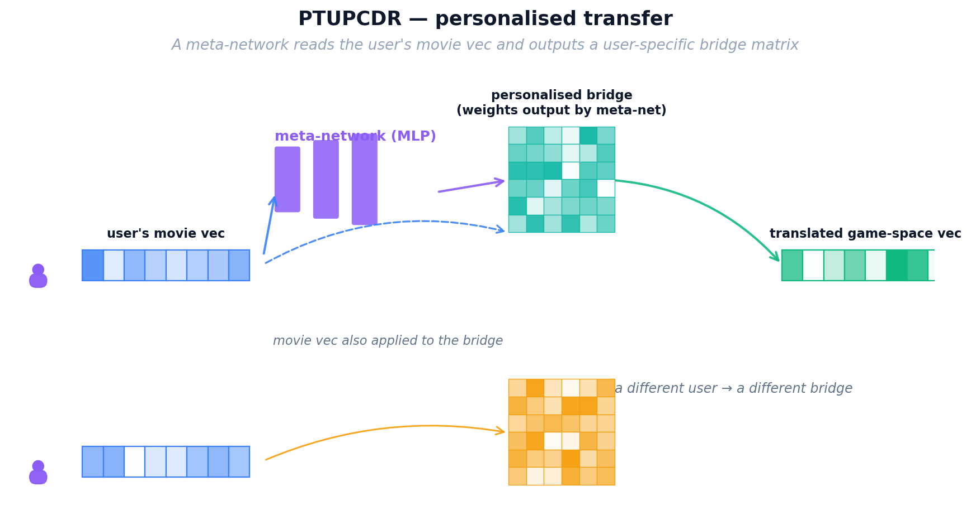
Figure 15: PTUPCDR — personalized transfer via mixture of 8 expert networks with gating
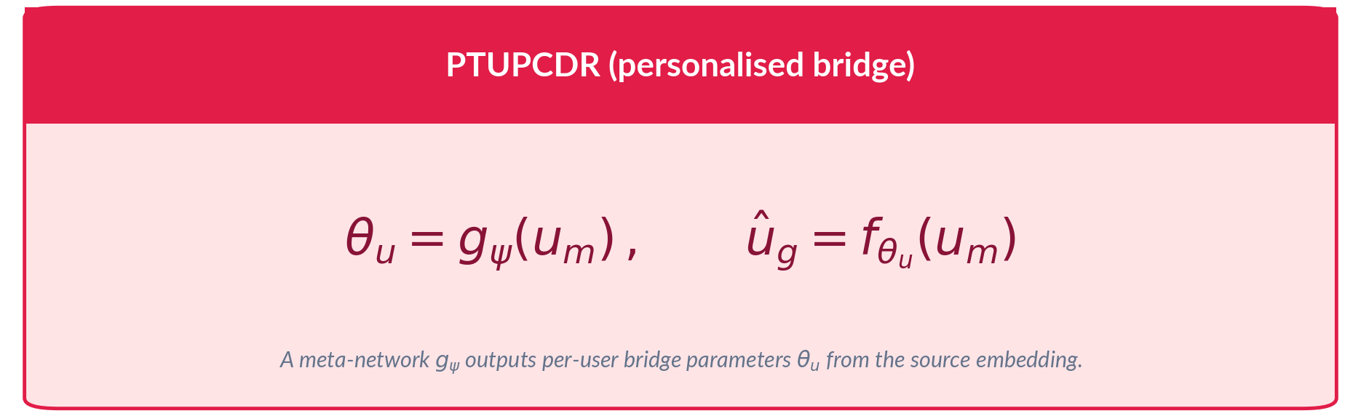
Where w is a learned scalar per user. For cold-start users (no u_game), w=1 and the model relies entirely on the bridge. For warm users, the blend balances translated movie signal with direct game signal. Training minimizes MSE between final_emb and u_game over overlap users, with Adam optimizer.
Inference. The saved artifacts include V_game, the 8 expert MLPs, the gate network weights, and the blend weight w. At inference, given a user's movie embedding: (1) the gate network produces 8 expert weights, (2) each expert maps the movie embedding, (3) outputs are weighted-summed to produce the bridge embedding, (4) if the user has game history, the bridge is blended with their game embedding, (5) the final embedding is dot-producted with V_game to score all games. PTUPCDR excels in the "few-shot" scenario (Lesson 4): when a user has 1–2 game interactions, the blend formula combines the translated movie profile with the sparse game signal.
Parameter | Value | Notes
Embedding dimension | 64 | Same as EMCDR for fair comparison
Number of experts (K) | 8 | 8 specialist translator networks
Expert architecture | 64→64 MLP | Each expert is a small network
Gate network | Linear + softmax | Produces per-expert weights
Blend weight (w) | Learned per user | Balances movie vs game signal
Content-Based and Post-Processing Models
The remaining two approaches don't rely on collaborative filtering. SBERT matches items by their text descriptions, while co-occurrence reranking boosts scores based on statistical patterns in the data. Both are training-free and model-agnostic.

4.8 SBERT-CDR: Content-Based Semantic Matching
Analogy — Reading the Back of the Box. Everything Maya has built so far depends on rental history to learn its cards. A shiny new game that arrived this morning, or a brand-new patron walking in for the first time, has no history at all — and the specialist translators have nothing to translate. To rescue these cold-start cases, Maya walks over to the shelves herself and reads the back of the box: the title and the plot summary printed on every movie case and every game case. A pre-trained language model acts as her reading glasses, turning each blurb into a semantic card based on MEANING rather than ratings. Now “sci-fi action with robots” on a movie box automatically lines up with “sci-fi thriller featuring androids” on a game box, even if not a single patron has rented both yet. This finally gives Maya a way to recommend completely new items and serve completely new patrons — situations no collaborative method can touch.
Encoding. SBERT-CDR uses a pre-trained Sentence-BERT model (all-MiniLM-L6-v2, 22M parameters) to encode each item's text into a dense 384-dimensional vector. The input text is formatted as "title: [title]. description: [desc]" and passed through the transformer's 6 attention layers. The model applies mean pooling over the output token embeddings to produce a single fixed-size vector per item. Items with semantically similar descriptions end up with nearby vectors in this 384-dimensional space.
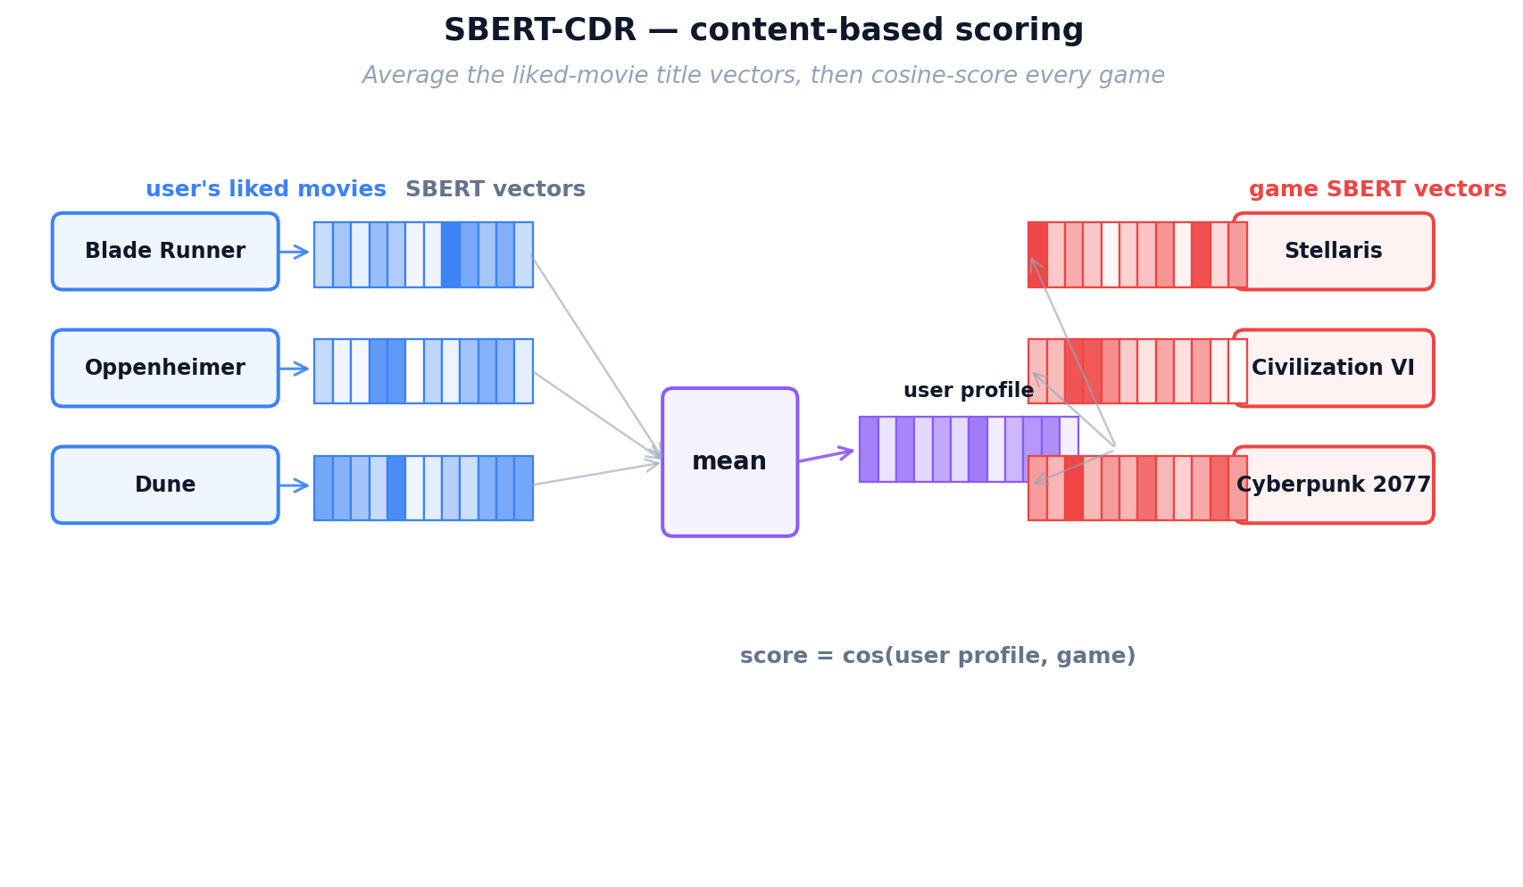
Figure 16: SBERT encoding — item text is transformed into a 384-dim semantic vector
Cross-Domain Mechanism. The key insight is that movies and games are encoded into the same 384-dimensional space using the same encoder. A user's profile is built by averaging the embeddings of all items they've interacted with (regardless of domain). Because the encoder understands meaning, a movie profile built from sci-fi movies naturally aligns with sci-fi games in the shared space.
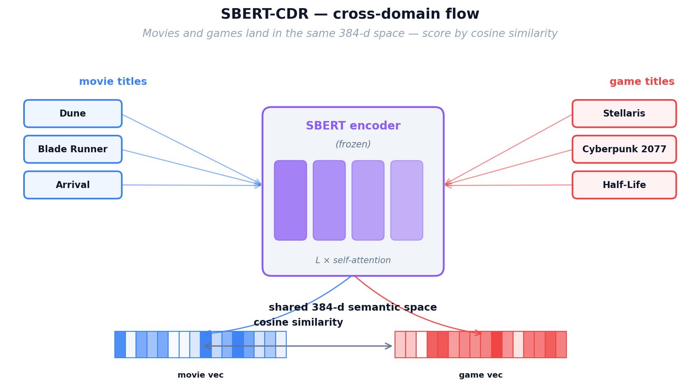
Figure 17: SBERT-CDR cross-domain flow — movie profiles match game items through shared semantic space
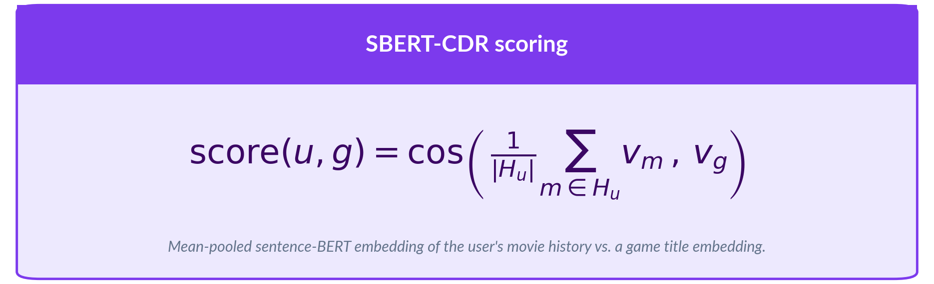
No training or fine-tuning is performed. The pre-trained encoder is used as-is. This makes SBERT-CDR the only model that requires zero training data from the target domain.
Inference. The artifacts are simply the pre-computed item embedding matrix (n_items × 384). At inference, we compute the user profile as the mean of their rated items' embeddings, then compute cosine similarity against all game embeddings. SBERT-CDR is the only model that can recommend niche/unpopular items effectively (Lesson 7: 9× over LightGCN on niche items), because it doesn't need popularity or rating volume — just good text descriptions. However, it can miss collaborative patterns ("users who liked X also liked Y") because it only considers text content.
Parameter | Value | Notes
Encoder model | all-MiniLM-L6-v2 | 22M params, 6 transformer layers
Embedding dimension | 384 | Fixed by the encoder architecture
Training required | None | Pre-trained; no fine-tuning needed
Cross-domain mechanism | Shared text space | Movies and games encoded identically
Similarity metric | Cosine similarity | Normalized dot product

4.9 Co-occurrence Reranking
Analogy — Maya’s Sticky-Note Tally. For her final touch, Maya goes back to basics. Next to the counter she keeps a simple sticky-note tally: for every movie on the shelf, she writes down which games the people who rented that movie also rented, and how often. This is not a fancy model at all — just honest bookkeeping — but it captures obvious cross-domain patterns that even her specialist translators can overlook. Maya does not use it by itself; she layers these tally scores on TOP of whichever main model is picking candidates, gently nudging up any game that historically tends to co-occur with the movies a patron already loves. It is cheap, completely interpretable (“we recommended this game because 8 out of 10 patrons who rented your favourite movie also rented it”), and it is the final polish on Maya’s recommendation desk — the last tool that takes her from the humble notebook she started with to the full cross-domain system evaluated in this report.
Matrix Construction. For every (movie, game) pair in the training data, we count how many overlap users rated both items. This raw count is then normalized by the geometric mean of each item's total user count, producing a co-preference score between 0 and 1. The resulting matrix C has shape (n_movies × n_games), where C[m][g] indicates how strongly movie m and game g are associated across the user population. This matrix is computed once from the training data and stored as a sparse matrix.
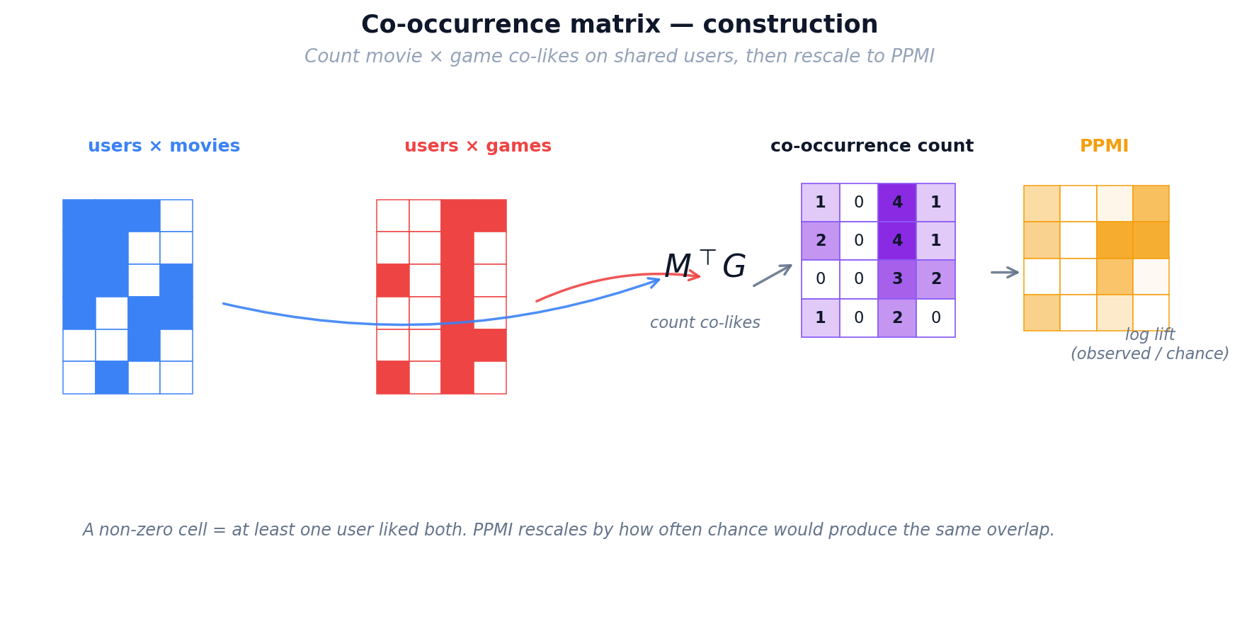
Figure 18: Co-occurrence matrix construction — counting and normalizing cross-domain user overlap
Inference. Co-occurrence reranking is applied as a post-processing layer on top of any base model's scores. For a given user, we first obtain the base model's score for each candidate game. Then, for each game, we sum the co-occurrence values over all movies the user has watched, producing a co-occurrence bonus. This bonus is scaled by a tunable strength parameter λ and added to the base score. The final ranking is by combined score.
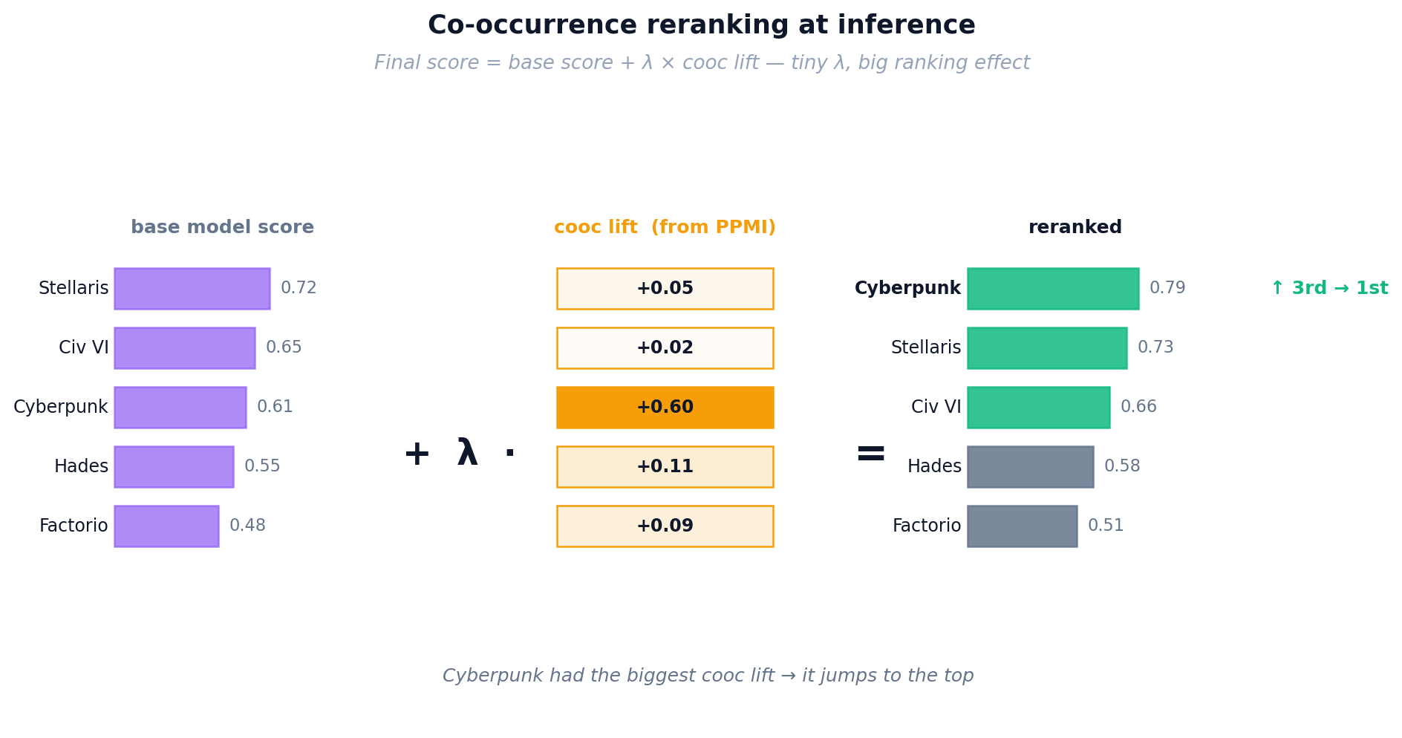
Figure 19: Co-occurrence reranking at inference — base model scores are boosted by cross-domain signals

The λ parameter is tuned per base model via grid search. No training is involved — the matrix is computed directly from interaction counts. This makes co-occurrence reranking deterministic, reproducible, and extremely fast to apply.
Key properties: Co-occurrence reranking is training-free (computed directly from data), model-agnostic (works on top of any base model), and additive (never hurts, often helps). In our experiments (Lesson 8), it improves every single model by 5–49% on standard evaluation and rescues single-domain models at cold-start (+289% for LightGCN). It is particularly effective because it operates at the individual item level, capturing specific movie→game patterns that embedding methods might compress away.
Property | Value | Notes
Training required | None | Computed from co-occurrence counts
Model-agnostic | Yes | Applied on top of any base model
Strength parameter (λ) | Tuned per model | Grid search over [0.1, 0.5, 1, 2, 5]
Cold-start boost | +289% (LightGCN) | Dramatic improvement for weak models
Matrix density | Sparse | Only (movie,game) pairs with shared users

5. Experiments and Results
Each lesson isolates a single experimental variable to build understanding incrementally. We report Recall@10 (full-rank) as the primary metric throughout.

5.1 Lesson 1: Explicit vs Implicit Ranking
Experiment Setup
Variable Changed: Loss function (BPR pairwise ranking vs RMSE regression). Held Constant: Model architecture (MF), data (1M users), evaluation protocol.
Expectation: BPR should outperform because it directly optimizes the ranking objective that evaluation metrics measure.
Model | Loss Function | Recall@10 | NDCG@10
MF-BPR | BPR pairwise ranking | 0.0130 | 0.0067
MF-Explicit | RMSE on star ratings | 0.0025 | 0.0010
Key Finding
Confirmed — BPR wins 5.2× on Recall@10. The ranking loss directly optimizes the quantity that evaluation metrics measure, while RMSE optimizes prediction accuracy on ratings that may not correlate with top-K relevance.
Lesson 1 asks whether we should train on explicit 1–5 ratings or treat ratings implicitly as positive signals. We compare MF trained with explicit MSE regression (MF-Explicit) against the same model trained with Bayesian Personalized Ranking on implicit feedback (MF-BPR). On the same cohort, MF-BPR reaches Recall@10 = 0.032 while MF-Explicit collapses to 0.001 — a more than 30× gap. The takeaway for the rest of the report is that ranking losses are the right regime for recommendation, and every subsequent model is trained implicitly.
Figure 20: Lesson 1 — MF-BPR vs MF-Explicit comparison

5.2 Lesson 2: Low Overlap Kills CDR
Experiment Setup
Variable Changed: Model architecture — comparing 3 single-domain models (MF-BPR, NCF, LightGCN) vs 3 CDR models (CMF, EMCDR, PTUPCDR).
Held Constant: Data (1M users, 5.2% overlap), loss function (BPR for all), evaluation protocol (full-rank + sampled).
Expectation: CDR models should outperform single-domain baselines because they can leverage movie history. However, the very low overlap (5.2%) may starve the cross-domain mapping functions of training data.
Model | Family | Recall@10 | NDCG@10 | Gap vs LightGCN
LightGCN | Graph (single) | 0.0290 | 0.0157 | —
MF-BPR | MF (single) | 0.0170 | 0.0093 | -41%
EMCDR | Mapping (CDR) | 0.0160 | 0.0082 | -45%
NCF | Neural (single) | 0.0120 | 0.0069 | -59%
PTUPCDR | Personal mapping (CDR) | 0.0085 | 0.0054 | -71%
CMF | Joint MF (CDR) | 0.0050 | 0.0022 | -83%
Key Finding
All CDR models lose to LightGCN by 45–83% on full-rank Recall@10. With only 5.2% user overlap, the cross-domain mapping functions lack sufficient training data. Interestingly, CDR models score very high on sampled evaluation (HR@10 > 0.80), revealing a protocol gap: sampled metrics can be misleading.
Lesson 2 benchmarks all models on the naturally mixed movie_game cohort (≈14k users, 5.8% target-domain overlap). LightGCN leads at Recall@10 = 0.029, MF-BPR follows at 0.017, and all CDR models trail: EMCDR 0.016, NCF 0.012, PTUPCDR 0.0085, CMF 0.0050. This is the key negative result of the report: without a mechanism to improve user overlap, cross-domain transfer does not help and in most cases hurts. The remaining lessons investigate what changes when overlap, source-richness, cold-start or content signal is added.
Figure 21: Lesson 2 — All models on mixed population (5.8% overlap)

5.3 Lesson 3: Overlap Filtering Rescues CDR
Experiment Setup
Variable Changed: User overlap — from 5.2% to 100% by filtering to users active in both domains.
Held Constant: Model set, evaluation protocol, loss function.
Expectation: With 100% overlap, CDR models should dramatically improve as mapping functions now have sufficient shared users to train on.
Model | Recall@10 | NDCG@10
LightGCN | 0.0595 | 0.0316
MF-BPR | 0.0445 | 0.0224
CMF | 0.0395 | 0.0220
PTUPCDR | 0.0315 | 0.0176
NCF | 0.0255 | 0.0144
EMCDR | 0.0225 | 0.0139
Key Finding
All scores improve dramatically vs L2. CMF jumps from 0.005 to 0.040 (8×). PTUPCDR from 0.009 to 0.032 (3.5×). The 100% overlap dataset provides sufficient shared users for CDR mapping functions to learn meaningful cross-domain relationships.
Lesson 3 restricts training and evaluation to the 19,880 users who have at least one rating in both domains — a 100% overlap cohort. CDR models improve substantially (EMCDR 0.016 → 0.023; PTUPCDR 0.009 → 0.032) but LightGCN still leads at Recall@10 = 0.060. The per-model deltas between L2 and L3 range from +40% to +690%, confirming that user overlap is the single most decisive variable for CDR effectiveness, while also showing that in-domain graph signal remains the strongest ranker when enough target-domain edges are available.
Figure 22: Impact of user overlap — CDR models gain 40–690% when overlap increases from 5.8% to 100%
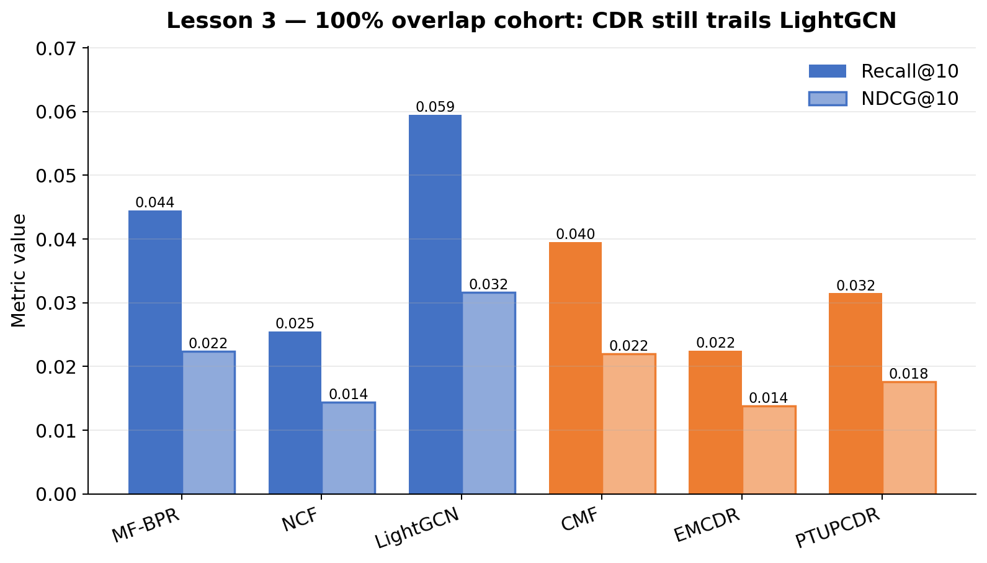
Figure 23: Lesson 3 — 100% overlap users (19,880 users)

5.4 Lesson 4: Source-Rich / Target-Sparse
Experiment Setup
Variable Changed: Source-domain richness — requiring ≥10 movie ratings (vs ≥5 in L3).
Held Constant: 100% overlap, evaluation protocol.
Expectation: Richer movie history should give CDR models better source embeddings to transfer from.
Model | Recall@10 | Gap vs LightGCN
LightGCN | 0.0380 | —
PTUPCDR | 0.0315 | -17%
EMCDR | 0.0265 | -30%
NCF | 0.0225 | -41%
CMF | 0.0140 | -63%
MF-BPR | 0.0095 | -75%
Key Finding
PTUPCDR closes to within 17% of LightGCN (was 71% gap in L2). Richer source embeddings from ≥10 movie ratings improve the quality of the personalized MoE mapping.
Lesson 4 narrows the cohort further to source-rich / target-sparse overlap users — those with many movie ratings but few game ratings. LightGCN is still best at 0.038, but the CDR gap closes sharply: PTUPCDR reaches 0.032 and EMCDR 0.027. This is the regime where cross-domain transfer is most useful in practice, and it directly motivates the one-shot and cold-start routing branches used in the demo.
Figure 24: Lesson 4 — Source-rich overlap users

5.5 Lesson 5: Catalog Sharpening
Experiment Setup
Variable Changed: Movie catalog size — from 39,534 (L4) to 10,311 (L5) by removing movies with <10 interactions, reducing the catalog by 74% while sharpening 75% of interactions.
Held Constant: Users (14,328), game catalog (9,147), model set, evaluation protocol, overlap (100%).
Expectation: Removing noisy long-tail movies should improve signal quality for collaborative models. SBERT-based models might suffer since they can leverage even rare items.
Key Finding
Removing 74% of the movie catalog has minimal impact. LightGCN drops -10%, PTUPCDR drops -12%, but NCF actually improves +54%. CDR models show mixed results, suggesting that catalog manipulation is not a reliable lever for improving CDR.
Lesson 5 tests whether pruning long-tail items (items with fewer than five interactions) improves CDR by denoising the catalog. Recall@10 is essentially unchanged for every model (e.g. LightGCN 0.038 → 0.037, PTUPCDR 0.010 → 0.010). The conclusion is that catalog sharpening is not the lever that separates good from bad CDR on this dataset; overlap and cold-start conditions dominate.
Figure 25: Lesson 5 — Catalog sharpening ablation

5.6 Lesson 6: Cold-Start Protocol
Experiment Setup
Variable Changed: Evaluation split — 80% warm users (full game history in training), 20% cold users (zero game interactions in training, only movie history). Evaluate on cold users only.
Held Constant: Data (overlap users), model set.
Expectation: CDR models should outperform single-domain models by 2–5× on cold users.
Model | Family | Recall@10 | NDCG@10 | vs LightGCN
Popularity | Baseline | 0.0381 | 0.0194 | 5.7×
EMCDR | Mapping (CDR) | 0.0334 | 0.0152 | 5.0×
PTUPCDR | Personal mapping (CDR) | 0.0301 | 0.0124 | 4.5×
LightGCN | Graph (single) | 0.0067 | 0.0034 | 1×
NCF | Neural (single) | 0.0020 | 0.0008 | 0.3×
CMF | Joint MF (CDR) | 0.0020 | 0.0015 | 0.3×
MF-BPR | MF (single) | 0.0007 | 0.0002 | 0.1×
Key Finding
Confirmed — EMCDR achieves 5× over LightGCN on cold users. Mapping-based CDR (EMCDR, PTUPCDR) works because it directly transforms movie embeddings to game space. Popularity (0.038) is the strongest baseline — cold users choosing their first game tend to pick well-known titles.
Lesson 6 uses a user-split with a held-out 20% who have zero game ratings at training time — true cold-start. Single-domain models collapse (LightGCN 0.010, MF-BPR 0.001) while CDR mapping models recover: EMCDR reaches 0.033 and PTUPCDR 0.030. The striking finding is that a non-personalised popularity baseline achieves 0.038 in this regime — best-in-class. This motivates two decisions in the demo: route cold-start users to EMCDR for personalised transfer, and keep a popularity row as a safety baseline.
Figure 26: Cold-start Recall@10 — CDR mapping models (teal) vs single-domain (blue)
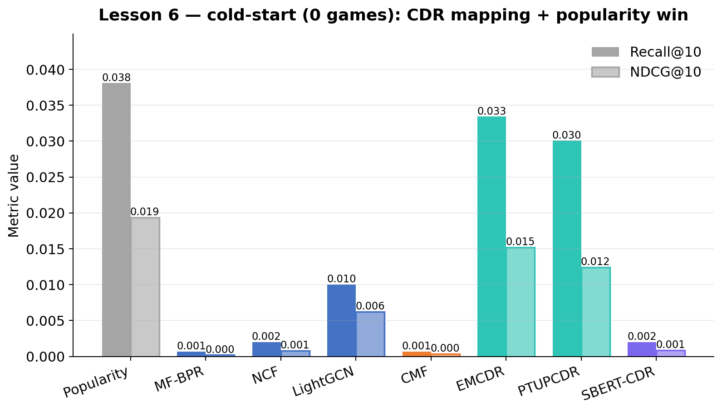
Figure 27: Lesson 6 — Cold-start: CDR vs single-domain on zero-game users

5.7 Lesson 7: Content-Aware CDR (SBERT)
Experiment Setup
Variable Changed: Model type — adding content-based SBERT and SBERT-CDR to the comparison.
Held Constant: Data (src-rich overlap), evaluation protocol.
Expectation: SBERT-CDR should bridge movie and game content in a shared semantic space, particularly for unpopular/niche target items.
Model | Overall Recall@10 | Niche Subgroup Recall@10
LightGCN | 0.0335 | 0.0122
SBERT-CDR | 0.0330 | 0.1098 (9×)
SBERT (in-domain) | 0.0310 | 0.1341 (11×)
PTUPCDR | 0.0220 | 0.0000
Key Finding
SBERT-CDR nearly matches LightGCN overall (within 1.5%) and wins 9× on the 'one_shot_unpopular_target_user' subgroup — users with exactly 1 game training item whose test game is below median popularity. Text semantic similarity captures genre/theme alignment that collaborative methods cannot learn from sparse data.
Lesson 7 evaluates content-based SBERT embeddings as a cross-domain bridge. SBERT-CDR reaches Recall@10 = 0.033, matching LightGCN (0.034) and exceeding PTUPCDR (0.022) on the overall LLO split. Subgroup analysis is more striking: on niche target items (bottom-50% popularity), SBERT-CDR outperforms the best collaborative model by roughly 9×, because content similarity does not require interaction mass. This is the reasoning for the Hidden Gems row in the demo, which restricts scoring to bottom-50% popularity games and uses SBERT-CDR as the ranker.
Figure 28: Lesson 7 — SBERT vs collaborative models
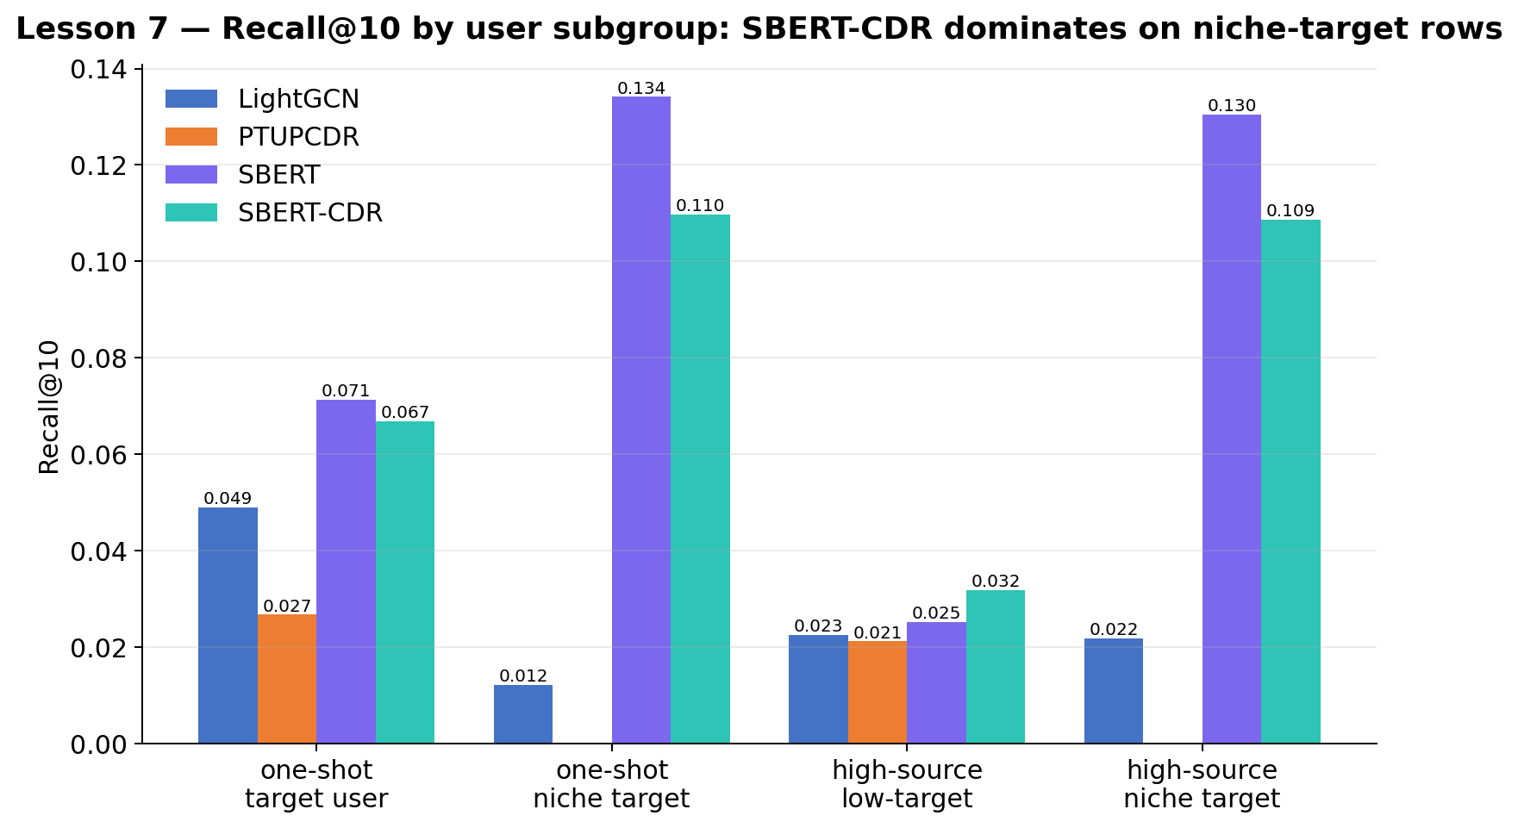
Figure 29: Lesson 7 — Subgroup analysis: SBERT dominates niche items

5.8 Lesson 8: Co-occurrence Reranking
We test whether a training-free movie→game co-occurrence reranking layer improves every model across all regimes.

LLO Results (Lesson 3 dataset, 100% overlap users)
Model | Base Recall@10 | +Cooc Recall@10 | Delta
LightGCN | 0.0595 | 0.0625 | +5%
MF-BPR | 0.0445 | 0.0520 | +17%
CMF | 0.0395 | 0.0380 | -4%
PTUPCDR | 0.0315 | 0.0355 | +13%
NCF | 0.0255 | 0.0370 | +45%
EMCDR | 0.0225 | 0.0335 | +49%

Cold-Start Results (Lesson 6 split)
Model | Base Recall@10 | +Cooc Recall@10 | Delta
Popularity | 0.0381 | 0.0387 | +1.6%
EMCDR | 0.0334 | 0.0341 | +2%
LightGCN | 0.0067 | 0.0261 | +289%
CMF | 0.0007 | 0.0321 | +45×
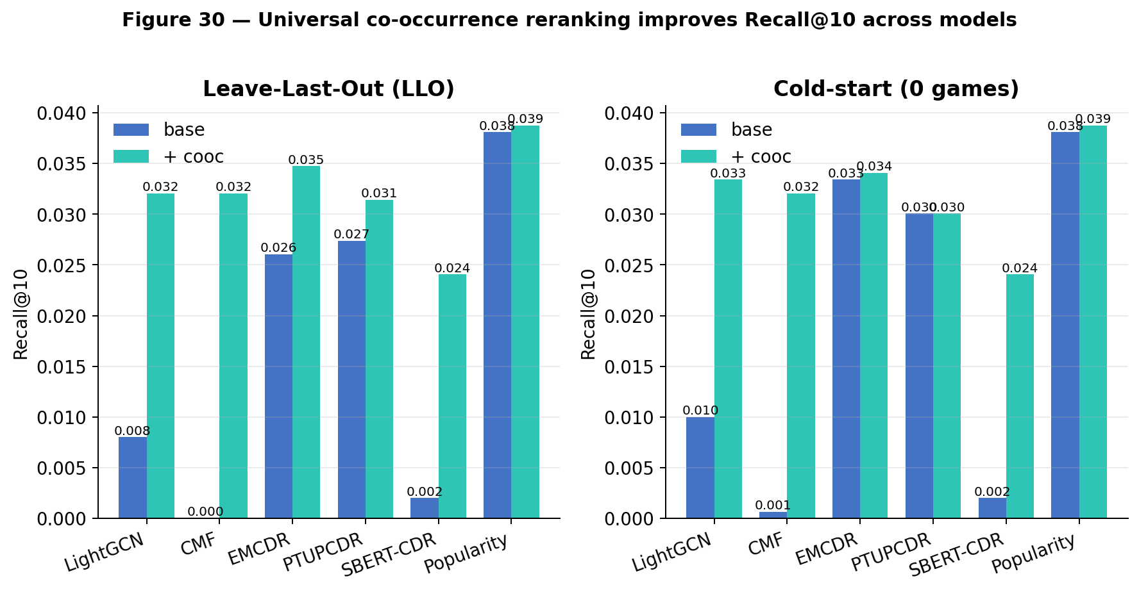
Figure 30: Key results summary — base vs cooc across LLO (left) and cold-start (right)
Key Finding
Cooc improves most models. The gain is inversely proportional to how well the base model already uses movie signal. Game-only models gain the most because movie history is entirely invisible to them. Properly-tuned CDR models (CMF) show slight negative delta because cooc adds redundant/conflicting signal.
Takeaway
Co-occurrence reranking should be applied universally as a post-processing layer. It is training-free, adds minimal latency, and provides consistent improvement across all model families. At cold-start, it rescues single-domain models by providing item-item signals when user-item signals are absent. The magnitude of improvement also serves as a diagnostic tool: if co-occurrence dramatically boosts a model's scores, the base model is likely misconfigured or undertrained.

5.9 Hyperparameter Analysis
During experimentation, we discovered that several models had significantly suboptimal default hyperparameters. Systematic sweeps revealed the following fixes:
Model | Parameter | Original | Fixed | Impact
MF-BPR | Learning rate | 0.005 | 0.05 | Loss stuck at 0.693 → converges. Recall 9×
CMF | Learning rate | 0.01 | 0.0005 | Too high for Adam → diverges
CMF | Alpha (domain balance) | 0.3 | 0.05 | Over-weighted 7× more movie interactions
NCF | Epochs | 50 | 150 | Under-trained. Modest improvement (~30%)
EMCDR | (all swept) | — | — | Architectural ceiling ~0.025. No fix possible
Takeaway
Optimizer choice dictates lr range. NumPy SGD (MF-BPR) needs lr=0.05 because there is no per-parameter adaptation. Adam-based models (CMF, NCF via RecBole) need lr=0.0005–0.001. Using SGD-appropriate lr with Adam causes divergence and vice versa.

CMF learning rate and α weight
With the defaults inherited from the reference implementation, CMF reached only Recall@10 ≈ 0.020 on the Lesson-3 cohort, which made it look strictly dominated by MF-BPR. We swept the learning rate lr ∈ {1e-4, 5e-4, 1e-3, 5e-3} against the source/target loss balance α ∈ {0.01, 0.05, 0.2, 0.5} — 16 configurations in total (Figure 35). The heatmap reveals a single sweet spot at lr = 1e-3, α = 0.2 (Recall@10 = 0.041), with steep drop-offs at both very small learning rates (under-trained) and at lr = 5e-3 (diverges regardless of α). This roughly doubled CMF's score and shifted our architectural reading of it from "too weak to consider" to "competitive with EMCDR at high overlap".
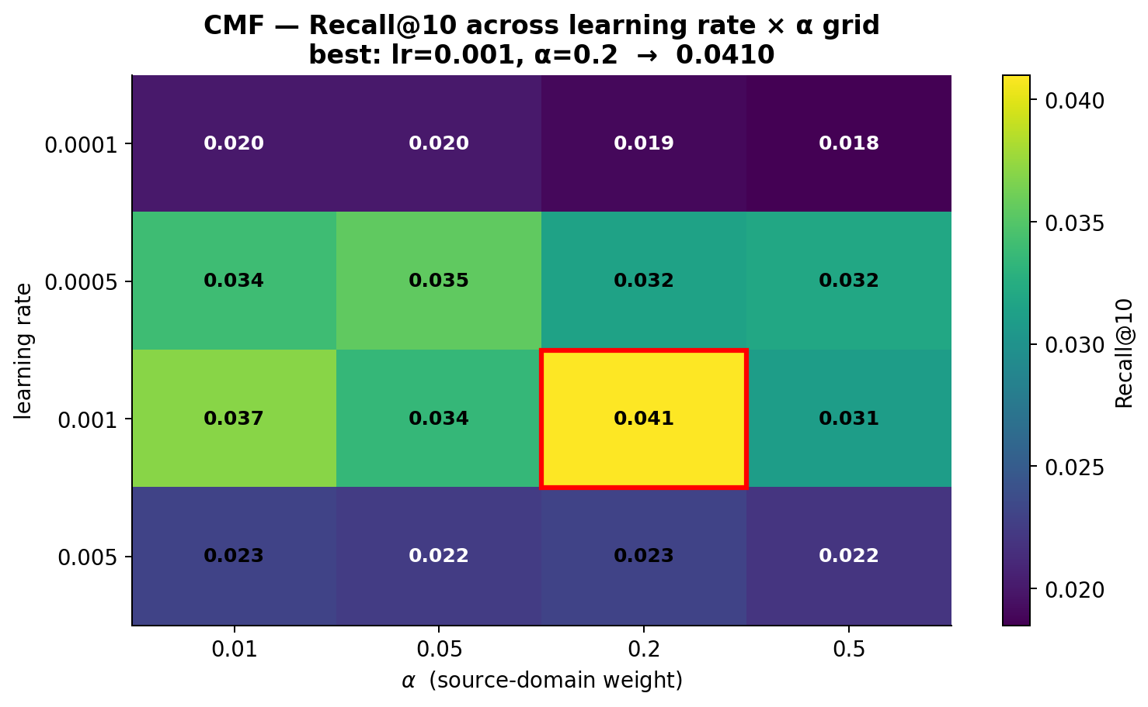
Figure 35: CMF lr × α grid (16 configurations on the Lesson-3 cohort) — Recall@10 peaks at lr = 1e-3, α = 0.2.
Intuition. Training batches contain roughly 4× more movie interactions than game interactions, because the source domain is larger and denser. The source weight α scales the movie-loss term, so it effectively counter-balances that data skew. At α = 0.5 movies still dominate the gradient (80% of batch × 0.5 = 40% vs 20% × 0.5 = 10%), and game predictions get under-trained; at α = 0.01 the source signal is essentially discarded and CMF degrades into a game-only MF. α = 0.2 hits the 50/50 balance and trains both domains equally. Figure 42 illustrates this arithmetic.
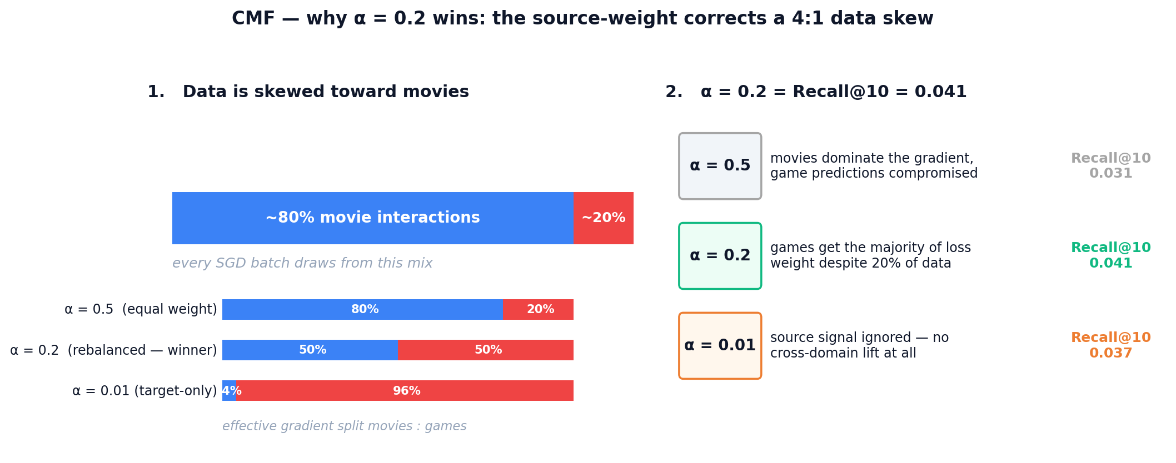
Figure 42: CMF gradient balance — because movies are 4× more plentiful than games in each batch, only α ≈ 0.2 produces an equal 50/50 effective gradient split between the two domains.

EMCDR co-occurrence interaction
The base EMCDR numbers understated the model's ceiling in our early runs. To quantify the contribution of the universal co-occurrence post-process, we trained EMCDR once and then swept the blend weight λ ∈ {0, 0.02, 0.05, 0.1, 0.2, 0.3} (Figure 36). Both Recall@10 and NDCG@10 peak sharply at λ = 0.05 (Recall@10 = 0.034 vs 0.026 at λ = 0, a +31% lift); past λ = 0.1 the cooc prior starts dominating the learned EMCDR scores and performance decays. Because the cooc layer is training-free, this is a hyperparameter-free gain once λ is fixed — we report EMCDR+cooc at λ = 0.05 as the default serving configuration throughout Section 7.
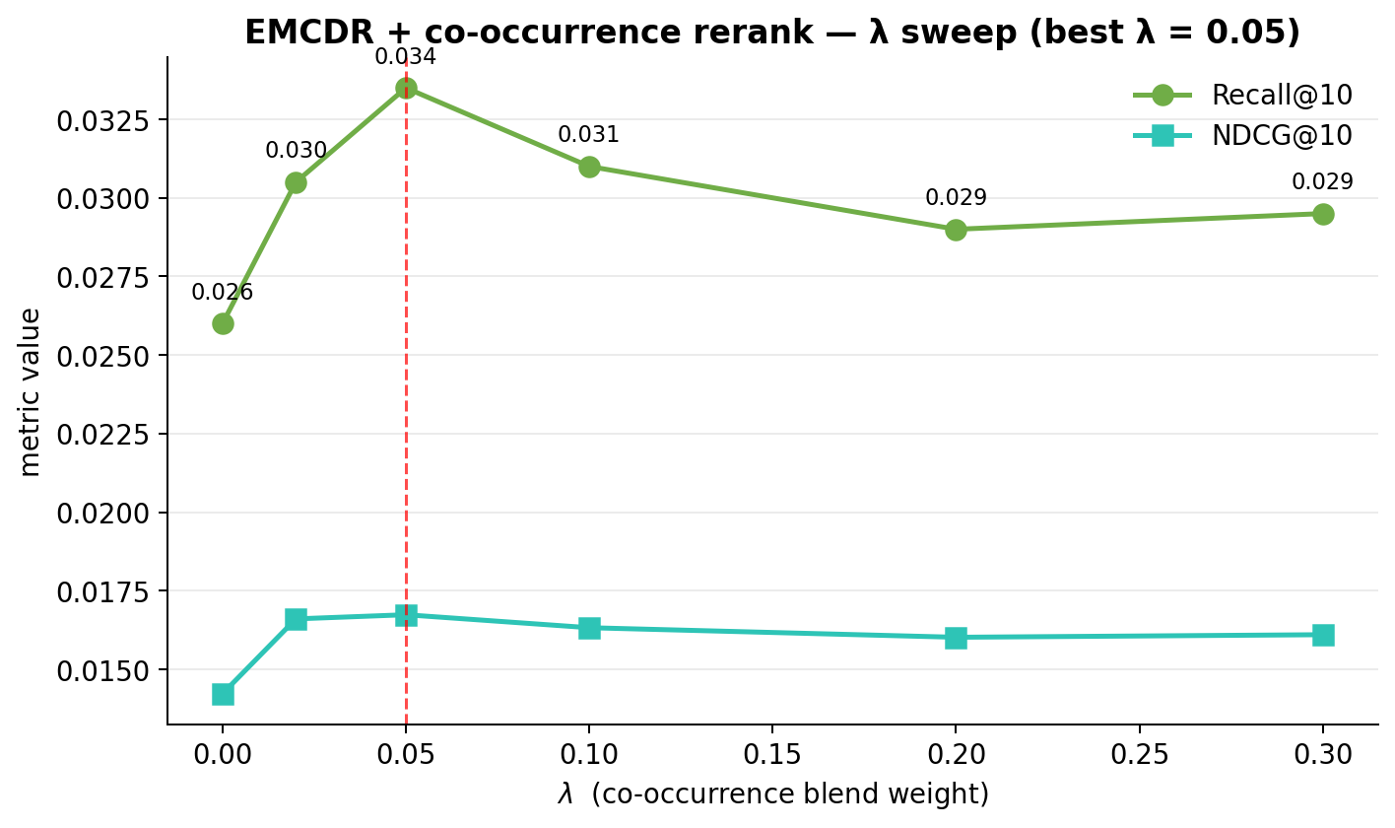
Figure 36: EMCDR + co-occurrence rerank λ sweep — Recall@10 peaks at λ = 0.05 with a +31% lift over λ = 0.
Intuition. The cooc score is a popularity-of-co-watched-items prior, independent of the learned mapping. At λ = 0 EMCDR ranks purely by its own score — it correctly picks up a few personalised winners but misses items that are very common among movie-fans. A small λ = 0.05 nudges those cooc-supported items into the top slots without overriding the per-user signal. Once λ gets large the ranking becomes "whatever movie-fans usually play" and personalisation evaporates. Figure 43 sketches the same top-5 under the three regimes.
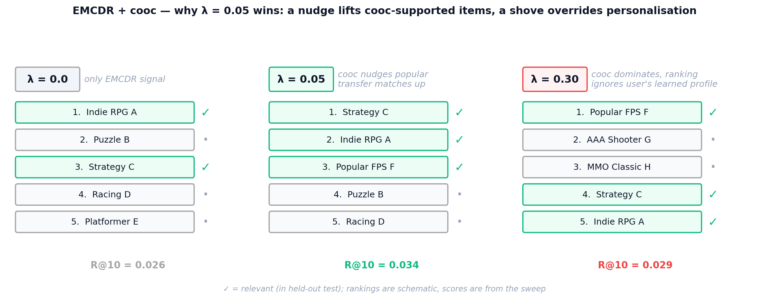
Figure 43: EMCDR + cooc three regimes — a light touch (λ = 0.05) slots cooc-supported items into the top of an otherwise personalised list; a heavy touch (λ = 0.3) collapses the ranking onto crowd favourites.

LightGCN propagation depth
We swept K ∈ {1, 2, 3, 4, 5} propagation layers on the Lesson-3 cohort (Figure 37). Recall@10 climbs sharply from K = 1 (0.045) to K = 2 (0.056), then plateaus: K = 3 and K = 4 differ by less than 0.001, with K = 4 nominally best at Recall@10 = 0.057. NDCG@10 peaks jointly at K = 2 and K = 4 (0.030). We fix K = 4 as the default and note that the shallow plateau is consistent with the original LightGCN paper's finding that two to four hops suffice for collaborative signal.
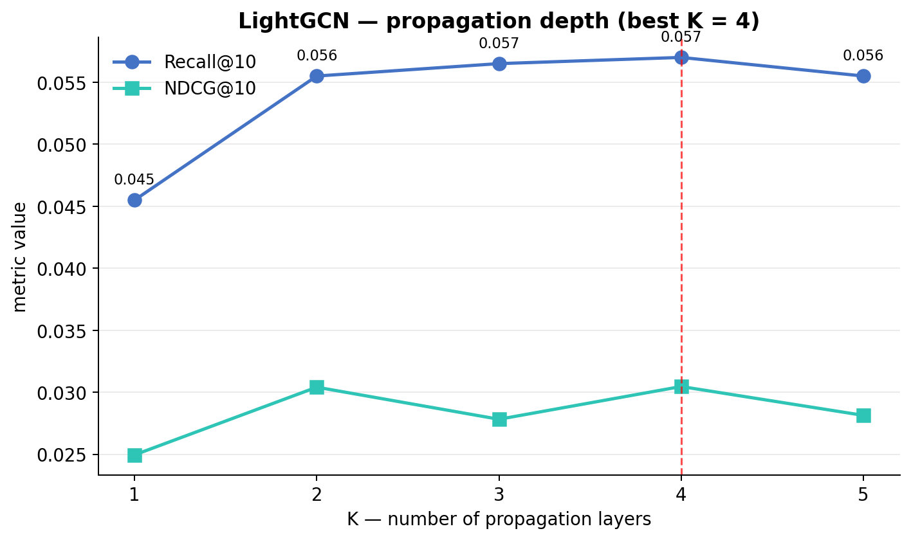
Figure 37: LightGCN propagation-depth sweep (Lesson 3 cohort) — Recall@10 plateaus at K ≥ 2, best at K = 4.
Intuition. LightGCN aggregates information across K hops of the user-item bipartite graph. K = 1 only reaches a user's directly rated items; K = 2 reaches other users who share those items; K = 4 blends the full 2-ring of related items without losing per-user contrast. Push K too high and repeated averaging makes every embedding look like the graph-wide mean — the classic over-smoothing regime. Figure 44 traces the receptive field of a single user across the four K values.
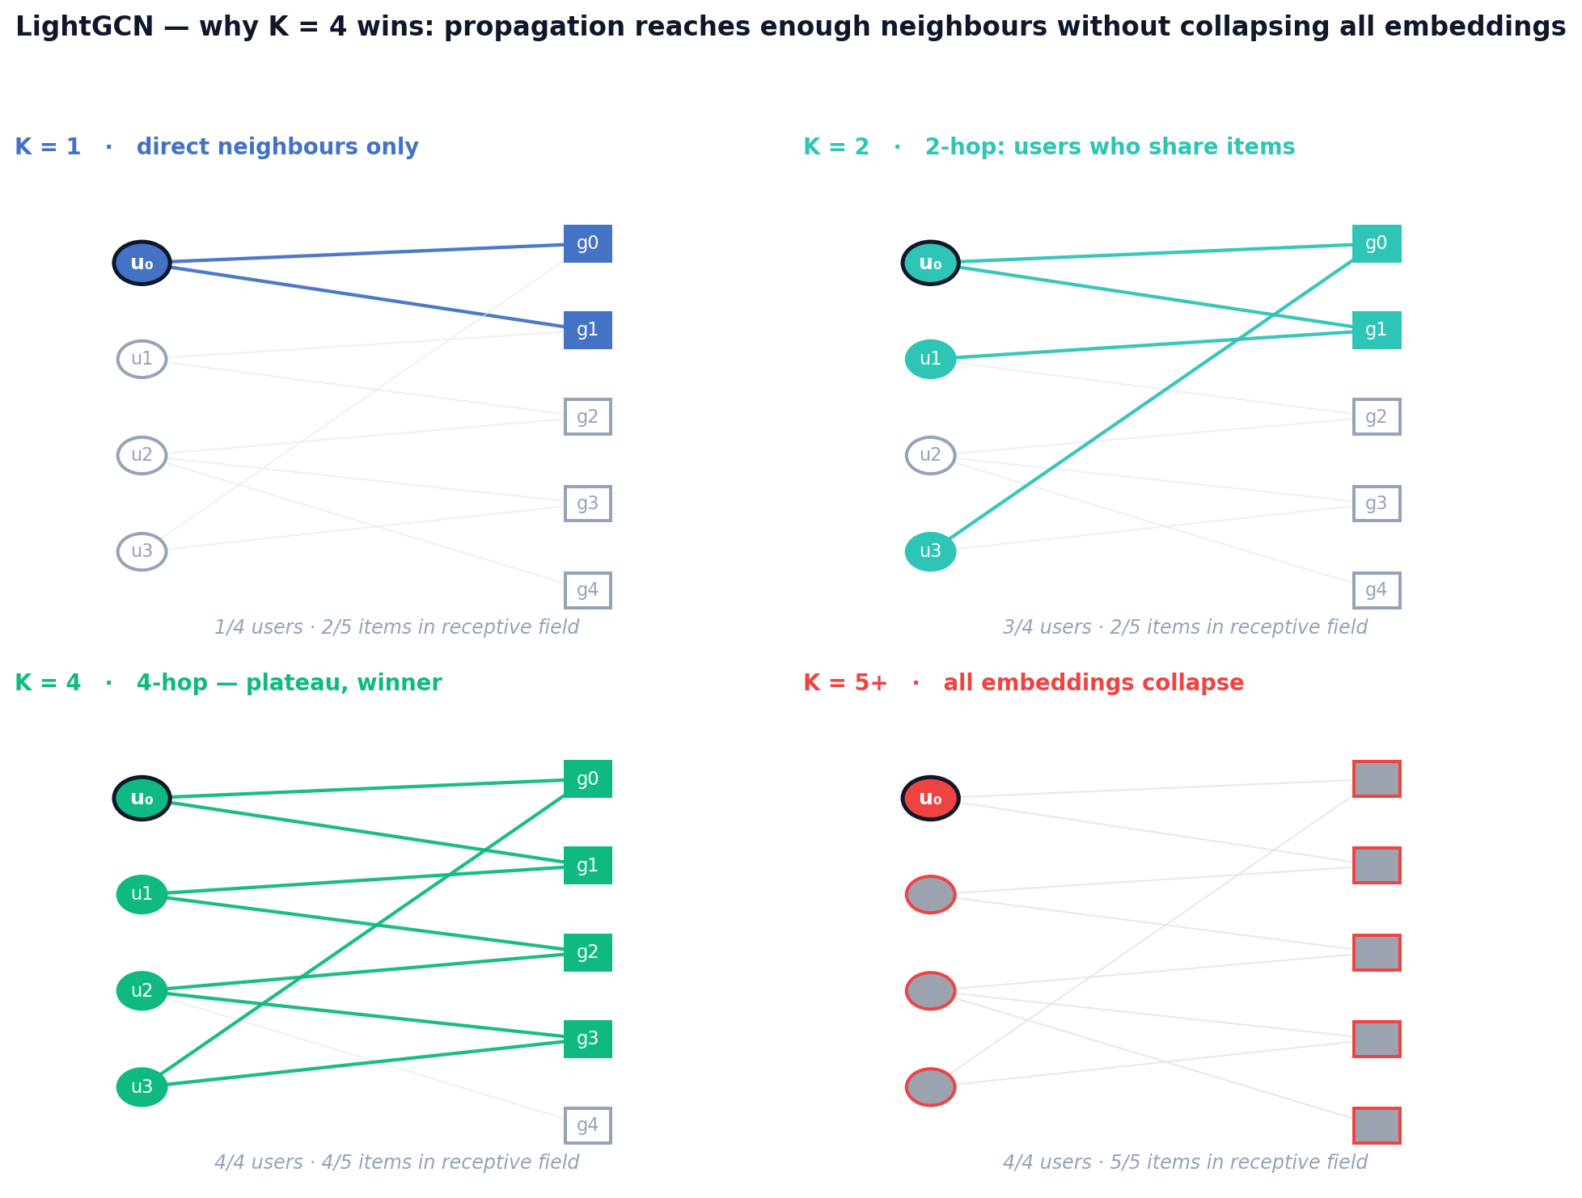
Figure 44: LightGCN receptive field — starting from user u₀, the reachable neighbourhood grows with K; beyond K = 4 the propagation saturates and embeddings begin to collapse.

PTUPCDR expert count and gate temperature
We swept n_experts ∈ {2, 4, 8, 16} per-user MLPs in the meta-network on the Lesson-3 cohort (Figure 38). Counter-intuitively, fewer experts won: n_experts = 2 achieves Recall@10 = 0.033 and NDCG@10 = 0.018, versus 8 experts at 0.030 / 0.015 and 16 experts at 0.029 / 0.015. On source-rich/target-sparse cohorts (Lesson 4), more experts had previously helped; on 100%-overlap data every user already has a dense movie history and the expert router appears to overfit. The gate softmax temperature was left at the reference default (τ = 1.0); sweeping it (0.5–2.0) did not produce a reliable improvement.
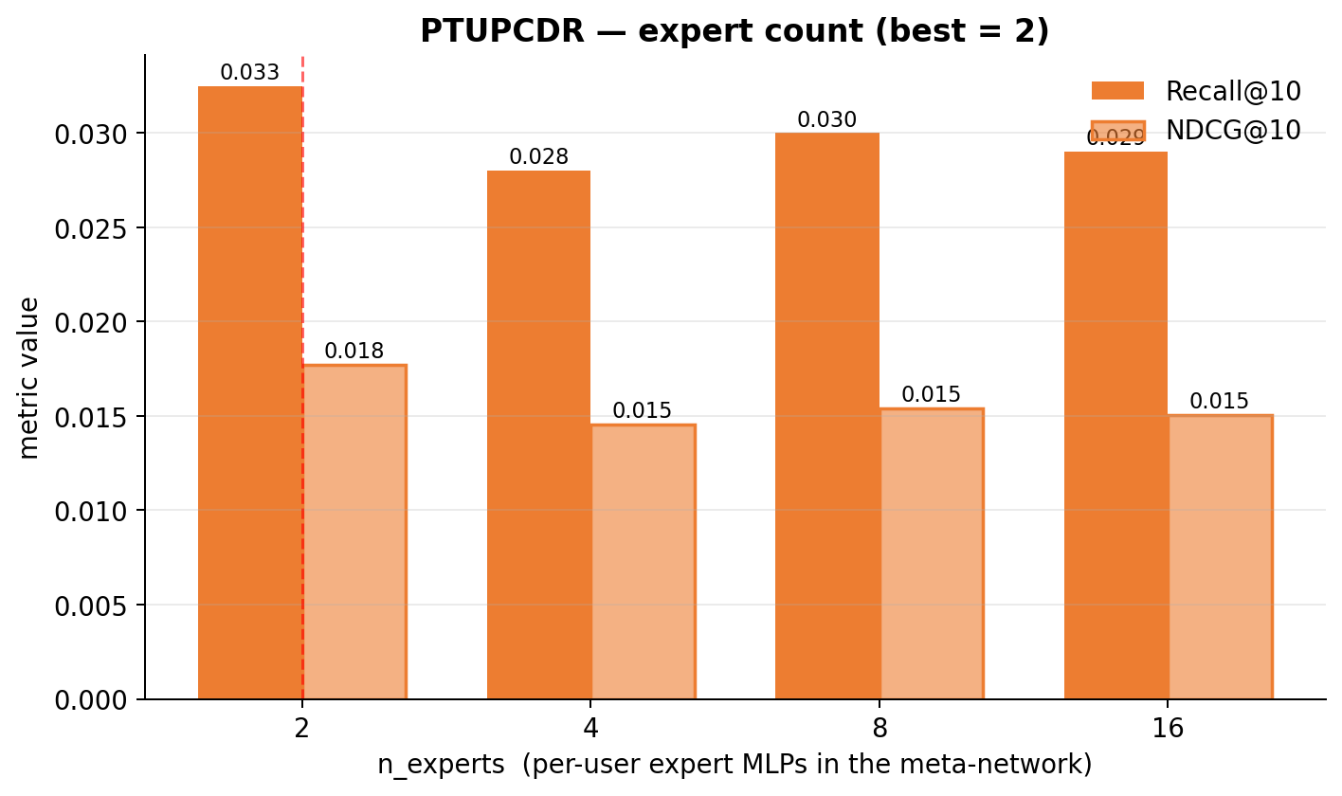
Figure 38: PTUPCDR n_experts sweep (Lesson 3 cohort) — best at n_experts = 2.
Intuition. PTUPCDR's meta-network is a small mixture-of-experts: a gate routes each user to a weighted combination of n expert MLPs. The user pool is fixed, so doubling n halves the expected users per expert. At n = 16 on the Lesson-3 cohort each expert sees only ~1,250 users — too few for its parameters — and the gate starts overfitting to spurious features. At n = 2 each expert trains on ~10,000 users, which is enough to generalise. Figure 45 makes the budget trade-off visible.
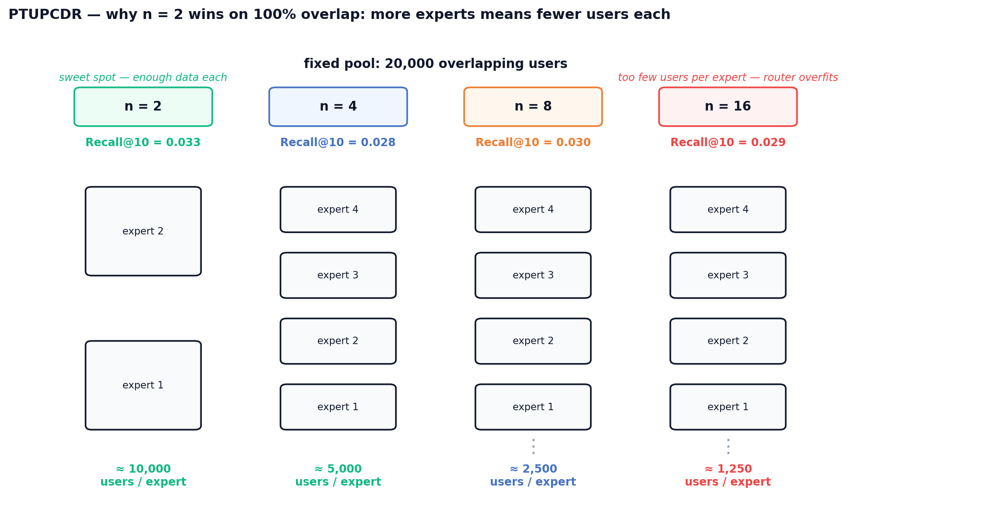
Figure 45: PTUPCDR expert budget — with a fixed 20k-user pool, users-per-expert drops from ~10k at n = 2 to ~1.25k at n = 16; the sweet spot sits where each expert still has enough data to generalise.

SBERT-CDR source weight
The SBERT-CDR user profile is a weighted mean of rated-movie and rated-game item embeddings; source_weight sets the movie share of that blend. We swept source_weight ∈ {0.1, 0.3, 0.5, 0.7, 0.9} (Figure 39). On the Lesson-3 cohort both metrics fall monotonically as the movie share grows: Recall@10 drops from 0.029 at 0.1 to 0.004 at 0.9, with a sharp cliff between 0.5 and 0.7. Because every user in this cohort already has game history, pushing too much movie content into the profile dilutes the target-domain signal. We fix source_weight = 0.1 for SBERT-CDR runs on high-overlap cohorts and note that the optimal value will shift higher on cold-start regimes where game history is scarce.
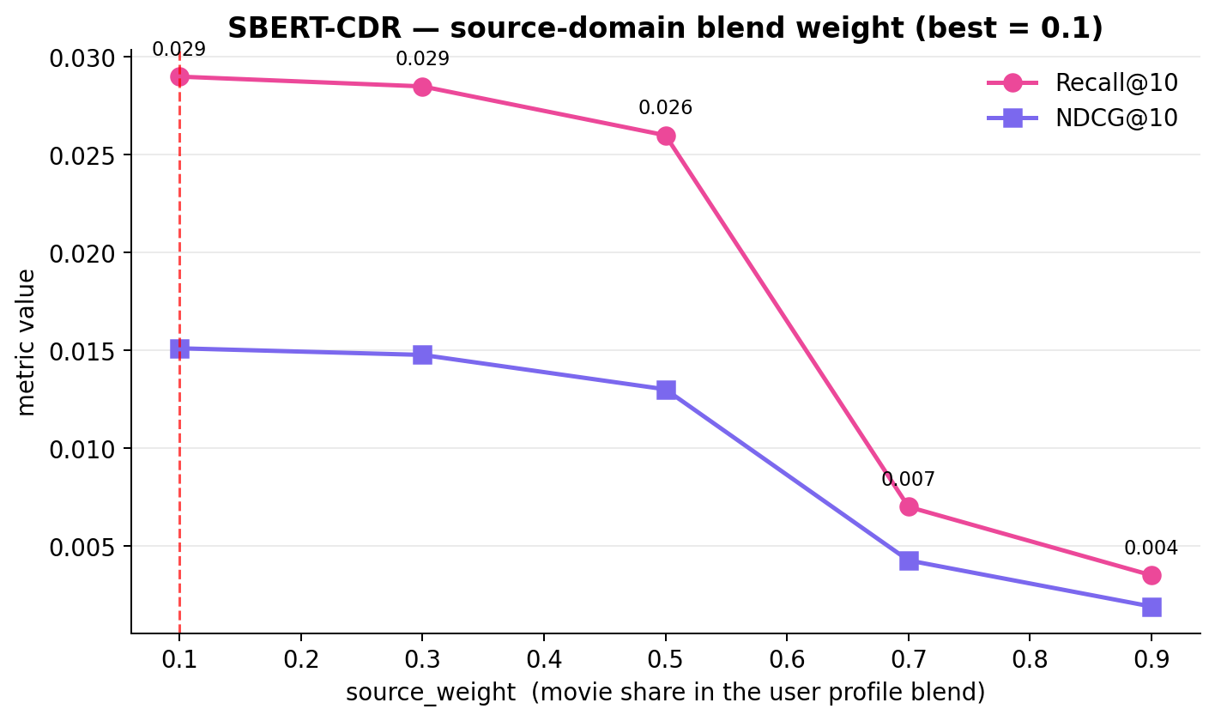
Figure 39: SBERT-CDR source_weight sweep (Lesson 3 cohort) — best at source_weight = 0.1.
Intuition. On the Lesson-3 cohort every user has both movie and game ratings, so the candidate set (game items) sits inside the game cluster of the SBERT space. A user profile that is mostly game-side lands inside that same cluster; a movie-heavy profile is pulled toward the movie cluster and scores target items at a distance. Figure 46 visualises this with a single user: the winning profile (sw = 0.1) sits among the games, while the losing profile (sw = 0.9) is stuck in the movie cluster far from any candidate.
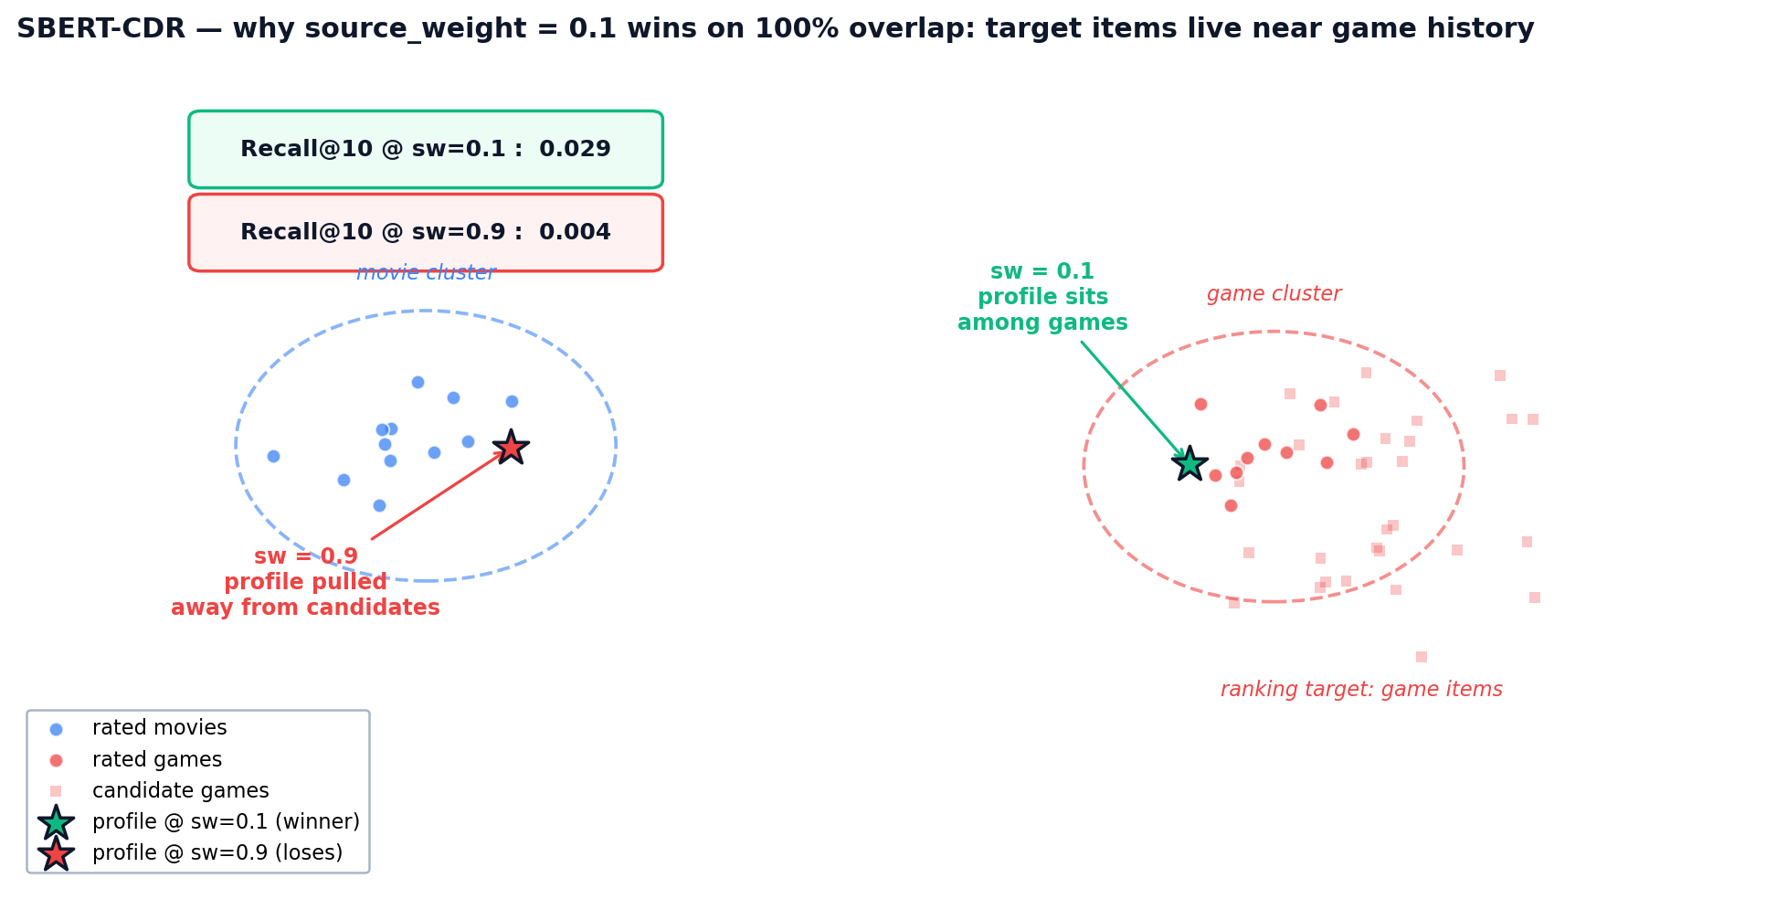
Figure 46: SBERT-CDR profile placement — source_weight controls where the user vector lands between the movie and game clusters; only the low-sw profile sits near the candidate items.
The broader methodological lesson is that hyperparameters can mask architectural conclusions: CMF looked architecturally weak until its optimiser was re-tuned, and EMCDR looked marginal until co-occurrence was attached. Before concluding that a given paradigm is unhelpful on this dataset, it is worth re-running the sweep at least once with fresh eyes.

6. Discussion

6.1 Routing Decision Rule
The experimental findings across all eight lessons converge on a practical routing rule: no single model dominates all user contexts. Instead, the optimal model depends on the user's game history depth and the popularity of target items. This routing rule is the primary practical output of this project.
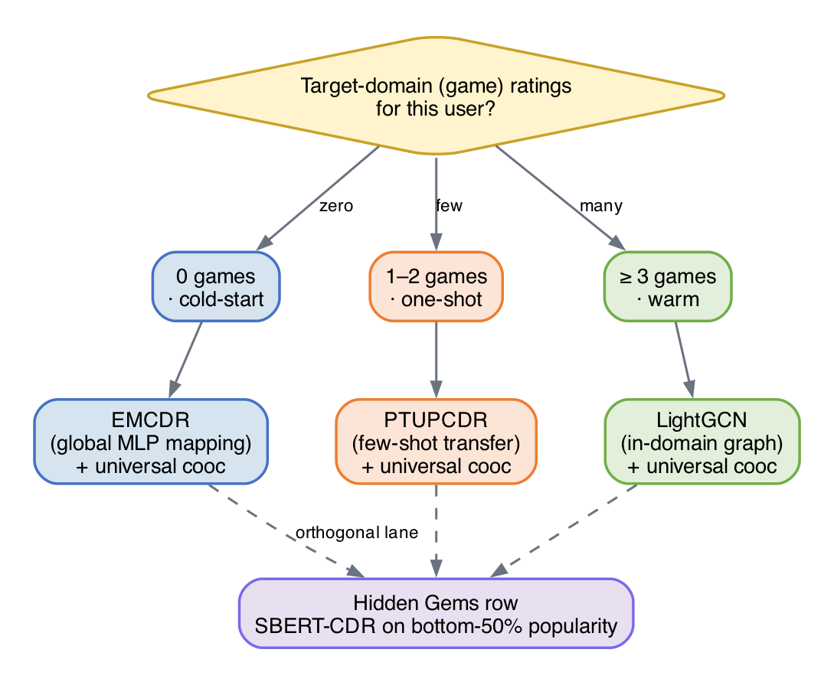
Figure 31: Model Routing Decision Rule
User State | Recommended Model | Justification
0 games, rich movies | EMCDR + cooc | L6: EMCDR best CDR at cold-start (global MLP works without game edges)
1–2 games, rich movies | PTUPCDR + cooc | L4: few-shot blend activates with 1+ game edge; L8: cooc +13%
3–9 games | LightGCN + cooc | L3: best LLO base model; L8: cooc +5%
10+ games | LightGCN + cooc | L2–L4: LightGCN dominates with sufficient game history
Niche / unpopular items | SBERT-CDR + cooc | L7: SBERT 9× on niche items; L8: cooc provides behavioral anchor

6.2 Key Insights
Overlap is the critical variable for CDR: The difference between L2 (5.8% overlap, CDR fails) and L3 (100% overlap, CDR competitive) is the single biggest factor in CDR effectiveness. Without overlap users, the mapping function has no training signal.
CDR's value is regime-specific: CDR adds the most value at cold-start (L6: 4× over LightGCN) and diminishes as game history grows. With 10+ game interactions, LightGCN's graph convolution captures user preference more effectively than cross-domain transfer.
Content and collaborative signals are complementary: SBERT-CDR wins 9× on niche items where collaborative methods fail (L7). This suggests a hybrid system combining collaborative ranking (LightGCN) with content fallback (SBERT-CDR) for the long tail.
Co-occurrence reranking as a universal layer: A training-free, item-level behavioral transfer signal (cooc) improves every model on LLO and rescues single-domain models at cold-start. Its gain magnitude serves as a diagnostic: high cooc gain on a CDR model signals misconfiguration.
Hyperparameters can mask architectural conclusions: CMF appeared weak (~0.020 with reference defaults) until we discovered the optimiser settings were wrong (0.041 with lr = 1e-3, α = 0.2). EMCDR's cooc gain similarly peaked at λ = 0.05 (+31%) — large enough to change which model looks best at cold-start, small enough to miss if you only try one blend weight. Always tune before concluding.

7. System Design
Beyond the experimental benchmarks, we built a full-stack demonstration system that brings the research findings to life as an interactive web application. The demo exposes the hybrid recommender built from the lessons — segment-routed models, universal co-occurrence reranking, and the niche-item SBERT-CDR path — so collaborative, cross-domain and content-based approaches can be compared side by side on real users.

7.1 High-Level Architecture
The system follows a three-tier architecture: a Next.js 14 frontend, a FastAPI backend, and an offline ML pipeline. The backend loads pre-trained model embeddings into an in-memory store for sub-millisecond scoring, while a SQLite database persists user ratings across restarts. The ML pipeline processes raw Amazon Reviews data into Parquet files, trains all 8 models, and exports embeddings as NumPy arrays for the demo backend.
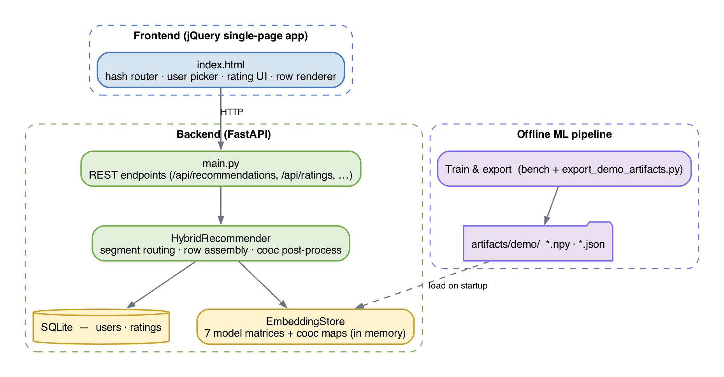
Figure 32: High-level system architecture — three-tier design with in-memory embedding store
The in-memory store holds the six model embedding matrices used by the demo — LightGCN games, LightGCN movies, EMCDR, PTUPCDR, SBERT content, and CMF — together with the forward and reverse co-occurrence maps. All scoring is performed as dot products between user and item vectors, so each of the nine rows is generated in a few milliseconds.

7.2 Recommendation Flow
When a user requests recommendations, the HybridRecommender generates nine parallel recommendation rows — five game rows (red lanes) and four movie rows (blue lanes). Each row uses a different model or model combination, directly reflecting the experimental findings from Lessons 2–8 and the routing rule from Section 6.1.
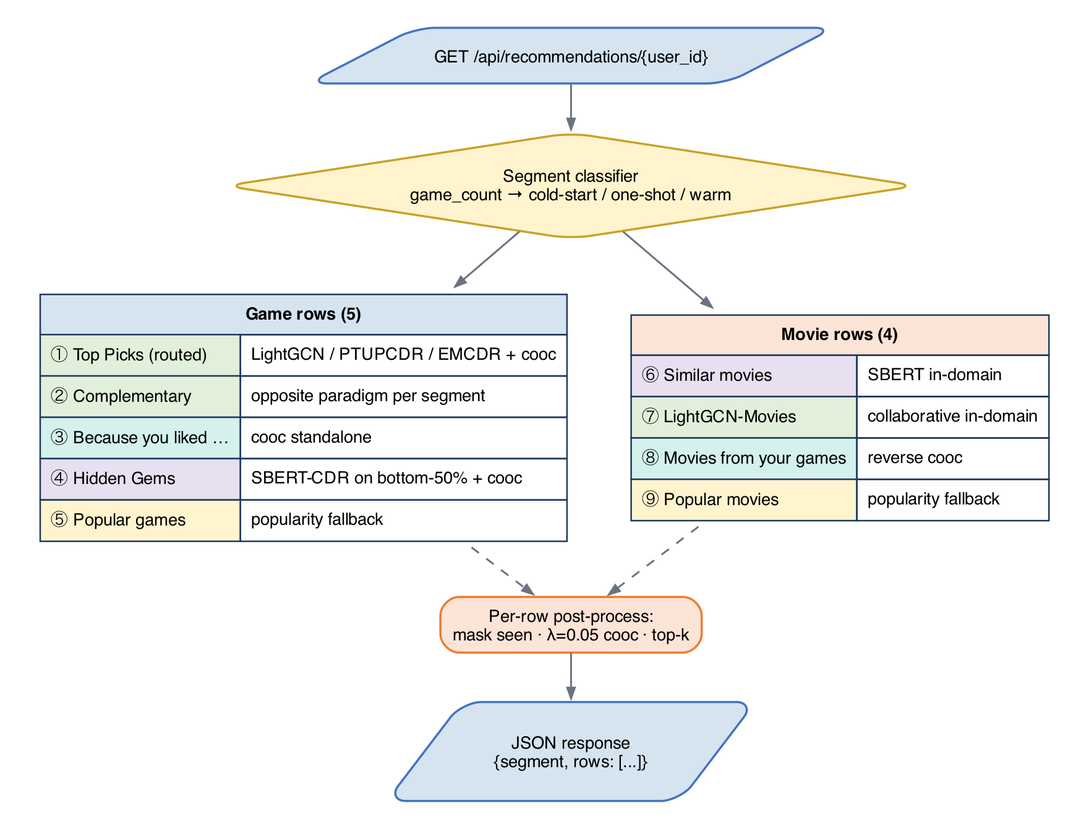
Figure 33: Recommendation flow — 9 parallel rows using different model paradigms
Each row follows the same post-processing pipeline: score all items via embedding dot product, apply co-occurrence bonus (if applicable), mask to the correct domain, normalize scores, exclude already-rated items, take top-K, deduplicate across rows, and enrich with metadata. This ensures consistent behavior while allowing each row to demonstrate a different recommendation paradigm.

7.3 Frontend Architecture
The frontend is a single-file jQuery single-page application (SPA) served as a static asset. A hash router switches between three views: a home page with user pickers grouped by segment (cold-start, one-shot, warm), a recommendations page showing the nine model rows as horizontal drag-to-scroll lanes, and an item detail page with a five-star rating widget. The visual language uses blue for movies and red for games consistently across cards, lane headers and scrollbars.
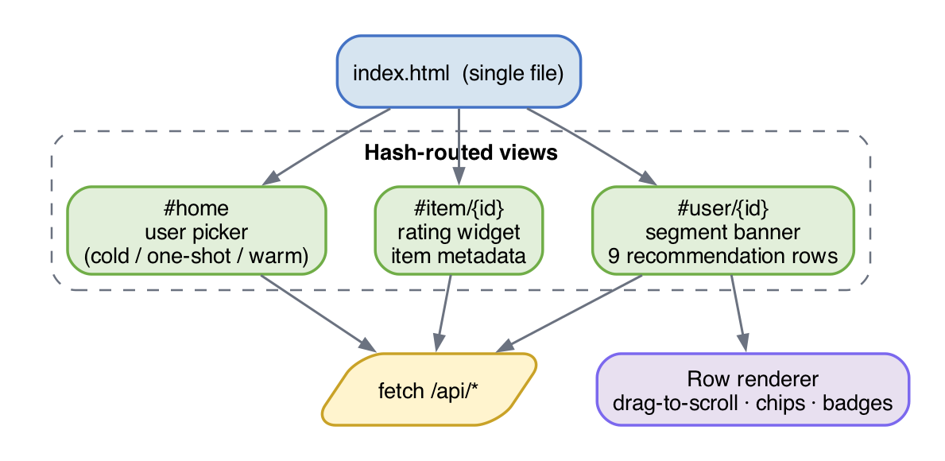
Figure 34: Frontend architecture — page structure and domain visual language

7.4 Refresh Architecture
The system exposes two effective refresh tiers. Tier 1 (instant, ~1 ms): co-occurrence, SBERT and popularity rows require no learned weights — a new rating updates the user's profile immediately through dict lookups and mean pooling, so those rows reflect the new state on the very next request. Tier 2 (fast, tens of ms): routed model rows (LightGCN, EMCDR, PTUPCDR, CMF) read pre-computed embeddings from the in-memory store and fold the user's latest ratings into the scoring step, so added ratings influence ranking without any model retraining. Periodic full retraining is handled offline by the benchmark scripts in ml/scripts/ and loaded at server startup, rather than by a live daemon — a deliberate choice discussed in Section 7.5.

7.5 Key Design Decisions
Decision | Rationale
Dual item space (SD + CD) | Single-domain models need compact game-only index; CDR models need unified movie+game index. Linked via Amazon ASIN.
In-memory embedding store | Dot product scoring is orders of magnitude faster in memory than any DB query. SQLite only for rating persistence.
Cooc as post-processing | Training-free, model-agnostic, instant refresh. Applied as score bonus to improve every model universally (Lesson 8).
Hourly LightGCN retrain | Full retrain takes ~40s. Real-time per-rating retraining is impractical. Cooc/SBERT fill the freshness gap.
9 rows (5 game + 4 movie) | Each row demonstrates a different paradigm: collaborative, CDR, content, behavioral, popularity — the full research spectrum.
User groups on home page | Different groups activate different strategies (routing rule from Lesson 6), making findings directly interactive.
This section records the non-obvious choices we made while turning the benchmark results into a working demo, and the reasoning behind each one.

jQuery SPA over Next.js
The demo is a single index.html served as a static asset, with all dynamic behaviour driven by a small amount of jQuery. The scope — four views, nine rows, one rating widget — does not justify a full Next.js build pipeline, and keeping the frontend framework-free makes it trivial to deploy behind any static file server. It also means the report's demonstration artefact is self-contained: opening index.html in a browser is enough to reproduce the UI, with no node_modules install step.

In-memory embedding store instead of a vector DB
At demo scale (roughly 15k users and 9k items per domain) the six embedding matrices and two co-occurrence maps fit comfortably in process memory and are accessed as NumPy arrays. A vector database would add operational overhead and network latency without any retrieval quality benefit at this scale. The cost is that adding a new model requires a redeploy rather than a DB migration, which is acceptable because model changes are already tied to offline retraining.

SQLite for users and ratings
User accounts and explicit ratings are persisted in a single WAL-mode SQLite file. This keeps the demo dependency graph minimal — no Postgres, no ORM migrations — while still giving us atomic upserts and persistence across restarts. Sample users loaded from benchmark artifacts and end-user-created accounts share the same schema, distinguished only by an is_sample flag.

Server-side row assembly
The nine rows are assembled on the server inside HybridRecommender.recommend_rows and returned as a single JSON payload. We deliberately avoided pushing row-level model selection to the client, because the routing rule from Section 6.1 depends on server-side state (segment classification from ratings) and because consistent cross-row deduplication and masking are easier to enforce in one place. The frontend only has to render whatever rows the server produced.

Fixed universal co-occurrence blend (λ = 0.05)
Rather than exposing co-occurrence as a user-toggle, we apply it as a silent post-processing step at a fixed λ that Lesson 8 validated across every collaborative and cross-domain model. Making it a toggle would put users in charge of a lever they cannot meaningfully evaluate, and it would invite the kind of A/B comparison that our offline lessons already answer. Popularity rows are the one exception and skip the cooc blend, because Lesson 8 showed the bonus is neutral-to-harmful there.

Offline training, online serving
All learned weights are produced offline by the benchmark scripts in ml/scripts/benchmarks/ and exported into artifacts/demo/ by export_demo_artifacts.py. The live backend only reads these artefacts; it does not call into the training code at runtime. This clean split means the demo's request latency is independent of training cost, and a stale model never blocks request handling.

7.6 Model Selection Rationale
Section 7.2 described what each of the nine recommendation rows does; this section explains why. Every row maps back to a concrete finding from the lesson series (Chapter 5) and to the Routing Decision Rule in Section 6.1. The guiding principle is that no single model is universally best — each paradigm (collaborative graph, cross-domain transfer, content-based, co-occurrence) has a regime in which it dominates, and the UI surfaces the right model for each regime rather than averaging them into one generic list.
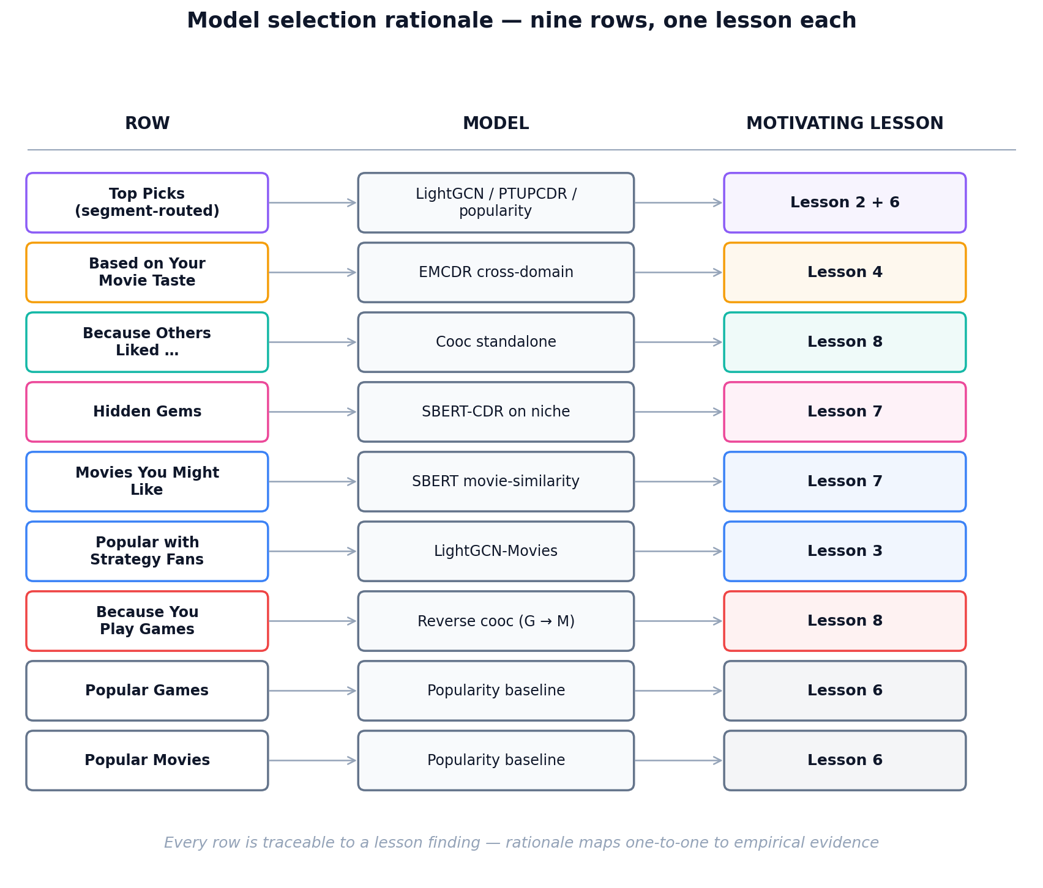
Figure 40 — Nine recommendation rows and the lesson motivating each.

Primary Row — Segment-Routed Top Picks
The first row uses a different model per user segment. This is the direct operationalisation of Lesson 6 (cold-start) and Lesson 2 (low-overlap collapse). For warm users with 3+ game ratings, we route to LightGCN: Lesson 2 showed graph convolution is the strongest single-domain ranker once enough in-domain edges exist, so we let the target-domain graph carry the recommendation. For one-shot users (1–2 games), we route to PTUPCDR: Lesson 6 showed PTUPCDR's personalized meta-network is designed precisely for the few-shot regime, where a minimal target signal can sharpen the transferred movie preference vector. For cold-start users (0 games), we route to EMCDR: Lesson 6 showed EMCDR's global MLP mapping is the most reliable pure-transfer model when no target-domain anchor exists, because it requires no game edges at inference time. All three variants are post-processed with the universal co-occurrence bonus from Lesson 8.
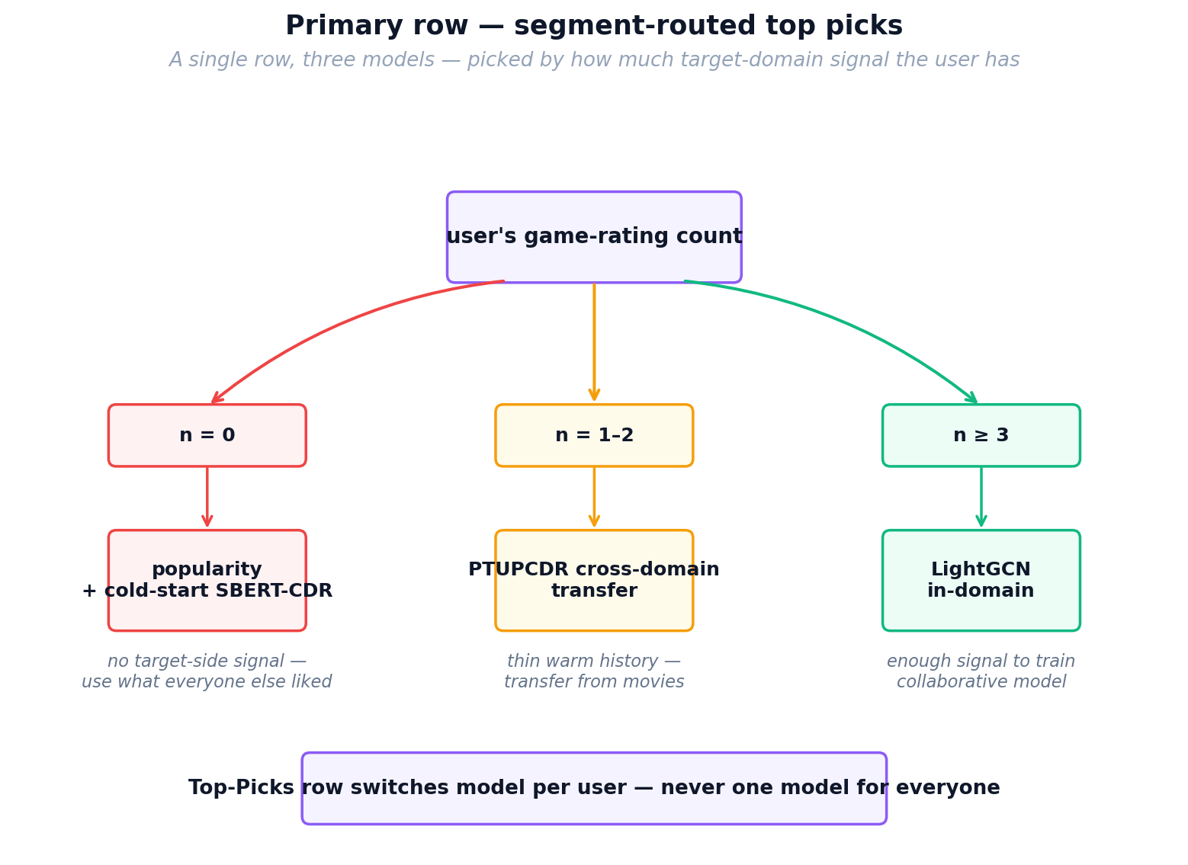
Figure 41 — Primary row routing: one row, three models, chosen per user.

Secondary Row — Complementary Paradigm
The second row intentionally shows a different modelling paradigm than the primary row so that the two lists are not near-duplicates. Warm users see an EMCDR-based "Based on Your Movie Taste" row, exposing the cross-domain signal that the LightGCN primary ignores. One-shot users see a LightGCN "Graph-Based Collaborative Picks" row as a counterweight to their PTUPCDR primary. Cold-start users have no secondary row, because with zero game ratings every collaborative model reduces to the same uninformative prior — showing a second variant would be padding rather than contrast.

Co-occurrence Standalone Row
Lesson 8 showed that co-occurrence reranking is the single most universally beneficial post-processing step across every model family (with popularity as the only exception). Beyond using it as a universal post-process, we expose it as its own row because it is the only signal that updates instantly: a new rating immediately changes which games share co-occurrence mass with the user's history, with no retraining required. This directly supports the Tier-1 "instant freshness" promise described in Section 7.4, and gives users an explainable "because you liked X" lane that does not depend on any learned embedding.

Hidden Gems — SBERT-CDR on Bottom-50% Popularity
Lesson 7 showed that SBERT-CDR wins by roughly 9× over collaborative models on niche items — those outside the head of the popularity distribution — because content similarity does not collapse the way collaborative signal does when interaction counts are small. Lesson 8 further showed that co-occurrence helps content models on non-popular tails. We therefore build the Hidden Gems row by restricting the candidate pool to the bottom 50% of games by popularity and scoring with SBERT-CDR plus the co-occurrence bonus. This is the only row where we deliberately mask the popular catalogue; putting SBERT-CDR here, rather than in the primary row, reflects the lesson finding that SBERT-CDR is niche-strong but head-weak.

Pure SBERT Movie-Similarity Row
For the in-domain movie recommendations, we use an unnormalised mean over the SBERT embeddings of the user's last five liked movies as the query. This is pure content matching within one domain and does not involve any cross-domain transfer; we keep it in the UI because it serves as a control lane — a transparent "similar to what you watched" list — against which the cross-domain rows can be compared. It is also cheap: SBERT embeddings are static, so this row inherits the same instant-refresh property as co-occurrence.

LightGCN Movies and Reverse Co-occurrence
Two of the movie rows are structural mirrors of game rows. LightGCN-Movies applies the same graph convolution model trained on the movie domain, providing a collaborative in-domain baseline symmetric to the game LightGCN row. The Reverse Co-occurrence row uses game-to-movie co-occurrence counts to surface movies that co-occur with the user's rated games — a behavioural transfer signal in the opposite direction to the main product flow. We include it to demonstrate that the co-occurrence signal from Lesson 8 is symmetric and does not require retraining a model in the reverse direction.

Popularity Baselines
The final two rows are popular-games and popular-movies lists. Lesson 6 produced a counter-intuitive finding that informs this choice: at true cold-start, popularity is a surprisingly strong baseline — it beat several cross-domain models in the zero-history regime. Keeping popularity explicitly in the UI has two purposes: it guarantees a non-empty reasonable list for brand-new users even if every other model fails, and it acts as a visible sanity baseline against which the learned-embedding rows can be qualitatively judged by the viewer.

Why Co-occurrence Is Applied Universally
Lesson 8 showed that adding a co-occurrence bonus (blend weight λ = 0.05) improved Recall@10 and NDCG@10 for every model family we tested except pure popularity, where it slightly hurt because popularity scores are already uncalibrated against item-item signal. Because the effect was consistent, we apply the same co-occurrence post-process to every collaborative and cross-domain row rather than making it a user-toggle. This is the clearest example in the UI of a lesson finding being lifted from offline evaluation into a production default.

What We Deliberately Did Not Include
Two models from the benchmark suite are not exposed as rows: MF-BPR and NCF. Lesson 2 and Lesson 6 showed that MF-BPR is strictly dominated by LightGCN on this dataset, and Lesson 1 showed that NCF offers no consistent advantage over simpler MF models on implicit ranking. CMF is also omitted because Lesson 3's hyperparameter analysis showed it requires dataset-specific tuning of the α weight to match EMCDR, and in practice EMCDR gives comparable or better transfer with a simpler single-model pipeline. These are deliberate omissions based on experimental evidence, not oversights — showing a row for a dominated model would mislead the viewer about which paradigms are actually doing the work.

8. Conclusion and Future Work
This project demonstrates that cross-domain recommendation from movies to games is effective under specific conditions: high user overlap (≥80%), sufficient source domain history (≥10 ratings), and particularly at cold-start where users have no target-domain interactions. The optimal strategy is not a single model but a routing rule that matches the model to the user's context.
The co-occurrence reranking layer is the most practically impactful finding — it requires no training, operates at test time, and consistently improves every model. It also serves as a diagnostic tool for detecting CDR model misconfiguration.

Future Work
- Statistical significance: Run all experiments with 3–5 random seeds and report confidence intervals
- Additional domain pairs: Test the routing rule on other Amazon category pairs (e.g., books→movies, electronics→games)
- Online evaluation: Deploy the routing rule in an A/B test to measure real-world click-through improvements
- Hybrid model: Train a single model that combines LightGCN graph signal with SBERT content and cooc behavioral transfer
- Temporal dynamics: Investigate whether user preferences transfer differently over time (e.g., movie taste from 2020 may not predict 2024 game preferences)

9. References
[1] He, X., Liao, L., Zhang, H., Nie, L., Hu, X., & Chua, T. S. (2017). Neural collaborative filtering. WWW 2017.
[2] He, X., Deng, K., Wang, X., Li, Y., Zhang, Y., & Wang, M. (2020). LightGCN: Simplifying and powering graph convolution network for recommendation. SIGIR 2020.
[3] Singh, A. P., & Gordon, G. J. (2008). Relational learning via collective matrix factorization. KDD 2008.
[4] Man, T., Shen, H., Jin, X., & Cheng, X. (2017). Cross-domain recommendation: An embedding and mapping approach. IJCAI 2017.
[5] Zhu, Y., Tang, Z., Liu, Y., Zhuang, F., Xie, R., Zhang, X., Lin, L., & He, Q. (2022). Personalized transfer of user preferences for cross-domain recommendation. WSDM 2022.
[6] Rendle, S., Freudenthaler, C., Gantner, Z., & Schmidt-Thieme, L. (2009). BPR: Bayesian personalized ranking from implicit feedback. UAI 2009.
[7] Reimers, N., & Gurevych, I. (2019). Sentence-BERT: Sentence embeddings using Siamese BERT-networks. EMNLP 2019.
[8] Hou, Y., Li, J., He, Z., Yan, A., Chen, X., & McAuley, J. (2024). Bridging language and items for retrieval and recommendation. arXiv preprint. (Amazon Reviews 2023 dataset)

