To construct an ER diagram based on the given DDL queries, we will follow the steps provided:

Step 1: Identify All Entities

Entities:

1. Users

2. Orders

3. Products

4. Orders_Products (associative entity)

5. User_Role

6. Users_Product_List

Step 2: Identify Relationships Between the Entities

Relationships:

1. A user can place multiple orders (Users to Orders).

2. An order can contain multiple products, and a product can be part of multiple orders (Orders to Products via Orders_Products).

3. A user can have multiple roles (Users to User_Role).

4. A user can have a list of products (Users to Products via Users_Product_List).

Step 3: Identify Cardinality and Ordinality

Cardinality and Ordinality:

1. Users to Orders: One-to-Many (One user can place many orders).

2. Orders to Products (via Orders_Products): Many-to-Many (One order can contain many products, and one product can be part of many orders).

3. Users to User_Role: One-to-Many (One user can have multiple roles).

4. Users to Products (via Users_Product_List): Many-to-Many (One user can have many products in their list, and one product can be in many users' lists).

Step 4: Add Attributes for the Entities

Attributes:

1. Users

- id (PK)

- activation_code

- active

- address

- city

- email

- first_name

- last_name

- password

- password_reset_code

- phone_number

- post_index

2. Orders

- id (PK)

- address

- city

- date

- email

- first_name

- last_name

- phone_number

- post_index

- total_price

- user_id (FK)

3. Products

- id (PK)

- type

- product_title

- brand

- year

- details

- description

- filename

- price

- storage

- condition

4. Orders_Products

- order_id (FK)

- products_id (FK)

5. User_Role

- user_id (FK)

- roles

6. Users_Product_List

- user_id (FK)

- product_list_id (FK)

ER Diagram

Below is the ER diagram based on the entities, relationships, and attributes identified:

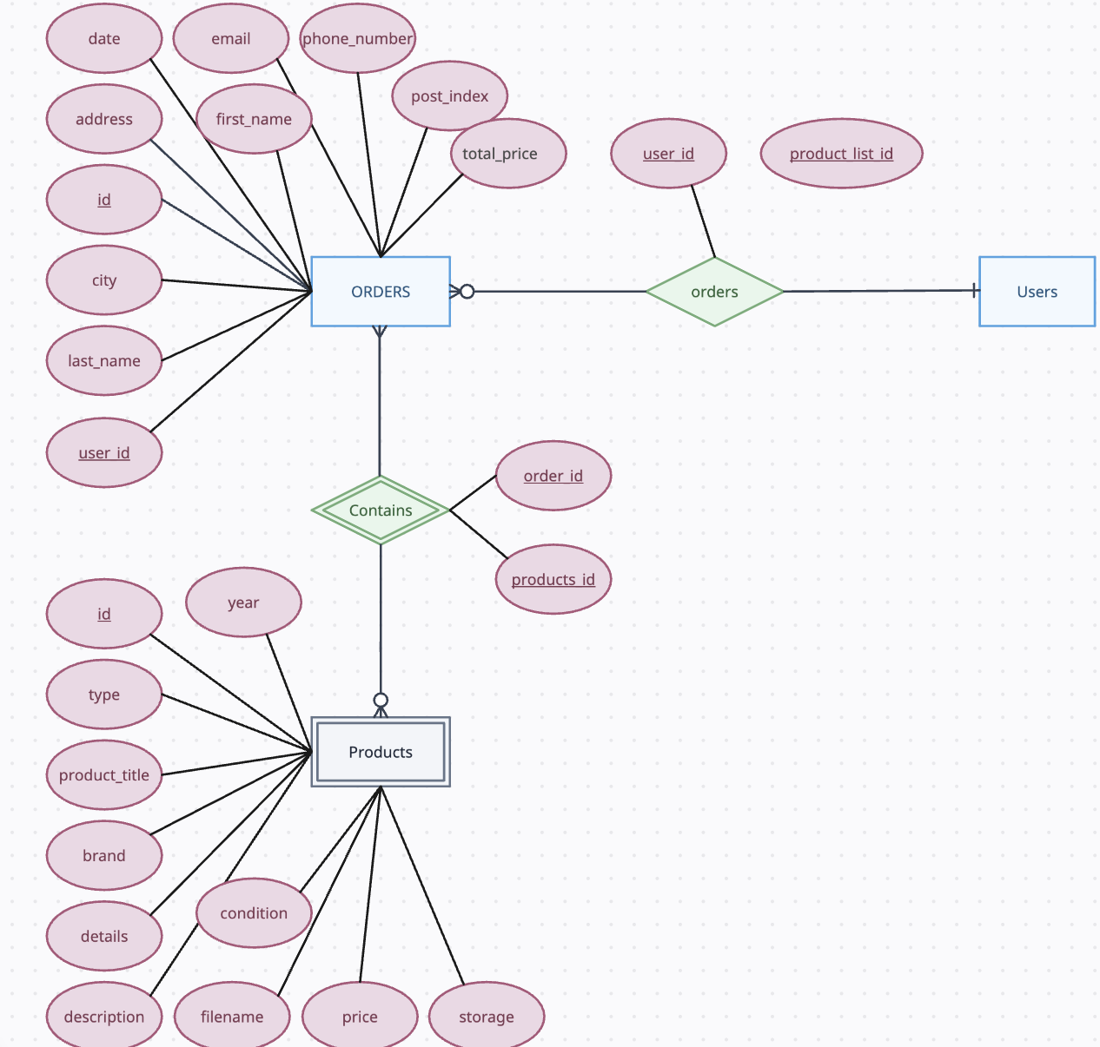

Explanation

1. Users: Contains user details.

2. Orders: Contains order details, each order is linked to a user.

3. Products: Contains product details.

4. Orders_Products: An associative entity that links orders and products to represent the many-to-many relationship.

5. User_Role: Links users with their roles, representing a one-to-many relationship.

6. Users_Product_List: An associative entity that links users and products for user-specific product lists, representing a many-to-many relationship.

Sequences

The sequences specified in the DDL are used for auto-incrementing the primary keys in the tables, ensuring unique identifiers for orders, products, and users.