###### 钮子开关 MTS-203 DPDT 6脚3档

###### Mini MTS-203 6-Pin DPDT ON-OFF-ON 6A 125VAC Toggle Switches

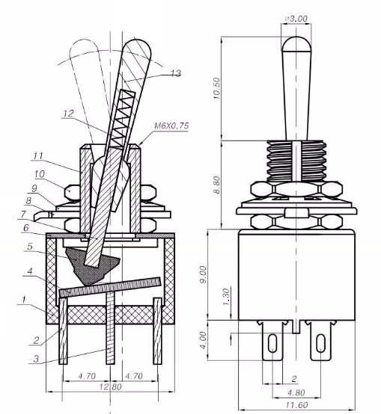

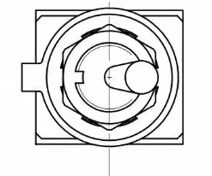 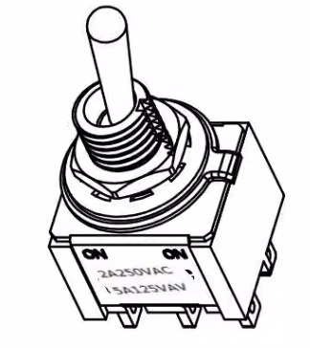

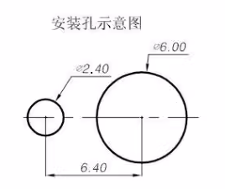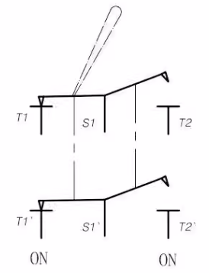

技术要求:

1.规格:2A 250VAC，5A 125VAC

2.操作温度:-25℃--+85℃

3.接触电阻:<0.02Q

4.绝缘电阻:>1000MQ

5.耐压:AC1500V/min

6.扭柄换向力:2--15N

7.寿命:10000次

Technical Requirements.

1.Specification:2A 250VAC, 5A 125VAC

2.Operating temperature:-25℃--+85℃

3.Contact resistance:<0.02Q

4. Insulation resistance:>1000MQ

5.Withstanding voltage:AC1500V/min

6. Torque handle reversing force: 2--15N

7. Life: 10000 times