**CURRICULLUM VITAE (CV)**

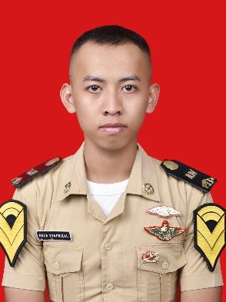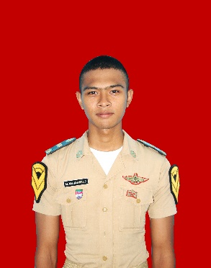

**PERSONAL IDENTITY**

Name : REZA SAYFRIZAL

Registration number : 541711206429 T

Department : TECHNICAL

Place & datesof birth : KENDAL, MARCH 11TH 1998

Sex : MALE

Blood type : O

Home address : DS.SIDOMUKTI RT.07 RW.O1 KEC.WELERI KAB.KENDAL

SEMARANG, JAWA TENGAH

Instituation Academy : PIP SEMARANG

Contact address : 081326256985

E-mail address : rizalrezz4321@gmail.com

1. **DOCUMENTS**

|  |  |  |  |  |  |
| --- | --- | --- | --- | --- | --- |
| No | Name of Documents | Serial Number | Date of Issued | Place of Issued | Valid Until |
| **1** | **Passpor** | C3753094 | 05 JUL 2019 | SEMARANG | 05 JUL 2024 |
| **2** | **Seaman Book** |  |  | SEMARANG |  |
| **3** | **Yellow Book** | - | - | - | - |

1. **CERTIFCIATES**

|  |  |  |  |  |
| --- | --- | --- | --- | --- |
| No | Name of Certificate | Certificate Number | Date of Issued | Place of Issued |
| **1** | BASIC SAFETY TRAINING | 6211853647010318 |  | SEMARANG |
| **2** | BASIC TRAINING FOR LIQUEFIED GAS TANKER CARGO OPERATIONS | 6211853647370319 |  | SEMARANG |
| **3** | BASIC TRAINING FOR OIL AND CHEMICAL TANKER CARGO OPERATIONS | 6211853647390319 |  | SEMARANG |
| **4** | MEDICAL CARE ON BOARD SHIP |  |  | SEMARANG |
| **5** | MEDICAL FIRST AID | 6211853647070318 |  | SEMARANG |
| **6** | ADVANCED FIRE FIGHTING | 6211853647060318 |  | SEMARANG |
| **7** | ISM CODE |  |  | SEMARANG |
| **8** | SEAFARERS WITH DESIGNATED SECURITY DUTIES | 6211853647320318 |  | SEMARANG |
| **9** | SECURITY AWARENESS TRAINING | 6211853647310318 |  | SEMARANG |

1. **ACADEMIC ACHIEVEMENS**

|  |  |  |
| --- | --- | --- |
| No | Semester | GPA (General Point Average) |
| 1 | Semester I |  |
| 2 | Semester II |  |
| 3 | Semester III |  |
| 4 | Semester IV |  |

Your Faithfully

(REZA SYAFRIZAL)