**PRIEDS Assignment Technical Design Document**

**Date Created**

11/02/2022

**Date Updated**

-

**Author(s)**

Khalid Al Asad

## **Functionality**

* There is an API so that user can get all the Hospital Customer
* There is an API so that user can create Hospital Customer
* There is an API so that user can get the detail about one of Hospital Customer
* There is an API so that user can update the detail about one of Hospital Customer
* There is an API so that user can update wheter the Customer has/has not been checked
* There is an API so that user can delete Hospital Customer

# **Technical Architecture**

### Database Schema

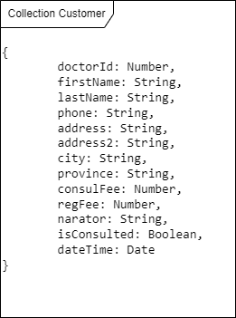

### Sequence Diagram

#### User getAll the Hospital Customer

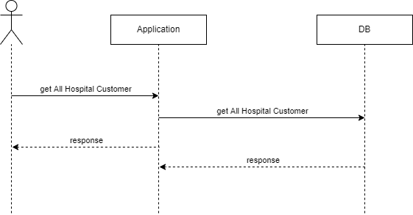

#### User can create Hospital Customer

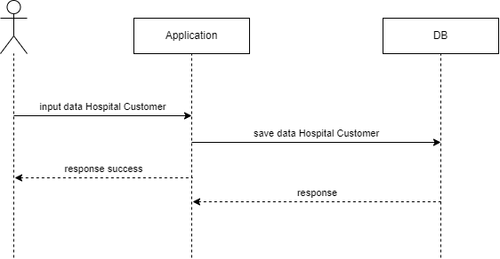

#### User can get detail one of the Hospital Customer

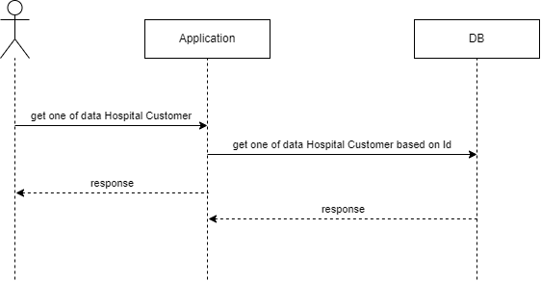

#### User can update Hospital Customer

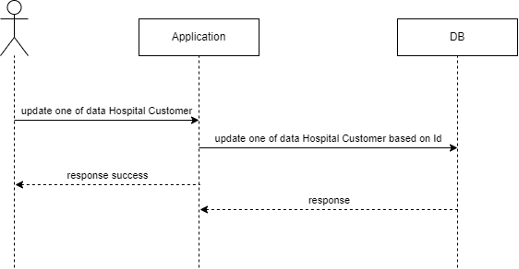

#### User can update wheter the Customer has/has not been checked

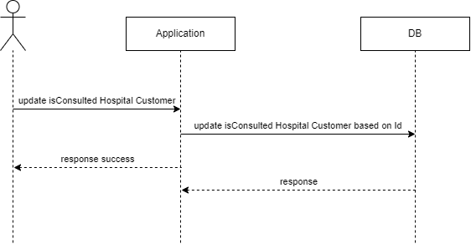

#### User can delete Hospital Customer

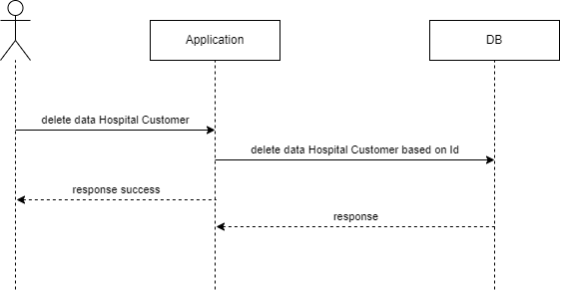

### API Contract

#### API User get All Hospital Customer

* + Base Url : /api/customer
  + HTTP Method : GET
  + Request Payload:
  + Response :
    - Status: STRING
    - Result:
      * Array
        + doctorId: Number
        + firstName: String
        + lastName: String
        + phone: String
        + address: String
        + address2: String
        + city: String
        + province: String
        + consulFee: Number
        + regFee: Number
        + narator: String
        + isConsulted: Boolean
        + dateTime: Date

#### API User create Hospital Customer

* + Base Url : /api/customer
  + HTTP Method : POST
  + Request Payload:
    - Data:
      * + doctorId: Number
        + firstName: String
        + lastName: String
        + phone: String
        + address: String
        + address2: String
        + city: String
        + province: String
        + consulFee: Number
        + regFee: Number
        + narator: String
        + isConsulted: Boolean
        + dateTime: Date
  + Response :
    - Status: STRING

#### API User get Detail Hospital Customer

* + Base Url : /api/customer/<CustomerId>
  + HTTP Method : GET
  + Request Payload:
  + Response :
    - Status: STRING
    - Data:
      * + doctorId: Number
        + firstName: String
        + lastName: String
        + phone: String
        + address: String
        + address2: String
        + city: String
        + province: String
        + consulFee: Number
        + regFee: Number
        + narator: String
        + isConsulted: Boolean
        + dateTime: Date

#### API User update Hospital Customer

* + Base Url : /api/customer/<CustomerId>
  + HTTP Method : POST
  + Request Payload:
    - Data:
      * + doctorId: Number
        + firstName: String
        + lastName: String
        + phone: String
        + address: String
        + address2: String
        + city: String
        + province: String
        + consulFee: Number
        + regFee: Number
        + narator: String
        + isConsulted: Boolean
        + dateTime: Date
  + Response :
    - Status: STRING

#### API User delete Hospital Customer

* + Base Url : /api/customer/<CustomerId>
  + HTTP Method : DELETE
  + Request Payload:
  + Response :
    - Status: STRING

#### API User isConsulted Hospital Customer

* + Base Url : /api/customer/<CustomerId>
  + HTTP Method : PUT
  + Request Payload:
  + Response :
    - Status: STRING