AAM Performance  
Setup JMeter with TeamCity



Contents

1.1 Introduction 2

1.2 Objective 2

1.3 Versions 2

1.4 Prerequisites 2

1.5 Steps 3

1.5.1 JMeter Plugin for TeamCity Installation 3

1.5.2 Push Project to GitHub. 3

1.5.3 Configure the JMeter TeamCity Project 4

1.5.4 Configure TeamCity Plugin Build Feature 5

1.5.5 Include JMeter HTML Report in the Build Results 6

1.5.6 Send the HTML Report in the Notification Email 7

1.5.7 Monitor Machine Performance. 8

1.6 References. 9

## Introduction

Continuous Integration and Continuous Delivery are vital for developing and producing complex applications, technology and automation help to move faster and more efficiently. Being an important part of the software development lifecycle, load testing needs to be included into the Continuous Integration process, bringing confidence to software performance and capacity.

## Objective

The objective of this document is to show steps used to configure TeamCity for running AAM Performance JMeter Tests.

## Versions

Below are the versions used to demonstrate this document:

* TeamCity 2017.2.1
* JMeter 3.3

## Prerequisites

Following prerequisites are not mandatory if we already pushed the whole JMeter folder to GitHib with installed plugins.  
After installing latest JMeter we should download some Plugins as below:

1. Download the [JMeter Plugin Manager](https://jmeter-plugins.org/downloads/all/) and put it into *lib/ext* directory.
2. Open JMeter (By double click on *bin/jmeter.bat*) and Then navigate to Options > Plugins Manager and make sure to install the following list of plugins:

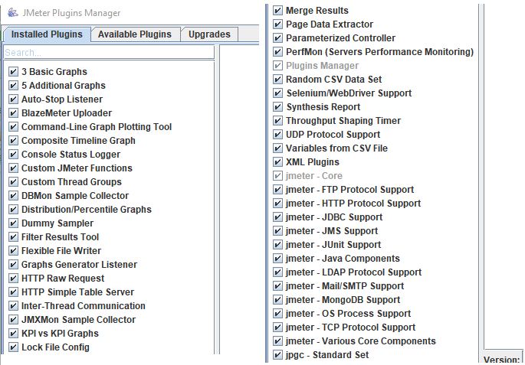

## Steps

### JMeter Plugin for TeamCity Installation

1. Download the [latest version of the plugin](https://teamcity.jetbrains.com/repository/download/TeamCityPluginsByJetBrains_JMeterPlugin_Build/.lastSuccessful/jmeter.zip).
2. Drop ‘*jmeter.zip’* file to the TeamCity Plugin folder – by default it is *C:\ProgramData\JetBrains\TeamCity\plugins*
3. Restart TeamCity.

If everything goes as expected, the JMeter plugin should be listed among others under TeamCity > Administration > Plugins List Page:

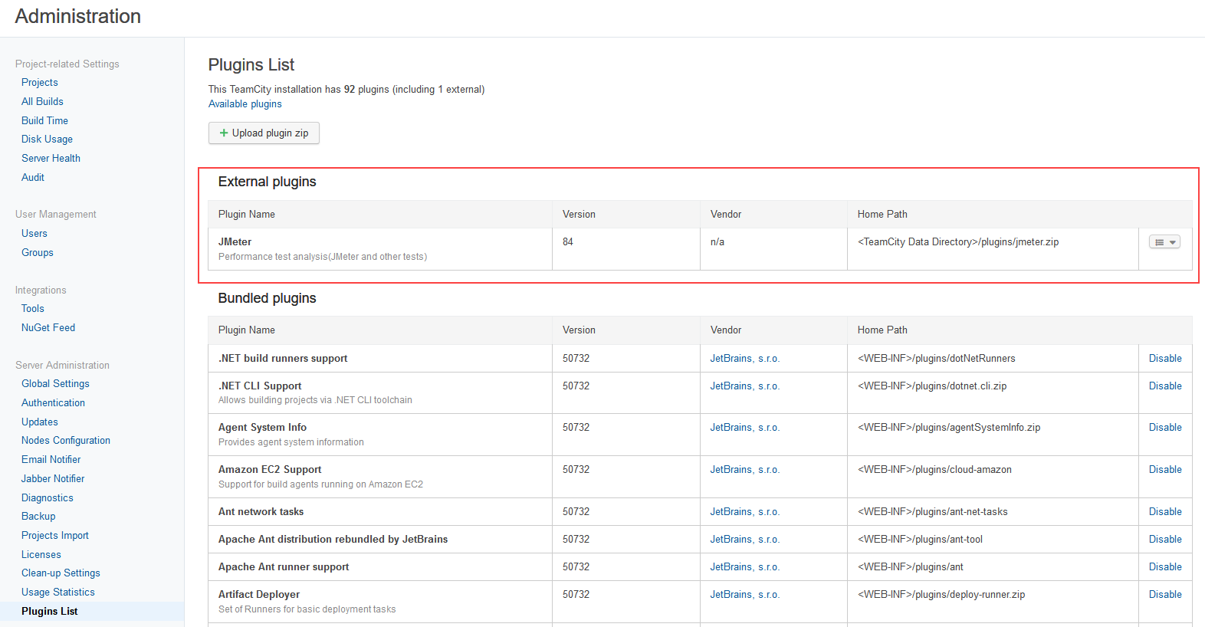

**Note:**

The JMeter TeamCity Plugin expected the jmeter results file to be in a specific non-default format, so the following 2 lines should be added to *user.properties* file (it is located under the “bin” folder of JMeter folder):  
 jmeter.save.saveservice.default_delimiter=\t  
 jmeter.save.saveservice.print_field_names=true

### Push Project to GitHub.

JMeter itself in additional to ‘AAMLive.jmx’ and the ‘logintestdata.txt’ should be pushed to Github at the same directory level as below:

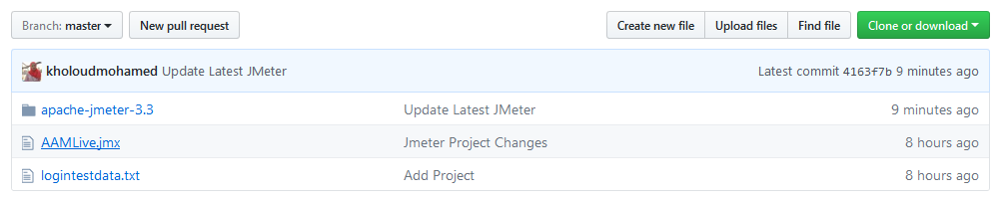

### Configure the JMeter TeamCity Project

In order to trigger a JMeter test from TeamCity, we need to add a TeamCity project with a build step which will call JMeter and provide the test script as a parameter as below:

1. Either to create a new TeamCity project then Create a new TeamCity Build Configuration or we can create the build configuration inside any of the available projects.
2. In Version Control Settings, create a new Git VCS Root to checkout the repo from, in our example it will look like as below:

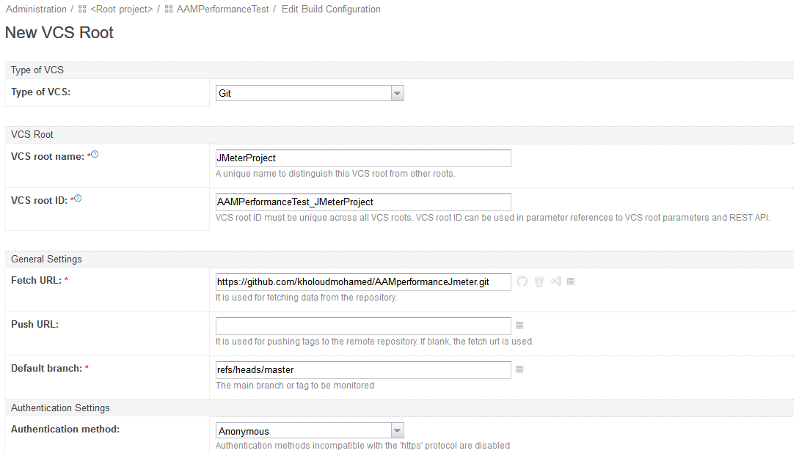

1. Create a Command Line build step as below:

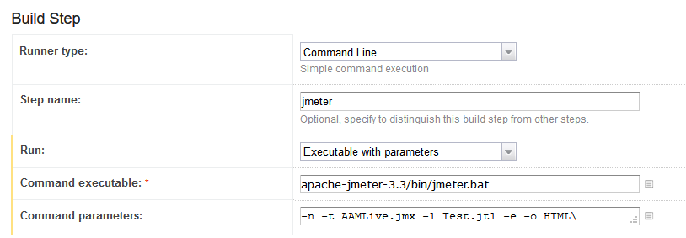

### Configure TeamCity Plugin Build Feature

The next step is to point the JMeter TeamCity plugin to the .jtl results file so we could see the performance statistics along with the build results.

1. Go to Build Features and set the configurations as below

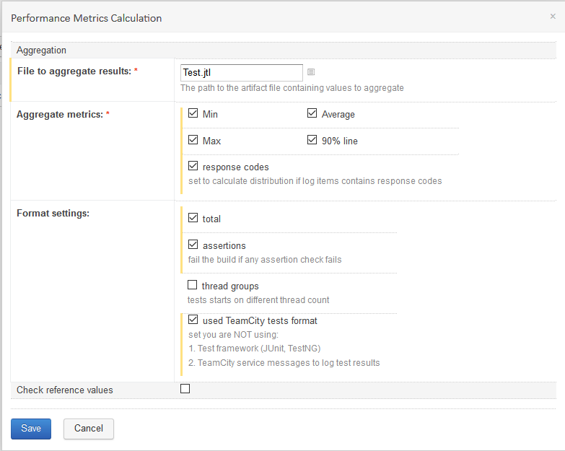

1. Now when we run the test we should be able to see an extra tab on the build results page – ‘performance Statistics’

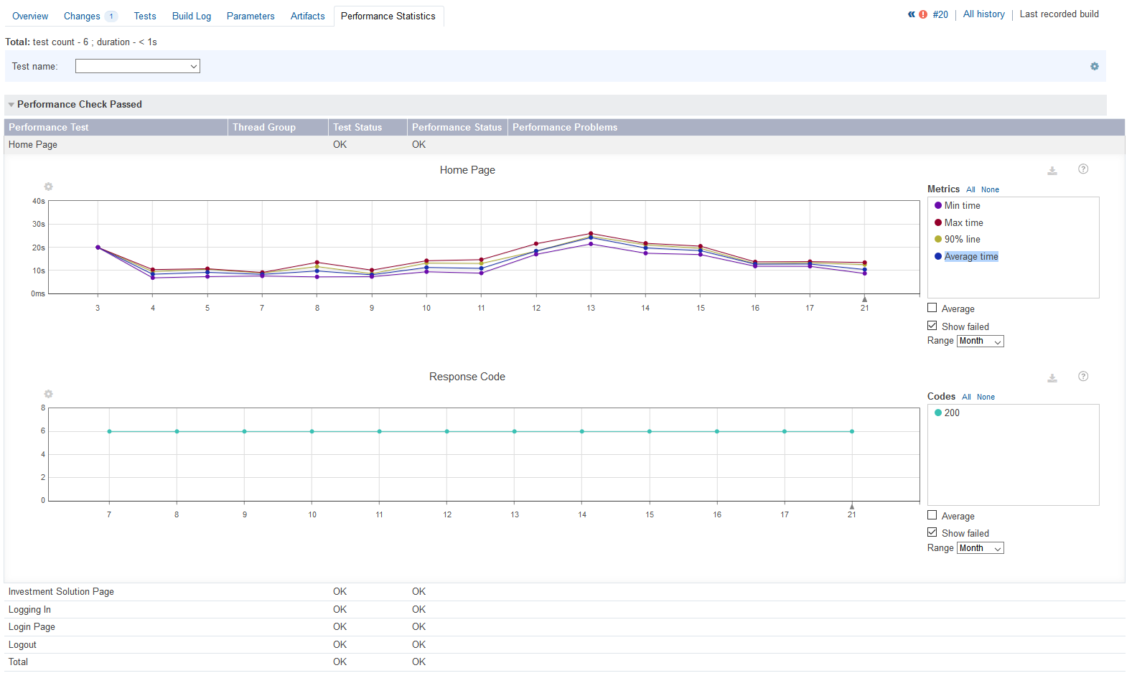

### Include JMeter HTML Report in the Build Results

As the JMeter already produces reports in HTML format then we can extend TeamCity with a custom tab to show this report.

1. Configure the build script to produce the HTML Report.

This step is already done in the command parameters HTML report will be placed in ‘CheckoutDirectory/HTML/’

1. Configure the report as the build artifact, from the General Settings of the build configuration set Artifact Paths as below:



1. From the Root Project, Edit Settings and go to ‘Report Tabs’, then Create new build report tab as below:

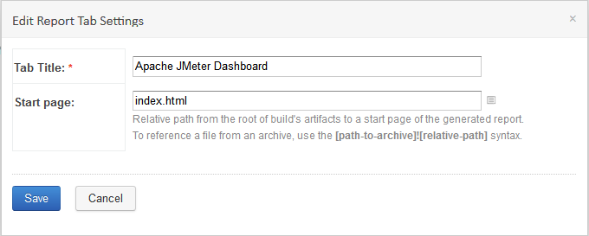

1. Now when we run the test we should be able to see an extra tab on the build results page – ‘Apache JMeter Dashboard’

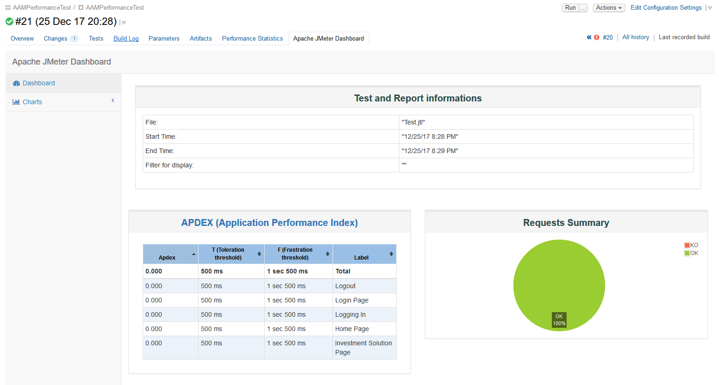

### Send the HTML Report in the Notification Email

In order to include the HTML report in TeamCity Email Notification we can do below steps:

1. Navigate to TeamCity _notification folder – by default it is C:\ProgramData\JetBrains\TeamCity\config\_notifications\email
2. Add below lines to build_failed.ftl and build_successful.ftl

<p>Build artifacts:</p>

<#list build.artifactsDirectory.listFiles() as file>

<a href="${webLinks.getDownloadArtefactUrl(build.buildTypeExternalId, build.buildId, file.name)}">${file.name}</a> (${file.length()}B)<br/>

</#list>

1. From TeamCity, click the arrow next to username, and select My Settings & Tools from the drop-down list. Open the Notification Rules tab.

Add a new rule for the Performance Project as below:

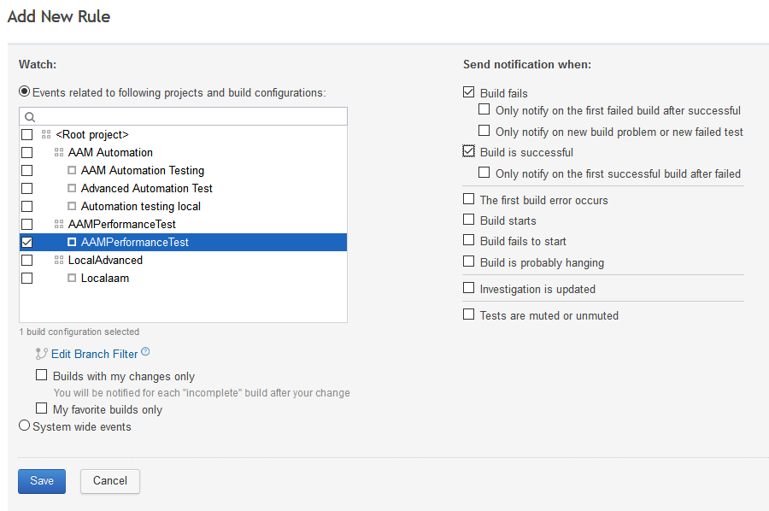

1. Now when we run the project we should receive an email with link to the HTML Report as below sample:

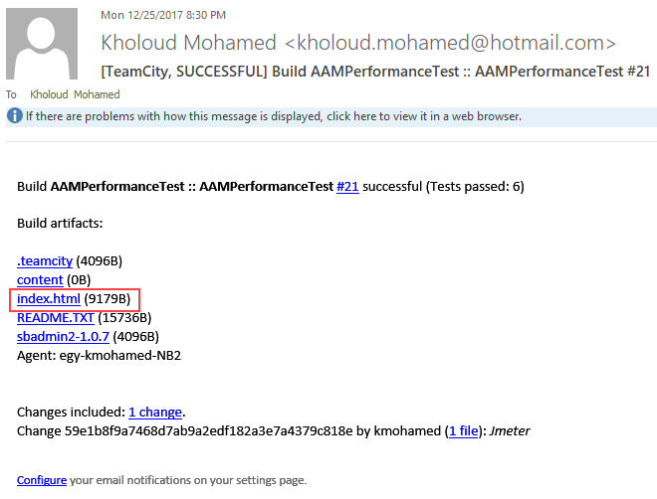

### Monitor Machine Performance.

There is a feature in TeamCity in which we can collect metrices about CPU, memory, disk so we can monitor the test server while performance testing is running to track any memory leak issue etc.

This can be added as a build feature and it should be configured from window below:  
**Refer to references links for more info about how to configure it.

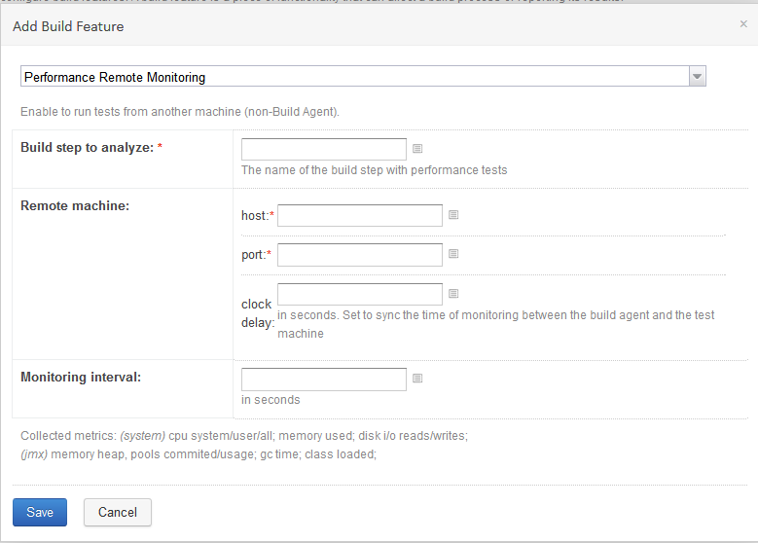

## References.

* <https://www.blazemeter.com/blog/how-run-jmeter-tests-teamcity-continuous-integration>
* <https://confluence.jetbrains.com/display/TCD10/Including+Third-Party+Reports+in+the+Build+Results>
* <https://devexplore.wordpress.com/2015/01/20/include-artifacts-in-team-city-e-main-notifier/>
* <https://blog.jetbrains.com/teamcity/2013/02/teamcity-performance-monitor/>
* <https://www.blazemeter.com/blog/how-run-jmeter-tests-teamcity-continuous-integration>
* <https://confluence.jetbrains.com/display/TCD10/Performance+Monitor>