Feedback

* Add the logo at the top and basically onto every page .
* 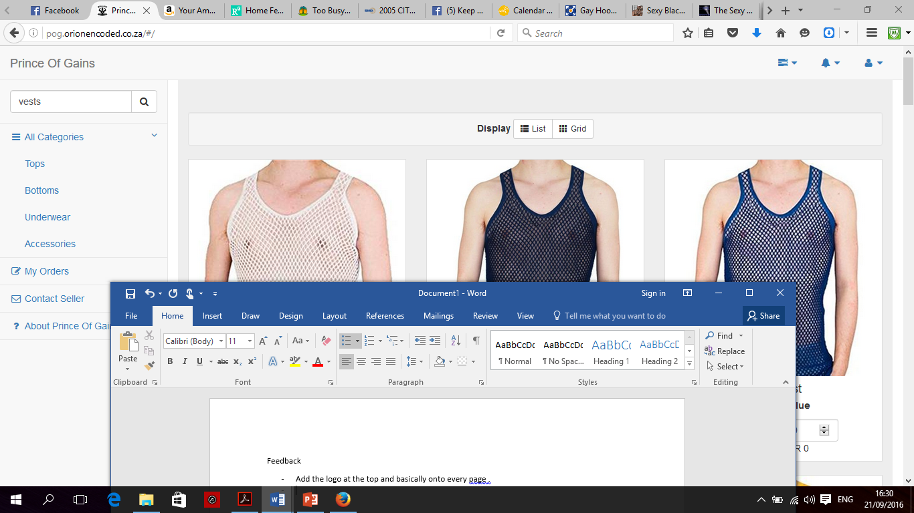



* That area should be more emboldened with text on the side of the icons to show a person what its about before they pull down the menu.
* Ok the front page is all products, that’s fine , the list view vs grid view toggle should work as well. Is there a way to set restrictions for the images such that they will be forced by limits to best fit within the same standard space ? with perhaps the option to click on image and get an image popup alone ?
* Tumblr.com uses a system whereby your images will be delimited into a set space determined by the theme you choose and if you put too many images they just spill over into page 2 etc virtually ad infitum. ( unless you choose a ribbon theme which just continually scrolls down on demand till your browser memory is full.)
* For the front page or home whats the possibility of adding a random product gallery of all products plus logo in random slideshow covering just 3 images or one row ?
* 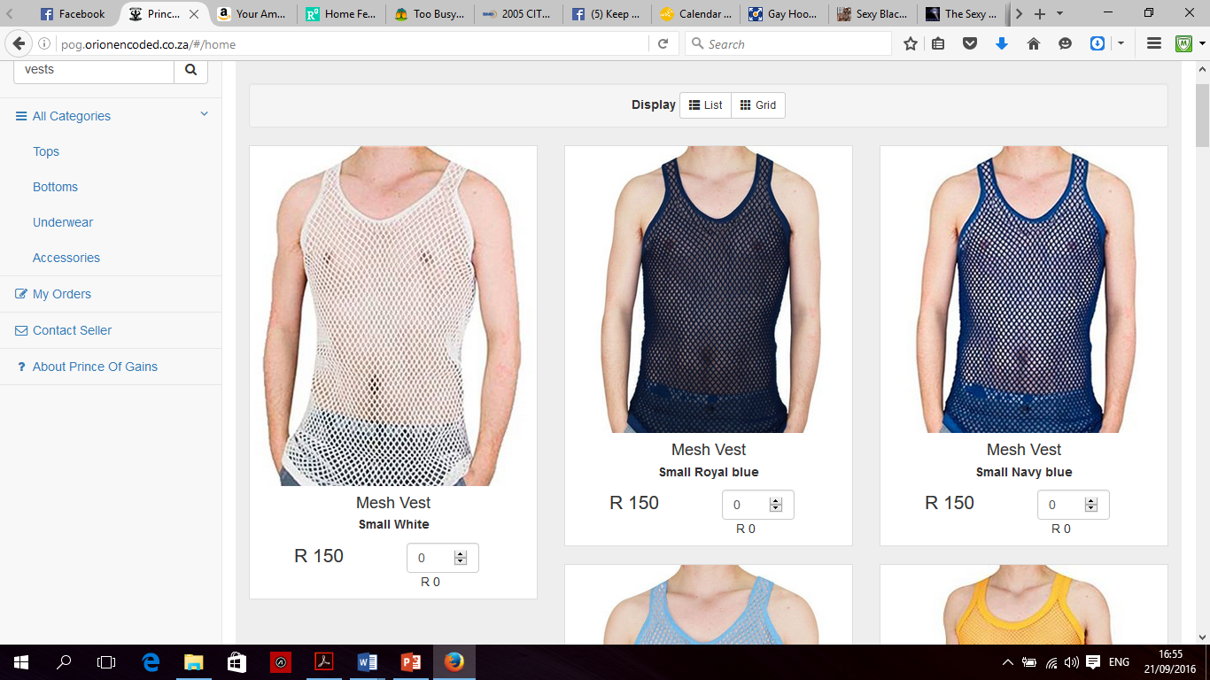

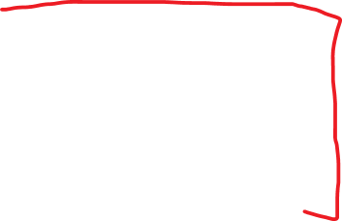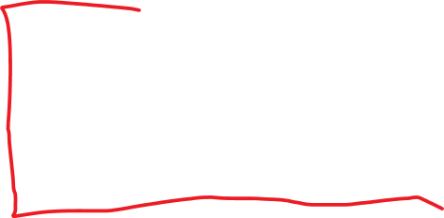

* 1, 2 and 3 are images changing in a slideshow of products and the logo. Red area is the noticeboard. The bottom red line would then be the end of home page , nothing further to scroll down to.
* Enable checkout from either the bottom of a products page or the basket .
* 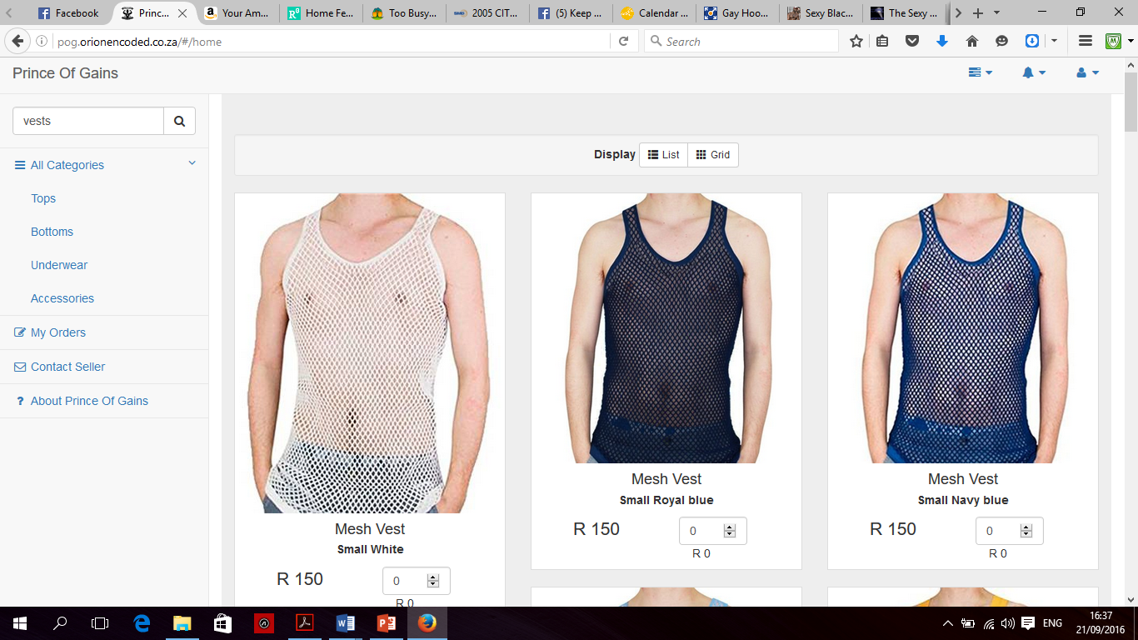

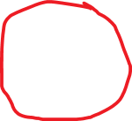

* Ok can we have a notice board there ? easily edited space to announce stuff like specials etc and hyperlinks and or live feed to the official insta, twitter and facebook page ?
* 



* Can we have some button look or effect to highlight that these are actually working links ? especially for home page ( Prince of gains ) area?
* 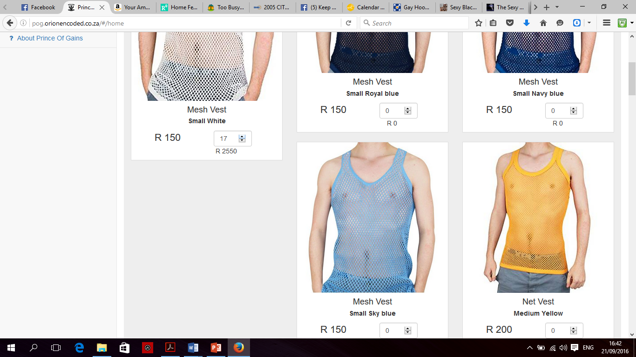



* On the administrator side we should be able to cap quantity , there is potential someone might order above whats available and then pay for it leading to an embarrassing refund , at the same time we don’t want to readily show on the customer side how much stock we have , its unprofessional but as they click away they should reach the stock limit warning…….. the next one will crack you up …….
* 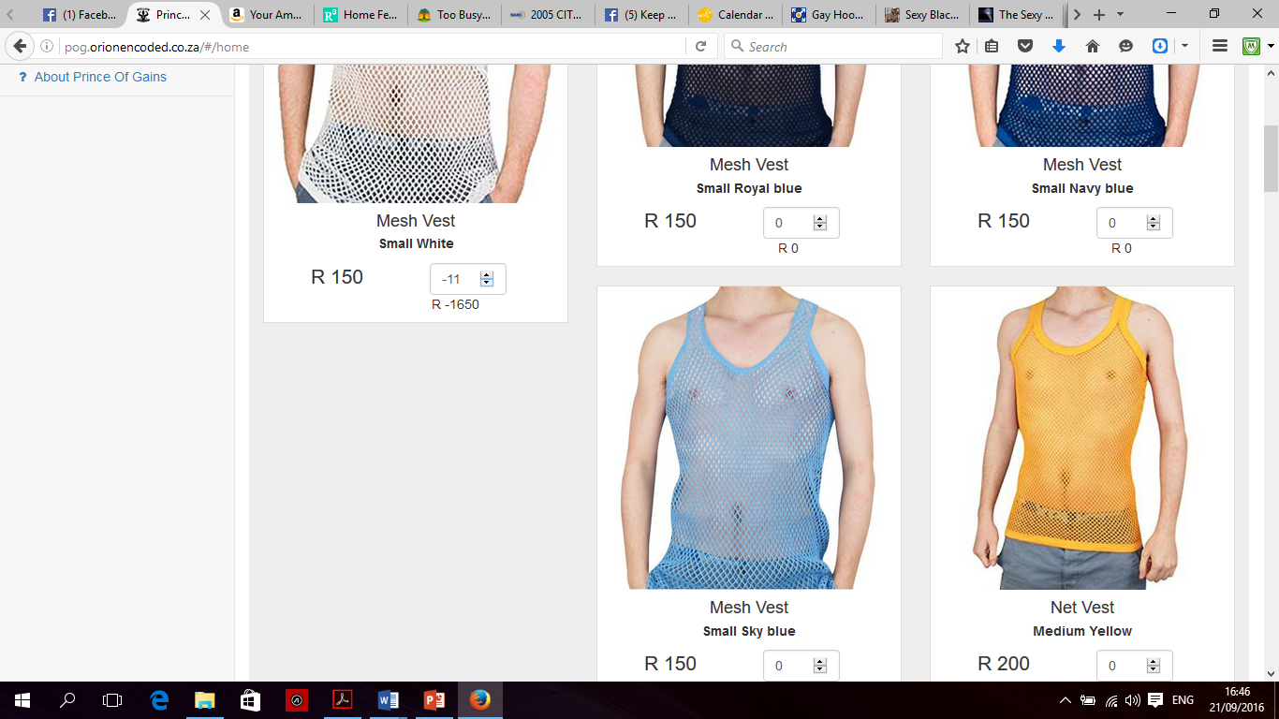



* Whilst reversing an order one can actually end up in negative and im sure generate an error in the resulting basket . the software must be forbidden to count into negatives.
* Colour scheme. Blue and whote or black and whote is great for me but take not black and white may compete with the logo. overall I like the simple nature of it it keeps one focused on shopping without too much distracting imagery , visuals and graphics . keeping it simple is great and allows us to show off the product and skilful presentation without being confounded by a complicated layout.
* So new stock basically comes in daily now , from bulk orders to singular sample orders, I hope there will be ease of admin editing to add items , especially with that tumblr like system I mentioned earlier.
* Is there an algorithm capable of applying say a 20 % discount ? or remove a R100 delivery for orders above a certain amount e.g R1000 when activated ? otherwise add R100 delivery automatically to every order unless admin set not to do so or half it or remove it for qualifying orders as mentioned above ?

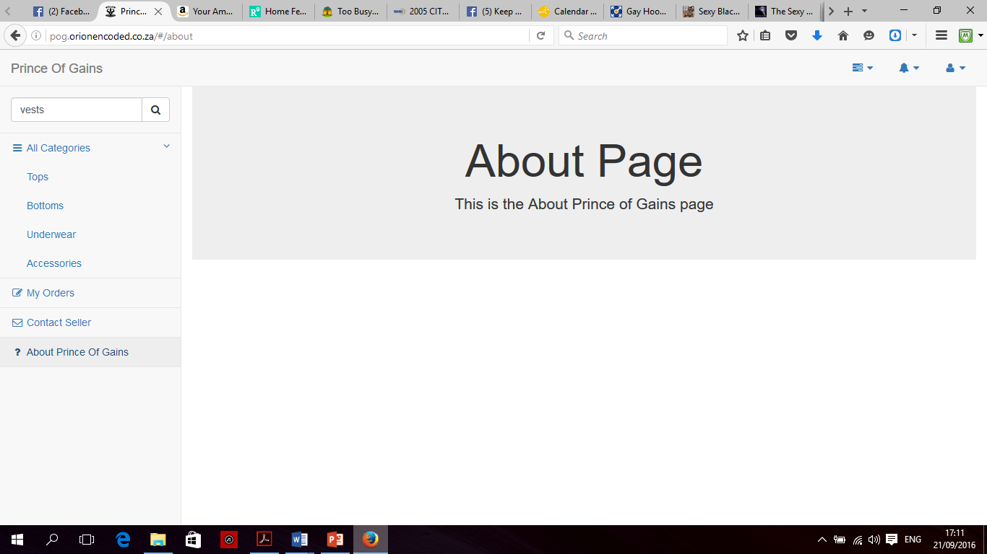

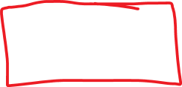

Move the about page to the side and put logo next t it then text below, same for contact us and basket page.

Populate the product pages in grid view like it is now , no need for list view I think , because this is the clients only chance to see the product they want to buy clearly .

Upon checking out the client gets their e mail with me receiving a copy same time

The admin should be able to also “lock”a product when its out of stock