**SQL Default Dataset ‘Sakila’ All questions and Answers**

1. **Find Actor Details by Full Name**
   * Write a query to retrieve the actor_id, full_name, and last_update of the actor whose full name is 'SUSAN DAVIS'.
   * **Hint:** Use CONCAT to combine first_name and last_name.

**Answer :**

SELECT

Output

actor_id,

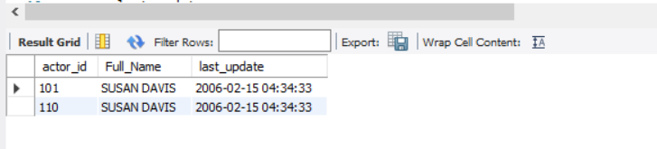 CONCAT(first_name, ' ', last_name) AS Full_Name,

last_update

FROM

sakila.actor

WHERE

concat(first_name, ' ', last_name) = 'SUSAN DAVIS';

1. **Actors Updated on Specific Date**
   * Write a query to list the full_name and last_update of all actors who were last updated on '2006-02-15'.
   * **Hint:** Use the DATE function to extract only the date part of last_update.

**Answer :**

SELECT

CONCAT(first_name, ' ', last_name) AS Full_Name,

last_update

FROM

sakila.actor

WHERE

date(last_update) ='2006-02-15';

1. **Count Actors Updated on Specific Date**
   * Write a query to count the total number of actors whose last_update is on '2006-02-15'.

**Answer :**

Output

SELECT

COUNT(*)

FROM

sakila.actor

Where

date(last_update) ='2006-02-15';

1. **Payment Statistics**
   * Write a query to calculate the minimum, maximum, and average payment amounts from the payment table.
   * **Hint:** Use the MIN, MAX, and AVG functions.

**Answer :**

Output

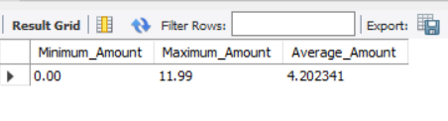

SELECT

MIN(amount) as Minimum_Amount,

MAX(amount) as Maximum_Amount,

AVG(amount) as Average_Amount

FROM

sakila.payment;

1. **Highest Payment Details**
   * Write a query to retrieve all details of the payment with the maximum amount.
   * **Hint:** Use a subquery to find the maximum amount first.

**Answer :**

Output

SELECT

 MAX(amount) as Maximum_Amount

FROM

sakila.payment;

1. **Actor with the Highest Actor ID**
   * Write a query to retrieve all details of the actor with the maximum actor_id.
   * **Hint:** Sort the result in descending order of actor_id.

**Answer :**

SELECT *

FROM

sakila.actor

ORDER BY actor_id DESC;

1. **Insert New Actor**
   * Write a query to insert a new actor with the following details:
     + first_name = 'John'
     + last_name = 'Doe'
     + Set last_update to the current timestamp.

**Answer :**

insert into

Output

sakila.actor

(actor_id, first_name, Last_name, last_update)

values

('201','John','Doe','2024-11-27');

1. **Update Actor's Last Update Timestamp**
   * Write a query to update the last_update column of the actor with actor_id = 5 to the current timestamp.

**Answer :**

Output

UPDATE sakila.actor

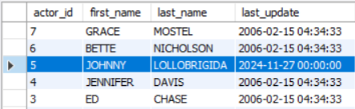SET

last_update = '2024-11-27'

WHERE

sakila.actor_id = 5;

set sql_safe_updates = 0;

1. **Delete Small Payments**
   * Write a query to delete all rows from the payment table where the amount is less than 1.00.

**Answer :**

DELETE FROM sakila.payment

WHERE

amount <=1;

set sql_safe_updates =1;

1. **Count Films with Long Rental Duration**
   * Write a query to find the total count of films in the film table where the rental duration is greater than 5 days.
   * **Hint:** Use the COUNT function.

**Answer :**

SELECT

Output

COUNT(*)

FROM

sakila.film

WHERE

rental_duration >= 5;