SEIS 764: Artificial Intelligence
University of St. Thomas
Name: Khongmeng Kormoua
St. Thomas ID: 101323019
Assignment 1: Collect setup for “Search, Collect, Process”.
Part 1a: Information sources.
- Nivida News Feed: The purpose of “Seach, Collect, Process” in this case is to stay up to date with new technology. Therefore, one of the good choices in my opinion is a leading company in terms of cutting-edge technology such as Nvidia in case of AI and AI processing unit in particular.
- MIT Tech Review: MIT has always been a source of tech that I personally follow in a last few year. They tend to have a wide range of research topics and most of the time they are leading in those research topics too. They also have different type of media such as videos on YouTube where a lot of prototypes or research are demonstrated there.
- ArXiv: ArXiv is where I tends to turn to a lot of time when doing research, literature review or writing paper. A lot of times when ever I have an idea of anything, I would find some paper related to that in there.
- Google Search: Almost every time before I read a blog, paper or video google is my first tools just to get a rough idea of the topic or see relevant source. And it has been good in term of give results that I am looking for either a source, news, implementation, etc. Therefore, setting up a simple keyword like “Vision AI” which is a topic that I am interested on google search and just pull RSS from that topic is my initial set up for now.

Part 1b: “Collect” Workflow
My “Collect” workflow is fairly simple, as I already have a source that I will be pulling feed from, I decided to use Zapier to create a Zap where capture a new feed when posted and send it to a Notion database where field are match accordingly. Apart from Google feed, other sources are not expected to be frequently posted new articles. Expected about once or twice a week. However, a google feed new entries are updated quite often as you can see in Fig 02, after I created a workflow, multiple entries has already been added. More optimization in the future would be nice I would say. For now I plan to review these article once a week around weekend which just a few days before class so I still have a clear I idea of article that I read.
A database receives and stores entries from Zapier
Source, Title, URL, Pub Date, Summary, Tag, Status.
Collect data {title, link, description, pub date, etc.} then map and send to destination
Zapier
Notion
Google Feed
MIT Tech Review
ArXiv
Nvidia RSS

Fig 01: Collect Workflow diagram
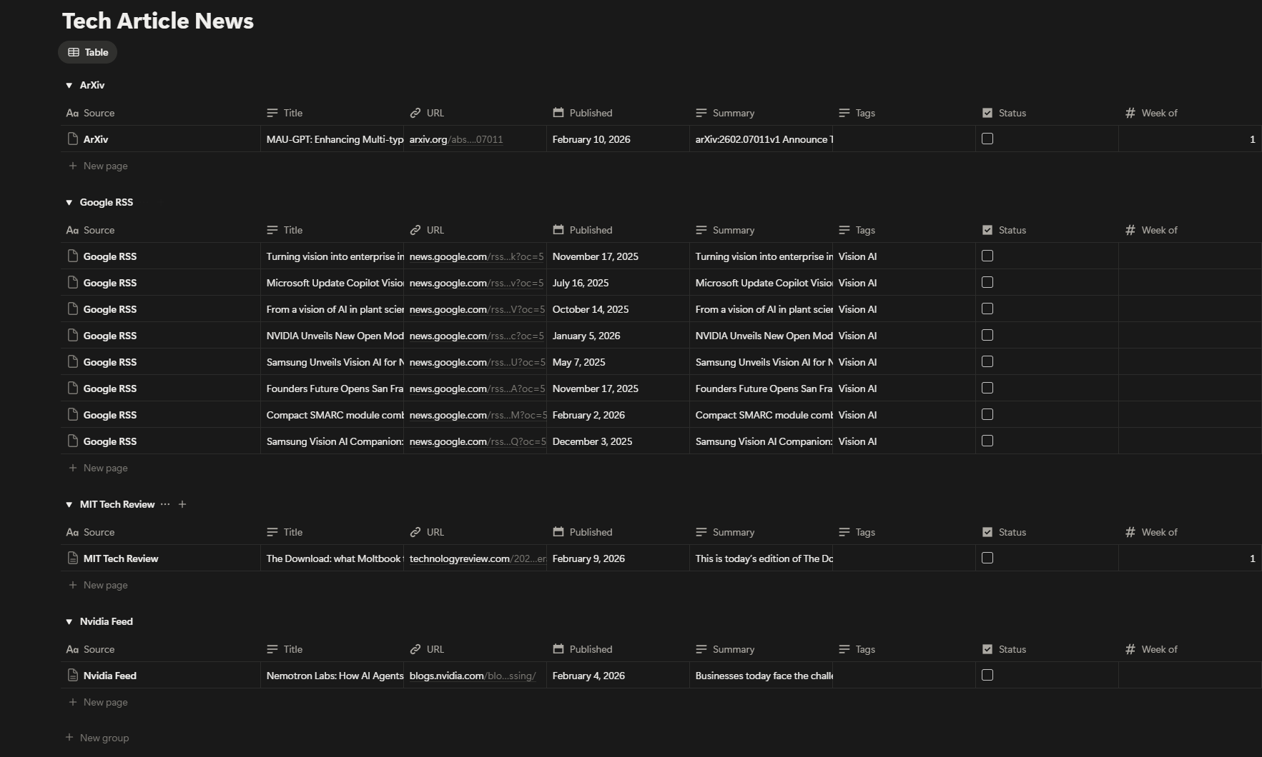
Fig 02: Collected article dashboard

