SEIS 766: Vision AI
University of St. Thomas
Name: Khongmeng Kormoua
St. Thomas ID: 101323019
HW 1: Image generation
My goal is to give an image of a town/landscape and ask an agent to generate an image of the same town/landscape, how it would look like in 50 years.
Tools: Stable diffusion
Link: https://github.com/AUTOMATIC1111/stable-diffusion-webui
Model: dvArch - Multi-Prompt Architecture Tuned Model
Link: https://civitai.com/models/8552/dvarch-multi-prompt-architecture-tuned-model
Prompt: same camera angle, same street layout, same location 50 years later, expanded urban development, modern mid-rise buildings added, renovated houses, larger mature trees, updated infrastructure, wider roads, smart city design, clean modern architecture, realistic city photography, natural lighting, high detail, skyscraper added
Negative prompt: cyberpunk, flying cars, sci-fi, extreme futuristic, warped perspective, distorted buildings, unrealistic structures, blurry
Config: CFG Scale (7), Seed(-1), Denoising Strength(0.75), Sample Step(50)
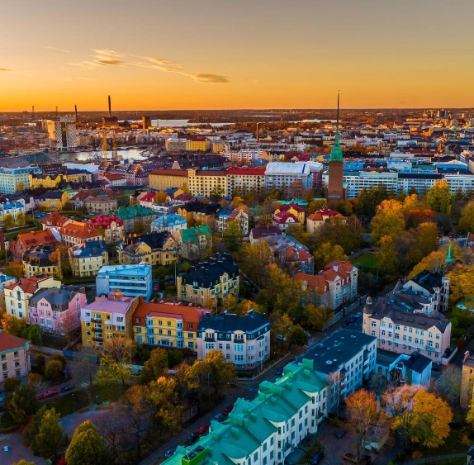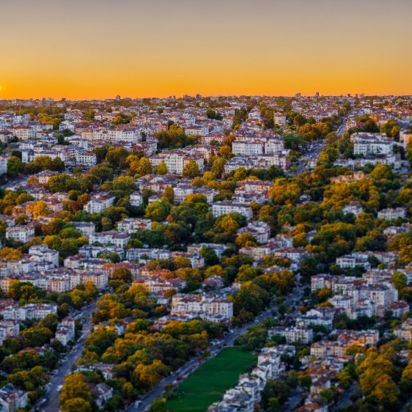
Input image (gen on 2/11/26) Output image (gen on 2/11/26)

