SEIS 766: Vision AI
University of St. Thomas
Name: Khongmeng Kormoua
St. Thomas ID: 101323019
Homework 2: Image processing
- Read in a gray-scale image from “HW_toyobjects_Gray.bmp” to a variable “Img_RAW”.
from pathlib import Path
from PIL import Image

file_path = Path("./HW_toyobjects_Gray")
file_name = "HW_toyobjects_Gray.bmp"

Img_RAW = Image.open(file_path / file_name)

- Display how many unique colors are in this gray-scale image “Img_RAW”.
import numpy as np

np_bitmap = np.array(Img_RAW)
unique_bitmap = np.unique(np_bitmap).size

print(f"Unique colors in bitmap file: {unique_bitmap}")

- Convert the gray-scale image “Img_RAW” into an index-color image with whatever number of colors you find out in the previous question.
idx_img = Img_RAW.quantize(colors = unique_bitmap)

- Display how many unique colors are in your index-color image.
np_idx = np.array(idx_img)
unique_idx = np.unique(np_idx).size

print(f"Unique colors in index-image: {unique_idx}")

- Resize the index-color image you obtained in question 3 to 180 × 180 and display how many unique colors are in this resized image.
idx_img_180 = idx_img.resize((180, 180), resample=Image.Resampling.NEAREST)
np_idx_180 = np.array(idx_img_180)
unique_idx_180 = np.unique(np_idx_180).size
print(f"Unique colors in 180x180 index-image: {unique_idx_180}")

- Resize the index-color image you obtained in question 3 to 480 × 480 and display how many unique colors are in this resized image.
idx_img_480 = idx_img.resize((480, 480), resample = Image.Resampling.NEAREST)
np_idx_480 = np.array(idx_img_480)
unique_idx_480 = np.unique(np_idx_480).size
print(f"Unique colors in 480x480 index-image: {unique_idx_480}")

- Write the index-color image you obtained in question 3 into a “HW_toyobjects_index.jpg” file.
idx_img_rgb = idx_img.convert("RGB") # JPEG doesn't support index-image
idx_img_rgb.save(file_path / "HW_toyobjects_index.jpg", quality=95)

- Write the index-color image you obtained in question 3 into a “HW_toyobjects_index.bmp” file.
idx_img.save(file_path / "HW_toyobjects_index.bmp")

- Read in an image from “HW_toyobjects_index.jpg” to a variable “Img_JPG”.
Img_JPG = Image.open(file_path / "HW_toyobjects_index.jpg")

- Display how many unique colors are in “Img_JPG”.
img_jpg_np = np.array(Img_JPG)
img_jpg_np_flat = img_jpg_np.reshape(-1, 3)
print(f"Unique colors in Img_JPG: {np.unique(img_jpg_np_flat, axis=0).shape[0]}")

- Read in an image from “HW_toyobjects_index.bmp” to a variable “Img_BMP”.
Img_BMP = Image.open(file_path / "HW_toyobjects_index.bmp")

- Display how many unique colors are in “Img_BMP”.
img_bmp_np = np.array(Img_BMP)
print(f"Unique colors in Img_BMP: {np.unique(img_bmp_np).size}")

- Show / display the three images in “Img_RAW”, “Img_JPG”, “Img_BMP”.
import matplotlib.pyplot as plt

plt.figure(figsize=(12, 4))
# Grayscale Image
plt.subplot(1, 3, 1)
plt.imshow(Img_RAW, cmap="gray")
plt.title("Raw Data")
plt.axis("off")

# JPEG Image
plt.subplot(1, 3, 2)
plt.imshow(Img_JPG)
plt.title("JPEG Image")
plt.axis("off")

# BMP Image
plt.subplot(1, 3, 3)
plt.imshow(Img_BMP)
plt.title("BMP Image")
plt.axis("off")

plt.tight_layout()
plt.show()

- Make sure you can see the colors in those three images.
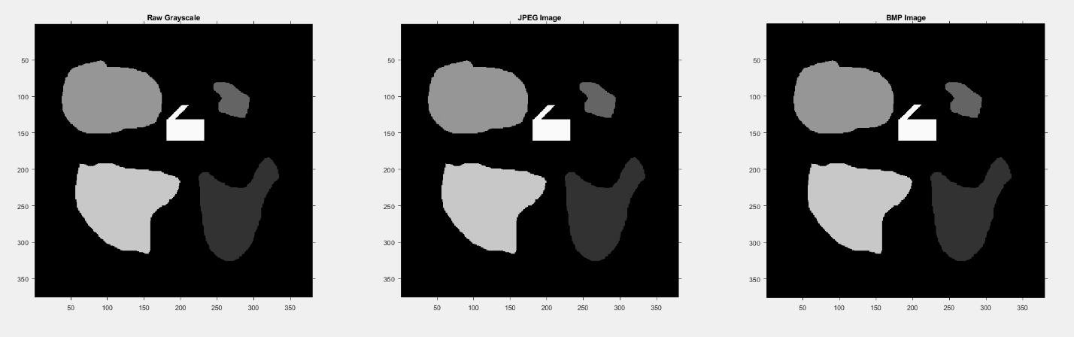
Fig. 1: Three image side by side
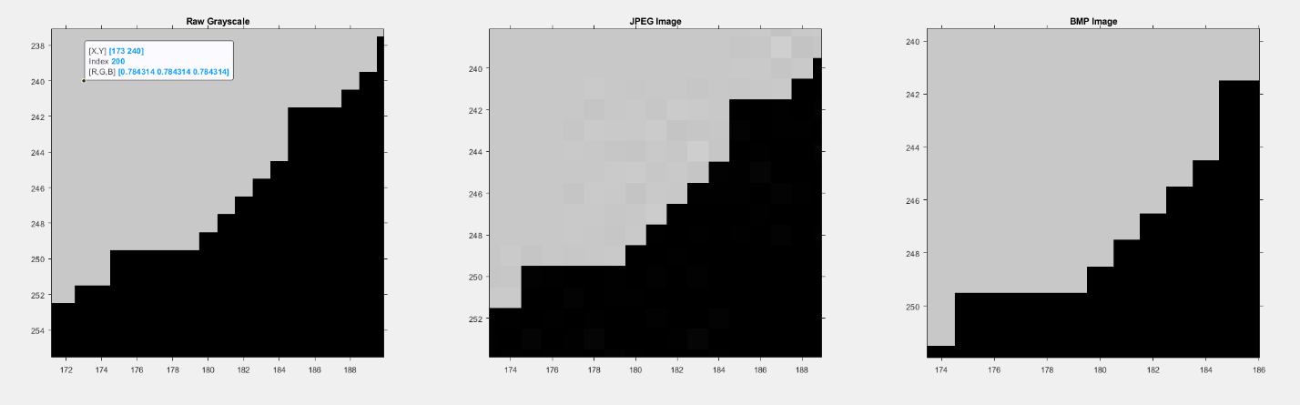
Fig. 2: Three image zoomed
More colors are introduced

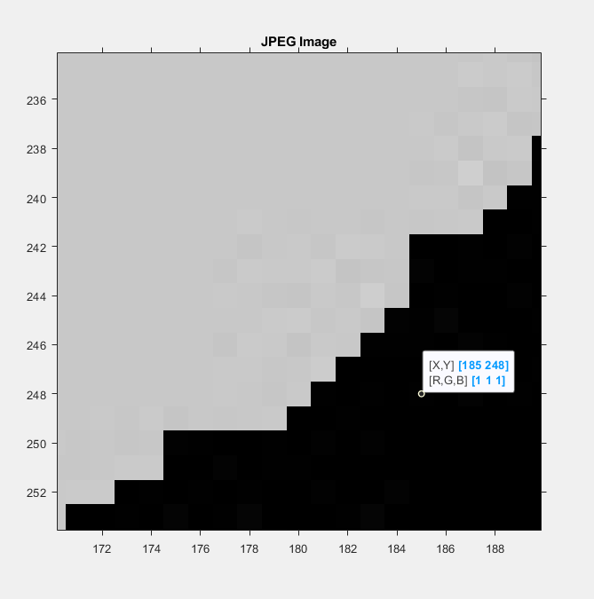 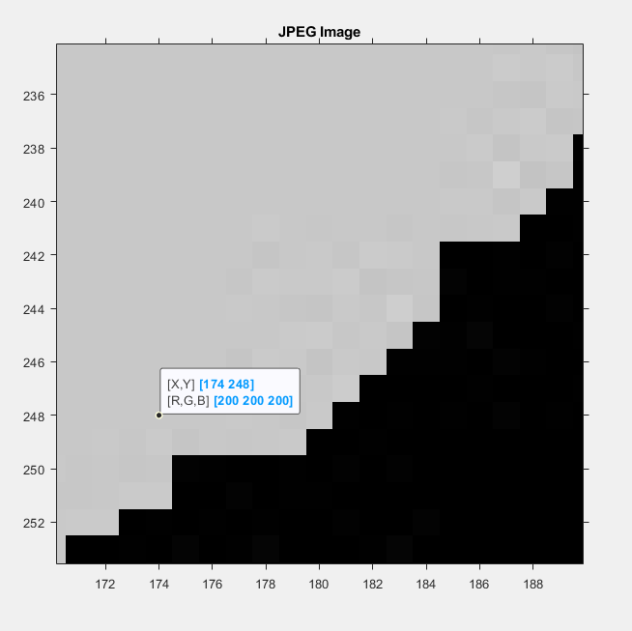
Fig. 3: JPEG_01 Fig.4: JPEG_02
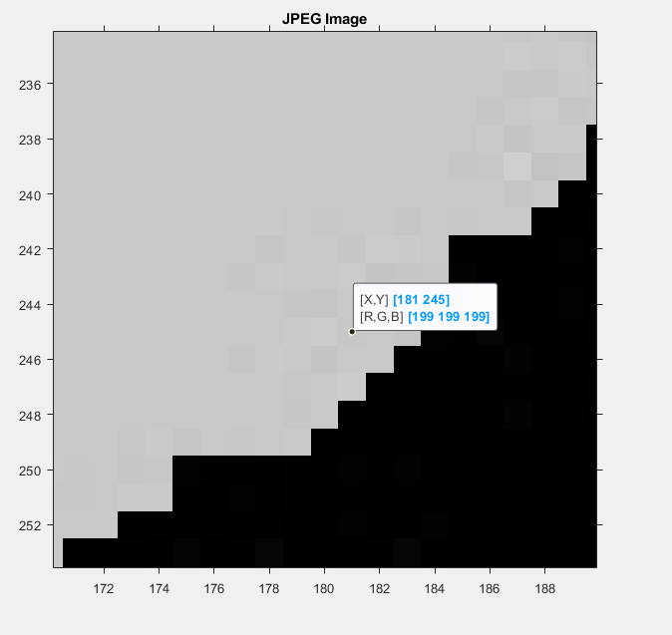 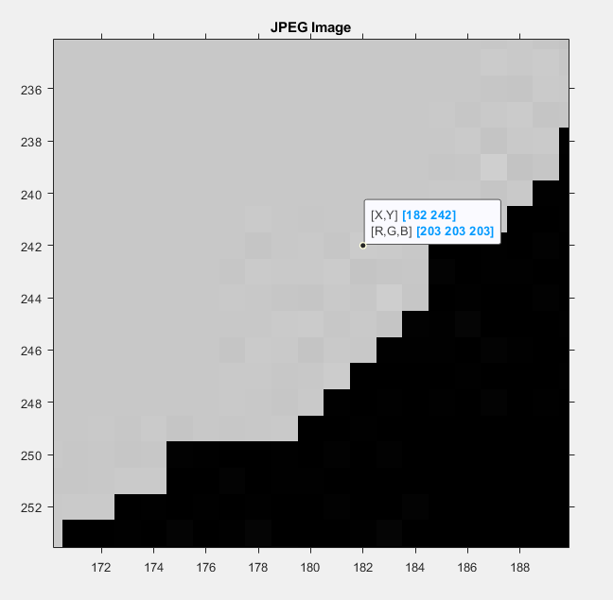
Fig. 5: JPEG_03 Fig. 6: JPEG_04
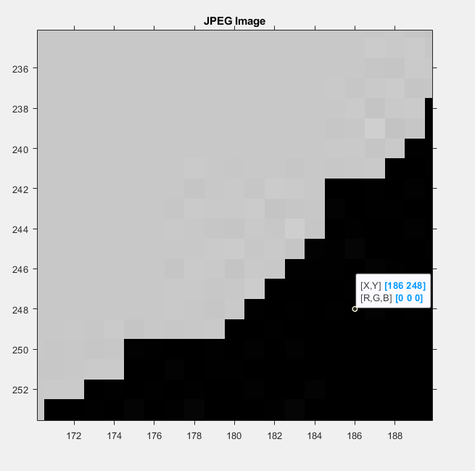 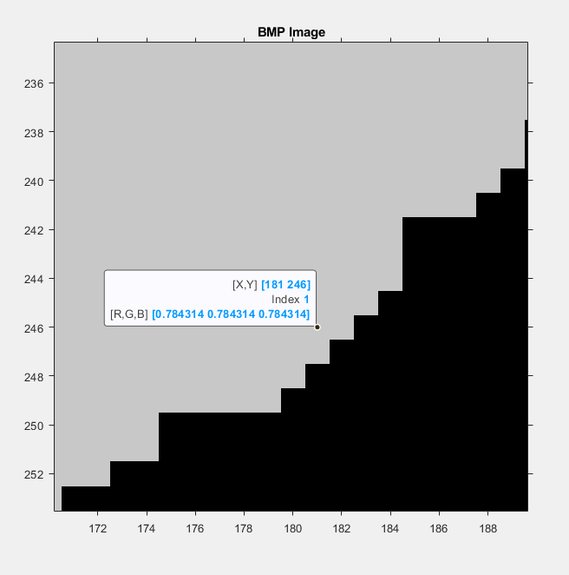
Fig. 7: JPEG_05 Fig.8: BMP Image

