SEIS 766: Vision AI
University of St. Thomas
Name: Khongmeng Kormoua
St. Thomas ID: 101323019
Homework 5: AutoEncoder vs Regular NN.
Confusion metrics of two model evaluating on dataset (30 rows)
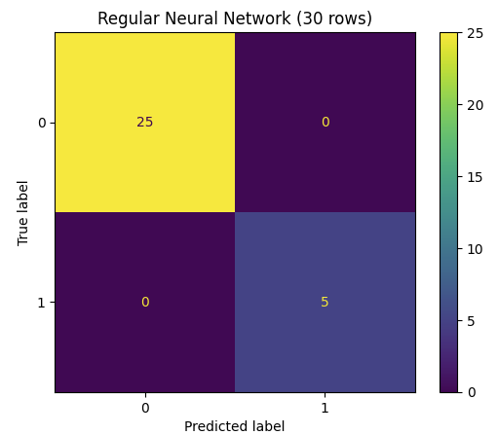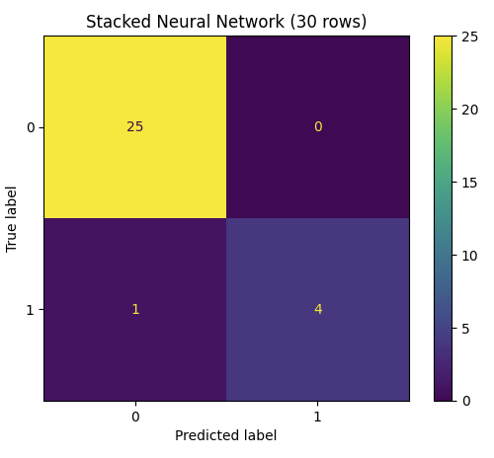
Confusion metrics of two model evaluating on full dataset
