**CH 1 Vector-Valued Functions and Motion in Space**

**Overview**  
In this chapter, we study vector-valued functions—functions that output vectors instead of single numbers.

**1.1 Curves in Space and Their Tangents**

When a particle moves over a time period I, its position is given by three functions:  
x = f(t), y = g(t), and z = h(t) for t in I.

As t changes, the points (f(t), g(t), h(t)) form a curve in space—this is the particle's path. We can also describe the position with a vector:

r(t) = f(t)i + g(t)j + h(t)k,

where f, g, and h are the components of the position vector.

The curve traced by r(t) as time goes by is the particle’s path (see Fig).

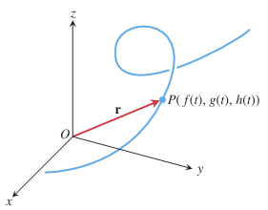

DEFINITION The vector function r(t) = ƒ(t)i + g(t)j + h(t)k has a derivative (is differentiable) at t if ƒ, g, and h have derivatives at t. The derivative is the vector function r′(t) = dr dt = lim ∆tS0 r(t + ∆t)- r(t) ∆t = dƒ dt i + dg dt j + dh dt k

If r is the position vector of a particle moving along a smooth curve in space, then v(t) = dr dt is the particle’s velocity vector, tangent to the curve. At any time t, the direction of v is the direction of motion, the magnitude of v is the particle’s speed, and the derivative a = dv>dt, when it exists, is the particle’s acceleration vector

**EXAMPLE** Find the velocity, speed, and acceleration of a particle whose motion in space is given by the position vector r(t) = 2 cos t i + 2 sin t j + 5 cos2 t k

Solution The velocity and acceleration vectors at time t are

v(t) = r′(t) =-2 sin t i + 2 cos t j- 10 cos t sin t k

=-2 sin t i + 2 cos t j- 5 sin 2t k,

a(t) = r″(t) =-2 cos t i- 2 sin t j- 10 cos 2t k,

and the speed is

|v(t)| = sqrt((-2 sin t)^2 + (2 cos t)^2 + (-5 sin 2t)^2) = sqrt(4 + 25 sin^2 2t).

When t = 7p/4, we have

v( 7pi/4) = sqrt(2)i + sqrt(2)j + 5k, a( 7pi/ 4 ) =-sqrt(2) i + sqrt(2) j, |v( 7pi /4)= sqrt(29).

In Exercises, r(t) is the position of a particle in space at time t. Find the particle’s velocity and acceleration vectors. Then find the particle’s speed and direction of motion(v/|v|) at the given value of t. Write the particle’s velocity at that time as the product of its speed and direction.

r(t)=(t +1)i +(t^2-1)j+2t k, t =1

r(t)=(1+ t)i + t^2/sqrt(2) j+ t^3/3 k, t =1

r(t)=(2 cos t)i +(3 sin t)j+4t k, t =p>2

**1.2 Integrals of Vector Functions**

To integrate a vector function, we integrate each of its components

∫<sub>0</sub><sup>π</sup> ((cos t) **i** + **j** - 2t **k**) dt = (∫<sub>0</sub><sup>π</sup> cos t dt) **i** + (∫<sub>0</sub><sup>π</sup> dt) **j** - (∫<sub>0</sub><sup>π</sup> 2t dt) **k**

= (sin π - sin 0) **i** + (π - 0) **j** - (π² - 0) **k**

= π **j** - π² **k**

**EXAMPLE** Suppose we do not know the path of a hang glider, but only its acceleration vector a(t) =-(3 cos t)i- (3 sin t)j + 2k. We also know that initially (at time t = 0) the glider departed from the point (4, 0, 0) with velocity v(0) = 3j. Find the glider’s position as a function of t.

Solution Our goal is to find r(t) knowing

The differential equation: a = d^2r/dt^2 =-(3 cos t)i- (3 sin t)j + 2k

The initial conditions: v(0) = 3j and r(0) = 4i + 0j + 0k.

Integrating both sides of the differential equation with respect to t gives

v(t) =-(3 sin t)i + (3 cos t)j + 2t k + C1

We use v(0) = 3j to find C1:

3j =-(3 sin 0)i + (3 cos 0)j + (0)k + C1

3j = 3j + C1   
 C1 = 0.

The glider’s velocity as a function of time is

Dr/dt = v(t) =-(3 sin t)i + (3 cos t)j + 2t k.

Integrating both sides of this last differential equation gives

r(t) = (3 cos t)i + (3 sin t)j + t2k + C2.

We then use the initial condition r(0) = 4i to find C2:

4i = (3 cos 0)i + (3 sin 0)j + (02)k + C2

4i = 3i + (0)j + (0)k + C2

C2 = i.

The glider’s position as a function of t is

r(t) = (1 + 3 cos t)i + (3 sin t)j + t2k.

This is the path of the glider shown in Figure

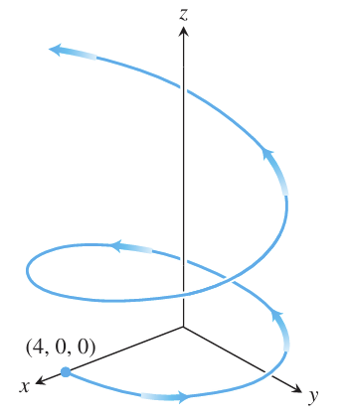

Evaluate the integrals

∫<sub>0</sub><sup>1</sup> t³ **i** + 7 **j** + (t+1) **k** dt

Solve the initial value problems

Differential equation: dr/dt =-t i-t j-t k

Initial condition: r(0)= i +2j+3k

Differential equation: dr/dt =(180t)i + (180t-16t^2)j

Initial condition: r(0)=100j

**1.3 Arc Length in Space**

The length of a smooth curve r(t) = x(t)i + y(t)j + z(t)k, a <= t <= b, that is traced exactly once as t increases from t = a to t = b, is

L = ∫<sub>a</sub><sup>b</sup> √((dx/dt)² + (dy/dt)² + (dz/dt)²) dt.

**EXAMPLE** A glider is soaring upward along the helix r(t) = (cos t)i + (sin t)j + tk. How long is the glider’s path from t = 0 to t = 2pi?

The path segment during this time corresponds to one full turn of the helix (Figure 13.13). The length of this portion of the curve is

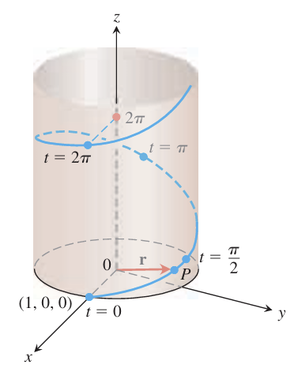

L = ∫<sub>a</sub><sup>b</sup> |**v**| dt = ∫<sub>0</sub><sup>2π</sup> √((-sin t)² + (cos t)² + (1)²) dt = ∫<sub>0</sub><sup>2π</sup> √2 dt = 2π√2 units of length.

Speed on a Smooth Curve

ds/dt = |v(t)| .

Unit Tangent Vector

We already know the velocity vector v = dr/dt is tangent to the curve r(t) and that the vector

T = v/|v|

is therefore a unit vector tangent to the (smooth) curve, called the unit tangent vector. You can think of the unit tangent vector as a vector of velocity’s direction.

**EXAMPLE** Find the unit tangent vector of the curve

r(t) = (1 + 3 cos t)i + (3 sin t)j + t^2k

Solution

we find that v = dr/dt =-(3 sin t)i + (3 cos t)j + 2tk

and

|v| = sqrt(9+4t^2).

Thus,

T = **v** / |**v**| = -(3 sin t / √(9 + 4t²)) **i** + (3 cos t / √(9 + 4t²)) **j** + (2t / √(9 + 4t²)) **k**.

In Exercises, find the curve’s unit tangent vector. Also, find the length of the indicated portion of the curve.

1. r(t)=(2 cos t)i +(2 sin t)j+sqrt(5)t k, 0<=t<=p

2. r(t)=(6 sin 2t)i +(6 cos 2t)j+5t k, 0<=t<=p

3. r(t)= ti +(2/3)t^(3/2) k, 0<=t<=8

**1.4 Curvature and Normal Vectors of a Curve**

As a particle moves along a smooth curve in the plane, T = dr/ds turns as the curve bends. The rate at which T turns per unit of length along the curve is called the curvature

κ = |dT/ds|, κ = (1/|**v**|) |d**T**/dt|.

If the curvature is large at a point then T turns sharply as the particle passes through that point.

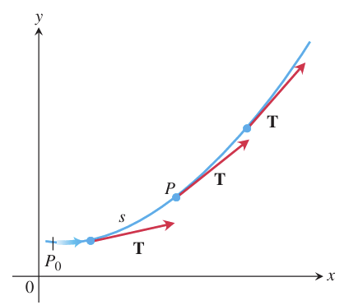

**EXAMPLE** Here we find the curvature of a circle. We begin with

r(t)=(a cos t)i +(a sin t)j a circle of radius a.

Then,

**v** = d**r**/dt = -(a sin t) **i** + (a cos t) **j**

|**v**| = √((-a sin t)² + (a cos t)²) = √a² = |a| = a.

From this we find

T = **v** / |**v**| = -(sin t) **i** + (cos t) **j**

d**T**/dt = -(cos t) **i** - (sin t) **j**

|d**T**/dt| = √(cos² t + sin² t) = 1.

Hence, for any value of the parameter t, the curvature of the circle is

κ = (1/|**v**|) |d**T**/dt| = (1/a) (1) = 1/a = 1/radius.

Among the vectors orthogonal to the unit tangent vector T, there is one of particular significance because it points in the direction in which the curve is turning. Principal unit normal points in the direction in which the curve is turning

N = (1/κ) dT/ds or N = (dT/dt) / |dT/dt|.

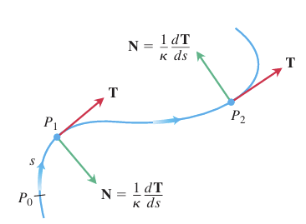

**EXAMPLE** Find T and N for the circular motion r(t) = (cos 2t)i + (sin 2t)j

Solution We first find T:

**v** = -(2 sin 2t) **i** + (2 cos 2t) **j**

|**v**| = √(4 sin² 2t + 4 cos² 2t) = 2

**T** = **v** / |**v**| = -(sin 2t) **i** + (cos 2t) **j**.

From this we find

d**T**/dt = -(2 cos 2t) **i** - (2 sin 2t) **j**

|d**T**/dt| = √(4 cos² 2t + 4 sin² 2t) = 2

and

**N** = (d**T**/dt) / |d**T**/dt| = -(cos 2t) **i** - (sin 2t) **j**. Eq. (2)

Notice that T * N = 0, verifying that N is orthogonal to T. Notice too, that for the circular motion here, N points from r(t) toward the circle’s center at the origin.

EXERCISES Find T, N, and k for the plane curves.

1. r(t)= t i +(ln cos t)j, -pi/2<t<pi/2

2. r(t)=(ln sec t)i + t j, -pi/2<t<p/2

3. r(t)=(2t +3)i + (5-t2)j

**1.5 Tangential and Normal Components of Acceleration**

**Overview**

This section introduces the TNB (Frenet) frame, a moving coordinate system that better describes motion along a curve. It consists of the unit tangent (T), normal (N), and binormal (B) vectors, which help analyze direction, turning, and twisting.

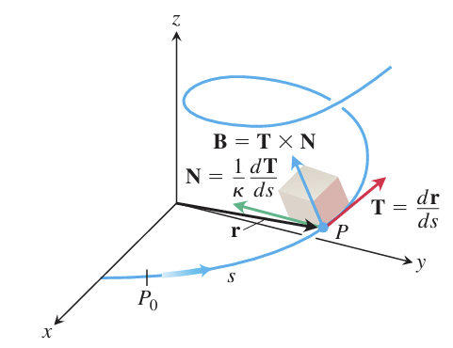

**The TNB Frame**

The binormal vector of a curve in space is B = T * N, which is a unit vector that is orthogonal to both T and N (See Fig.). Together T, N, and B define a moving right handed vector frame.

**Tangential and Normal Components of Acceleration**

If the acceleration vector is written as

a = a_TT + a_NN,

then

a_T = d/dt |v| (1)and

a_N = k|v|^2 (2)

are the tangential and normal scalar components of acceleration.

To calculate aN, we usually use the formula

a<sub>N</sub> = √(|**a**|² - a<sub>T</sub>²) (3)

The tangential component of acceleration a_T measures the rate of change of the length of v (that is, the change in the speed). The normal component of acceleration a_N measures the rate of change of the direction of v.

**EXAMPLE**

Without finding T and N, write the acceleration of the motion

r(t) = (cos t + t sin t)i + (sin t- t cos t)j, t > 0

in the form a = a_TT + a_NN

**v** = d**r**/dt = (-sin t + sin t + t cos t) **i** + (cos t - cos t + t sin t) **j** = (t cos t) **i** + (t sin t) **j**

|**v**| = √(t² cos² t + t² sin² t) = √t² = |t| = t

a<sub>T</sub> = d/dt |**v**| = d/dt (t) = 1.

Knowing a_T, we use Equation (3) to find a_N:

**a** = (cos t - t sin t) **i** + (sin t + t cos t) **j**

|**a**|² = t² + 1

a<sub>N</sub> = √(|**a**|² - a<sub>T</sub>²) = √(t² + 1) - (1) = √t² = t.

Thus

a = a<sub>T</sub>T + a<sub>N</sub>N = (1)T + (t)N = T + tN.

**Curvature**

The curvature k can be thought of as the rate at which the normal plane turns as the point P moves along its path.

Vector Formula for Curvature

κ = |v × a| / |v|³ (4)

or k = 1/|v||dT/dt|

**Torsion**

Formula for Torsion

τ = | ẋ ẏ ż | | ẍ ÿ <0xC8><0xB3> | / |**v** × **a**|² (if **v** × **a** ≠ 0) | <0xC8><0xB3> <0xC8><0xB3> <0xC8><0xB3> |

(5)

The torsion t is the rate at which the osculating plane turns about T as P moves along the curve. Torsion measures how the curve twists.

**EXAMPLE**

Find the curvature k and torsion t for the helix

r(t) = (a cos t)i + (a sin t)j + bt k,

We calculate the curvature with Equation (4):

v=-(a sin t)i +(a cos t)j+bk

a=-(a cos t)i-(a sin t)j

**v** × **a** = | **i** **j** **k** | | -a sin t a cos t b | | -a cos t -a sin t 0 |

= (ab sin t) **i** - (ab cos t) **j** + a² **k**

κ = |**v** × **a**| / |**v**|³ = √(a²b² + a⁴) / (a² + b²)³/² = a√(a² + b²) / (a² + b²)³/² = a / (a² + b²).

To evaluate Equation (5) for the torsion, we find the entries in the determinant by differentiating r with respect to t. We already have v and a, and

**ȧ** = d**a**/dt = (a sin t) **i** - (a cos t) **j**.

Hence,

τ = | ẋ ẏ ż | | -a sin t a cos t b | | ẍ <0xC8><0xB3> <0xC8><0xB3> | / |**v** × **a**|² = | -a cos t -a sin t 0 | | <0xC8><0xB3> <0xC8><0xB3> <0xC8><0xB3> | | a sin t -a cos t 0 | (a√(a² + b²))²

= b(a² cos² t + a² sin² t) / a²(a² + b²)

= b / (a² + b²).

**Computation Formulas for Curves in Space**

**Unit tangent vector:** T = v / |v|

**Principal unit normal vector:** N = (dT/dt) / |dT/dt|

**Binormal vector:** B = T × N

**Curvature:** κ = |dT/ds| = |v × a| / |v|³

**Torsion:** τ = -(dB/ds) · N = | ẋ ẏ ż | | ẍ <0xC8><0xB3> <0xC8><0xB3> | / |v × a|² | <0xC8><0xB3> <0xC8><0xB3> <0xC8><0xB3> |

**Tangential and normal scalar components of acceleration:** a = a<sub>T</sub>T + a<sub>N</sub>N

a<sub>T</sub> = d/dt |v|

a<sub>N</sub> = κ |v|² = √(|a|² - a<sub>T</sub>²)

**EXERCISES**

1. Write a in the form a=a_TT+a_NN without finding T and N (find a_T and a_N)

r(t)=(a cos t)i +(a sin t)j+bt k

2. Find T, N, B, k, t

r(t)=(3 sin t)i +(3 cos t)j+4t k

**CH2 Partial derivatives**

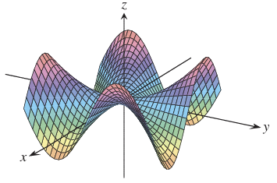

**Overview**

This chapter extends single-variable calculus to functions of several variables and introduces partial derivatives.

**2.1 Partial Derivatives**

**Overview**

This section introduces partial derivatives, which are found by differentiating one variable while keeping others constant.

We define the partial derivative of ƒ with respect to x at the point (x0, y0) as the ordinary derivative of ƒ(x, y0) with respect to x at the point x = x0. To distinguish partial derivatives from ordinary derivatives we use the symbol \delta rather than the d previously used.

(∂f/∂x)|<sub>(x₀, y₀)</sub> = (d/dx) f(x, y₀) |<sub>x=x₀</sub>.

**EXAMPLE** Find the values of ∂f/∂x and ∂f/∂y at the point (4, -5) if f(x, y) = x² + 3xy + y - 1.

Solution To find ∂f/∂x, we treat y as a constant and differentiate with respect to x:

∂f/∂x = ∂/∂x (x² + 3xy + y - 1) = 2x + 3·1·y + 0 - 0 = 2x + 3y.

The value of ∂f/∂x at (4, -5) is 2(4) + 3(-5) = -7.

To find ∂f/∂y, we treat x as a constant and differentiate with respect to y:

∂f/∂y = ∂/∂y (x² + 3xy + y - 1) = 0 + 3·x·1 + 1 - 0 = 3x + 1.

The value of ∂f/∂y at (4, -5) is 3(4) + 1 = 13.

**Functions of more than two variables**

For functions with more than two variables, partial derivatives are found by differentiating with respect to one variable while keeping the others constant. The process is similar to that for functions of two variables.

**EXAMPLE** If x, y, and z are independent variables and f(x, y, z) = x sin (y + 3z),

then

∂f/∂z = ∂/∂z [x sin (y + 3z)] = x ∂/∂z sin (y + 3z)

= x cos (y + 3z) ∂/∂z (y + 3z)

= 3x cos (y + 3z).

**Second-Order Partial Derivatives**

When we differentiate a function ƒ(x, y) twice, we produce its second-order derivatives. These derivatives are usually denoted by

∂²f/∂x² or f<sub>xx</sub>, ∂²f/∂y² or f<sub>yy</sub>,

EXERCISES

find fx and fy

ƒ(x, y) = 2x^2- 3y- 4

ƒ(x, y) = (x2- 1)(y + 2)

find ƒx, ƒy, and ƒz.

ƒ(x, y, z) = 1 + xy^2- 2z^2

**2.2 Directional Derivatives and Gradient Vectors**

Suppose that the function f(x, y) is defined throughout a region R in the xy-plane, that P₀(x₀, y₀) is a point in R, and that **u** = u₁**i** + u₂**j** is a unit vector. Then the equations

x = x₀ + su₁, y = y₀ + su₂

parametrize the line through P₀ parallel to **u**. If the parameter s measures arc length from P₀ in the direction of **u**, we find the rate of change of f at P₀ in the direction of **u** by calculating df/ds at P₀

**DEFINITION** The derivative of f at P₀(x₀, y₀) in the direction of the unit vector **u** = u₁**i** + u₂**j** is the number

(df/ds)<sub>**u**, P₀</sub> = lim<sub>s→0</sub> [f(x₀ + su₁, y₀ + su₂) - f(x₀, y₀)] / s, (1)

provided the limit exists.

The directional derivative is also denoted by

D<sub>**u**</sub>f(P₀) or D<sub>**u**</sub>f|<sub>P₀</sub> "The derivative of f in the direction of **u**, evaluated at P₀"

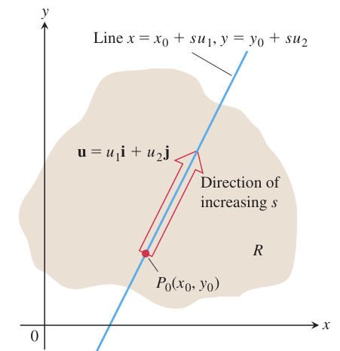

The directional derivative measures the rate of change of a function in any direction, not just along the x- or y-axes. Geometrically, it is the slope of the tangent to a curve formed by slicing the surface in a given direction. Physically, it can represent how temperature changes at a point when moving in a specific direction.

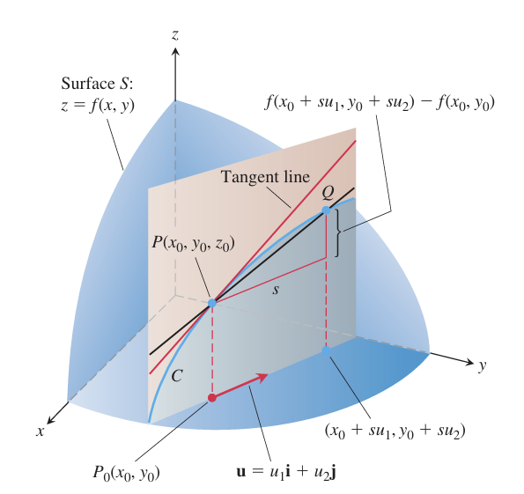

**DEFINITION** The **gradient vector** (or **gradient**) of f(x, y) is the vector

∇f = (∂f/∂x) **i** + (∂f/∂y) **j**.

The value of the gradient vector obtained by evaluating the partial derivatives at a point P₀(x₀, y₀) is written

∇f|<sub>P₀</sub> or ∇f(x₀, y₀).

**THEOREM—The Directional Derivative Is a Dot Product**

If f(x, y) is differentiable in an open region containing P₀(x₀, y₀), then

(df/ds)<sub>**u**, P₀</sub> = ∇f|<sub>P₀</sub> · **u**,

the dot product of the gradient ∇f at P₀ with the vector **u**. In brief, D<sub>**u**</sub>f = ∇f · **u**.

Properties of the Directional Derivative D<sub>**u**</sub>f = ∇f · **u** = |∇f| cos θ

1. The function f increases most rapidly when cos θ = 1, which means that θ = 0 and **u** is the direction of ∇f. That is, at each point P in its domain, f increases most rapidly in the direction of the gradient vector ∇f at P. The derivative in this direction is

D<sub>**u**</sub>f = |∇f| cos (0) = |∇f|.

1. Similarly, f decreases most rapidly in the direction of -∇f. The derivative in this direction is D<sub>**u**</sub>f = |∇f| cos (π) = -|∇f|.
2. Any direction **u** orthogonal to a gradient ∇f ≠ 0 is a direction of zero change in f because θ then equals π/2 and

D<sub>**u**</sub>f = |∇f| cos (π/2) = |∇f| ⋅ 0 = 0.

Exercises, find the gradient of the function at the given point.

1. ƒ(x, y)=y-x, (2, 1)

2. ƒ(x, y)= ln (x^2+y^2), (1, 1)

3. g(x, y)=xy^2, (2, -1)

**2.3 Tangent Planes and Differentials**

**Overview**

Just as the derivative defines the tangent line in single-variable calculus, the gradient defines the tangent plane to a surface for functions of three variables. This tangent plane helps approximate the function near a point and leads to the concept of the total differential.

**Tangent Planes and Normal Lines**

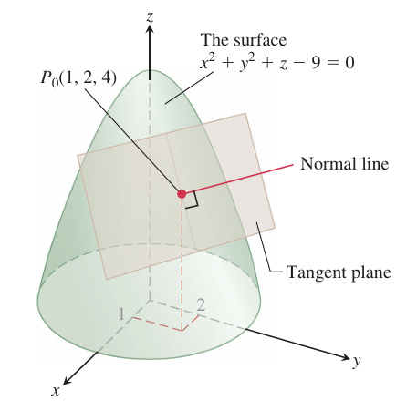

**Tangent Plane to** f(x, y, z) = c **at** P₀(x₀, y₀, z₀)

f<sub>x</sub>(P₀)(x - x₀) + f<sub>y</sub>(P₀)(y - y₀) + f<sub>z</sub>(P₀)(z - z₀) = 0

**Normal Line to** f(x, y, z) = c **at** P₀(x₀, y₀, z₀)

x = x₀ + f<sub>x</sub>(P₀)t, y = y₀ + f<sub>y</sub>(P₀)t, z = z₀ + f<sub>z</sub>(P₀)t

**EXAMPLE** Find the tangent plane and normal line of the level surface f(x, y, z) = x² + y² + z - 9 = 0 A circular paraboloid at the point P₀(1, 2, 4).

Solution The tangent plane is the plane through P₀ perpendicular to the gradient of f at P₀. The gradient is

∇f|<sub>P₀</sub> = (2x**i** + 2y**j** + **k**) |<sub>(1, 2, 4)</sub> = 2**i** + 4**j** + **k**.

The tangent plane is therefore the plane

2(x - 1) + 4(y - 2) + (z - 4) = 0, or 2x + 4y + z = 14.

The line normal to the surface at P₀ is

x = 1 + 2t, y = 2 + 4t, z = 4 + t.

**How to Linearize a Function of Two Variables**

Functions of two variables can be complex, so we approximate them with simpler functions for easier calculations. This process is similar to finding linear approximations for single-variable functions.

**DEFINITIONS** The **linearization** of a function f(x, y) at a point (x₀, y₀) where f is differentiable is the function

L(x, y) = f(x₀, y₀) + f<sub>x</sub>(x₀, y₀)(x - x₀) + f<sub>y</sub>(x₀, y₀)(y - y₀).

The approximation

f(x, y) ≈ L(x, y)

is the **standard linear approximation** of f at (x₀, y₀).

**EXAMPLE** Find the linearization of

f(x, y) = x² - xy + (1/2)y² + 3

at the point (3, 2).

Solution We first evaluate f, f<sub>x</sub>, and f<sub>y</sub> at the point (x₀, y₀) = (3, 2):

f(3, 2) = (x² - xy + (1/2)y² + 3)|<sub>(3, 2)</sub> = 8

f<sub>x</sub>(3, 2) = (∂/∂x)(x² - xy + (1/2)y² + 3)|<sub>(3, 2)</sub> = (2x - y)|<sub>(3, 2)</sub> = 4

f<sub>y</sub>(3, 2) = (∂/∂y)(x² - xy + (1/2)y² + 3)|<sub>(3, 2)</sub> = (-x + y)|<sub>(3, 2)</sub> = -1,

giving

L(x, y) = f(x₀, y₀) + f<sub>x</sub>(x₀, y₀)(x - x₀) + f<sub>y</sub>(x₀, y₀)(y - y₀) = 8 + (4)(x - 3) + (-1)(y - 2) = 4x - y - 2.

The linearization of f at (3, 2) is L(x, y) = 4x - y - 2

**EXERCISES**

In Exercises, find equations for the (a) tangent plane and (b) normal line at the point P₀ on the given surface.

1. x² + y² + z² = 3, P₀(1, 1, 1)
2. x² + y² - z² = 18, P₀(3, 5, -4)
3. 2z - x² = 0, P₀(2, 0, 2)

**CH 3 Multiple Integrals**

This chapter introduces double and triple integrals, which extend integration to functions of two and three variables. Double integrals compute signed volumes and areas, while triple integrals find volumes in space. We also explore coordinate transformations, such as polar, cylindrical, and spherical coordinates, to simplify calculations.

**3.1 Double and Iterated Integrals over Rectangles**

Just as a definite integral is defined as a limit of Riemann sums for single-variable functions, a double integral extends this idea to functions of two variables over a rectangle. It is constructed by partitioning the region, multiplying function values by small area elements, and summing the results.

**Double Integrals**

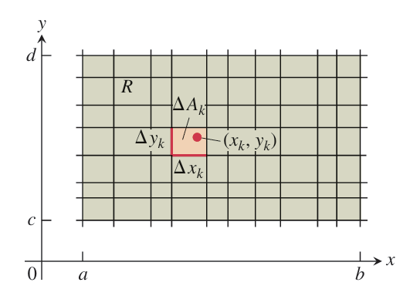

To define a double integral, we first consider a function over a rectangular region R. We divide R into small rectangles, each with area ΔA=ΔxΔy. A Riemann sum is then formed by choosing points (xk,yk ​) in each small rectangle, multiplying f(xk,yk) by ΔAk and summing the results. The value of this sum depends on the chosen points.

As the widths and heights of the partitioned rectangles approach zero, the Riemann sums may converge to a single value, regardless of the chosen points (xk,yk). If this limit exists, the function is considered integrable, and the limit is defined as the double integral of f over R.

∫∫<sub>R</sub> f(x, y) dA or ∫∫<sub>R</sub> f(x, y) dxdy.

**Double Integrals as Volumes**

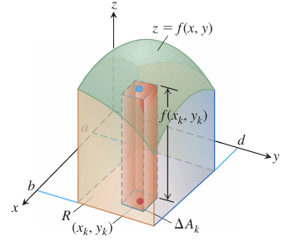

When f(x,y) is positive over a rectangular region RRR, the double integral represents the volume of the solid bounded by R in the xy-plane and the surface z=f(x,y). The Riemann sum approximates this volume by summing the volumes of vertical rectangular boxes above each partitioned area ΔAk

Volume = lim<sub>n→∞</sub> S<sub>n</sub> = ∫∫<sub>R</sub> f(x, y) dA,

where ΔA<sub>k</sub> → 0 as n → ∞.

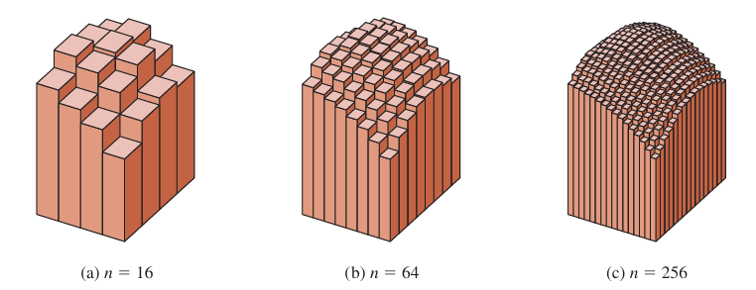

**Fubini’s Theorem for Calculating Double Integrals**

Fubini's Theorem states that if a function f(x, y) is continuous over a rectangular region R, then the double integral over R can be computed as an iterated integral in either order:

∬<sub>R</sub> f(x, y) dA = ∫<sub>c</sub><sup>d</sup> ∫<sub>a</sub><sup>b</sup> f(x, y) dx dy = ∫<sub>a</sub><sup>b</sup> ∫<sub>c</sub><sup>d</sup> f(x, y) dy dx.

**Interpretation:**

* **Iterated Integrals Represent Volume:** When the function f(x, y) represents the height of a surface over a region R, the double integral computes the volume under the surface.
* **Choice of Order of Integration:** We can integrate with respect to x first and then y, or vice versa, which allows for flexibility in choosing the easier computation path.

In Exercises, evaluate the iterated integral.

1. ∫<sub>1</sub><sup>2</sup> ∫<sub>0</sub><sup>4</sup> 2xy dy dx
2. ∫<sub>0</sub><sup>2</sup> ∫<sub>-1</sub><sup>1</sup> (x - y) dy dx
3. ∫<sub>-1</sub><sup>0</sup> ∫<sub>-1</sub><sup>1</sup> (x + y + 1) dx dy
4. ∫<sub>0</sub><sup>1</sup> ∫<sub>0</sub><sup>1</sup> (1 - (x² + y²)/2) dx dy

**3.2 Double Integrals over General Regions**

In this section, we define and evaluate double integrals over more general bounded regions in the plane, not just rectangles. These integrals are computed as iterated integrals, but the main challenge is determining the limits of integration.

To find the double integral over a non-rectangular region, we approximate it with small rectangles that fit inside the region. We calculate the sum of the function's value times the rectangle's area for each rectangle. As the rectangles get smaller, this sum approaches the double integral.

**EXAMPLE** Find the volume of the prism whose base is the triangle in the xy-plane bounded by the x-axis and the lines y = x and x = 1 and whose top lies in the plane z = f(x, y) = 3 - x - y.

Solution For any x between 0 and 1, y may vary from y = 0 to y = x. Hence,

V = ∫<sub>0</sub><sup>1</sup> ∫<sub>0</sub><sup>x</sup> (3 - x - y) dy dx = ∫<sub>0</sub><sup>1</sup> [3y - xy - y²/2]<sub>y=0</sub><sup>y=x</sup> dx

= ∫<sub>0</sub><sup>1</sup> (3x - 3x²/2) dx = [3x²/2 - x³/2]<sub>x=0</sub><sup>x=1</sup> = 1.

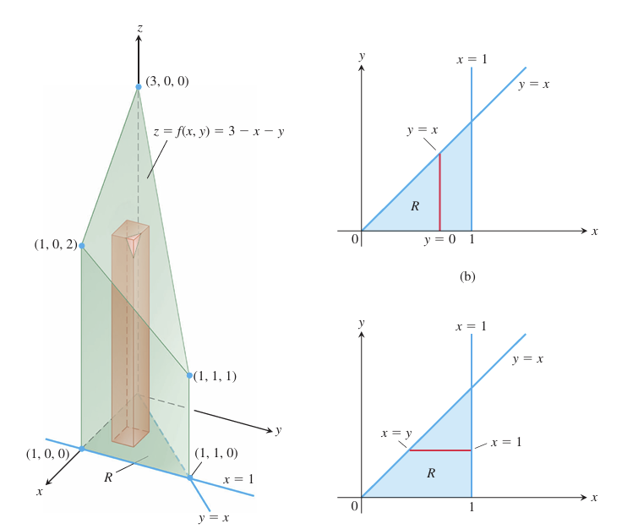

Although a double integral may be calculated as an iterated integral in either order of integration, the value of one integral may be easier to find than the value of the other. The next example shows how this can happen.

**EXAMPLE** Calculate

∬<sub>R</sub> (sin x / x) dA,

where R is the triangle in the xy-plane bounded by the x-axis, the line y = x, and the line x = 1.

Solution. If we integrate first with respect to y and next with respect to x, then because x is held fixed in the first integration, we find

∫<sub>0</sub><sup>1</sup> (∫<sub>0</sub><sup>x</sup> (sin x / x) dy) dx = ∫<sub>0</sub><sup>1</sup> [y (sin x / x)]<sub>y=0</sub><sup>y=x</sup> dx = ∫<sub>0</sub><sup>1</sup> sin x dx = -cos(1) + 1 ≈ 0.46.

If we reverse the order of integration and attempt to calculate

∫<sub>0</sub><sup>1</sup> ∫<sub>y</sub><sup>1</sup> (sin x / x) dx dy,

**Properties of Double Integrals**

If f(x, y) and g(x, y) are continuous on the bounded region R, then the following properties hold.

1. **Constant Multiple:** ∫∫<sub>R</sub> cf(x, y) dA = c ∫∫<sub>R</sub> f(x, y) dA (any number c)
2. **Sum and Difference:** ∫∫<sub>R</sub> (f(x, y) ± g(x, y)) dA = ∫∫<sub>R</sub> f(x, y) dA ± ∫∫<sub>R</sub> g(x, y) dA
3. **Domination:** (a) ∫∫<sub>R</sub> f(x, y) dA ≥ 0 if f(x, y) ≥ 0 on R (b) ∫∫<sub>R</sub> f(x, y) dA ≥ ∫∫<sub>R</sub> g(x, y) dA if f(x, y) ≥ g(x, y) on R
4. **Additivity:** If R is the union of two nonoverlapping regions R₁ and R₂, then ∫∫<sub>R</sub> f(x, y) dA = ∫∫<sub>R₁</sub> f(x, y) dA + ∫∫<sub>R₂</sub> f(x, y) dA

**EXERCISES**

In Exercises, sketch the region of integration and evaluate the integral.

1.∫<sub>1</sub><sup>ln 8</sup> ∫<sub>0</sub><sup>ln y</sup> e<sup>x+y</sup> dx dy

2.∫<sub>0</sub><sup>1</sup> ∫<sub>0</sub><sup>y²</sup> 3y³ e<sup>xy</sup> dx dy

**3.** ∫<sub>0</sub><sup>π</sup> ∫<sub>0</sub><sup>x</sup> x sin y dy dx

**3.3 Double Integrals in Polar Coordinates**

Double integrals are sometimes easier to evaluate if we change to polar coordinates.

When we work with double integrals in the usual xy-plane, we divide the region into rectangles. This makes sense because the sides of these rectangles have constant x or y values. However, in polar coordinates, the natural shape to use is a "polar rectangle." These shapes have sides with constant r (radius) and θ (angle) values.

Suppose that a function ƒ(r, \theta) is defined over a region R that is bounded by the rays \theta = a and \theta = b and by the continuous curves r = g1(\theta) and r = g2(\theta). Suppose also that 0 < g1(\theta) < g2(\theta) < a for every value of \theta between a and b. Then R lies in a fan shaped region Q defined by the inequalities 0 < r < a and a <\theta< b, where 0 <b- a <2pi.

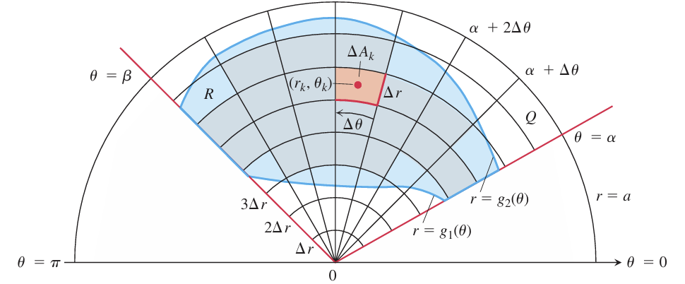

∫∫<sub>R</sub> f(r, θ) dA = ∫<sub>θ=α</sub><sup>θ=β</sup> ∫<sub>r=g₁(θ)</sub><sup>r=g₂(θ)</sup> f(r, θ) r dr dθ.

**EXAMPLE** Evaluate

∬<sub>R</sub> e<sup>x²+y²</sup> dy dx,

where R is the semicircular region bounded by the x-axis and the curve y = √(1 - x²).

Solution In Cartesian coordinates, the integral in question is a nonelementary integral and there is no direct way to integrate e<sup>x²+y²</sup> with respect to either x or y. Polar coordinates make this possible. Substituting x = r cos θ and y = r sin θ and replacing dy dx by r dr dθ give

∬<sub>R</sub> e<sup>x²+y²</sup> dy dx = ∫<sub>0</sub><sup>π</sup> ∫<sub>0</sub><sup>1</sup> e<sup>r²</sup> r dr dθ = ∫<sub>0</sub><sup>π</sup> [½ e<sup>r²</sup>]<sub>0</sub><sup>1</sup> dθ

= ∫<sub>0</sub><sup>π</sup> ½ (e - 1) dθ = ½ (e - 1) π.

In Exercise, change the Cartesian integral into an equivalent polar integral. Then evaluate the polar integral.

∫<sub>-1</sub><sup>1</sup> ∫<sub>0</sub><sup>√(1-x²)</sup> dy dx

∫<sub>0</sub><sup>1</sup> ∫<sub>0</sub><sup>√(1-y²)</sup> (x² + y²) dx dy

∫<sub>0</sub><sup>2</sup> ∫<sub>0</sub><sup>√(4-y²)</sup> (x² + y²) dx dy

**3.4 Triple Integrals in Rectangular Coordinates**

Just as double integrals extend single integrals, triple integrals handle even more complex problems. They are used to find volumes of 3D shapes and average values of functions within 3D regions.

**Triple Integrals**

To define the triple integral of a function F(x, y, z) over a 3D region D, we divide a box containing D into small rectangular cells. We only consider the cells completely inside D. Within each cell, we multiply the function's value at a selected point by the cell's volume and sum these products. As the cells become infinitely small, this sum converges to the triple integral of F over D, denoted as

∫∫∫<sub>D</sub> F(x, y, z) dV or ∫∫∫<sub>D</sub> F(x, y, z) dx dy dz.

This process is valid when F is continuous and D has a "reasonably smooth" boundary.

EXERCISES

Evaluate the integrals in the Exercises.

∫<sub>0</sub><sup>1</sup> ∫<sub>0</sub><sup>1</sup> ∫<sub>0</sub><sup>1</sup> (x² + y² + z²) dz dy dx

∫<sub>0</sub><sup>√2</sup> ∫<sub>0</sub><sup>3y</sup> ∫<sub>x²+3y²</sub><sup>8-x²-y²</sup> dz dx dy

∫<sub>1</sub><sup>e</sup> ∫<sub>1</sub><sup>e²</sup> ∫<sub>1</sub><sup>e³</sup> (1/xyz) dx dy dz

**CH4 Integrals and Vector Fields**

This chapter extends integration to curves and surfaces in space. Line integrals calculate work along paths and mass of curved wires. Surface integrals determine fluid flow and describe electromagnetic forces.

**4.1 Line integrals of Scalar Functions**

To calculate quantities like the mass of a wire or work done along a curved path, we use line integrals, an extension of standard integrals. Given a function f(x, y, z) and a curve C, we divide C into small subarcs. Within each subarc, we multiply the function's value at a selected point by the subarc's length and sum these products. As the subarcs become infinitely small, this sum converges to the line integral of f along C. This process is valid when f and the curve are sufficiently smooth.

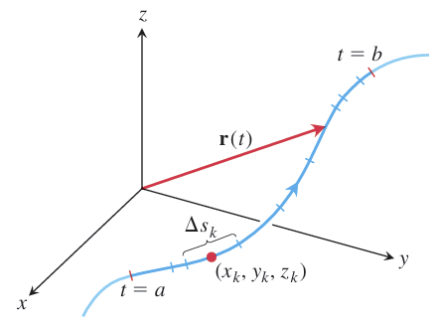

**DEFINITION** If f is defined on a curve C given parametrically by **r**(t) = g(t)**i** + h(t)**j** + k(t)**k**, a ≤ t ≤ b, then the **line integral of f over C** is

∫<sub>C</sub> f(x, y, z) ds = lim<sub>n→∞</sub> Σ<sub>k=1</sub><sup>n</sup> f(x<sub>k</sub>, y<sub>k</sub>, z<sub>k</sub>) Δs<sub>k</sub>,

provided this limit exists.

**How to Evaluate a Line Integral**

To integrate a continuous function f(x, y, z) over a curve C:

1. **Find a smooth parametrization of C**,

**r**(t) = g(t)**i** + h(t)**j** + k(t)**k**, a ≤ t ≤ b.

1. **Evaluate the integral as**

∫<sub>C</sub> f(x, y, z) ds = ∫<sub>a</sub><sup>b</sup> f(g(t), h(t), k(t)) |**v**(t)| dt.

**EXAMPLE** Integrate f(x, y, z) = x - 3y² + z over the line segment C joining the origin to the point (1, 1, 1)

**Solution** Since any choice of parametrization will give the same answer, we choose the simplest parametrization we can think of:

**r**(t) = t**i** + t**j** + t**k**, 0 ≤ t ≤ 1.

The components have continuous first derivatives and |**v**(t)| = |**i** + **j** + **k**| = √(1² + 1² + 1²) = √3 is never 0, so the parametrization is smooth. The integral of f over C is

∫<sub>C</sub> f(x, y, z) ds = ∫<sub>0</sub><sup>1</sup> f(t, t, t) √3 dt Eq. (2), ds = |**v**(t)| dt = √3 dt

= ∫<sub>0</sub><sup>1</sup> (t - 3t² + t) √3 dt

= √3 ∫<sub>0</sub><sup>1</sup> (2t - 3t²) dt = √3 [t² - t³]<sub>0</sub><sup>1</sup> = 0.

**Line Integrals in the Plane**

Line integrals in the xy-plane have a visual meaning. Imagine a smooth curve C defined by **r**(t) = x(t)**i** + y(t)**j**. If we move a line along C, perpendicular to the xy-plane and parallel to the z-axis, we create a cylindrical surface. Now, if we have a non-negative function z = f(x, y), its graph forms a surface above the xy-plane. This surface intersects our cylindrical surface, creating a curve above C. The portion of the cylinder beneath this curve and above the xy-plane forms a "curved wall" standing on C. The height of this wall at any point (x, y) along C is f(x, y). By definition, the line integral ∫<sub>C</sub> f ds represents the area of this "curved wall".

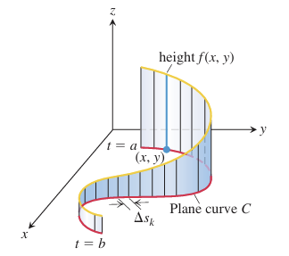

Evaluating Line Integrals over Space Curves

Evaluate ∫<sub>C</sub> (x + y) ds where C is the straight-line segment x = t, y = (1 - t), z = 0, from (0, 1, 0) to (1, 0, 0).

Evaluate ∫<sub>C</sub> (x - y + z - 2) ds where C is the straight-line segment x = t, y = (1 - t), z = 1, from (0, 1, 1) to (1, 0, 1).

Evaluate ∫<sub>C</sub> (xy + y + z) ds along the curve **r**(t) = 2t**i** + t**j** + (2 - 2t)**k**, 0 ≤ t ≤ 1.

**4.2 Vector Fields and Line Integrals: Work, Circulation, and Flux**

Gravitational and electric forces, having direction and magnitude, form vector fields. We can calculate the work done moving an object through these fields using line integrals. Similarly, velocity fields, like fluid flow, can be analyzed with line integrals to find the flow rate along or across a curve.

**Vector Fields**

A vector field assigns a vector to each point in its domain. Imagine a fluid flow: each point has a velocity vector. This is a vector field. Similarly, gravitational, electric, and magnetic forces create vector fields. Mathematically, a 3D vector field is defined by **F**(x, y, z) = M(x, y, z)**i** + N(x, y, z)**j** + P(x, y, z)**k**, where M, N, and P are component functions. Tangent and normal vectors along a curve, as well as gradient vectors of scalar functions, also form vector fields.

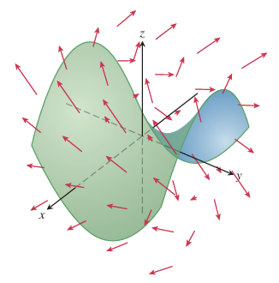

**Gradient Fields**

The gradient vector of a differentiable scalar function f(x, y, z) defines a vector field, known as the gradient field, ∇f = (∂f/∂x)**i** + (∂f/∂y)**j** + (∂f/∂z)**k**. At each point, this field indicates the direction of the function's greatest increase. The magnitude of the gradient vector represents the directional derivative in that direction. Gradient fields can model force fields, fluid motion, or heat flow. In many applications, particularly those involving potential energy, f is taken to be negative. This convention makes the gradient field represent the force that drives the system towards decreasing potential energy.

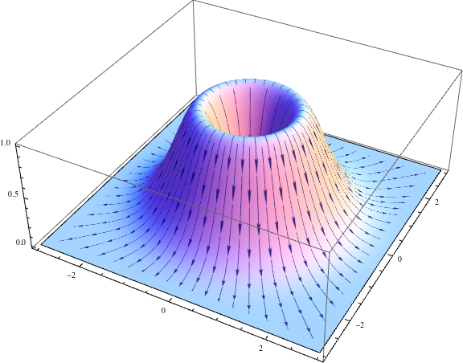

**Line Integrals of Vector Fields**

Imagine integrating a force field along a path; this is a line integral of a vector field. Such integrals are crucial in fields like fluid dynamics, work-energy calculations, and electromagnetism.

Given a continuous vector field **F** = M(x, y, z)**i** + N(x, y, z)**j** + P(x, y, z)**k** and a smooth curve C parameterized by **r**(t) = g(t)**i** + h(t)**j** + k(t)**k**, we define a direction along C called the forward direction. At each point on C, the unit tangent vector **T** = d**r**/ds = **v**/|**v**| points in this forward direction. The line integral of **F** along C is the integral of the scalar tangential component of **F**, which is found by the dot product **F** · **T** = **F** · (d**r**/ds).

**DEFINITION** Let **F** be a vector field with continuous components defined along a smooth curve C parametrized by **r**(t), a ≤ t ≤ b. Then the **line integral of F along C** is

∫<sub>C</sub> **F** · **T** ds = ∫<sub>C</sub> (**F** · (d**r**/ds)) ds = ∫<sub>C</sub> **F** · d**r**.

Evaluating the Line Integral of **F** = M**i** + N**j** + P**k** Along C: **r**(t) = g(t)**i** + h(t)**j** + k(t)**k**

1. Express the vector field **F** along the parametrized curve C as **F**(**r**(t)) by substituting the components x = g(t), y = h(t), z = k(t) of **r** into the scalar components M(x, y, z), N(x, y, z), P(x, y, z) of **F**.
2. Find the derivative (velocity) vector d**r**/dt.
3. Evaluate the line integral with respect to the parameter t, a ≤ t ≤ b, to obtain

∫<sub>C</sub> **F** · d**r** = ∫<sub>a</sub><sup>b</sup> **F**(**r**(t)) · (d**r**/dt) dt.

**EXAMPLE** Evaluate ∫<sub>C</sub> **F** · d**r**, where **F**(x, y, z) = z**i** + xy**j** - y²**k** along the curve C given by **r**(t) = t²**i** + t**j** + √t**k**, 0 ≤ t ≤ 1

**Solution** We have

**F**(**r**(t)) = √t**i** + t³**j** - t²**k** [z = √t, xy = t³, -y² = -t²]

and

d**r**/dt = 2t**i** + **j** + (1/2√t)**k**.

Thus,

∫<sub>C</sub> **F** · d**r** = ∫<sub>0</sub><sup>1</sup> **F**(**r**(t)) · (d**r**/dt) dt

= ∫<sub>0</sub><sup>1</sup> (2t³/² + t³ - (1/2)t³/²) dt

= [(3/2)(2/5)t⁵/² + (1/4)t⁴]<sub>0</sub><sup>1</sup> = 17/20.

**Work Done by a Force Field Along a Curve**

When a force field **F** moves an object along a curve C, the work done depends on the force and the path taken. We approximate this work by dividing C into small segments, finding the force's tangential component along each segment, and multiplying it by the segment's length. Summing these approximations gives an estimate of the total work. As the segments shrink, this sum converges to the line integral ∫<sub>C</sub> **F** · **T** ds, which defines the exact work done. This integral can be calculated as ∫<sub>a</sub><sup>b</sup> **F**(**r**(t)) · (d**r**/dt) dt, where **r**(t) parameterizes the curve. Reversing the direction of C changes the sign of the work done.

**EXAMPLE** Find the work done by the force field **F** = (y - x²)**i** + (z - y²)**j** + (x - z²)**k** in moving an object along the curve **r**(t) = t**i** + t²**j** + t³**k**, 0 ≤ t ≤ 1, from (0, 0, 0) to (1, 1, 1).

**Solution** First we evaluate **F** on the curve **r**(t):

**F** = (y - x²)**i** + (z - y²)**j** + (x - z²)**k** = (t² - t²)**i** + (t³ - t⁴)**j** + (t - t⁶)**k**. [Substitute x = t, y = t², z = t³.] = 0**i** + (t³ - t⁴)**j** + (t - t⁶)**k**.

Then we find d**r**/dt,

d**r**/dt = d/dt (t**i** + t²**j** + t³**k**) = **i** + 2t**j** + 3t²**k**.

Finally, we find **F** · d**r**/dt and integrate from t = 0 to t = 1:

**F** · d**r**/dt = [(t³ - t⁴)**j** + (t - t⁶)**k**] · (**i** + 2t**j** + 3t²**k**) = (t³ - t⁴)(2t) + (t - t⁶)(3t²) = 2t⁴ - 2t⁵ + 3t³ - 3t⁸. [Evaluate dot product.]

So,

Work = ∫<sub>a</sub><sup>b</sup> **F** · d**r**/dt dt = ∫<sub>0</sub><sup>1</sup> (2t⁴ - 2t⁵ + 3t³ - 3t⁸) dt = [(2/5)t⁵ - (2/6)t⁶ + (3/4)t⁴ - (3/9)t⁹]<sub>0</sub><sup>1</sup> = 29/60.

**Flux Across a Simple Closed Plane Curve**

Flux measures the rate a fluid enters or leaves a region enclosed by a simple closed curve C. It's calculated by integrating the normal component of the fluid's velocity field **F** across C. We focus on the normal component (**F** · **n**) because it determines flow across C.

**DEFINITION** If C is a smooth simple closed curve in the domain of a continuous vector field **F** = M(x, y)**i** + N(x, y)**j** in the plane, and if **n** is the outward-pointing unit normal vector on C, the **flux** of **F** across C is

Flux of **F** across C = ∫<sub>C</sub> **F** · **n** ds.

**n** = **T** × **k** = ((dx/ds)**i** + (dy/ds)**j**) × **k** = (dy/ds)**i** - (dx/ds)**j**.

If **F** = M(x, y)**i** + N(x, y)**j**, then

**F** · **n** = M(x, y)(dy/ds) - N(x, y)(dx/ds).

Hence,

∫<sub>C</sub> **F** · **n** ds = ∫<sub>C</sub> (M(dy/ds) - N(dx/ds)) ds = ∮<sub>C</sub> M dy - N dx.

Flux of **F** = M**i** + N**j** across C = ∮<sub>C</sub> M dy - N dx

The integral can be evaluated from any smooth parametrization x = g(t), y = h(t), a ≤ t ≤ b, that traces C counterclockwise exactly once.

**EXAMPLE** Find the flux of **F** = (x - y)**i** + x**j** across the circle x² + y² = 1 in the xy-plane.

**Solution** The parametrization **r**(t) = (cos t)**i** + (sin t)**j**, 0 ≤ t ≤ 2π, traces the circle counterclockwise exactly once.

With

M = x - y = cos t - sin t, dy = d(sin t) = cos t dt, N = x = cos t, dx = d(cos t) = -sin t dt,

we find

Flux = ∮<sub>C</sub> M dy - N dx = ∫<sub>0</sub><sup>2π</sup> (cos² t - sin t cos t + cos t sin t) dt Eq. (9) = ∫<sub>0</sub><sup>2π</sup> cos² t dt = ∫<sub>0</sub><sup>2π</sup> (1 + cos 2t)/2 dt = [t/2 + (sin 2t)/4]<sub>0</sub><sup>2π</sup> = π.

The flux of **F** across the circle is π. Since the answer is positive, the net flow across the curve is outward. A net inward flow would have given a negative flux.

EXERCISES

Find the gradient fields of the functions

1. f(x, y, z) = (x² + y² + z²)⁻¹/²

Find the line integrals of **F** from (0, 0, 0) to (1, 1, 1) over each of the following paths in the accompanying figure.

**a.** The straight-line path C₁: **r**(t) = t**i** + t**j** + t**k**, 0 ≤ t ≤ 1

**b.** The curved path C₂: **r**(t) = t**i** + t²**j** + t⁴**k**, 0 ≤ t ≤ 1

**2. F** = 3y**i** + 2x**j** + 4z**k**

**3. F** = [1/(x² + 1)]**j**

**4.3 Path Independence, Conservative Fields, and Potential Functions**

Gravitational and electric fields are examples of vector fields where the work done moving an object depends only on the starting and ending points, not the path taken.

**Path Independence**

For some vector fields, the line integral between two points is the same regardless of the path taken. Such integrals are called path-independent, and the fields are conservative. A field is conservative if and only if it's the gradient of a scalar potential function. Once a potential function 'f' is found, the line integral between points A and B simplifies to f(B) - f(A).

∫<sub>A</sub><sup>B</sup> **F** · d**r** = ∫<sub>A</sub><sup>B</sup> ∇f · d**r** = f(B) - f(A).

Conservative fields also have the property that their line integral around any closed path is zero.

**Line Integrals in Conservative Fields**

**THEOREM 1- Fundamental Theorem of Line Integrals**

Let C be a smooth curve joining the point A to the point B in the plane or in space and parametrized by **r**(t). Let f be a differentiable function with a continuous gradient vector **F** = ∇f on a domain D containing C. Then

∫<sub>C</sub> **F** · d**r** = f(B) - f(A).

**EXAMPLE** Suppose the force field **F** = ∇f is the gradient of the function

f(x, y, z) = -1 / (x² + y² + z²).

Find the work done by **F** in moving an object along a smooth curve C joining (1, 0, 0) to (0, 0, 2) that does not pass through the origin.

**Solution** An application of Theorem 1 shows that the work done by **F** along any smooth curve C joining the two points and not passing through the origin is

∫<sub>C</sub> **F** · d**r** = f(0, 0, 2) - f(1, 0, 0) = -1/4 - (-1) = 3/4.

**EXERCISES**

Evaluate the integrals

• ∫<sub>(0,2,1)</sub><sup>(1,π/2,2)</sup> 2 cos y dx + (1/y - 2x sin y) dy + (1/z) dz

• ∫<sub>(1,1,1)</sub><sup>(1,2,3)</sup> 3x² dx + (z²/y) dy + 2z ln y dz

• ∫<sub>(1,2,1)</sub><sup>(2,1,1)</sup> (2x ln y - yz) dx + (x²/y - xz) dy - xy dz

**4.4 Surfaces and Area**

Surfaces in space can be defined explicitly (z = f(x, y)), implicitly (F(x, y, z) = 0), or parametrically. A parametric surface uses two parameters, u and v, to define a point on the surface as **r**(u, v) = f(u, v)**i** + g(u, v)**j** + h(u, v)**k**. This vector function **r** maps a region R in the uv-plane to the surface S. We often consider R to be a rectangle for simplicity. This parametric form allows us to express the surface using three equations: x = f(u, v), y = g(u, v), and z = h(u, v).

**EXAMPLE 1** Find a parametrization of the cone

z = √(x² + y²), 0 ≤ z ≤ 1.

**Solution** Here, cylindrical coordinates provide a parametrization. A typical point (x, y, z) on the cone has x = r cos θ, y = r sin θ, and z = √(x² + y²) = r, with 0 ≤ r ≤ 1 and 0 ≤ θ ≤ 2π. Taking u = r and v = θ gives the parametrization

**r**(r, θ) = (r cos θ)**i** + (r sin θ)**j** + r**k**, 0 ≤ r ≤ 1, 0 ≤ θ ≤ 2π.

The parametrization is one-to-one on the interior of the domain R, though not on the boundary tip of its cone where r = 0.

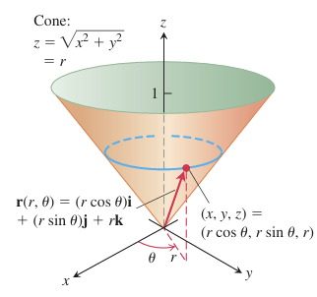

**Surface Area**

To find the area of a parametric surface **r**(u, v), we approximate it using small parallelograms. The vectors **r**<sub>u</sub> and **r**<sub>v</sub>, partial derivatives of **r**, are tangent to the surface. Their cross product, **r**<sub>u</sub> × **r**<sub>v</sub>, is normal to the surface. We approximate a small surface patch with a parallelogram having sides Δu **r**<sub>u</sub> and Δv **r**<sub>v</sub>, whose area is |**r**<sub>u</sub> × **r**<sub>v</sub>| Δu Δv. Summing these areas and taking the limit as Δu and Δv approach zero yields the surface area integral: ∫∫<sub>R</sub> |**r**<sub>u</sub> × **r**<sub>v</sub>| dA. This integral can be abbreviated as ∫∫<sub>S</sub> dσ, where dσ = |**r**<sub>u</sub> × **r**<sub>v</sub>| du dv is the surface area differential.

**DEFINITION** The **area** of the smooth surface

**r**(u, v) = f(u, v)**i** + g(u, v)**j** + h(u, v)**k**, a ≤ u ≤ b, c ≤ v ≤ d

is

A = ∫∫<sub>R</sub> |**r**<sub>u</sub> × **r**<sub>v</sub>| dA = ∫<sub>c</sub><sup>d</sup> ∫<sub>a</sub><sup>b</sup> |**r**<sub>u</sub> × **r**<sub>v</sub>| du dv.

**EXAMPLE** Find the surface area of the cone in Example 1

**Solution** In Example 1, we found the parametrization

**r**(r, θ) = (r cos θ)**i** + (r sin θ)**j** + r**k**, 0 ≤ r ≤ 1, 0 ≤ θ ≤ 2π.

we first find **r**<sub>r</sub> × **r**<sub>θ</sub>:

**r**<sub>r</sub> × **r**<sub>θ</sub> = | **i** **j** **k** | | cos θ sin θ 1 | | -r sin θ r cos θ 0 |

= -(r cos θ)**i** - (r sin θ)**j** + (r cos² θ + r sin² θ)**k** = -(r cos θ)**i** - (r sin θ)**j** + r**k**.

Thus, |**r**<sub>r</sub> × **r**<sub>θ</sub>| = √(r² cos² θ + r² sin² θ + r²) = √(2r²) = √2 r. The area of the cone is

A = ∫<sub>0</sub><sup>2π</sup> ∫<sub>0</sub><sup>1</sup> |**r**<sub>r</sub> × **r**<sub>θ</sub>| dr dθ Eq. (4) with u = r, v = θ

= ∫<sub>0</sub><sup>2π</sup> ∫<sub>0</sub><sup>1</sup> √2 r dr dθ = ∫<sub>0</sub><sup>2π</sup> √2/2 dθ = √2/2 (2π) = π√2 square units.

**Implicit Surfaces**

Surfaces can be defined implicitly by an equation F(x, y, z) = c, where c is a constant. These surfaces are called level surfaces and don't have explicit parametrizations. Examples include equipotential surfaces in physics.

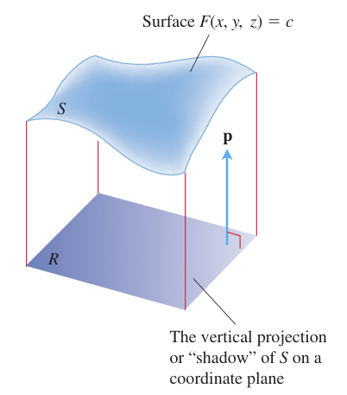

**Formula for the Surface Area of an Implicit Surface**

The area of the surface F(x, y, z) = c over a closed and bounded plane region R is

Surface area = ∫∫<sub>R</sub> |∇F| / |∇F · **p**| dA,

where **p** = **i**, **j**, or **k** is normal to R and ∇F · **p** ≠ 0.

Find a parametrization of the surface. (There are many correct ways to do these)

1. The paraboloid z = x² + y², z ≤ 4
2. The paraboloid z = 9 - x² - y², z ≥ 0

**그래서**